Online supplementary material for

Testing the automaticity of an attentional bias towards predictive cues in human associative learning

David Luque, Sara Molinero, Mina Jevtović & Tom Beesley

Online supplementary material #1. Instructions
Experiment 1. Beginning of the experiment:
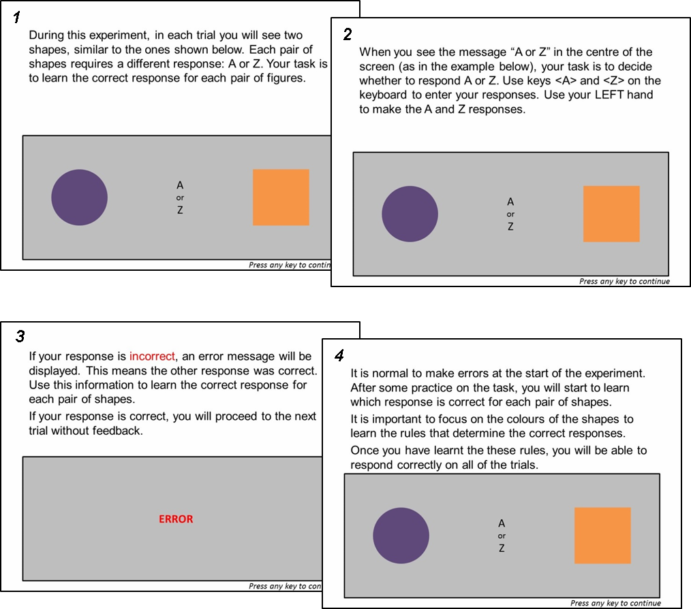

Between Phase 1 and 2:

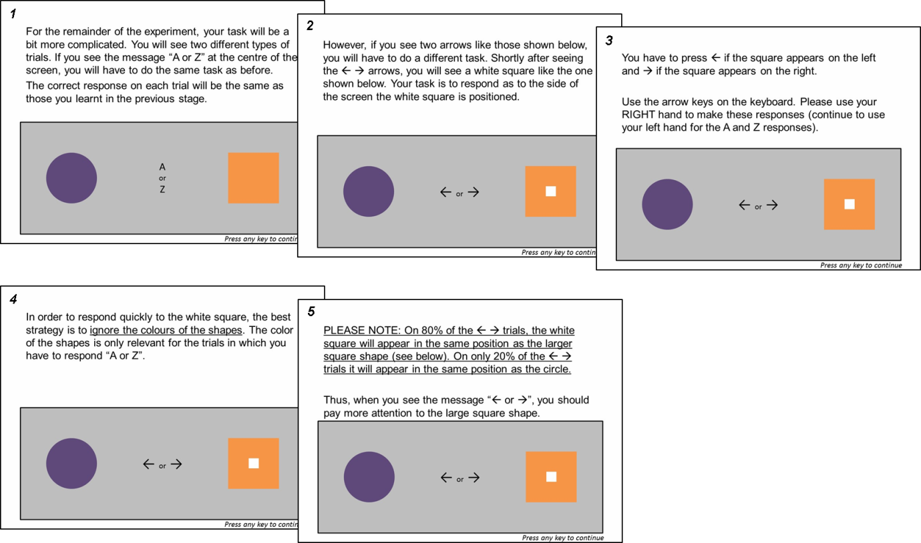

Experiment 2
Beginning of the experiment: The same as in Experiment 1.
Between Phase 1 and 2
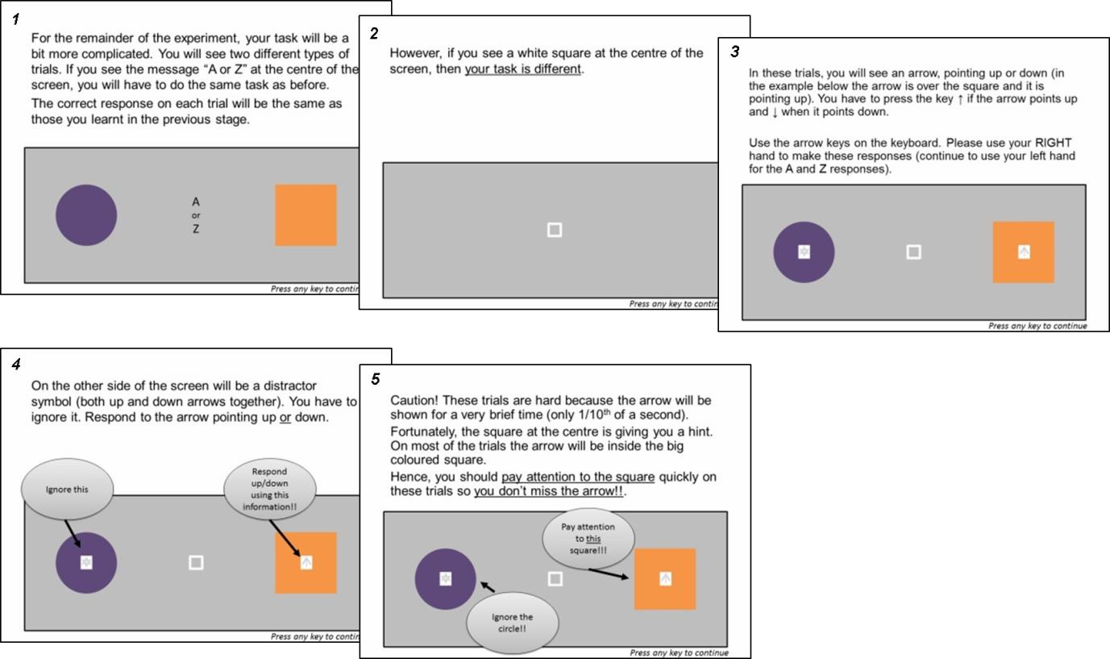

Experiment 3

All instructions were the same as in Experiment 2.

