A cross-country comparison of gender traditionalism in business leadership: How supportive are female supervisors?

Accompanying appendix explicitly mentioned in paper

Table A1. Selection of sample per survey
 | Employed,  aged 25 to 65 |  | After exclusion missing information
 | Men | Women | Men | Women
 | % | % | %(n) | %(n)
Australia-2005 | 43.04 | 40.54 | 97.09(267) | 96.17(301)
Australia-2012 | 50.26 | 44.38 | 95.26(362) | 97.50(312)
Canada-2006 | 48.98 | 39.22 | 92.69(469) | 94.09(414)
Chile-2012 | 57.61 | 38.26 | 89.44(254) | 82.47(160)
Estonia-2011 | 45.20 | 46.15 | 95.82(298) | 98.21(383)
Finland-2005 | 44.86 | 43.75 | 95.87(209) | 95.24(220)
France-2006 | 47.39 | 41.95 | 99.56(226) | 97.72(214)
Germany-2006 | 42.83 | 42.64 | 88.76(379) | 90.11(410)
Germany-2013 | 51.70 | 45.22 | 93.81(485) | 92.39(437)
Hungary-2009 | 45.74 | 32.59 | 88.37(190) | 91.43(160)
Italy-2005 | 36.44 | 31.36 | 90.76(167) | 89.31(142)
Japan-2005 | 54.04 | 40.95 | 63.98(167) | 69.32(174)
Japan-2010 | 51.66 | 40.21 | 65.63(399) | 66.21(337)
South Korea-2005 | 50.59 | 21.75 | 97.00(291) | 96.97(128)
South Korea-2010 | 43.17 | 29.16 | 91.02(233) | 92.09(163)
Mexico-2005 | 39.37 | 16.65 | 92.05(278) | 94.70(125)
Mexico-2012 | 33.33 | 19.18 | 97.00(323) | 98.96(190)
Netherlands-2006 | 52.05 | 49.16 | 84.27(225) | 82.95(219)
Netherlands-2012 | 45.25 | 43.32 | 89.00(356) | 90.93(401)
New Zealand-2011 | 56.37 | 51.45 | 76.88(153) | 88.71(220)
Norway-2007 | 57.59 | 58.71 | 98.99(293) | 98.33(295)
Poland-2005 | 41.39 | 33.21 | 87.31(172) | 89.66(156)
Poland-2012 | 45.92 | 34.89 | 89.90(187) | 90.50(162)
Slovenia-2005 | 50.41 | 34.41 | 90.95(221) | 84.82(162)
Slovenia-2011 | 48.22 | 40.91 | 91.24(198) | 90.48(228)
Spain-2007 | 42.78 | 29.13 | 87.55(218) | 92.78(167)
Spain-2011 | 36.22 | 29.25 | 93.78(196) | 91.62(164)
Sweden-2006 | 58.02 | 57.03 | 98.63(289) | 97.18(276)
Sweden-2011 | 55.65 | 47.85 | 94.03(315) | 95.50(276)
Switzerland-2007 | 54.14 | 49.41 | 96.09(295) | 95.50(318)
Great Britain-2005 | 43.00 | 41.77 | 86.05(185) | 89.82(203)
United States-2011 | 47.09 | 39.13 | 83.14(424) | 83.11(374)
Total | 47.11 | 38.88 | 89.48(8,725) | 90.14(7,891)
Source: WVS
Table A2. Country level variables (n=32)
 | Women in managerial positions¹  (%) | National legislative gender quota policy (binding)  0 = no  1 = yes | Traditional normative climate towards working women¹ (%)
Australia-2005 | 33.50 | 0 | 13.87
Australia-2012 | 36.10 | 0¹ | 6.99
Canada-2006 | 35.90 | 1² (2006) | 14.25
Chile-2012 | 23.60 | 0 | 17.89
Estonia-2011 | 36.10 | 0 | 17.93
Finland-2005 | 28.20 | 1 (2005) | 9.65
France-2006 | 37.60 | 0 | 18.11
Germany-2006 | 28.20 | 0 | 17.85
Germany-2013 | 28.60 | 0¹ | 15.59
Hungary-2009 | 36.50 | 0 | 12.76
Italy-2005 | 33.30 | 0 | 21.99
Japan-2005 | 10.70 | 0 | 27.06
Japan-2010 | 10.70 | 0 | 32.16
South Korea-2005 | 6.90 | 0 | 36.46
South Korea-2010 | 8.60 | 0 | 32.29
Mexico-2005 | 24.60 | 0 | 25.34
Mexico-2012 | 35.00 | 0 | 16.78
Netherlands-2006 | 25.50 | 0 | 12.45
Netherlands-2012 | 29.30 | 0¹ | 7.67
New Zealand-2011 | 40.00 | 0 | 7.18
Norway-2007 | 33.20 | 1 (2003) | 6.46
Poland-2005 | 32.80 | 0 | 30.81
Poland-2012 | 38.00 | 0¹ | 26.58
Slovenia-2005 | 33.40 | 0 | 13.56
Slovenia-2011 | 34.80 | 0 | 9.89
Spain-2007 | 31.90 | 1 (2007) | 17.45
Spain-2011 | 34.30 | 1 (2007) | 12.37
Sweden-2006 | 31.90 | 0 | 2.07
Sweden-2011 | 31.40 | 0¹ | 1.98
Switzerland-2007 | 30.60 | 0 | 22.08
Great Britain-2005 | 33.10 | 0 | 16.22
United States-2011 | 39.10 | 0¹ | 5.75
Min. | 6.90 |  | 1.98
Max. | 40.00 |  | 36.46
Mean (n=32) | 29.79 |  | 16.55
SD (n=32) | 8.85 |  | 9.00
Source: WVS
1: A governance code including board gender recommendations (non-binding)
2: In Quebec

Table A3. Logistic multilevel analyses of being a female supervisor (1; n=2,594) or one other employee-group (0)
 | Women |  | Men
 | Non-supervisors  (n=5,297) |  | Supervisors  (n=4,260) |  | Non-supervisors  (n=4,465)
 | B |  | B |  | B
Constant | -0.48 | *** | -0.86 | *** | -0.95 | ***
Age | 0.03 | ** | 0.004 |  | 0.04 | ***
Squared | -0.0003 |  | -0.001 | * | -0.001 | ***
Married
Separated | 0.001 |  | 0.76 | *** | 0.52 | ***
Single | -0.13 | * | 0.24 | *** | -0.11
Widow | 0.26 |  | 1.75 | *** | 1.48 | ***
Number of children | 0.003 |  | -0.08 | *** | 0.08 | ***
Religious service attendance | 0.02 | ** | 0.06 | *** | 0.09 | ***
Education (ref. university)
Lower than complete secondary school | -1.29 | *** | -0.46 | *** | -1.72 | ***
Complete secondary school | -0.68 | *** | -0.22 | *** | -0.90 | ***
University preparatory (completed or not) | -0.65 | *** | -0.25 | *** | -0.66 | ***
Some university without degree | -0.18 | ** | -0.23 | ** | -0.35 | ***
Part-time employment | -0.60 | *** | 1.93 | *** | 1.03 | ***
Private occupational sector (ref.)
Public | -0.01 |  | 0.77 | *** | 0.63 | ***
Private non-profit | 0.27 | *** | 0.91 | *** | 0.76 | ***
Variance
Country | 0.05 |  | 0.03 |  | 0.13 | *
Survey | 0.30 | *** | 0.17 | ** | 0.53 | ***
-2LL | 35706.65 |  | 31083.19 |  | 33389.37
Source: WVS. Two-tailed: *p <.10; **p<.05; ***p<.01

Figure A1 Support for the opinion “men make better business executives”: per survey-country (n=32)
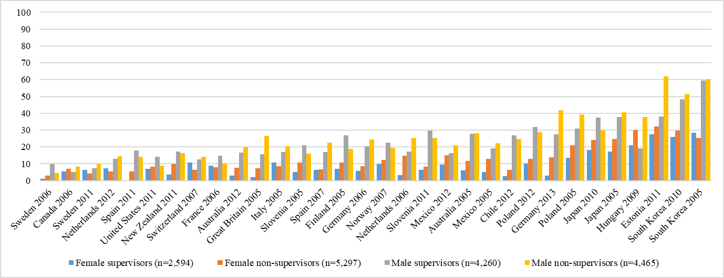
Source: WVS
Table 3. (continue): Control variables
 | Model 5 |  |  | Model 6 |  |  | Model 7
 | B |  | SE | B |  | SE | B |  | SE
Age | -0.02 | ** | 0.01 | -0.02 | ** | 0.01 | -0.02 | ** | 0.01
Squared | 0.001 | *** | 0.00 | 0.001 | *** | 0.00 | 0.001 | *** | 0.00
Married (ref.)
Divorced | 0.10 |  | 0.08 | 0.10 |  | 0.08 | 0.10 |  | 0.08
Single | 0.04 |  | 0.07 | 0.04 |  | 0.07 | 0.04 |  | 0.07
Widowed | 0.39 | ** | 0.16 | 0.38 | ** | 0.16 | 0.39 | ** | 0.16
Number of children | 0.01 |  | 0.02 | 0.02 |  | 0.02 | 0.02 |  | 0.02
Religious service attendance | 0.06 | *** | 0.01 | 0.06 | *** | 0.01 | 0.06 | *** | 0.01
Education (ref. university)
Lower than incomplete secondary school | 0.35 | *** | 0.07 | 0.34 | *** | 0.07 | 0.34 | *** | 0.07
Complete secondary school | 0.26 | *** | 0.07 | 0.26 | *** | 0.07 | 0.26 | *** | 0.07
University-preparatory (completed or not) | 0.15 | ** | 0.06 | 0.15 | ** | 0.06 | 0.14 | ** | 0.06
Some university without degree | -0.08 |  | 0.09 | -0.09 |  | 0.09 | -0.08 |  | 0.09
Part-time employment | -0.01 |  | 0.07 | -0.01 |  | 0.07 | -0.01 |  | 0.07
Private occupational sector (ref.)
Public | -0.13 | ** | 0.05 | -0.13 | ** | 0.05 | -0.13 | ** | 0.05
Private non-profit | -0.22 | ** | 0.09 | -0.21 | ** | 0.09 | -0.22 | ** | 0.09
Source: WVS. Two-tailed: *p<.10; **p<.05; ***p<.01;

