WEB APPENDIX:

EXPERIMENTAL MATERIALS (SAMPLE SCREENSHOTS)

Experiment 1

Preview Instructions:
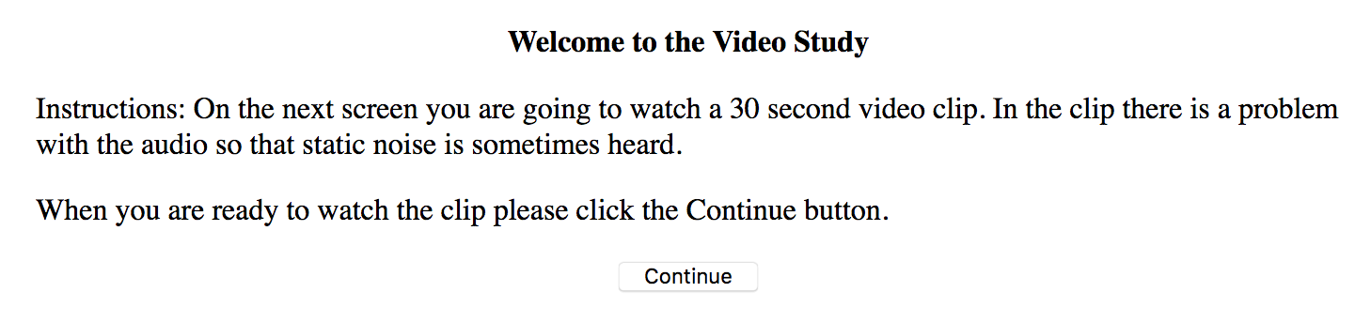

Preview Display:
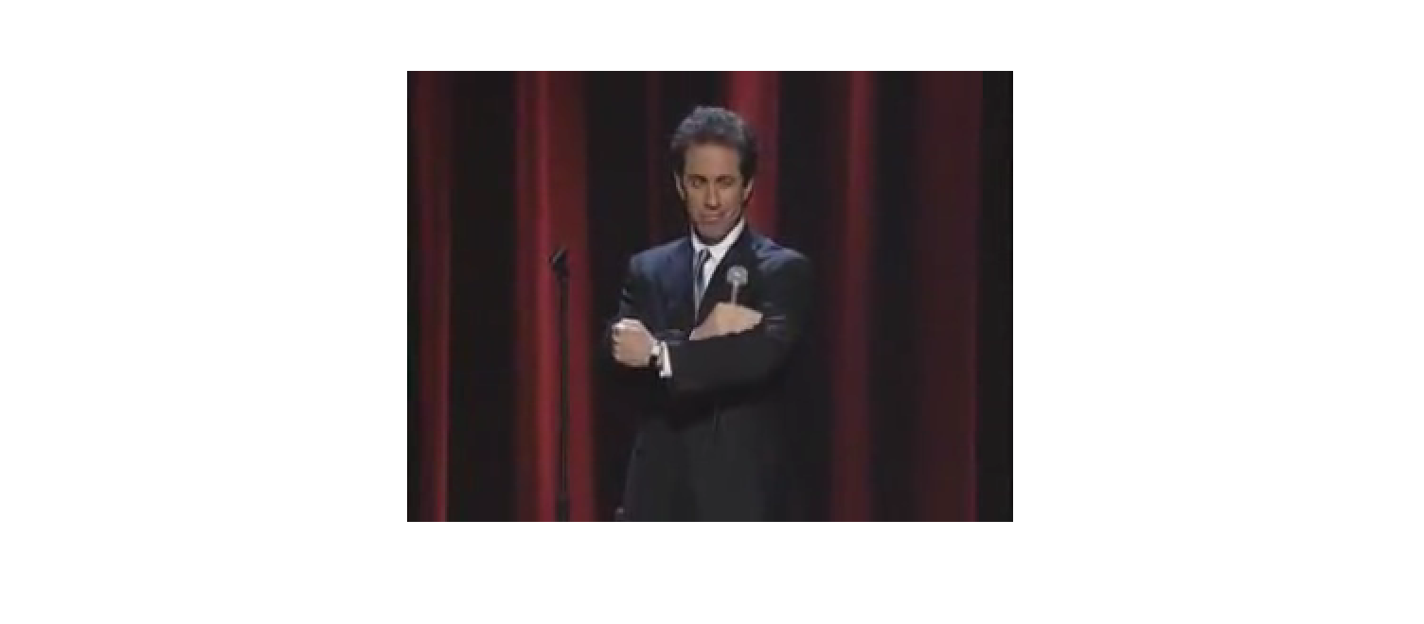

Manipulation Check:
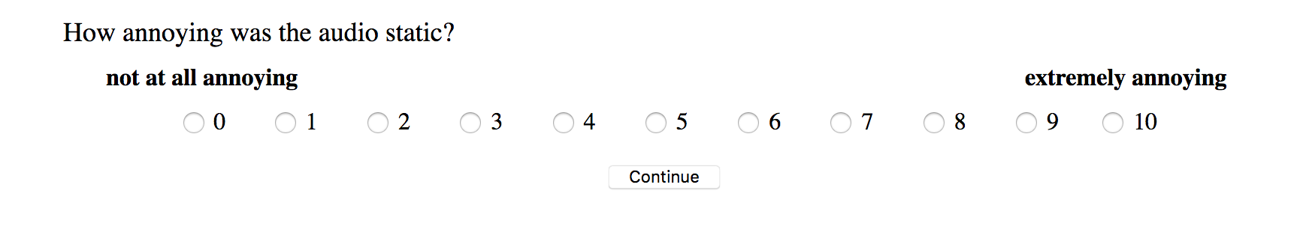

Final Instructions:
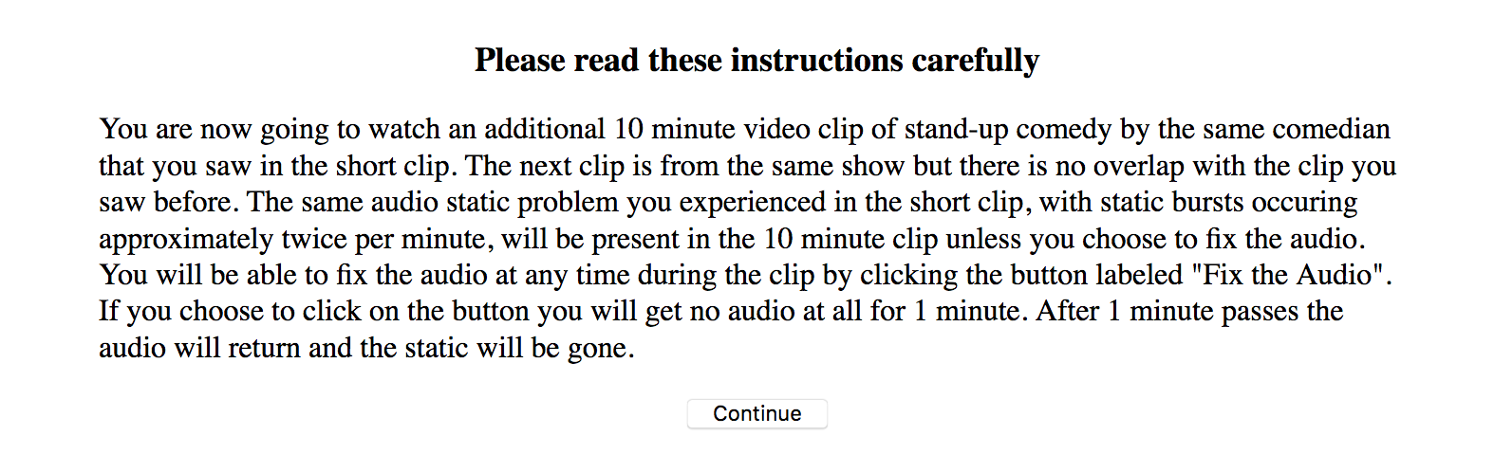

Main Experience:
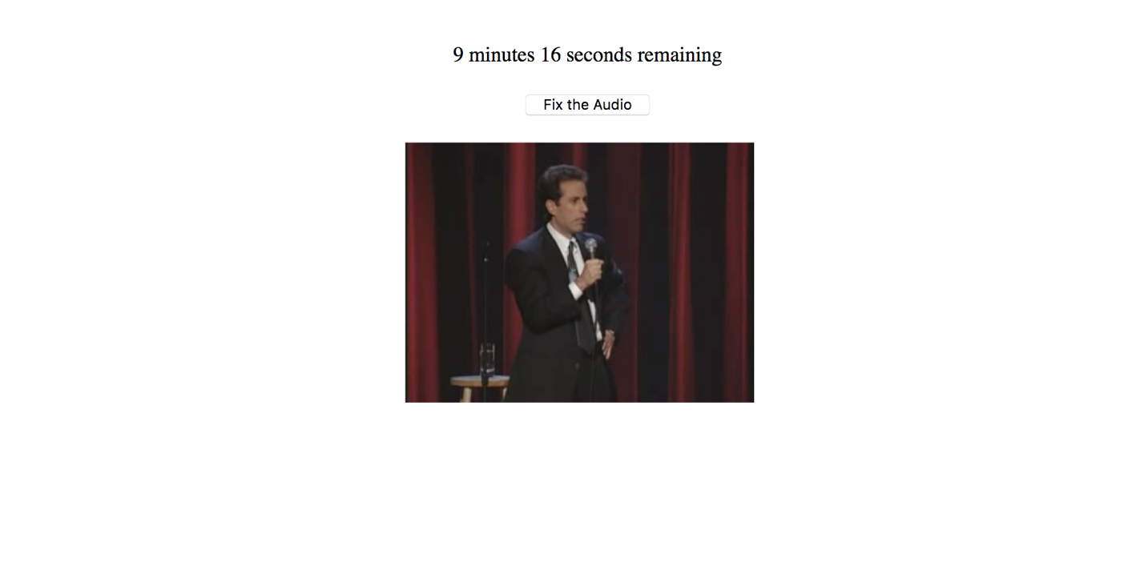

Enjoyment Measure:
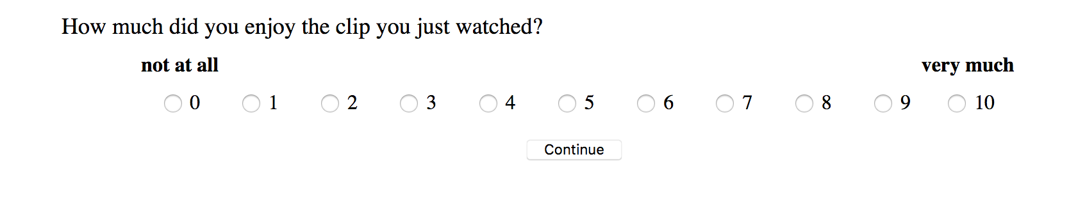

Experiment 2

Initial Instructions:
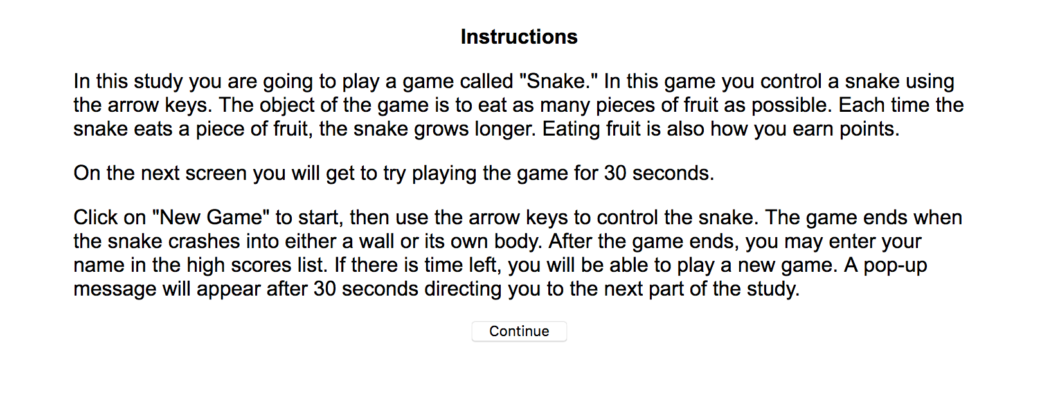

Game Preview:
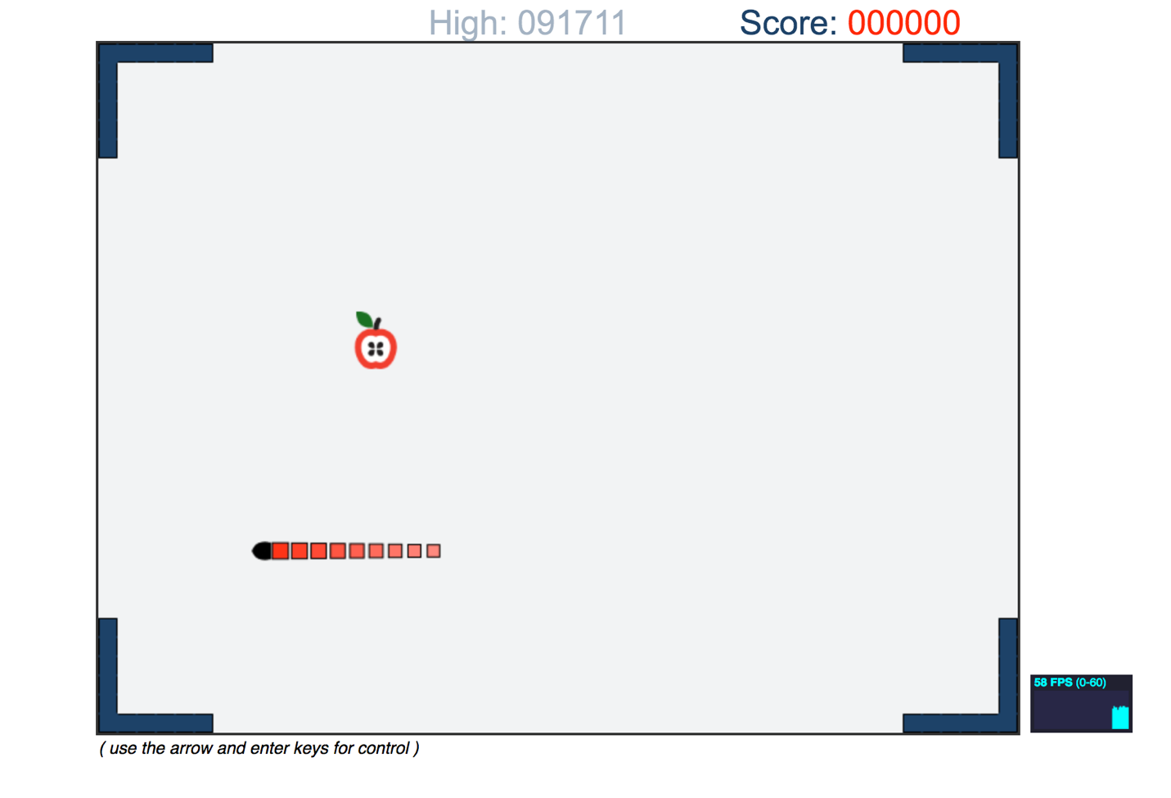

Malfunction Instructions:
Note: Larger malfunction version shown. For smaller malfunction conditions instructions would state “3 times per minute”.
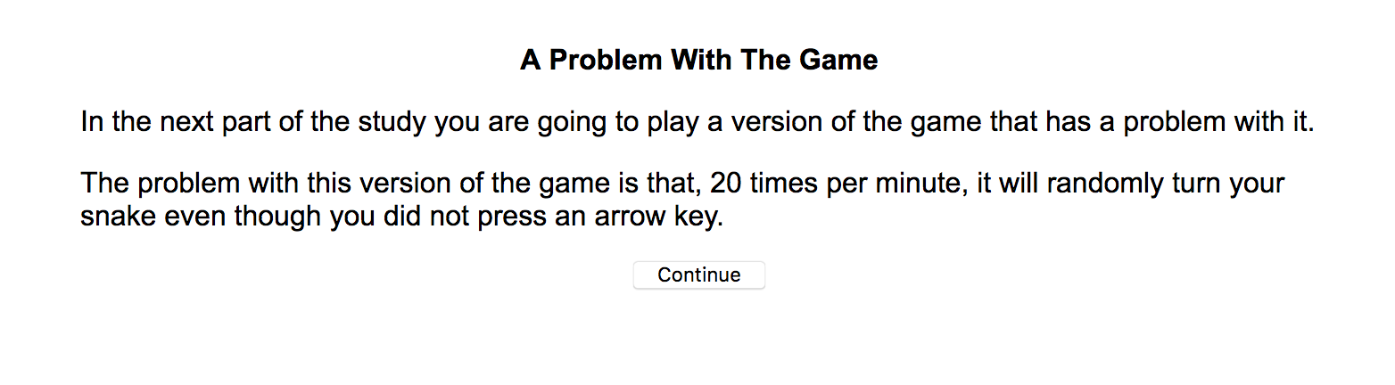

Malfunction Preview:
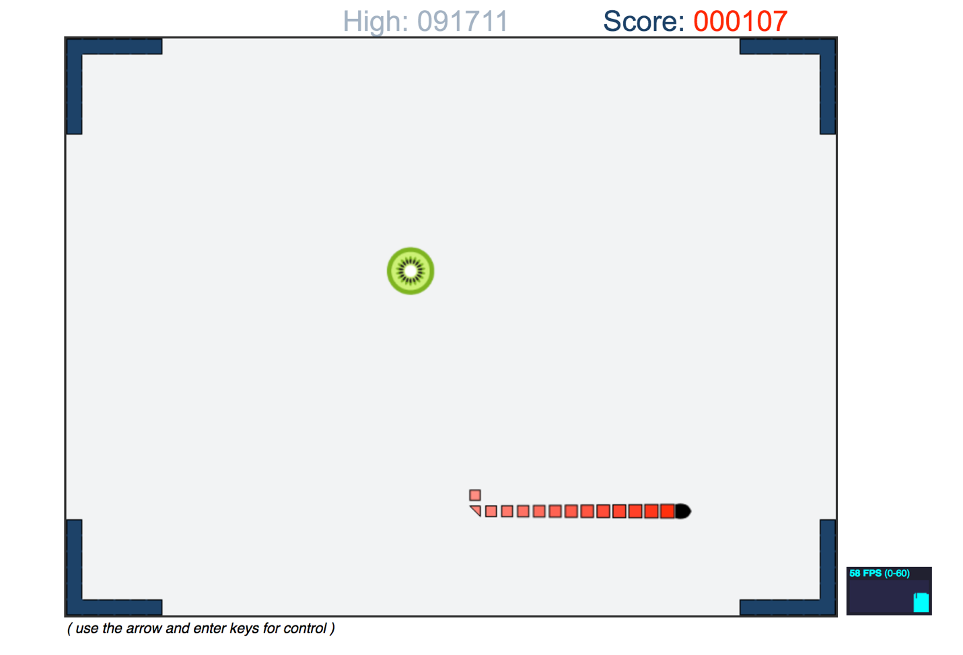

Manipulation Check:
Note: Larger malfunction version shown. For smaller malfunction conditions instructions would state “3 times per minute”.
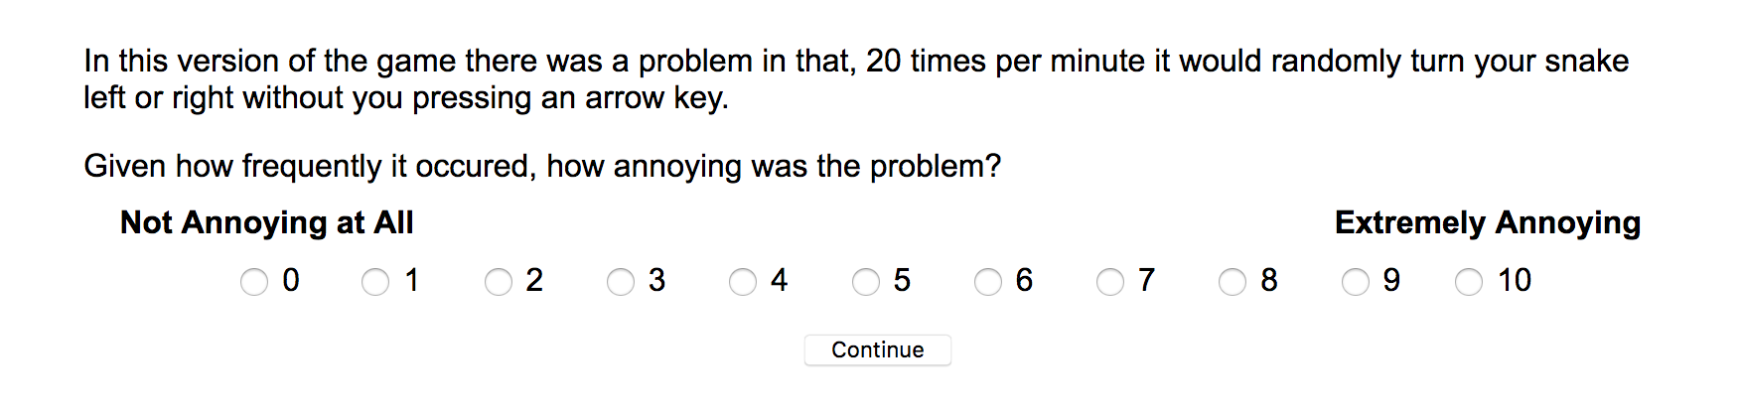

Number Task Preview:
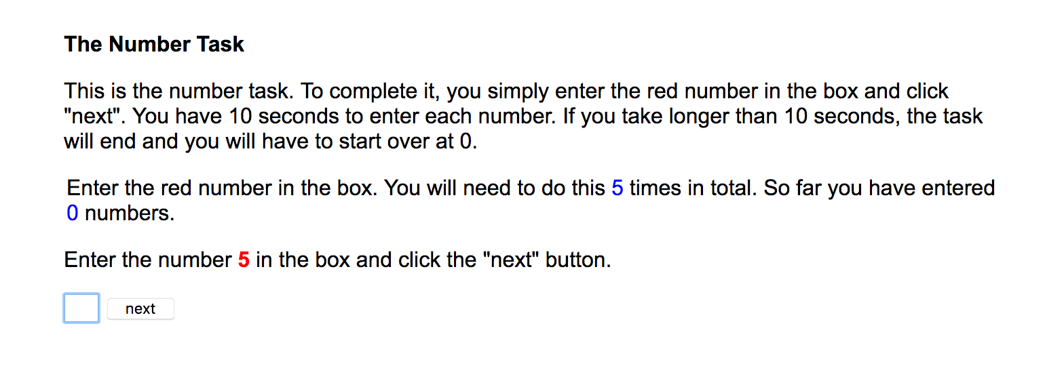

Final Instructions (for beginning only opportunity conditions):
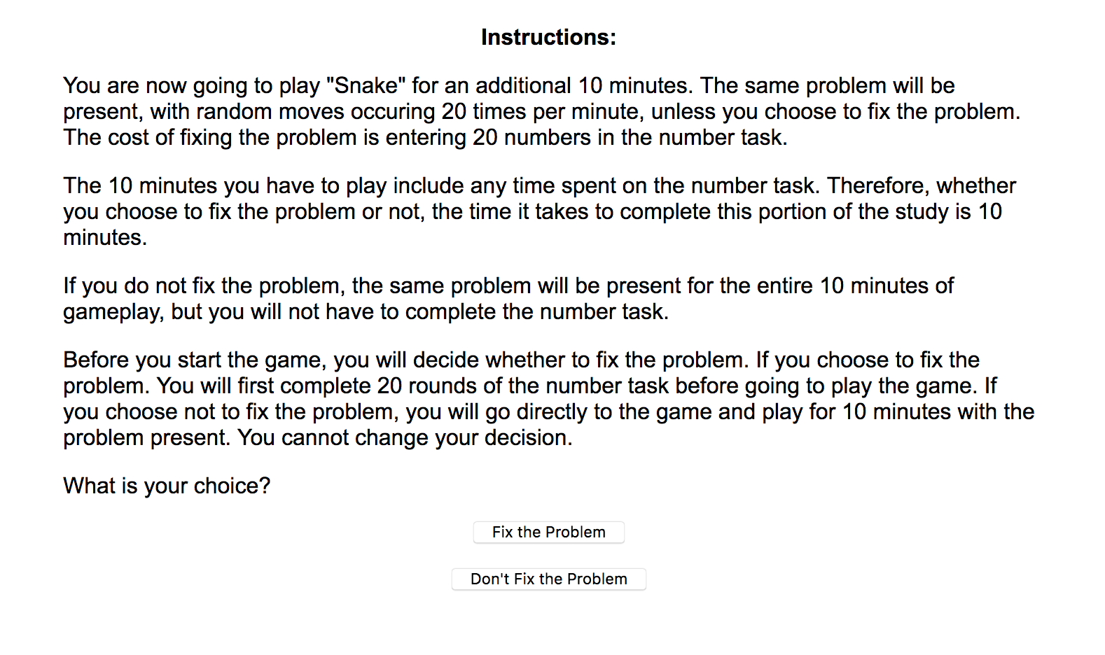

Final Instructions (for ongoing opportunity conditions):
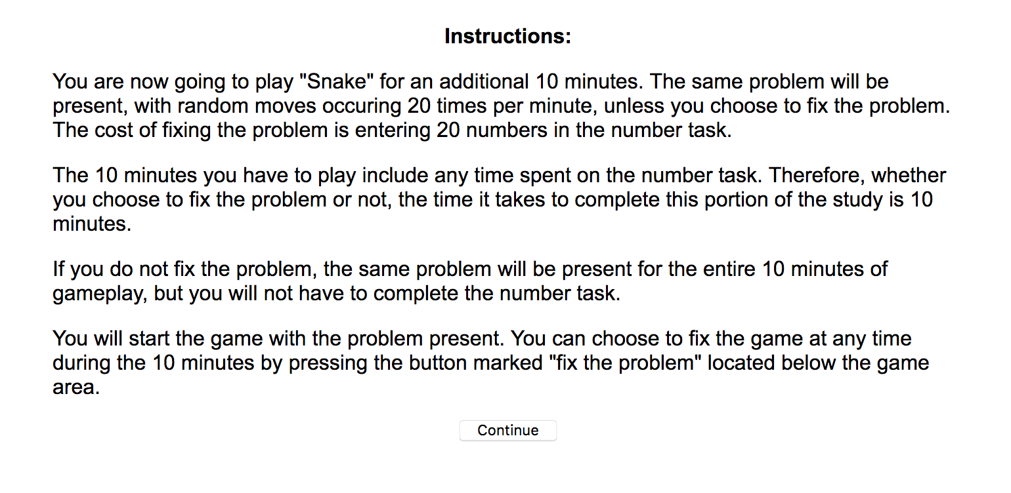

Main Experience:
Note: Ongoing opportunity conditions shown. “Click to Fix the Problem” button absent in beginning only conditions.
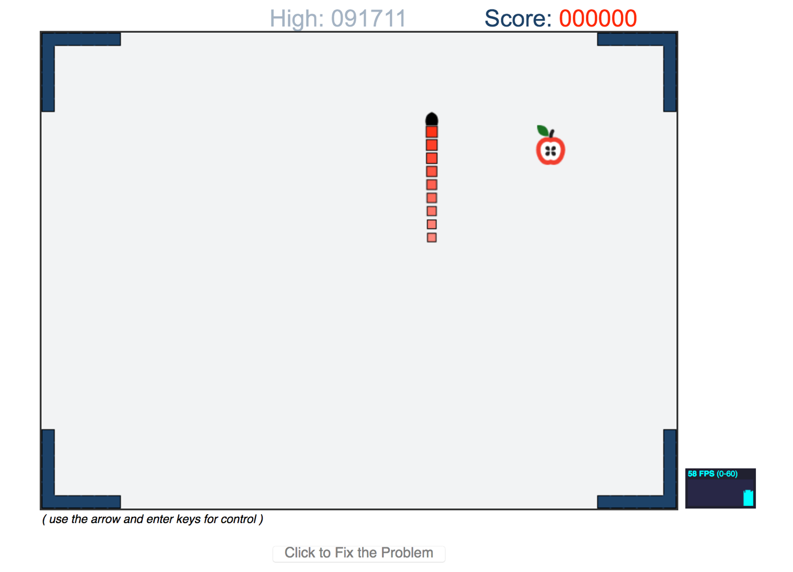

Enjoyment Measure:
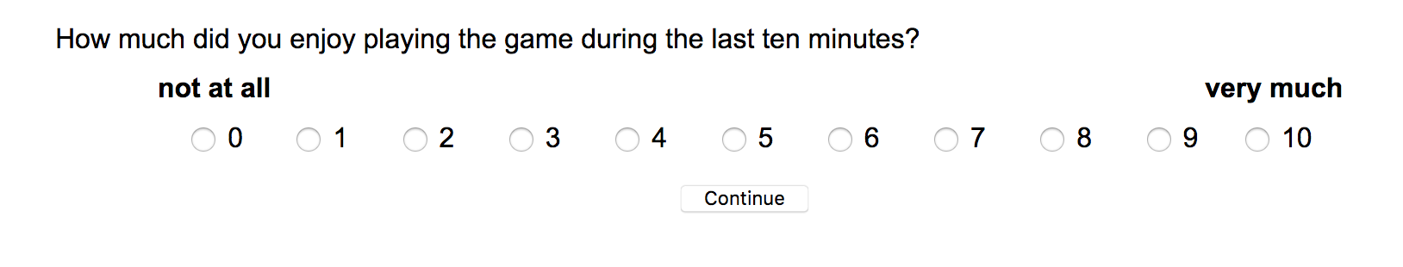

Relative Preference Measure:
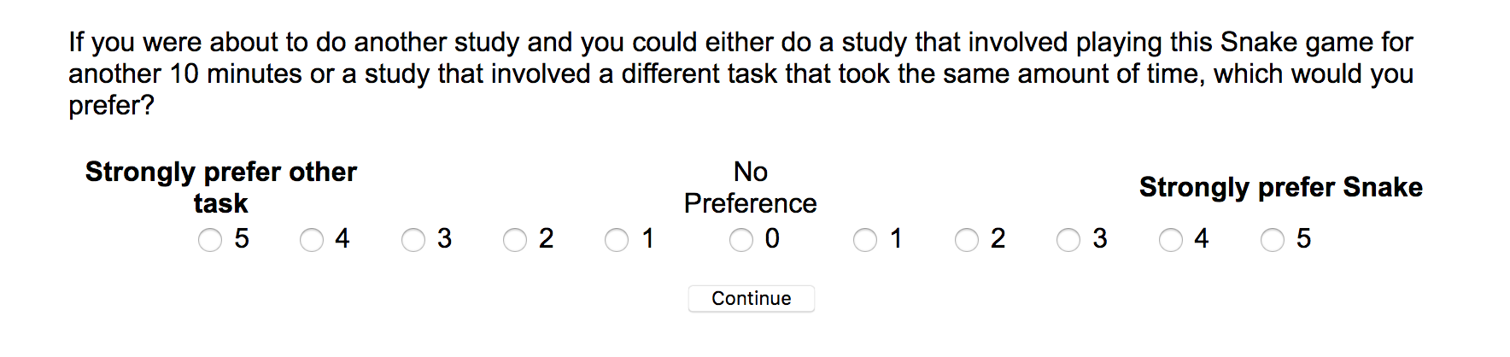

Future Access Sign-Up:
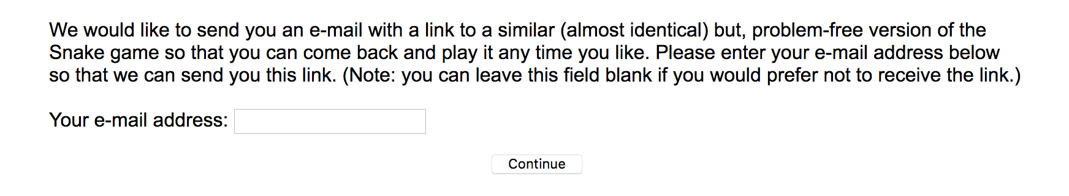

Experiment 3
Initial Instructions: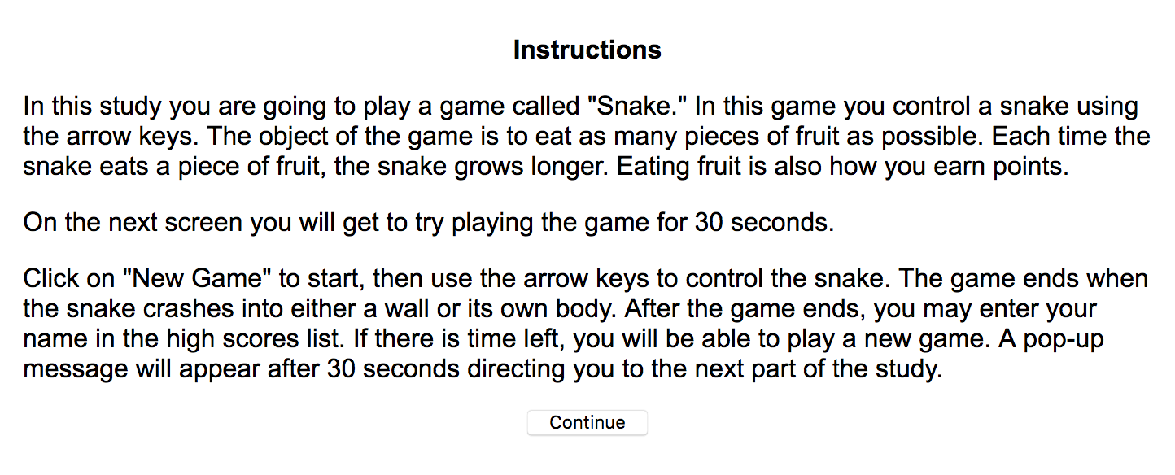

Game Preview:
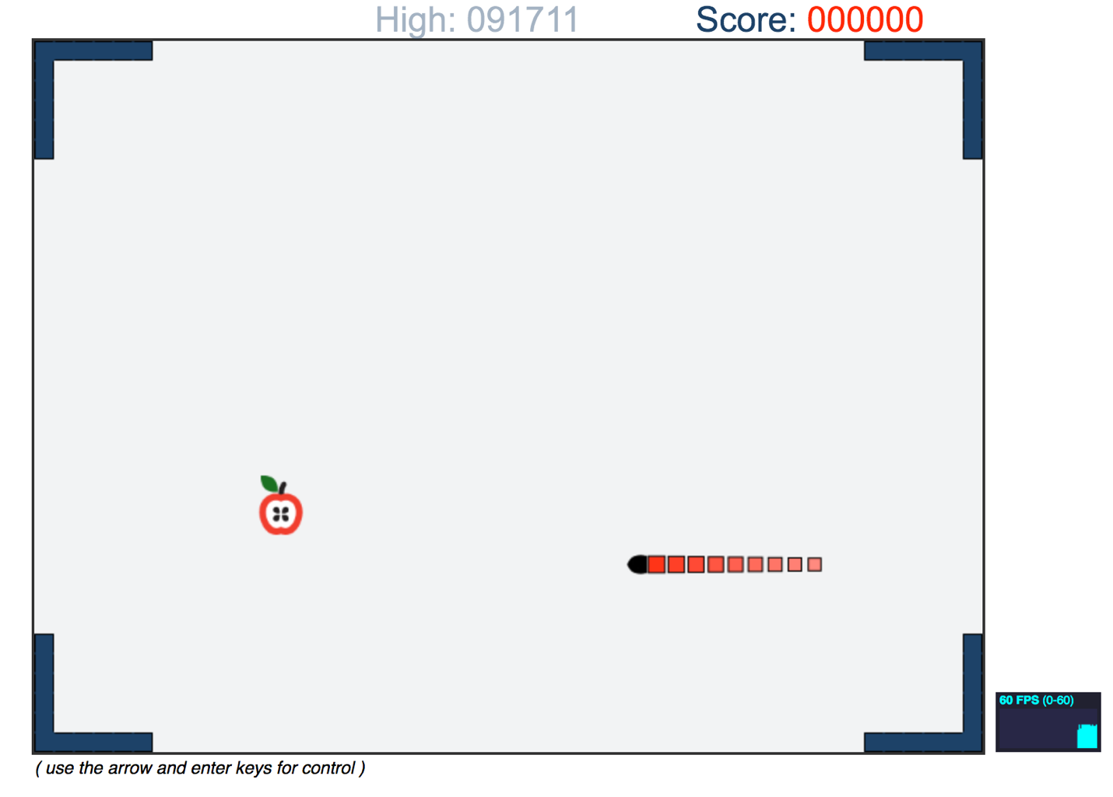

Malfunction Instructions:
Note: Smaller constant malfunction and escalating malfunctions version shown. For larger constant malfunction condition instructions would state “20 times per minute”.
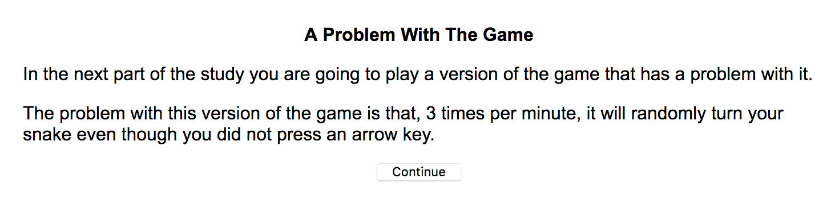

Malfunction Preview:
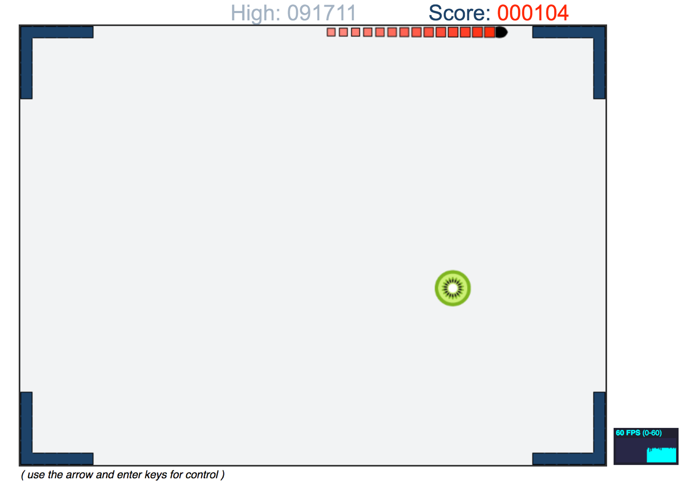

Number Task Preview:
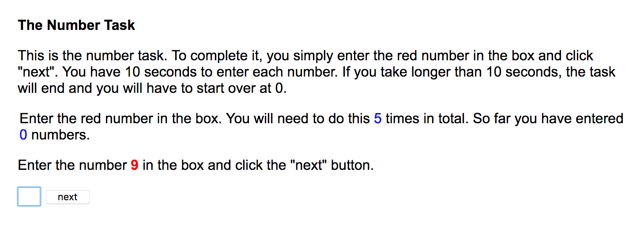

Final Instructions:
Note: Smaller constant malfunction and escalating malfunctions version shown. For larger constant malfunction condition instructions would state “20 times per minute”.
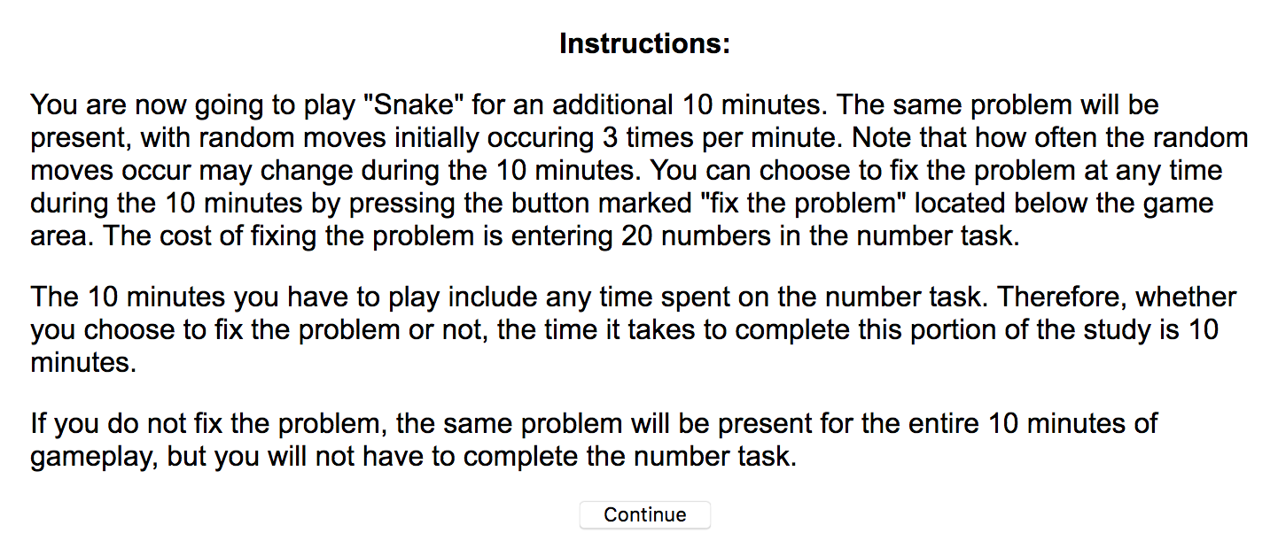

Main Experience:
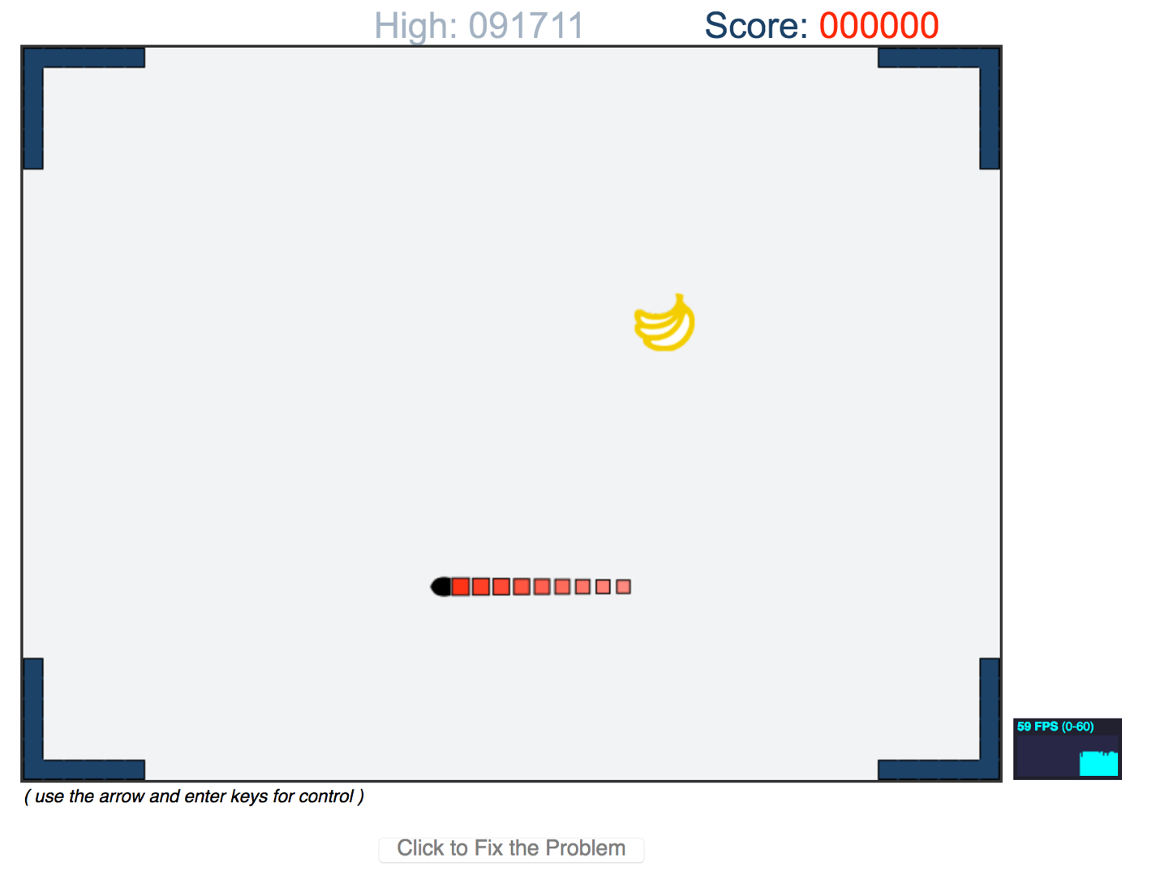

Enjoyment Measure:

Relative Preference Measure:

Future Access Sign-Up

Experiment 4

Number Task Preview:
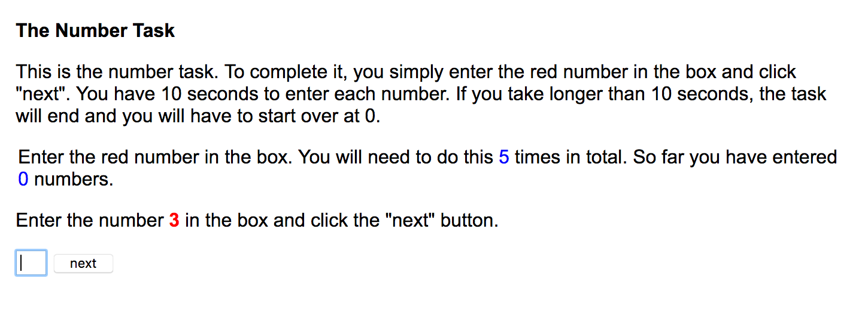

Music Player Instructions:
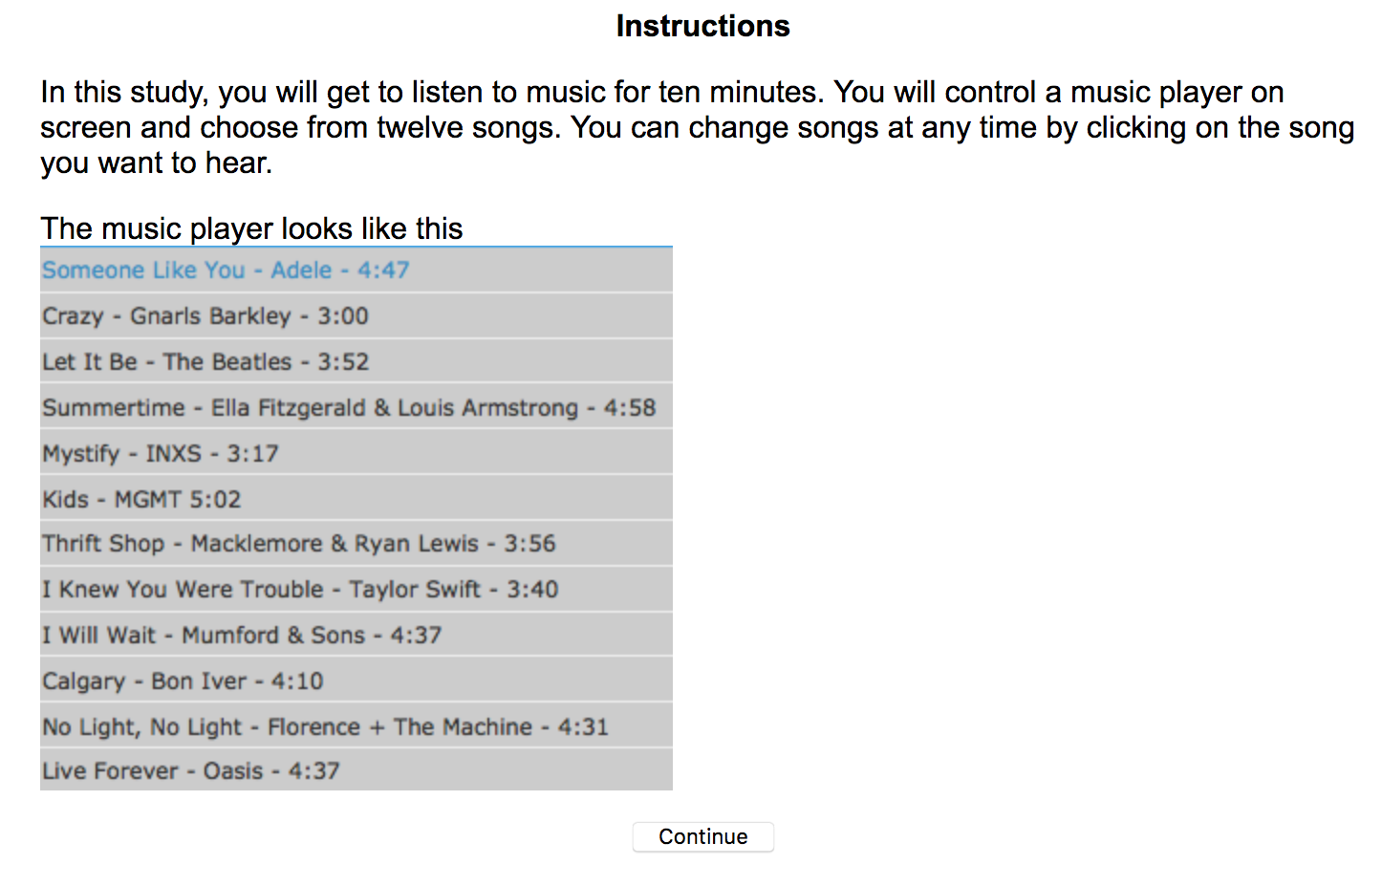

Malfunction Instructions:
Note: Continuous conditions version shown. For intermittent conditions first sentence reads: “Throughout your listening experience you will hear short bursts of audio static. You will always have the option of completing 20 rounds of the number task to get rid of all future bursts of static…”
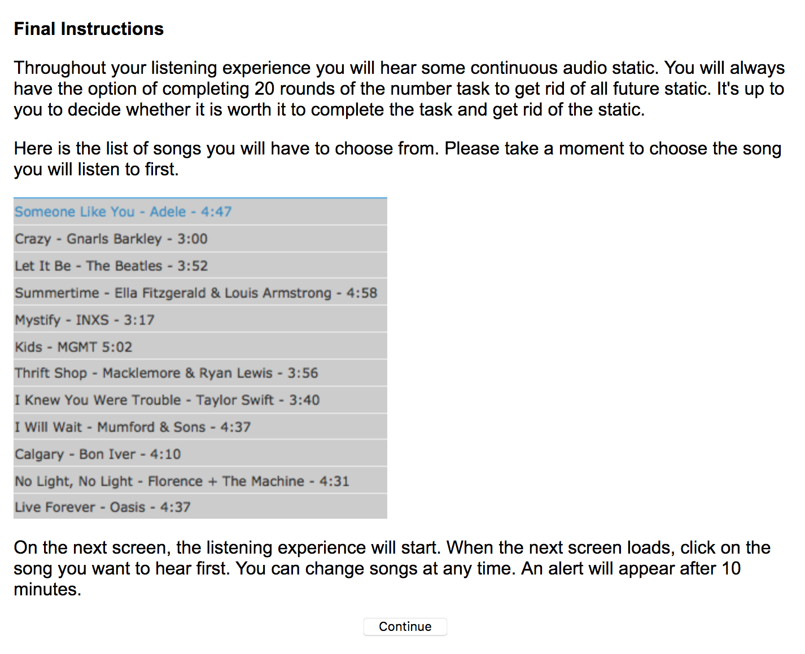

Main Experience:
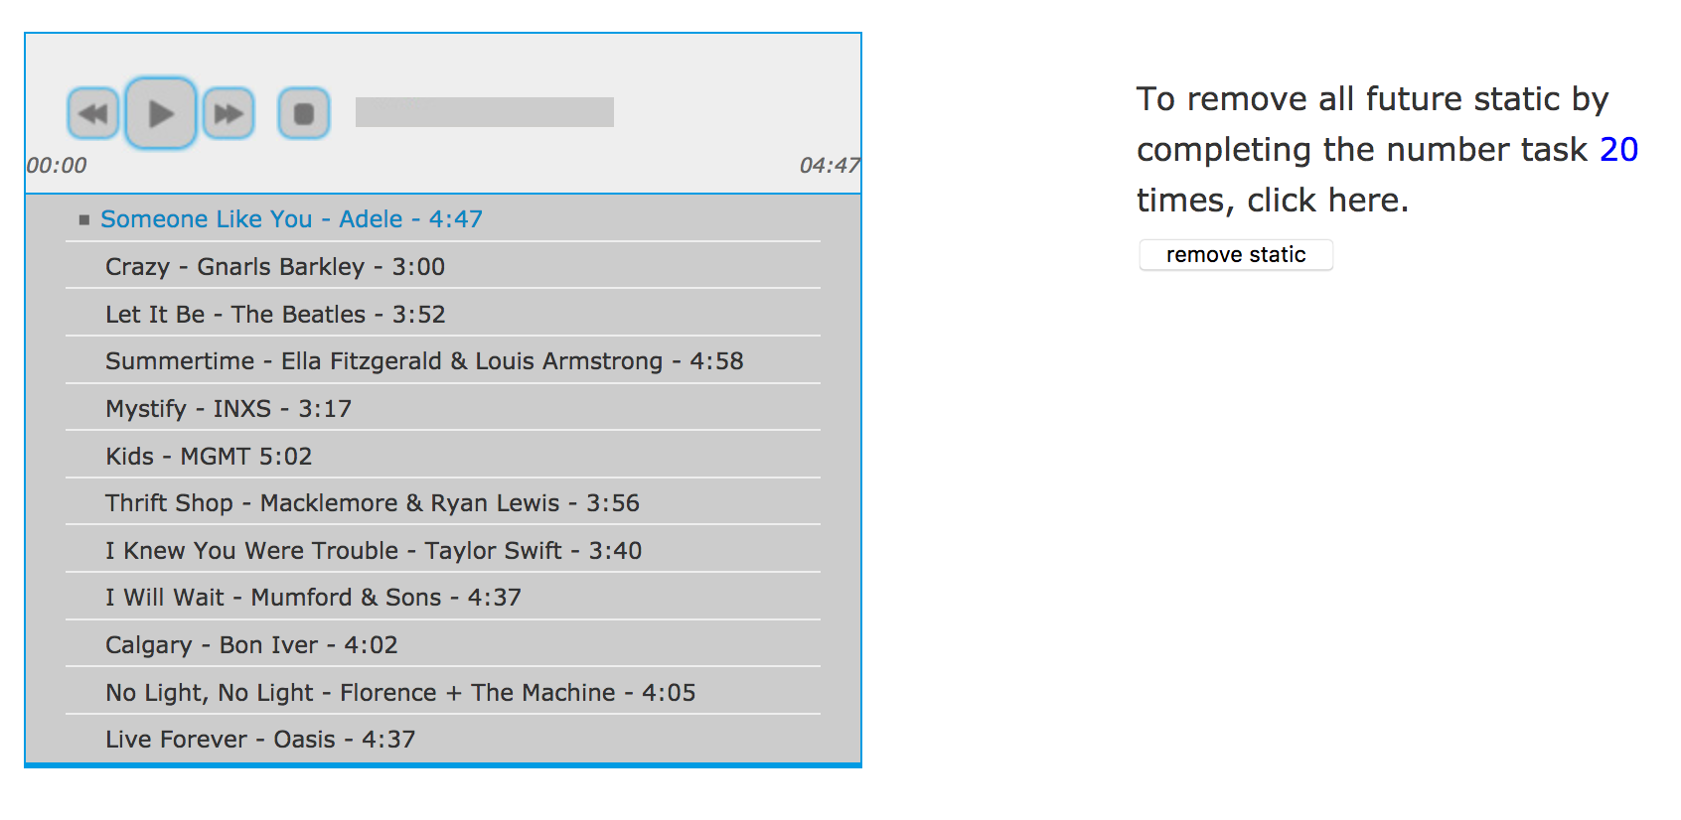

Enjoyment Measure:
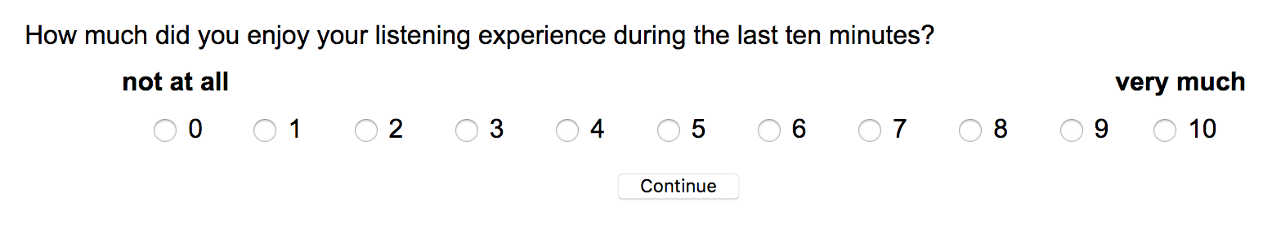

Experiment 5

Number Task Preview:
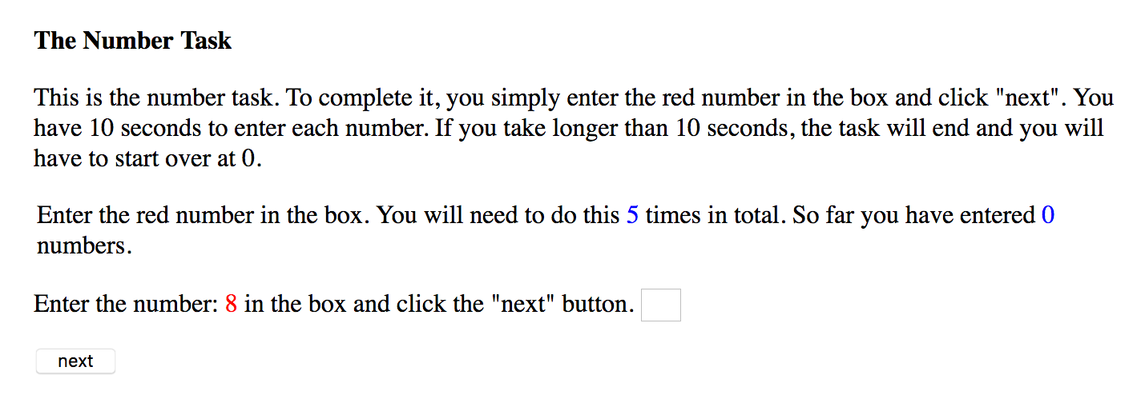

Music Player Instructions:
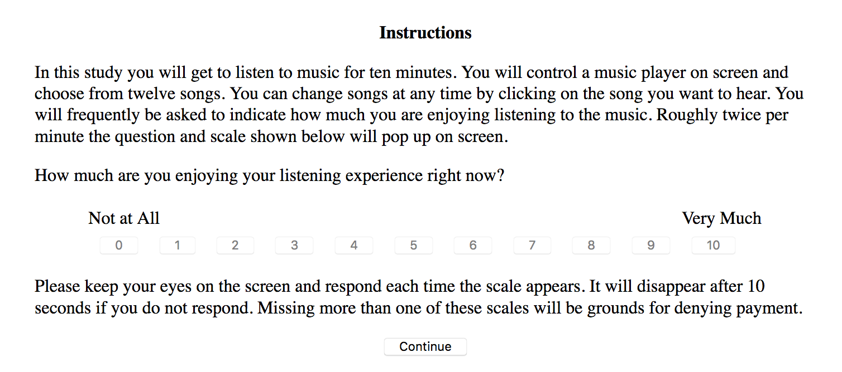

Malfunction Instructions:
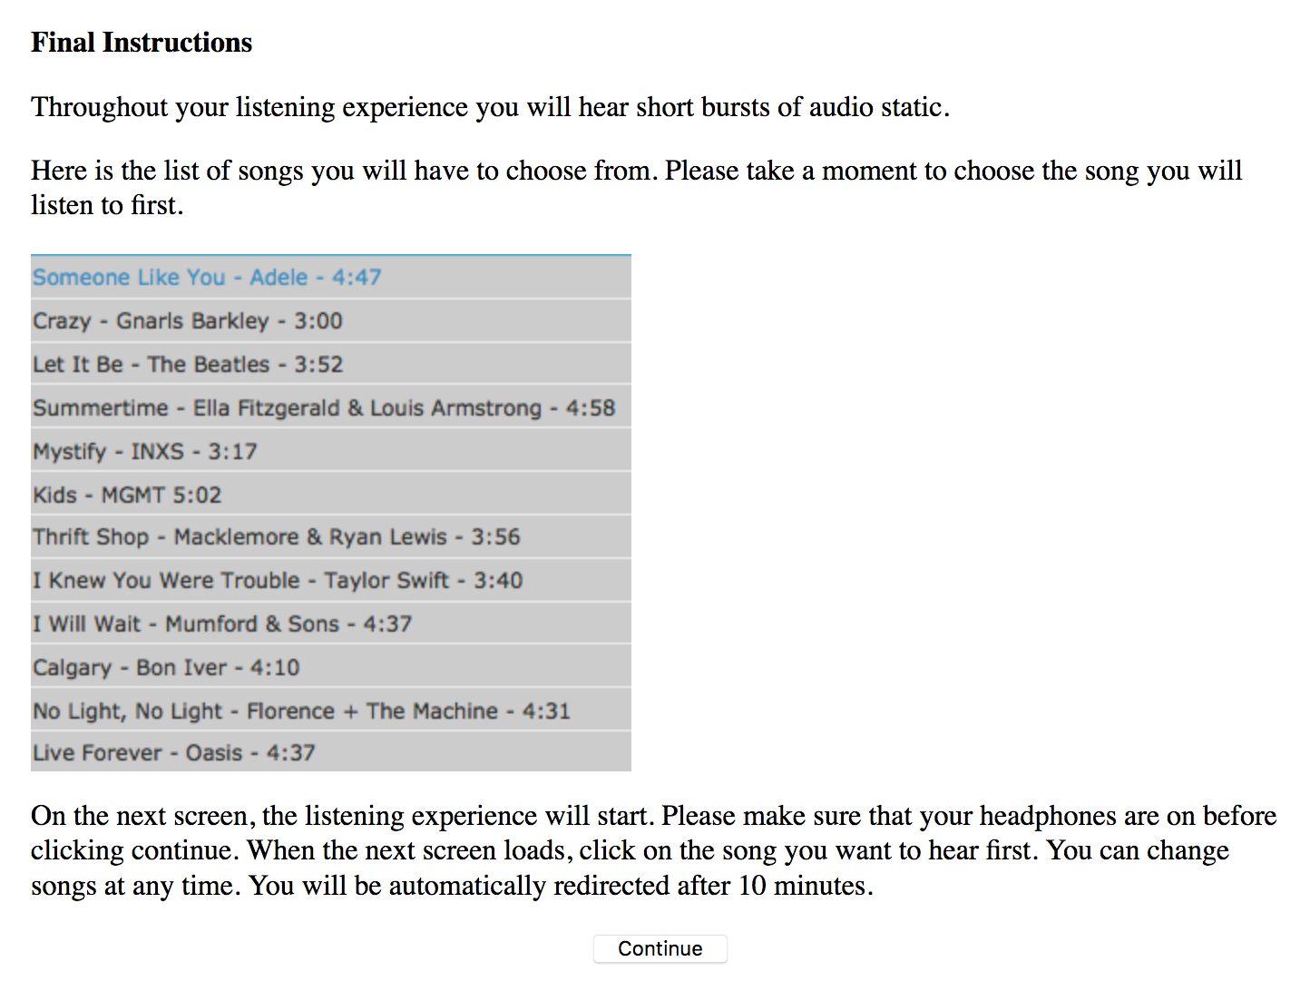

Main Experience (for immediate opportunity conditions):
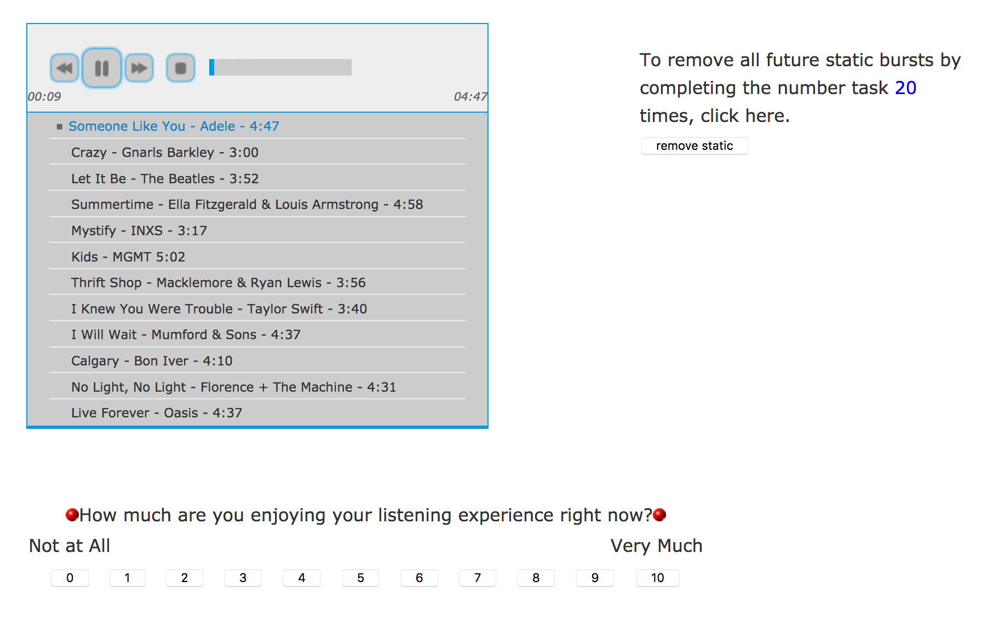

Main Experience (for delayed opportunity conditions):
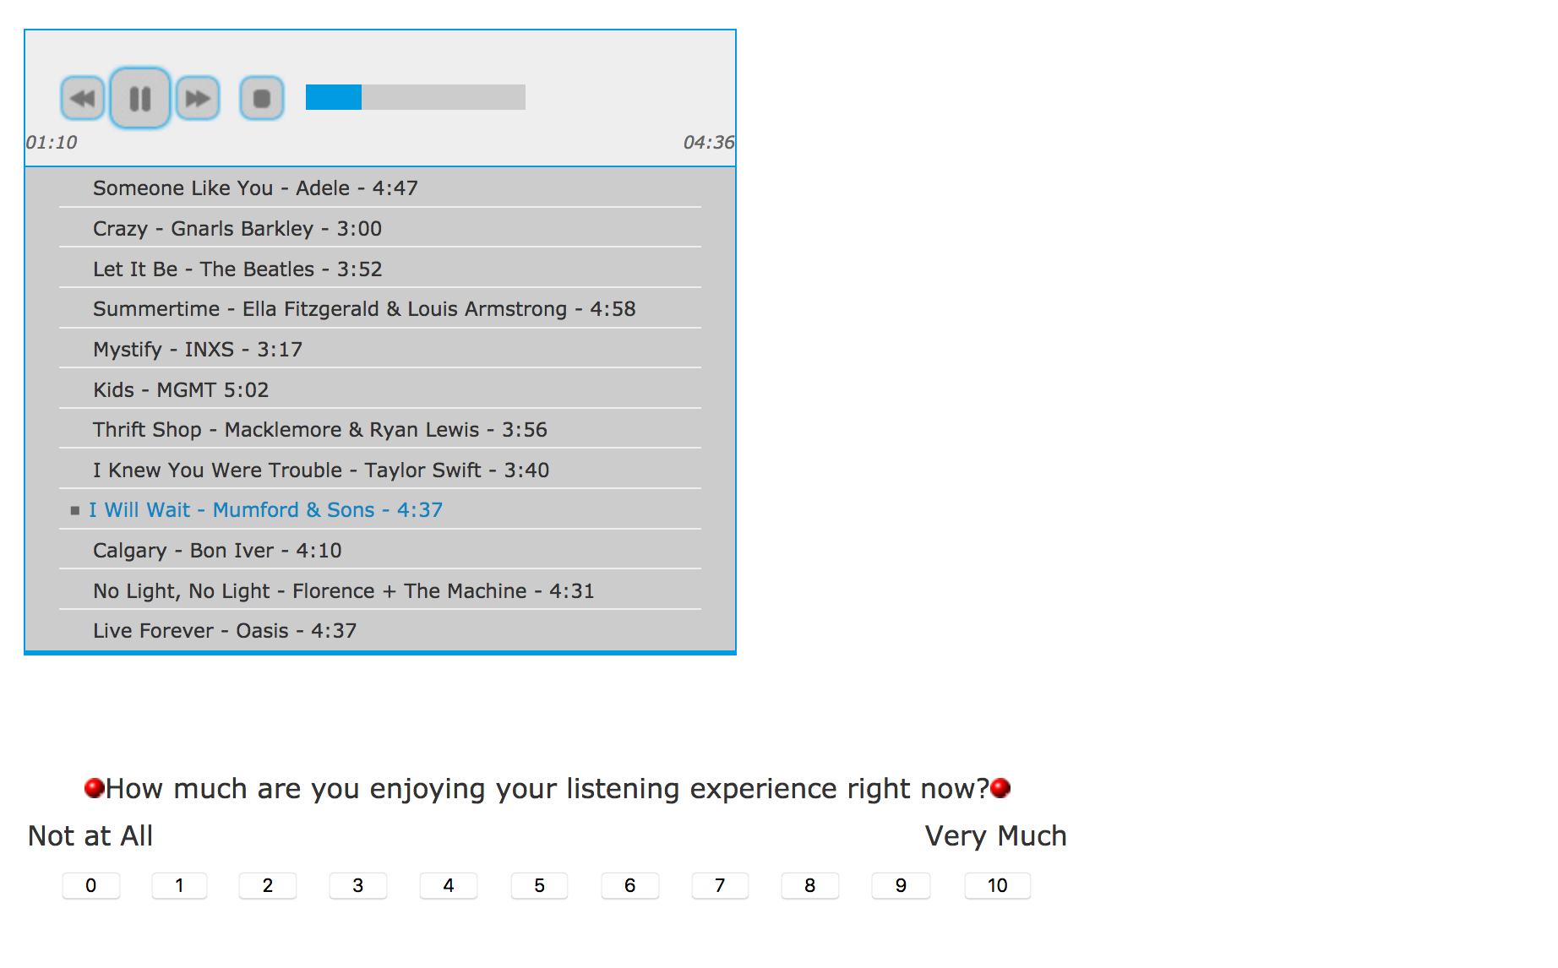

After 150s (in delayed opportunity conditions):
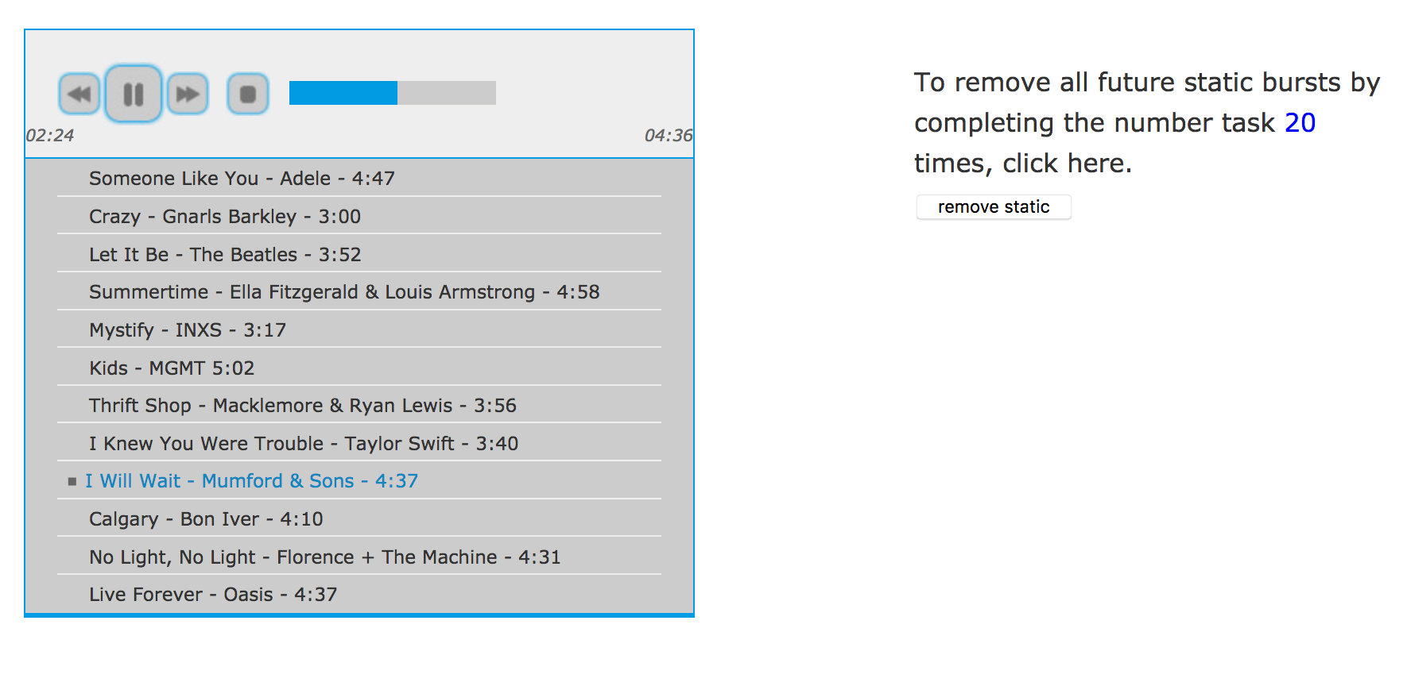

Completing the Number Task (in all conditions):
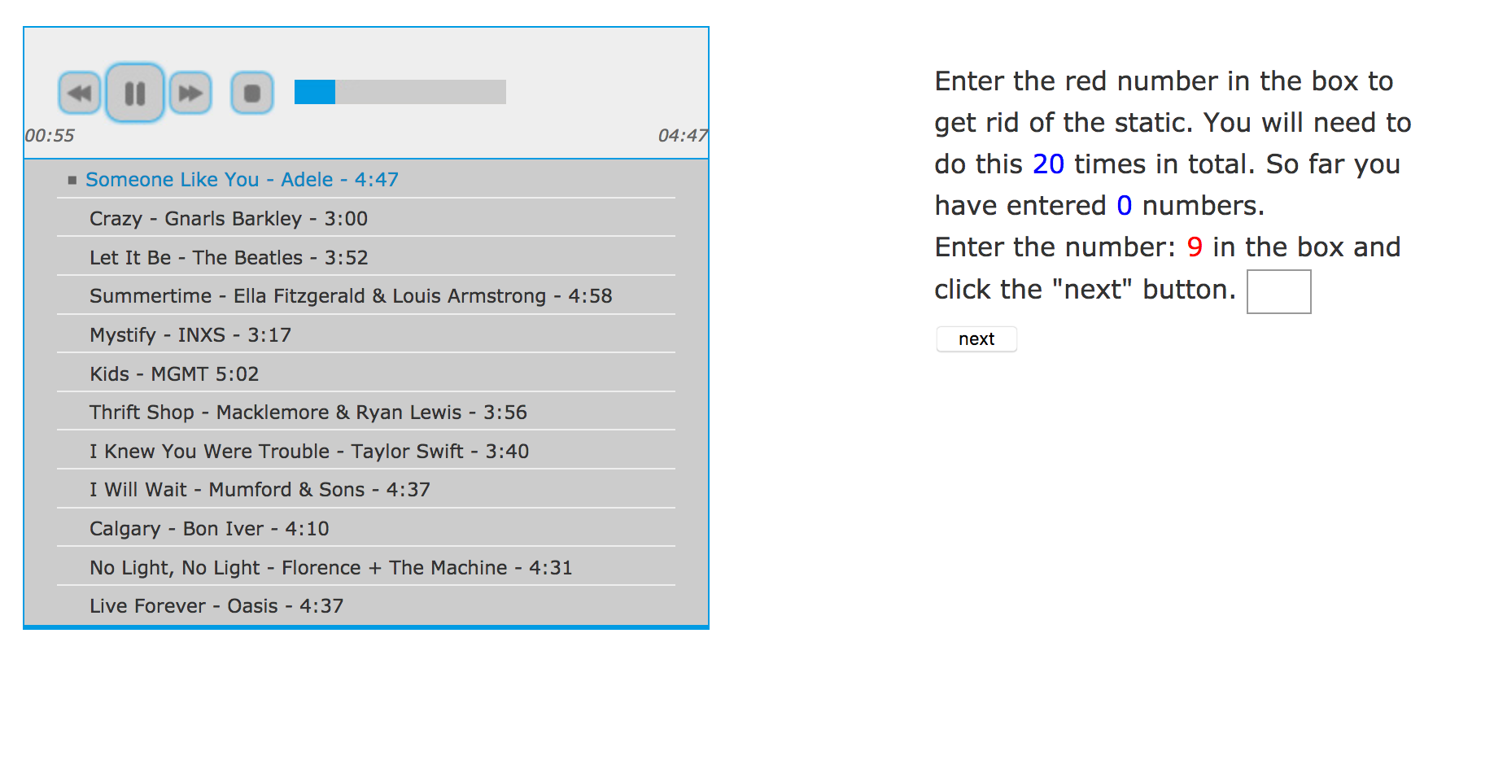

Enjoyment measure:
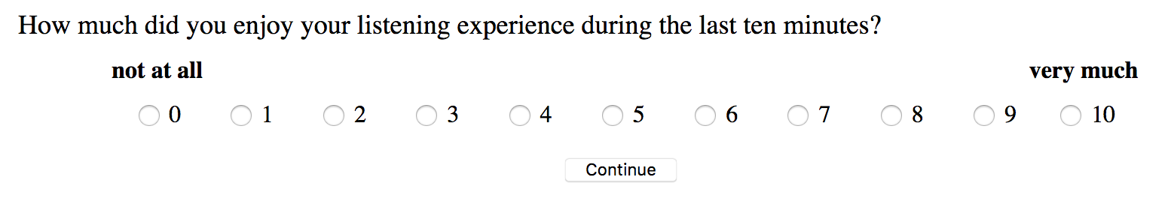

Experiment 6

Music Player Instructions:

Malfunction Instructions:
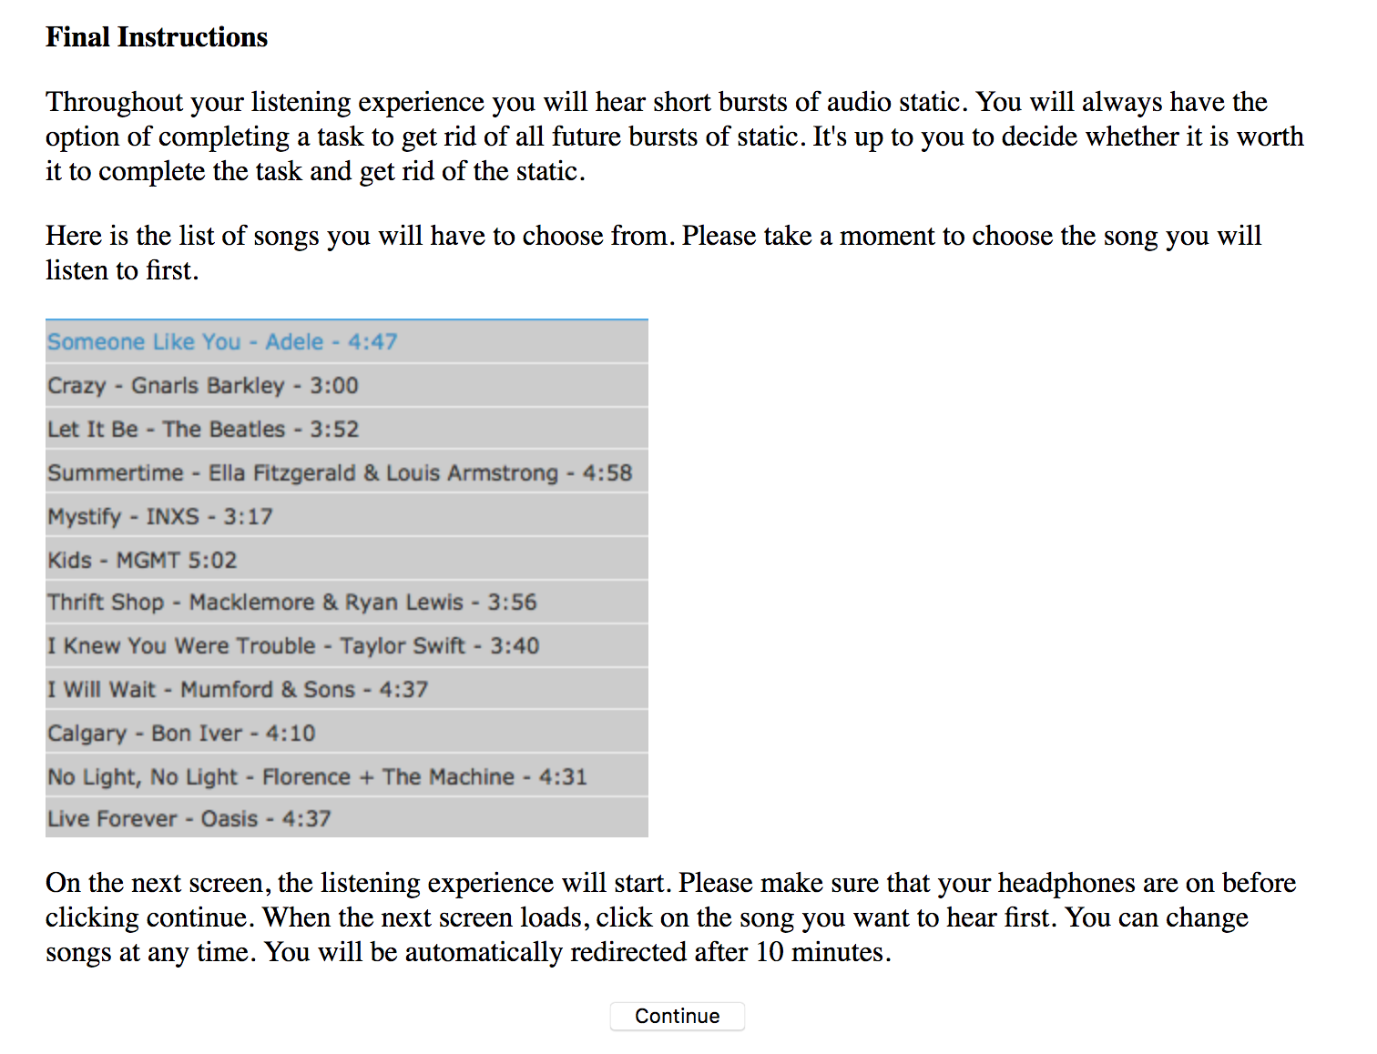

Main Experience:
Note: For half of the participants the first means of corrective action was the letter task rather than the number task.
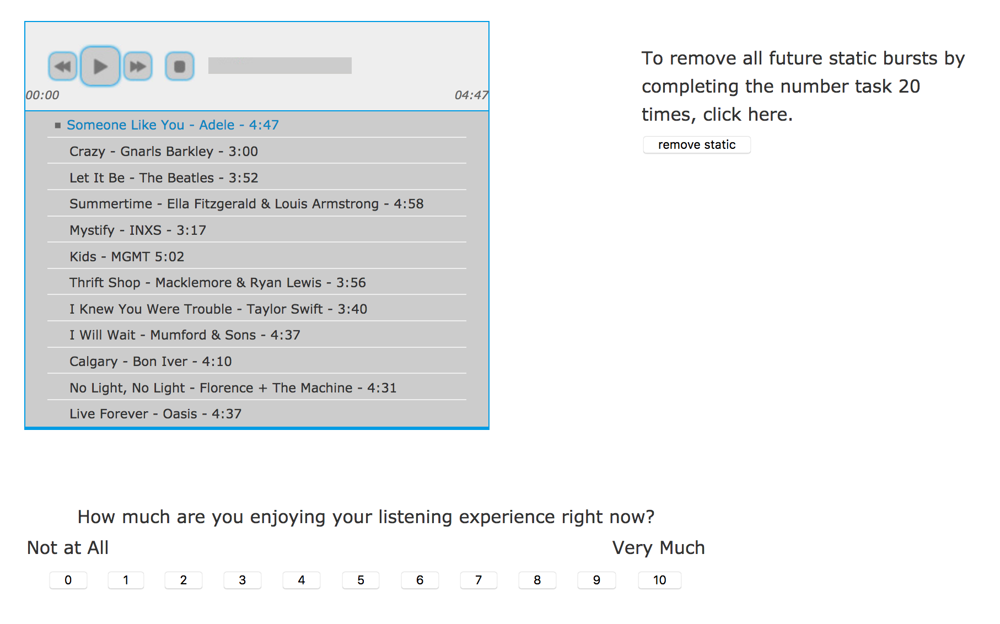

At 150s (in changed means conditions):
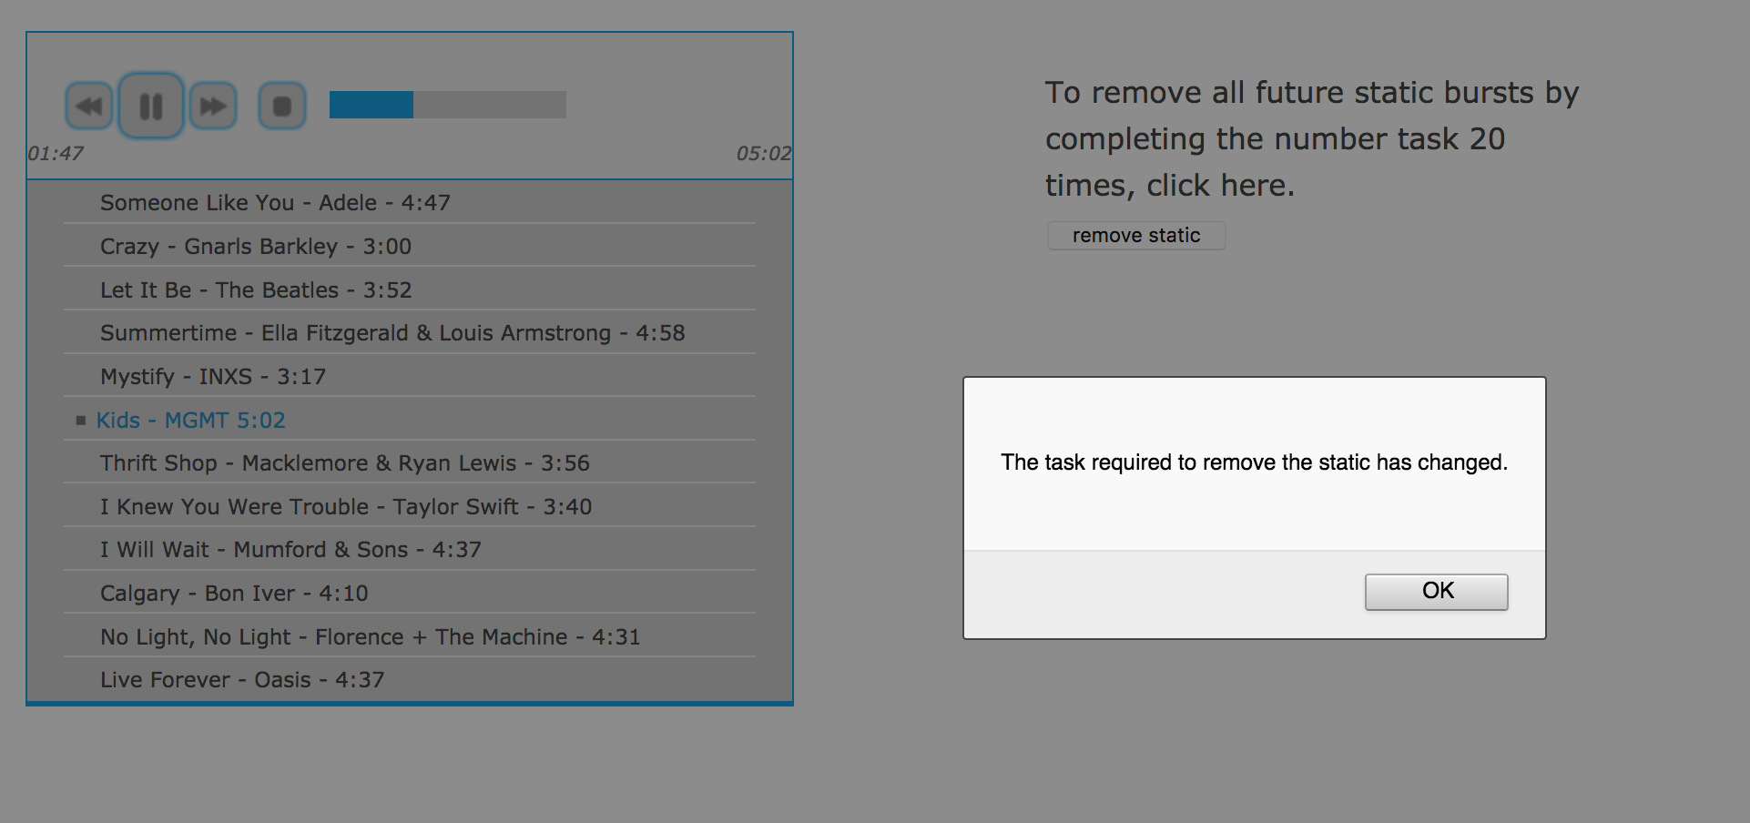

After 150s (in changed means conditions):
Note: For half of the participants the first means of corrective action was the letter task and therefore, switched to the number task at this point.
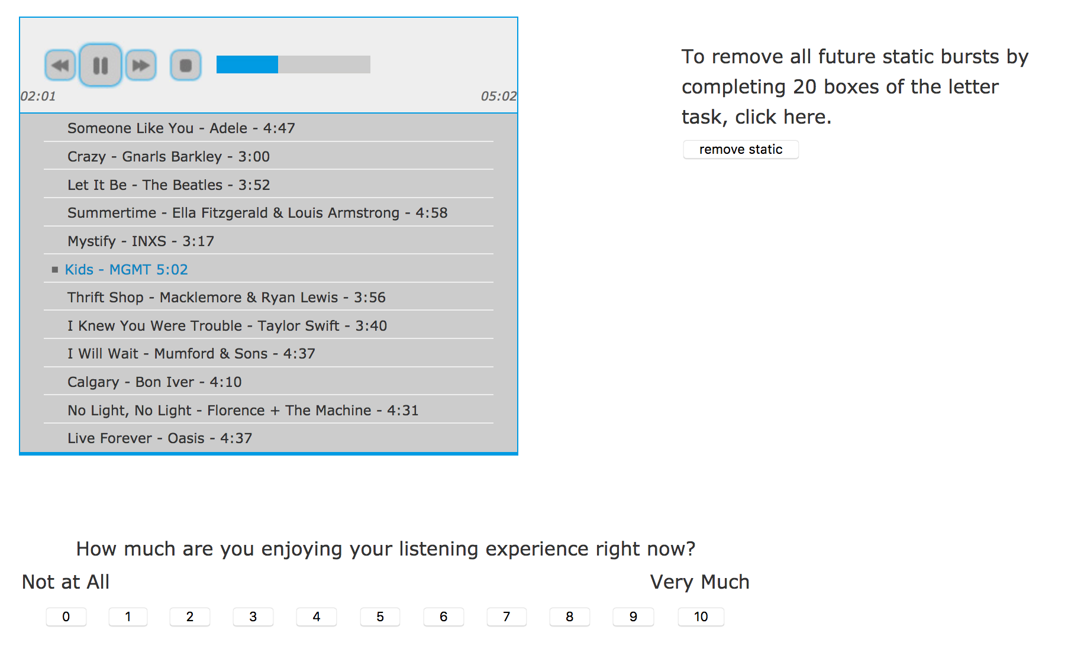

Completing the Letter Task:
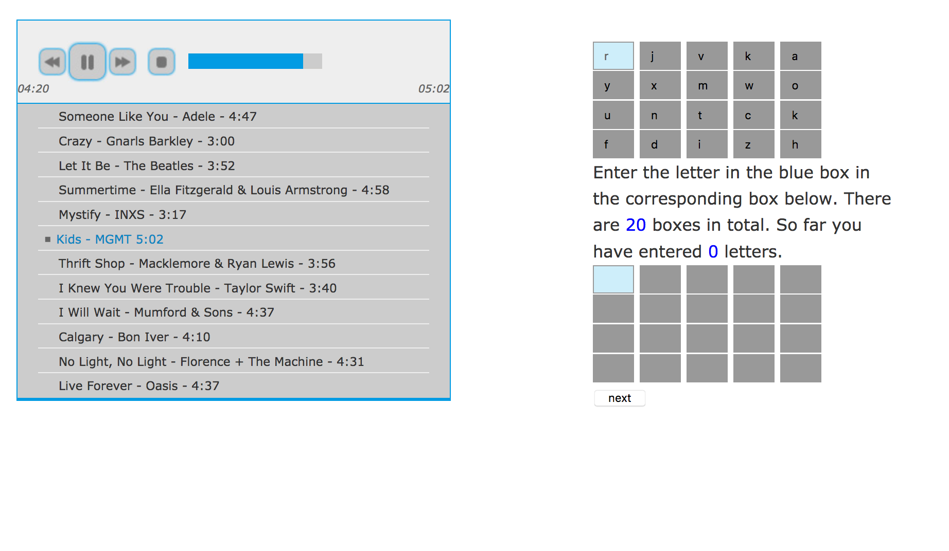

Enjoyment Measure:

Experiment 7

WTP Task Instructions:
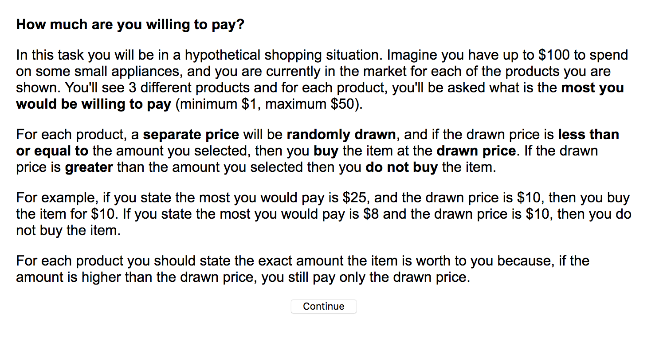

WTP Practice Task (Round 1):
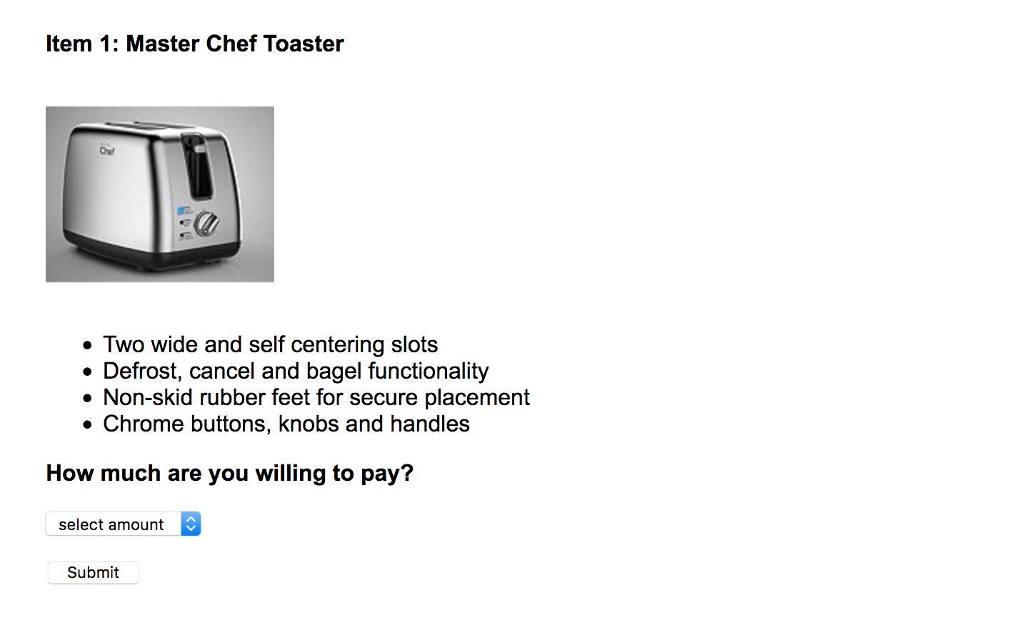

WTP Practice Task (Round 1):
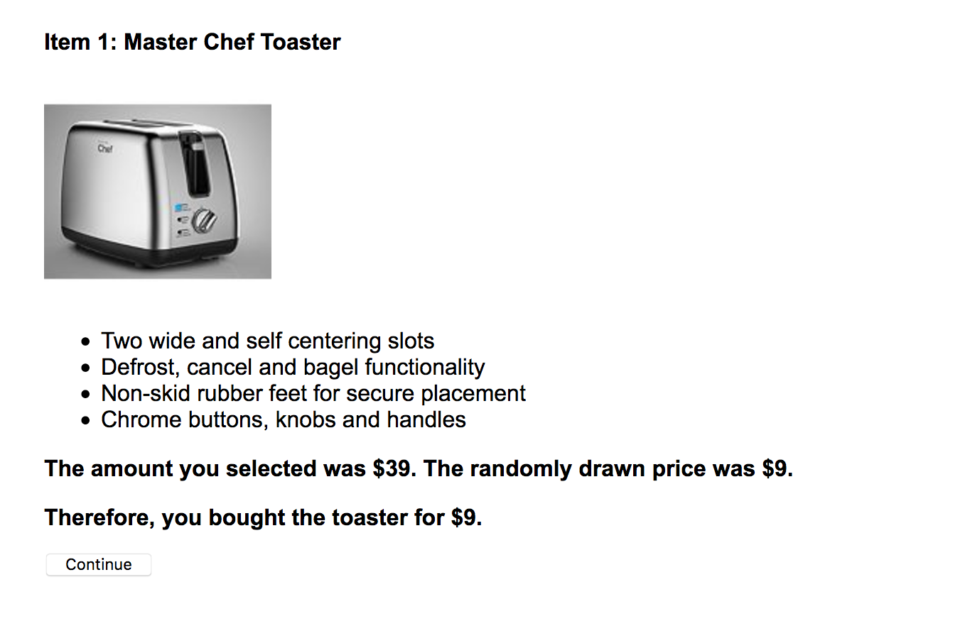

WTP Practice Task (Round 2):
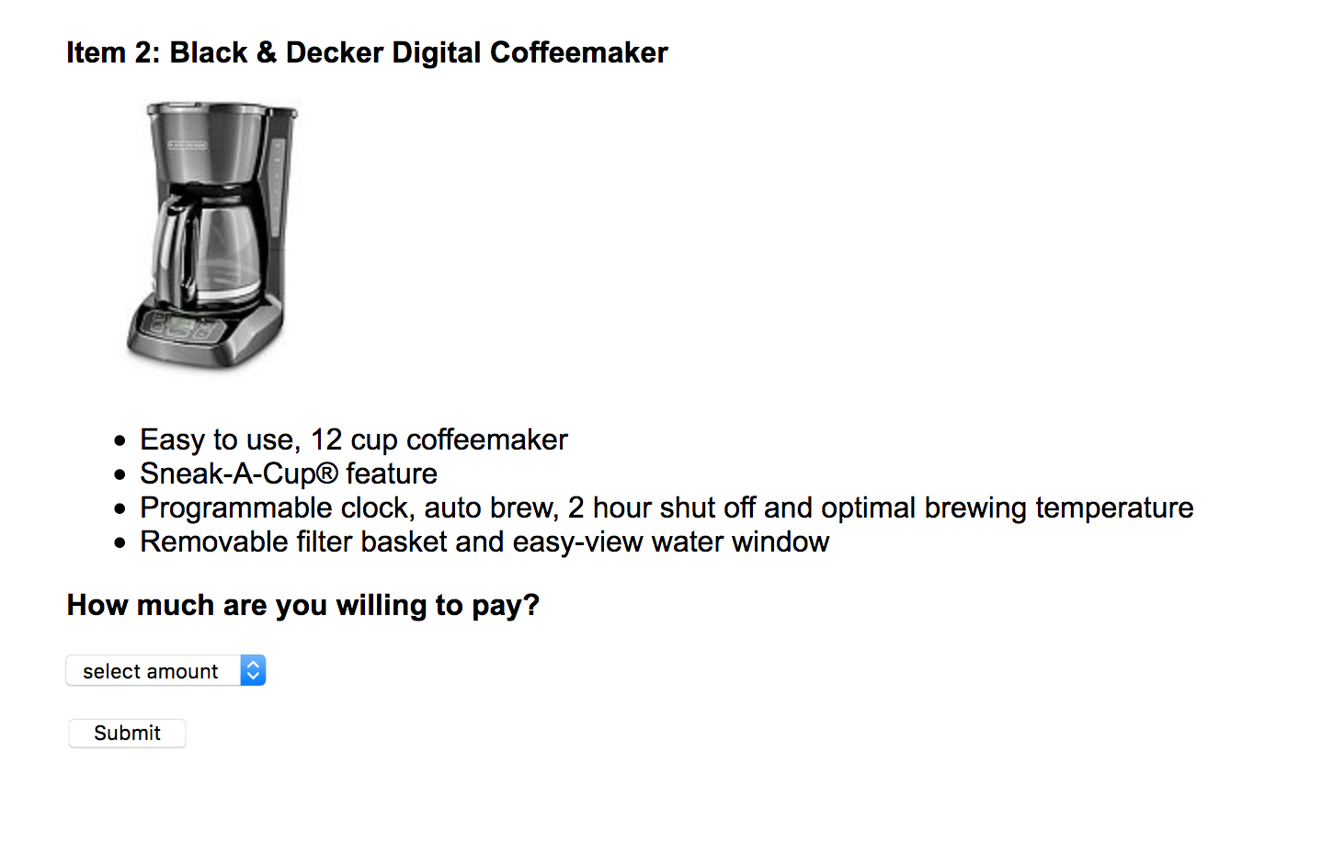

WTP Practice Task (Round 2):
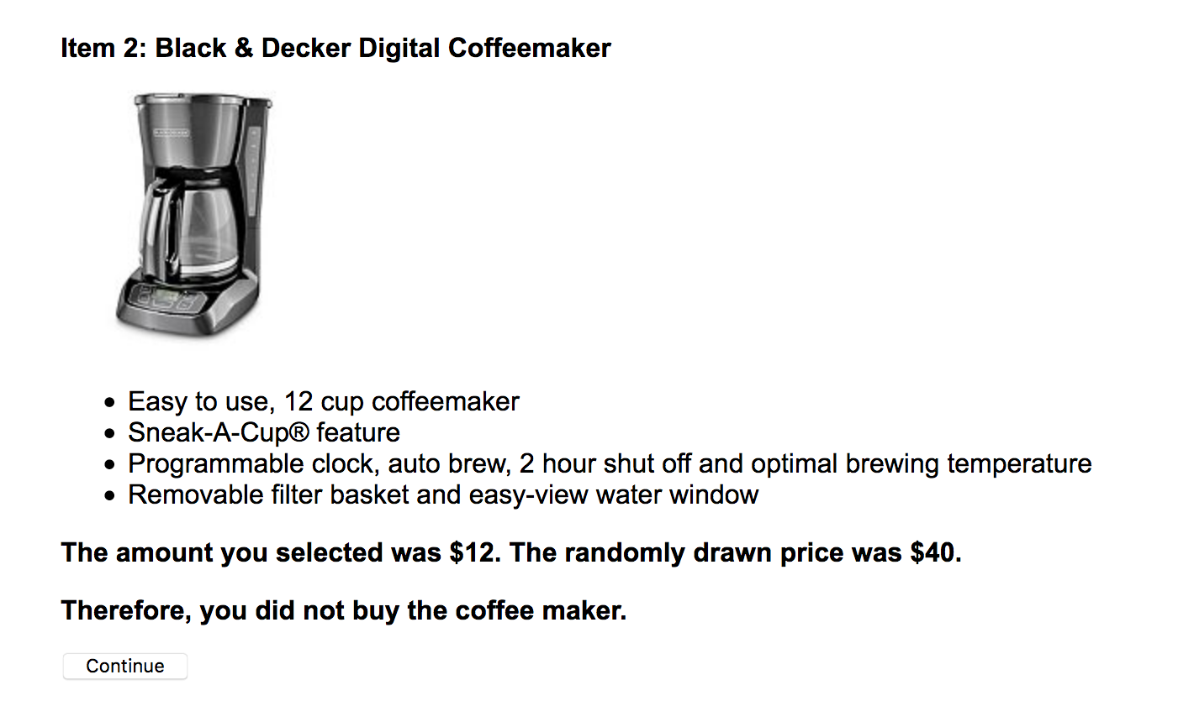

WTP Practice Task (Round 3):
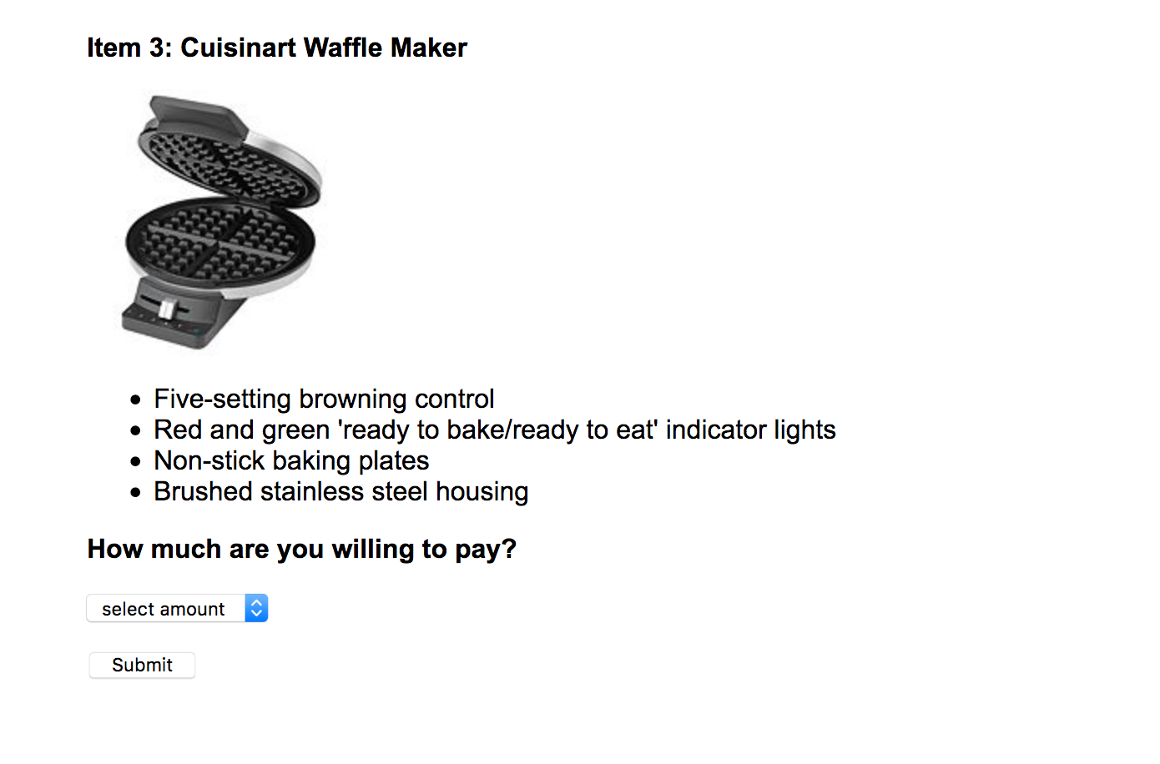

WTP Practice Task (Round 3):
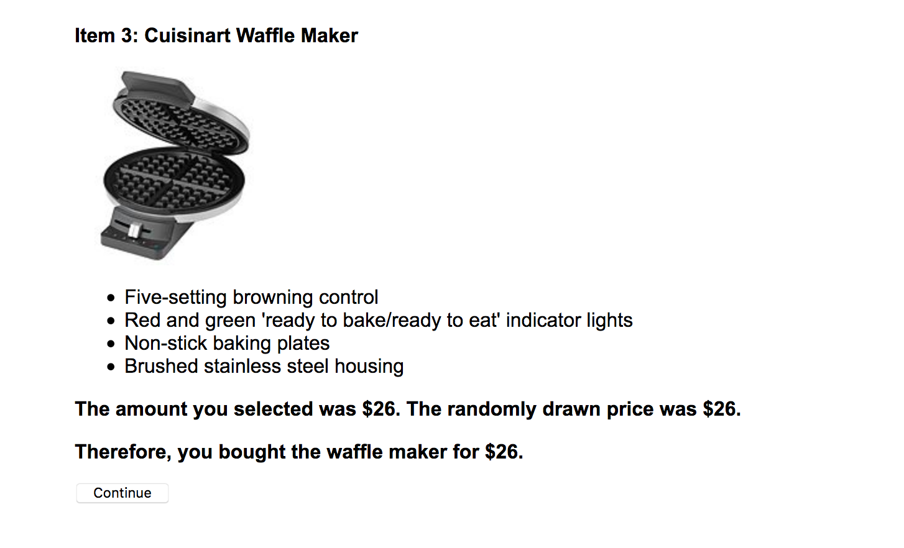

Music Player Instructions:
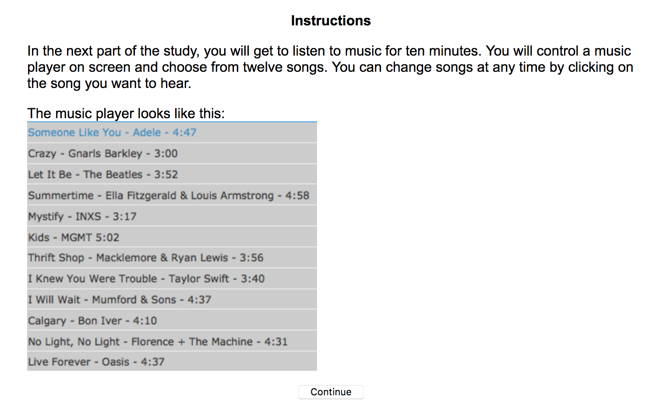

Malfunction and Payment Instructions:
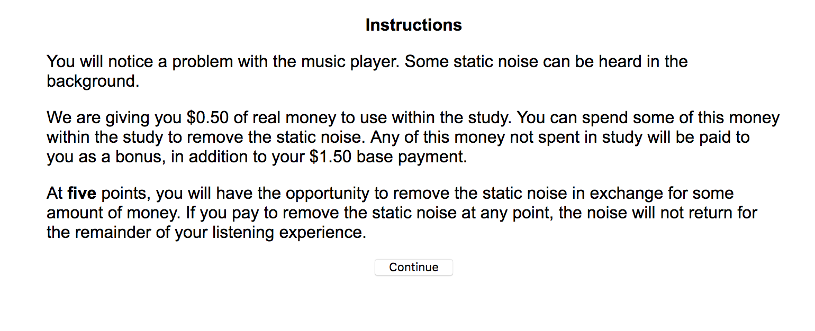

Malfunction and Payment Instructions Continued:
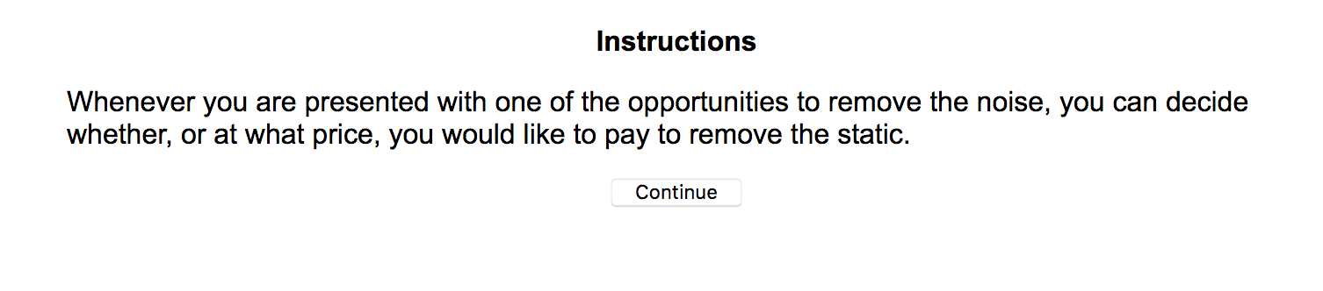

Final Instructions:
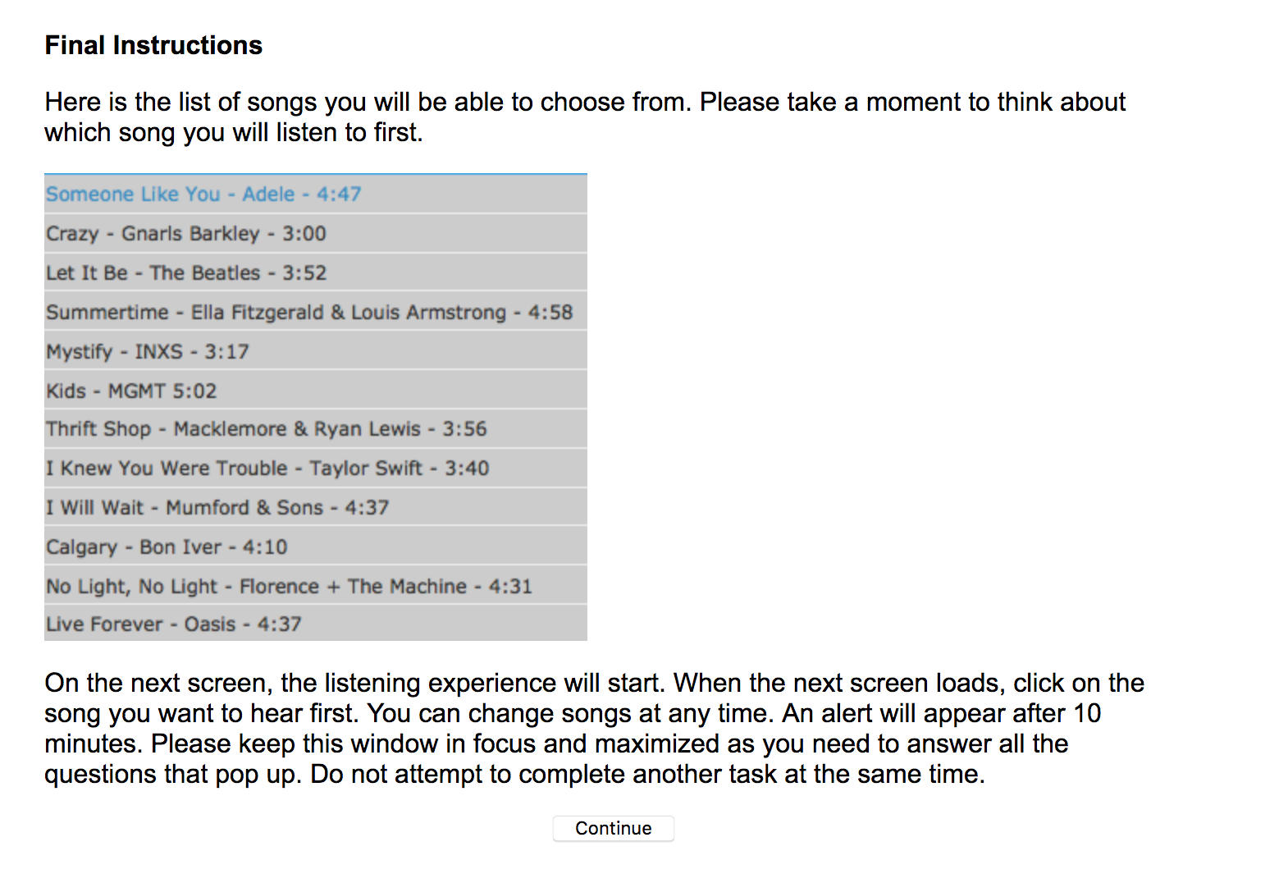

Main Experience:
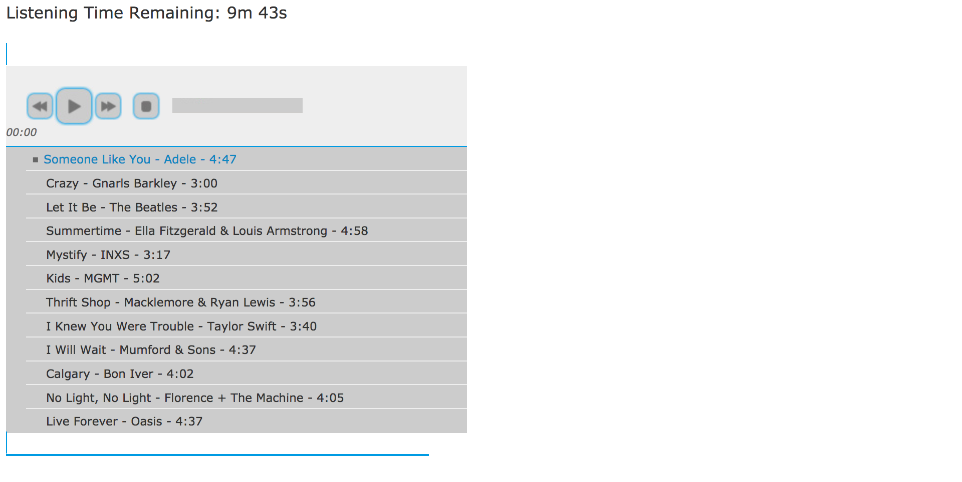

Initial Opportunities (in forgone opportunity condition only, at 50s and 100s):
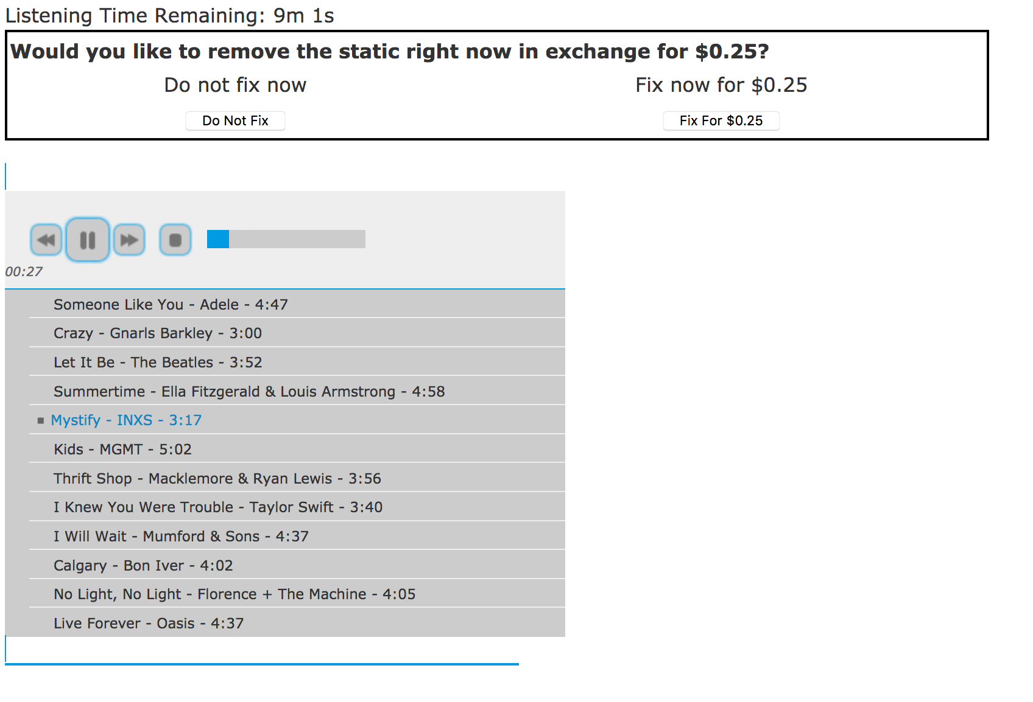

WTP Measure (in both conditions at 150s):
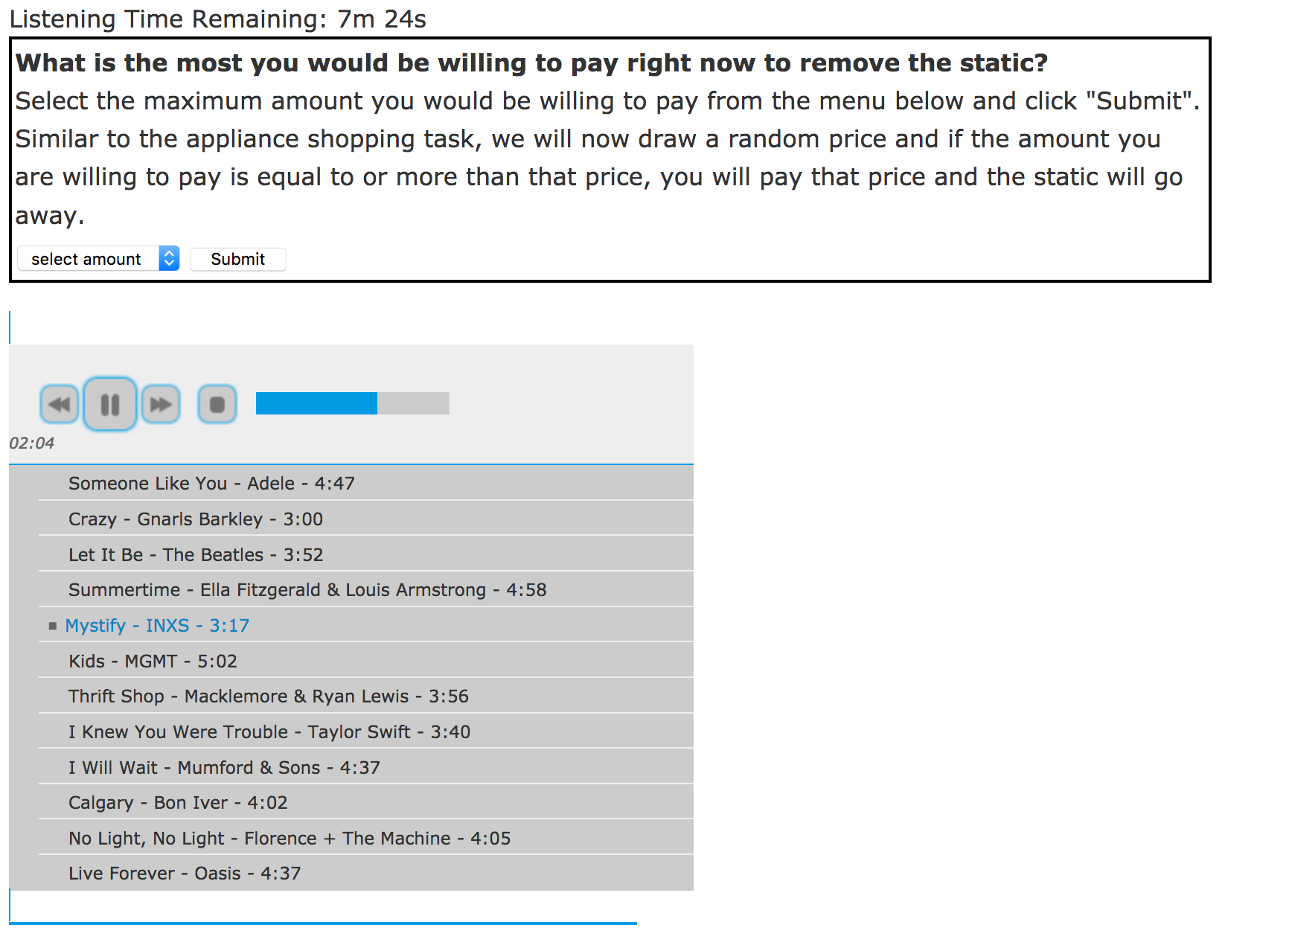

WTP Resolution:
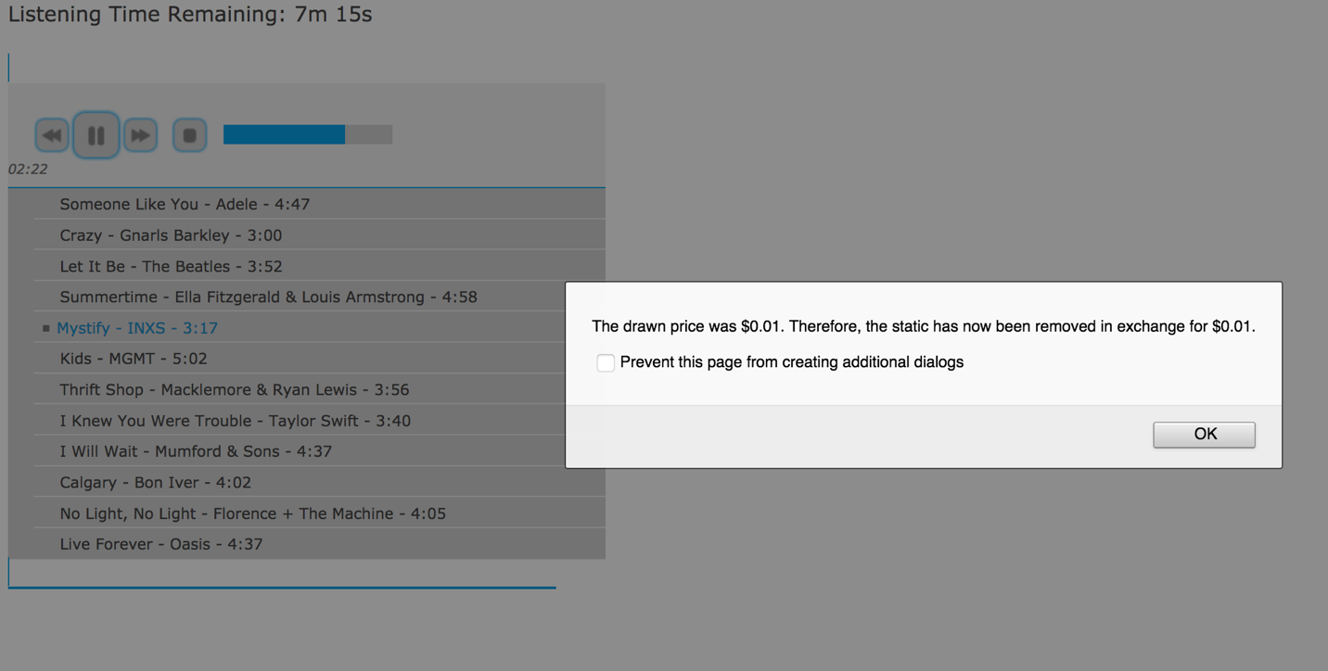

Enjoyment Measure:
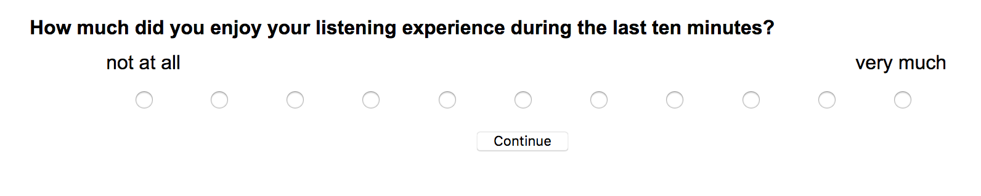

Experiment 8

Initial Instructions:
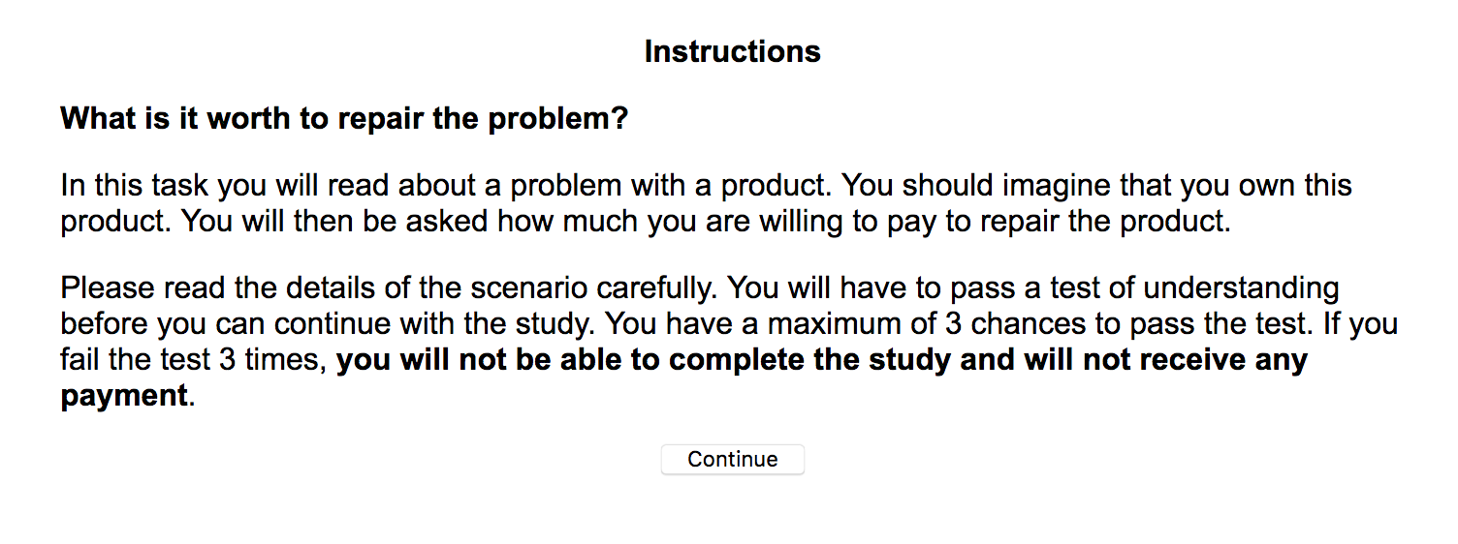

Phone Scenario Introduction:
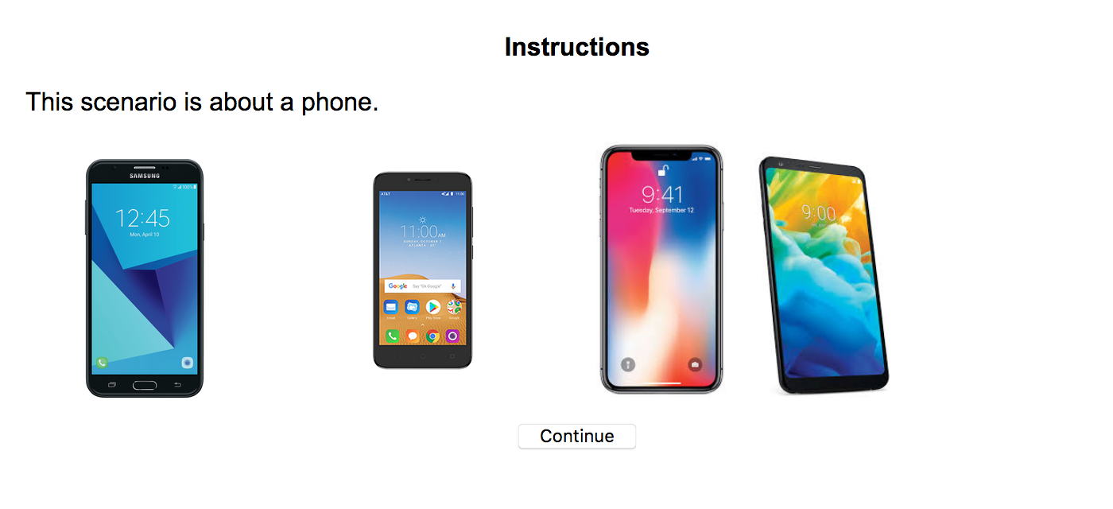

Phone Scenario (no forgone opportunity condition):
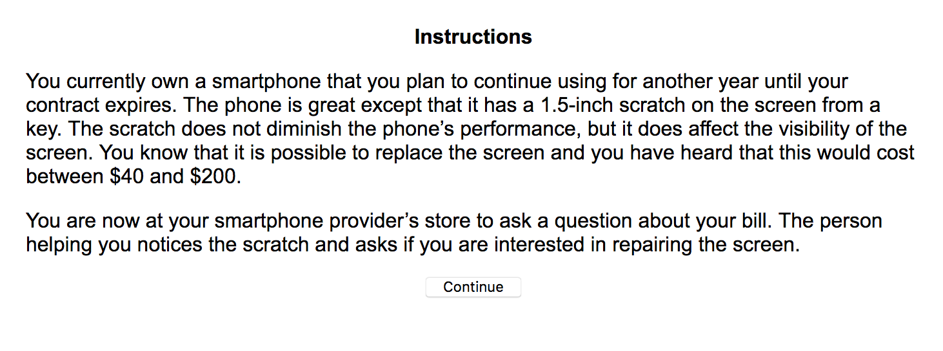

Phone Scenario (forgone opportunity condition):
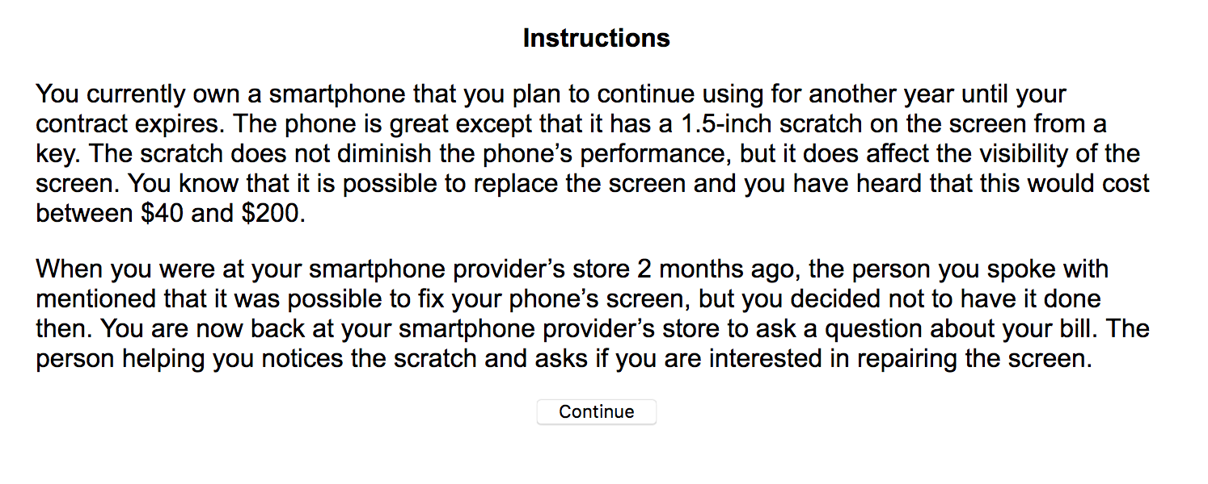

Car Scenario Introduction:

Car Scenario (no forgone opportunity condition):
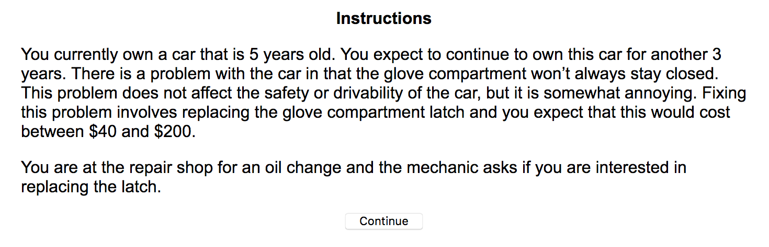

Car Scenario (forgone opportunity condition):
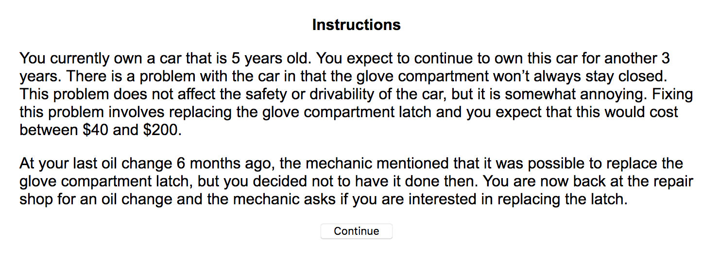

WTP Measure:
Note: Phone scenario forgone opportunity condition shown. Scenario information matches previous screens in all conditions.
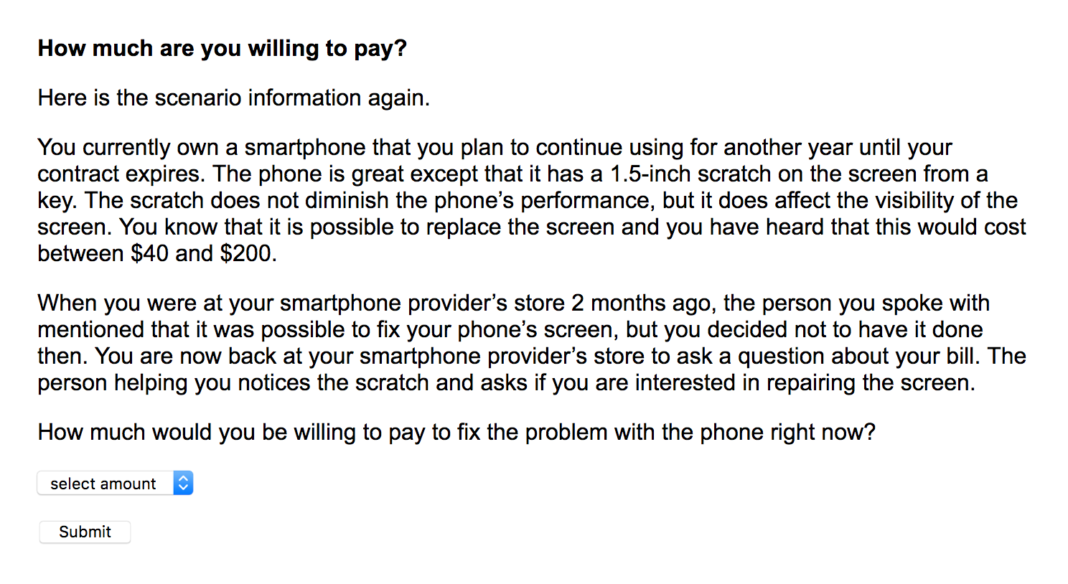

Survey

List Malfunctions:
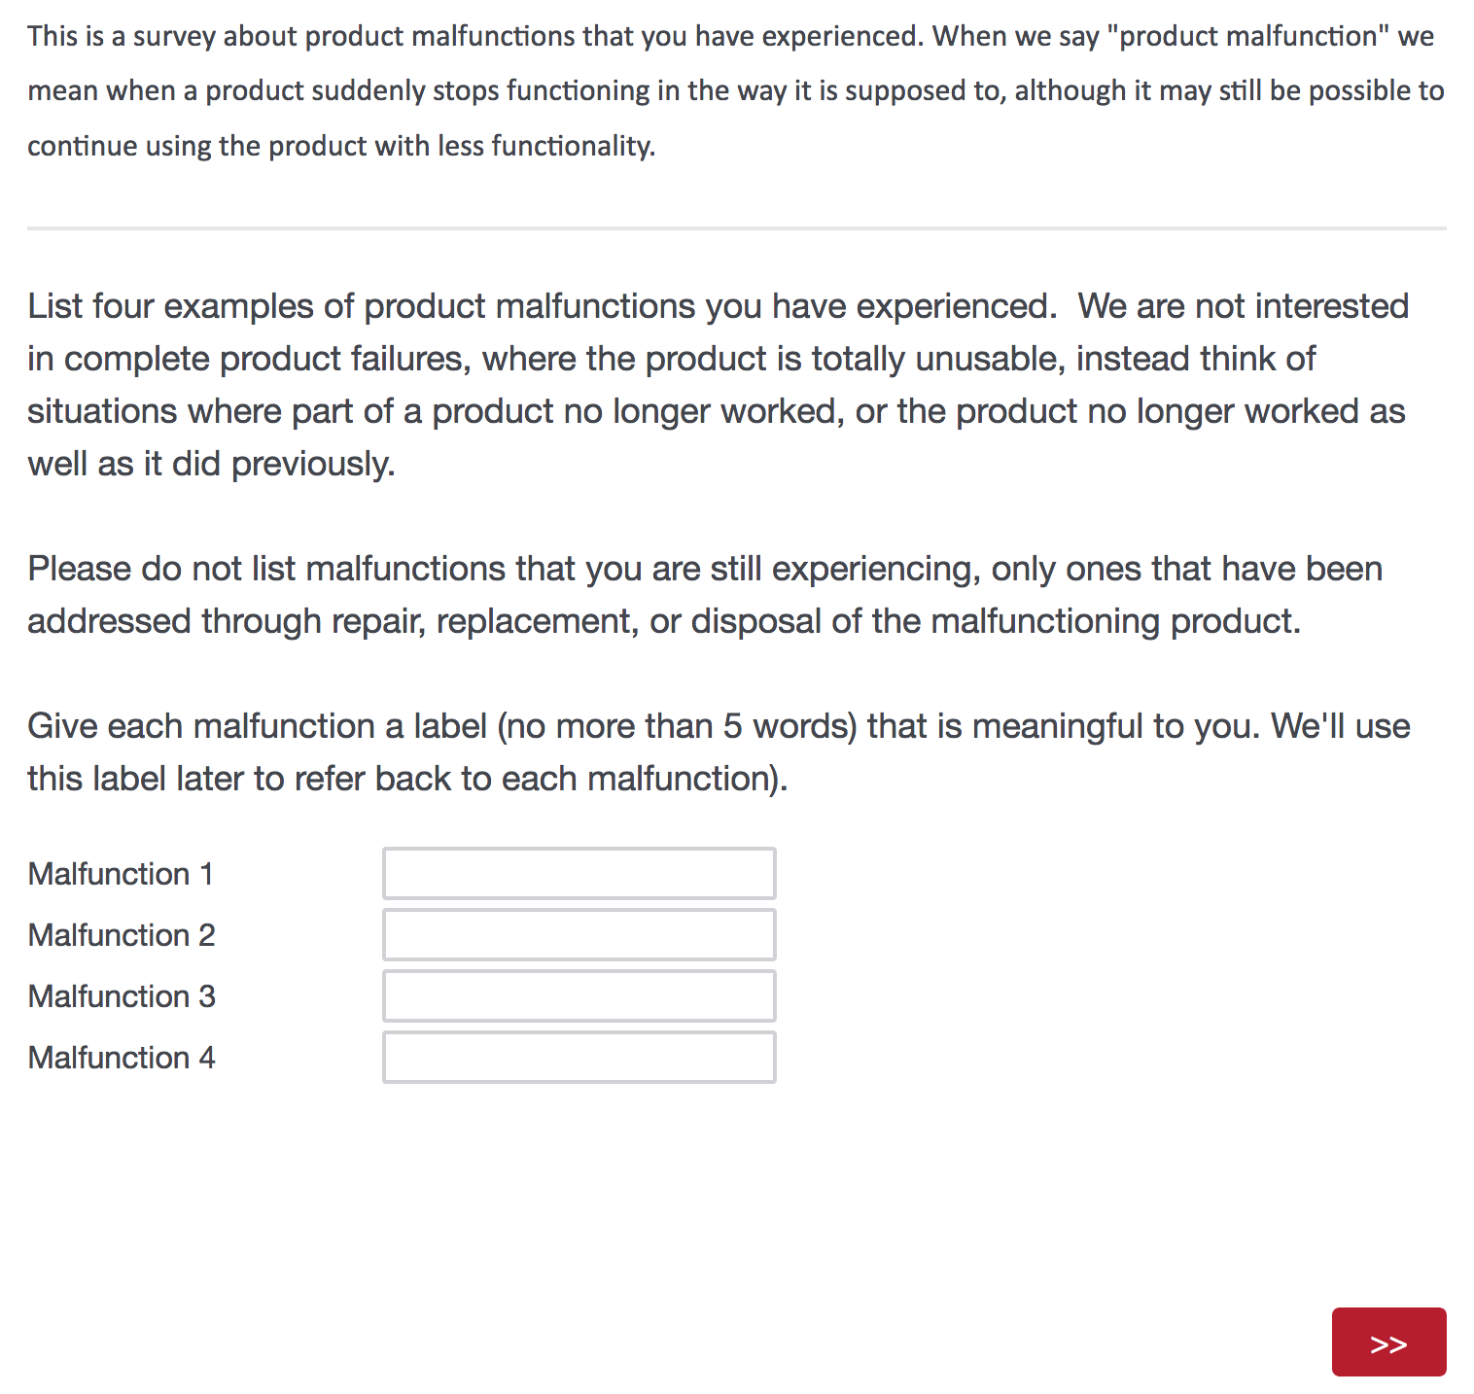

Start of Loop (through each of the four malfunctions):
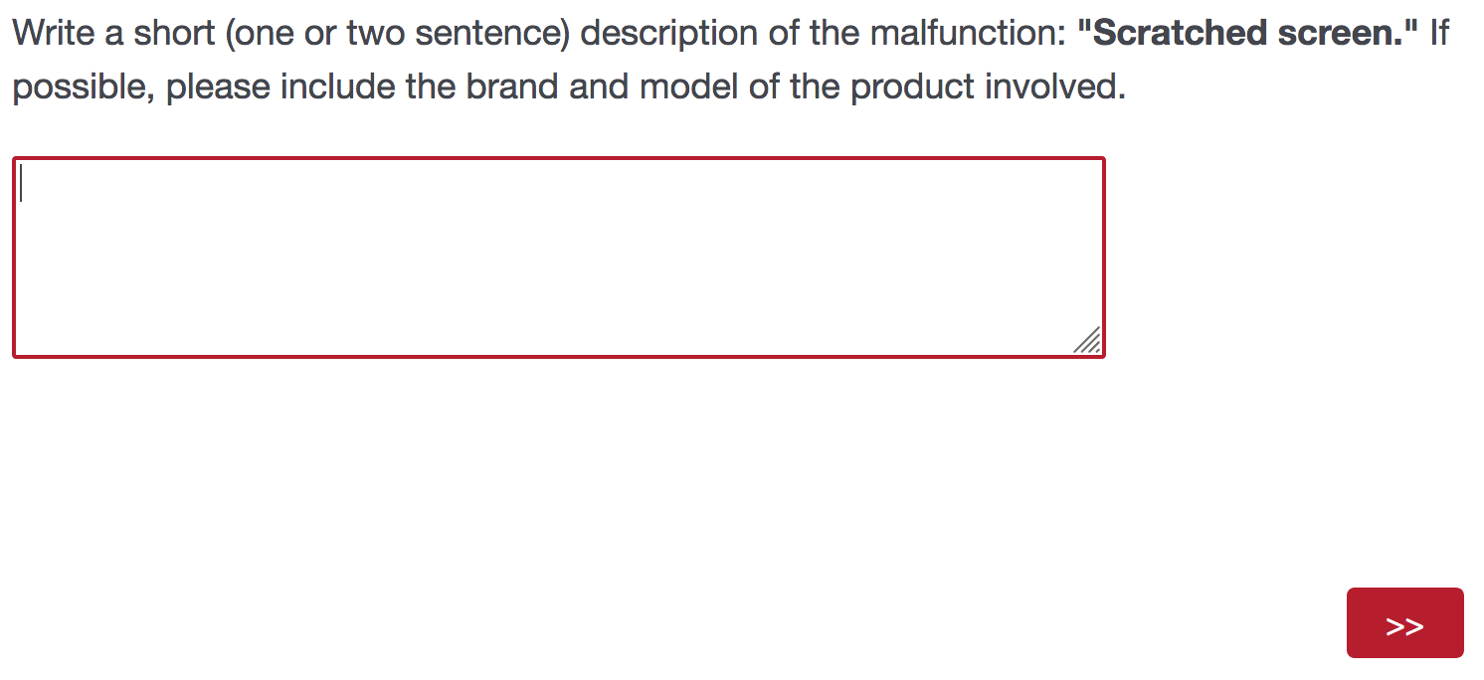

Severity Measure:
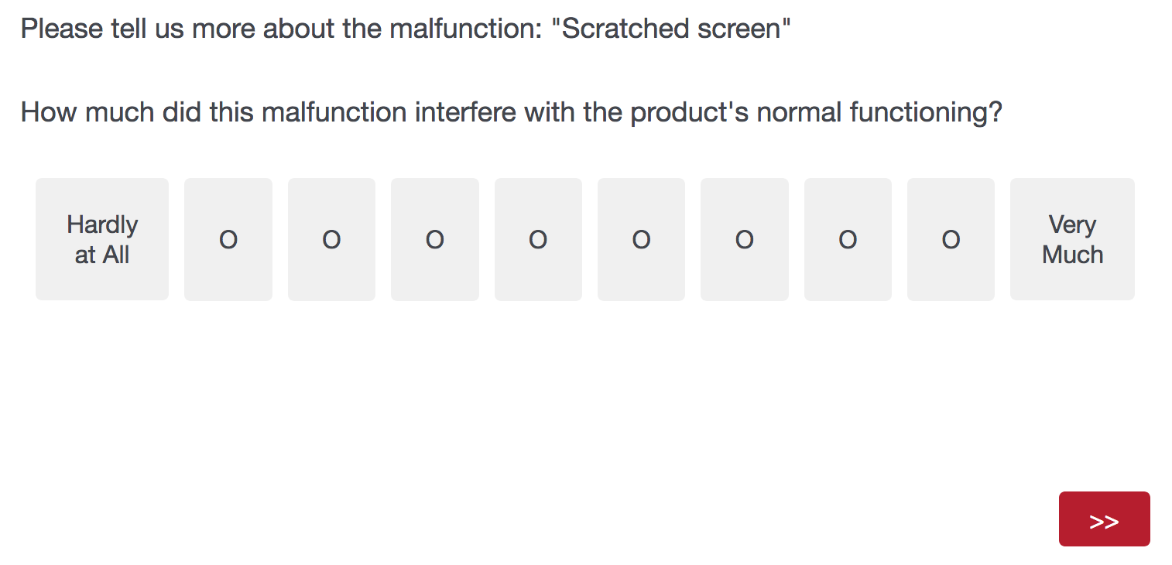

Duration Measure:
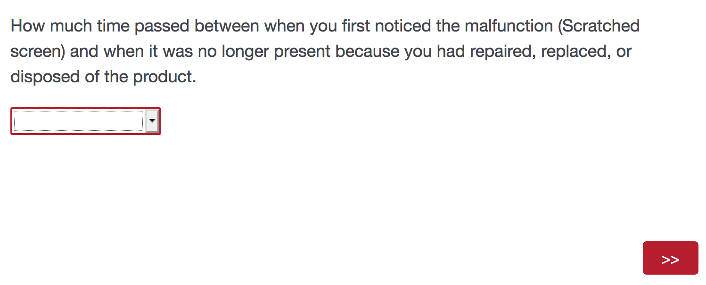

Suffering Measure:
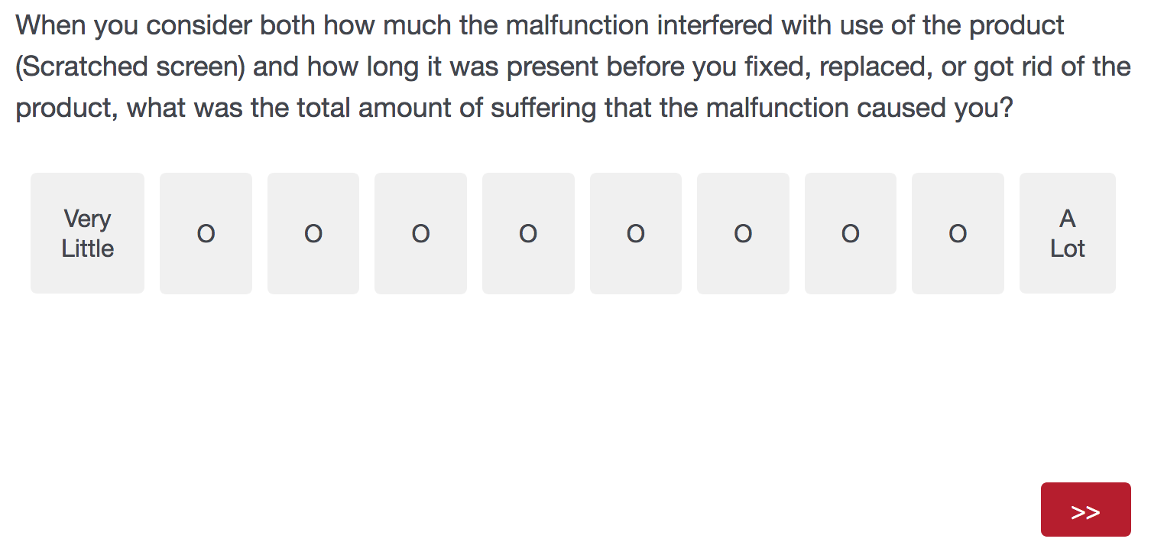

Product Age, Expected Life and Brand-Attitude Change Measures:
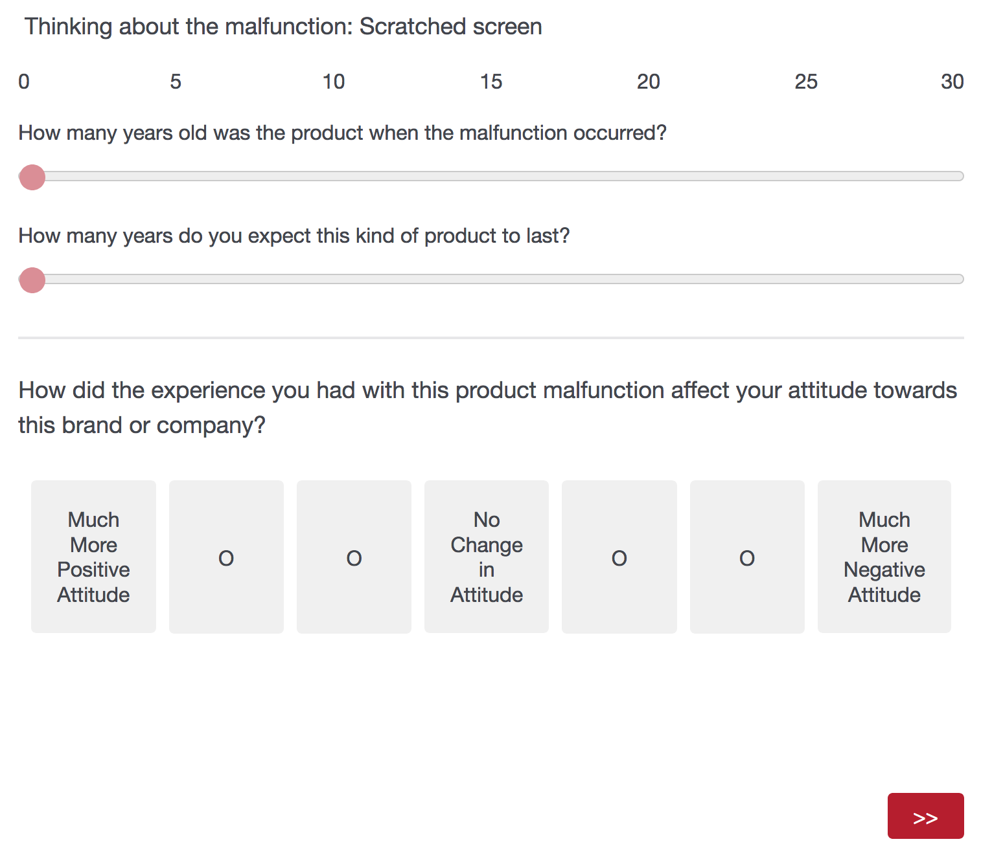

End of Loop

Suffering Rank:
