Appendix A – Distributions of the preferred BackX™ AC support modes and levels for females and males in each experimental condition. Note that the BackX™ AC has two support levels (low vs. high) and two modes (instant vs. standard), allowing for four different combinations of support. For each combination of horizontal distance, orientation angle, and vertical height tested, color codes show the percentages selected for each of the four combinations of support model and level.

A.1 Unsupported scenarios

A.1.1 Female

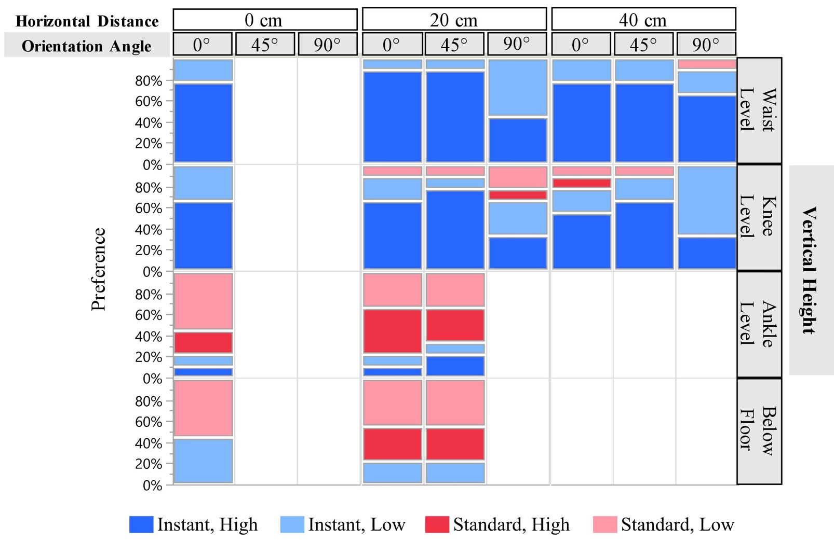

A.1.2 Male

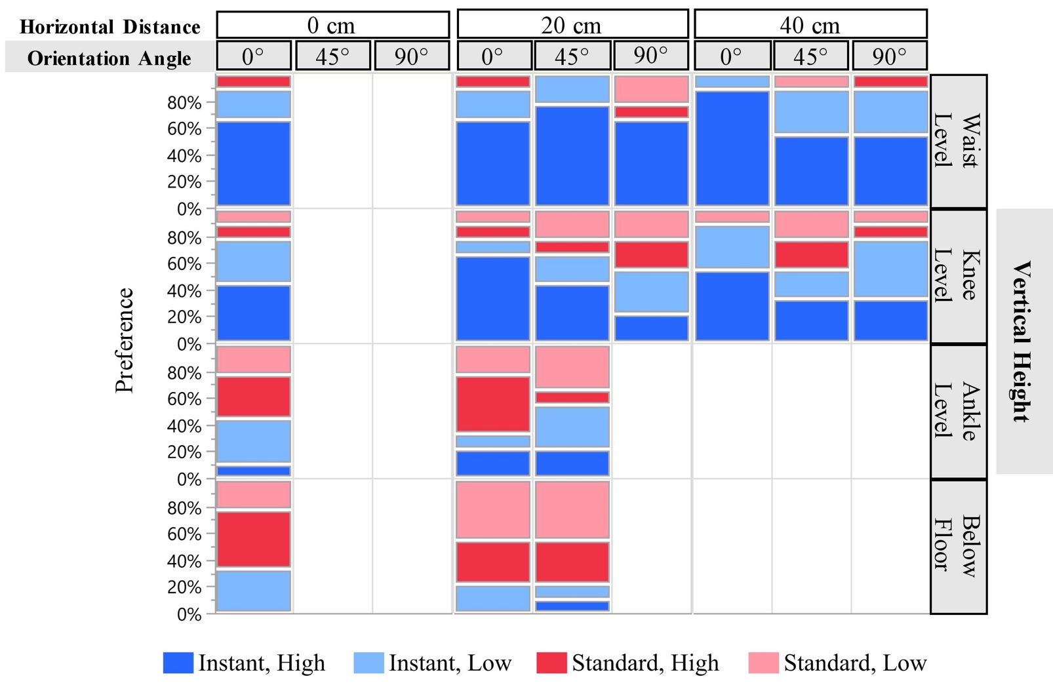

A.2 Supported scenarios

A.2.1 Female

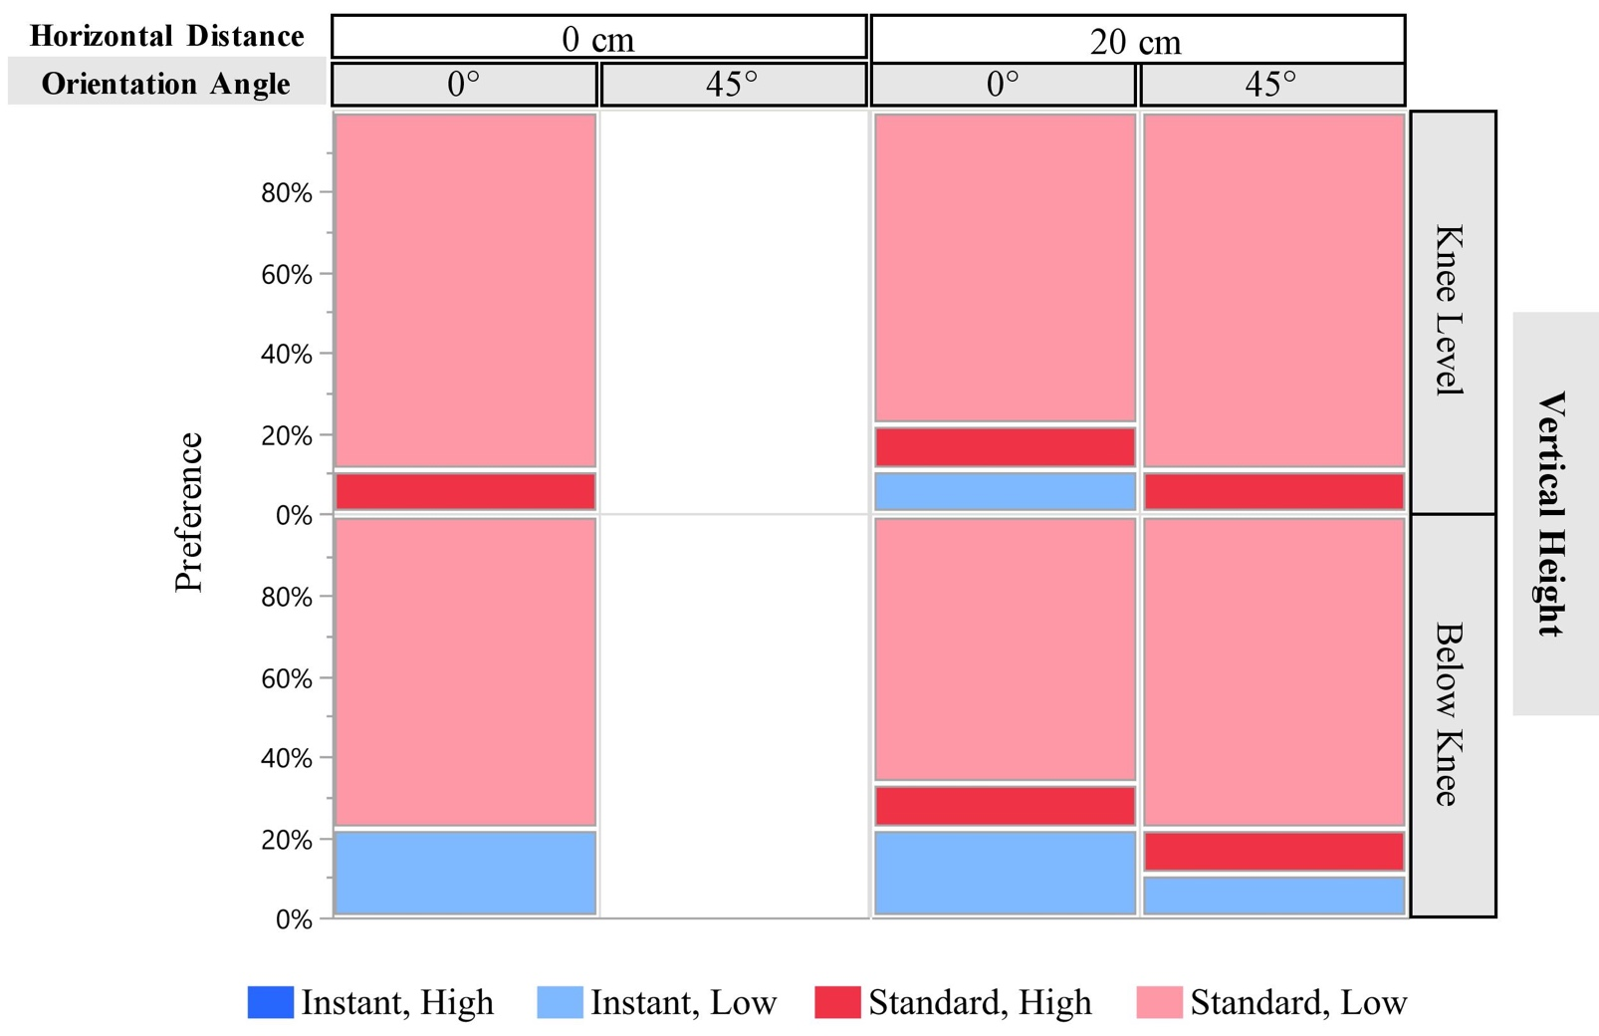

A.2.2 Male

