Study 1a

Verbatim wording of the instructions in both religion and God conditions (page 1):

THINKING AND COGNITION SURVEY

Welcome to our survey.

This survey aims at understanding how people think about several concepts.
You will next be randomly shown a concept, a name or a word.
Your task is to write down what this concept makes you think.
Please continue now.

Verbatim wording of the task in God condition (page 2):

THINKING AND COGNITION SURVEY
Your word is:
GOD
Please allow you some time to think about God.
And, please write IN A COUPLE OF SENTENCES what thoughts came to your mind about God.
Verbatim wording of the task in religion condition (page 2):

THINKING AND COGNITION SURVEY
Your word is:
CHRISTIANITY
Please allow you some time to think about Christianity.
And, please write IN A COUPLE OF SENTENCES what thoughts came to your mind about Christianity.

Study 1b
In study 1b, the exact translations of the above instructions were given in participants’ native language. The word Christianity was replaced with the word Islam, and the word God was replaced with Allah.

Next, participants were given the exact translation of the instructions and items in the Behavior Identification Form (Vallacher & Wegner, 1989).

Study 2

On page 1, participants were given the exact God or religion prime as in study 1b.

Next, on page 2, the verbatim wording of the task (in participants’ native language) about a student club called “Community Volunteers Club” was as follows:

Concrete Condition
SURVEY ON STUDENT CLUBS
Please find below a text on the activities of Community Volunteers.
Please read this text carefully, and answer the questions given.

“Community Volunteers is a student club affiliated to the Registrar’s Office with more than 100 volunteers. The student club gives every weekend tutorials that supplement the school curriculum of elementary school students. The club offers classes of music and drama to elementary school students.”

Concrete Condition
SURVEY ON STUDENT CLUBS
Please find below a text on the activities of Community Volunteers.
Please read this text carefully, and answer the questions given.

“Community Volunteers is a student club affiliated to the Registrar’s Office with more than 100 volunteers. The student club helps elementary school students improve their academic skills and succeed in their exams. The club contributes to artistic and creative development of elementary school students.”

Immediately after this text, participants were given on the same page (page 2) the following questions:

 | Strongly disagree | Disagree | Somewhat disagree | Neither agree nor disagree | Somewhat agree | Agree | Strongly Agree
This description clearly explains that what this student club does is important. | (1) | (2) | (3) | (4) | (5) | (6) | (7)
This description gives adequate information on what this student club does. | (1) | (2) | (3) | (4) | (5) | (6) | (7)
I found this description interesting. | (1) | (2) | (3) | (4) | (5) | (6) | (7)

Next, on page 3, participants were asked the following question:

How much time (in minutes) would you like to spend in the activities of the Community Volunteers as a volunteer next weekend? (please type 0 if you would prefer not to volunteer):

_____________ minutes

Study 3

On page 1, participants were given the exact God or religion prime as in study 1a.

Next, on page 2, participants were given the following information on additional bonus:

“Thank you.

This is the end of the survey.

As of now, you have earnt the monetary reward advertised on Amazon Mechanical Turk website for your participation.

By continuing to the second part of the survey, you will be given an additional bonus of 50 cents.

In the second part of the survey, you will be shown a message by UNICEF.

You may donate any amount of the additional reward to UNICEF after reading the message.

You may continue now.”

On page 3, the following message was shown.

Abstract Condition

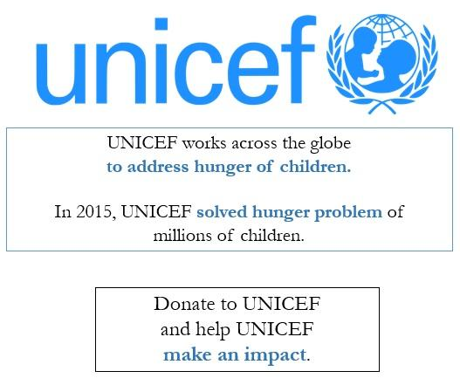
Concrete Condition

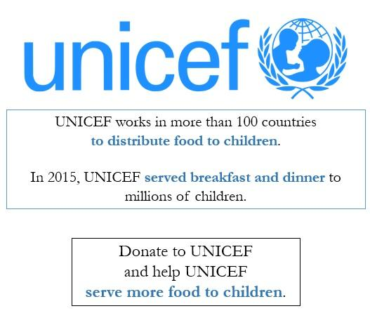
On page 4, participants were asked the following question:

How much of your additional reward of 50 cents would you like us to donate to UNICEF on behalf of you? (Please type 0 if you do not prefer to donate. You may type any amount between 0 and 50).

________________

On page 5, we asked participants to rate their agreement with the following three statements, which acted as the “feeling right” measure:

You have just made a donation decision.

Please indicate below how you felt while making this decision.

 | Strongly disagree | Disagree | Somewhat disagree | Neither agree nor disagree | Somewhat agree | Agree | Strongly Agree
I felt right while making the decision. | (1) | (2) | (3) | (4) | (5) | (6) | (7)
I felt motivated while making the decision. | (1) | (2) | (3) | (4) | (5) | (6) | (7)
I felt wrong while making the decision. | (1) | (2) | (3) | (4) | (5) | (6) | (7)

