Table S1: Description of sites

Site | Occupancy at  baseline (n) | RNs /Overnight nursing  staff | GP access and relationships
1 | 88 | 8 in total/1 | “Regular rounds with 2 GPs. 75%of our nursing home is under their care.”
2 | 42 | 3 per shift /on-call until  10:30pm | “We’re a bit lucky in a way too in that we don’t have a lot of GPs that  come here […]We’ve really only got two at the facility”
3 | 165 | 2 per shift (10 total)/1 | “We predominantly use three GPs”
4 | 83 | 1/unknown | “It’s very hard to get hold the doctor to actually start a palliative pathway whereas now [after the trial] it just makes so much easier for us
5 | 48 | 8/1 | “We’ve got a GP for the facility but he works at his own practice.”
6 | 178 | 28/2 | “We don’t have an in house GP”
7 | 137 | Data not collected due to withdrawal from study
8 | 115 | 17 total/1 | [We deal with] A lot … twenty plus [GPs] more than ten GP are coming on  a regular basis, but maybe 3 or 4 they hardly come.”
9 | 82 | 2 per shift/1 | “We have two GPs that visit regularly.”
10 | 114 | 7/1 | “we have [four] regular GPs that come in”
11 | 98 | 11 in total/1 | “We have GPs who come to the facility, and they come once in a week.  We have 3 or 4 GPs and most of the residents are with the same GP”
12 | 156 | 20 in total/1 | “more than twenty different GPs we’re working with…it’s quite a difficult to work with us while doing the profile paperwork and keeping all the medication charts signed on time and to especially in the palliative care, to contact some GPs are easier to contact, some of them are not. In the case of prescribing medication or doing any review as urgent for example palliative care or end of life care, we always rely on [the specialist palliative care team]”

Table S2. Rating on the extent of fidelity with the intervention

Site | Compliance with the intervention
1 | High
2 | Low
3 | High
4 | Moderate
5 | High
6 | High
7 | Low*
8 | Moderate
9 | Moderate
10 | Moderate
11 | High
12 | Moderate
*Site 7 withdrew at month 12.

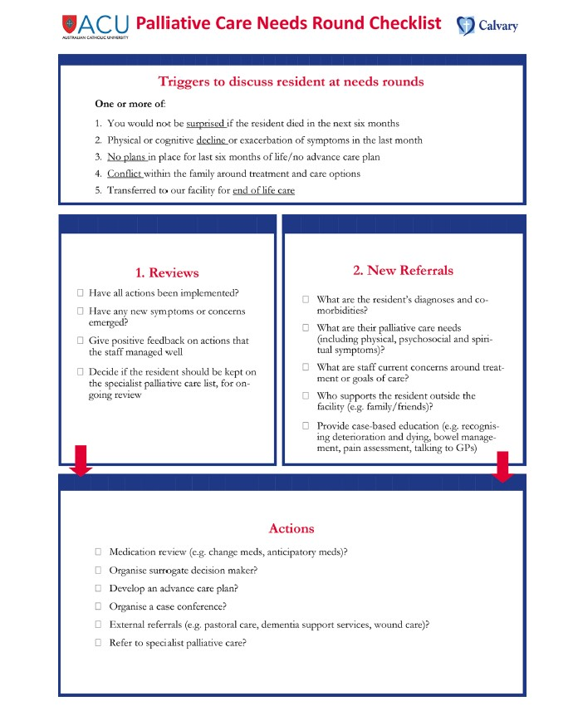
Figure S3: Palliative Care Needs Round Checklist

From: Forbat L, Chapman M, Lovell C, Liu WM, Johnston N. Improving specialist palliative care in residential care for older people: a checklist to guide practice. BMJ supportive & palliative care. 2017;8:347-353.

Supplementary materials 3: Checklist of information to include when reporting a stepped wedge cluster randomised trial (SW-CRT)

Topic | Item no | Checklist item | Page no
Title and abstract
 | 1a | Identification as a SW-CRT in the title. | 2
 | 1b | Structured summary of trial design, methods, results, and conclusions (see separate SW-CRT checklist for abstracts). | 3-4
Introduction
Background and objectives | 2a | Scientific background. Rationale for using a cluster design and rationale for using a stepped wedge design. | 5-6
 | 2b | Specific objectives or hypotheses. | 6
Methods
Trial design | 3a | Description and diagram of trial design including definition of cluster, number of sequences, number of clusters randomised to each sequence, number of periods, duration of time between each step, and whether the participants assessed in different periods are the same people, different people, or a mixture. | 6-11
 | 3b | Important changes to methods after trial commencement (such as eligibility criteria), with reasons. | 9
Participants | 4a | Eligibility criteria for clusters and participants. | 6
 | 4b | Settings and locations where the data were collected. | 6
Interventions | 5 | The intervention and control conditions with sufficient details to allow replication, including whether the intervention was maintained or repeated, and whether it was delivered at the cluster level, the individual participant level, or both. | 7-8
Outcomes | 6a | Completely defined prespecified primary and secondary outcome measures, including how and when they were assessed. | 9
 | 6b | Any changes to trial outcomes after the trial commenced, with reasons. | 9
Sample size | 7a | How sample size was determined. Method of calculation and relevant parameters with sufficient detail so the calculation can be replicated. Assumptions made about correlations between outcomes of participants from the same cluster. (see separate checklist for SW-CRT sample size items). | 10
 | 7b | When applicable, explanation of any interim analyses and stopping guidelines. | n/a
Randomisation
Sequence generation | 8a | Method used to generate the random allocation to the sequences of treatments. | 7
 | 8b | Type of randomisation; details of any constrained randomisation or stratification, if used. | 7
Allocation concealment mechanism | 9 | Specification that allocation was based on clusters; description of any methods used to conceal the allocation from the clusters until after recruitment. | 7
Implementation | 10a | Who generated the randomisation schedule, who enrolled clusters, and who assigned clusters to sequences. | 7
 | 10b | Mechanism by which individual participants were included in clusters for the purposes of the trial (such as complete enumeration, random sampling; continuous recruitment or ascertainment; or recruitment at a fixed point in time), including who recruited or identified participants. | 7
 | 10c | Whether, from whom and when consent was sought and for what; whether this differed between treatment conditions. | 9
Blinding | 11a | If done, who was blinded after assignment to sequences (eg, cluster level participants, individual level participants, those assessing outcomes) and how. | n/a
 | 11b | If relevant, description of the similarity of treatments. | n/a
Statistical methods | 12a | Statistical methods used to compare treatment conditions for primary and secondary outcomes including how time effects, clustering and repeated measures were taken into account. | 10
 | 12b | Methods for additional analyses, such as subgroup analyses, sensitivity analyses, and adjusted analyses. | 10
 |  |  |  | (Continued)

Supplementary materials 3 (Continued)
Topic Item no Checklist item Page no
Results
Participant flow (a diagram is strongly recommended) | 13a For each treatment condition or allocated sequence, the numbers of clusters and participants who were assessed for eligibility, were randomly assigned, received intended treatments, and were analysed for the primary outcome (see separate SW-CRT flow chart). | Fig1
 | 13b For each treatment condition or allocated sequence, losses and exclusions for both clusters and participants with reasons. | Fig 1
Recruitment | 14a Dates defining the steps, initiation of intervention, and deviations from planned dates. Dates defining recruitment and follow-up for participants. | Fig 1
 | 14b Why the trial ended or was stopped. | 9
Baseline data 15 Baseline characteristics for the individual and cluster levels as applicable for  each treatment condition or allocated sequence. |  | Table 1
Numbers analysed 16 The number of observations and clusters included in each analysis for each  treatment condition and whether the analysis was according to the allocated schedule. |  | Fig1
Outcomes and estimation | 17a For each primary and secondary outcome, results for each treatment condition, and the estimated effect size and its precision (such as 95% confidence interval); any correlations (or covariances) and time effects estimated in the analysis. | Table 2
 | 17b For binary outcomes, presentation of both absolute and relative effect sizes is recommended. | Table 2
Ancillary analyses 18 Results of any other analyses performed, including subgroup analyses and  adjusted analyses, distinguishing prespecified from exploratory. |  | n.a
Harms 19 Important harms or unintended effects in each treatment condition (for  specific guidance see CONSORT for harms). |  | 13
Discussion
Limitations 20 Trial limitations, addressing sources of potential bias, imprecision, and, if  relevant, multiplicity of analyses. |  | 15
Generalisability 21 Generalisability (external validity, applicability) of the trial findings.  Generalisability to clusters or individual participants, or both (as relevant). |  | 15
Interpretation 22 Interpretation consistent with results, balancing benefits and harms, and considering other relevant evidence. |  | 13-15
Other information
Registration 23 Registration number and name of trial registry. |  | 9
Protocol 24 Where the full trial protocol can be accessed, if available. |  | 6
Funding 25 Sources of funding and other support (such as supply of drugs), and the role  of funders. |  | 16
Research ethics 26 Whether the study was approved by a research ethics committee, with review identification of the review committee(s). Justification for any waiver or  modification of informed consent requirements. |  | 9
This checklist has been taken from table 3 in BMJ 2018;363:k1614, as a standalone document for readers to print out or fill in electronically.

Item
The TIDieR (Template for Intervention Description and Replication) Checklist*:

Information to include when describing an intervention and the location of the information

Item Where located **

number

Primary paper (page or appendix number)

Other † (details)

BRIEF NAME
- Provide the name or a phrase that describes the intervention.

WHY

- Describe any rationale, theory, or goal of the elements essential to the intervention.

WHAT

- Materials: Describe any physical or informational materials used in the intervention, including those provided to participants or used in intervention delivery or in training of intervention providers. Provide information on where the materials can be accessed (e.g. online appendix, URL).

1

5

7-8

- Procedures: Describe each of the procedures, activities, and/or processes used in the intervention, including any 8-9 enabling or support activities.
WHO PROVIDED

- For each category of intervention provider (e.g. psychologist, nursing assistant), describe their expertise, background and any specific training given.
HOW

7

- Describe the modes of delivery (e.g. face-to-face or by some other mechanism, such as internet or telephone) of 7-8 the intervention and whether it was provided individually or in a group.
WHERE

- Describe the type(s) of location(s) where the intervention occurred, including any necessary infrastructure or 6-7 relevant features.
WHEN and HOW MUCH
8. Describe the number of times the intervention was delivered and over what period of time including the Fig1
number of sessions, their schedule, and their duration, intensity or dose.
TAILORING
9. If the intervention was planned to be personalised, titrated or adapted, then describe what, why, when, and how. 9
MODIFICATIONS
10.ǂ If the intervention was modified during the course of the study, describe the changes (what, why, when, and 9
how).
HOW WELL
11. Planned: If intervention adherence or fidelity was assessed, describe how and by whom, and if any strategies 8
were used to maintain or improve fidelity, describe them.
12.ǂ Actual: If intervention adherence or fidelity was assessed, describe the extent to which the intervention was Table S2
delivered as planned.

** Authors - use N/A if an item is not applicable for the intervention being described. Reviewers – use ‘?’ if information about the element is not reported/not sufficiently reported.

† If the information is not provided in the primary paper, give details of where this information is available. This may include locations such as a published protocol or other published papers (provide citation details) or a website (provide the URL).
ǂ If completing the TIDieR checklist for a protocol, these items are not relevant to the protocol and cannot be described until the study is complete.

- We strongly recommend using this checklist in conjunction with the TIDieR guide (see BMJ 2014;348:g1687) which contains an explanation and elaboration for each item.

The focus of TIDieR is on reporting details of the intervention elements (and where relevant, comparison elements) of a study. Other elements and methodological features of studies are covered by other reporting statements and checklists and have not been duplicated as part of the TIDieR checklist. When a randomised trial is being reported, the TIDieR checklist should be used in conjunction with the CONSORT statement (see www.consort-statement.org) as an extension of Item 5 of the CONSORT 2010 Statement. When a clinical trial protocol is being reported, the TIDieR checklist should be used in conjunction with the SPIRIT statement as an extension of Item 11 of the SPIRIT 2013 Statement (see www.spirit-statement.org). For alternate study designs, TIDieR can be used in conjunction with the appropriate checklist for that study design (see www.equator-network.org

