Supplemental Material

Supplemental Figure 1: Distribution of the Modified-ICH Score for all VISTA patients with available baseline information for calculations (a), and included patients for study analysis (b). The distributions are similar.

Supplemental Figure 2: Calculation of the Youden’s Index.

A. MORTALITY
ROC Curve Coordinates for Mortality:
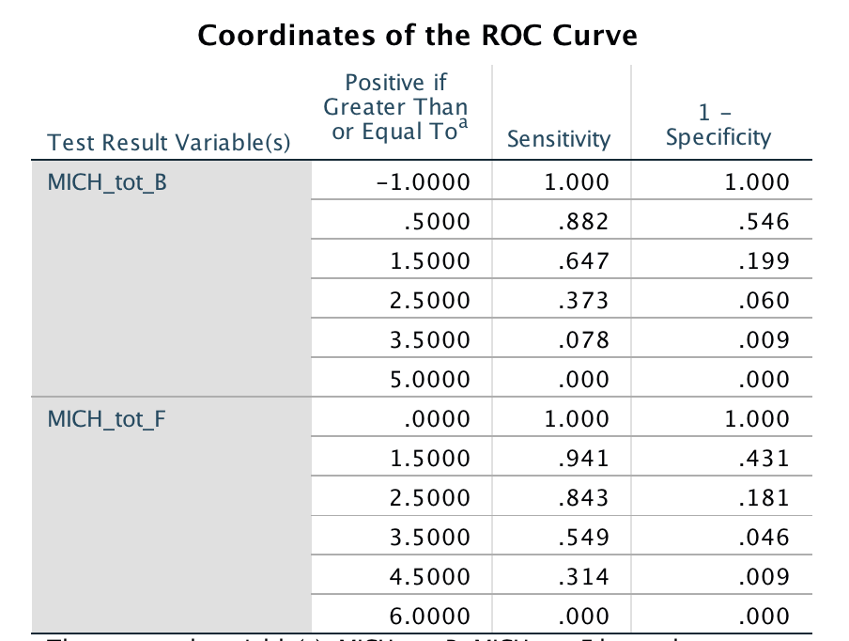

Baseline MICH (MICH_tot_B):
Hosmer and Lemeshow Goodness-of-Fit Test (Chi-Square 0.029, df=2, p=0.98)
Youden’s Index = (0.647 + 0.801) -1 = 0.448; representing a score cutoff ≥2
Cutoff of ≥2: sensitivity of 0.647 and specificity of 0.801

Delayed MICH (MICH_tot_F):
Hosmer and Lemeshow Goodness-of-Fit Test (Chi-Square 0.54, df=3, p=0.91)
Youden’s Index = (0.843 + 0.819) -1 = 0.662; representing a score cutoff ≥3
Cutoff of ≥3: sensitivity of 0.843 and specificity of 0.819

B. POOR FUNCTIONAL OUTCOME
ROC Curve Coordinates for poor functional outcome
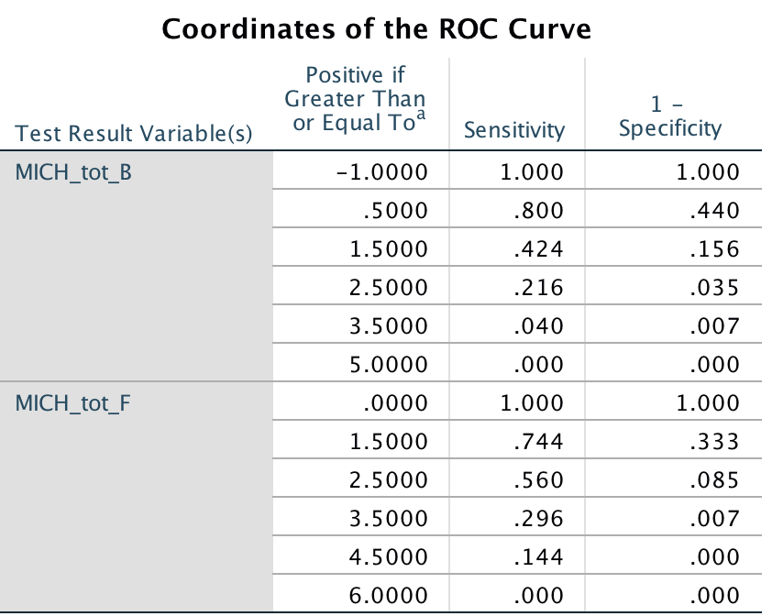

Baseline MICH (MICH_tot_B):
Hosmer and Lemeshow Goodness-of-Fit Test (Chi-Square 3.30, df=2, p=0.19)
Youden’s Index = (0.800+0.560) – 1 = 0.360; representing a score cutoff ≥1
Cutoff of ≥1: sensitivity of 0.800 and specificity of 0.560

Delayed MICH (MICH_tot_F):
Hosmer and Lemeshow Goodness-of-Fit Test (Chi-Square 3.53, df=3, p=0.34)
Youden’s Index = (0.744+0.667) – 1 = 0.411, representing a score cutoff ≥2
Cutoff of ≥2: sensitivity of 0.744 and specificity of 0.667

