Web Appendix

WEB APPENDIX W1: CHARACTERIZATION OF (OTHER) EVENT TYPES

TABLE WA1: Average Discount Depth and Advertising Spending in Event Weeks for Different Types of Events
 | Retailer |  |  |  | Overall Indexª
 | Plus | C1000 | AH | SdB
Panel A: Discount Depth
Overall Average | 15.08 | 15.50 | 12.31 | 15.63 | 1
ReTSS | 18.45 | 17.62 | 16.87 | 19.81 | 1.25
Popular Events | 14.63 | 16.08 | 10.97 | 12.36 | 0.92
Temp. Loyalty Programs | 14.72 | 16.61 | 11.07 | 14.82 | 0.97
Category Events | 14.31 | 13.40 | 11.90 | 12.26 | 0.89
Seasonal Events | 14.87 | 14.63 | 10.99 | 15.18 | 0.95
Panel B: Mass Media Advertising Spending
Overall Average | 499,068 | 867,348 | 1,070,746 | 189,150 | 1
ReTSS | 400,074 | 902,664 | 811,428 | 305,510 | 1.05
Popular Events | 831,844 | 1,449,372 | 1,359,834 | 550,094 | 1.88
Temp. Loyalty Programs | 486,284 | 965,383 | 1,012,472 | 207,904 | 1.03
Category Events | 328,730 | 658,327 | 1,108,442 | 74,809 | .71
Seasonal Events | 597,243 | 1,020,858 | 1,475,661 | 279,094 | 1.31
ª Index obtained as follows: For each retailer, and for each event type, we first calculate an index within the retailer column, i.e., we calculate the level of the discount (advertising) variable of that event type, relative to the overall average of the retailer. We then average these indices across retailers (columns) to obtain the overall index in the last column.

Table WA1 reports the average discount depth and number of feature promotions in an average week (‘Overall Average’) and during weeks in which a specific type of event was run at the retailer. We note that also during event weeks, the retailer offers many promotions that do not belong to the event. The discount depths and features in the table are calculated across all items at the retailer during event weeks. This explains, for instance, why the average discount depth during ReTSS weeks is so low (amounts to only 18.45% for Plus, 17.62% for C1000, etc.): it is the average of discounts that do and do not fall under the ReTSS theme during ReTSS weeks.
Keeping this in mind, the table shows in each chain, that the average discount depth during ReTSS weeks is markedly and systematically higher than average, and higher compared to weeks with other types of events.
Interestingly, mass media advertising spending is highest during seasonal and popular events. A likely explanation is that such events occur at the same time for different players, such that higher budges are needed to break through the competitive clutter.
WEB APPENDIX W2: MODEL SPECIFICATION AND ESTIMATION

The likelihood for a household (h) to visit a set of retailers in week (w) is given by the following equation:
$$P_{w}^{h}\left({ret}_{1}=d_{1},{ret}_{2}=d_{2},…,{ret}_{r}=d_{r}\right)= \left[\prod_{r=1}^{R}{\frac{e^{\left(\frac{v_{wr}^{h}}{σ_{r}}\right)*d_{r}}}{1+e^{\left(\frac{v_{wr}^{h}}{σ_{r}}\right)}}}\right]*\left[1+\sum_{r=1}^{R-1}{\sum_{k=r+1}^{R}{{\left(-1\right)}^{d_{r}+d_{k}}*θ_{rk}\left\{1-\frac{e^{\left(\frac{v_{wr}^{h}}{σ_{r}}\right)*d_{r}}}{1+e^{\left(\frac{v_{wr}^{h}}{σ_{r}}\right)}}\right\}\left\{1-\frac{e^{\left(\frac{v_{wk}^{h}}{σ_{k}}\right)*d_{k}}}{1+e^{\left(\frac{v_{wk}^{h}}{σ_{k}}\right)}}\right\}}}\right]$$
Where $d_{r}$ takes on the value of 1 when a retailer was visited and 0 otherwise. The correlation between the different retailers is governed by the $θ_{rk}$ terms. Specifically, we allow for different correlations between different types of retailers, by specifying $θ_{rk}$ as:
$$θ_{rk}=\left(2*\left(\frac{e^{δ^{ts,ts}*D_{rk}^{ts,ts}+δ^{ts,hd}*D_{rk}^{ts,hd}+δ^{hd,hd}*D_{rk}^{hd,hd}}}{1+e^{δ^{ts,ts}*D_{rk}^{ts,ts}+δ^{ts,hd}*D_{rk}^{ts,hd}+δ^{hd,hd}*D_{rk}^{hd,hd}}}\right)\right)-1$$
The correlation between retailers is governed by three parameters: $δ^{ts,ts}$ , $δ^{ts,hd}$, $δ^{hd,hd}$, where superscripts ‘ts’ and ‘hd’ respectively refer to a traditional supermarket and hard-discounter. $D_{rk}^{ts,ts}$ , $D_{rk}^{ts,ts}, D_{rk}^{ts,ts}$ are dummy variables equal to 1 when (i) both retailers (r) and (k) are traditional supermarkets, (ii) when both are hard discounters, or (iii) when one is a traditional supermarket and the other a hard discounter, respectively, resulting in differential correlations for traditional supermarket pairs, hard-discounter pairs, and traditional supermarket with hard-discounter pairs. The functional form above ensures that the $θ_{rk}$ terms are between -1 and 1, in addition to symmetry (Bhat and Sener 2009). The parameter $σ_{r}$ is specified as:
$$σ_{r}=\exp\left(ϖ_{hd}*D_{r}^{hd}\right)$$
such that for traditional retailers ($D_{r}^{hd}=0)$it is set to 1 and for hard-discounters ($D_{r}^{hd}=1)$it can take any positive value. The equations were estimated using simulated maximum likelihood. The correlation parameters for traditional supermarkets were -.162 (p <.00), for hard-discounters -.251 (p <.00) and for a traditional supermarket with a hard-discounter -0.004 (p >.1).
The purchase volume equation (Equation (3) in the main text), which is conditional upon a retailer visit, is estimated with maximum likelihood to accommodate unobserved heterogeneity in the parameter vectors $ι_{r}^{h}$, $β^{h}$ and $τ$. In addition, we assume that $ε_{rw}^{h}$ has a multivariate normal distribution with mean equal to zero and a covariance matrix that is conditional upon the number of retailers visited (R). As such, for the covariance matrix $Σ_{R}$ (for R = 1, …, 6), the diagonal is given by $σ_{R,R}$ and the off-diagonals by $σ_{R,R^{'}}$.
WEB APPENDIX W3

TABLE WA2: Calendar Time of ReTSS
 | EVENT |  |  |  |  |  |  |  |  |  | EVENT |  |  |  |  |  |  |  |  |  | EVENT
YEARWEEK | 1 | 2 | 3 | 4 | 5 | 6 | 7 | 8 | 9 | YEARWEEK | 1 | 2 | 3 | 4 | 5 | 6 | 7 | 8 | 9 | YEARWEEK | 1 | 2 | 3 | 4 | 5 | 6 | 7 | 8 | 9
200834 | 0 | 0 | 0 | 0 | 0 | 0 | 0 | 0 | 1 | 201041 | 0 | 1 | 0 | 0 | 0 | 0 | 0 | 0 | 0 | 201149 | 0 | 1 | 0 | 0 | 0 | 0 | 0 | 0 | 0
200835 | 0 | 0 | 0 | 0 | 0 | 0 | 0 | 0 | 1 | 201042 | 0 | 1 | 0 | 0 | 0 | 0 | 0 | 0 | 0 | 201201 | 0 | 0 | 1 | 0 | 0 | 0 | 0 | 0 | 0
200836 | 0 | 0 | 0 | 0 | 0 | 0 | 0 | 0 | 1 | 201049 | 0 | 1 | 0 | 0 | 0 | 0 | 0 | 0 | 0 | 201202 | 0 | 0 | 1 | 0 | 0 | 0 | 0 | 0 | 0
200901 | 0 | 1 | 1 | 0 | 0 | 1 | 0 | 0 | 0 | 201101 | 0 | 0 | 1 | 1 | 0 | 0 | 0 | 0 | 1 | 201203 | 0 | 0 | 1 | 0 | 0 | 0 | 0 | 0 | 0
200902 | 0 | 1 | 1 | 0 | 0 | 1 | 0 | 0 | 1 | 201102 | 0 | 0 | 1 | 1 | 0 | 0 | 0 | 0 | 1 | 201208 | 0 | 0 | 0 | 0 | 1 | 0 | 0 | 0 | 0
200903 | 0 | 1 | 1 | 0 | 0 | 1 | 0 | 0 | 1 | 201103 | 0 | 0 | 1 | 1 | 0 | 0 | 0 | 0 | 1 | 201209 | 0 | 0 | 0 | 0 | 1 | 0 | 0 | 0 | 0
200904 | 0 | 1 | 0 | 0 | 0 | 1 | 0 | 0 | 1 | 201104 | 0 | 0 | 0 | 1 | 0 | 0 | 0 | 0 | 1 | 201210 | 0 | 0 | 0 | 0 | 1 | 0 | 0 | 0 | 0
200905 | 0 | 0 | 0 | 0 | 0 | 0 | 0 | 0 | 1 | 201107 | 0 | 1 | 0 | 0 | 0 | 0 | 0 | 0 | 0 | 201211 | 0 | 0 | 0 | 0 | 1 | 0 | 0 | 0 | 0
200916 | 0 | 0 | 0 | 0 | 0 | 0 | 1 | 0 | 0 | 201108 | 0 | 1 | 0 | 0 | 0 | 0 | 0 | 0 | 0 | 201216 | 0 | 1 | 0 | 0 | 0 | 0 | 0 | 0 | 0
200917 | 0 | 0 | 0 | 0 | 0 | 0 | 1 | 0 | 0 | 201112 | 0 | 0 | 0 | 0 | 1 | 0 | 0 | 0 | 0 | 201217 | 0 | 1 | 0 | 0 | 0 | 0 | 0 | 0 | 0
200918 | 0 | 0 | 0 | 0 | 0 | 0 | 1 | 0 | 0 | 201113 | 0 | 0 | 0 | 0 | 1 | 0 | 0 | 0 | 0 | 201218 | 0 | 1 | 0 | 0 | 0 | 0 | 0 | 0 | 0
200934 | 0 | 1 | 1 | 0 | 0 | 0 | 0 | 0 | 0 | 201114 | 0 | 0 | 0 | 0 | 1 | 0 | 0 | 0 | 0 | 201227 | 1 | 0 | 0 | 0 | 0 | 0 | 0 | 1 | 0
200935 | 0 | 1 | 1 | 0 | 0 | 1 | 0 | 0 | 1 | 201117 | 0 | 0 | 0 | 1 | 0 | 0 | 0 | 0 | 0 | 201228 | 1 | 0 | 0 | 0 | 0 | 0 | 0 | 1 | 0
200936 | 0 | 1 | 1 | 0 | 0 | 1 | 0 | 0 | 1 | 201118 | 0 | 0 | 0 | 1 | 0 | 0 | 0 | 0 | 0 | 201229 | 1 | 0 | 0 | 0 | 0 | 0 | 0 | 0 | 0
200937 | 0 | 1 | 0 | 0 | 0 | 0 | 0 | 0 | 1 | 201119 | 0 | 0 | 0 | 1 | 0 | 0 | 0 | 0 | 0 | 201230 | 1 | 0 | 0 | 0 | 0 | 0 | 0 | 0 | 0
200944 | 0 | 0 | 0 | 0 | 0 | 0 | 1 | 0 | 0 | 201120 | 0 | 1 | 0 | 0 | 0 | 0 | 0 | 0 | 0 | 201231 | 1 | 0 | 0 | 0 | 0 | 0 | 0 | 0 | 0
200945 | 0 | 0 | 0 | 0 | 0 | 0 | 1 | 0 | 0 | 201121 | 0 | 1 | 0 | 0 | 0 | 0 | 0 | 0 | 0 | 201232 | 1 | 0 | 0 | 0 | 0 | 0 | 0 | 0 | 0
200946 | 0 | 0 | 0 | 0 | 0 | 0 | 1 | 0 | 0 | 201124 | 0 | 0 | 0 | 0 | 0 | 0 | 1 | 0 | 1 | 201233 | 0 | 1 | 0 | 0 | 0 | 0 | 0 | 0 | 0
201001 | 0 | 1 | 1 | 0 | 0 | 0 | 0 | 0 | 1 | 201125 | 0 | 0 | 0 | 0 | 0 | 0 | 1 | 0 | 1 | 201234 | 0 | 1 | 0 | 0 | 0 | 0 | 0 | 0 | 0
201002 | 0 | 1 | 1 | 0 | 0 | 0 | 0 | 0 | 1 | 201126 | 0 | 0 | 0 | 0 | 0 | 0 | 1 | 0 | 0 | 201235 | 0 | 1 | 1 | 0 | 0 | 0 | 0 | 0 | 0
201003 | 0 | 1 | 1 | 0 | 0 | 0 | 0 | 0 | 1 | 201133 | 0 | 1 | 0 | 0 | 0 | 0 | 0 | 0 | 0 | 201236 | 0 | 0 | 1 | 0 | 0 | 0 | 0 | 0 | 0
201004 | 0 | 0 | 0 | 0 | 0 | 0 | 0 | 0 | 1 | 201134 | 0 | 1 | 1 | 1 | 0 | 0 | 0 | 0 | 0 | 201237 | 0 | 0 | 1 | 0 | 0 | 0 | 0 | 0 | 0
201014 | 0 | 0 | 0 | 1 | 0 | 0 | 1 | 0 | 0 | 201135 | 0 | 1 | 1 | 1 | 0 | 0 | 0 | 0 | 0 | 201243 | 0 | 0 | 0 | 0 | 0 | 0 | 1 | 0 | 0
201015 | 0 | 0 | 0 | 1 | 0 | 0 | 1 | 0 | 0 | 201136 | 0 | 0 | 1 | 1 | 0 | 0 | 0 | 0 | 0 | 201244 | 0 | 0 | 0 | 0 | 0 | 0 | 1 | 0 | 0
201016 | 0 | 0 | 0 | 1 | 0 | 0 | 1 | 0 | 0 | 201137 | 0 | 0 | 1 | 0 | 0 | 0 | 0 | 0 | 0 | 201245 | 0 | 0 | 0 | 0 | 0 | 0 | 1 | 0 | 0
201017 | 0 | 0 | 0 | 1 | 0 | 0 | 0 | 0 | 0 | 201142 | 0 | 0 | 0 | 0 | 1 | 0 | 0 | 0 | 0 | 201246 | 0 | 0 | 0 | 0 | 0 | 0 | 0 | 1 | 0
201034 | 0 | 0 | 1 | 0 | 0 | 0 | 0 | 0 | 1 | 201143 | 0 | 0 | 0 | 0 | 1 | 0 | 0 | 0 | 0 | 201247 | 0 | 0 | 0 | 0 | 0 | 0 | 0 | 1 | 0
201035 | 0 | 0 | 1 | 0 | 0 | 0 | 0 | 0 | 1 | 201144 | 0 | 0 | 0 | 0 | 1 | 0 | 0 | 0 | 0 | 201248 | 0 | 1 | 0 | 0 | 0 | 0 | 0 | 1 | 0
201036 | 0 | 0 | 1 | 0 | 0 | 0 | 0 | 0 | 1 | 201148 | 0 | 1 | 0 | 0 | 0 | 0 | 0 | 0 | 0 | 201249 | 0 | 1 | 0 | 0 | 0 | 0 | 0 | 0 | 0

(‘1’ indicates that the event occurred in the considered week)
WEB APPENDIX W4: PROCEDURE TO CONSTRUCT HOUSEHOLD-SPECIFIC WEEKLY RETAILER PRICES, DISCOUNT DEPTHS, FEATURE ACTIVITY AND ASSORTMENTS

To obtain store-level values for the price, discount depth, feature activity and assortment variables, we use a procedure similar to van Heerde et al. (2008). Starting from the detailed panel data, the procedure goes as follows.
- We calculate actual unit prices for each SKU per retailer per week by dividing the SKU sales value (in Eurocents) by its sales volume (in category-specific volume units, e.g., grams, liters, …)
- For each SKU, retailer and week, we determine:
  - whether the SKU is on feature in that week at that retailer, based on the feature dummy variable provided by GfK,
  - if an SKU is on promotion: the regular price as the median price of the SKU at the retailer for the surrounding 4 weeks,
  - the percentage discount depth given a promotion. We use the promotion flag of GfK to assess whether an SKU is promoted at the store in the considered week. We then set the discount depth to
    - zero for weeks in which the SKU is not on promotion at that
retailer
    - (regular price – actual price) / (regular price) * 100 for weeks with a
promotion for that SKU at that retailer,
and calculate volume share of the SKU within the brand at the retailer in the past 26 weeks.
- For each brand, retailer and week, we calculate the:
  - regular brand price at the retailer as a weighted average of regular SKU prices, using the SKU volume shares (obtained as above) within the brand as weights
  - brand discount depth at the retailer as a weighted average of SKU discount depths across promoted SKUs, using the SKU shares within the brand as weights (weights normalized to sum to one)
  - brand feature activity at the retailer as a weighted average of SKU feature dummies, using the SKU volume shares (obtained as above) within the brand as weights
  - brand volume share within the category at the retailer, in the past 26 weeks
- For each category, retailer and week, we obtain the:
  - regular category price as a weighted average of regular brand prices, using the brand shares (obtained as above) within the category as weights (normalized to sum to one)
  - category discount depth as a weighted average of brand discount depths for brands with a discount, using the brand shares within the category as weights (normalized to sum to one)
  - category feature activity as a weighted average of brand feature activity, using the brand shares within the category as weights (normalized to sum to one)
  - normalize the retailer weekly regular category price into an index using the mean category price of the first 26 weeks (outside of estimation sample) across all retailers to ensure comparability across categories with different volume units.
- For each household and category, we calculate the share of the category in the household’s total spending, in the first 26 weeks of the households’ purchase history
- We then use these category shares as weights to aggregate the retailer-week-category specific regular price, discount depth and feature-activity variables to household-specific retailer-week price-, discount depth- and feature variables.

For household-specific assortment, we use the following procedure:
- For each SKU observed in our dataset and each week, we check if it was sold in the preceding four-week period at the focal retailer to determine availability.
- We aggregate the number of available SKUs in that week at that retailer to the category level
- For each household and category, we calculate the share of the category in the household’s total spending, in the first 26 weeks of the households’ purchase history
- We use these category shares as weights to aggregate the SKU availability for a given week and retailer, to a household-specific retailer-week assortment variable

As we aim to capture variation in regular price, discount depth, feature activity and assortment over time, we normalize these variables within each retailer. Finally, to account for competitive effects, we divide each variable by the average across retailers in that week.

Reference:
van Heerde, Harald, Els Gijsbrechts, and Koen Pauwels (2008), "Winners and Losers in a Major Price War," Journal of Marketing Research, 45 (5), 499-518.

WEB APPENDIX W5: SIMULATION RESULTS

Table WA5: Impact of ReTSS Over Timeª
 | Panel A: During Event |  |  | Panel B: Before Event |  |  | Panel C: After Event^{b} |  |  | Panel D: Net Effect (All Periods)^{c}
Event | Visit Propensity | Conditional Purchase Volume | Total Purchase Volume | Visit Propensity | Conditional Purchase Volume | Total Purchase Volume | Visit Propensity | Conditional Purchase Volume | Total Purchase Volume | Visit Propensity | Conditional Purchase Volume | Total Purchase Volume
1 | 0.39 | -69.33** | -18.14* | -0.23* | -67.28** | -19.89** | 0.08 | -14.3** | -1.32 | 0.13 | -32.51** | -7.07**
 | 3.55% | -1.94% | -6.96% | -2.31% | -1.81% | -7.72% | 0.94% | -0.40% | -0.49% | 1.32% | -0.90% | -2.71%
2 | 2.85** | 43.14** | 98.11** | -0.57** | -51.50** | -39.17** | 0.54** | -48.77** | 0.25 | 1.02** | -26.02** | 21.43**
 | 13.30% | 1.23% | 19.29% | -2.68% | -1.39% | -7.61% | 2.45% | -1.33% | 0.05% | 4.74% | -0.70% | 4.22%
3 | 2.99** | 178.82** | 192.90** | -1.14** | -158.13* | -75.00** | 0.95** | -48.46** | -2.22 | 1.28** | -0.78 | 40.49**
 | 7.57% | 5.00% | 19.94% | -2.85% | -4.24% | -7.75% | 2.41% | -1.32% | -0.23% | 3.26% | 0.01% | 4.19%
4 | 0.74** | 7.53 | 24.04** | -0.23* | -67.28** | -19.89** | 0.13* | -15.39* | -0.88 | 0.25** | -13.98* | 3.77
 | 6.70% | 0.20% | 9.22% | -2.31% | -1.81% | -7.72% | 1.38% | -0.42% | -0.33% | 2.40% | -0.38% | 1.44%
5 | 0.16 | -51.94* | -20.16 | -0.57** | -51.50** | -39.17** | 0.13 | -45.65** | -6.51* | 0.08 | -47.71** | -12.65**
 | 0.75% | -1.44% | -3.98% | -2.68% | -1.39% | -7.61% | 0.56% | -1.25% | -1.24% | 0.34% | -1.31% | -2.45%
6 | 2.21** | 45.09 | 54.05** | -0.23* | -67.28** | -19.89** | 0.31** | -15.92* | 1.56 | 0.74** | -4.95 | 12.90**
 | 20.22% | 1.27% | 20.74% | -2.31% | -1.81% | -7.72% | 3.07% | -0.44% | 0.58% | 6.91% | -0.13% | 4.93%
7 | -0.06 | -28.72 | -7.23 | -0.57** | -51.50** | -39.17** | 0.09 | -46.15** | -7.35* | 0.00 | -42.24** | -9.97**
 | -0.25% | -0.79% | -1.43% | -2.68% | -1.39% | -7.61% | 0.40% | -1.26% | -1.40% | -0.02% | -1.16% | -1.92%
8 | 4.24** | -14.23 | 115.23** | -1.14** | -158.13* | -75.00** | 1.14** | -44.53** | 1.55 | 1.72** | -46.42** | 23.59**
 | 10.75% | -0.37% | 11.92% | -2.85% | -4.24% | -7.75% | 2.90% | -1.22% | 0.16% | 4.38% | -1.26% | 2.44%
9 | 0.67** | -3.32 | 12.58** | -0.34* | -3.72 | -15.12** | -0.09 | -3.33* | -3.82** | 0.08 | -3.36 | -0.66
 | 7.20% | -0.09% | 7.52% | -3.64% | -0.10% | -9.10% | -1.08% | -0.09% | -2.30% | 0.78% | -0.09% | -0.41%
Average | 1.58** | 11.89 | 50.15** | -0.56* | -75.15** | -38.03** | 0.36* | -31.39** | -2.08 | 0.59** | -24.22** | 7.98*
 | 7.75% | 0.34% | 8.47% | -2.70% | -2.02% | -7.84% | 1.45% | -0.86% | -0.58% | 2.68% | -0.66% | 1.08%
*: p<.05, **: p<.01, one-tailed tests based on distribution across parameter draws. ª Conditional Purchase Volume’ is the change in purchase volume over the considered period, per household, given a visit, expressed in constant monetary value (Euros). ‘Total Purchase Volume’ is the change in total purchase volume (in Euros) over the considered period, per household, unconditional on a store visit (so: zero if the household did not visit the store in those weeks). The economic significance of these figures is clear from Table 9, where we report the equivalent value at the market level. ^{b} Impact over the eight-week period following the event. ^{c} Impact over the twelve-week period (1 pre-event week + three event weeks + eight post-event weeks).
FIGURE WA1: Impact of ReTSS’ Theme vs. Support (Discounts, Features and Advertising), over Timeª
Panel A: VISITS | Panel B: PURCHASES
Event 4 (average) | Event 4 (average)
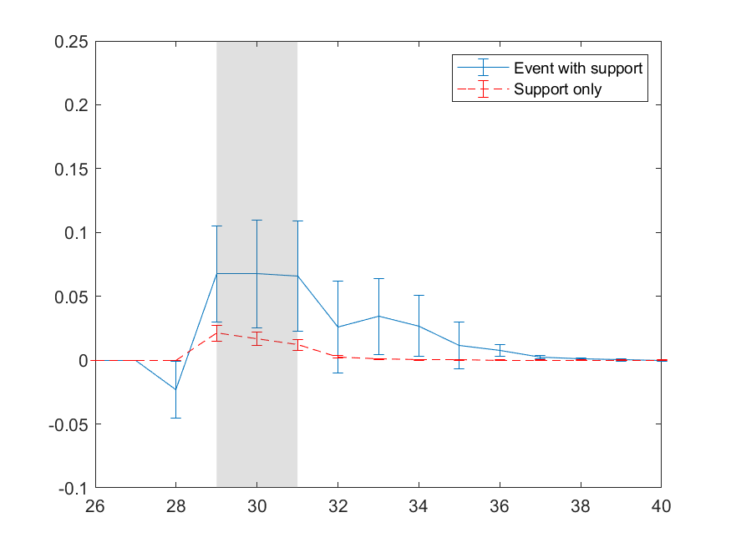 | 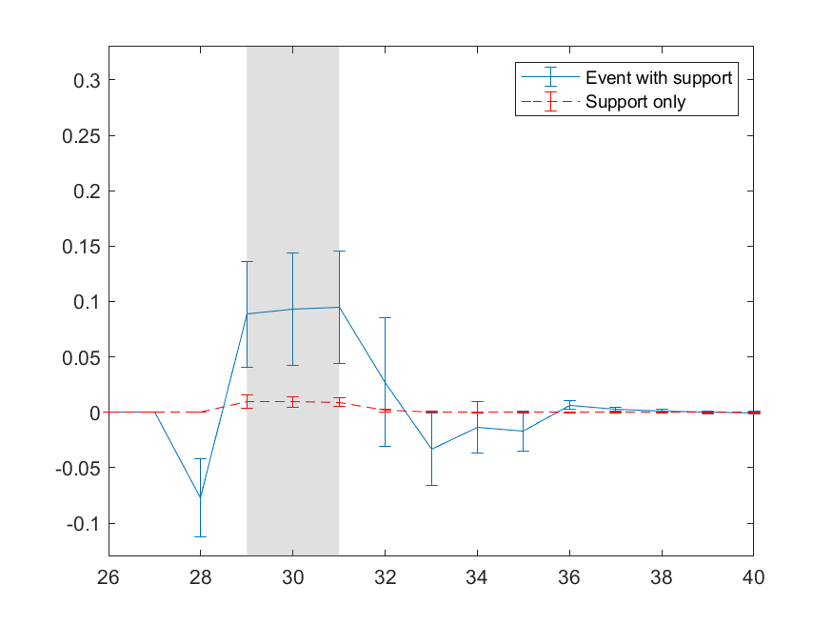
Event 1 (worst) | Event 1 (worst)
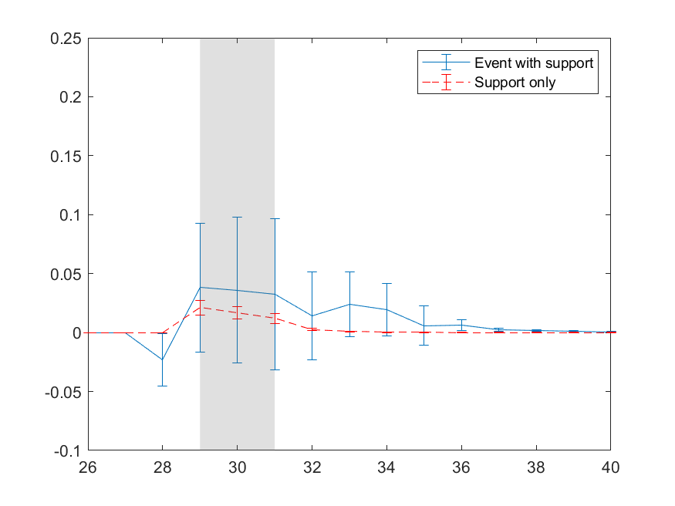 | 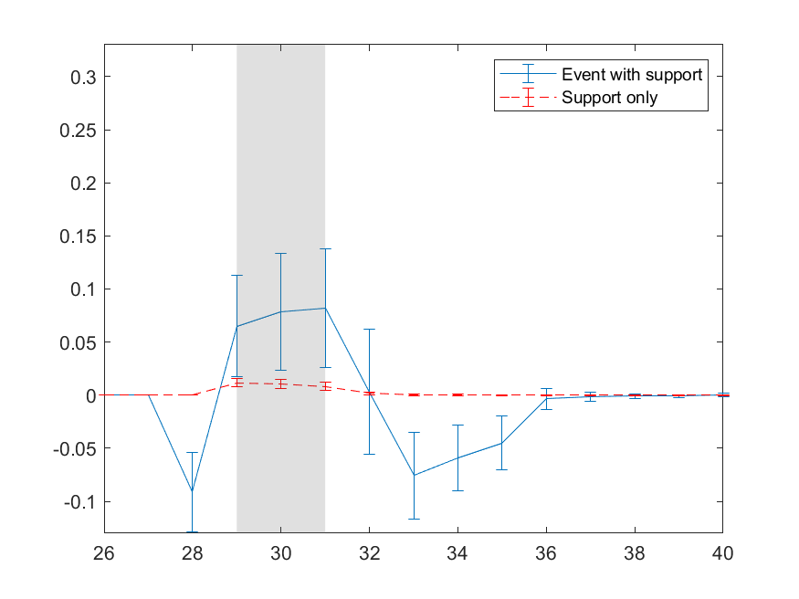
Event 2 (best) | Event 2 (best)
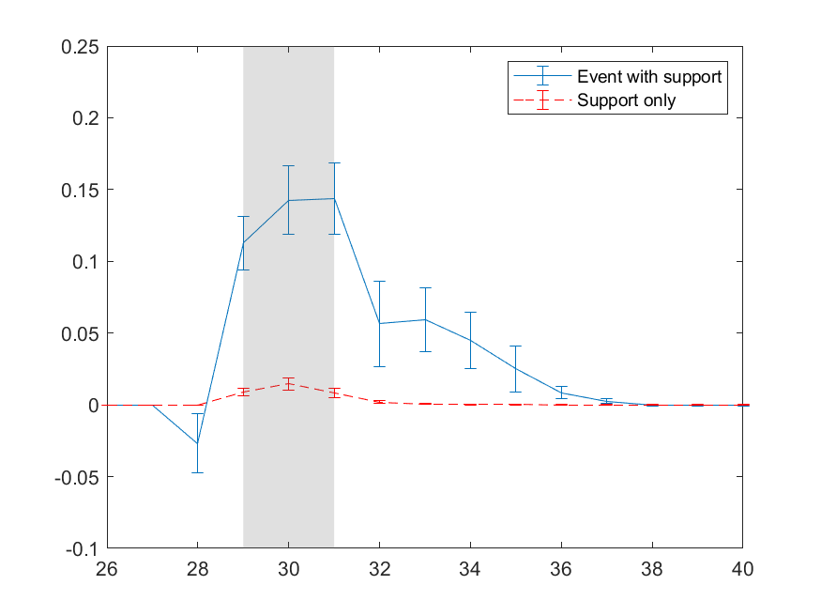 | 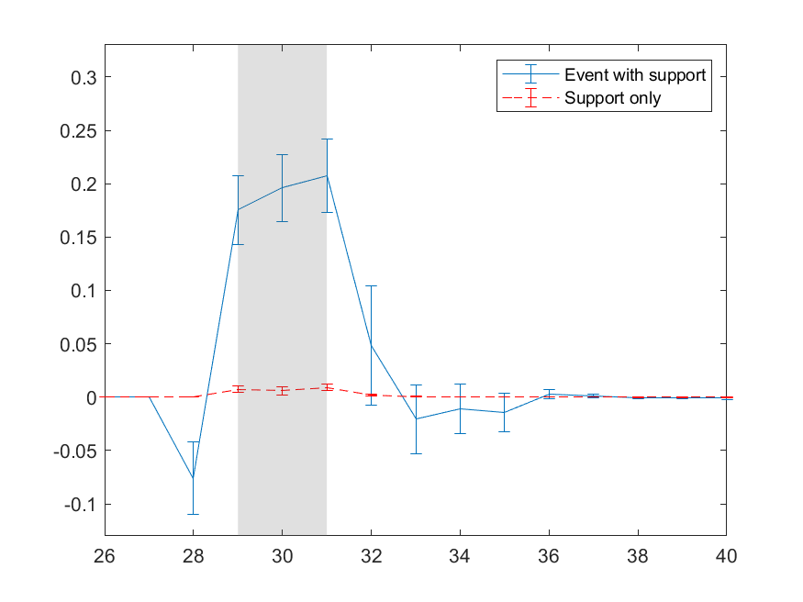
ª X-axis indicates week numbers. The event is scheduled from week 29 to 31. Y-axis indicates the relative increase in visits and spending (relative to the baseline), for (i) the ‘Support Only’ scenario, with extra discount and advertising support only (dotted line) and (ii) the ‘Event + Support’ scenario, with extra discounts and advertising support around the event theme (i.e., the event dummy set to one) (full line).

TABLE WA6: Impact of ReTSS as a whole vs. Support Only
 | (1)‘Event + Support’ Scenario |  | (2)‘Support Only’ Scenario |  | Share of ‘Support Only’ (=(2)/(1))
Event | Visit Propensity | Conditional Purchase Volume | Visit Propensity | Conditional Purchase Volume | Visit Propensity | Conditional Purchase Volume
1 | 0.39 | -69.33** | 0.18** | 1.46 | 46.15% | -2.11%
 | 3.55% | -1.94% | 1.66% | 0.05%
2 | 2.85** | 43.14** | 0.22** | 1.17 | 7.72% | 2.71%
 | 13.30% | 1.23% | 1.06% | 0.04%
3 | 2.99** | 178.82** | 0.13** | 6.16 | 4.35% | 3.44%
 | 7.57% | 5.00% | 0.33% | 0.17%
4 | 0.74** | 7.53 | 0.18** | 1.46 | 24.32% | 19.39%
 | 6.70% | 0.20% | 1.66% | 0.05%
5 | 0.16 | -51.94* | 0.22** | 1.17 | 137.50% | -2.25%
 | 0.75% | -1.44% | 1.06% | 0.04%
6 | 2.21** | 45.09 | 0.18** | 1.46 | 8.14% | 3.24%
 | 20.22% | 1.27% | 1.66% | 0.05%
7 | -0.06 | -28.72 | 0.22** | 1.17 | -366.67% | -4.07%
 | -0.25% | -0.79% | 1.06% | 0.04%
8 | 4.24** | -14.23 | 0.13** | 6.16 | 3.07% | -43.29%
 | 10.75% | -0.37% | 0.33% | 0.17%
9 | 0.67** | -3.32 | 0.08** | 0.21 | 11.94% | -6.33%
 | 7.20% | -0.09% | 0.84% | 0.01%
Average | 1.58** | 11.89 | 0.17** | 2.27 | 10.76% | 19.09%
 | 7.75% | 0.34% | 1.07% | 0.07%
*: p<.05, **: p<.01, one-tailed tests based on distribution across parameter draws. Because the ‘Support Only’ effects hardly extend beyond the promotion period (see Figure WA1), we only compare the effects during the event period.
FIGURE WA2: Impact of ReTSS by Customer Group, over Timeª
Panel A: VISITS | Panel B: PURCHASES
Event 4 (close to average) | Event 4 (close to average)
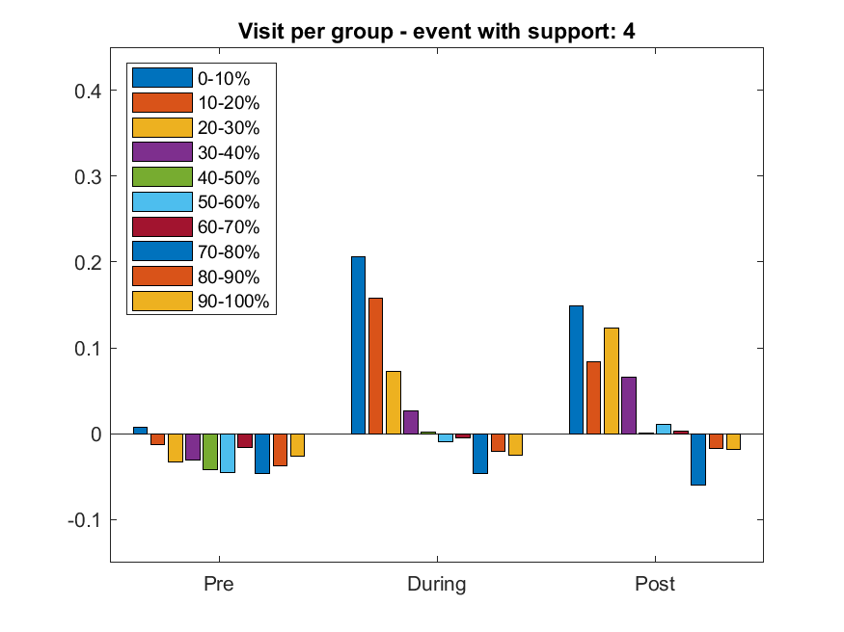 | 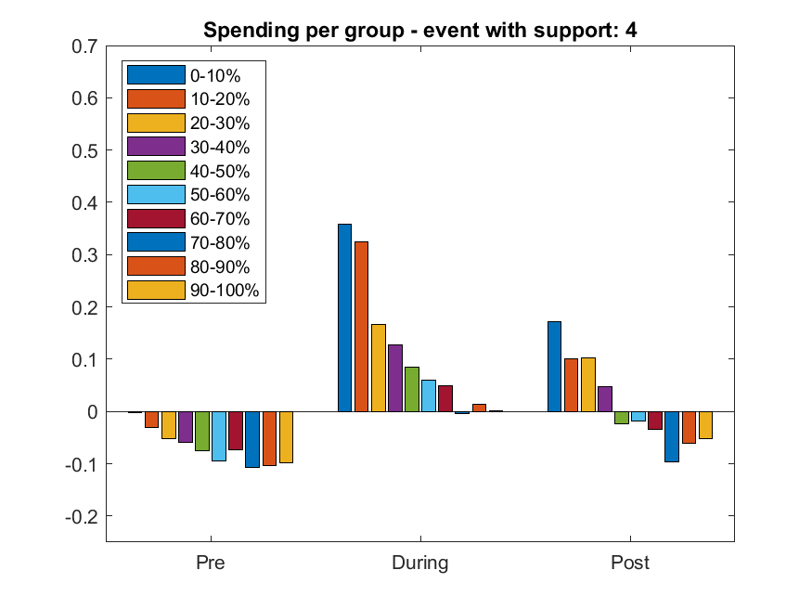
Event 1 (worst) | Event 1 (worst)
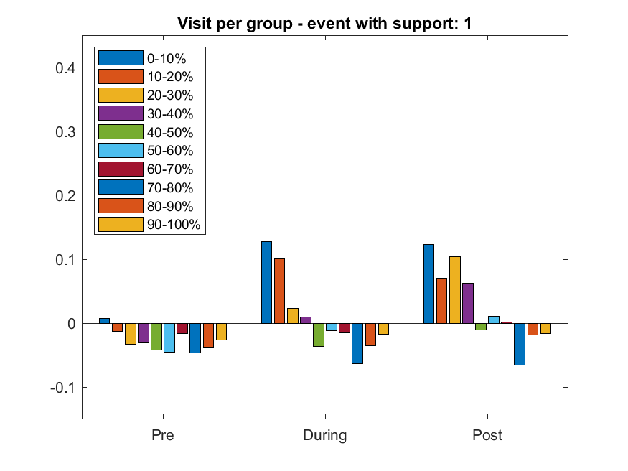 | 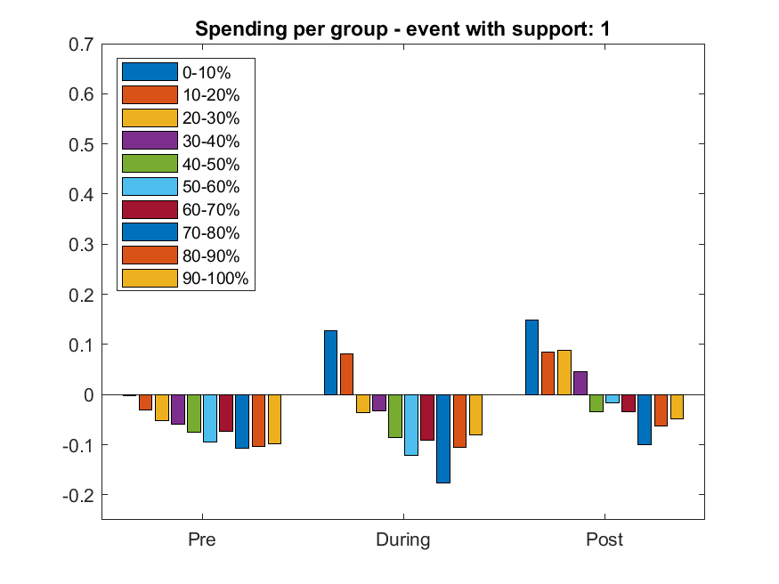
Event 2 (best) | Event 2 (best)
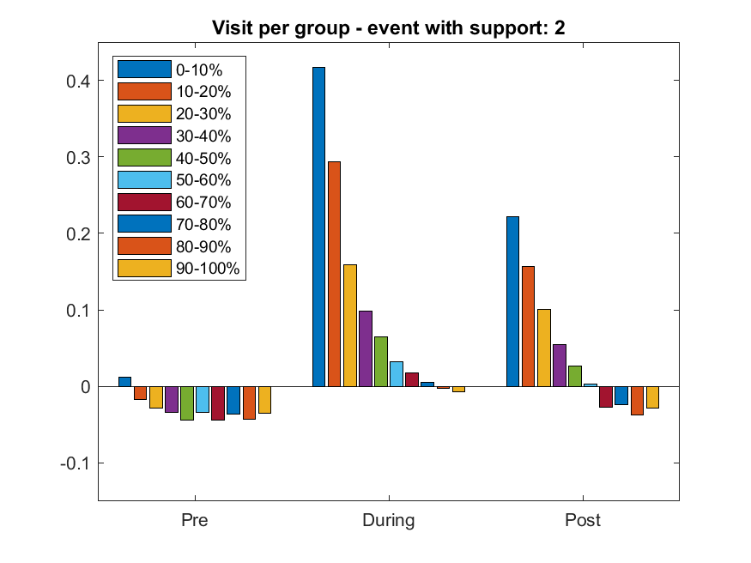 | 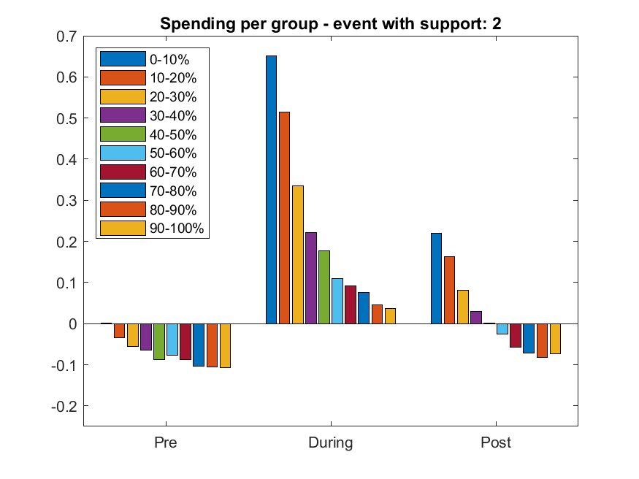
ª Bins are based on the consumers’ share of wallet in the 26-week initialization period, at the store running the event. E.g., the first bin comprises consumers who spent up to 10% of their wallet at the store, etc.

WEB APPENDIX W6: COMPETITIVE SHIFTS

TABLE WA7: Store-type Allegiance of Consumers Most vs. Least Responsive to ReTSS
 | Visits |  |  |  |  |  | Purchase Volumes
Event | Most Responsiveª |  | Least Responsiveª |  | Δ HD share | p-value | Most Responsive^{b} |  | Least Responsive^{b} |  | Δ HD share | p-value
 | TS share^{c} | HD share | TS share | HD share |  |  | TS share | HD share | TS share | HD share
1 | 0.697 | 0.303 | 0.790 | 0.210 | 0.093 | 0.013 | 0.689 | 0.311 | 0.855 | 0.145 | 0.166 | 0.000
2 | 0.661 | 0.339 | 0.891 | 0.109 | 0.230 | 0.000 | 0.683 | 0.317 | 0.870 | 0.130 | 0.187 | 0.000
3 | 0.637 | 0.363 | 0.944 | 0.056 | 0.308 | 0.000 | 0.725 | 0.275 | 0.950 | 0.050 | 0.225 | 0.000
4 | 0.708 | 0.292 | 0.818 | 0.182 | 0.109 | 0.005 | 0.730 | 0.270 | 0.819 | 0.181 | 0.089 | 0.011
5 | 0.650 | 0.350 | 0.831 | 0.169 | 0.182 | 0.000 | 0.671 | 0.329 | 0.886 | 0.114 | 0.215 | 0.000
6 | 0.704 | 0.296 | 0.880 | 0.120 | 0.176 | 0.000 | 0.753 | 0.247 | 0.792 | 0.208 | 0.039 | 0.272
7 | 0.661 | 0.339 | 0.841 | 0.159 | 0.180 | 0.000 | 0.665 | 0.335 | 0.892 | 0.108 | 0.227 | 0.000
8 | 0.649 | 0.351 | 0.947 | 0.053 | 0.298 | 0.000 | 0.688 | 0.312 | 0.967 | 0.033 | 0.279 | 0.000
9 | 0.707 | 0.293 | 0.783 | 0.217 | 0.077 | 0.017 | 0.697 | 0.303 | 0.784 | 0.216 | 0.087 | 0.019
Average | 0.675 | 0.325 | 0.858 | 0.142 | 0.184 |  | 0.700 | 0.300 | 0.868 | 0.132 | 0.168
ª Subgroup of 10% most (least) responsive households; yielding the highest (lowest) immediate lift in visit probability in response to the event). ^{b} Subgroup of 10% most (least) responsive households; yielding the highest (lowest) immediate lift in purchase volume in response to the event). ^{c} Shares are consumers’ share of wallet at traditional stores or hard discounters during the 26-week initialization period.

WEB APPENDIX W7: PROFITABILITY ASSESSMENT

Let DD_{r,event} and DD_{r,no_event} the average discount depth for items sold on promotion in event and nonevent weeks. Moreover, let p_{r} be the average regular unit price, m be the average retailer margin absent promotions (expressed as a fraction of the selling price), g_{w} the fraction of the promotional discount borne by the retailer in week w, and $A_{rw}$ the retailer’s advertising budget in week w.
Consider a retailer (r) in a given week (w). If X^{R}_{rw} is the quantity sold at the regular price, and X^{P}_{rw} the quantity sold under promotion conditions, then the total revenue for the retailer in that week can be approximated by:
(W1) | $$R_{rw}=p_{r}*X_{rw}^{R}+{(1-DD}_{rw})*p_{r}*X_{rw}^{P}$$
and the associated gross profit is obtained as:
(W2) | $${GP}_{rw}={m*p}_{r}*X_{rw}^{R}+{(m-DD}_{rw}*g_{w})*p_{r}*X_{rw}^{P}-A_{rw}$$
Let PromShare_{rw} be the average fraction of revenue sold under promotion conditions in a given week (w), or:
(W3) | $${PromShare}_{rw}=\frac{{(1-DD}_{rw})*p_{r}*X_{rw}^{P}}{p_{r}*X_{rw}^{R}+{(1-DD}_{rw})*p_{r}*X_{rw}^{P}}$$
It follows that $p_{r}*X_{rw}^{R}=R_{rw}*\left(1-{PromShare}_{rw}\right)$,
and $p_{r}*X_{rw}^{P}=R_{rw}*{PromShare}_{rw}/{(1-DD}_{rw})$.
Substituting (W3) in (W2), the total gross profit associated with revenue R_{rw} can be written as:
(W4) | $${GP}_{rw}={[R}_{rw}*\left(m\left(1-{PromShare}_{rw}\right)+\left(m-{DD}_{rw}*g_{w}\right)*\frac{{PromShare}_{rw}}{{(1-DD}_{rw})}\right)]-A_{rw}$$
So, given information on retailer revenue in week w, the fraction of revenue sold under promotion conditions, the average discount depth on promoted items, the average retailer margin (which we set at .25), and an estimate of the retailer participation in the discount, we can approximate the gross profit for that retailer and week. Because the fraction sold on promotion, the average discount depth on promoted items, the ad budget, and the retailer (versus manufacturer) contribution in the discount, may differ between event and nonevent weeks, we use expression (W4) with different values for these quantities in event vs. nonevent weeks, and calculate the profit implications of revenues obtained in such weeks.
Specifically, we start from our simulation outcomes for the ‘Event + Support’ scenario (i.e., the retailer revenues for weeks prior to, during, and following the event). We then convert the simulated purchase volumes to revenues (using the average observed ratio of sales value over purchase volume in event and nonevent weeks, after trend correction). Next, we use expression (W4) to calculate the corresponding gross profit for each week without the advertising correction (i.e., the ‘square-bracketed’ part on the right side of equation (W4)). Lastly, we aggregate across weeks to get the total gross profit for that scenario. We follow the same procedure for the baseline scenario and calculate the difference.
We do so for different values of g_{w}. Finally, we ‘rescale’ this difference obtained for our household sample to the market level, and then subtract the (market-level) change in advertising budget associated with the event to obtain the profitability.

The largest number of retailers visited in one week was six.
Using the standard ‘translation key’ of the data provider, based on the number of households in the market.

