Artificial Pancreas Systems (APS) Comparison Fact Sheet
Developed by James Murray, D.N.P., F.N.P-C. Please contact author for permission prior to distribution. <u1085342@utah.edu>
 | MANUFACTURED | DO-IT-YOURSELF
Description | Under warranty with technical support  No customization | Systems are built/maintained by the user  (Loop is undergoing FDA approval for use with multiple pumps)
System | Medtronic 670G | Loop | Open APS
Components | 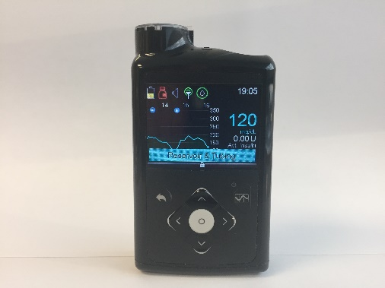 | 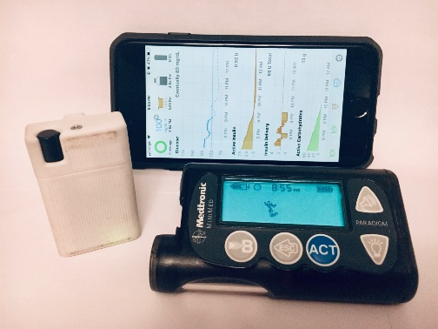 | 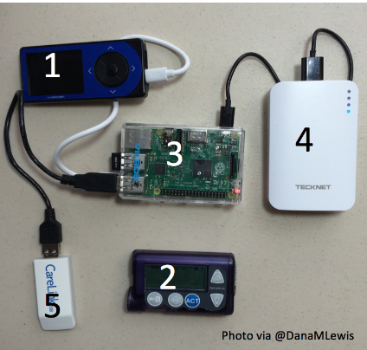  Used with permission
Pump | Medtronic 670G pump  (~$8000) | Older Medtronic pumps, not available from Manufacturer  515/715, 522/722, 523/723, 554/754  Cannot have updated firmware (~$500) | Older Medtronic pumps, not available from Manufacturer  512/712, 515/715, 522/722, 523/723  Cannot have updated firmware (~$500)
Continuous glucose monitor | Guardian 3  Transmitter and sensors required ($ varies)  Minimum 3-4 calibrations/day required | Dexcom  Minimed Enlight or Guardian  Freestyle Libre  Transmitter and sensors required ($ varies)  Receiver optional ($ varies)  Calibration requirement varies by device | Dexcom  MiniMed Revel or Enlite,  FreeStyle Libre  Transmitter and sensors required ($ varies)  Receiver optional ($ varies)  Calibration requirement varies by device
Communicator | Embedded within the Pump and CGM  No Wi-Fi required | Riley link (~$150)  No Wi-Fi or cellular data required | Radio board/stick (~$75)  Wi-Fi or cellular data required
HYPERglycemia adjustment | Basal rate algorithm in pump | Basal rate algorithm in phone | Basal rate algorithm in mini-computer  Micro-bolus algorithm in mini-computer
HYPOglycemia treatment | Basal suspend algorithm in pump | Basal suspend algorithm in phone | Basal suspend algorithm in mini-computer
Set-Up Computer Requirements | No computer required (optional) | Mac required | Either Mac or PC required
Controller | Embedded within the Pump and CGM | iPhone 5s/iPod touch 6 or later  (Apple watch optional) | Mini-computer (~$75)  iPhone or Android phone to view data
Account(s) | No accounts required  CareLink optional to view data | Apple developer account (~$100)  Heroku & Nightscout optional | Heroku & Nightscout required
Other |  | Reverts to standard pump settings in case of loss of Bluetooth or phone connectivity | Reverts to standard pump settings in case of loss of Wifi or Bluetooth connectivity

Helpful Links for further information

MEDTRONIC 670G
More information about Medtronic 670G components, testimonials, and operation
https://www.medtronicdiabetes.com/products/minimed-670g-insulin-pump-system

Video by manufacturer
https://www.medtronicdiabetes.com/products/minimed-670g-insulin-pump-system

LOOP
More information about Loop, including purchasing hardware, accounts, setup, and operation
https://loopkit.github.io/loopdocs/

Setup overview by Loop user (YouTube video)
https://www.youtube.com/watch?v=WbRASKfTrwA

OPEN APS
More information about Open APS, including purchasing hardware, accounts, setup, and operation
https://openaps.readthedocs.io/en/latest/index.html

Overview by Open APS user (YouTube video)
https://www.youtube.com/watch?v=qcmedjz_FpI

HEROKU
A cloud-based solution for open-source applications, such as Loop
https://www.heroku.com

NIGHTSCOUT
Both a foundation and an application providing cloud-based CGM alternatives
http://www.nightscoutfoundation.org/nightscoutproj

