**Appendix A**

*Database search strategy*

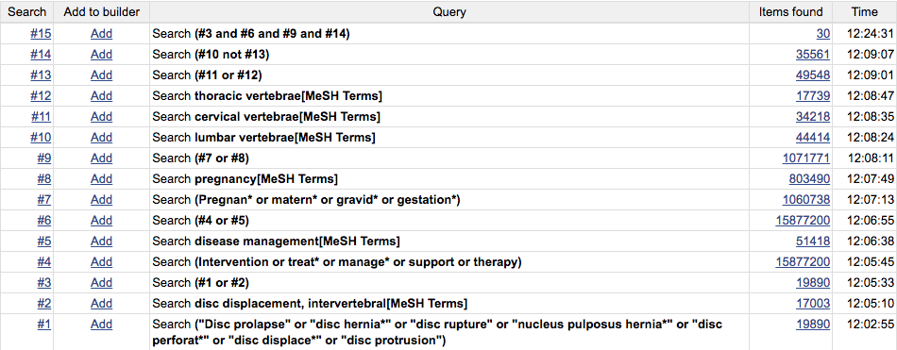

**Figure A1** Literature search strategy for PubMed. Each line represents one aspect of the final search or a combination of lines. Search 15 represents the complete and final search.

**Appendix B**

*Joanna Critical Appraisal Tool*

**Figure B1** The Joanna Briggs Institute critical appraisal tool for Case Reports

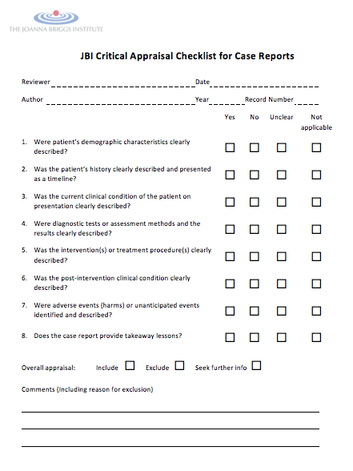

**Appendix C**

*Study characteristics*

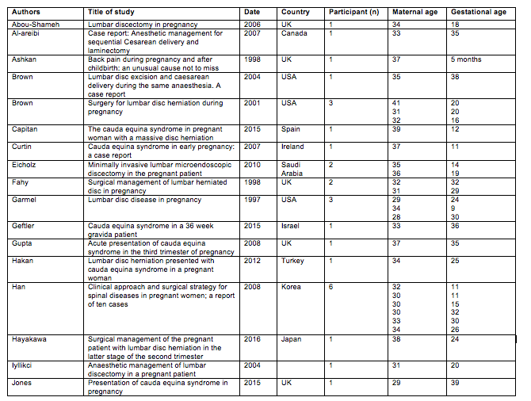

**Figure C1** A table illustrating study and patient demographics for the individual studies used in this review

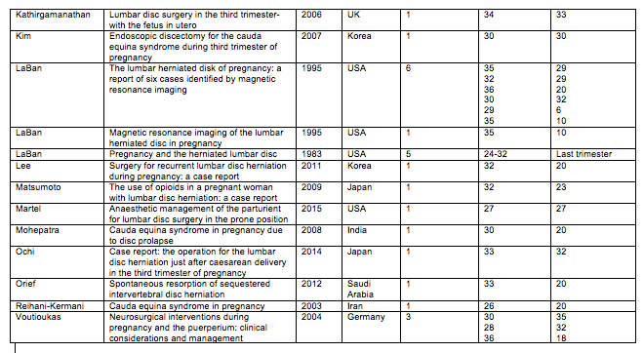

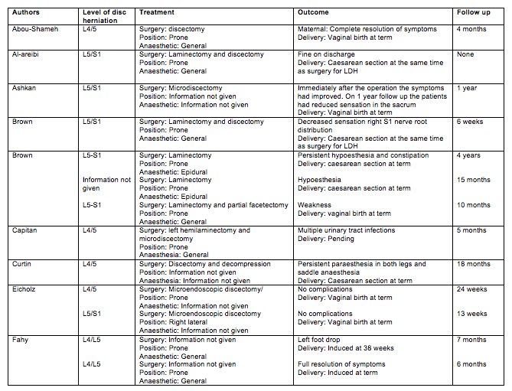

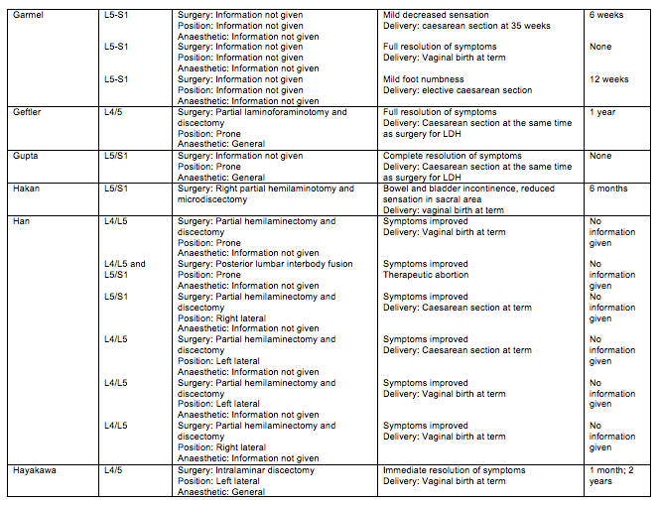

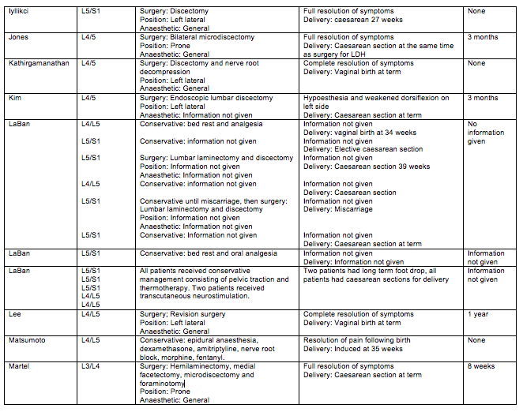

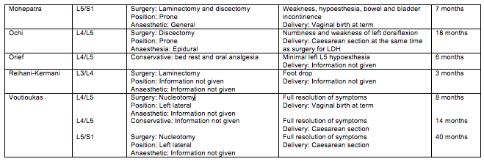

**Figure C1** A table illustrating the management of patients in the individual studies, including treatment, outcomes and time until follow up