Independent Variables Other Than Transparency

Experiments 1 and 2

Automation Malfunctions
The 2000 and 2001 experiments originally had a strong focus on two types of automation malfunctions called ‘automation slips’ and ‘automation mistakes’, manipulated through scenario design (HWR-659, pp. 4-11). We revealed a few inconsistent effects of the automation malfunction manipulation across the two studies, but failed to identify any convincing pattern of results. A cross-experimental reanalysis reported in HWR-686 (pp. 70-72) concluded that the operationalization of the automation malfunction manipulation had been unsuccessful. The accumulated experience from HAMMLAB seems to be that precise scenario-based experimental manipulations are only feasible for obvious distinctions like easy/difficult, rule-based/knowledge-based, or familiar/unfamiliar scenarios.

Operator Role
The participating crews consisted of a Reactor Operator (RO) and a Turbine Operator (TO). In Experiment 2, we added a Shift Supervisor (SS) who acted in a managerial role to increase the operational realism of the experiment.

Scenario period
The scenario period variable was a simple repeated measurement to follow the operators’ progress at different points throughout the scenario (early, mid, late disturbance).

Experiment 3

Staffing solution
The experiment included a comparison of staffing solutions (reported separately in HWR-938). The purpose of this manipulation was to explore new operator roles, work process and staffing solutions in highly automated multi-unit plants, such as Small Modular Reactors. We compared a traditional crew composition for single unit plants (RO, TO and SS) to an experimental staffing solution for highly automated multi-unit plants. The experimental crew consisted of a Main Operator (MO), who collaborated with plant-wide automation and handled residual human actions. A Work Manager (WM) acted as a planner and coordinator across plant units. An Assistant Operator (AO) provided support on demand, such as helping the MO if technical failures obstructed the automatic procedure execution, or providing services at the other plant. It was up to the crew, and the WM in particular, to allocate the AO resource effectively depending on the situation.

Overview display
We compared two design concepts for overview displays: (1) a typical design based on process mimics, and (2) an innovative design with configural graphics. In the post-experimental debriefing, the participants reported that there was insufficient time to learn the fine details of these overview displays. The statistical results confirmed this impression, as there were few differences between the overview display conditions.

Scenario period
In the easy scenario period, the crews experienced isolated and familiar process failures under low levels of time pressure. In the difficult period, we added considerable time pressure and introduced several unfamiliar, and sometimes dependent, failures that were hard to understand in terms of their root causes. The approximate lengths of the scenario periods are depicted below.

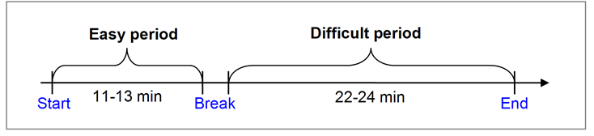
HWR-659, Skjerve, A. B. M., Andresen, G., Saarni, R. & Skraaning, G. (2001). How Automation Malfunctions Influence Operator Performance. Study Plan For The HCA-2000 Experiment. OECD Halden Reactor Project, Halden, Norway.
HWR-686, Skjerve, A. B. M., Strand, S., Saarni, R., & Skraaning, G. (2002). The influence of automation malfunctions and interface design on operator performance. The HCA-2001 experiment. OECD Halden Reactor Project, Halden, Norway.
HWR-938, Eitrheim, M. H., Skraaning, G, Lau, N., Karlsson, T., Nihlwing, C., Hoffmann, M., & Farbrot, J. E. (2010). Staffing Strategies in highly automated future plants: Results from the 2009 HAMMLAB Experiment. OECD Halden Reactor Project, Halden, Norway.

