Supplementary File 3

This supplement contains graphs detailing the differences between weights obtained under Alt. 1 and Alt. 2A in the empirical example using logistic regression. We compare the results to those obtained with a non-parametric method (empirical balancing calibration weighting, EBCW), which do not suffer from the same modelling artefacts noted in the discussion section of the paper. The left hand side Figure S2 shows a Bland-Altman plot that compares the weights from Alt. 1 and Alt. 2 based on the logistic regression models used in the paper, as well as density and empirical cumulative distribution plots. There are small, but systematic differences in the weights as shown by the Bland-Altman plot, but the difference is hardly noticeable in the distribution plots. These errors are not, at least in this case (or in separate simulations that we have run), large enough to produce in any meaningful differences in the weighted results. To avoid this issue altogether, one can use a non-parametric weighting method, e.g., EBCW, which – as is shown on the right-hand side of Figure S2 – results in exactly identical weights under both Alt. 1 and Alt. 2.
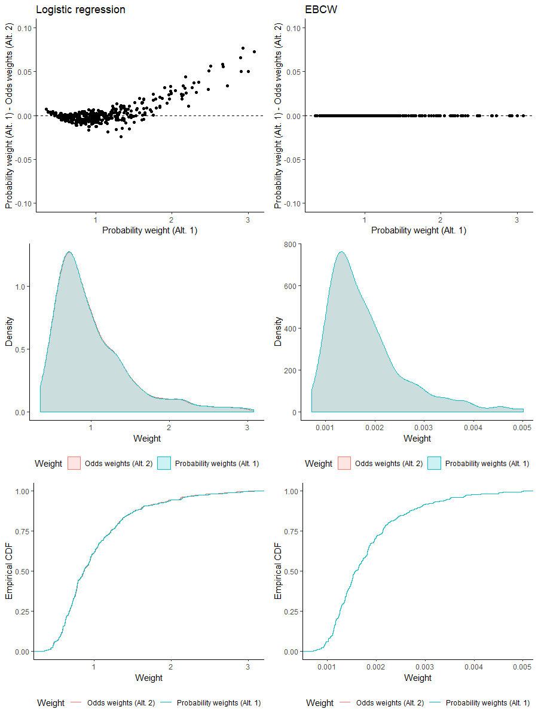
Figure S2. Agreement and comparison between distributions between weights constructed using Alt. 1 and Alt. 2A with either logistic regression or empirical balancing calibration weighting (EBCW). Empirical data is from the example used in the paper.

