Supplementary Material 1. Literature search strategies

For PubMed:
(cancer[mesh] OR malignancy[mesh] OR carcinoma[mesh])
AND
(“air pollution”[mesh] OR “air pollutants”[mesh] OR “particulate matter”[tiab] OR “PM_{2.5}”[tiab] OR “PM₁₀”[tiab] OR “nitrogen dioxide” [tiab] OR “sulphur dioxide”[tiab] OR “ozone”[tiab])
NOT systematic review[pt] NOT review[pt] NOT case reports[pt] NOT clinical conference[pt] NOT congresses[pt] NOT editorial[pt] NOT Meta-analysis[pt] NOT other animals[mh]

EMBASE: limited to Humans and Article
('cancer' or ‘malignancy’ or ‘carcinoma’) and ('air pollution' or ‘air pollutants’ or ‘particulate matter’ or ‘PM_{2.5}’ or ‘PM₁₀’ or ‘nitrogen dioxide’ or ‘sulphur dioxide’ or ‘ozone’) and (‘cross-sectional study’ or ‘case-control study’ or 'cohort study')

Cochrane Library: No limit
(cancer or malignancy or carcinoma) and (air pollution or air pollutants or particulate matter or PM_{2.5} or PM₁₀ or nitrogen dioxide or sulphur dioxide or ozone) and (cross-sectional study or case-control study or cohort study)
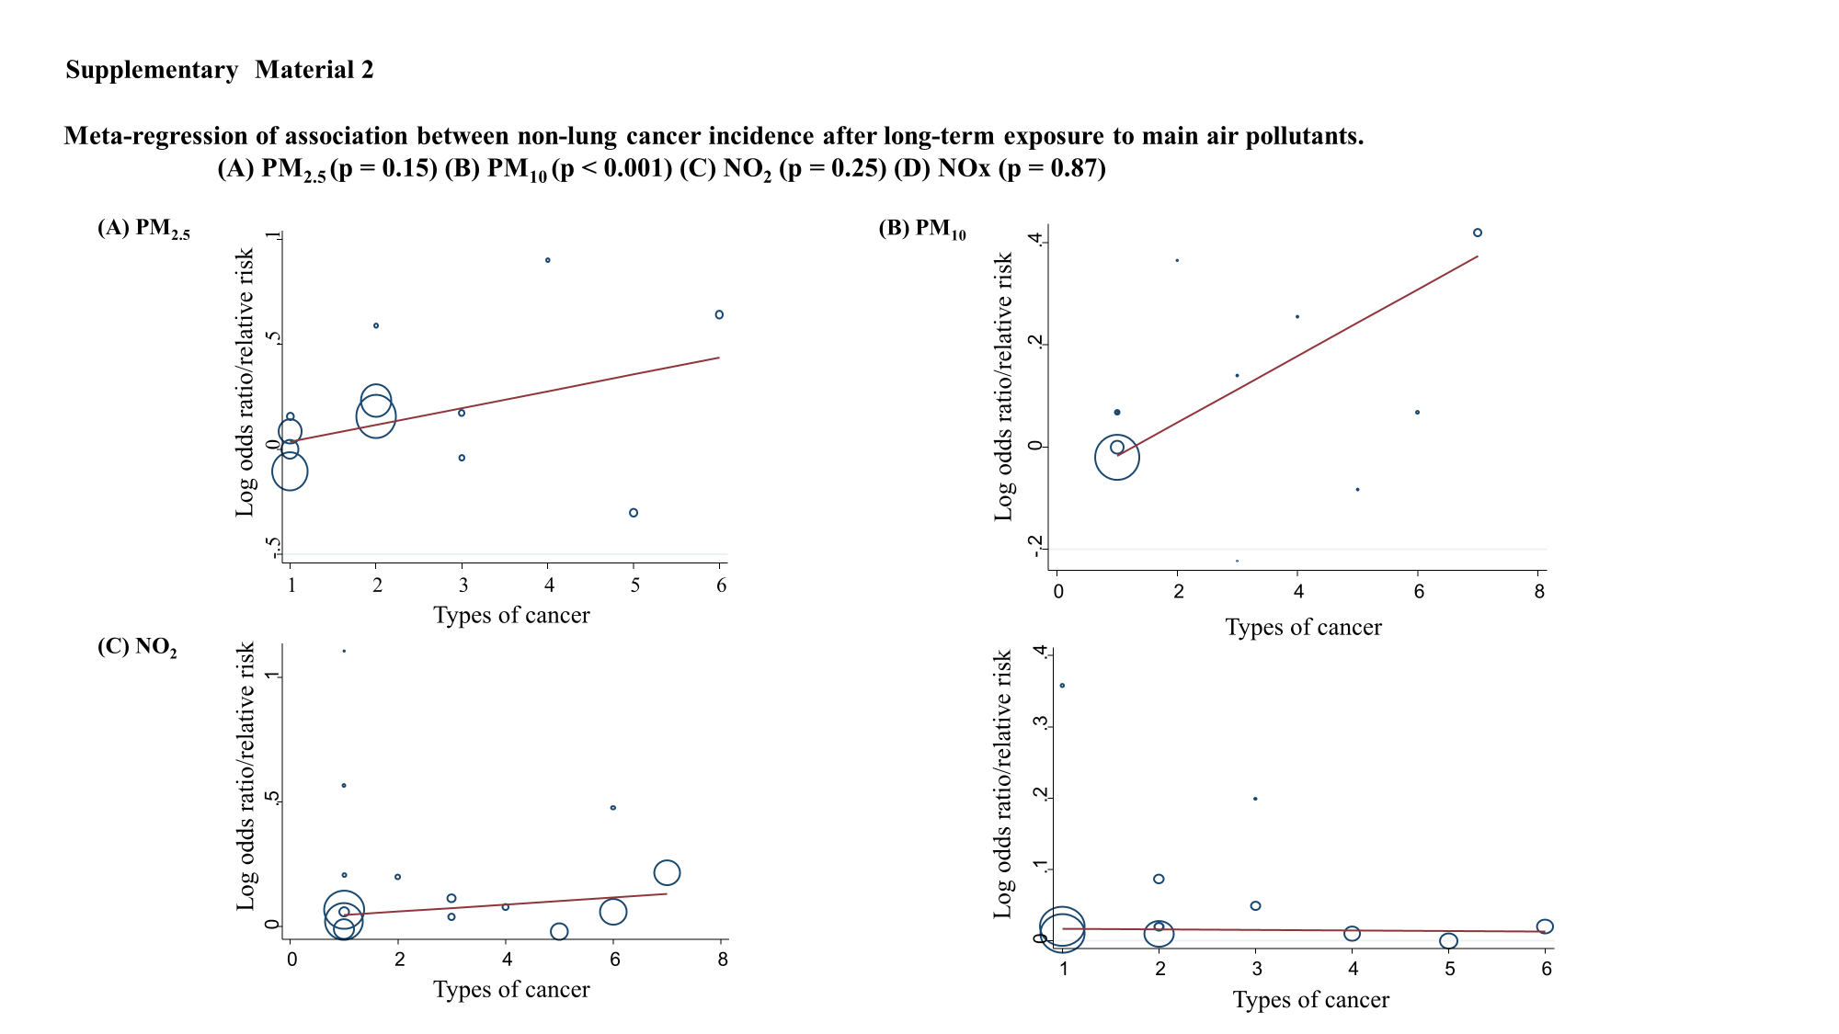
Types of cancer: (A) 1: Breast cancer, 2: Liver cancer, 3: Brain cancer, 4: Kidney cancer,
5: Bladder cancer, 6: Stomach cancer
(B) 1: Breast cancer, 2: Liver cancer, 3: Brain cancer, 4: Kidney cancer,
5: Bladder cancer, 6: Stomach cancer, 7: NMSC (non-melanoma skin cancer)
(C) 1: Breast cancer, 2: Liver cancer, 3: Brain cancer, 4: Kidney cancer,
5: Bladder cancer, 6: Prostate cancer, 7: NMSC (non-melanoma skin cancer)
(D) 1: Breast cancer, 2: Brain cancer, 3: Liver cancer, 4: Kidney cancer,
5: Bladder cancer, 6: Stomach cancer

