Using fluid walls for single-cell cloning provides assurance in monoclonality
Cristian Soitu^{1†}, Cyril Deroy^{1†}, Alfonso A. Castrejón-Pita¹, Peter R Cook², Edmond J. Walsh¹*
¹ Department of Engineering Science, University of Oxford, Oxford OX1 3PJ, UK,
² Sir William Dunn School of Pathology, University of Oxford, Oxford OX1 3RE, UK.
*Corresponding author, edmond.walsh@eng.ox.ac.uk
†Authors contributed equally
Keywords: fluid walls, single cell cloning, optical clarity, monoclonality
Supplementary information
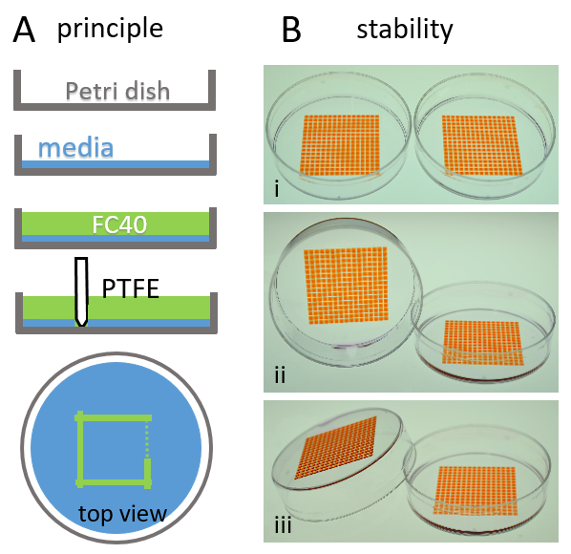
Figure S1. Making GRIDs, and some demonstrations of their stability. (A) Steps in making a GRID. 1 mL of cell-culture media (DMEM) containing 10% FBS is added to a virgin Petri dish, and subsequently most (~0.95 mL) removed by pipetting. This leaves a very thin film of media that has wetted the surface of the dish (approximately 50 µL). 1 mL of FC40 is then added on top of the media to limit evaporation. A stylus made of polytetrafluoroethylene (PTFE, Teflon) is lowered on to the surface of the dish. As FC40 wets Teflon and polystyrene better than water, the fluorocarbon becomes pinned to the substrate around the tip of the stylus. The stylus is then dragged along the surface in the pattern shown; it pushes media aside, to leave a fluid wall of FC40 pinned to the polystyrene substrate. In the case shown, one central chamber isolated by fluid FC40 walls from surrounding media is created. “Printing” more lines (not shown), can then subdivide the original body of media into the wanted number of chambers. These chambers are used like the wells of a microplate, except that liquids are pipetted into them, and removed from them, through FC40 instead of air. (B) Stability of two GRIDs each containing 256 square chambers (1.9 x 1.9 mm) in a 6 cm dish. GRIDs are made as in (A) using tissue-culture media. Each chamber initially contains ~200 nL, and–as media volumes are too small to be seen–200 nL red dye is added to each chamber to aid visualization. (i) Two GRIDs after manufacture. FC40 is transparent, and so invisible. (ii) The left-hand dish is tilted by 90˚; most FC40 has spilt out, but a small residue can be seen at the bottom corner of the dish–chambers remain firmly pinned by interfacial forces to the dish. (iii) The left-hand dish has now been almost completely flipped over; chambers still remain pinned to the dish, and FC40 drains out almost entirely. This illustrates the dominance of interfacial forces at the microscale over gravitational ones, and how firmly chambers are attached to the dish.
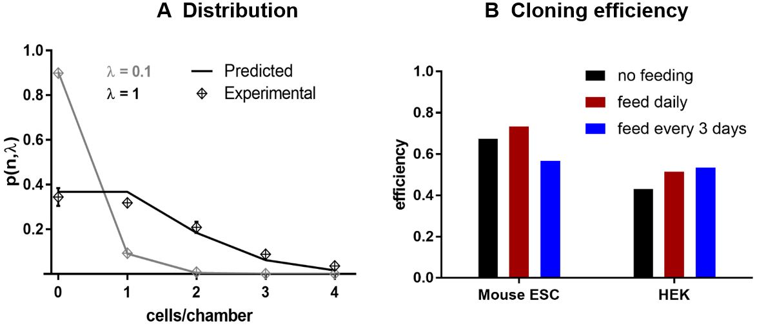
Figure S2. Cloning cells by limited dilution yields the expected Poissonian statistics, and efficiencies. A suspension of HEK cells, or mouse ESCs, are deposited by scanning²³ (~400 nL in each chamber in a GRID with 256 chambers of 1.9 x 1.9 mm in a 6 cm dish), and the number of cells per chamber immediately determined by microscopy using a 4X objective (as in Fig. 4B,C). (A) The process of dispensing a single-cell suspension of HEK cells in GRIDs does not introduce any bias in the distribution. Cells were seeded at densities, λ, of 0.1 and 1 cell/chamber. Distributions of numbers of cells in each chamber follow Poisson’s distribution. (B) Cloning efficiencies of the two cell types assessed using three different feeding regimes. Cells are plated and imaged as in (A), grown, and some fed by removing 350 nL spent medium and replacing it with 350 nL fresh medium. Chambers are reimaged after 8 days of growth, and the number of colonies with ≥16 cells derived from a single progenitor are recorded. The resulting cloning efficiencies are in the expected ranges.
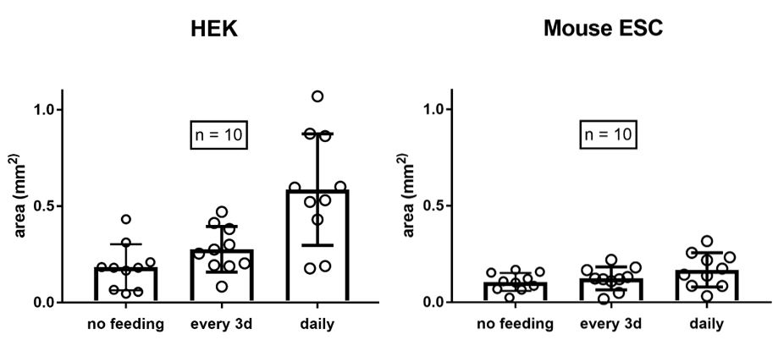
Figure S3. Size of colonies. Cells were cloned and fed as described in Figure S2, and areas occupied by clones scored in the images collected after 8 days. Areas occupied by the clones are as expected, and the different feeding regimes have marginal effects on colony size. This indicates that the 400 nL media in a chamber is nevertheless sufficient to support early clonal growth.
Movie 1. Withdrawing fluid from a droplet. A withdrawing needle is withdrawing fluid from a sessile drop deposited under FC40. As the fluid is extracted, the pinning line remains fixed and does not recede.
Movie 2. Plating cells using a scanning motion. A needle infusing cell suspension at constant flowrate traverses at constant height above equally-spaced fluidic chambers, such that each one receives the same volume.

