SUPPLEMENTARY MATERIAL
Two New Compounds from Rhizomes of Musa basjoo

Li Jiang^{1,3}, Yang Wang^{1,3}, Min Hui Zhu^{1,3}, Lin Zheng², Lin Zhen Li³, Ai Min Wang², Chang Hu Lin¹,
Ting Liu² and Yong Jun Li¹

¹State Key Laboratory of Functions and Applications of Medicinal Plants & Engineering Research Center for the Development and Application of Ethnic Medicine and TCM (Ministry of Education), Guizhou Medical University, Guiyang 550004, Guizhou, P. R. China
²Guizhou Provincial Key Laboratory of Pharmaceutics, Guizhou Medical University, Guiyang 550004, Guizhou, P. R. China
³School of Pharmacy, Guizhou Medical University, University Town, Guian New District 550025, Guizhou, P. R. China

1586740@qq.com for T. Liu, liyongjun026@126.com for Y.-J. Li

Contents Page
Table S1. HMBC correlations of compounds 1- 2
Figure S1: HR-ESI-MS spectrum of Compound 1
Figure S2: ¹H-NMR (400 MHz, CDCl₃) Spectrum of Compound 1
Figure S3: ¹³C-NMR (100 MHz, CDCl₃) Spectrum of Compound 1
Figure S4: HMQC (400 MHz, CDCl₃) Spectrum of Compound 1
Figure S5: HMBC (400 MHz, CDCl₃) Spectrum of Compound 1
Figure S6: HR-ESI-MS spectrum of Compound 2
Figure S7: ¹H-NMR (400 MHz, CDCl₃) Spectrum of Compound 2
Figure S8: ¹³C-NMR (100 MHz, CDCl₃) Spectrum of Compound 2
Figure S9: HMQC (400 MHz, CDCl₃) Spectrum of Compound 2
Figure S10: HMBC (400 MHz, CDCl₃) Spectrum of Compound 2

Position |  | 1 | 2
 |  | HMBC(H→C) | HMBC(H→C)
1
2
3 | C-2′, 6′ |  |  | C-1′, 1
4 |  |  |  | C-2, 5, 8a
4a
5 |  |  |  | C-7, 8a
6 | C-7 |  |  | C-7, 8, 4a
6a
7 | C-6, 6a, 9
8 |  |  |  | C-6, 7, 4a
8a
9
10 | C-6a, 8, 10b |  |  | C-9, 11
10a
10b
11 |  |  |  | C-10
1′
2′, 6′ | C-4′,3′, 5′, 3 |  |  | C-3′, 5′,1′, 2
3′,5′ | C-1′,4′ |  |  | C-2′, 6′,1′
4′
9-OCH₃ | C-9
4′-OCH₃ | C- 4′
8--OH
Table S1. HMBC correlations of compounds 1- 3
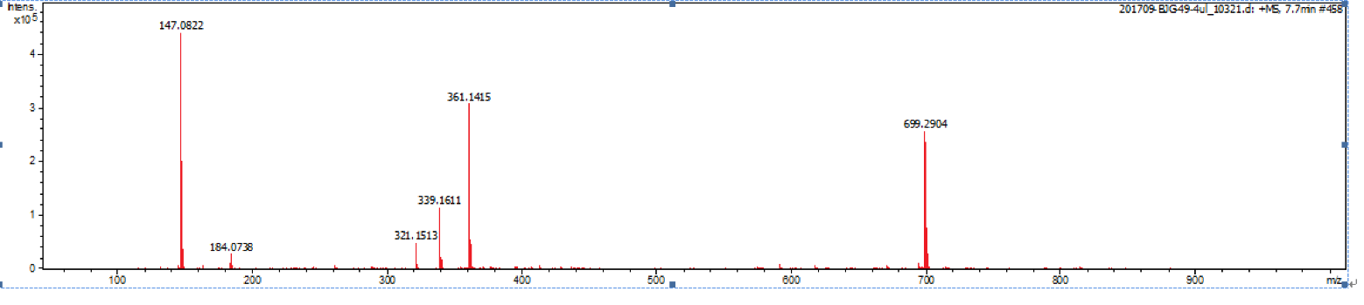
Figure S1: HR-ESI-MS spectrum of Compound 1
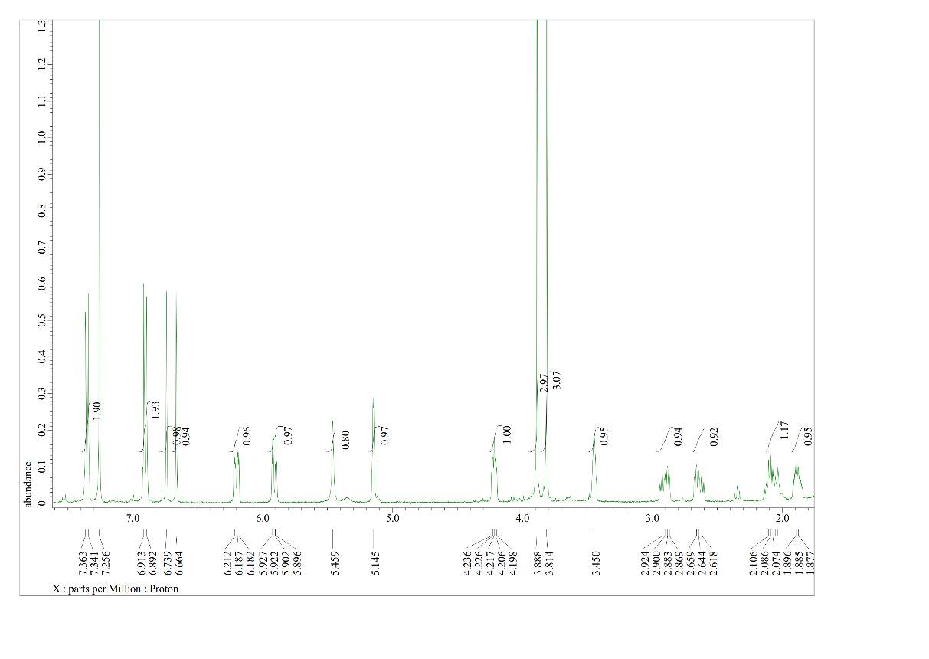
Figure S2: ¹H-NMR (400 MHz, CDCl₃) Spectrum of Compound 1
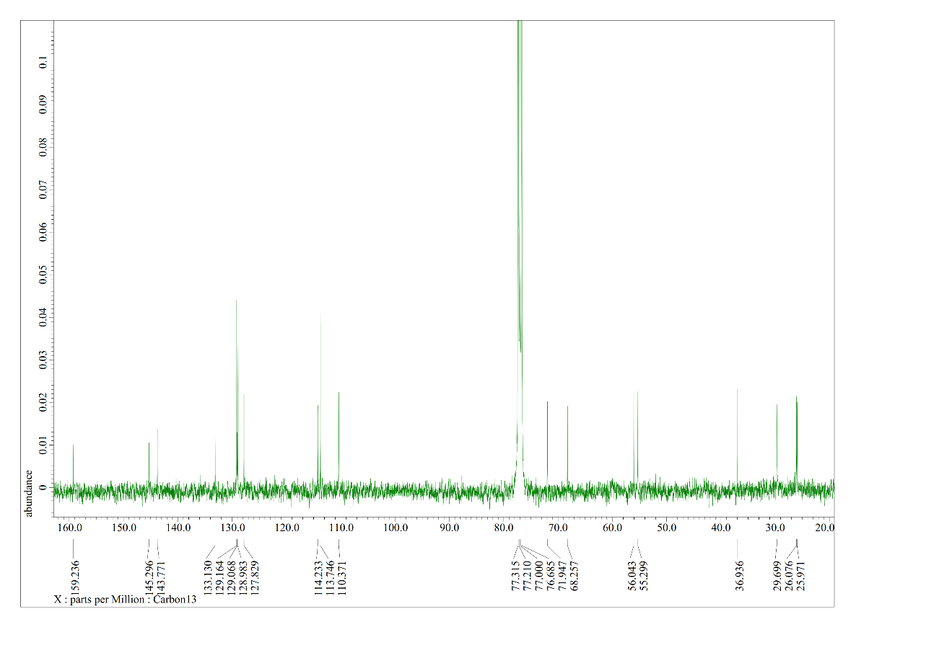
Figure S3: ¹³C-NMR (100 MHz, CDCl₃) Spectrum of Compound 1
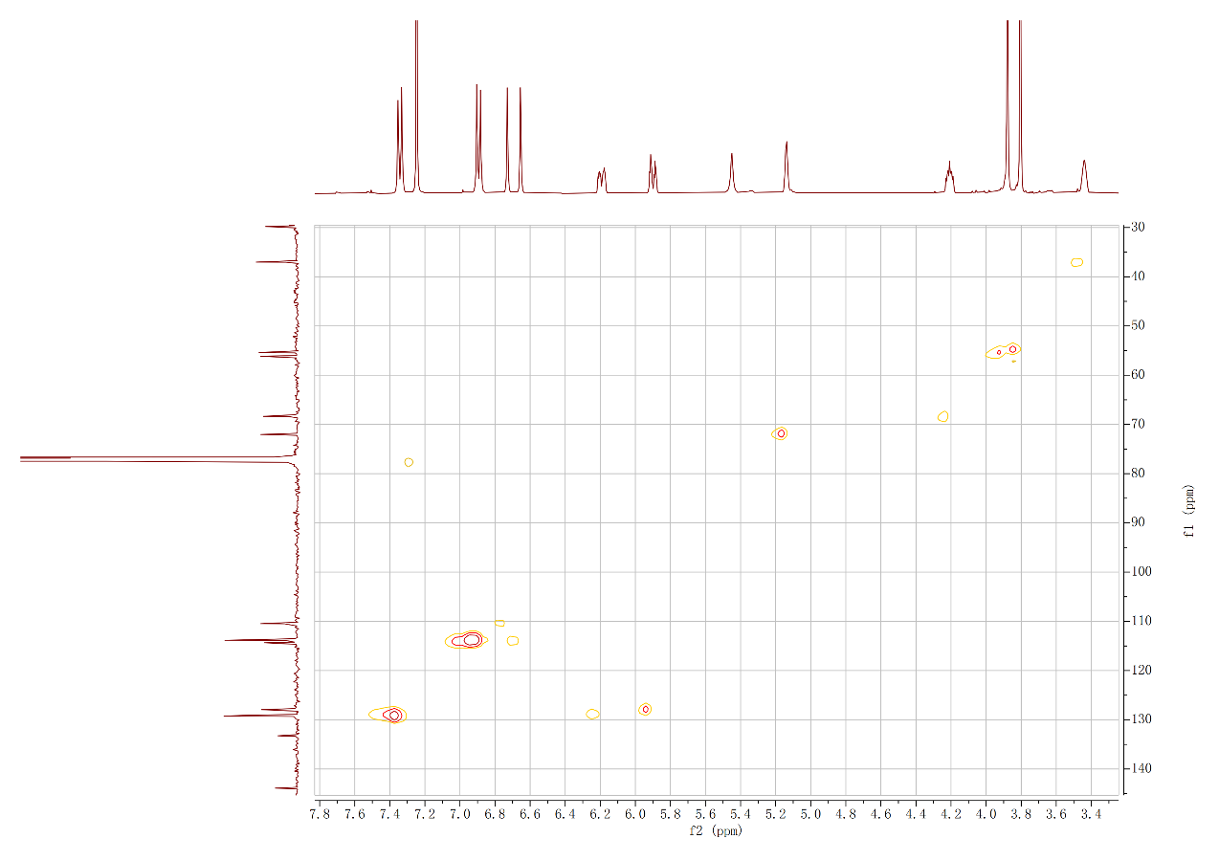
Figure S4: HMQC (400 MHz, CDCl₃) Spectrum of Compound 1
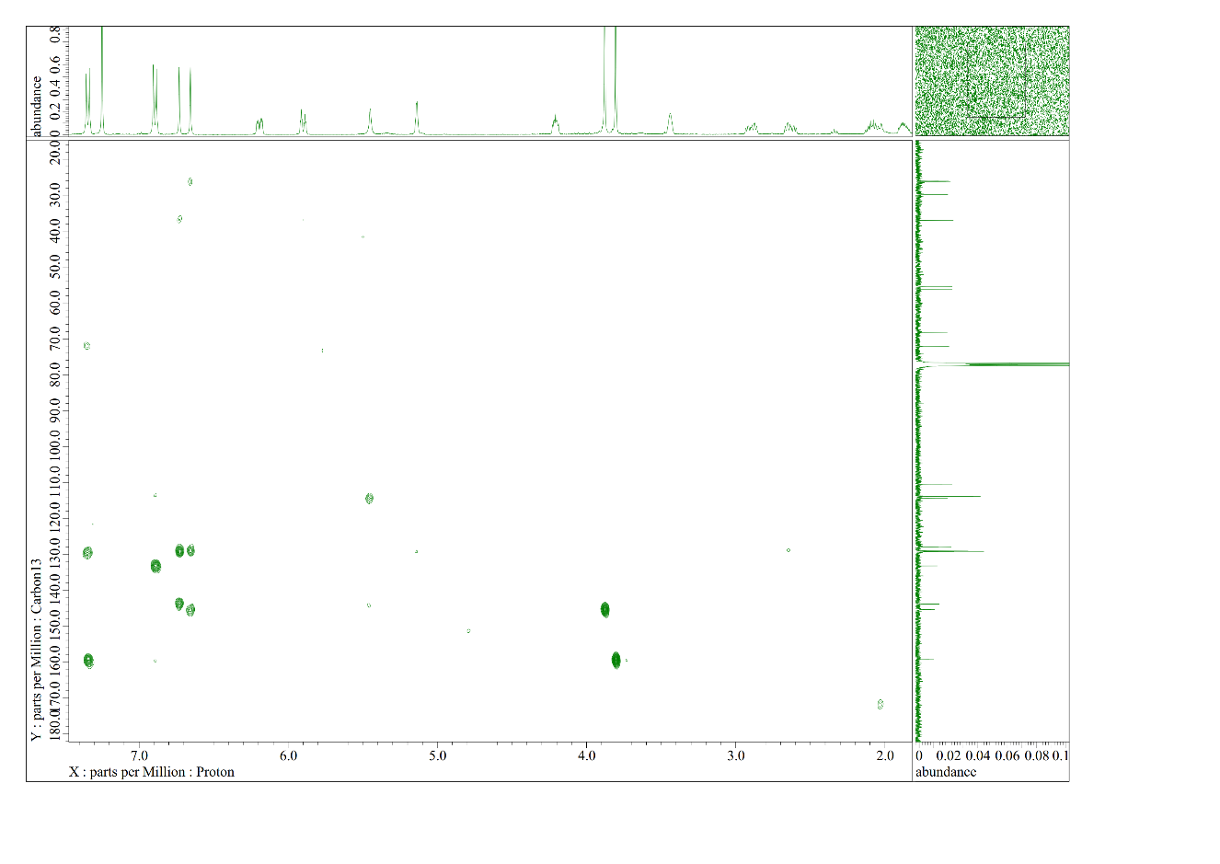
Figure S5: HMBC (400 MHz, CDCl₃) Spectrum of Compound 1
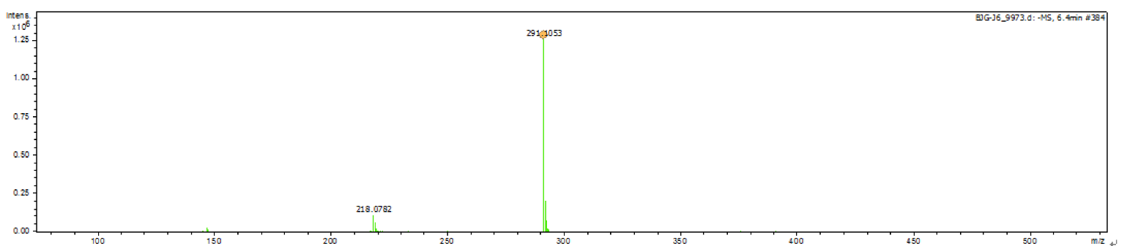
Figure S6: HR-ESI-MS spectrum of Compound 2
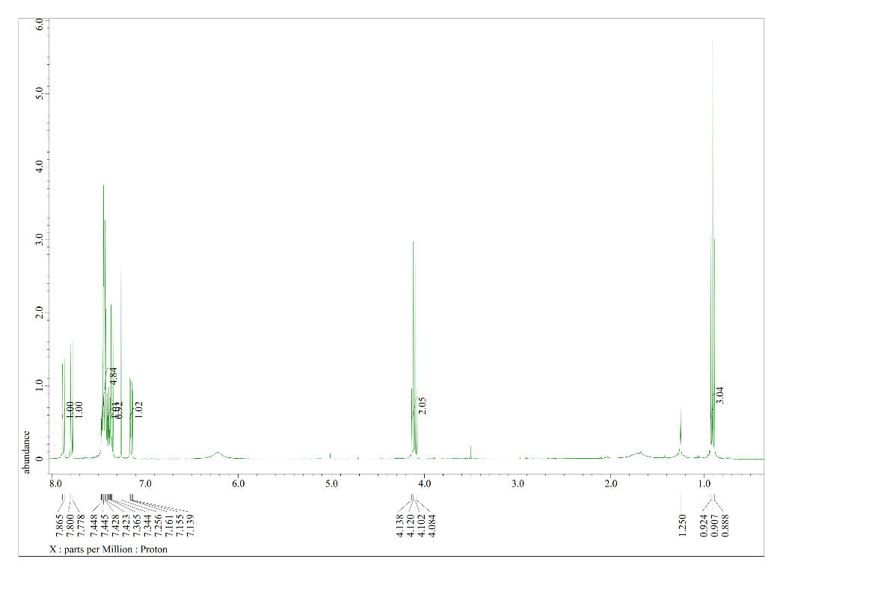
Figure S7: ¹H-NMR (400 MHz, CDCl₃) Spectrum of Compound 2
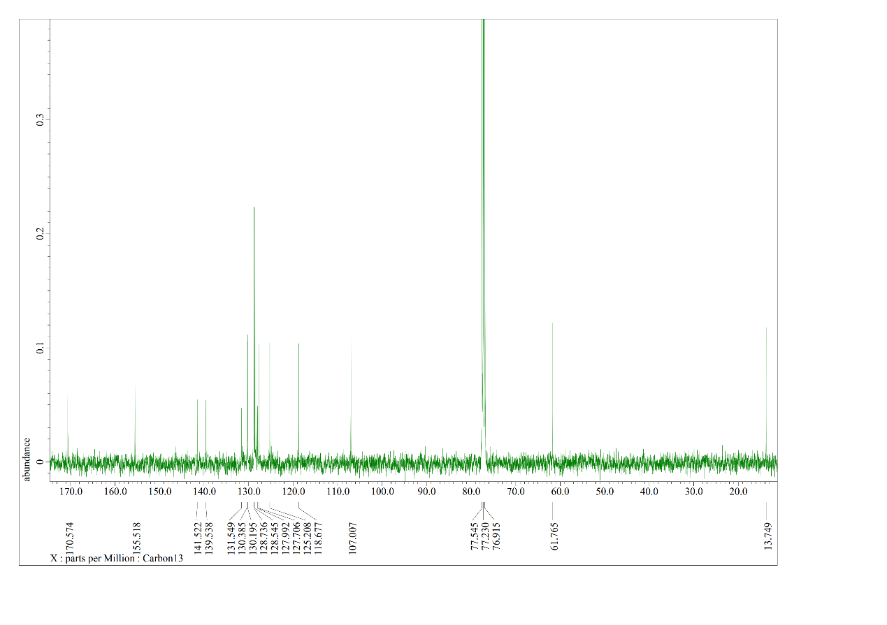
Figure S8: ¹³C-NMR (100 MHz, CDCl₃) Spectrum of Compound 2
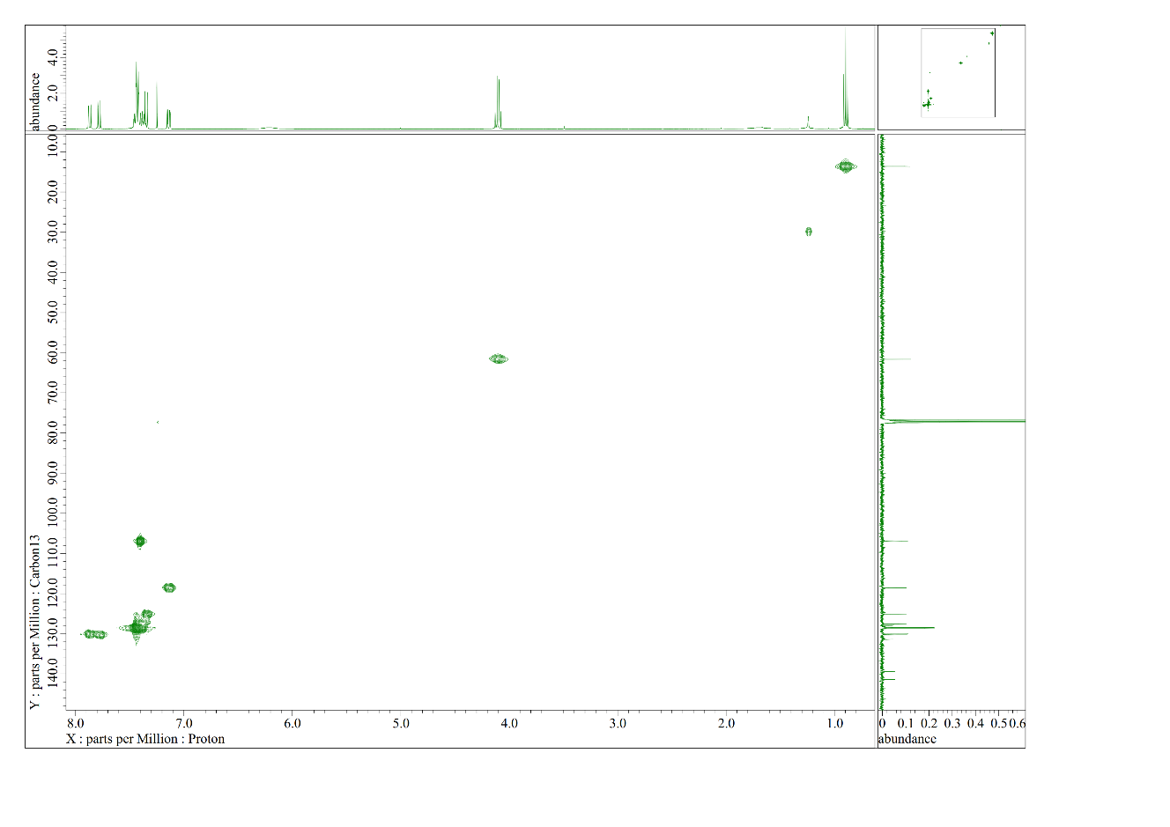
Figure S9: HMQC (400 MHz, CDCl₃) Spectrum of Compound 2
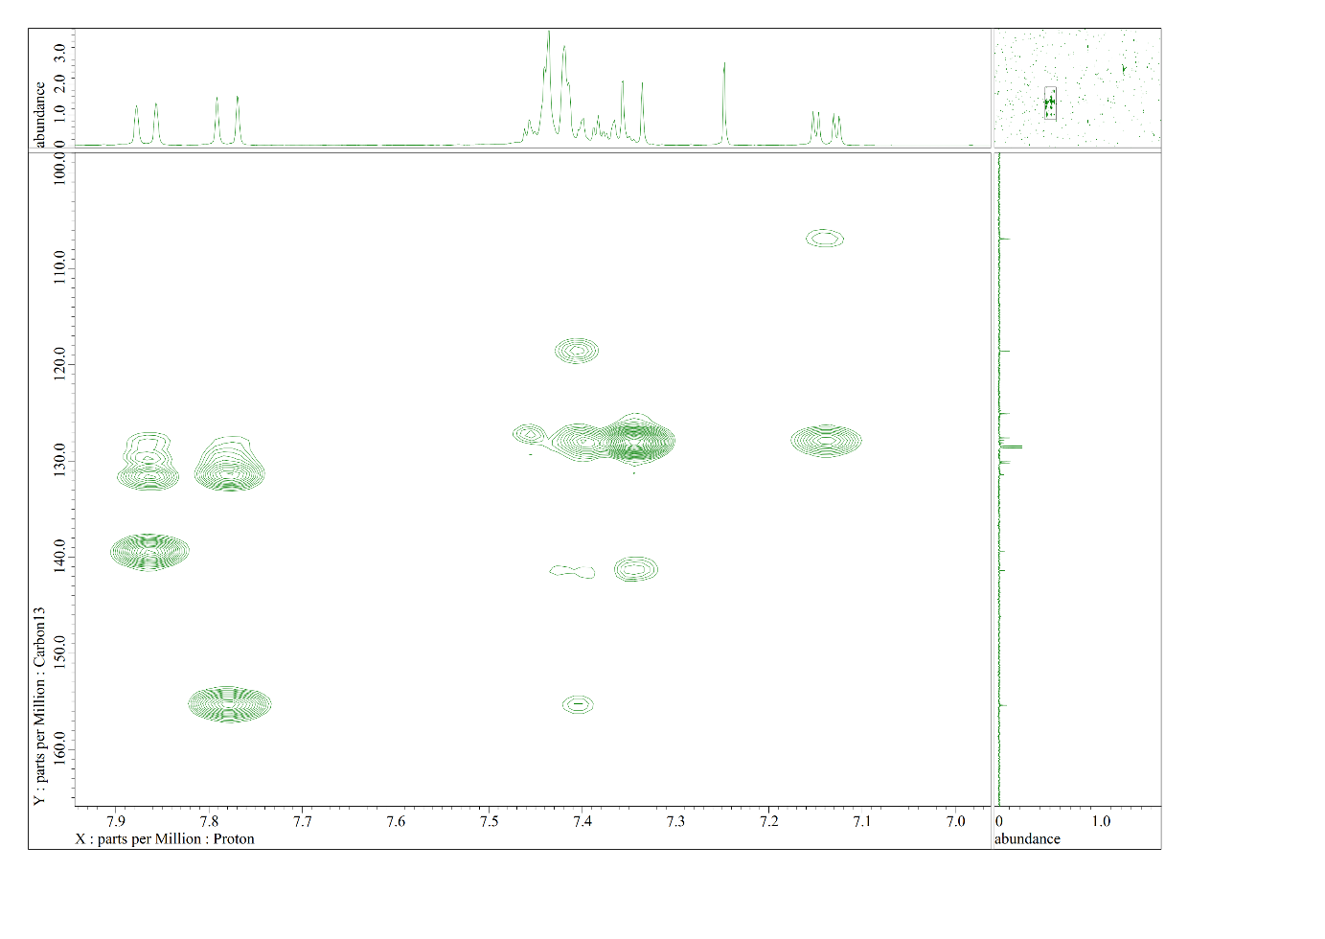
Figure S10: HMBC (400 MHz, CDCl₃) Spectrum of Compound 2

