Online Supplement
This online supplement is intended to include additional, technical information that researchers hoping to write CRTs are likely to find useful. The first part of this supplement provides examples of how JMs for CRTs should not be constructed. These are annotated to indicate where they fail to conform to the recommended content needed for well-formed and functioning JMs (e.g., where they describe affect and behavior rather than reasoning). The second part of this supplement includes illustrations of CR items and attempts to construct CR items. These items all stem from the effort to construct items for the CRT-CP. The final versions (as they currently appear on the CRT-CP) of these items are presented. The majority of example CR items in existing literature are example items from the CRT-A and CRT-RMS. To be clear, this supplement is not intended to be a standalone document, but instead to provide examples and additional details for our description of the application of the JM discovery and description process to item writing. We hope the presentation of items from the CRT-CP and accompanying descriptions of the process for constructing these items provide insight to those hoping to construct their own CRT.
JMs Written in Affective and Behavioral Terms
The following three JMs are revisions of the three illustrative JMs (see Figure 1 of the main document) from the CRT for creative personality (Schoen et al., 2018). These three JMs have been revised to illustrate how JMs should not be constructed. Unlike the correctly constructed versions presented in the main document, these revised versions primarily describe affect and behavior rather than reasoning (e.g. framing of information, selective attention, confirmation). All JMs are likely to contain some description of affect and behavior but it is key that a well-designed JM include the reasoning used to justify the behavior and the rationalizations used to circumvent threatening affective reactions (e.g., to allow the individual to ignore or feel positive about the behavior). It would be challenging if not impossible to write CR items from the JMs below as they do not contain descriptions of reasoning.
Impact Bias – Those with this bias do not like (affect) the existing ways of doing things. They get frustrated or even angry (affect) with the status quo and act to change it (behavior). They feel (affect) that solutions developed by others can be improved and they do things their own way when given a chance to do so. They fear (affect) that they will not be able to achieve their lofty objectives, and this causes considerable anxiety. They have a habit of taking on new tasks, taking over tasks from others, and stealing ideas (behavior).
Novelty Appreciation Bias – Individuals with this bias think that new ideas are fun (affect) and they are attracted to (affect) novelty, innovation, etc. They do not enjoy (affect) the current ways of doing things and act as if the implementation / development and use of new tasks, structures, and product line ups is easy (behavior). They fear (affect) a lack of change, appear to question data presented by others, and are attracted to (affect) data discovered through their own research. They enjoy new ideas (affect), thinking about new ideas, and often continue to mull over previously rejected ideas, products, or processes because they think others may have drawn the wrong conclusion about these ideas’ potential uses/benefits.
Malleability of Social Norms – These individuals behave as if organizational rules and social norms do not apply to them (behavior). They feel that people should not become attached to societal expectations (affect) because rules do change over time. They do not exhibit the expected anxiety from breaking rules or ignoring norms. They enjoy (affect) being the person who causes debate in groups and conflict among team members. They do not feel bad (affect) if they have to break rules as long as they can achieve their goals (behavior).
Constructing CR Items: A Tutorial
As noted in the main document, a primary way that researchers fail when constructing CR items is that they write items that do not actually include reasoning. We believe a major reason for this is because the JM concept has not been sufficiently described or emphasized in the CR literature. But we also know that many researchers hoping to work with CR fail to follow the published advice to first learn how to write regular inductive reasoning items (e.g., James & LeBreton, 2012). The following sections include two poorly-formed items that were written in an initial attempt to construct items for the CRT-CP, their conversion to inductive reasoning items, and their subsequent conversion to well-formed CR items (we would note that the failed versions were written after JMs for the CRT-CP were developed and those JMs had received positive feedback from other CR researchers including Larry James). We hope the presentation of the incorrect path taken by many so far will help to illustrate the benefits of following the recommended path (James & LeBreton, 2012) and help future CR researchers to avoid duplicating our early mistakes.
Example Poorly Written CR Items
We provide two examples of CRT items that were initially poorly-formed from initial attempts to write CR items for the CRT-CP. The first item, given at the top of Figure 1, even though it has the format of a CR item, is a situational judgement (SJ) problem (i.e., what would you or another person do in this situation?). The second example given at the bottom of Figure 1 also takes the form of a CR item but is an attribution / framing (AF) item. SJ and AF items are what LeBreton and colleagues (in press) referred to as “close, but no cigar” items. SJ problems ask individuals to insert themselves into a situation and select an answer related to what they would have done. AF problems ask individuals to “assign / impute / attribute meaning to the actions [of someone]” and essentially ask the test taker their opinion (LeBreton et al., in press: 20). We present these two items because we believe they are very close to being correct and represent common problems encountered in attempts to write CR items. In other words, these items have many of the elements of effective CR items but ultimately lack an inductive reasoning task resulting in “no ‘problem’ that must be solved” (LeBreton et al., in press: 20). We hope that our illustration of the conversion of these very “close, but no cigar” items to working CR items will prove informative to future CR researchers.
Before exploring how to fix these items, it is useful to understand why they fail as CR items. The first item sets out a series of statements about a new employee, Scott, who is asked to work on a task. Scott is given instructions for completing the task but ignores them. The stem concludes by prompting the test taker to make an inference about why Scott ignored the instructions. Again, this item has the structure one would expect from a CR item (premises, something that looks like an inductive reasoning task, and response options) but there are at least two issues with this item. While nearly taking the form of the inductive reasoning task of ‘evaluation of evidence,’ the first issue is that the question at the end of the stem is really asking the test taker to express an opinion rather than perform an inductive reasoning task. The second issue is that none of the response options reflect the logical conclusion a respondent would form after evaluating the evidence in the stem. Instead, test takers are left to form an opinion rather than solve an inductive reasoning problem. Item two in Figure 1 is similarly problematic. Like the first item, the form looks correct and the question concluding the stem appears to ask test-takers to evaluate evidence. However, the available response options reflect attributions rather than inductive reasoning.

Figure 1

Poorly Formed CR Items
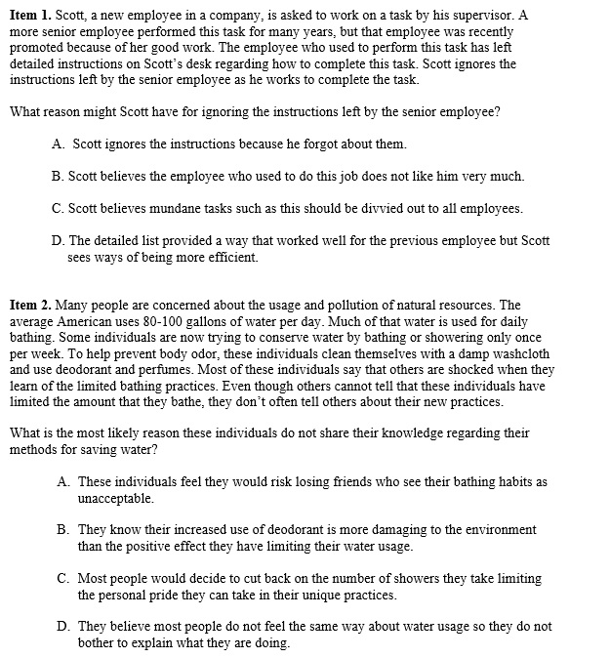

At this time, we are aware of no ready-made set of rules or guidelines for the development of CR items. As noted in the main document, common issues with poorly-formed CR items are that:
1) They are not inductive reasoning problems by nature. While they may take the superficial form of a CR item, they instead elicit a judgment, opinion, framing preference, or attribution.
2) The logic of a JM is not built into the item. This may be because the JMs are poorly formed and cannot ever be converted to items, the researcher does not know how to write a general inductive reasoning problem, or the problem is an SJ or AF item.
We hope these example items and the accompanying description of their issues will serve to aid researchers until a more thorough and formal set of guidelines is developed.
Elements of Inductive Reasoning Items
We discuss inductive reasoning items before CR items because understanding inductive reasoning is a key step often skipped by those hoping to write CR items. The elements contained in the construction of inductive reasoning items appears deceptively simple, but it is critical to first gain mastery of this skill. Researchers may wish to consult with a logician to ensure that the items they develop are true inductive reasoning items (as Larry James originally did).
Inductive reasoning problems generally adhere to a common structure or format. If any of these features are missing, then the problem is unlikely to function as an inductive reasoning item. The first is that the problem will contain a stem with a series of premises or statements. Premises are fact-like statements about a situation or interaction. These premises tend to be rather brief with just one to five sentences all stating fact-like information about the situation in a simple and declarative fashion. The conclusion of the item stem must then ask individuals to perform an inductive reasoning task. The second key feature is that inductive reasoning problems have answers choices (typically four or five) available that follow, in varying degrees, from the premises set out in the stem of the item.
Deductive reasoning problems can be solved with certainty; there is only one possible conclusion that can be made from the information provided in the item. In contrast, inductive reasoning problems can only be solved with probability. In traditional inductive reasoning items there will be one answer that most logically follows from the premises but that solution still does not conclude the premises with certainty. That is to say, additional information, if known, could change whether or not one or another answer most logically follows from the premises. There are many inductive reasoning tasks from which individuals can chose when attempting to write inductive reasoning (and CR) items. Common inductive reasoning tasks include: making an inference, evaluation of evidence, evaluation of the relevance of arguments, recognition of assumptions, inductive generalizations, providing expectations of outcomes, and evaluation of analogies.
Developing Inductive Reasoning Problems
In our experience, one effective way to write an inductive reasoning item is to state a series of premises about a situation that ultimately resolves the situation presented in the premises. One can then consider the information that could be removed that, once removed, would then insert uncertainty into the item. Figure 2 represents an attempt to provide such “closed form” premises to the “close, but no cigar” items in Figure 1. This is a useful step when starting item writing from the beginning or in trying to “fix” CR items that lack inductive reasoning. When starting from scratch, it is useful to consider the types of situations that may draw out a specific JM of interest (building the logic of a JM into the item happens in a later step). There are no answers provided after these statements because there is no problem to solve (though they are still labeled as “Item 1” and “Item 2” for consistency).
Figure 2

Closed Form Statements of Premises

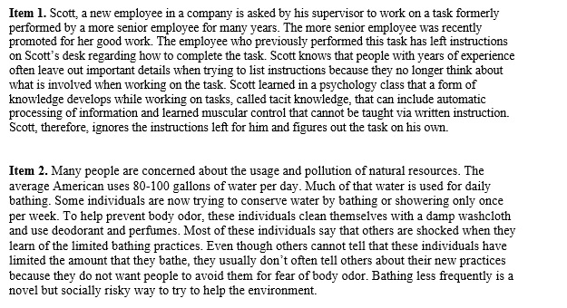

Even though these “closed form” series of statements are intended to make sense on their own, the information in them still relates to JMs they are intended to measure. The information in Item 1 was designed to activate or draw on the Impact Bias. According to information in the description of the JM, individuals who reason with the Impact Bias believe the only way to be successful is to make a task or problem their own and that is exactly what is set out in the closed form statements of Item 1 in Figure 2. But, unlike an inductive reasoning problem, the information for ignoring a set of instructions is supported by a description of tacit knowledge. This information helps to make Scott’s choice to ignore the instructions make sense. The information in Item 2 was designed to activate the Malleability of Social Norms JM. Malleability of Social Norms suggests individuals whose reasoning is influenced by this JM see rules and normative standards as dynamic and changeable rather than fixed. The information provided for Item 2 describes information and choices that support ignoring a normative standard. While rationalization is still involved in both items, the provided information clarifies how and why someone would come to the given conclusion. That is to say, we may or may not agree with the choices made, but we can fully understand the information that was used.
The next step is to consider the information that could be removed from the series of premises that then opens up the item to a probabilistic conclusion. Because inductive reasoning items require participants to make an inductive leap, information must be left out of the premises. The same two items provided in Figure 2 are given in Figure 3 but each of the items in Figure 3 has information now highlighted in bold. This is the information that, once removed, helps to begin the conversion to an inductive reasoning problem. In Item 1, two premises, one regarding tacit knowledge and another seeking approval for the action taken, are highlighted for removal. Once these premises are removed, Scott’s choice to ignore instructions seem less reasonable (i.e., the clear rationale used is now absent from the premises). Multiple key premises are also highlighted for removal from Item 2 including information about alternative steps related to hygiene, conformation of a lack of apparent body odor, fears related to body odor, and affirmation that bathing less is risky. Similar to Item 1, once removed, the choice to bathe less frequently seems less reasonable.

Figure 3

Removing Information from Premises

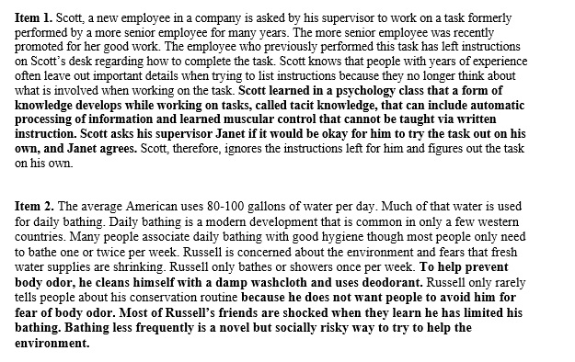

The next steps are interrelated and involve selecting an inductive reasoning task to use and to develop an answer that inductively follows from that task. The two most frequently used inductive reasoning tasks in CR items are evaluation of evidence and the development of an inference. Evaluation of evidence tasks in CR items typically follow the format of the sentence, “What is the biggest strength/weakness with the situation outlined above?”. Inference tasks in CR items are typically written around some variation of the sentence, “What is the most logical conclusion based on the above?” (additional examples are given in Exhibit 3.1 of James & LeBreton, 2012). Figure 4 contains the same two items in Figure 3 but with the bolded information removed. Additionally, the stem of Item 1 now concludes with an inductive reasoning task that asks test takers to evaluate evidence and the stem of Item 2 now concludes with an inductive reasoning task that asks test takers to form an inference. Finally, each item now has four response options available.
Like traditional inductive reasoning items, three of the answer choices available are distractors (B, C, and D for Item 1 and A, B, and C for Item 2). As noted in the main document, the distractor responses in CR items do not follow from the premises and are easy to eliminate. The development of these distractor responses is one step where researchers can “skip ahead.” Traditional inductive reasoning items include distractors that vary in their difficulty level and are intended to pull test takers away from the most logically correct answer in varying degrees. Developing distractors that pull test takers away from the inductively logical choices is not desirable in CR items (the rationale for this is explained more fully in the main document). Thus, a researcher trying to learn how to develop inductive reasoning items for the purpose of eventually converting them to CR items can feel free to develop easily discarded distractors at this point. The distractor responses still contain information related to the premises but they are not intended to inductively follow from the premises. If the distractors did not contain information related to the information in the premises, then this effectively turns the problem into a deductive reasoning problem as it would be deductively clear which answers are incongruent with the stem (technically, items at this stage are deductive reasoning items because there is only one logical choice from which to choose but this issue will be resolved when converting these items to true CR items). Relevance to stem content is still a concern with CR items even though there are two inductively plausible answers to each item. Writing distractors that are related to stem content but also easily discarded helps maintain the ruse that CR items assess inductive reasoning ability. We suggest that researchers should conduct an analysis of distractor responses to ensure they are selected only rarely as distractors have occasionally been found to unintentionally pull test-takers away from the intended responses.
Figure 4

Example Inductive Reasoning Problems

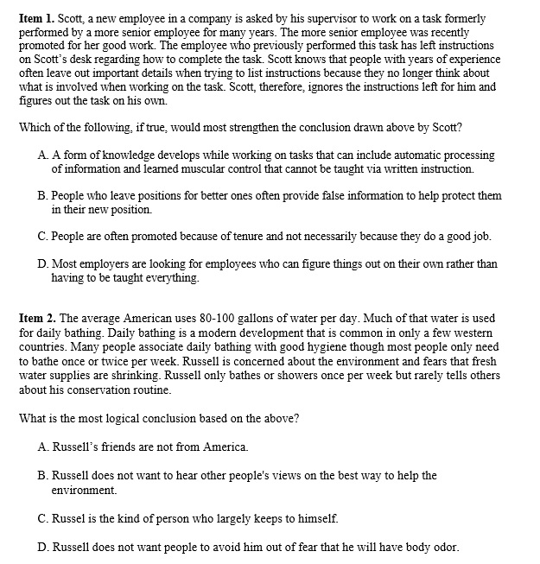

For Item 1, all of the choices available are assumptions that could strengthen Scott’s choice. In this example, answer A most closely follows from the premises and works within the confines of the problem statement. This answer partially confirms information in the stem indicating that instructions can be incomplete. Note that this answer is highly similar to some of the information highlighted for removal from the premises in Figure 3. That information, if true, does support Scott’s decision. With regard to the distractors, there is no indication in the stem that purposefully misleading information was provided, allowing respondents to rule out answer B. Answer C may be a true statement, but conflicts with information in the stem that the more senior employee received the promotion not because of tenure but because of good work. Finally, answer D, like B, may be true in some cases, but does not logically follow from the information provided in the stem. Additionally, it is quite possible that employers prefer employees who follow instructions.
As noted previously, answers A, B, and C do not follow from the premises for Item 2 of Figure 4. The stem states that daily bathing is common in western countries. If Russell’s friends are not from America, this fact would increase the chances (by a small amount) of them being from a country where daily bathing is less common, thereby eliminating answer A. Answer B is unlikely because the premises state that Russell is concerned about the environment and would then be likely to want to know about other ways to further his efforts. Finally, there is no indication in the premises regarding whether Russell is or is not an introverted individual, ruling out answer C. Answer D most logically follows from the premises provided. There are many reasons that Russell would elect to not tell others about his conservation routine but the premises specifically state that many people associate daily bathing with good hygiene and likely a way to limit body odor as well. Thus, of the answers provided, answer D provides arguments that most closely align with the premises. Similar to the logical response option in Item 1, this answer contains information highlighted for removal from the stem of Item 2 in Figure 3. Because the premises no longer state that Russell’s hygiene is perfectly fine, it is logical to conclude that Russell does not tell people about his conservation routine because he is afraid people will stereotype him as having body odor and, thus, avoid him.
Converting Inductive Reasoning Items to CR Items
CR items contain the same basic elements as inductive reasoning items. In many cases, there is little effort necessary to covert an inductive reasoning item into a CR item if following the guidelines above. As noted above, it is useful if the premises for inductive reasoning items are selected and written with a specific JM in mind. As we indicated in the main document, researchers may benefit from cataloging the types of situations and interactions likely to evoke a specific JM. If inductive reasoning items were written from that information, then one can proceed with converting the inductive reasoning items to CR items. Otherwise, researchers hoping to work with CR now need to backtrack, consider the types of situations and interactions likely to evoke their JMs of interest, draft premises related to those situations and interactions, and then draft inductive reasoning items related to those premises. Figure 5 displays two CR items developed from the inductive reasoning items in Figure 4 (Item 2 is the same as the CR item appearing in Figure 5 of the main document).

Figure 5

Example CR Items

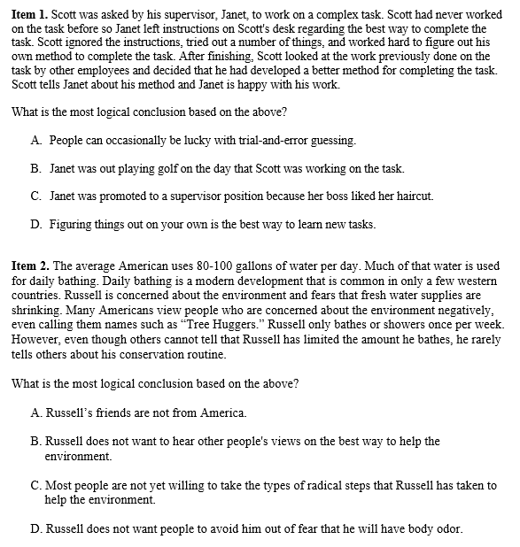

Item 1 of Figure 5 is highly similar to that of Item 1 in Figure 4. Small changes were made in order to increase the potency of the problem. First, rather than another employee having left instructions on Scott’s desk, it is now Scott’s supervisor who has left the instructions on Scott’s desk. Scott still ignores the instructions, and most people would see higher risk in ignoring a supervisor over another employee. Second, the rest of the information about why Scott ignored the instructions has been removed (as compared to Figure 2) in order to simplify the item and further allow the Impact Bias to influence respondent reasoning. Third, a firm conclusion about Scott’s work is now included that states his supervisor, Janet, is happy with Scott’s work. Finally, the stem now concludes with an inference task as the inductive reasoning task rather than an evaluation of evidence task.
The premises of Item 1 in Figure 5 were written to activate the Impact Bias and, in fact, largely follow the logic of the Impact Bias. Someone who reasons with this bias is likely to conclude that Scott has done what any other reasonable person (in their mind) would do. Before describing the logical answers, answers B and C are the distractors. They are not logical as they do not follow from the premises set out in the stem of the question and include considerable irrelevant information. These two distractors are different from those given in Figure 4. They still contain information linking back to information in the premises but were designed to be even more illogical and shorter. Answer D, on the other hand, allows those with the Impact Bias to confirm their way of thinking. Note that the stem does not ask test takers what they would / should do in a similar situation, nor does it ask their opinion of whether Scott was right or wrong. The question asks them to come to a conclusion about Scott’s actions and those with the Impact Bias are provided an answer consistent with their JM. This answer allows individuals with the Impact Bias to confirm their preferred way of thinking (i.e., employ the generic heuristic of a confirmation bias) that current methods are likely inadequate, flawed, or suboptimal. The Impact Bias also suggests that those who reason with this bias (as given in Figure 2 of the main document), are likely to prefer to figure out how to perform many tasks their own way. They are subsequently likely to reason via an unstated assumption that learning-by-doing is the best way to approach tasks. Those who do not reason via the Impact Bias are likely to view Answer D as extreme. While learning-by-doing is a way to learn, those who do not reason with this bias are likely to see learning-by-doing as just one of several ways to learn a new task including training from others and following instructions. That is to say, those who lack the Impact Bias are unlikely to automatically assume that learning-by-doing is a preferred approach. Those without the Impact Bias are more likely to frame Scott’s actions, from an unstated assumption, as risky or even dangerous because he has willfully ignored the instructions given to him by his supervisor.
A key part of converting this item from an inductive reasoning problem to a CR item was the removal of information in the premises that provide a less extreme rationalization for Scott’s choice. If the stem still contained information about Scott’s personal experiences with people leaving out information (as in the inductive reasoning version of this item in Figure 4) or even more specific information about tacit knowledge, automatic processing, and muscle memory (as in the premises of Figure 2) then it is likely that answer D would seem less extreme and likely more reasonable to a wider range of individuals (including those who may not reason via the Impact Bias). This highlights a major challenge in writing effective CR items, which involves providing enough information to test takers so that the premises can serve as an inductive reasoning task, but not so much information that respondents need not make a decision. We have often found it useful to attempt to edit items down to only their core, necessary components after having “finished” them.
As described in the main document, CR items must have two inductively logical answers. One answer is intended to seem logical to individuals who reason with the JM of interest whereas the other must be logical to those who do not reason with the JM of interest. The other logical answer to this question is answer A and follows the wounding response style of forming a logical and JM-irrelevant answer. Rather than providing an answer directly stating the risk taken by Scott in ignoring the instructions given to him by his supervisor, answer A allows the reasoning or unstated assumption about this risky choice to operate so that one can conclude that Scott was lucky. Answer A is not viewed as the most reasonable answer available to those with the Impact Bias because they attribute Scott’s success to his decision to develop a better method as opposed to Scott being lucky that he succeeded in his efforts and that Janet approved. While they might see some logic in answer A, they are likely to view it as flawed (or possibly illogical because Scott, after all, was successful). Those without the Impact Bias may see the logic in answer D, but similar to how those with the Impact Bias frame answer A as flawed, are more likely to see the extreme nature of answer D and discount it as the most logical response option. Thus, those without the Impact Bias are likely to select answer A.
Response option A follows the wounding response format for constructing non-JM response options. This response does not say that Scott’s efforts were wrong. As noted in the main document, a wounding response “goes along” with the logic of the premises. This response does not deny that Scott worked hard, was successful, or that Janet praised his work. Additionally, the stem does not indicate that Scott was foolish, that he wasted time, or the he risked being reprimanded. Denial of Scott’s success or admonishment of his efforts would go against the logic in this problem even though those who do not reason with the Impact Bias may believe these things. Instead, response A relies on a key piece of information added to the item in Figure 5 that did not appear on early versions and that information is that Scott “tired out a number of things.” This information provides for enough evidence in the stem for someone to build a defense for selecting response option A indicating that Scott relied, at least to some extent on trial-and-error in his efforts. James notes (1998: 141) that a wounding response only causes “minor logical damage” but provides for the, still logical, outlet for those who do not reason with the targeted JM.
The concept of differential framing (described in the main document) is evident in the choices made by different individuals. Those who select answer D are more likely to frame Scott’s actions as reasonable and, as a consequence, may overweigh the value of learning-by-doing and the positive impact of Scott’s decision and behavior while simultaneously discounting or wholly ignoring the risk taken by neglecting a set of instructions given to Scott by his supervisor. Similarly, those who select answer A are more likely to frame Scott’s actions as risky and, as a consequence, overweigh the information that Scott ignored Janet’s instructions. Furthermore, respondents who select answer A may assume that employers desire employees who follow rules and instructions while discounting the possibility that Scott’s decision and subsequent behavior could have a positive impact for the organization if Scott discovers a more efficient work method that can subsequently be taught to other employees.
While Item 1 largely taps the Impact Bias, there are other JMs described for creative personality at play. Specifically, NAB and, to a lesser extent, Malleability of Social Norms, are also at work. As discussed in the main document, we expect JMs to coexist within people and, accordingly, they frequently coexist within items. The content of this item suggests that Scott values performing tasks in a new way (which includes elements of NAB) and Scott ignored the typical expectation that he should follow the set of instructions given to him (which includes elements of Malleability of Social Norms). This characteristic is only problematic if the biases in question are diametrically opposed (i.e., one represents the high end of a given motive, whereas the other represents the low end). Under typical circumstances, a given individual’s reasoning is likely to either be affected by multiple related biases or by only one – neither of which is a problem from a measurement perspective.
The majority of the information describing Item 2 of Figure 5 is contained in the main document. We limit our description here the changes made to Item 2 in Figure 4 in converting it to a CR item. Like Item 1, much of the content of the inductive reasoning version of the item remains in the CR version though there are revisions. First, information suggesting that daily bathing is not necessary for good personal hygiene was removed from the CR version. Removal of this phrase (similar to removal of the statement of Scott’s personal experiences) eliminates information that supports Russell’s choice so that an explicitly stated rationalization for Russell’s choice is no longer given in the stem. Second, information suggesting that people cannot tell that Russell has limited his bathing has been included in this version. This change indicates that Russell’s action has not resulted in direct negative consequences for Russell. Finally, a statement was added to the CR version to indicate that some people view others who are concerned about the environment in negative ways. This change provides information that could serve rationalizations in opposition to Russell’s choice. With the exception of information suggesting that other people do not notice that Russell has limited his bathing, the rest of the changes to the premises were made to increase the potency of this item as they help to make Russell’s choice seem more extreme.
Answer C is the response then that allows the rationalizations described in the Malleability of Social Norms JM to operate. Individuals who reason with the Malleability of Social Norms JM are thought to easily discount normative standards with minimal information suggesting that it is okay to do so (such as when their creative ideas push against these standards but offer potential efficiency gains). As described in the main document, this response allows people who reason with this JM to confirm that Russell is not doing anything wrong by ignoring the normative standard of daily bathing. A premise in the stem suggests that others cannot tell that Russell has limited his bathing. Those who reason with the Malleability of Social Norms JM are likely to pick up on this statement and overemphasize its value in the face of normative pressures to conform including being labeled as a “Tree Hugger.” Those who do reason with this JM are also likely to wear such labels as badges of honor.
As noted in the main document, Answer D allows test takers to apply a stereotype to people who do not bathe regularly (i.e., they will have body odor) and, as such, this response follows the stereotyped/cynical format for writing non-JM answers (as described in the main document). Individuals who do not reason with the Malleability of Social Norms JM should be more reluctant to jettison normative standards and are allowed a biased logical outlet in Answer D that follows the implicit assumption (i.e., stereotype) that people who do not bathe will smell bad (an expectation built from the normative standard that bathing regularly is necessary to prevent body odor). Answer D does not say that Russell actually has body odor, as that information would directly oppose information in the stem. Instead, answer D relies on the assumption that people who do not bathe will be likely to have body odor and will, subsequently, be avoided. When given as an inductive reasoning problem in Figure 4, this was the most logical choice but the newly constructed response, Answer C, for the CR version of this item provides those who reason with the Malleability of Social Norms JM a response option that better supports their preferred way of thinking.
We noted in the main document that those who select the stereotyped/cynical response designed as the non-JM response exhibit an almost profound disbelief that the information stated in the stem of the problem in support of the targeted JM could, in fact, be true. Item 2 of Figure 5 illustrates this aspect to these responses. There is no information in the stem stating or indicating any negative impact to Russell whatsoever regarding his conservation routine. The problem specifically states that “others cannot tell that Russell has limited the amount he bathes,” yet the idea that Russell does not tell others about his conservation efforts is enough information for those who do not reason with the targeted JM to use to support the stereotype that people who do not bathe frequently will have body odor. Unlike the CR version of Item 1, where support was given for one reasonable way of completing tasks and solving problems (learning-by-doing) when there were other logical methods available (following instructions), stereotyped/cynical responses rely, essentially, on a non-critical evaluation of the evidence of the information provided by ignoring (discounting) relevant information that fails to align with one’s preferred ways of thinking.
Similar to Item 1, there are multiple JMs at work in this problem even though it was primarily designed to tap Malleability of Social Norms. NAB is at work as bathing less frequently (a change from current normative standards) will help save the environment whereas daily bathing risks the environment through an unwillingness to change. This item also contains elements that align with the Efficacy of Tenacity Bias in that Russell is committed to a strategy that others may view is irrational and Answer C also contains the temporal component described by this JM as it implies that others may eventually becoming willing to limit their daily bathing as well (“people are not yet willing”).
Parting Tips
Our primary suggestions for learning how to write CR items is to first learn how to write inductive reasoning items. Many researchers likely believe they already understand how to write these items likely because they have seen many of them (when studying for the SAT, ACT, GMAT, GRE, etc.). Our experience suggests that identifying and solving inductive reasoning problems (a skill set many researchers do have) is a different skill set than involved in actually writing inductive reasoning problems. Our second suggestion is to explore idiomatic expressions, as many CR items were constructed from these phrases with the now classic example problem used in most presentations of the CRT-A of how best to interpret the “eye-for-an-eye” phrase (see James et al., 2005). Another example of an item built from an idiomatic expression is a sample item from the CRT-CP provided in the online supplement to the presentation of that test (Schoen et al., 2018). Our final piece of advice is to practice, practice, practice. It is highly likely that half or more of the questions developed for a CRT will fail the full item validation process. Even when following the guidelines and best-practice recommendations we have presented here, there is no substitute for empirical item analysis. In this respect, writing CR items is no different from writing items for all forms of psychometric testing (see Hinkin, 1998).

