WEB APPENDIX A: STUDY MATERIAS

STUDY 1
Control condition: Sender-benefiting referral condition:
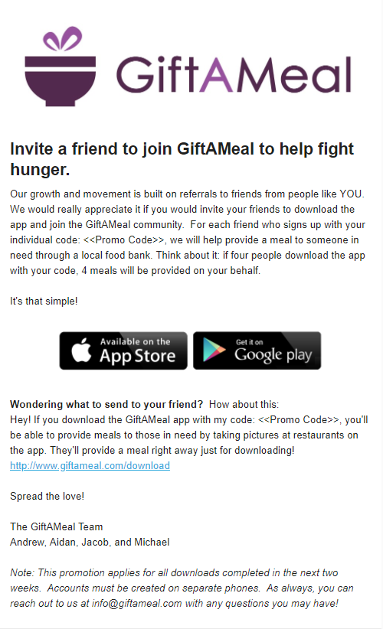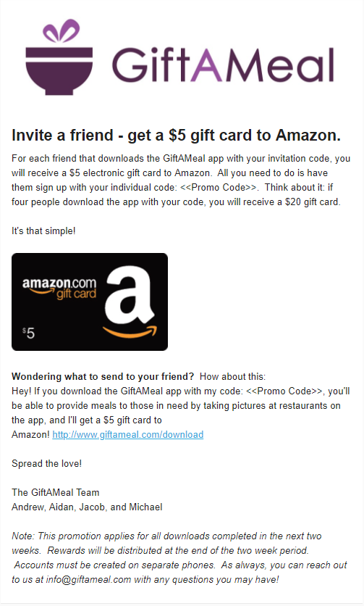

Recipient-benefiting referral condition: Shared referral condition:
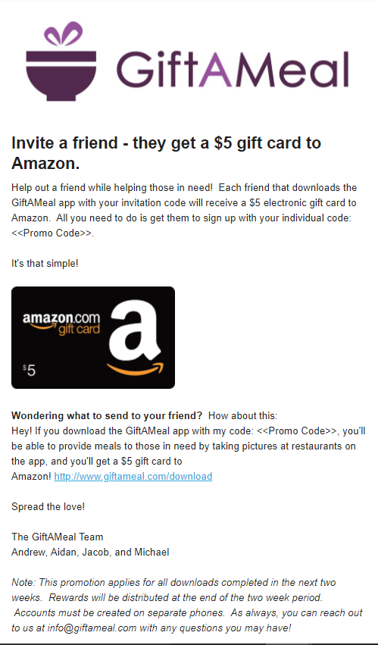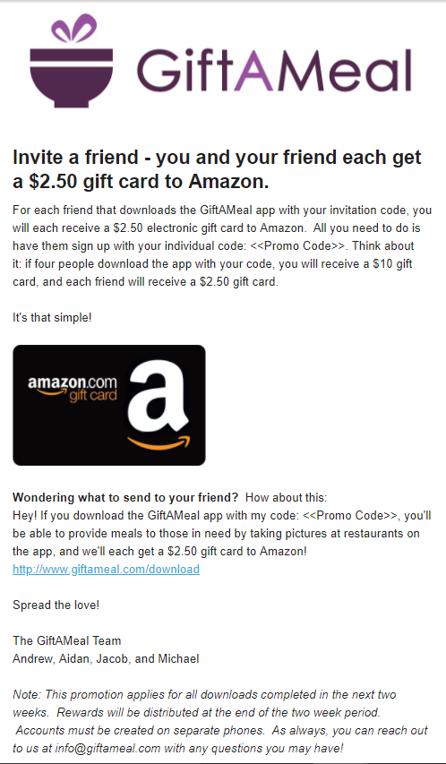

Donation referral condition:
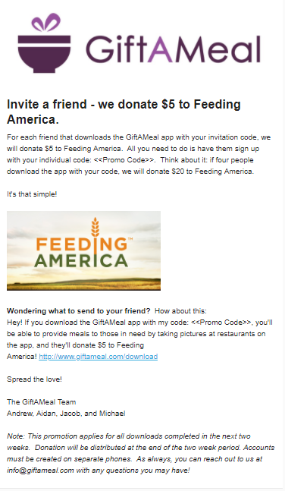

STUDY 2
Control condition:
Sender email

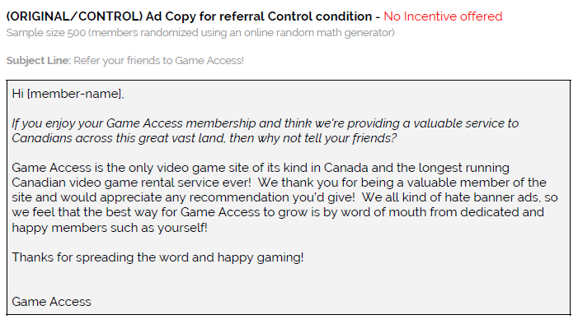
Recipient email
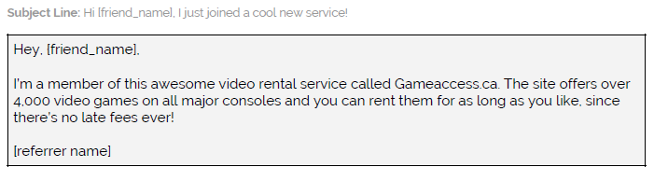

Sender-benefiting condition:
Sender email
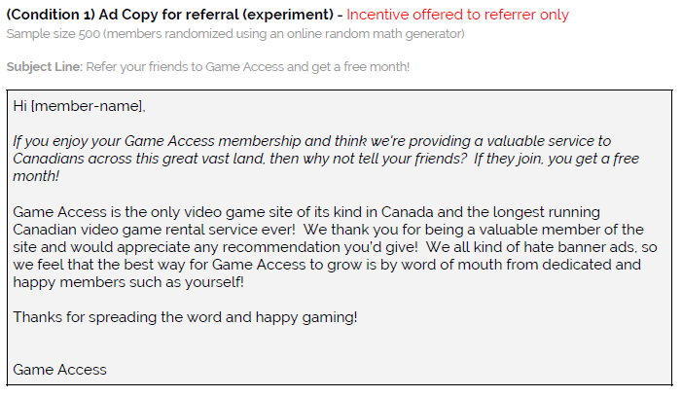
Recipient email
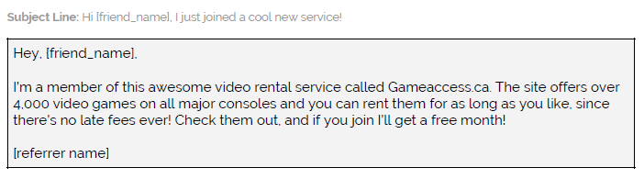

Recipient-benefiting condition:
Sender email
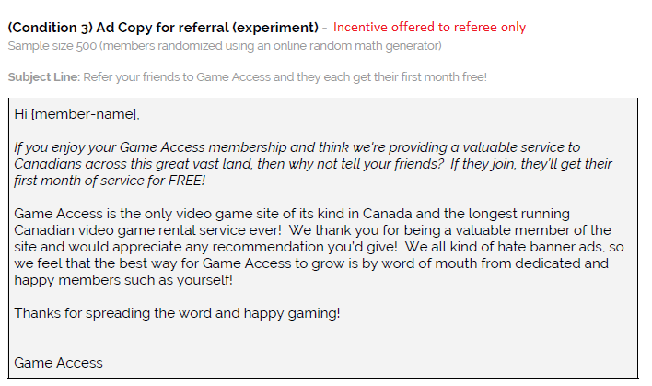
Recipient email
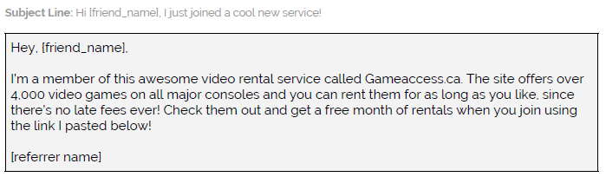

STUDY 3:
Sender role/Sender-benefiting referral
Please imagine the following scenario.
You joined a food delivery service called Food2Me which delivers food from your favorite local restaurants for $50/year.
Food2Me sends you an email, asking if you would like to refer a friend to join the service. If your friend signs up, Food2Me will give you a free year of delivery.
If you chose to refer your friend, [Friend], Food2Me would send [Friend] the following email:
________________________________________________________________________________
From: Food2Me <Food2Me@delivery.com>
To: [Friend]
Subject: Download Food2Me!

​Dear [Friend],

[Participant] might like it too! Food2Me delivers food from your favorite local restaurants for an annual fee of $50. Download the app using this link and [Participant] will receive a free year of Food2Me deliveries!
________________________________________________________________________________

Sender role/Recipient-benefiting referral
Please imagine the following scenario.
You joined a food delivery service called Food2Me which delivers food from your favorite local restaurants for $50/year.
Food2Me sends you an email, asking if you would like to refer a friend to join the service. If your friend signs up, Food2Me will give you a free year of delivery.
If you chose to refer your friend, [Friend], Food2Me would send [Friend] the following email:
________________________________________________________________________________
From: Food2Me <Food2Me@delivery.com>
To: [Friend]
Subject: Download Food2Me and get a free year of delivery!

​Dear [Friend],

[Participant] might like it too! Food2Me delivers food from your favorite local restaurants for an annual fee of $50. Download the app using this link and you will receive a free year of Food2Me deliveries!
________________________________________________________________________________

Recipient role/Sender-benefiting referral
Please imagine the following scenario.
You receive the following email stating that your friend, [Friend] referred you to try a new food delivery app called Food2Me.
________________________________________________________________________________
From: Food2Me <Food2Me@delivery.com>
To: [Participant]
Subject: Download Food2Me!

​Dear [Participant],
[Friend] has been using our new food delivery app, and thought you might like it too! Food2Me delivers food from your favorite local restaurants for an annual fee of $50. Download the app using this link and [Friend] will receive a free year of Food2Me deliveries!
________________________________________________________________________________

Recipient role/Recipient-benefiting referral
Please imagine the following scenario.
You receive the following email stating that your friend, [Friend] referred you to try a new food delivery app called Food2Me.
________________________________________________________________________________
From: Food2Me <Food2Me@delivery.com>
To: [Participant]
Subject: Download Food2Me and get a free year of delivery!

​Dear [Participant],
[Friend] has been using our new food delivery app, and thought you might like it too! Food2Me delivers food from your favorite local restaurants for an annual fee of $50. Download the app using this link and you will receive a free year of Food2Me deliveries!
________________________________________________________________________________

STUDY 4A:
Personality quiz test results:
You are somewhat more Extroverted:

This means you like getting energy from active involvement in events and having a lot of different activities. You are excited when you're around people and you like to energize other people. You like moving into action and making things happen. You generally feel at home in the world. You often understand a problem better when you can talk out loud about it.

You are both Extroverted AND Introverted:

You are a balance of both Extroversion and Introversion, sometimes referred to as an "Ambivert". Ambiverts have introverted and extroverted traits, but neither trait is dominant. As a result, they have more balanced or nuanced personalities. Ambiverts move between being social or being solitary, speaking up or listening carefully with greater ease than either extroverts or introverts.

You are somewhat more Introverted:

Don't confuse introversion with shyness or reclusiveness. They are not related. Being an introvert means that you like getting your energy from dealing with the ideas, pictures, memories, and reactions that are inside your head, in your inner world. You often prefer doing things alone or with a few people you feel comfortable with. You take time to reflect so that you have a clear idea of what you'll be doing when you decide to act. Ideas are almost solid things for you. Sometimes you like the idea of something better than the real thing.

Note: These results were adapted from the Myers & Briggs Foundation (http://www.myersbriggs.org/my-mbti-personality-type/mbti-basics/extraversion-or-introversion.htm)

Control and Sender-benefiting condition recipient e-mails:
_____________________________________________________________________________________
From: CBlabWUSTL@gmail.com
Subject: _____________ thought you would enjoy this survey!

Your friend, ______________, just took a quick personality quiz as part of a study at WashU and they wanted to share the link with you! You can take the survey by using this link www.linkwillgohere.com and entering this code _____________.

_____________________________________________________________________________________

Recipient-benefiting condition recipient e-mail:
_____________________________________________________________________________________
From: CBlabWUSTL@gmail.com
Subject: _____________ thought you would enjoy this survey (plus get a Starbucks gift card)!

Your friend, ______________, just took a quick personality quiz as part of a study at WashU and they wanted to share the link with you! You can take the survey by using this link www.linkwillgohere.com and entering this code -------------.

If you take the quick survey, you will receive a $3.00 electronic gift card to Starbucks.

_____________________________________________________________________________________

Shared condition recipient e-mail:
_____________________________________________________________________________________
From: CBlabWUSTL@gmail.com
Subject: _____________ thought you would enjoy this survey (plus get a Starbucks gift card)!

Your friend, ______________, just took a quick personality quiz as part of a study at WashU and they wanted to share the link with you! You can take the survey by using this link www.linkwillgohere.com and entering this code __________.

If you take the quick survey, you will receive a $1.50 electronic gift card to Starbucks.

_____________________________________________________________________________________

STUDY 5B

High cost/Sender-benefiting referral
________________________________________________________________________________
From: Food2Me <Food2Me@delivery.com>
To: [Participant]
Subject: Download Food2Me!

​Dear [Participant],
[Friend] has been using our new food delivery app, and thought you might like it too! Food2Me delivers food from your favorite local restaurants for an annual fee of $5. Sign up today and [Friend]​ will receive a receive a $20 gift card to Amazon for referring you!

This is an exclusive offer - to verify that only one person uses this offer, print out the attached documents, fill them out, and mail them to the Food2Me headquarters with your unique code: xyq6msp204.

Food2Me address: 201039 5th Ave, Seattle, WA 98121

________________________________________________________________________________

High cost/Recipient-benefiting referral
________________________________________________________________________________
From: Food2Me <Food2Me@delivery.com>
To: [Participant]
Subject: Download Food2Me!

​Dear [Participant],
[Friend] has been using our new food delivery app, and thought you might like it too! Food2Me delivers food from your favorite local restaurants for an annual fee of $5. Sign up today and you will receive a $20 gift card to Amazon for joining!

This is an exclusive offer - to verify that only one person uses this offer, print out the attached documents, fill them out, and mail them to the Food2Me headquarters with your unique code: xyq6msp204.

Food2Me address: 201039 5th Ave, Seattle, WA 98121

________________________________________________________________________________

Low cost/Sender-benefiting referral
________________________________________________________________________________
From: Food2Me <Food2Me@delivery.com>
To: [Participant]
Subject: Download Food2Me!

​Dear [Participant],
[Friend] has been using our new food delivery app, and thought you might like it too! Food2Me delivers food from your favorite local restaurants for an annual fee of $5. 5. Sign up today and [Friend] will receive a $20 gift card to Amazon for referring you!

This is an exclusive offer - to verify that only one person uses this offer, simply click this unique link to sign up: Food2Me.com/xyq6msp204.
________________________________________________________________________________

Low cost/Recipient-benefiting referral
________________________________________________________________________________
From: Food2Me <Food2Me@delivery.com>
To: [Participant]
Subject: Download Food2Me!

​Dear [Participant],
[Friend] has been using our new food delivery app, and thought you might like it too! Food2Me delivers food from your favorite local restaurants for an annual fee of $5. Sign up today and you will receive a $20 gift card to Amazon for joining!

This is an exclusive offer - to verify that only one person uses this offer, simply click this unique link to sign up: Food2Me.com/xyq6msp204.

________________________________________________________________________________

WEB APPENDIX B: ADDITIONAL ANALYSES

STUDY 4A:
Referral Results:
Condition | N | Referral Choice | Reputational Benefits | Psychological Costs | Social Impositon
Control | 93 | 26.37% | 3.56 (1.26) | 2.43 (1.27) | 3.49 (1.43)
Sender-Benefiting | 91 | 64.84% | 3.69 (1.34) | 2.48 (1.32) | 2.98 (1.34)
Recipient-Benefiting | 93 | 58.06% | 4.41 (1.33) | 1.75 (1.17) | 2.65 (1.36)
Shared | 93 | 56.99% | 4.14 (1.33) | 2.07 (1.20) | 2.71 (1.34)

Control vs. Sender-benefiting referral results
There was a non-significant difference in reputational benefits between the control, no incentive condition (M_{Control} = 3.56, SD = 1.26) and the sender-benefiting condition (M_{Sender} = 3.69, SD = 1.34; t(181) = -.70, p = .49). Participants also reported no difference in the psychological costs in the sender-benefiting condition (M_{Sender} = 2.48, SD = 1.32) compared to the control condition (M_{Control} = 2.43, SD = 1.27; t(181) = -.26, p =.79). Interestingly, participants reported a greater social imposition when sending a referral with no reward (M_{Control} = 3.49, SD = 1.43) as opposed to a sender-benefiting referral (M_{Sender} = 2.98, SD = 1.34; t(181) = 2.48, p = .01). We simultaneously tested the significance of all three measured mediators by calculating standardized indirect effects for 10,000 bootstrapped samples (Hayes 2009) and found that social imposition mediates the effect of referral type on referral choice. We found a statistically significant indirect effect of social imposition (.29; 95% CI [.07, .66]). The indirect effect of psychological costs was not significant (.01; 95% CI [-.06, .14]) nor was the indirect effect of reputational benefits (.03; 95% CI [-.05, .22]).

Shared referral vs. Sender-benefiting referral results
As with the recipient-benefiting incentive, participants felt that the reputational benefits of referring were higher in the shared condition (M_{Shared} = 4.14, SD = 1.33) than the sender-benefiting condition (M_{Sender} = 3.69, SD = 1.34; t(182) = 2.29, p = .023). Participants also reported higher psychological costs in the sender-benefiting condition (M_{Sender} = 2.48, SD = 1.32) compared to the shared condition (M_{Shared} = 2.07, SD = 1.20; t(182) = 2.21, p =.029). There was a non-significant difference in reported social imposition for the two conditions (M_{Sender} = 2.98, SD = 1.34) compared to the shared condition (M_{Shared} = 2.71, SD = 1.36; t(182) = 1.36, p = .18). We simultaneously tested the significance of all three measured mediators by calculating standardized indirect effects for 10,000 bootstrapped samples (Hayes 2009) and found that reputational benefits mediate the effect of referral type on referral choice. We found a statistically significant indirect effect of reputational benefits (.19; 95% CI [.02, .47]). The indirect effect of psychological costs was not significant (-.09; 95% CI [-.37, .03]) nor was the indirect effect of imposing a social obligation (.21; 95% CI [-.07, .57]).

Recipient Uptake:
Condition | N | Recipient Uptake | Imposing | Annoyed | Enjoy
Control | 6 | 24% | 2.83 (2.32) | 2 (1.27) | 3.8 (1.30)
Sender-benefiting | 16 | 28.07% | 1.56 (1.50) | 1.5 (1.51) | 4.38 (1.31)
Recipient-benefiting | 37 | 69.81% | 1.48 (.91) | 1.45 (1.06) | 4.41 (1.38)
Shared | 33 | 64.71% | 1.35 (.63) | 1.23 (.59) | 4.81 (1.27)

Follow up Questions:
- How much did you feel like your friend was imposing on you by sending this quiz? (1 = Not at all, 7 = Very much so)
- How annoyed were you about receiving this quiz from your friend? (1 = Not at all, 7 = Very much so)
- How much did you enjoy this personality quiz (1 = Did not enjoy at all, 7 = Very much enjoyed it)

Study 5A
Full results of manipulation check:
As expected, the high cost condition was perceived as having higher action costs than the low cost condition (F(1, 823) = 53.28, p < .001). Further, there was a non-significant effect of referral incentive type on action costs (F(1, 823) = .52, p = .47). There was a significant interaction of action cost and incentive type (F(1, 823) = 9.23, p = .002). In the high cost condition, perceived action costs were directionally, though not significantly, higher for the recipient-benefiting referral (M_{Recipient-benefiting} = 3.76, SD = 1.75) than the sender-benefiting referral (M_{Sender-benefiting} = 3.48, SD = 1.75; t(406) = -1.62, p = .11). Surprisingly, in the low-cost condition, perceived action costs were significantly higher in the sender-benefiting condition (M_{Sender-benefiting} = 2.96, SD = 1.85 vs. M_{Recipient-benefiting} = 2.50, SD = 1.61; t(414) = 2.68, p = .008).

Moderated Mediation:
We additionally conducted a moderated mediation analysis (Hayes 2013-model 8) to test the predicted relationship of reward type on referral choice when action costs are high or low. We tested the significance by calculating standardized indirect effects for 10,000 bootstrapped samples. Reputational benefits mediated the effect of reward type on referral choice when action costs are low (indirect effect = 0.64 (95% CI [0.34, 0.99])), and when action costs are high (indirect effect = 1.03 (95% CI [0.71, 1.38])). The index of moderated mediation was not significant at the 95% level of confidence, however, at the 90% level of confidence, the index of moderated mediation was significant (Index = .38 (90% CI [0.03, 0.75]). This provides some evidence that reputational benefits play an even stronger role in the choice to refer for a recipient-benefiting (vs. sender-benefiting) incentive when action costs are high. However, this does not translate to a higher referral rate, likely due to the higher personal cost.

Study 5B
Full results of manipulation check:
As expected, the high cost condition was perceived as having higher action costs than the low cost condition (F(1, 739) = 311.40, p < .001). There was also a main effect of referral incentive type (F(1, 739) = 5.26, p = .022). There was a non-significant interaction of action cost and incentive type (F(1, 739) = .19, p = .67). In the high cost condition, perceived action costs were significantly lower for the recipient-benefiting referral (M_{Recipient-benefiting} = 4.53, SD = 1.35) than the sender-benefiting referral (M_{Sender-benefiting} = 4.83, SD = 1.43; t(361) = 1.97, p = .05). In the low-cost condition, there was a non-significant difference in perceived action costs (M_{Sender-benefiting} = 2.92, SD = 1.56 vs. M_{Recipient-benefiting} = 2.72, SD = 1.37; t(375) = 1.29, p = .20).
Moderated Mediation:
We conducted a moderated mediation analysis (Hayes 2013-model 8) to test the predicted relationship of reward type on uptake choice when action costs are high or low. We tested the significance by calculating standardized indirect effects for 10,000 bootstrapped samples. Reputational benefits mediated the effect of reward type on uptake choice when action costs are low (indirect effect = -0.18 (95% CI [-0.34, -0.04])), but not when action costs are high (indirect effect = -0.02 (95% CI [-0.18, 0.13])). This provides some evidence that anticipated reputational benefits drive the increased performance of the other-benefiting incentive (as compared to the self-benefiting incentive) at the uptake stage, but more so when action costs are low. However, the index of moderated mediation was not significant (Index = .16 (95% CI [-0.04, 0.40]).

WEB APPENDIX C: ADDITIONAL STUDIES

APPENDIX STUDY 1

This appendix study was designed to replicate Study 3. Note – as with Study 3, in this study we label the incentive from the participants’ perspective as either self-benefiting or other-benefiting.

Methods
We recruited 800 MTurk participants (803 participants took the survey; M_{Age} = 36.90, 66.29% female). This study involved a 2(incentive: self-benefiting vs. other-benefiting) x 2(role: sender vs. recipient) between-subjects design. This study used the same materials as Study 3. In addition to measuring action choice, we measured action costs (α = .81), expected reputational benefits (α = .96), relationship benefits (α = .87) and psychological costs (α = .94).

Results
Action Choice. We observed a significant interaction between participant role (sender/recipient) and incentive type (self-benefiting/other-benefiting; χ ² (1) = 11.51, p = .001). For participants in the sender condition, we observed more participants choosing to refer for an other-benefiting incentive (90.59%) than a self-benefiting incentives (83.74%; (χ ² (1) = 4.24, p =.038). For participants in the recipient condition, we observed more participants choosing to follow-through for a self-benefiting incentive (59.60%) than an other-benefiting incentive (46.23%; (χ ² (1) = 7.12, p =.008).
APPENDIX STUDY 1: CHOICE TO ACT BY INCENITVE (SELF-BENEFITING/OTHER-BENEFITING) AND ROLE (SENDER/RECIPIENT)

Action Costs. We observed a main effect of incentive type on ratings of action cost; other-benefiting incentives were viewed as a lower cost than self-benefiting incentives (F(1, 791) = 13.41, p < .001). Participant role also has a main effect; taking action in the recipient role was perceived as a greater burden than taking action in the sender role (F(1, 791) = 253.78, p < .001). There was also a significant interaction between incentive and role; F(1, 796) = 14.21, p < .001). Specifically, in sender condition, there was no difference in perceived cost of taking action (referring) between the two incentives (M_{Self} = 2.08, SD = 1.28 vs. M_{Other} = 2.07, SD = 1.28; t(397) = .08, p = .93). In the recipient condition, action cost was significantly higher when offered an other-benefiting incentive (M_{Other} = 4.03, SD = 1.53) compared to a self-benefiting incentive (M_{Self} = 3.29, SD = 1.50; t(391) = -4.84, p < .001).
Reputational Benefits. There was a main effect of incentive type on ratings of reputational benefits; participants expected higher reputational benefits when offered an other-benefiting (vs. self-benefiting) incentive (F(1, 792) = 34.56, p < .001). Participant role, however, did not have a main effect on reputational benefits (F(1, 792) = .42, p = .52). There was a non-significant interaction for role and incentive type (F(1, 792) = 1.14, p = .29). In the sender condition, reputational benefits were significantly higher for the other-benefiting incentive (M_{Other} = 5.44, SD = 1.49) than the self-benefiting incentive (M_{Self} = 4.79, SD = 1.29; t(398) = -3.87, p < .001). Similarly, in the recipient condition, reputational benefits were higher for the other-benefiting incentive (M_{Other} = 5.40, SD = 1.16 vs. M_{Self} = 4.95, SD = 1.29; t(391) = -3.64, p < .001).
Relationship Benefits. We observed a main effect of incentive type on ratings of relationship benefits; following through with an other-benefiting referral resulted in higher relationship benefits than self-benefiting referrals (F(1, 795) = 30.15, p < .001). There was also a significant effect of participant role on relationship benefits (F(1, 795) = 5.97, p = .015). However, there was a non-significant interaction between the incentive type and role (F(1, 795) = .09, p = .76). For participants in the sender condition, relationship benefits were significantly higher for the other-benefiting incentive than the self-benefiting incentive (M_{Other} = 4.62, SD = 1.09 vs. M_{Self} = 4.22, SD = .95; t(399) = -4.64, p < .001). Similarly, participants in the recipient condition, believed that relationship benefits would be higher when offered an other-benefiting incentive (M_{Other} = 4.76, SD = 1.00 vs. M_{Self} = 4.41, SD = .78; t(393) = -3.92, p <.001).
Psychological Costs. There was a marginally significant main effect of incentive type on psychological costs (F(1, 791) = 2.84, p = .092) and a main effect of participant role on psychological costs (F(1, 791) = 10.52, p = .001). We also found a significant interaction between incentive and role; (F(1, 791) = 20.89, p < .001). For participants in the sender condition, psychological costs were significantly higher for the self-benefiting incentive than the other-benefiting incentive (M_{Selfish} = 2.45, SD = 1.61 vs. M_{Prosocial} = 1.85, SD = 1.41; t(392) = 3.91, p <.001). For participants in the recipient condition, psychological costs for not following through were higher for the other-benefiting incentive (t(391) = -2.42, p = .016).

APPENDIX STUDY 2
This appendix study was designed to replicate Study 4B.

Methods
The study used a 2(rewards: sender-benefiting vs. recipient-benefiting) x 2(control vs. anonymous) between-subjects design. 580 Mechanical Turk participants (M_{Age} = 35.01, 58.72% Female) completed the study. This study used the same materials as Study 4B. We additionally measured relationship benefits, psychological costs, and social obligations (see Appendix Table 2 for follow-up results). We did not measure reputational benefits, because half of the participants made anonymous referrals.

Results
We found an interaction between referral condition (control/anonymous) and reward type (sender-benefiting /recipient-benefiting; X² (1) = 6.58, p = .01). For participants in the control condition, we observed an equal number of referrals for the recipient-benefiting (88.74%) and the sender-benefiting referral reward (89.26%; χ ² (1) = .01, p = .89). However, when the referral was anonymous, the sender-benefiting reward (92.62%) was significantly more successful than the recipient-benefiting reward (75.57%; χ ² (1) = 15.54, p < .001).

APPENDIX STUDY 2: REFERRAL CHOICE BY REWARD AND ANONYMITY

APPENDIX TABLE 2
Anonymity Condition | Referral Reward Condition | Relationship Benefits  (1-7) | Psychological Costs  (1-7) | Social Obligations  (1-7)
Named | Sender-benefiting | 4.15  (.69) | 2.42  (1.56) | 3.08  (1.67)
 | Recipient-benefiting | 4.41**  (.89) | 1.67***  (.95) | 2.59**  (1.59)
Anonymous | Sender-benefiting | 4.11  (.72) | 2.23  (1.47) | 2.83  (1.73)
 | Recipient-benefiting | 4.33*  (.77) | 1.89*  (1.28) | 2.81  (1.67)
† p<.10, *p < .05, **p < .01, ***p<.001; these significance notations refer to differences in mean evaluations for sender-benefiting referral rewards compared to recipient-benefiting referral rewards with standard deviations in parentheses. A° symbol next to the variable name indicates that there is a significant interaction between anonymity condition and referral reward condition on this variable at a p < .05 level.

APPENDIX STUDY 3
As additional evidence for the role of reputational benefits in the choice to make a recipient-benefiting (vs. sender-benefiting) referral, we manipulated the relationship between sender and recipient. We expect that, because the potential for reputational benefits is substantially reduced when the recipient is a stranger (instead of a friend), the performance of recipient-benefiting referrals will decline relative to sender-benefiting referrals in this case.
Methods
As outlined in our pre-registered research plan (available at https://bit.ly/2V0j1De), we recruited 800 MTurk participants (810 participants completed the study; M_{Age} = 35.91, 61.54% female). The study used a 2(referral: sender-benefiting vs. recipient-benefiting) x 2(referral recipient: friend vs. stranger) between-subjects experimental design. We used the same context as in Study 4A (Amazon BOLD referral), and the same incentive (a $10 Visa gift card). All participants were asked to give their first name and the first name of a close friend. We showed participants a sample referral email that Amazon was interested in sending to either 1) their close friend or 2) “a potential customer” (whom the participant does not know). In both conditions, we used the participant’s name in the sample email (e.g., One of our customers, Rosie, has been using our new loyalty program, Amazon BOLD, and wanted to share the savings with you!). Participants were then required to correctly identify who would receive a reward for a successful referral (themselves or the recipient) before they could move to the referral decision to confirm that they understood the incentive structure. We then asked, “Would you refer your friend [name of close friend inserted]/this potential customer, to Amazon BOLD”? (Yes/No).

Results
A binary logistic regression was performed on the choice to refer as a function of referral recipient type (friend/stranger) and incentive type (sender-benefiting/recipient-benefiting). This analysis yielded a significant interaction of recipient and incentive type (χ² (1) = 14.85, p < .001). For participants in the friend condition, we observed an equal number of referrals for the recipient-benefiting (87.75%) and the sender-benefiting referral (87.00%, χ² (1) = 0.05, p = .82). This pattern is consistent with results from studies 2 and 3. However, when referring a stranger, the sender-benefiting incentive (82.76%) was significantly more successful than the recipient- benefiting incentive (54.73%, χ² (1) =35.78, p < .001), consistent with standard incentivized behavior.
APPENDIX STUDY 3: REFERRAL CHOICE BY REWARD AND RECIPIENT

APPENDIX STUDY 4
This appendix study was designed to replicate Study 5B with an additional manipulation of action cost.

Methods
As outlined in our pre-registered research plan (available at https://bit.ly/2GQ33ru), we recruited 800 MTurk participants; 818 completed the study (M_{Age} = 35.52, 50.86% female).
To further understand the uptake stage of the referral process, we had participants imagine that a friend sent them an email asking if they would like to try Food2Me (the same food delivery service described in Studies 3 and 5A). Participants provided their own first name and the first name of a close friend. We manipulated whether the referral was recipient-benefiting or sender-benefiting. We also manipulated action costs by directly varying the cost of uptake ($2 or $100 per year to join).
Participants then read, “The Food2Me restaurant delivery service costs [$100/$2] per year and you may cancel at any time. Would you sign up for the Food2Me delivery service? Remember if you join, [you/Friend] get(s) a free year of deliveries!” Participants could respond either “Yes, I would sign up for the Food2Me delivery service” or “No, I would not sign up for the Food2Me delivery service.”
Note that, as in Study 2, 3, 5A, and 5B, we told participants (recipients) in the sender-benefiting referral conditions that the friend who referred them would be rewarded if they followed through on the referral. We informed participants of this benefit to their friend to examine whether, even when recipients know that their friend will receive an incentive (which is not always the case in these incentive designs), sender-benefiting referrals have a minimal positive effect at the uptake stage due to the higher burden of follow-through. Participants were required to correctly identify who would receive an incentive (themselves or their friend) before they could move to the uptake decision to confirm that they understood the incentive structure before making their uptake choice. Finally, as a manipulation check, we measured action costs (α = .78).
Results
Manipulation Check. As expected, the high cost condition was perceived as having higher action costs than the low cost condition (M_{High-Cost} = 3.83, SD = 1.39 vs. M_{Low-Cost} = 2.41, SD = 1.46; t(816) = 1.431, p <.001).
Uptake decision. We performed a binary logistic regression on uptake decision as a function of uptake cost (high/low) and referral type (sender-benefiting/recipient-benefiting). This analysis yielded a significant interaction of uptake cost and incentive type (χ² (1) = 5.49, p = .019). For participants in the high-cost condition, we observed more sign-ups for the recipient-benefiting referral (51.94%) than the sender-benefiting referral (34.76%, (χ² (1) = 12.37, p < .001), consistent with Studies 2-3 as well as typical incentivized behavior. However, when uptake cost was low, there was no difference in uptake choice by those in the recipient-benefiting condition (69.84%) versus the sender-benefiting condition (69.50%, χ² (1) = .004, p = .95).
APPENDIX STUDY 4: UPTAKE CHOICE BY ACTION COST (HIGH/LOW) AND INCENITVE (SENDER-BENEFITING/RECIPIENT-BENEFITING)

APPENDIX STUDY 5
This exploratory study was designed to test whether the attractiveness of a service moderates the effect of sender-benefiting and recipient-benefiting incentives on referral choice. Specifically, if a company has received negative press, do sender-benefiting incentives become more effective at motivating referrals, because the referring customer needs an additional nudge to refer? Alternatively, are recipient-benefiting incentives more effective for companies that have received negative press because the sender anticipates that the positive response from sending a reward will balance out the unfavorable response of referring a brand that is viewed negatively? To test this question, we varied the referred service using two rideshare companies: Lyft (the desirable company, reinforced by telling participants, truthfully, that the company had received widespread positive press) versus Uber (the undesirable company, reinforced by telling participants, truthfully, that the company had received widespread negative press).

Methods
We recruited 915 MTurk participants (M_{Age} = 38.45, 55.25% female). The study used a 2(referral: sender-benefiting vs. recipient-benefiting) x 2(service: negative press [Uber] vs. positive press [Lyft]) between-subjects experimental design. All participants were asked to give their first name and the first name of a close friend. We had participants imagine the following: “You have been using Uber [Lyft], an alternative to taxicabs, which sends a driver directly to your location”. Participants in the Uber condition then read the following: “While Uber is a convenient service, lately they have received widespread negative press for having a toxic work culture and not offering their employees the same benefits that their competitors provide”. Those in the Lyft condition read, “Lyft is a convenient service and lately they have received widespread positive press for having a good work culture and offering their employees better benefits than their competitors”. Participants were then told that the service has a promotion that is either sender-benefiting (“gives you a $10 Visa gift card for every person that you refer to Uber [Lyft] who then takes their first Uber [Lyft] ride”) or recipient-benefiting (“gives a $10 Visa gift card to each individual that you refer to Uber [Lyft] who then takes their first [Uber] Lyft ride”). Participants read a sample email that would be sent to their friend if they chose to refer. In both conditions, we used the participant’s name in the sample email (e.g., Rosie, has been riding with Lyft and thought you might enjoy it too. They then read, “Imagine that your friend, [Friend’s name], has never used Uber [Lyft] before. Would you refer [Friend’s name] to Lyft?” Participants could respond either “Yes, I would refer my friend” or “No, I would not refer my friend”.
We used two additional measures to verify that our negative press manipulation was successful by asking “How do you feel about the driving app, Uber [Lyft]”, 1) “I would be proud to support Uber [Lyft]” and 2) “Uber [ Lyft] is a good company” (1 = Not at all, 7 = Very much so; α = .92).

Results
Manipulation Check. As expected, Lyft was viewed more positively than Uber (M_{Lyft}= 5.18, SD = 1.33 vs. M_{Uber}= 3.79, SD = 1.50; t(911) = 14.87, p < .001).
Referral decision. A binary logistic regression was performed on the choice to refer as a function of incentive type (sender-benefiting/recipient-benefiting) and the press manipulation (negative/positive. This analysis did not yield a significant interaction of incentive type and press manipulation (χ² (1) = 2.20, p = .14). For participants in the Uber (negative press) condition, we did not observe a difference in referral choice for the recipient-benefiting (70.94%) and the sender-benefiting incentive (65.35%, χ² (1) = 1.66, p = .20). When referring to a company with positive press (Lyft), the recipient-benefiting incentive (90.75%) was significantly more successful than the sender- benefiting incentive (81.86%, χ² (1) = 7.33, p = .007).

APPENDIX STUDY 5: REFERRAL CHOICE BY REWARD AND SERVICE

Discussion
To summarize, this study found no interaction of incentive type and negative press on the choice to refer a friend to a company. Future work might continue to explore boundary conditions: Are there companies or products for which sender-benefiting incentives are more effective at motivating customers to refer than recipient-benefiting incentives?

