# **Supplemental Material**

We used standard cost-effectiveness analysis methods to compare costs and effectiveness of the TeenHC chlamydia screening program with a “no TeenHC screening” scenario using a societal perspective (Gold MR, 1996). Measures of effectiveness included cases of CT infection prevented, cases of epididymitis and pelvic inflammatory disease (PID) prevented, and quality-adjusted life years (QALYs) gained. Cost estimates included program costs, costs of chlamydia testing and treatment, and costs of treatment for epididymitis, PID, and PID sequelae. The time frame for estimating the number of cases of CT infections, epididymitis, and PID was one year post the TeenHC screening, and the analytic horizon extended to 20 years after development of PID to incorporate QALY losses and medical treatment cost associated with PID sequelae. Cost-effectiveness was measured as cost per QALY gained. Future QALY losses and medical costs were discounted at 3%, and all costs were in 2016 dollars. All calculations were performed in Excel.

The base-case analysis was conducted in 4 steps. Step 1 focused on evaluating the health effects of the TeenHC program on students who tested positive by comparing the expected number of CT infections, epididymitis, and PID in the coming year in two scenarios — the TeenHC scenario and a “no TeenHC” scenario. Figure S1 shows the disease pathway for infected female students. In the TeenHC scenario, infected students who experienced reinfection or treatment failure were at risk of developing PID. In the non-TeenHC scenario, infected students could be tested at a clinical setting with the probability of background testing rate. Infected students who experienced treatment failure or reinfection were at risk of developing PID. In addition, infected students who were not tested or had false negatives were also at risk of developing PID if CT infections were not naturally cleared. In this study, for simplicity, we used the term “persistent infections” for all infections persisting to the next year due to treatment failure, not being tested, or having false negatives. The differences in the number of persistent CT infections and PID between the two scenarios were the number of CT infections and PID prevented by the TeenHC screening. For infected male students the disease pathway is similar to the one for infected female students, the only difference is the final outcome is epididymitis instead of PID.

Step 2 focused on evaluating the impact of the TeenHC program on one-generation infection transmission prevented. Students who had persistent CT infection or reinfection in the next year could transmit infections to their uninfected partners. Using 2015 Duval County Youth Risk Behavior Survey data, we estimated that male students had an average of 1.86 partners in the past 3 months and female students had an average of 1.37 partners (Centers for Disease Control and Prevention, 2019). Figure S2 shows the disease pathway for uninfected female partners of male students who had persistent CT infection or reinfection. The number of transmitted CT infections was calculated as a product of four variables — 1) the number of CT infected students who had persistent infection or reinfection, 2) the average number of current partners per sexually active student, 3) the probability of a current partner being uninfected (1 - the probability of CT transmission per partnership), and 4) the probability of CT transmission per partnership. We assumed each partner would be tested at the rate of background testing and infected female partners have the same rate of developing PID as infected female students in the “No TeenHC” scenario. The differences in the number of CT infections and PID between the two scenarios were the number of CT and PID prevented. Using the same approach, we also estimated the number of cases of epididymitis prevented by the TeenHC screening among male partners of infected female students.

Table S1 shows all model parameters used to assess the cost-effectiveness of the TeenHC screening, including base-case values, ranges and data sources. We used published literature to derive estimates for transmission probability per partnership (Quinn et al., 1996), test sensitivity (Owusu-Edusei, Chesson, Gift, Brunham, & Bolan, 2015), treatment efficacy (Owusu-Edusei et al., 2015), probability of reinfection (Fung, Scott, Kent, & Klausner, 2007; Hosenfeld et al., 2009), probability of spontaneous cure (Geisler, Lensing, Press, & Hook, 2013), and probability of developing epididymitis or PID (Fisman, Spain, Salmon, & Goldberg, 2008; Gift et al., 2008; Owusu-Edusei et al., 2015). For background testing among females, we used a CT testing rate of 34.4% from a CDC study of the Florida Medicaid-enrolled female adolescents aged 13-18 years (personal communication). A recent study of the New York State (NYS) Medicaid-enrolled adolescents showed CT testing rate of male adolescents was about half that of female adolescents (Wang, Chang, Burstein, & Hocevar Adkins, 2018). Based on this, we assumed that in Florida, the background CT testing rate among sexually active male adolescents would be 17%, half of that of sexually active female adolescents. There has been considerable debate in the literature among experts about the true PID rate among females with untreated CT infection. Some studies (Blake et al., 2008; Fisman et al., 2008; Huang, Gaydos, Barnes, Jett-Goheen, & Blake, 2011) used 30% for both symptomatic and asymptomatic PID and others used 15% for symptomatic PID only (Gift et al., 2008; Owusu-Edusei et al., 2015). Wiesenfeld et al.(Wiesenfeld et al., 2002) demonstrated that 23% of women with CT infection had asymptomatic PID. Given that about 60% of PID is asymptomatic, the true PID rate of asymptomatic and symptomatic PID combined would be much higher than 15%. We believe the true PID rate falls between 15% and 30%, so we used the midpoint (22.5%) of the two rates for our base-case analysis and used the range of 10-30% for sensitivity analysis.

Step 3 was to estimate medical costs saved and QALYs gained associated with cases of epididymitis and PID prevented from steps 1&2. The cost estimates for PID were derived from published research by Yeh et al. (Yeh, Hook, & Goldie, 2003), which estimated the average lifetime cost of PID and its complications (ectopic pregnancy, chronic pelvic pain, and infertility). The overall per-person lifetime medical cost for a woman aged 15-24 years with PID was $2,150 (2000 dollars), ranged between $1,060 and $3,180 (Yeh et al., 2003). We first adjusted all costs to 2016 dollars using the Medical Component of the Consumer Price Index and then multiplied unit costs with number of cases prevented to calculate total medical costs saved associated with cases of epididymitis and PID prevented. For QALY losses associated with epididymitis we considered both outpatient and inpatient care. For QALY losses associated with PID we considered acute PID and PID sequelae — ectopic pregnancy, chronic pelvic pain, and infertility. Table S2 depicts how we calculated QALY lost per case of epididymitis or PID including data sources and assumptions made. Quality weights and probabilities of developing epididymitis, acute PID, and PID sequelae were obtained from a study by the Institute of Medicine on vaccine development (Institute of Medicine, 2000). Assumptions made by Yeh et al. (Yeh et al., 2003) about the onset and duration of PID sequelae were used in our calculation.

Step 4 was to estimate CT testing and treatment costs in both the TeenHC scenario and the “no TeenHC scenario”. In the TeenHC scenario, we first estimated the overall TeenHC program cost including personnel, testing kit, medications, supplies, travel, and incentives. To tease out the cost of CT screening, we asked the TeenHC manager “What proportion of staff time was related to CT testing/treatment?” and “What proportion of the supplies, travel, and incentives was needed if only CT screening/treatment was offered?” Based on the proportion estimates provided and the overall TeenHC program cost, we estimated the program cost of CT screening during the 2015-2016 school year. In the “no TeenHC” scenario, total medical costs of CT testing and treatment were estimated using the published cost estimate of CT testing and treatment in a clinical setting (Owusu-Edusei, Hoover, & Gift, 2016) and the estimated number of students or partners who would be tested or treated in absence of the TeenHC program.

Multivariate sensitivity analysis was conducted to assess the robustness of the results to uncertainty in the input parameter values by varying all major parameter values over a wide range that we considered plausible assuming a triangular distribution of values for all parameters. Monte Carlo simulation of 10,000 trials was performed using @RISK (Palisade Corp). We also performed a scenario analysis to determine at what student participation level or program cost level the TeenHC CT screening would cost ≤ $50,000 per QALY, a benchmark that is frequently used for cost-effectiveness in the U.S. (Grosse, 2008). In addition, as an alternative approach to the TeenHC screening program, school-based mass screening programs have shown success in screening 35%-79% of students (Cohen, Nsuami, Martin, & Farley, 1999; Dunville et al., 2018; Fisman et al., 2008). We performed a threshold analysis to determine at what level of program cost, a mass CT screening program can be cost-effective if implemented in the five schools. We considered 3 mass screening scenarios — 25%, 50% and 75% of all sexually active students being tested. For each scenario, we first estimated the number of students who were sexually active based on the total number of students enrolled in the five schools (8,309) and the percentage of students who were sexually active (27% in males and 24% in females). We then estimated the number of sexually active students who would be tested and tested positive in each scenario assuming that the test positive rate reflected the actual prevalence among sexually active students in the five schools. Lastly, we calculated total costs averted and total QALYs gained in each scenario and then set the cost-effectiveness ratio to $50,000/QALY gained to calculate the maximum program cost in each scenario.

# **References**

Blake, D. R., Maldeis, N., Barnes, M. R., Hardick, A., Quinn, T. C., & Gaydos, C. A. (2008). Cost-effectiveness of screening strategies for Chlamydia trachomatis using cervical swabs, urine, and self-obtained vaginal swabs in a sexually transmitted disease clinic setting. *Sex Transm Dis, 35*(7), 649-655. doi:10.1097/OLQ.0b013e31816ddb9a

Centers for Disease Control and Prevention. (2019). 1991-2017 High School Youth Risk Behavior Survery Data. Retrieved from <https://nccd.cdc.gov/youthonline/>

Cohen, D. A., Nsuami, M., Martin, D. H., & Farley, T. A. (1999). Repeated school-based screening for sexually transmitted diseases: a feasible strategy for reaching adolescents. *Pediatrics, 104*(6), 1281-1285.

Dunville, R., Peterson, A., Liddon, N., Roach, M., Coleman, K., & Dittus, P. (2018). Sustained Reduction in Chlamydia Infections Following a School-Based Screening: Detroit, 2010-2015. *Am J Public Health, 108*(2), 231-233. doi:10.2105/AJPH.2017.304163

Fisman, D. N., Spain, C. V., Salmon, M. E., & Goldberg, M. (2008). The Philadelphia High-School STD Screening Program: key insights from dynamic transmission modeling. *Sex Transm Dis, 35*(11 Suppl), S61-65. doi:10.1097/OLQ.0b013e3181802822

Fung, M., Scott, K. C., Kent, C. K., & Klausner, J. D. (2007). Chlamydial and gonococcal reinfection among men: a systematic review of data to evaluate the need for retesting. *Sex Transm Infect, 83*(4), 304-309. doi:10.1136/sti.2006.024059

Geisler, W. M., Lensing, S. Y., Press, C. G., & Hook, E. W., 3rd. (2013). Spontaneous resolution of genital Chlamydia trachomatis infection in women and protection from reinfection. *J Infect Dis, 207*(12), 1850-1856. doi:10.1093/infdis/jit094

Gift, T. L., Gaydos, C. A., Kent, C. K., Marrazzo, J. M., Rietmeijer, C. A., Schillinger, J. A., & Dunne, E. F. (2008). The program cost and cost-effectiveness of screening men for Chlamydia to prevent pelvic inflammatory disease in women. *Sex Transm Dis, 35*(11 Suppl), S66-75. doi:10.1097/OLQ.0b013e31818b64ac

Gold MR, S. J., Russell LB, Weinstein MC, editors. . (1996). *Cost-effectiveness in health and medicine*. New York: Oxford University Press.

Grosse, S. D. (2008). Assessing cost-effectiveness in healthcare: history of the $50,000 per QALY threshold. *Expert Rev Pharmacoecon Outcomes Res, 8*(2), 165-178. doi:10.1586/14737167.8.2.165

Hosenfeld, C. B., Workowski, K. A., Berman, S., Zaidi, A., Dyson, J., Mosure, D., . . . Bauer, H. M. (2009). Repeat infection with Chlamydia and gonorrhea among females: a systematic review of the literature. *Sex Transm Dis, 36*(8), 478-489. doi:10.1097/OLQ.0b013e3181a2a933

Huang, W., Gaydos, C. A., Barnes, M. R., Jett-Goheen, M., & Blake, D. R. (2011). Cost-effectiveness analysis of Chlamydia trachomatis screening via internet-based self-collected swabs compared with clinic-based sample collection. *Sex Transm Dis, 38*(9), 815-820. doi:10.1097/OLQ.0b013e31821b0f50

Institute of Medicine. (2000). *Vaccines for the 21st Century: A Tool for Decisionmaking. Washington, DC*: The National Academies Press.

Owusu-Edusei, K., Jr., Chesson, H. W., Gift, T. L., Brunham, R. C., & Bolan, G. (2015). Cost-effectiveness of Chlamydia vaccination programs for young women. *Emerg Infect Dis, 21*(6), 960-968. doi:10.3201/eid2106.141270

Owusu-Edusei, K., Jr., Hoover, K. W., & Gift, T. L. (2016). Cost-Effectiveness of Opt-Out Chlamydia Testing for High-Risk Young Women in the U.S. *Am J Prev Med, 51*(2), 216-224. doi:10.1016/j.amepre.2016.01.007

Quinn, T. C., Gaydos, C., Shepherd, M., Bobo, L., Hook, E. W., 3rd, Viscidi, R., & Rompalo, A. (1996). Epidemiologic and microbiologic correlates of Chlamydia trachomatis infection in sexual partnerships. *JAMA, 276*(21), 1737-1742.

Wang, L. Y., Chang, M. H., Burstein, G., & Hocevar Adkins, S. (2018). Human Immunodeficiency Virus, Chlamydia, and Gonorrhea Testing in New York Medicaid-Enrolled Adolescents. *Sex Transm Dis, 45*(1), 14-18. doi:10.1097/OLQ.0000000000000686

Wiesenfeld, H. C., Hillier, S. L., Krohn, M. A., Amortegui, A. J., Heine, R. P., Landers, D. V., & Sweet, R. L. (2002). Lower genital tract infection and endometritis: insight into subclinical pelvic inflammatory disease. *Obstet Gynecol, 100*(3), 456-463.

Yeh, J. M., Hook, E. W., 3rd, & Goldie, S. J. (2003). A refined estimate of the average lifetime cost of pelvic inflammatory disease. *Sex Transm Dis, 30*(5), 369-378.

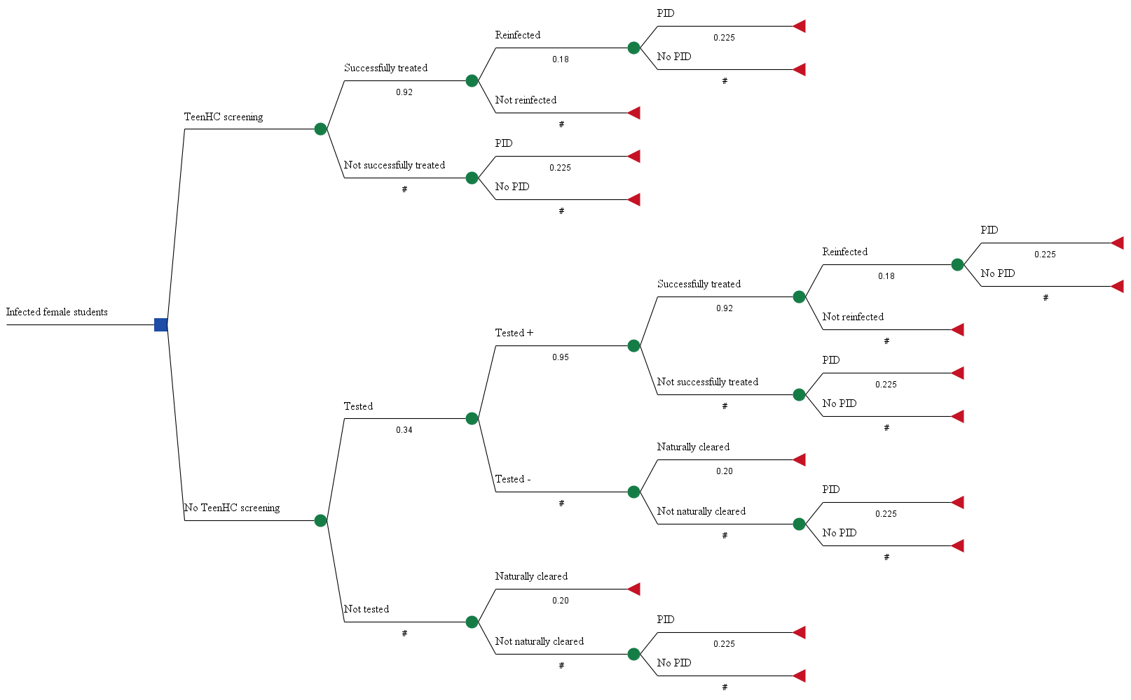

Figure S1. Disease pathway in chlamydia infected female students

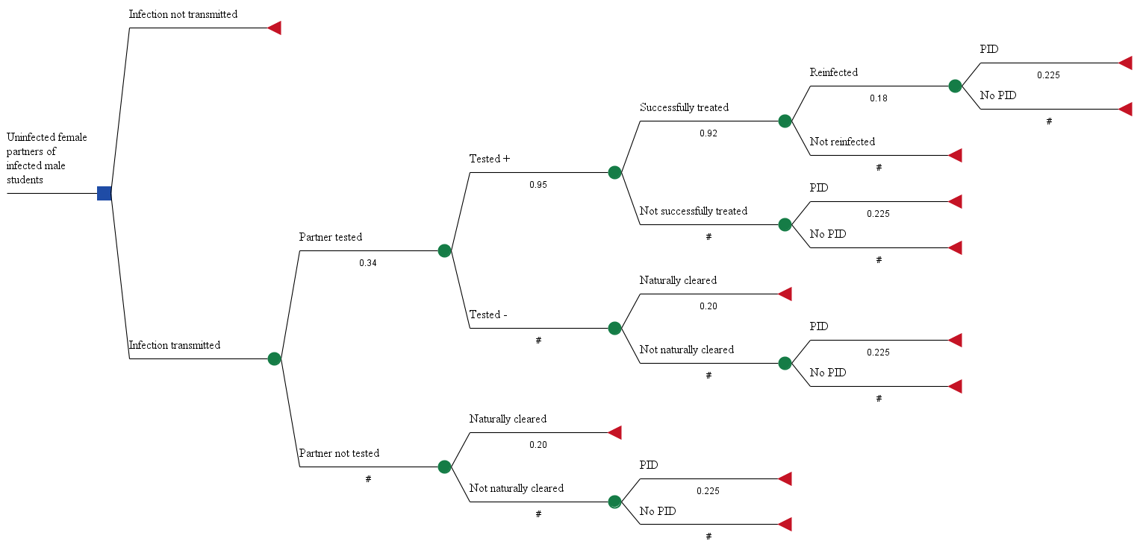

Figure S2. Disease pathway in uninfected female partners of infected male students who had persistent infection or reinfection



