**Who Receives Credit or Blame? The Effects of Made-to-Order Production on Responses to Unethical and Ethical Company Practices**

**Neeru Paharia**

**WEB APPENDIX**

**TABLE OF CONTENTS**

**Appendix A:** Study 1 Facebook Ad Stimuli

**Appendix B:** Table of Facebook Click-Through Rates

**Appendix C:** Study 2 Stimuli

**Appendix D:** Study 2 Mediation Path Model

**Appendix E:** Study 2 Follow Up

**Appendix F:** Study 3 Mediation Path Model

**Appendix G:** Study 4 Mediation Path Model

**Appendix H:** Study 5 Stimuli

**Appendix I:** Study 5 Mediation Path Model

**Appendix J:** Study Measures

**Appendix K:** Data Exclusions

**WEB APPENDIX A**

**Figure W1**

**Study 1: Facebook Ads Fair Trade**

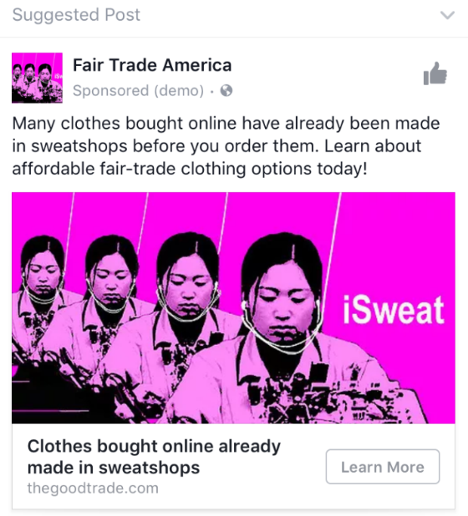

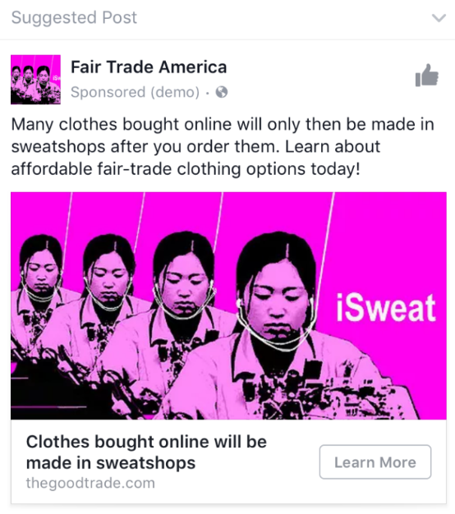

**Figure W2**

**Study 1: Facebook Ads for Petition**

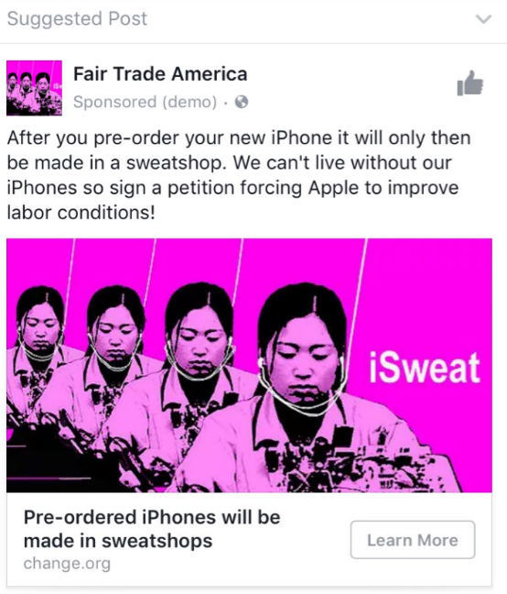

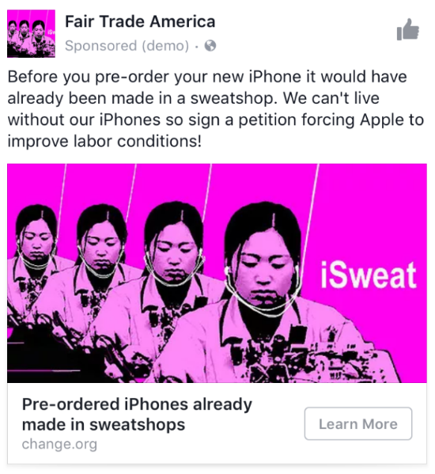

**WEB APPENDIX B**

**Table W1**

**Study 1: Facebook Click-Through Rates**



**WEB APPENDIX C**

**Study 2: Stimuli**

***Main Study Stimuli***

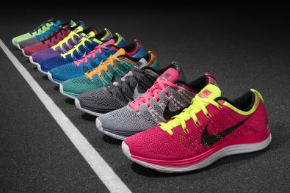

*Made-to-stock*

Imagine that you are looking for a pair of athletic shoes. Imagine you found a pair of Nike shoes online with your preferred color and style. The shoes sell for $89.99. *(These shoes were made in Bangladesh)*. After you choose which options you want, the shoes will ship from their large in-stock inventory within 5-7 business days.

*Made-to-order*

Imagine that you are looking for a pair of athletic shoes. Imagine you found a pair of Nike shoes online that you can have custom-made in your preferred color and style. That is, Nike will only produce the shoes after you order them. The shoes sell for $89.99. (*These shoes will be manufactured in Bangladesh*). After you choose which custom options you want, the shoes will be sewn immediately and shipped within 5-7 business days.

***Marketing Manager Survey Stimuli***

*Participants viewed the picture from study 2 and read the following:*

We would like for you to evaluate the following scenarios from the view of a marketing manager. Using your experience we would like for you to determine what you think are the best options to launch in the market. We want you to take the perspective as a marketing manager from Nike. As a Marketing Manager at Nike, consider the following two options:

Option 1: Nike sells shoes online. As Nike, you will offer a variety of colors and styles for shoes that sell for $89.99 that were manufactured in Bangladesh, a country known for underpaying labor. After a customer places an order, the shoes ship from a large in-stock inventory within 5-7 business days.

Option 2: Nike sells custom-made shoes online. As Nike, you will offer a variety of colors and styles that sell for $89.99 that will be manufactured in Bangladesh, a country known for underpaying labor. After a customer chooses which custom options they want, the shoes will be sewn immediately and shipped within 5-7 business days.

The offers are similar except in one case the shoes are pre-made, and in the other case they are made on-demand. Price, variety, quality, delivery time, etc. are similar.

**WEB APPENDIX D**

**Figure W3**

**Study 2: Mediation Path Model**

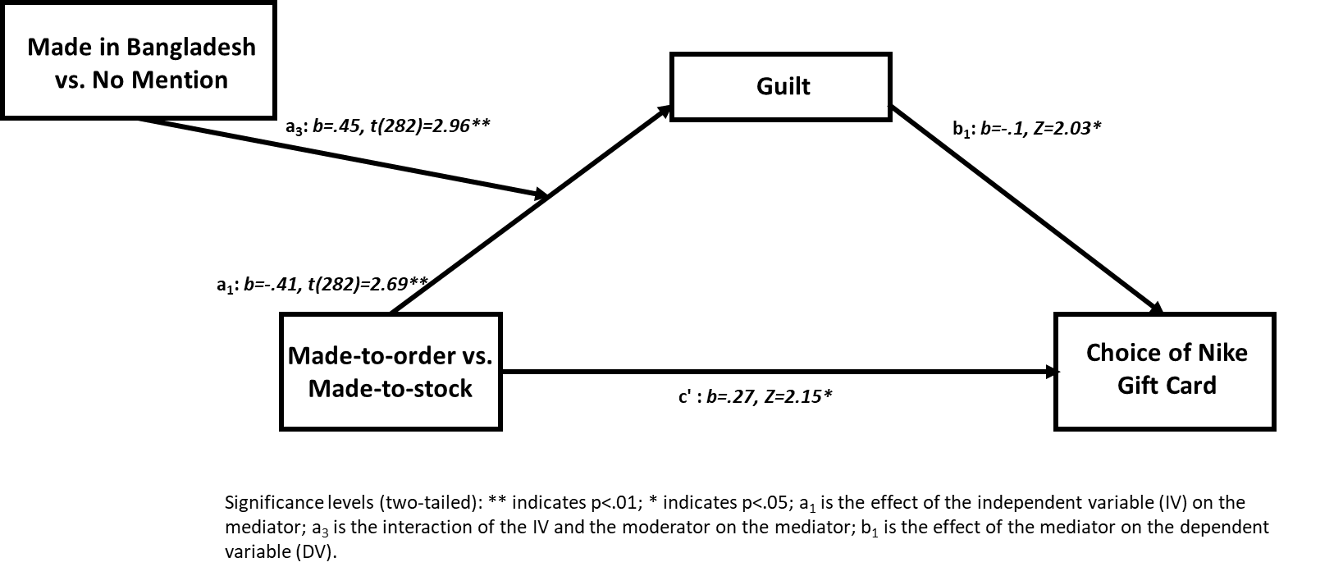

**WEB APPENDIX E**

**Study 2: Follow Up Study**

***Procedure***

Three hundred and forty-nine participants were recruited from Prolific (Mage=37, 58% female). We restricted the sample to the United Kingdom, United States, and Canada and required that English was spoken as a first language. This resulted in a distribution of 73% U.K., 22% U.S., and 5% Canadian participants. There were no interactive effects of country on any of the dependent variables so we do not mention this further. Participants were randomly assigned to a production condition (made-to-order vs. made-to-stock) and an ethicality condition (no living wage vs. no mention) in a 2 × 2 between-subjects design. All participants read about a furniture company. In the made-to-order conditions participants read “Imagine that you are looking for some wood furniture. Imagine that a brand sells high quality custom-made furniture which you can choose to be made in a variety of styles (classic, modern, urban), finishes (dark, light, natural), and wood options (pine, oak, cherry). The furniture is given 4.8 out of 5 stars by customers, and is similar in price and quality to comparable furniture sold in stores. After you choose which custom options you want, the furniture will be made after you order it and shipped within 5-7 business days.” In the made-to-stock conditions participants read “Imagine that you are looking for some wood furniture. Imagine that a brand sells high quality furniture which you can choose a variety of styles (classic, modern, urban), finishes (dark, light, natural), and wood options (pine, oak, cherry). The furniture is given 4.8 out of 5 stars by customers, and is similar in price and quality to comparable furniture sold in stores. After you choose which options you want, the furniture will be shipped from their large in-stock inventory within 5-7 business days. In the no living wage conditions participants also read “The company does not pay a living wage, which prevents several of the workers from sending their children to school. The company [will not pay] (had not payed) a living wage when they made the furniture you are considering to order.” Participants were then asked a purchase intention measure “How likely would you buy a piece of furniture from this company” (1=“very unlikely”; 9=“very likely”). In the case of anticipated guilt, because guilt can arise for many reasons (e.g., purchase indulgence), we included a prompt referring to the context of ethicality. More specifically, participants were asked: “Consider how buying this furniture would make you feel about the ethicality of its production. How would you feel?” with items guilty and bad (r = .94; 1=“not at all”; 9=“very much”). Participants also answered two manipulation check items on direct responsibility and agency: “Think about the production of the furniture. How much agency did you have in the furniture being produced?” (1 = “no agency,” 7 = “a lot of agency”) and “Think about the production of the furniture. How responsible would you have been for having the furniture made?” (1 = “not responsible,” 7 = “very responsible”; r = .72). Participants also answered a manipulation check on wage favorability “This furniture is made with favorable wages.” (1=“strongly disagree”; 7=“strongly agree”).

***Results and Discussion***

*Manipulation checks.* We conducted a 2 × 2 analysis of variance (ANOVA) with participation in production and ethicality as the independent variables and the agency/responsibility manipulation check as the dependent variable. We found a main effect of participation in production (F(1, 345)=65.58, *p<*.001, ηp2=.16; other *p*s>.1), in which agency/responsibility was higher in the made-to-order condition than in the made-to-stock condition (Mmade-to-order=4.55, SD=1.74 vs. Mmade-to-stock=3.08, SD=1.7). A similar analysis was conducted with wage favorability as the dependent variable. Participants indicated a significantly lower wage favorability when the product was made without a living wage compared to when there was no mention of wages (F(1, 344)=741.32, *p<*.001, ηp2=.68; other *p*s>.1; Mno living wage=1.54, SD=1.06 vs. Mno mention=4.39, SD=.86).

*Purchase Intention.* We conducted a 2 × 2 ANOVA with participation in production (made-to-order = –1, made-to-stock = 1), ethicality (no living wage = –1, no mention = 1), and their interaction as the independent variables and purchase intention as the dependent variable. We found a significant main effect of participation in production (F(1, 345)=18.63, p<.001, ηp2=.05), a significant main effect of ethicality (F(1, 345)=300.45, p<.001, ηp2=.47), and a significant interaction between participation in production and ethicality (F(1, 345)=6.9, p<.01, ηp2=.02). When there was underpaid labor in production, purchase intention for the made-to-order furniture was lower than the made-to-stock furniture (Mmade-to-order=2.88, SD=2.05 vs. Mmade-to-stock=4.24, SD=2.25; F(1, 345)=24.99, p<.001, ηp2=.15). However, when there was no mention of the labor conditions, there was no significant difference in purchase intention between the made-to-order and made-to-stock conditions (Mmade-to-order=6.79, SD=1.59 vs. Mmade-to-stock=7.12, SD=1.2; F(1, 345)=1.38, n.s., ηp2=.15).

*Guilt.* We conducted 2 × 2 ANOVA with guilt as the dependent variable and found a significant main effect of participation in production (F(1, 345)=4.24, *p=*.04, ηp2=.01), a significant main effect of ethicality (F(1, 345)=443.5, *p<*.001, ηp2=.56), and a significant interaction between participation in production and ethicality (F(1, 345)=10.02, *p=*.002, ηp2=.03). Regarding the interaction, when there was no living wage, participants anticipated feeling more guilt in the made-to-order condition than in the made-to-stock condition (Mmade-to-order=7.12, SD=2.3 vs. Mmade-to-stock=5.98, SD=2.62; F(1, 345)=14.15, *p<.*001, ηp2=.04); In the no-mention conditions, there were no effects of participation in production on guilt (no mention: Mmade-to-order=1.83, SD=1.25 vs. Mmade-to-stock=2.07, SD=1.65; F(1, 345)=.59, n.s).

*Mediation*. We conducted a bootstrap moderated mediation (Model 7 in PROCESS; Hayes 2017) using 5,000 resamples, with participation in production as the independent variable (made-to-order = –1, made-to-stock = 1), ethicality as the moderator (no living wage = –1, no mention = 1), anticipated guilt as the mediator, and purchase intention dependent variable. Guilt mediated the effect of participation in production on purchase intention in the no living wage conditions (b=–.35, 95% confidence interval [CI]: .12, .58), but not in the no mention conditions (b=-.07, CI: –.21, .06).

In this follow-up study to study 2, we found an interaction between ethicality and participation in production. Under negative ethicality (no fair wage), participants indicated a lower purchase intention if the furniture was made-to-order than if it was made-to-stock, in support of H1a. However, when there was no mention of wages, there was no difference based on participation in production. Furthermore, anticipated guilt mediated these effects, in support of H2.

**WEB APPENDIX F**

**Figure W4**

**Study 3: Mediation Path Model**

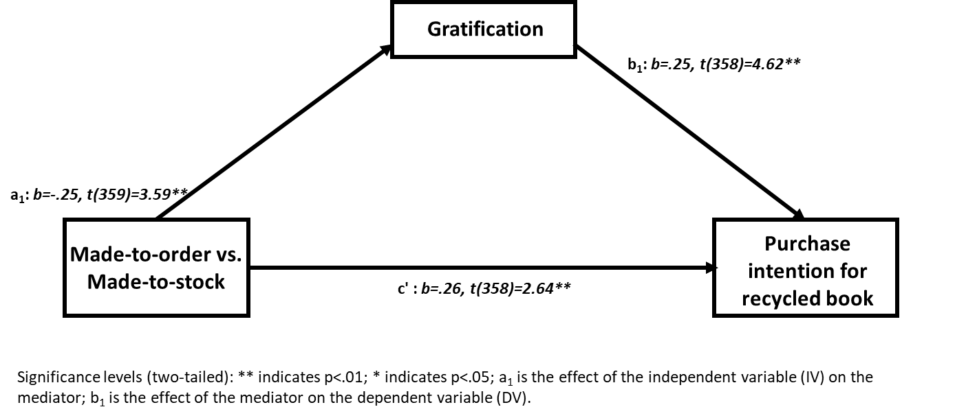

**WEB APPENDIX G**

**Figure W5**

**Study 4: Mediation Path Model**

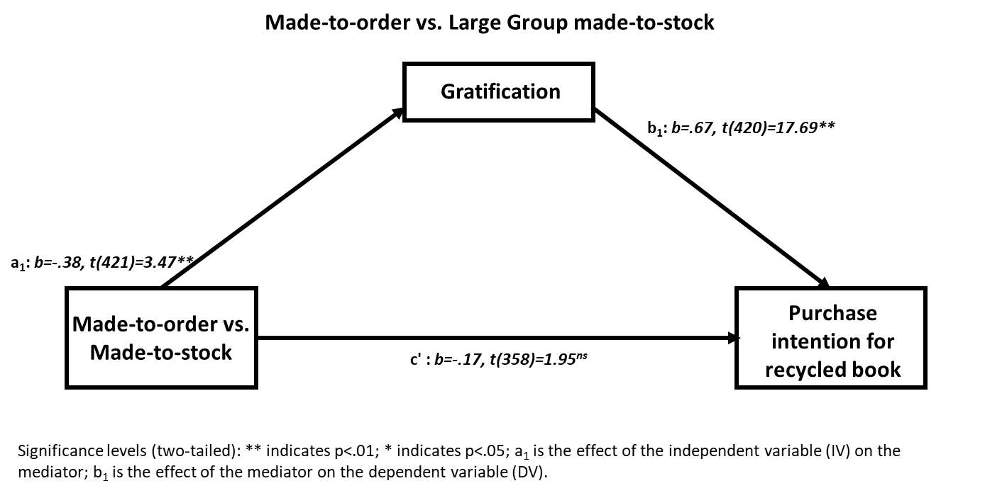

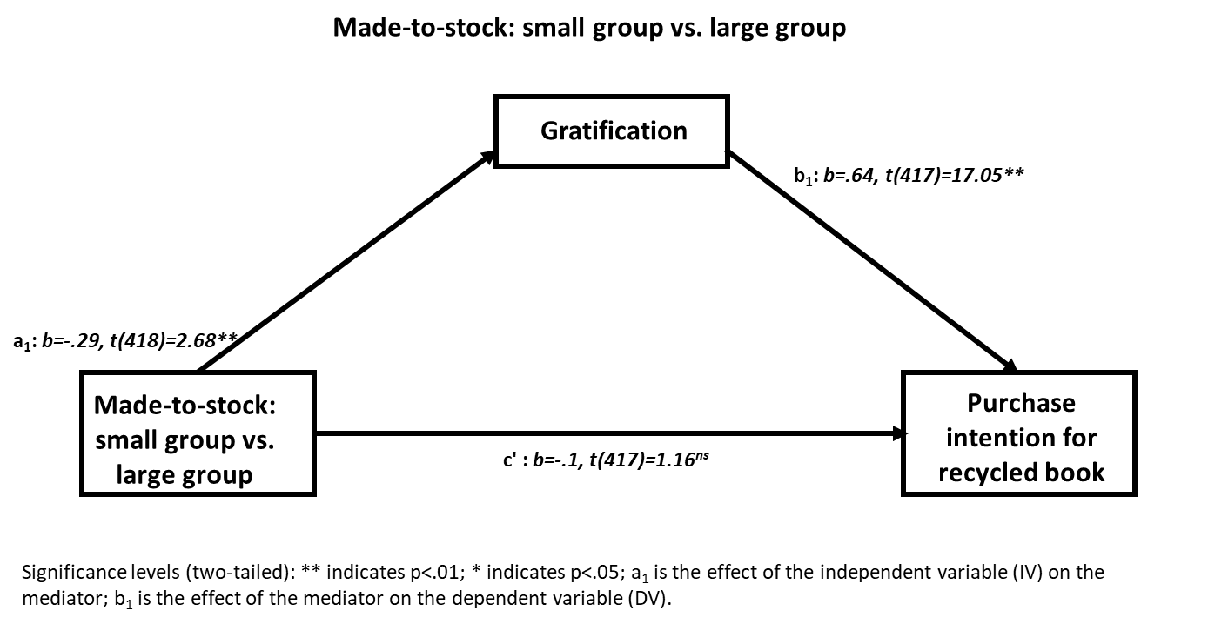

**WEB APPENDIX H**

**Study 5 Stimuli**

In the following study, you will be asked about jeans made by company A. The name of the company has been disguised for the purpose of this study.

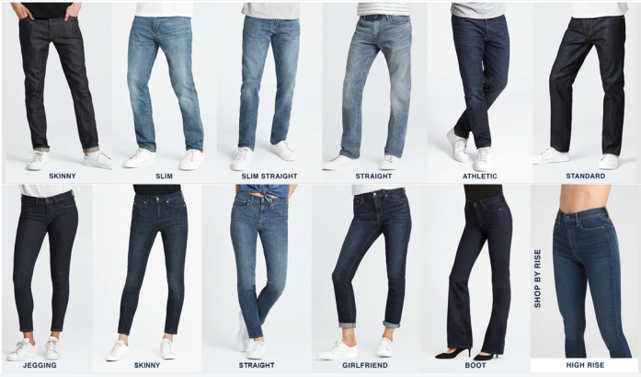

Imagine that you would like to buy jeans from company A online. Company A sells reasonably priced jeans online. Jeans are for men and women, come in a wide variety of sizes, and have the following attributes:

**Wash:** Light blue, dark blue, very dark blue, black

**Cut:** Straight leg, boot cut, skinny, slim, athletic, standard, relaxed

**Material:** 100% cotton, cotton Lycra blend for added stretch

*Made-to-Order Condition*

The company will use a factory in Vietnam that does not pay a living wage to make the jeans you are considering to order.

The jeans in your selected style are produced on-demand and will be made only after you order them. It will take 7-10 business days for the company to make and ship the jeans to your house.

*Made-to-Stock Condition*

The company had used a factory in Vietnam that does not pay a living wage to make the jeans you are considering to order.

The jeans in your selected style were already made and are in-stock at the time of order. It will take 7-10 business days for the company to ship the jeans to your house.

**WEB APPENDIX I**

**FIGURE W6**

**Study 5: Mediation Path Model**

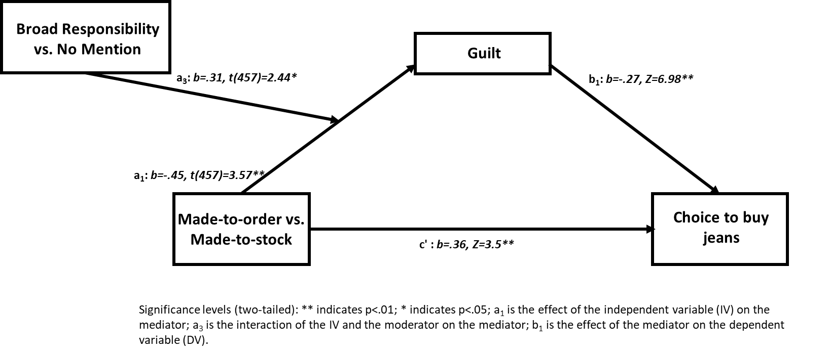

**WEB APPENDIX J**

**Study Measures**

**Study 1:**

*Pretest:*

* “This ad is realistic.” (1= “strongly disagree,” 7=“strongly agree”)

**Study 2:**

*Pretest:*

* “This product was made with ethical production practices.” (1= “strongly disagree,” 7=“strongly agree”)

*Choice:*

* “One person from this survey will be randomly selected to receive a prize. You can choose to either receive $100 gift card from Nike (Nike ID) to purchase these (customized) shoes or $40 in cash. If you win, which option would you prefer?” (“$40 cash/$100 gift card”)

*Guilt:*

* “Consider how buying these shoes would make you feel about the wages paid to produce these shoes. How would you feel?” with items guilty and bad (1=“not at all”; 9=“very much”).

*Manipulation Check:*

* “Think about the production of the shoes. How much agency did you have in the shoes being produced?” (1 = “no agency,” 7 = “a lot of agency”)
* “Think about the production of the shoes. How responsible would you have been for having the shoes made?” (1 = “not responsible,” 7 = “very responsible”)

**Study 3:**

*Pretest:*

* *“*Imagine a book that is produced with recycled paper. How much do you agree or disagree with the following: This product was made with ethical production practices.” (1= “strongly disagree,” 7=“strongly agree”)
* *“*Imagine a book that is produced with regular paper. How much do you agree or disagree with the following: This product was made with ethical production practices.” (1= “strongly disagree,” 7=“strongly agree”)
* *“*Imagine a book that is produced with recycled paper. How much do you agree or disagree with the following: This product would be expensive.” (1= “strongly disagree,” 7=“strongly agree”)
* *“*Imagine a book that is produced with regular paper. How much do you agree or disagree with the following: This product would be expensive.” (1= “strongly disagree,” 7=“strongly agree”)
* *“*Imagine a book that is produced with recycled paper. How much do you agree or disagree with the following: This product would be high in quality.” (1= “strongly disagree,” 7=“strongly agree”)
* *“*Imagine a book that is produced with regular paper. How much do you agree or disagree with the following: This product would be high in quality.” (1= “strongly disagree,” 7=“strongly agree”)

*Purchase Intention:*

* “Which version of the book are you more likely to buy?” (1 = “more likely regular paper for $11,” 9 = “more likely recycled paper for $14”)
* “How likely would you buy the regular paper version of the book for $11?” (1=“very unlikely”; 9=“very likely”)
* “How likely would you buy the recycled paper version of the book for $14?” (1=“very unlikely”; 9=“very likely”).

*Guilt and Gratification:*

* “Think about your level of agency and responsibility in the process of causing the book to be made. How would you feel about choosing either option?” (1 = “more true for the regular version,” 9 = “more true for the recycled version”). This was followed by two items on guilt (“guilty” and “bad”) and two items on gratification (“gratification” and “happy”).

*Results for Guilt.* Measures on guilt were not included in the analysis. Participants indicated they would feel significantly more guilt with the regular version of the book in the made-to-order condition than in the made-to-stock condition (M=3.35, SD=1.57 vs. M=4.06, SD=1.5 vs, t(359)=4.4, p<.001, ηp2=.05)

*Manipulation Check:*

* “Think about the production of the book. How much agency did you have in the book being produced?” (1 = “no agency,” 7 = “a lot of agency”)
* “Think about the production of the book. How responsible would you have been for having the book made?” (1 = “not responsible,” 7 = “very responsible”)

*Control Variable:*

* “How much do you identify with the book?” (1 = “not at all,” 5 = “a lot”)

**Study 4:**

*Purchase Intention:*

* “How likely would you buy the regular paper version of the book for $11?” (1=“very unlikely”; 9=“very likely”)
* “How likely would you buy the recycled paper version of the book for $14?” (1=“very unlikely”; 9=“very likely”).

*Guilt and Gratification:*

* How would you feel about choosing either option?” (1 = “more true for the regular version,” 9 = “more true for the recycled version”). This was followed by two items on guilt (“guilty” and “bad”) and two items on gratification (“gratification” and “happy”).

*Results for Guilt.* Measures of guilt were not used in the analysis. There was a significant effect of condition on guilt (F(2, 626)=5.06, p=.007). Participants anticipated feeling more guilty in the made-to-order condition compared to the large group made-to-stock condition when considering the regular book (compared to the recycled book) (Mmade-to-order=3.16, SD=1.72, vs. Mlarge=3.7, SD=1.77, t(626)=3.2, p=.002; ηp2=.02). There was no significant difference between the small group and the large group made-to-stock conditions on guilt (Msmall=3.46, SD=1.73, t(626)=1.44, n.s.). There was a marginally significant difference between the made-to-order condition and the small group condition on guilt (t(626)=1.75, p=.08).

*Manipulation Check:*

* “Think about the production of the book. How much agency did you have in the book being produced?” (1 = “no agency,” 7 = “a lot of agency”)
* “My choice makes a difference.” (1 = “strongly disagree,” 7 = “strongly agree”)
* “My role in this system feels diffused.” (1 = “strongly disagree,” 7 = “strongly agree”)
* “I feel like an individual.” (1 = “strongly disagree,” 7 = “strongly agree”)

*Feeling Like an Individual.* This item was not included in the analysis. There was a significant effect of condition on feeling like an individual (F(2, 626)=29.23, p<.001). Participants anticipated feeling more like an individual in the made-to-order condition compared to the large group made-to-stock condition (Mmade-to-order=5.49, SD=1.21, vs. Mlarge=4.66, SD=1.62, t(626)=6.47, p<.001). There was a significant difference between the small group and the large group made-to-stock conditions on feeling like an individual (Msmall=5.53, SD=1.07, t(626)=6.73, p<.001). There was no significant difference between the made-to-order condition and the small group condition on feeling like an individual (t(626)=.26, n.s.).

*Control Variables:*

* “This choice will be visible to others.” (1 = “strongly disagree,” 7 = “strongly agree”)

**Study 5:**

*Pretest:*

* “Imagine you purchased the jeans. How directly responsible would you have been for having the jeans made?” (1=“not at all responsible”; 7=“very responsible”)
* “Imagine you purchased the jeans. In a more broad sense, how responsible would you have been for having the jeans made?” (1=“not at all responsible”; 7=“very responsible”)

*Choice:*

* “Would you buy these jeans?” (“yes/no”)

*Guilt:*

* “Consider how buying this jeans would make you feel about the wages paid to produce these jeans. How would you feel?” with items guilty and bad (r = .94; 1=“not at all”; 9=“very much”)

*Perceived Awareness of Research Hypothesis Scale* (Rubin, Paolini, and Crisp 2010)

* I knew what the researchers were investigating in this research. (1 = “strongly disagree,” 7 = “strongly agree”)
* I wasn’t sure what the researchers were trying to demonstrate in this research. (reverse coded; 1 = “strongly disagree,” 7 = “strongly agree”)
* I had a good idea about what the hypotheses were in this research. (1 = “strongly disagree,” 7 = “strongly agree”)
* I was unclear about exactly what the researchers were aiming to prove in this research. (reverse coded; 1 = “strongly disagree,” 7 = “strongly agree”)

**WEB APPENDIX K**

A decision was madea priori that participants would be excluded if they failed comprehension check questions. Across lab studies participants were asked binary choice questions to determine whether they paid attention to and understood the stimuli (e.g. “If I ordered the shoes”: with two choices: “the shoes would have been made before ordering”; “the shoes would have been made after ordering”). Those who failed these questions were excluded. Following Meyvis and Van Osselaer’s (2018) guidelines specified in tutorial on increasing statistical power, we did not exclude these participants if failure was higher in one condition than another. In Study 3, we found that significantly more people failed the check item in the made-to-order condition than in the made-to-stock condition. Therefore, we did not exclude participants who failed to answer this item correctly (as expected, excluding these participants increases the statistical significance of various tests in this study). The percentage of participants who failed the check item are in the same range as in other research following similar exclusion procedures (e.g., 600 of 714 participants passed the attention check) (Mislavsky and Simonsohn 2018).

|  |  |  |  |
| --- | --- | --- | --- |
| Study | Raw Number | Number of Participants Who Failed to Answer Check Correctly | Number of Participants Used in the Final Analysis |
| 2 | 319 | 35 | 284 |
| 2 *follow up* | 394 | 55 | 349 |
| 3 | 361 | 52 | 361 |
| 4 | 736 | 105 | 631 |
| 5 | 519 | 59 | 460 |

**REFERENCES**

Meyvis, Tom, and Stijn MJ Van Osselaer (2018), "Increasing the Power of Your Study by Increasing the Effect Size," *Journal of Consumer Research,* 44(5): 1157-1173.

Mislavsky, Robert, and Uri Simonsohn (2018), "When Risk Is Weird: Unexplained Transaction Features Lower Valuations," *Management Science*, 64 (11), 4967-5460.