SUPPORTIVE INFORMATION (for online): Appendix A

Table A1. Descriptive statistics of all variables used in analysis, N=877, % or mean
Variable | School | Vocational training
Perceives discrimination after transition (%) | 40.3 | 42.4
Perceives discrimination before transition (%) | 48.4 | 45.5
Age | 15.8 | 16.1
 | (.036) | (.035)
Female (%) | 49.7 | 42.0
Highest parental education (%)
Lower secondary | 16.1 | 17.8
Intermediate secondary | 29.6 | 33.9
Upper secondary | 13.9 | 10.7
Higher education | 18.0 | 10.5
No qualification | 4.6 | 5.4
Missing | 17.7 | 21.8
Highest parental occupation (%)
Manager, professional, specialist | 19.9 | 23.4
Skilled manual | 29.8 | 23.6
Service worker or clerk | 20.2 | 27.7
Unskilled | 8.6 | 6.7
Missing | 21.5 | 18.6
Regional supply/demand ratio of apprenticeships | .958 | .984
 | (.007) | (.006)
School-leaving qualification (%)
Intermediate secondary | 66.1 | 45.0
Lower secondary | 33.9 | 55.0
Grade point average | .241 | -.042
 | (.053) | (.041)
Not German citizen (%) | 30.0 | 30.3
Origin group (%)
Turkey | 23.1 | 22.0
Central and Eastern Europe | 12.1 | 14.5
Southern Europe, FYO | 19.1 | 24.9
Former Soviet Union | 20.4 | 21.8
Small minorities | 25.2 | 16.8
Migration generation
First (%) | 9.4 | 10.1
Second (%) | 58.3 | 54.3
Third or 1 native parent (%) | 32.3 | 35.6
Literacy score in German | -.416 | -.614
 | (.043) | (.037)
German among languages learnt at home (%) | 66.9 | 72.1
Share of students with migration background in 9th grade
<25% | 29.3 | 25.5
25…50% | 14.5 | 17.2
>50% | 15.6 | 21.0
Missing | 40.6 | 36.2
Graduated at 2012 (%) | 83.6 | 61.4
Has experienced discriminating treatment at school or firm (%) | 23.6 | 20.0
Has experienced discrimination in hiring process (%) | 8.4 | 9.4
Occupational aspiration (%)
Manager, professional | 35.2 | 24.0
Specialist | 16.1 | 19.6
Service worker or clerk | 13.7 | 16.8
Manual worker | 2.4 | 12.3
Missing | 32.5 | 27.3
Lower skill level of apprenticeship than aspired (%) | 0 | 10.3
High literacy | 30.1 | 22.6
High grades | 34.1 | 21.4
Entry to semi-skilled apprenticeship (%) | 0 | 23.2
Entry to skilled apprenticeship (%) | 0 | 75.8
Missing skill level | 0 | 1
Entry to not aspired apprenticeship (%) | 0 | 31.7
Entry to aspired apprenticeship (%) | 0 | 37.0
Missing evaluation on accordance to aspirations | 0 | 31.3
Note: All percentages are calculated from the sample that includes young people who continue in school or enter to apprenticeship at firm.

Table A2. ATT Estimates, Balancing of the Covariates between Control and Treatment Group and the Overlap of These Two Groups

 | ATT | Balancing test |  |  | Treated cases off support (number) | N
 |  | Pseudo R2 | Mean bias | Median bias
Staying in school compared to transition to:
VET | .066 | .004 | 2.4 | 1.9 | 3 | 877
Semi-skilled VET position | .142** | .011 | 4.2 | 2.7 | 2 | 494
Skilled VET position | .051 | .004 | 2.2 | 2.2 | 4 | 760
Not aspired VET position | .129** | .010 | 4.1 | 3.6 | 2 | 532
Aspired VET position | .042 | .005 | 2.5 | 2.1 | 6 | 559
Note: Significance levels are calculated based on bootstrapped standard errors with 200 replications
*** p<.01, ** p<.05, * p<.1 (two-tailed tests)

Table A3. Likelihood of Different Transitions to Apprenticeship Compared to Staying in School

 | Staying in school (reference group) compared to entry to apprenticeship:
 | M1: any position | M2: semi-skilled | M3: skilled | M4: not aspired | M5: aspired
Perceived discrimination | -.028 | -.058 | -.007 | -.082* | -.005
before transition | (.034) | (.038) | (.038) | (.042) | (.042)
Female | -.092*** | -.095*** | -.061* | -.060 | -.051
 | (.032) | (.034) | (.035) | (.038) | (.037)
Parental education (ref. lower secondary)
Intermediate secondary | .020 | .064 | -.007 | .005 | .021
 | (.048) | (.052) | (.056) | (.057) | (.058)
Upper secondary | -.019 | -.029 | -.024 | -.009 | -.073
 | (.060) | (.063) | (.065) | (.072) | (.070)
Higher education | -.123** | -.055 | -.143** | -.156** | -.054
 | (.059) | (.056) | (.063) | (.061) | (.066)
No qualification | .097 | .124 | .031 | .108 | .113
 | (.078) | (.091) | (.093) | (.105) | (.110)
Parental occupation (ref. manager, professional, specialist)
Skilled manual | .060 | .052 | .069 | .026 | .114*
 | (.047) | (.050) | (.053) | (.056) | (.058)
Service worker or clerk | .104** | .119** | .109** | .110* | .107*
 | (.044) | (.052) | (.050) | (.056) | (.056)
Unskilled | -.022 | .065 | -.065 | -.008 | -.055
 | (.067) | (.072) | (.073) | (.074) | (.075)
Regional supply/demand ratio of | .201* | .084 | .197 | .001 | .220
apprenticeships | (.122) | (.137) | (.132) | (.149) | (.145)
Intermediate qualification | -.027 | -.134*** | .010 | -.058 | .002
 | (.043) | (.044) | (.049) | (.051) | (.053)
Grade point average | -.052*** | -.031* | -.051*** | -.059*** | -.030
 | (.016) | (.017) | (.018) | (.019) | (.020)
Not German citizen | .033 | .011 | .052 | .040 | .014
 | (.040) | (.043) | (.044) | (.046) | (.049)
Origin group (ref. Turkey)
Central and Eastern Europe | .083 | .109 | .070 | -.004 | .109
 | (.056) | (.067) | (.064) | (.070) | (.071)
Southern Europe, FYO | .039 | -.013 | .038 | .061 | .000
 | (.049) | (.050) | (.054) | (.057) | (.058)
Former Soviet Union | .069 | .010 | .084 | .020 | .030
 | (.052) | (.058) | (.058) | (.064) | (.066)
Small minorities | -.084 | .013 | -.114** | -.039 | -.072
 | (.051) | (.053) | (.056) | (.058) | (.057)
Migration generation (ref. first)
Second | .021 | .072 | .022 | .039 | .001
 | (.057) | (.050) | (.061) | (.062) | (.064)
Third or 1 native parent | .145** | .112* | .171** | .064 | .132**
 | (.066) | (.065) | (.072) | (.077) | (.060)
Literacy score in German | -.030 | -.049 | -.019 | .006 | -.018
 | (.021) | (.023) | (.023) | (.026) | (.025)
Learnt German at home | .082** | .095** | .053 | .083* | .056
 | (.038) | (.042) | (.043) | (.044) | (.047)
Students with migration background in the class (ref. <25%)
25 … 50% | .033 | -.071 | .039 | -.029 | .081
 | (.050) | (.054) | (.055) | (.060) | (.061)
> 50% | .063 | .008 | .065 | -.009 | .085
 | (.058) | (.054) | (.055) | (.059) | (.060)
Pseudo R-squared | .125 | .245 | .102 | .141 | .132
Observations | 877 | 494 | 760 | 532 | 559
Note: Average marginal effects from logistic regression. Standard errors are in parentheses. Models control for entry time and age.
*** p<.01, ** p<.05, * p<.1 (two-tailed tests)

Figure A1. Effects of Transition to Apprenticeship on Perceived Discrimination, Depending on Application Behavior in the Control Group

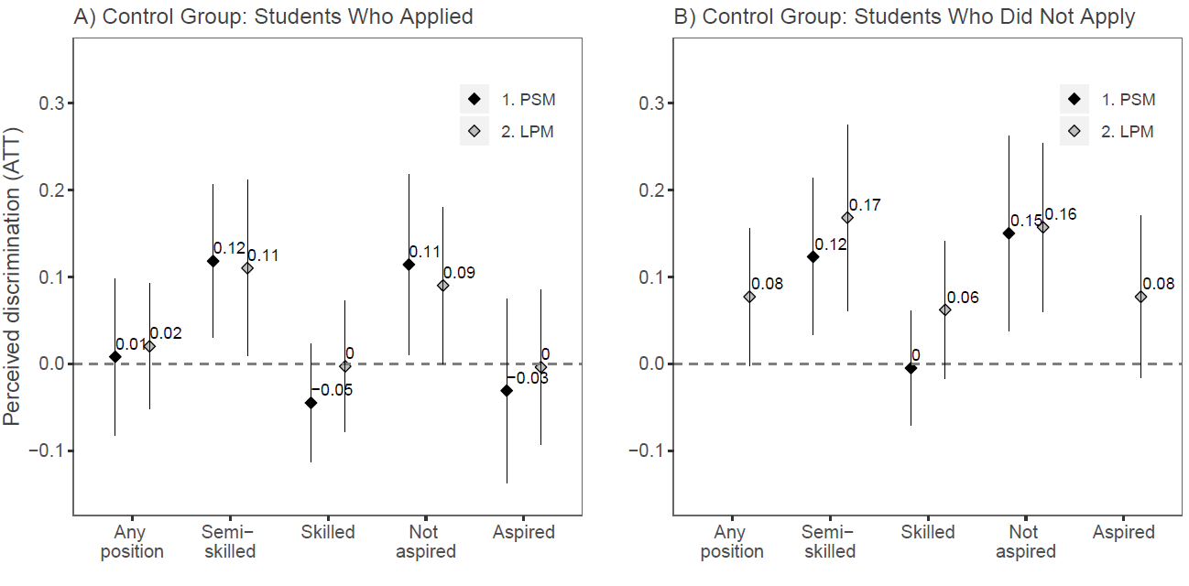
Note: The reference category is: A) students staying in school and applied for apprenticeship; B) students staying in school and did not apply for apprenticeship. Reference category is presented by the line crossing the vertical axes at 0. PSM denotes propensity score matching; LPM denotes the linear probability regression; 90 percent confidence intervals. Results are not presented for two treatment groups where PSM failed to assign counterfactuals for more than 10% of treated respondents.

Table A4. Explaining the Effect of Transition to Apprenticeship on Perceived Discrimination

 | - Skill level, N=768 |  |  |  |  |  | - Accordance with Career Aspirations, N=586
 | M1 | M2 | M3 | M4 | M5 | M6 | M1 | M2 | M3 | M4 | M5
Transition (ref. school)
Semi-skilled position | .134** | .129** | .139** | .126** | .101 | .092
 | (.059) | (.059) | (.057) | (.060) | (.073) | (.074)
Skilled position | .036 | .038 | .028 | .029 | .037 | .029
 | (.041) | (.040) | (.040) | (.041) | (.041) | (.041)
Not aspired position |  |  |  |  |  |  | .112** | .109** | .098* | .102* | .089*
 |  |  |  |  |  |  | (.054) | (.052) | (.053) | (.054) | (.053)
Aspired position |  |  |  |  |  |  | .049 | .051 | .054 | .026 | .034
 |  |  |  |  |  |  | (.049) | (.049) | (.049) | (.051) | (.050)
Unequal treatment |  | .137*** |  |  |  |  |  | .148**
 |  | (.046) |  |  |  |  |  | (.051)
Unfair rejection in hiring |  |  | .393*** |  |  |  |  |  | .305*** |  | .299***
 |  |  | (.062) |  |  |  |  |  | (.072) |  | (.077)
Occupational aspiration (ref. manager, professional)
Specialist |  |  |  | .043 |  | .047 |  |  |  | .084 | .062
 |  |  |  | (.054) |  | (.055) |  |  |  | (.061) | (.060)
Service worker or clerk |  |  |  | .037 |  | .041 |  |  |  | .090 | .058
 |  |  |  | (.057) |  | (.057) |  |  |  | (.064) | (.064)
Manual worker |  |  |  | .069 |  | .068 |  |  |  | .163* | .159*
 |  |  |  | (.074) |  | (.074) |  |  |  | (.086) | (.085)
Mismatch |  |  |  |  | .077 | .078
 |  |  |  |  | (.095) | (.098)
R² | .054 | .066 | .102 | .056 | .055 | .057 | .054 | .068 | .082 | .062 | .088
Note: Coefficients from the linear probability regression. Standard errors are in parentheses. Models include all control variables in the full model (same as in online Appendix C). Sample excludes young people who did not reply to questions regarding personal discrimination experiences.
*** p<.01, ** p<.05, * p<.1 (two-tailed test)

Table A5. Interacting Effects of Apprenticeship Quality and Achievement at School on Perceived Discrimination

 | Grades |  | Literacy
 | M1: skill level | M2: fit with aspirations | M1: skill level | M2: fit with aspirations
High achievement | .087 | .061 | .096 | .098
 | (.065) | (.066) | (.067) | (.070)
Outcomes (ref. school)
Semi-skilled | .198*** |  | .169***
 | (.061) |  | (.061)
Skilled | .071 |  | .036
 | (.043) |  | (.043)
Not aspired |  | .157*** |  | .164***
 |  | (.053) |  | (.056)
Aspired |  | .069 |  | .028
 |  | (.053) |  | (.052)
Achievement * outcome (ref. low/average grades * school)
High grades * semi | -.272** |  | -.193
 | (.132) |  | (.138)
High grades * skilled | -.146* |  | -.035
 | (.081) |  | (.080)
High grades * not aspired |  | -.212* |  | -.213**
 |  | (.122) |  | (.106)
High grades * aspired |  | -.102 |  | .051
 |  | (.101) |  | (.104)
R squared | .055 | .055 | .049 | .049
N | 1132 | 979 | 1132 | 979
Note: Coefficients from the linear probability regression. Standard errors are in parentheses. Models include all control variables in the full model (same as in online Appendix C) and a category for preparatory program and its interactions.
*** p<.01, ** p<.05, * p<.1 (two-tailed tests)

Figure A2. Effects of Apprenticeship Quality on Perceived Discrimination by Migration Generation and Achievement

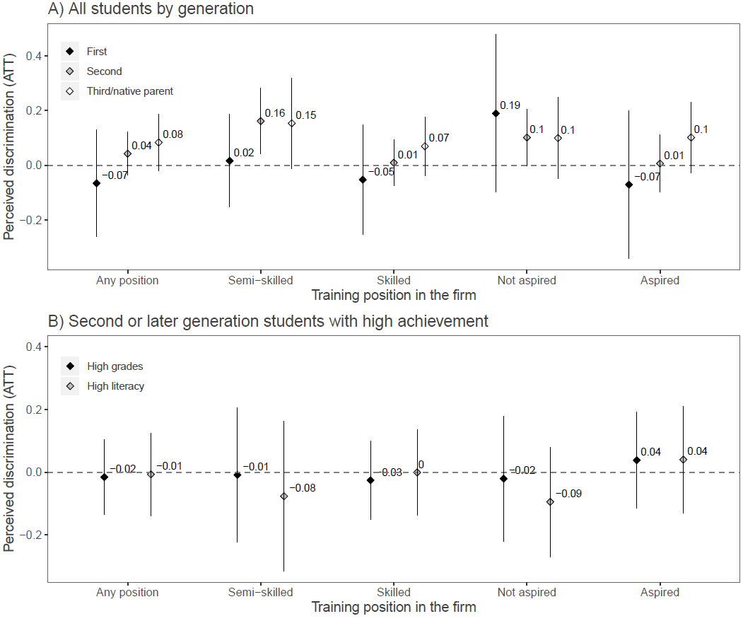

Note: Coefficients from the linear probability regression: A) separate models by migration generation; B) models only for second or later generation students with high achievement in school. Reference category (staying in school) is presented by the line crossing the vertical axes at 0; 90 percent confidence intervals.

Table A6. Effects of Apprenticeship Quality when Using 4-Point Scale for Perceived Discrimination

 | OLS regression |  | Ordered logistic regression
 | M1: skill level | M2: fit with aspirations | M1: skill level | M2: fit with aspirations
Outcomes (ref. school)
Semi-skilled | .154* |  | .367*
 | (.090) |  | (.217)
Skilled | .036 |  | .069
 | (.066) |  | (.142)
Not aspired |  | .146* |  | .348*
 |  | (.085) |  | (.188)
Aspired |  | .002 |  | .006
 |  | (.080) |  | (.178)
Control variables | + | + | + | +
R squared | .056 | .070 | .023 | .029
N | 872 | 719 | 872 | 719
Note: Coefficients from OLS regression models and from ordered logistic regression models. The scale is following: strongly disagree, rather disagree, rather agree and strongly agree. Standard errors are in parentheses. Models include same control variables as in the full model (same as in online Appendix C).
*** p<.01, ** p<.05, * p<.1 (two-tailed tests)

Figure A3. Effects of Apprenticeship Quality on Perceived Discrimination by Geographical Origin Groups

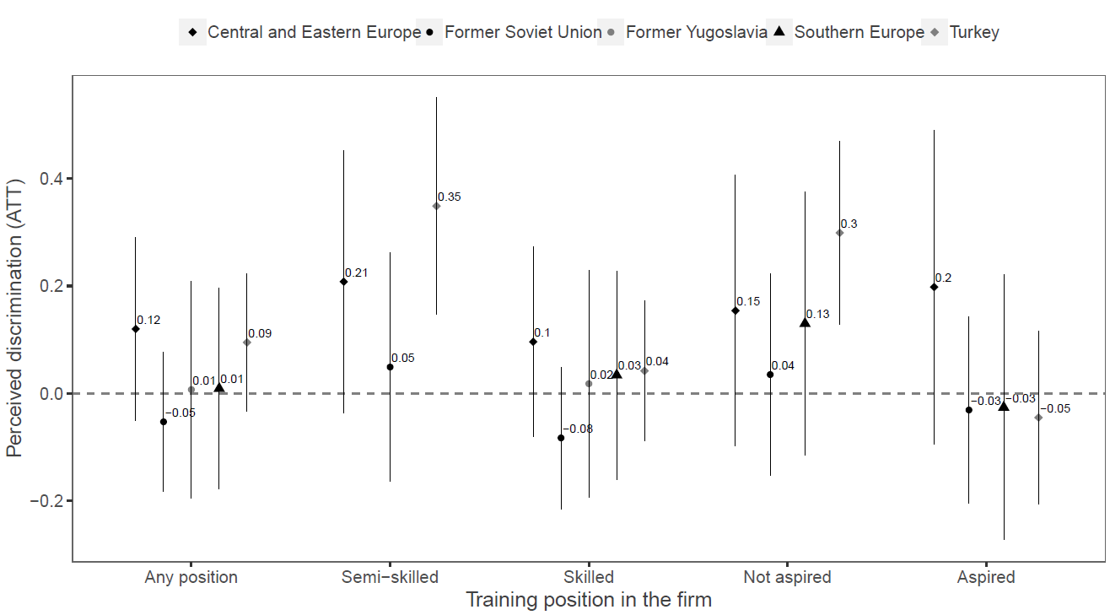

Note: Coefficients from the linear probability regression, separate models by origin groups. Sample sizes range from 88 for countries of Former Yugoslavia to 197 for Turkey. Results are not presented if less than 20 respondents were in the treatment group.
Reference category (staying in school) is presented by the line crossing the vertical axes at 0; 90 percent confidence intervals.

Figure A4. Effects of Apprenticeship Quality on Perceived Discrimination by Sense of Belonging to the People of Germany

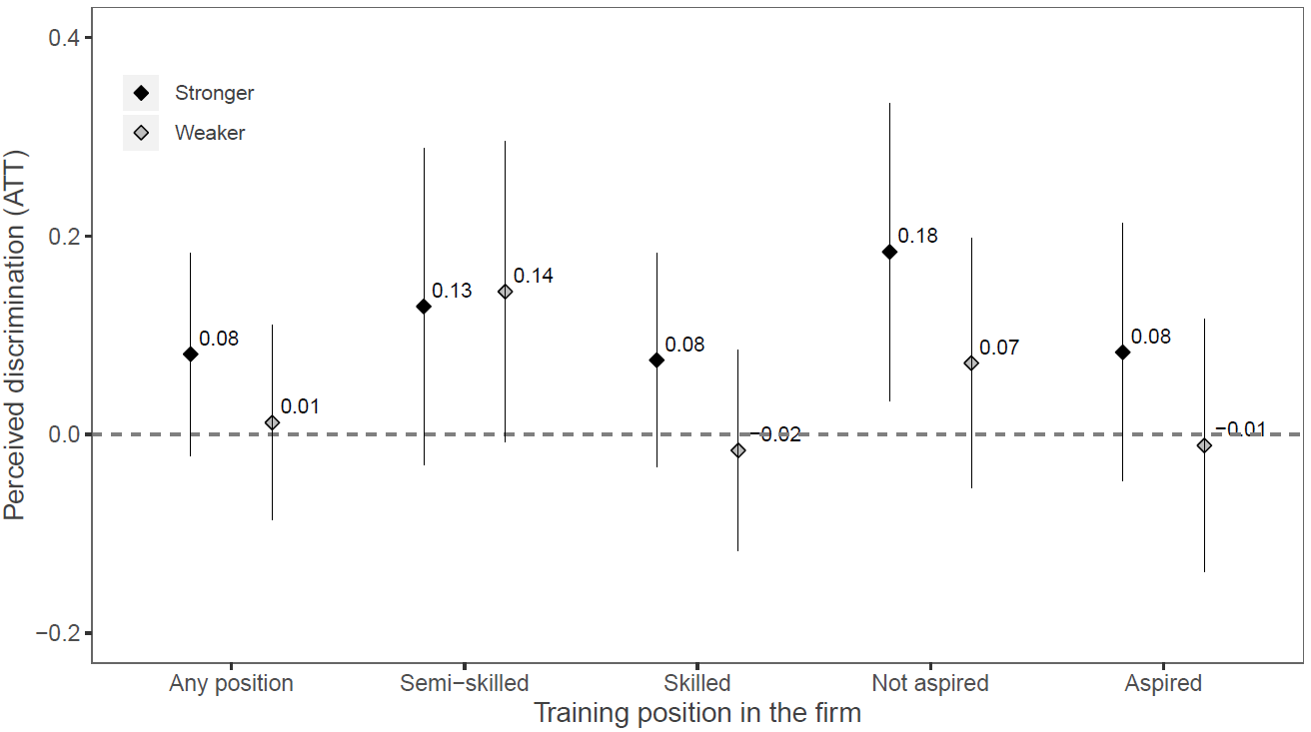

Note: Coefficients from the linear probability regression, separate models by the strength of sense of belonging. Students were asked about their sense of belonging to the people of Germany in 9th grade. Figure present the comparison of two groups: 1) weaker sense of belonging (N=572): young people who replied “not at all”, “almost not at all” or “average”; 2) stronger sense of belonging (N=496): young people who replied “quite strongly” or “very strongly”.
Reference category (staying in school) is presented by the line crossing the vertical axes at 0; 90 percent confidence intervals.

