ONLINE APPENDIX A1
USA Today In-Feed Native Ad (Accessed 2016 Sep 13)
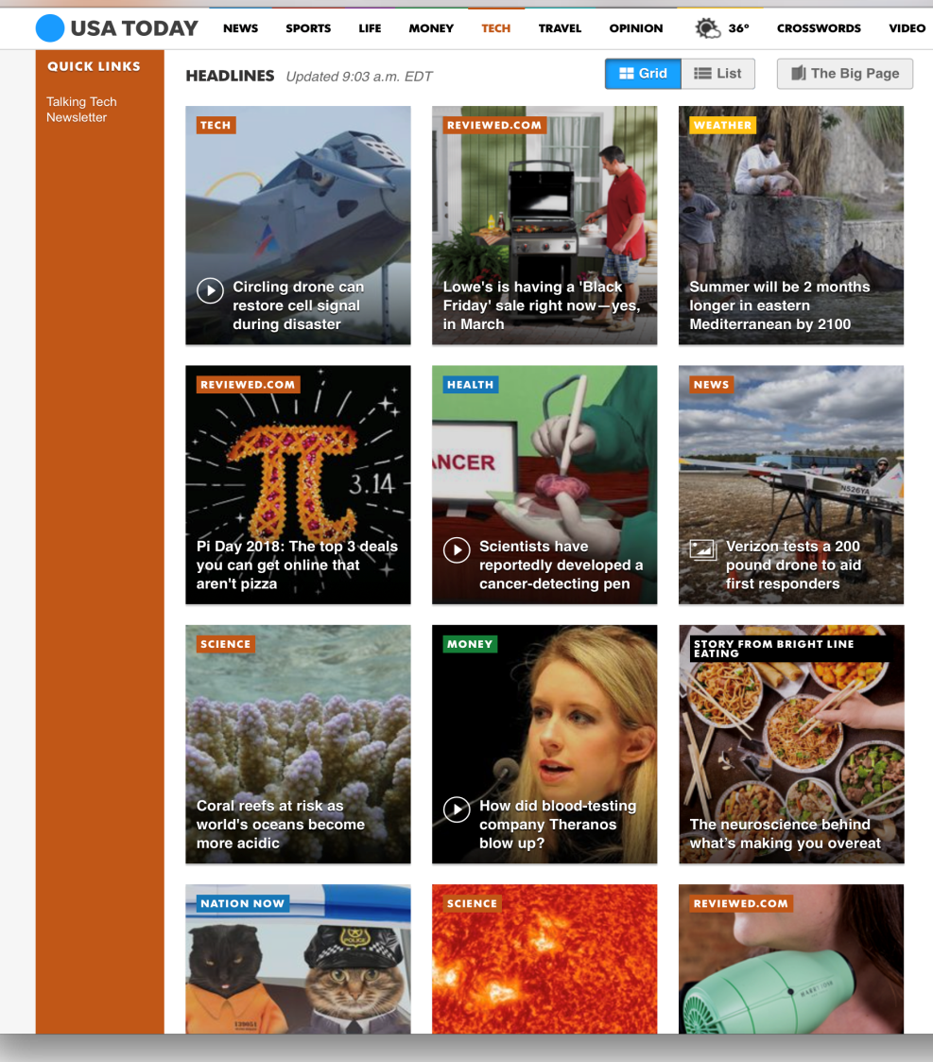

ONLINE APPENDIX A2
Detroit Free Press In-Feed Native Ad (Accessed 2016 Sep 13)

ONLINE APPENDIX A3

NYT In-Feed Native Ad (Accessed 2018 Feb 28)

CNN Tech In-Feed Display (Accessed 2018 Feb 23)

ONLINE APPENDIX A4
Navigable News Website Featuring Chevrolet in Native and In-Feed Display Formats
(additional screenshots from website stimuli used in Studies 1 and 2)
In-Feed Native In-Feed Display

ONLINE APPENDIX B
Descriptive Results from Eye-Tracking in Study 2

Attention on the final ad differs among the 8 conditions of the study, with an average of n=19 subjects per condition. Varying ad position has a greater impact than fixing ad position (10.27 versus 6.85, t-test p = .017.) We report some additional data summaries by condition, many of the differences are not large and not significant at the 95% level. Attention to ads (average ad fixations) changes more from the first three versions to the fourth (DDDN and NNND). The greatest change occurs in the DDDN conditions, from 5.73 to 7.75 fixations for fixed position and 7.85 to 11.61 for varying position. While the display format consistently draws more attention, the native format attracts more attention when appearing without previous exposure. Across conditions, the most top left ad position attracts the most attention (16.95 fixations) and brand recognition (61.7%). The ad position immediately to its right generates the highest click-through rate (32.1%). The average fixations between display (8.46) and native (7.85) condition are significantly different from each when using the count models as shown in Table 2 (model B1).

ONLINE APPENDIX C
Impact of Native Versus Display Format on Attention, Ad Click, Brand Recognition and Website Trustworthiness with Repeated Exposure (Study 2) – Fully Correlated Random Intercepts

 |  |  | Brand | Web
 | Attention | Ad Click | Recognition | Trustworthiness
Intercept | 2.190*** | -5.676*** | -1.290* | 3.497***
Chevrolet | .339** | 1.219** | .483 | -.103
GoPro | .606*** | .619 | 1.018*** | .008
Kohl's | .446*** | -.439 | .538 | -.074
Native ad format | -.247** | 2.487*** | .245 | -.054
Brand familiarity | .023 | .099 | .273*** | .011
Visual appeal | .016 | -.068 | .005 | .015
Positive ad attitude | .044 | .214 | -.029 | .088**
Browsing time | .071*** | .172 | .064 | .053***
First home page browsed | .075 | .241 | -.417** | .089**
Different format shown on the last home page | .218** | .159 | .107 | -.022
Attention spillover | .028*** | .063*** | .014** | -.003**
Ad shown in the middle row in the middle | -.674** | -1.864** | -.681 | .203*
Ad shown in the middle row to the right | -.821** | .393 | .290 | .008
Ad shown on the bottom row in the middle | -.713** | -1.327 | -.840* | .078
Ads shown in varying positions | .029 | 1.747** | 1.114*** | .092
Ads shown in varying positions x native format | .230 | .120 | -.479 | -.119
Std of the random intercept | .354*** | 1.702*** | .714*** | .426***
Correlations among random intercepts:
Ad click | -.247
Brand recognition | .230 | .631***
Web evaluation | -.183 | -.038 | -.307
Other model specific parameters:
Std of the error term |  |  |  | .481***
Dispersion parameter | 1.863***
¹ Baseline brand is AT&T.
² Attention spillover is measured as whether participants remembered seeing an article above or to the left of the ad.
³ *** significant at .99; ** significant at .95; * significant at .90

ONLINE APPENDIX D
Native Ad Disclosure Prominence Pre-Test Study

In this pre-test, we examine the impact of ad disclosure prominence on the same outcome measures as in Study 1. This study reflects the structure of the field experiment.

Method
We employed the same data collection procedure employed in Study 1. We developed new ads for three brands (GoPro, Microsoft, and Skinny Cow) and manipulated disclosures with different levels of prominence without altering overall visual appeal. The study employs a 3 x 3 (low, medium, and high disclosure prominence for the three brands) plus 1 (control with no ad) between-subjects design (Figure D1).
---------- Insert Figure D1 here ---------
Ad disclosure prominence is the key manipulation across conditions. All ad versions are legal but have differing degrees of compliance. According to the Federal Trade Commission guidelines, ad disclosures must be “clear and prominent” and if the “native ad’s focal point is an image or graphic, a disclosure might need to appear directly on the focal point itself” (Rich 2016).
The native ads, appearing in all but the control condition, had at least a minimal legal disclosure (“Sponsored by”), as in Studies 1 and 2. The low prominence condition featured the minimal disclosure in gray text at the bottom left of the ad’s image and text. The medium prominence condition featured an additional blue label saying “Sponsored” on the image, the focal point of the ad. The high prominence disclosure contained the same elements as the medium condition, as well as the advertising brand’s logo to elevate brand prominence.
We recruited 1,020 participants (50% were female, 27% were 40 years old or younger, and 68.9% completed college or higher) from a different commercial online panel, ResearchNow, and asked them to browse our news website and read articles before evaluating their experiences. They spent as long as desired on the site but cannot move on until after two minutes. The requirement was minimal, as we had observed previous participants choosing to browse an average of almost three minutes. The participants were given a survey and asked the same set of questions as in Studies 1 and 2.

Results
Of all participants, 49.2% have spent more than 15 hours on the internet the previous week. Most are familiar with the terms “banner ad” (78%) and “sponsored content” (63.2%), but only 6.2% are familiar with “native ad.” Some participants use an ad blocking service (32%), and 82.8% report they have mistakenly clicked on an ad thinking it was an article at least once. To examine the effects of disclosure prominence we exclude the control condition, only including participants who see an ad (N=908). Model results (Table D1) and summaries of the raw data with hypothesis tests show brand recognition is significantly greater for the highest disclosure prominence than medium prominence conditions, but the click-through rate is only marginally higher for the lowest level of disclosure prominence than medium prominence.
---------- Insert Table D1 ----------
Model results. We fit the Bayesian multivariate probit model of ad clicks and brand recognition, controlling for a similar set of variables as those in Study 1. Using high disclosure prominence as the baseline, the results show that while the ad with the low prominence disclosure generates a significantly higher click-through rate (.240, prob = .961, M1 in Table D1), the medium prominence disclosure does not lead to a significant difference in ad clicks (.001, prob = .503). At the same time, the high prominence disclosure helps improve brand recognition more significantly than both medium (-.406, prob = .001) and low (-.411, prob = .001) prominence disclosures (M2). Brand familiarity positively affects both ad clicks and brand recognition. Visual appeal and attention spillover positively and positive ad attitude negatively influence brand recognition. The correlation between the error terms for clicks and brand recognition is .54. We also examine if disclosure prominence may affect trustworthiness of the website but, unlike Studies 1 and 2, we do not find a significant result (M3). Only positive attitude towards advertising positively affects website trustworthiness.
Overall, the results support our prediction that advertisers need to make a tradeoff between clicks and brand recognition in deciding on the degree of disclosure prominence for their native ads. Notably, advertisers seem to have more to gain from high prominence disclosure in brand recognition than they are likely to lose in clicks. Complying more closely to the FTC guidelines to reduce confusion with the high prominent disclosure may be a “win-win” for advertisers. If they were to settle for disclosures resembling our medium prominence level, it would be a “lose-lose” prospect: they would not benefit from improved brand recognition.

FIGURE D1
Native Ad Stimuli Used for the Pre-test Disclosure Prominence Study

 | Low Prominence | Medium Prominence | High Prominence
Microsoft
GoPro
SkinnyCow

TABLE D1
Effects of Native Ad Disclosure Prominence on Ad Click-through Rate, Brand Recognition
and Website Trustworthiness – Pre-test

 | Ad Click |  | Br Recognition |  | Web Trust
 | M1 |  | M2 |  | M3
Intercept | -1.173 | .000 | -.214 | .138 | 3.584 | 1.000
High-level prominence |  |  |  |  | -.047 | .260
Medium-level prominence¹ | .001 | .503 | -.406 | .001 | -.031 | .481
Low-level prominence | .240 | .961 | -.411 | .001 | -.001 | .331
Microsoft | -.213 | .065 | -.218 | .028 | -.011 | .408
GoPro | .257 | .973 | .088 | .795 | .051 | .860
Brand familiarity | .086 | .997 | .142 | 1.000
Visual appeal | .027 | .755 | .113 | 1.000
Positive ad attitude | .030 | .738 | -.087 | .017 | .191 | 1.000
Attention spillover² | -.200 | .079 | .302 | .994
Correlation click - recognition | .540 (1.000)
¹ Baseline is high-level prominence
² Attention spillover is measured as whether participants remembered seeing an article above or to the left of the ad
³ For each model parameter, posterior mean estimates are shown (left) and one-tail posterior probabilities (right in
italics) indicate strength of evidence. The table indicates if the 90% posterior interval excludes zero (bold italics).

