Appendix II

The experiments results and mathematical graph based on the flow regime, are almost laminar (except for the Y-connector) based on the Reynolds numbers obtained. The fluid pressure is enough to keep fluid constantly in contact with walls without deformation or compression. Experimental graphs show continuous derivable functions approximated to second- and third-degree functions.
We enter and process data in the custom-made spreadsheet (Fig.2). First, flow and pressure data are inserted. Knowing the volume flow Q (m³/s) in the different circuit points, the continuity equation is used to calculate the flow velocity V (m/s) in the different sections we calculated the flow velocity with equation 2.1 and 2.2.
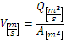
Equation 2.1: Q is the flow and V is the flow velocity of the fluid and A is the tubing cross sectional area [m²]. To obtain the cross-sectional area with applied the equation 2.2 and 2.3.
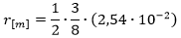
Equation 2.2: “r” is the radius and A_{pipe} is the cross-sectional area of the tubing.
Regarding the flow velocity exiting the cannulas, the cannula outflow area [m²] is needed and we applied the equation 3.1, 3.2 and 3.3 to obtain the sum of the centre hole area and the side holes area.
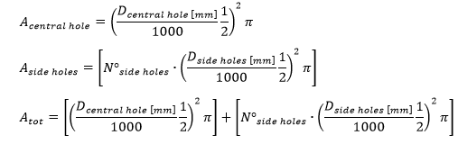

Equation 3.1: The A_{central hole} [mm²] is the area of the main hole placed at the tip of the cannula, A_{side hole} [mm²] is the area of a single lateral hole on the cannula shaft, the D_{centrale hole} [mm] is the diameter of the main hole placed at the tip of the cannula, the D_{side hole} [mm] is the diameter of a single hole placed on the cannula shaft, the Nº_{side hole} is the total number of the hole placed on the cannula’s shaft.
Through the continuity equation, the velocity at the cannula outlet is determined enabling the computation of the cannula outflow pressure [Pa] using the Bernoulli’s equation.
To assess the flow, the continuity equation along with Bernoulli’s equation for a stationary, incompressible and inviscid flow was applied. A Lagrange interpolation polynomial was used as described in the following series of equations:
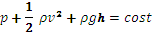
Equation 4.1 – 4.2: P_{pre} and P_{post} represent the pressure at the cannula connector and at the tip respectively, ρgh_{pre} and ρgh_{post} are the relative heights at the cannula connector and at the tip respectively, ρv_{pre} and ρv_{post} represent the fluid velocity at the cannula connector and at the tip respectively
Assuming the cannula is horizontal = . This yield:
Equation 5.1: P_{pre} and P_{post} are the pressures at the cannula connector and at the tip respectively, ρ represents the fluid density, v_{pre} and v_{post} [m/s] represent the fluid velocity at the cannula connector and at the tip respectively and h represents the height of the tube’s centre.
Thus, all the pressures, flows and velocities at any point of the circuit, from the post oxy, to the cannula outflow, can be estimated.
In addition to this, the spreadsheet shows pressures and velocities at pre and post cannula levels and the flow in both return limbs, showing the single input of the total flow ECMO.
Through a Lagrangian [17] interpolation, a function was obtained where the inflow and outflow pressures and velocities could be estimated from the experimentally obtained data. We then proceeded with the continuity law (to derive cannula outflow speed) and the Bernoulli’s law (for the pressure). This allowed us to assume a hypothetic Qtot [L/min], and see how the system responded.
These formulas (using Lagrange interpolation) calculate inflow and outflow pressures [mmHg] and velocities [m/s].
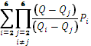
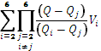
Equations 6.1 – 6.2: P_{i} [mmHg] is the pressure at the cannula connector, V_{i} [m/s] is the velocity at the cannula connector.
We wondered if it were possible to do the opposite, i.e, to calculate the Qtot [L/min] needed for a given desired arterial flow. This was solved by using the "bisection" or “dichotomy" method. In fact, thanks to this mathematical method we could answer the question: giving the desired arterial flow as an input to the calculator, the answer to the question as Qtot needed, was given.

