Supplementary Material
I - Correlation matrix between CHARnb, CHARar, W/L ratio and A/P ratio using Spearman correlation. The distribution of variable variables on the diagonal. At the bottom of the diagonal: The scatter plots are shown with the trend line.
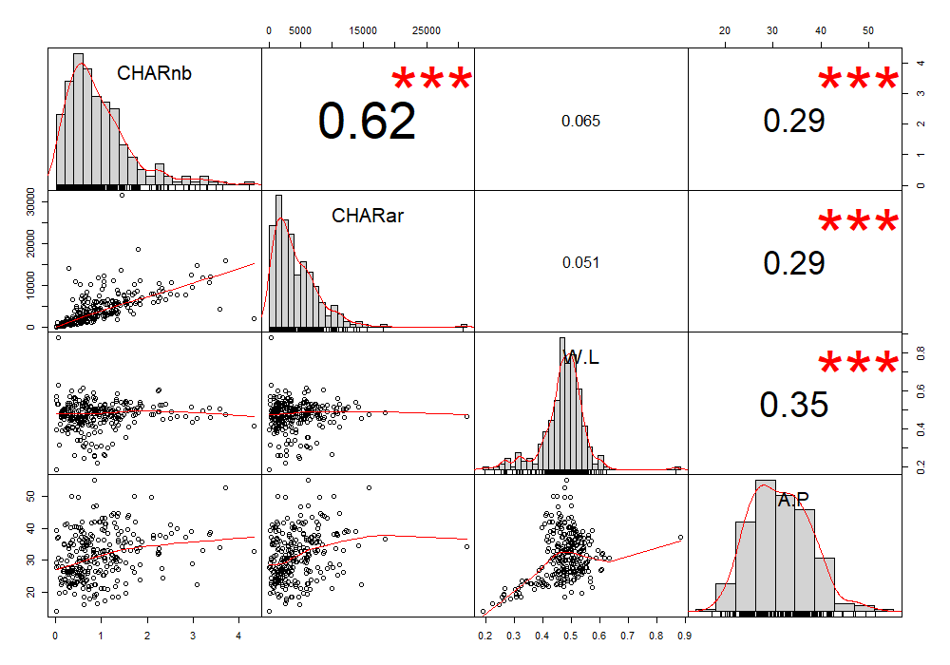

II - Pollen diagram detailed for BAS15
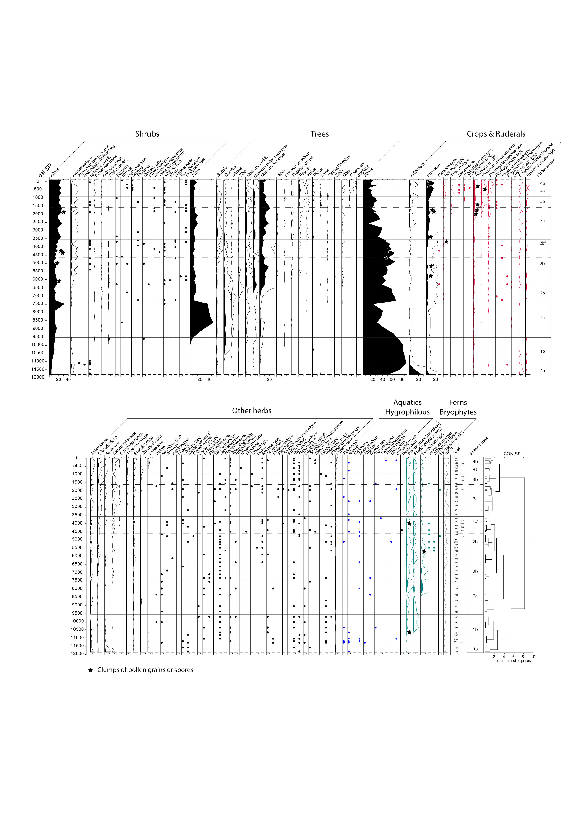

III - Fungal Remains diagram detailed for BAS15. They have been displayed, from left to right, from the most probably related to dung to the most probably plant parasites (according to literature in palaeocology (e.g. Baker et al., 2013; Van Geel, 2002; Van Geel and Aptroot, 2006) and present day ecology (e.g. Ellis and Ellis, 1985)

IV - Palynological richness (A), and evenness (B) over time estimated on a constant sum of 693 pollen grains.
B
A
V - Palynological richness (A), and evenness (B) in function of Sporormiella influx estimated on a constant sum of 693 pollen grains. Results of Spearman’s ranks correlation for A) Richness : Rho=0.81** (trees); Rho=0.36** (shrubs); Rho=0.21 (herbs); Rho=0.83** (total). B) Evenness : Rho=0.71** (trees); Rho=0.16** (shrubs); Rho=0.11 (herbs); Rho=0.74** (total). (*p-value<0.05; **p-value<0.01)
A
B
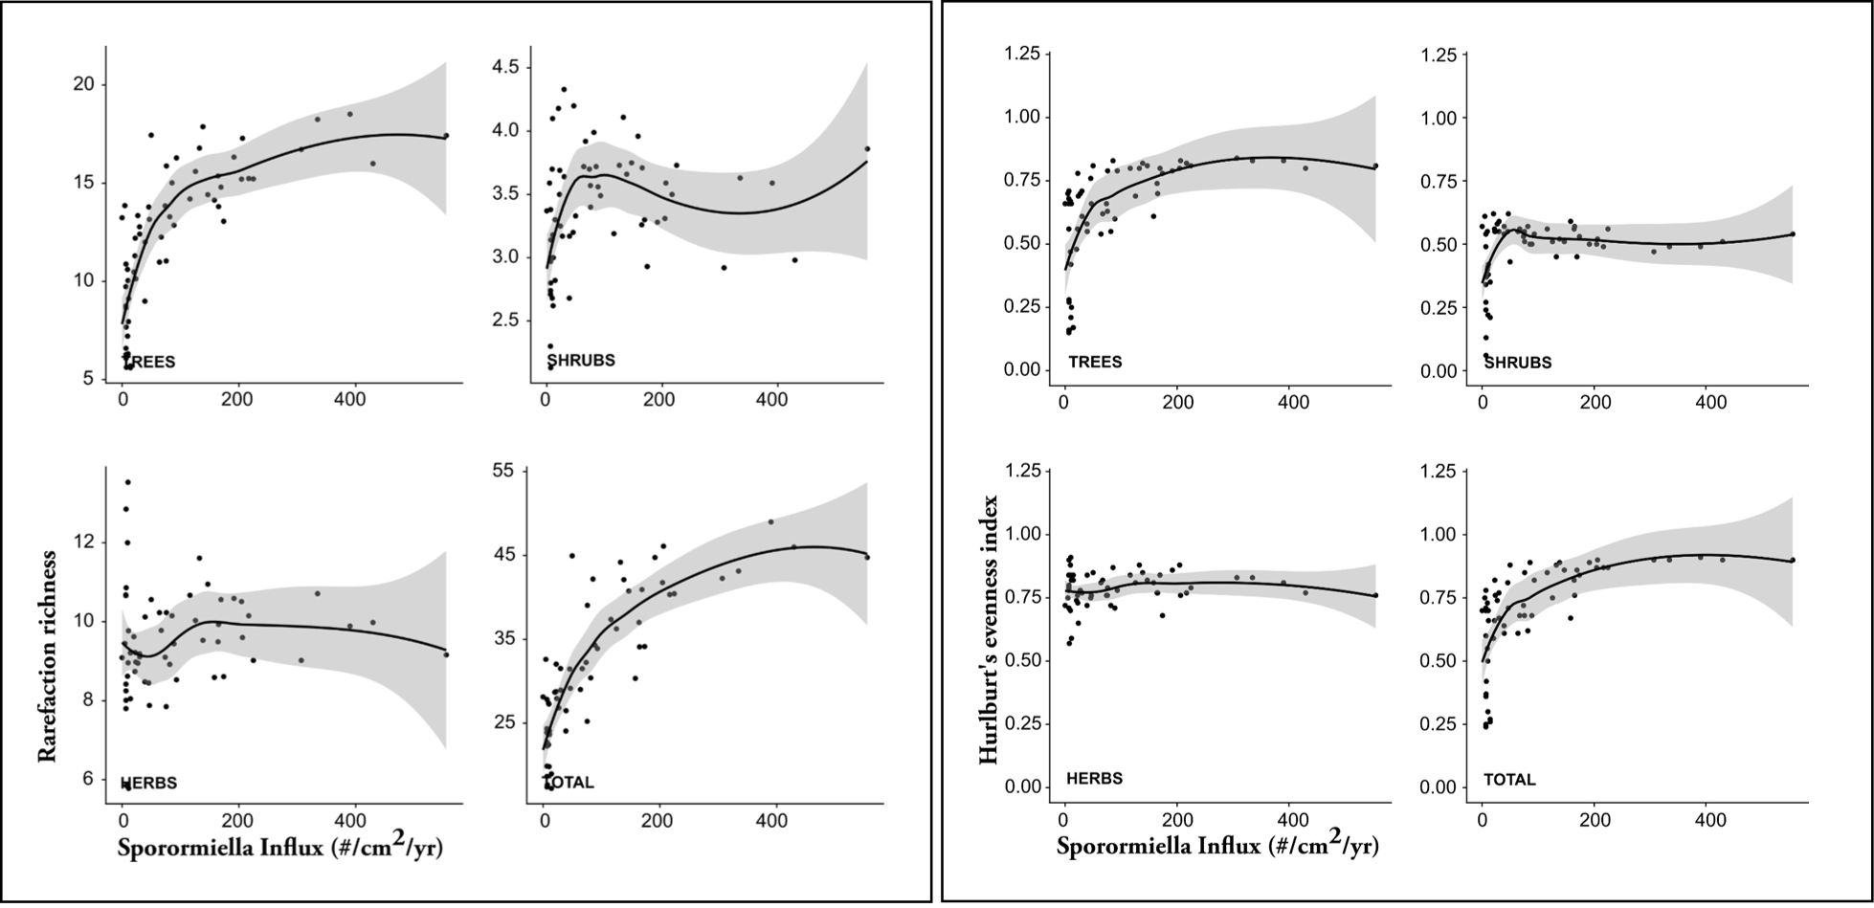
VI - Palynological richness (A), and evenness (B) in function of Charcoal Accumulation Rate (CHARnb) estimated on a constant sum of 693 pollen grains. Results of Spearman’s ranks correlation for A) Richness : Rho=-0.03 (trees); Rho=0.26* (shrubs); Rho=0.21 (herbs); Rho=-0.04 (total). B) Evenness : Rho=-0.11 (trees); Rho=0.55** (shrubs); Rho=-0.29* (herbs); Rho=-0.12 (total). (*p-value<0.05; **p-value<0.01)
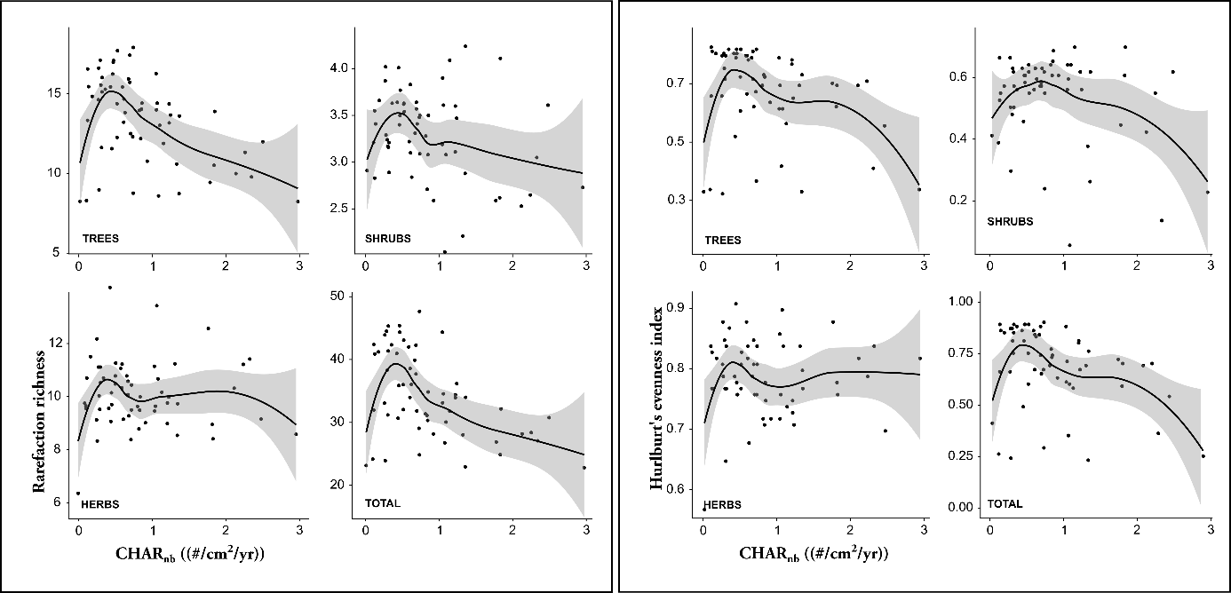
A
B

