Featuring Mistakes:

The Persuasive Impact of Purchase Mistakes in Online Reviews

TALY REICH, SAM MAGLIO

**Web Appendix**

**WEB APPENDIX A**

*MATERIALS FOR STUDIES 1 AND 3*

|  |  |  |
| --- | --- | --- |
|  | **Orbin (Study 1)**  **Mikana XPI (Study 3)** | **Raymour (Study 1)**  **Rokana SX2 (Study 3)** |
| Frequency Range | 20 Hz – 60 Hz | 20 Hz – 60 Hz |
| Low Frequency Type | PolyPlas | Polyfibre |
| High Frequency Type | Kortec | Kortec |
| Sensor Type | BSI-CMOS | CCD |
| Sensitivity (dB) | 96 | 96 |
| Maximum Amplifier Power (Watts) | 275 | 275 |

**WEB APPENDIX B**

*STUDY 2 MATERIALS*

|  |  |  |
| --- | --- | --- |
|  | **FreshBlooms** | **FlowersNow** |
| Flower wrapping | Clear floral sleeve | Waxed tissue paper |
| Type of flower shears used by the florist | Straight blade pruning shears | Curved blade pruning shears |
| Additional options | Balloons, cards, & chocolate | Balloons, cards, & chocolate |
| Custom arrangements | Yes | Yes |

**WEB APPENDIX C**

*STUDY 3 MATERIALS*

Note that both reviews were presented on the same page.

First Review – Success + Printer Condition:

First Review – Mistake + Printer Condition:



First Review – Success + Speaker Condition:



First Review – Mistake + Speaker Condition:





Second Review – All Conditions:



**WEB APPENDIX D**

*REVIEW TIMING MODERATION STUDY*

If the persuasive power of mistakes arises because people infer that admitting a mistake signals that the reviewer has gained expertise (H3), then consumers should be more persuaded by the mistaken reviewer *only* if the mistake occurred first, because it is only then that the mistake-driven knowledge could have informed the focal (subsequent) review. We test this prediction in this study.

***Method***

Two hundred eighty-five participants (mean age = 33.0; 56.1% male) participated in an online study in exchange for monetary payment. As in Study 3, participants imagined that they were looking for in-ceiling speakers and had narrowed their choice down to the Mikana XPI and the Rokana SX2 in-ceiling speakers. Also as in Study 3, they viewed specifications of the two speaker systems and saw two reviews written by a consumer named Taylor. The focal review, which was the same in all conditions, noted that the reviewer purchased the Mikana XPI speaker system and recommended it. In all conditions, participants also read a non-focal review in which Taylor described a bookshelf speaker purchase. However, the timing and content of the non-focal review differed by condition in a 2 (Non-focal review type: Mistake vs. Success) ×2 (Non-focal review timing: Prior vs. Subsequent) design. As in previous studies, participants read that the non-focal review involved either a successful or a mistaken purchase; participants also read that the non-focal review was written either two months prior to the focal review or two months after. Participants then reported whether they would choose to buy the Mikana XPI or the Rokana SX2 in-ceiling speakers.

***Results and Discussion***

We conducted a binary logistic regression using review type (Mistake vs. Success), non-focal review timing (Prior vs. Subsequent), and their interaction to predict participants’ choices. The regression revealed an interaction on choice, *b*= 1.31, *z* = 1.94, *p* = .052. Replicating our prior findings, when the reviewer’s non-focal review temporally preceded the focal review, participants who read the mistaken non-focal review chose the recommended speaker more often (94.6%) than participants who read the successful non-focal review (83.9%), *b* = 1.22, *z* = 2.23, *p* = .026. Conversely, when the reviewer’s non-focal review temporally followed the focal review, we found no such effect (Mistake = 80.8%; Success = 79.2%), *b* = -.10, *z* = -.24, *p* = .810. These findings indicate that the persuasive power of mistakes arises only when the purchases transpire in an order that allows for the gaining of expertise (a prior mistake followed by a subsequent success) and not when the order is reversed.

**WEB APPENDIX E**

*STUDY 4 MATERIALS*

No Mistake Condition (reviews were presented in random order):

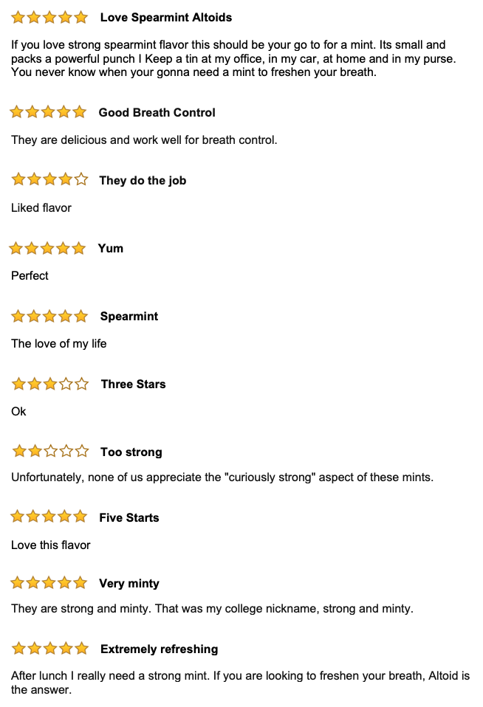

Mistake Condition (reviews were presented in random order):

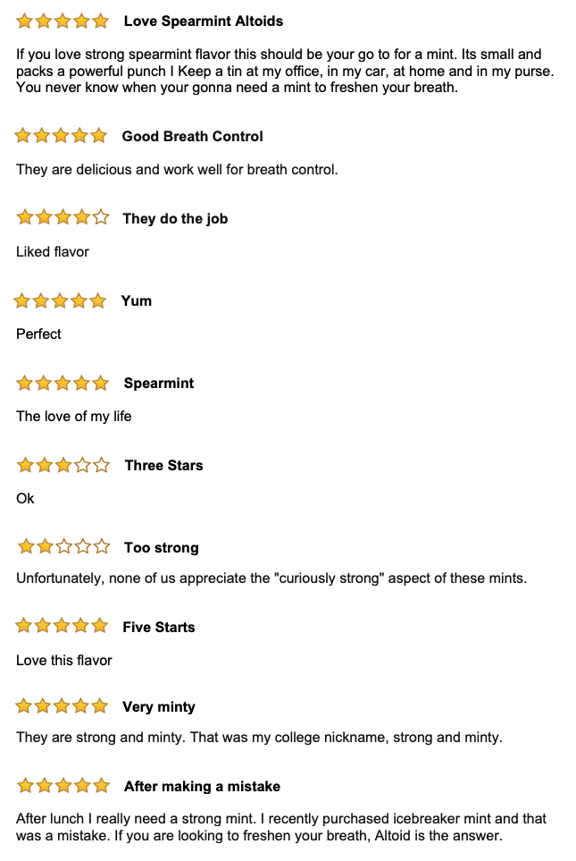

**WEB APPENDIX F**

*ADDITIONAL ANALYSIS FOR STUDY 5*

**Table.** Results of Regression Analysis on Helpfulness Index with the Manually-Coded Mistake Reference Reviews for Study 5.

|  |  |  |  |  |  |
| --- | --- | --- | --- | --- | --- |
| Predictor | *b* | *SE* | $$β$$ | *t* | *p* |
| (Constant) | .085 | .025 |  | 3.471 | .001 |
| Mistake reference | .053 | .014 | .160 | 3.638 | .000*** |
| Number of words | .001 | .000 | .140 | 3.945 | .000*** |
| Valence of review | .015 | .018 | .038 | .868 | .386 |
| Star rating | -.002 | .018 | -.010 | -.128 | .898 |
| Explicit Recommendation | -.031 | .029 | -.081 | -1.066 | .287 |
| Loyalty program member | .014 | .013 | .033 | 1.016 | .310 |
| Reviewer expertise | .194 | .230 | .028 | .841 | .400 |
| Number of uploaded images | .021 | .036 | .020 | .591 | .555 |
| Mention of another brand | -.010 | .020 | -.016 | -.493 | .622 |
| Date of review | -9.002E-5 | .000 | -.030 | -.739 | .460 |

*Note*. \*\*\**p* < .001, ** *p* < .01, \**p* < .05; The R square of the simple model (without controls) is .060; The R square of the full model with controls is .082.

**WEB APPENDIX G**

*ADDITIONAL ANALYSIS FOR STUDY 5*

**Table.** Descriptive Statistics for Study 5.

|  |  |  |
| --- | --- | --- |
|  | Reviews Referencing  a Mistake | Reviews Not Referencing  a Mistake |
| Mistake reference | 100% | 0% |
| Number of words | 100.80 (66.07) | 61.37 (44.67) |
| Valence of review | .33 (.86) | .60 (.73) |
| Star rating | 3.82 (1.55) | 4.17 (1.28) |
| Explicit Recommendation | 68% | 82% |
| Loyalty program member | 2.03 (.74) | 1.76 (.82) |
| Reviewer expertise | 1.00 (.00) | 1.00 (0.63) |
| Number of uploaded images | .04 (.24) | .09 (.34) |
| Mention of another brand | 10% | 4% |
| Date of review | 43240.10 (127.01) | 43380.82 (6.99) |
| Helpfulness Measure | .15 (.40) | .01 (.22) |

*Note*. For continuous measures, we report the means to the left of the standard deviations in parentheses. For binary measures, we report percentages.

**WEB APPENDIX H**

*ADDITIONAL ANALYSIS FOR STUDY 5*

**Table.** Results of Regression Analysis on Raw Number of Helpfulness Votes for Study 5.

|  |  |  |  |  |  |
| --- | --- | --- | --- | --- | --- |
| Predictor | *b* | *SE* | $$β$$ | *t* | *p* |
| (Constant) | 2.895 | 1.245 |  | 2.325 | .020 |
| Mistake reference | 2.376 | .700 | .142 | 3.393 | .001*** |
| Number of words | .038 | .009 | .136 | 4.016 | .000*** |
| Valence of review | -.001 | .900 | .000 | -.001 | .999 |
| Star rating | -.445 | .887 | -.038 | -.502 | .616 |
| Explicit Recommendation | .576 | 1.424 | .030 | .405 | .686 |
| Loyalty program member | .676 | .673 | .032 | 1.005 | .315 |
| Reviewer expertise | 8.178 | 11.910 | .022 | .687 | .492 |
| Number of uploaded images | -1.047 | 1.814 | -.019 | -.577 | .564 |
| Mention of another brand | -.623 | 1.038 | -.019 | -.600 | .549 |
| Date of review | -.001 | .006 | -.006 | -.155 | .877 |

*Note*. \*\*\**p* < .001, ** *p* < .01, \**p* < .05; The R square of the simple model (without controls) is .038; The R square of the model is .056.

**WEB APPENDIX I**

*ADDITIONAL ANALYSIS FOR STUDY 5*

As a direct application of our general model, we developed an extended model that predicts a measure of persuasion deriving from review helpfulness as featured on the Sephora website: the number of “loves” included on the product page. While “loves” speak to applicability as a behavior in which Sephora is likely very interested, there are important caveats to the analysis of the model that we present subsequently:

(1) It is possible to navigate to a product and denote it as “loved” without having ever read a single review, whereas it is impossible to evaluate the helpfulness of a review without ever reading a single review, making the link between the two somewhat tenuous.

(2) It is possible that consumers who denote that the (positive) review is helpful feel that they have virtually “loved” the product by taking an electronic action that supports the product, making them less likely to separately denote it as “loved” on the main page.

(3) At over 10,000 “loves”, the Sephora site rounds the number of “loves” to the nearest 10,000, rendering it an imprecise metric.

For these reasons, it is our opinion that “loves”, idiosyncratic to the Sephora site, introduce a number of limitations in drawing meaningful conclusions. Nonetheless, to provide evidence (albeit qualified evidence) for the downstream relevance for review helpfulness, we conducted a regression predicting the number of “loves” received by products on the Sephora site from the following product-level predictors: number of reviews mentioning a mistake, total number of reviews, average star rating, and price. The results of this analysis, summarized in the Table below, are consistent with our prediction that the more a product’s reviews mention mistakes, the more “loves” it garners on the Sephora site (with no effects of the control variables).

**Table.** Results of Regression Analysis on Love Ratings

|  |  |  |  |  |  |
| --- | --- | --- | --- | --- | --- |
| Predictor | *b* | *SE* |  | *t* | *p* |
| (Constant) | -15279.902 | 30776.858 |  | -.496 | .623 |
| Mistake reference | 989.455 | 353.856 | .756 | 2.796 | .008** |
| Star rating | 7036.565 | 7464.867 | .096 | .943 | .352 |
| Price | -19.260 | 27.617 | -.072 | -.697 | .490 |
| Total number of reviews | 5.364 | 33.517 | .044 | .160 | .874 |