Supplementary materials for “Popular music lyrics and musicians’ gender over time: A computational approach”
Manuel Anglada-Tort, Amanda Krause and Adrian North

Appendix A

Top five bands on each period and in total with the highest number of total words per song, organized by gender
Period | Rank | All-male | All-female | Mixed-gender
1960-1968 | 1st | Wink Martindale (577) | Mary Hopkins (367) | Peter Sellers & Sophia Loren (365)
(N = 247; | 2nd | Bob Dylan (411) | Mary Wells (2818) | Honeycombs (258)
M = 198.36; SD = 69.14) | 3rd | Val Donnican (406) | Helen Shapiro (M = 261.5; SD = 37.72) | Ike & Tina Turner (245)
 | 4th | Napoleon XIV (385) | Diana Ross & the Supremes (257) | Steve and Eydie (236)
 | 5th | Tommy Steele (380) | Twinkle (251) | Julie Driscoll, Brian Auger, & the Trinity (224)
1969-1976 | 1st | Don McClean (889) | Suzi Quatro (M= 377.34; SD= 254.28) | Elgins (359)
(N = 314; | 2nd | The Goodies (715) | Sylvia (337) | Blue Mink (M = 346.67; SD = 78.52)
M = 237.78; SD = 99.81) | 3rd | Laurie Lingo & the Dipsticks (694) | Carly Simon (318) | R & J Stone (322)
 | 4th | C. W. McCall (670) | Diana Ross & the Supremes & the Temptations (309) | Brotherhood of Man (306)
 | 5th | Benny Hill (637) | Diana Ross (M= 301; SD= 141.42) | Candi Staton (306)
1977-1984 | 1st | Sovine (738) | Chaka Khan (571) | Motorhead & Girlschool (555)
(N = 321; | 2nd | Sugarhill Gang 661) | Donna Summer & Barbara Streisand (508) | Fun Boy Three & Bananarama (527)
M = 285.69; SD = 108.74) | 3rd | Keith Mitchell (655) | Laura Branigan (495) | Shaky & Bonnie (438)
 | 4th | Detroit Spinners (621) | Suzi Quatro (447) | Style Council (427)
 | 5th | Tony Capstick & the Carlton Main Frickley Colliery Band (621) | Gloria Gaynor (446) | Fiddler's Dram (421)
1985-2008 | 1st | Nelly (M = 1095; SD = 527.50) | Kelly Rowland feat. Eve (771) | So Solid Crew (M = 1112.5; SD = 147.78)
(N = 1,209; | 2nd | Nelly Feat. City Spud (1066) | Lisa Maffia (700) | Busta Rhymes & Mariah Carey feat. The Flipmode Squad (892)
M = 360.47; SD = 175.07) | 3rd | Chamillionaire feat. Krayzie Bone (1053) | Gwen Stefani feat. Eve (682) | Deacon Blue (886)
 | 4th | Eminem (M = 959.07; SD = 223.48) | Amerie (617) | Beyonce feat. Slim Thug (852)
 | 5th | Queen with Wyclef Je (949) | Eve feat. Gwen Stefani (608) | Wyclef Jean feat. The rock & Melky Sedeck (850)
2009-2015 | 1st | Eminem (M = 1045; SD = 401.90) | Willow (777) | Will.i.am/ Cyrus/ Khalifa (928)
(N= 409; | 2nd | Justin Timberlake (1040) | Pink (648) | Wiley feat Ms. D (822)
M= 430.03; SD= 166.75) | 3rd | Eminem feat. Dr Dre & 50 Cent (935) | Jessie J / Grande/ Minaj (631) | Tinie Tempah feat. Jess Glynne (804)
 | 4th | T.I. Feat. Justin Timberlake (897) | Iggy Azalea feat. Rita Ora (627) | Roll Deep (M = 801; SD = 1.41)
 | 5th | Jeremih Feat. YG (839) | Katy B feat. Ms Dynamite (620) | Eminem feat. Rihanna (793)
TOTAL (1960-2015) | 1st | Nelly (M= 1095; SD= 527.50) | Willow (777) | So Solid Crew (M = 1112.5; SD = 147.78)
(N = 2,287; | 2nd | Nelly Feat. City Spud (1066) | Kelly Rowland feat. Eve (771) | Will.i.am/Cyrus/Khalifa (928)
M = 334.43; SD = 167.44) | 3rd | Chamillionaire feat. Krayzie Bone (1053) | Lisa Maffia (700) | Busta Rhymes & Mariah Carey feat. The Flipmode Squad (892)
 | 4th | Eminem (M= 978.17; SD= 260.86) | Gwen Stefani feat. Eve (682) | Deacon Blue (886)
 | 5th | Queen with Wyclef Je (949) | Jessie J / Grande/ Minaj (631) | Beyoncé feat. Slim Thug (852)
Note. N: Number of artists; M: Mean; SD: Standard deviation. M and SD are only provided in those cases where there is more than one song per artist. The artist/group was treated as it appeared on the chart, so that the weekly count does not include additional appearances as a nominated or featured artist in collaboration with other named musicians.​

Top five bands on each period and in total with the highest scores in self-reference (i.e., use of all first-person references in the lyrics), organized by gender
Period | Rank | All-male | all-female | Mixed-gender
1960-1968 | 1st | Clarence 'Frogman' Henry (114.38) | Millie (109.38) | Honeycombs (71.23)
(N = 247; | 2nd | Overlanders (107.14) | Nina Simone (86.96) | Esther and Abi Ofarim (68.97)
M = 41.36; SD = 22.48) | 3rd | Bonzo Dog Doo-Dah Band (88.82) | Ronettes (77.52) | Sonny & Cher (64.87)
 | 4th | Barry Ryan (85.32) | Julie Rogers (71.59) | Ike & Tina Turner (59.18)
 | 5th | P J Proby (82.78) | Susan Maughan (70.55) | Springfields (50.63)
1969-1976 | 1st | Tremeloes (M= 111.94; SD= 33.52) | Lyndsey de Paul (124.05) | Peter, Paul & Mary (85.03)
(N = 314; | 2nd | David Dundas (110.55) | Diana Ross & the Supremes & the Temptations (87.38) | Elton John And Kiki Dee (79.86)
M = 37.94; SD = 23.77) | 3rd | Joe Dolan (109.51) | Donna Summer (80.25) | Bobbie Gentry & Glen Campbell (78.61)
 | 4th | Fleetwood Mac (M = 93.345; SD = .09) | Clodagh Rodgers (M = 69.65; SD = 41.24) | Mac & Katie Kissoon (64.93)
 | 5th | Ken Boothe (91.58) | Dorothy Moore (68.38) | Pickettywitch (54.88)
1977-1984 | 1st | Dee D Jackson (133.56) | Chaka Khan (94.82) | Dollar (M= 88.23; SD= 18.45)
(N = 321; | 2nd | Beatles (97.35) | Anita Ward (81.56) | Kid's From Fame (71.43)
M = 36.26; SD = 23.06) | 3rd | Vapors (92.01) | Lene Lovich (80.39) | Bardo (68.46)
 | 4th | Slade (89.37) | Stephanie Mills (79.82) | Boystown Gang (67.89)
 | 5th | Mr Big (89.36) | Gloria Gaynor (72.87) | Darts (M = 65.45; SD = 45.23)
1985-2008 | 1st | Eric Prydz (151.52) | Spagna (100.42) | The Cardigans (126.56)
(N = 1,209; | 2nd | Benny Benassi presents the Biz (145.46) | Judy Boucher (99.3) | Evanescece feat. Paul McCoy (97.01)
M = 39.86; SD = 23.48) | 3rd | Camisra (125) | Temptations (98.16) | Ting Tings (96.63)
 | 4th | Adam Rickitt (103.12) | Sybil (93.56) | Livin' joy (95.05)
 | 5th | Brother Beyond (100.38) | Charlotte Church (90.90) | Jay-Z feat Beyonce Knowles (92.96)
2009-2015 | 1st | Galantis (193.01) | Agnes (107.27) | Rudimental feat. Ella Eyre (121.62)
(N = 409; | 2nd | Usher feat. Will.I.Am (105.85) | Willow (95.43) | Chase & Status Feat. Moko (107.39)
M = 44.20; SD = 23.74) | 3rd | Secondcity (93.46) | Icona Pop feat. Charli XCX (91.46) | Dr. Kucho/ Gregor Salto/ Ane Brun (95.02)
 | 4th | David Zowie(89.96) | Cheryl (M = 77.83; SD = 26.15) | Cash Cash feat. Bebe Rexha (87.56)
 | 5th | Tinchy Stryder feat. Taio Cruz (89.88) | Demi Lovato (77.1) | Clean Bandit (87)
TOTAL (1960-2015) | 1st | Galantis (193.01) | Dee d Jackson (133.56) | The Cardigans (126.56)
(N = 2,287; | 2nd | Eric Prydz (151.51) | Lyndsey de Paul (124.05) | Rudimental feat. Ella Eyre (121.62)
M = 40.22; SD = 23.34) | 3rd | Benny Benassi presents the Biz (145.46) | Millie (109.38) | Chase & Status Feat. Moko (107.39)
 | 4th | Camisra (125) | Agnes (107.27) | Route 94 feat. Jess Glynne (101.69)
 | 5th | Clarence 'Frogman' Henry (114.38) | Spagna (100.42) | Evanescece feat. Paul McCoy (97.01)

Note. N: Number of artists; M: Mean; SD: Standard deviation. M and SD are only provided in those cases where there is more than one song per artist. The artist/group was treated as it appeared on the chart, so that the weekly count does not include additional appearances as a nominated or featured artist in collaboration with other named musicians.​

Appendix B

Appendix B.1. Concreteness (i.e., words concerning tangibility and materiality) and band gender over time.
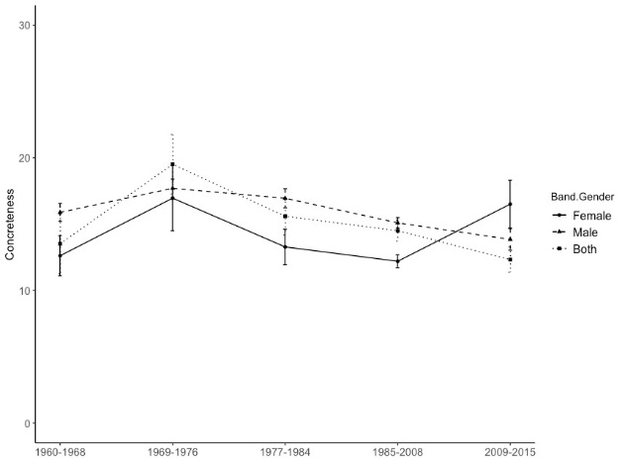

Appendix B.2. Complexity (i.e., the mean number of characters per word) and band gender over time
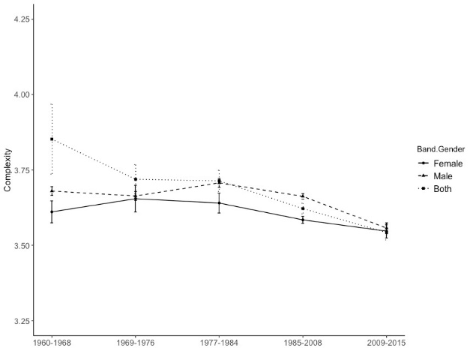
Appendix B.3. Variety (i.e., the number of different words divided by total words.) and band gender over time.
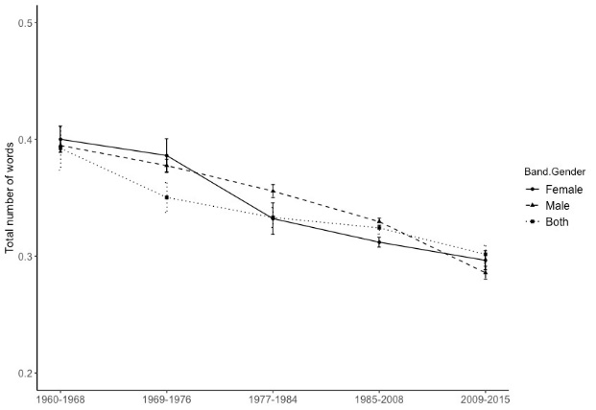

Appendix C
Appendix C.1. Concreteness (i.e., words concerning tangibility and materiality) and singer gender over time.
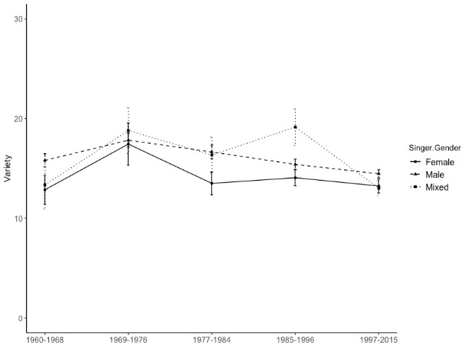

Appendix C.2. Complexity (i.e., the mean number of characters per word) and singer gender over time.
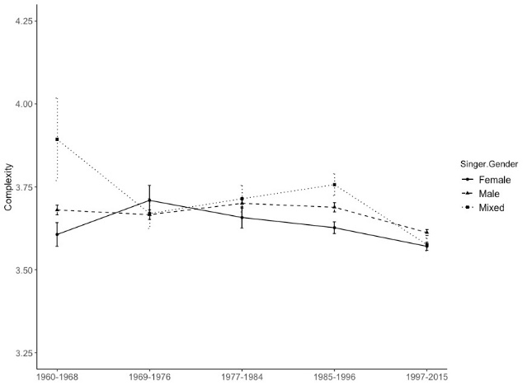

Appendix C.3. Self-reference (i.e., all first-person references) and singer gender over time.
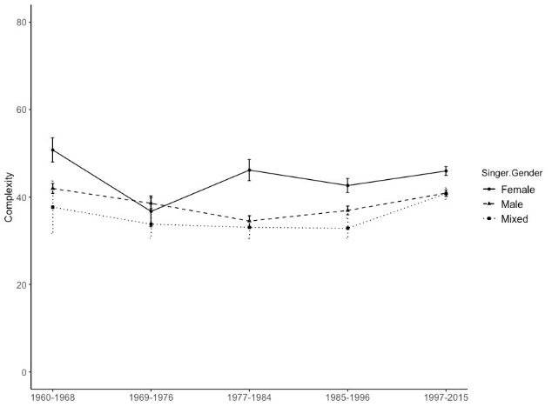

Appendix C.4. Denial (i.e., negative contractions and negative function words) and singer gender over time.
