Appendix Table 1. Sample Opportunities to Learn from Course Materials
 | Examples
Representations | Instructional Vignettes:  - Shana, a third grade teacher designed a lesson to help her students understand fractions. She uses Cuisenaire Rods to develop the concept. She starts by saying, “If a brown rod is the whole, then one red rod must be ” Shana demonstrates this on the Smart Board.  Shana goes on to show that the brown rod can be broken up into four equal parts by saying and demonstrating that four red rods equal one brown rod.  As she places the red rods under the brown rods, Shana says, “ and .”
Decompositions | Video Analysis: Dot Cards  1) Watch “Dot Card” video from a kindergarten classroom.  2) There are four types of subitizing:  - Initial perceptual subitizing: Students describe the shape of dots.  - Perceptual subgroup subitizing: Students subitize small groups but cannot subitize the entire group.  - Perceptual ascending subitizing: Students describe the subgroups and then the composite group.  - Perceptual descending subitizing: Students describe the composite group then describe the subgroups.  3) As a class we will answer the following questions:  - How are students making sense of the quantity?  - Notice the question types. How does the teacher know students understand? How does the teacher get students to explain their thinking?  - Why is subitizing important?  High and Low Cognitive Demand Questions  High Cognitive Demand Low Cognitive Demand  - Focus students’ attention on the use of procedures for the purpose of developing deeper levels of understanding of mathematical concepts. - Suggest pathways to follow that are broad general procedures that have close connections to underlying conceptual ideas. - Require some degree of cognitive effort. - Usually are represented in multiple ways (visual diagrams, manipulatives, symbols, problem situations). - Making connections among multiple modes of representations helps develop meaning. - Require students to access relevant knowledge and experiences and make appropriate use of then in working through the task. - Requires explanations and reasoning - Reproducing previously learned facts, rules, formulae or definitions - Committing facts, rules formulae or definitions to memory. - Are not ambiguous. - Require no explanations or reasoning - No connection to the meaning that underlie the facts, rules, formulae or definitions being learned or reproduced. - Are algorithmic. - Focused on producing correct answers  - There are five children in my family. Their average age is 9. How old might each child be? - My coach said I ran 100 yards in about 12 seconds. What might the numbers on the stopwatch have been? - The children in my family are 3, 8, 9, 10, and 15. What is their average age? - Round 11.7 to the nearest whole number.  Concrete, Representational, and Abstract Instructional Approach  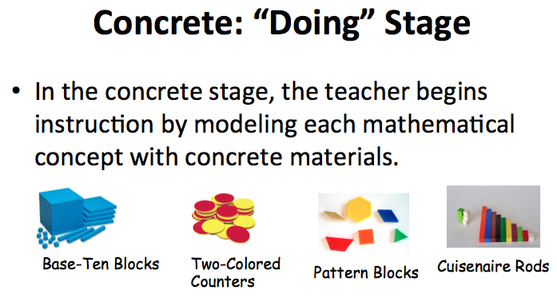  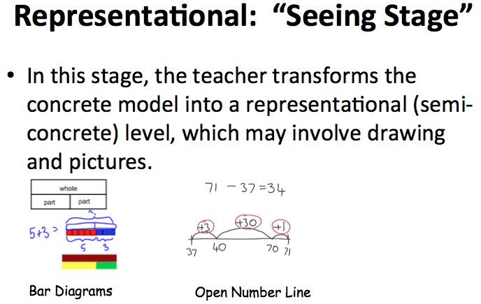  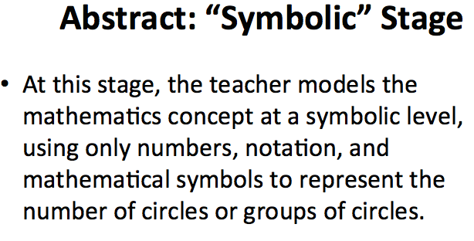  Curriculum Unpacking Assignment: “This assignment is designed to give you experience grappling with the content and design of existing resources so that in the future you can determine the extent to which resources you are given can be used effectively in your classroom and how, when they are used, they can be maximized.  Unpacking & Appraisal- As you answer the questions below, provide descriptions focused on conceptual understanding and procedural fluency. Substantiate your answers with evidence (ex: quotations, page numbers, images, and descriptions) directly from the lesson.  - Concrete-Representational-Abstract (CRA)  - Find three examples of the Concrete-Representational-Abstract (CRA) sequence in the unit. For each example, describe the relationships between each representation.  - Cognitive Demand  - Identify and describe high cognitive demanding tasks.  - In the same lesson, identify and describe low cognitive demanding tasks.  - Explain the connections between the task.  - How does the high cognitive demanding task support the lesson?  - How does the high cognitive demanding task connect the low cognitively demanding task?  - How do the task support conceptual understanding and the development of procedural fluency?  - Scope and Sequence  - What are the patterns (scope and sequence) you notice in the instructional sequence across the lessons in the unit?  - How does the scope and sequence support the development of conceptual understanding across the lessons in the unit?  - How does the scope and sequence support the development of procedural fluency across the lessons in the unit?  - Developing Mathematics Processes & Strategies  - List the different processes and/or strategies developed across the lessons over the unit.  - Discuss how these processes and/or strategies are connected and support the learning of the intended mathematics content in the unit.  - Formative Assessment  - Describe the ways formative assessment evidence is gathered across the lessons in the unit  - How might teachers use the evidence to make instructional and pedagogical decisions?  - Discuss the patterns in the questioning types, alignment, and question depth in the formative assessment opportunities.  - See “Questioning Considerations” pg. 44-45.  - Rigor:  - Describe opportunities for productive struggle in the lesson across the unit.  - See “productive struggle” pg. 22-23  - Task Design:  - Provide an example of a task in the unit that can be modified, supplemented, or replaced. Use the criteria in your textbook to explain how and why the task can be changed and explain how you would change it.  - Consider modifying, supplementing, or replacing to meet the needs of ELL and SPED  - See pgs. 36- 43 in your textbook and supplemental readings  - Alignment:  - Discuss the alignment between lessons in the unit and the the stated CCSSM standards.  - Discuss the alignment between the lessons and the associated assessment items.  Reflect on the process- As you develop more experiences as a teacher, the process of unpacking a unit become easier and shorter.  - Describe and discuss the process of unpacking a unit and the implications for teachers and students.
Approximations | Manipulative Interview: “This requires students to use manipulatives to demonstrate and model mathematics concepts for elementary grades. This will be a one-on-one interview with the instructors.”  SMART Board Notebook Lessons: “You will develop two lessons (one K-2 and one 3-5) using the provided mathematics curriculum materials. Both lessons must be in the same content domain/strand as your annotated bibliography. You should “script” your lessons such that another teacher could teach the lesson in a similar manner. For each lesson you will submit a Smart Notebook Script and a word document.”

