Appendix A – device users
Table A1. Multinomial logistic regressions

 |  | SSat (2015)  N = 6844 |  | UoST (2016)  N = 5555
 |  | Device used to open the survey (Ref: PC) |  | Device used to open the survey (Ref: PC)
 |  | Smartphone | Tablet | Smartphone | Tablet
Female |  | 1.41*** | 1.48*** | 1.67*** | 1.70***
 |  | (0.09) | (0.16) | (0.11) | (0.26)
Age | 21-22 | 0.91 | 0.79* | 0.85* | 1.16
Ref: 19-20 |  | (0.07) | (0.11) | (0.07) | (0.23)
 | 23-24 | 0.70*** | 0.61*** | 0.82* | 1.03
 |  | (0.07) | (0.10) | (0.09) | (0.26)
 | 25-26 | 0.58*** | 0.65** | 0.55*** | 0.88
 |  | (0.07) | (0.12) | (0.07) | (0.27)
 | 27+ | 0.43*** | 0.59*** | 0.48*** | 1.06
 |  | (0.05) | (0.11) | (0.06) | (0.28)
Department | CIBio | 0.62* | 0.94 | 0.91 | 1.04
Ref: Sociology and Social research |  | (0.15) | (0.38) | (0.21) | (0.48)
 | Cimec | 0.00 | 0.00 | 0.16* | 1.10
 |  | (0.00) | (0.00) | (0.17) | (1.16)
 | Economics and Management | 1.41*** | 1.69** | 1.41*** | 1.20
 |  | (0.18) | (0.37) | (0.16) | (0.29)
 | Physics | 1.27 | 1.34 | 1.53** | 0.95
 |  | (0.28) | (0.52) | (0.28) | (0.42)
 | Civil, environmental and mechanical engineering | 1.43*** | 1.39 | 1.86*** | 0.50**
 |  | (0.20) | (0.33) | (0.22) | (0.17)
 | Industrial Engineering | 0.98 | 1.54 | 1.89*** | 1.48
 |  | (0.17) | (0.44) | (0.29) | (0.50)
 | Information Engineering and Computer Science | 0.89 | 0.47** | 1.24 | 0.57
 |  | (0.14) | (0.16) | (0.17) | (0.20)
 | Humanities | 0.93 | 1.19 | 1.07 | 1.16
 |  | (0.12) | (0.26) | (0.12) | (0.26)
 | Mathematics | 1.48** | 1.24 | 2.09*** | 0.73
 |  | (0.29) | (0.45) | (0.37) | (0.36)
 | Law | 1.33* | 1.59* | 1.19 | 0.73
 |  | (0.19) | (0.39) | (0.16) | (0.22)
 | Psychology and Cog. Sci. | 1.87*** | 1.91*** | 2.32*** | 1.54*
 |  | (0.24) | (0.42) | (0.26) | (0.36)
 | School of international studies | 1.07 | 1.15 | 1.18 | 2.02
 |  | (0.18) | (0.35) | (0.43) | (1.31) **
Type of study | Master | 0.69*** | 0.76** | 0.71*** | 0.61
Ref: Bachelor |  | (0.06) | (0.10) | (0.06) | (0.13)
Constant |  | 0.47*** | 0.11*** | 0.60*** | 0.07***
 |  | (0.06) | (0.02) | (0.07) | (0.02)
Pseudo R2 |  | 0.034 |  | 0.038
Coefficients are presented as Relative Risk Ratios – S.E. in brackets - * p<0.1; ** p<0.05; *** p<0.01

Appendix B
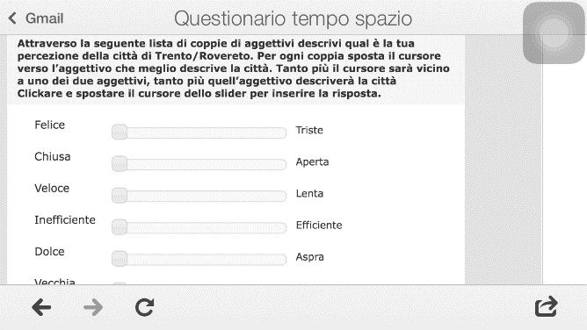
Figure B1. Screenshot of the UoST survey taken from iPhone 5 (4” screen)

Appendix C – Break off rates

Figure C1. Predicted probabilities of breaking off by device, estimated via logistic regression (controlling for age, gender and type of study) – SSat survey

Figure C2. Predicted probabilities of breaking off by device, estimated via logistic regression (controlling for age, gender and type of study) – UoST survey
Appendix D – Anchoring to central values
Figure D1: Predicted probabilities (estimated via binomial logistic regression) of selecting a central value by device (and controlled for gender, age and type of study) – SSat survey

Figure D2: Predicted probabilities (estimated via binomial logistic regression) of selecting a central value by device (and controlled for gender, age and type of study) – UoST survey

