Appendix online

Content: eMethods, eResults (eTable 1, eTable2, eTable3, eTable4, eFigure1, eFigure2).

eMethods

Search strategy

Search terms used:
1. (("Retrospective Studies") AND "Neoplasms") AND "Biomarkers" AND prognostic[Title/Abstract] AND (("2012/01/01"[PDat] : "2015/12/31"[PDat]))
2. (("Retrospective Studies") AND "Neoplasms") AND "Biomarkers" AND predictive[Title/Abstract] AND (Clinical Trial[ptyp] AND ("2012/01/01"[PDat] : "2015/12/31"[PDat]))
3. ("Neoplasms") AND "Biomarkers" AND (Clinical Trial[ptyp] AND ("2012/01/01"[PDat] : "2015/12/31"[PDat]))

We selected the subset of 15 journals, in two ways. First a set of 8 journals were selected as being top general medical or oncology journals that had statements on their websites that encouraged protocol submission with article submission (The New England Journal of Medicine, The BMJ, The Lancet, PLoS Medicine, JAMA, JAMA Oncology, Lancet Oncology, Journal of Clinical Oncology). We added 7 additional top clinical oncology journals to our sample of journals, based on impact factor rankings (Journal of the National Cancer Institute, Clinical Cancer Research, Annals of Oncology, Breast Cancer Research, Cancer, Journal Of Thoracic Oncology, The Oncologist). We used Scimago Journal and Country Rank (SJR ranking) within the “Cancer Research” subject category. Journals had to focus on primary clinical cancer research (i.e. cell biology and review journals were excluded).
The initial search retrieved 5029 references. After screening for journals, 654 references were eligible. Out of 654 references, 149 publications were deemed eligible and were searched for online protocols; 22 online protocols were found. Out of those, 19 were eligible for our study (we contacted the corresponding authors of 3 publications for which the protocol was deemed not sufficiently informative but were not provided with a protocol). The remaining 127 eligible publications constituted the pool for a random sample of 103 additional publications without protocol accessible online. Corresponding authors of those 103 studies were contacted to request access to their protocol, randomly selected among the pool of eligible publications for which we did not find an online protocol. Other details of the selection process a reported on Figure 1.

Protocol request:
To obtain protocols, we searched journal webpages for supplementary materials or contacted corresponding authors at least three times via email to request a copy of an original protocol (defining “original” as a version of the protocol before any biomarker analyses were conducted).

Additional definitions regarding data extraction of biospecimen

For the specimen characteristics, we collected 6 sub-items: tissue type, collection method, site, timing of specimen collection, method of specimen preservation, and eligibility.

For the assay characteristics, we collected 5 sub-items: assay method, reagent, scoring cut-off rule, and whether there was blinding of the endpoints in the assessment of the marker.

- Tissue type: ex. solid vs blood
- Collection method: ex. biopsy, surgery, aspiration,
- Anatomic site: primary tumor vs. metastasis
- Method of specimen preservation: ex: frozen tissue and formalin-fixed paraffin-embedded (FFPE)
- Eligibility of specimen: ex. % of tumor cells
- Method (= technique): ex. Immunohistochemistry, PCR
- Reagent: exact name of the reagent
- Control: control specimen used to assess positivity of the biomarker test

For blood specimen biomarkers, collection and anatomic site were considered irrelevant; likewise cutoff was considered irrelevant for techniques for which results are qualitative (e.g. presence of a mutation) or where quantitative results were not dichotomized.
For the primary outcome, 5 items were considered high priority for inclusion: collection, tissue type, method, cutoff and blinding) and are reported in eFigure1. Results for the other 6 items are reported in eFigure2.

Additional definitions
Predictive study: a study was defined as predictive if it was testing the effect of a treatment stratified on biomarker subgroups or if an interaction was tested between the treatment and the biomarker.¹³

eResults
The protocols found online were mostly published in two journals (JCO, NEJM), the protocols obtained through authors were published in two journals (Annals of Oncology, Clinical Cancer Research), when the publications for which we were not able to access protocols were coming from a more diversified number of journals (p<0.001) (eTable 1).

eTable1 Comparison of journals, cancer types, location, for which the protocol was accessed vs others (N = 116); comparison by Fisher test
 |  | Protocol online | Protocol provided | No protocol | No response | P-value
 |  | N=19 | N=12 | N=8 | N=77
 |  | n (%) | n (%) | n (%) | n (%)
Journal |  |  |  |  |  | <0.001
Annals of Oncol. |  | 0 (0) | 5 (42) | 2 (25) | 16 (21)
Breast Cancer Research |  | 0 (0) | 1 (8) | 0 (0) | 7 (9)
Cancer |  | 0 (0) | 0 (0) | 2 (25) | 7 (9)
Clinical Res Research |  | 0 (0) | 4 (33) | 1 (12) | 19 (25)
J Clin Oncol. |  | 13 (68) | 0 (0) | 1 (12) | 11 (14)
JNCI |  | 0 (0) | 0 (0) | 1 (12) | 4 (5)
J Thoracic Oncol. |  | 0 (0) | 2 (17) | 1 (12) | 9 (12)
Lancet Oncol. |  | 1 (5) | 0 (0) | 0 (0) | 2 (3)
NEJM |  | 5 (26) | 0 (0) | 0 (0) | 0 (0)
The Oncologist |  | 0 (0) | 0 (0) | 0 (0) | 2 (3)
Cancer |  |  |  |  |  | 0.37
Breast |  | 5 (26) | 1 (8) | 3 (38) | 20 (26)
Digestive |  | 1 (5) | 5 (42) | 1 (12) | 12 (16)
Head, neck, ORL |  | 0 (0) | 1 (8) | 1 (12) | 7 (9)
Hematologic cancer |  | 1 (5) | 0 (0) | 1 (12) | 4 (5)
Kidney/bladder/prostate |  | 0 (0) | 1 (8) | 0 (0) | 9 (12)
Lung |  | 7 (37) | 2 (17) | 1 (12) | 15 (19)
Skin |  | 2 (11) | 0 (0) | 0 (0) | 5 (6)
Other(<5) |  | 3 (16) | 2 (17) | 1 (12) | 5 (6)
Location (corresponding author) |  |  |  |  |  | 0.31
Asia |  | 3 (16) | 0 (0) | 1 (12) | 8 (10)
Australia |  | 0 (0) | 2 (17) | 0 (0) | 2 (3)
Europe |  | 6 (32) | 7 (58) | 4 (50) | 30 (39)
North-America |  | 10 (53) | 3 (25) | 3 (38) | 37 (48)

eTable 2. Comparison of studies for which the protocol was accessed vs others, for the subgroup of trials, n=92 (i.e. excluding 24 retrospective cohort studies). Results are reported as N (%) or median (interquartile range); comparison by Fisher or Wilcoxon test. Frequencies are specified into brackets for quantitative variables with missing data.
 | Protocol online | Protocol provided | No protocol | No response | P-value
 | N=19  n (%) | N=12  n (%) | N=5  n (%) | N=56  n (%)
Registered | 18 (95) | 8 (67) | 3 (60) | 43 (77) | 0.12
Funding |  |  |  |  | 0.091
industry | 13 (68) | 5 (42) | 1 (20) | 17 (30)
mixed | 3 (16) | 5 (42) | 2 (40) | 17 (30)
non-industry | 3 (16) | 2 (17) | 1 (20) | 20 (36)
none | 0 (0) | 0 (0) | 0 (0) | 0 (0)
unspecified | 0 (0) | 0 (0) | 1 (20) | 2 (4)
Primary vs secondary objective | 2 (11) | 0 (0) | 0 (0) | 5 (9) | 0.81
First vs ancillary publication | 16 (84) | 3 (25) | 0 (0) | 29 (52) | <0.001
Predictive hypothesis† |  |  |  |  | 0.097
predictive (+/-prognostic) | 15 (100) | 9 (82) | 5 (83) | 26 (72)
prognostic | 0 (0) | 2 (18) | 1 (17) | 10 (28)
unclear | 0 (0) | 0 (0) | 0 (0) | 0 (0)
Time between start of enrollment and publication, years [n=78] | 5  (4 - 7) | 8  (6 - 9) | 18  (13 - 25) | 7  (5 - 10) | <0.001
N patients (biomarker analysis) [n=91] | 272  (198 - 406) | 207  (168 - 401) | 390  (90 - 814) | 118  (46 - 310) | 0.62
† among randomized trials and excluding one study in which it was not assessable, as the correlation of biomarkers with endpoints was not reported due to the low prevalence of biomarkers

eTable3. Characteristics of studies (data extracted from publications) for which protocols were available (N=31). *or other in-situ hybridization
 |  | n | %
Primary biomarker | PD-L1 | 5 | 16.1
 | HER2 | 4 | 12.9
 | EGFR | 3 | 9.7
 | PIK3CA | 3 | 9.7
 | Other | 16 | 51.6
Type of primary | mutation / amplification | 12 | 38.7
biomarker | polymorphism (blood) | 1 | 3.2
 | protein expression | 11 | 35.5
 | protein expression & amplification | 2 | 6.5
 | serum/plasma protein | 5 | 16.1
Technique | ELISA | 3 | 9.7
 | FISH | 2 | 6.5
 | IHC | 10 | 32.3
 | IHC+FISH* | 3 | 9.7
 | PCR | 10 | 32.3
 | proteomic spectrometry+ELISA | 1 | 3.2
 | Unspecified | 2 | 6.5
Type of protocol | whole trial | 25 | 80.7
 | specific to biomarker analysis | 6 | 19.4
Disease stage | early | 6 | 19.4
 | advanced/metastatic | 24 | 77.4
 | both | 1 | 3.2
Exploratory | yes (vs no) | 9 | 29.0
Arms | 1 | 3 | 9.7
 | 2 | 23 | 74.2
 | 3 or more | 5 | 16.1
Randomized | no | 5 | 16.1
 | yes | 22 | 71.0
 | stratified on biomarker | 4 | 12.9
Result (primary biomarker) | significant (p≤0.05) | 14 | 45.2
 | non-significant | 11 | 35.5
 | unclear | 6 | 19.4
Total |  | 31 | 100.0

eTable4. Comparison of studies with A) protocol online vs. provided through authors studies, and B) with/without explicit discordance (N = 31); comparison by Fisher test.

eTable4A. | Protocol online | Protocol provided | P-value
 | N= 19  n (%) | N= 12  n (%)
Addition of biomarker | 9 (47%) | 2 (17%) | 0.13
Addition/removal of endpoint | 5 (26%) | 4 (33%) | 0.70
Discordance on assay/specimen | 1 (5%) | 1 (8%) | 1
Explicit discordance (at least one) | 13 (68%) | 5 (42%) | 0.26
Significant result (yes, as opposed to no) | 9 (47%) | 5 (42%) | 1
eTable4B. | No explicit discordance | Explicit discordance
 | N=13  n (%) | N=18  n (%) | P-value
Whole trial protocol (vs. specific to biomarker) | 8 (62%) | 17 (94%) | 0.059
Secondary objective (as opposed to primary) | 7 (54%) | 10 (56%) | 1
Significant result (yes, as opposed to no) | 6 (46%) | 8 (44%) | 1
\

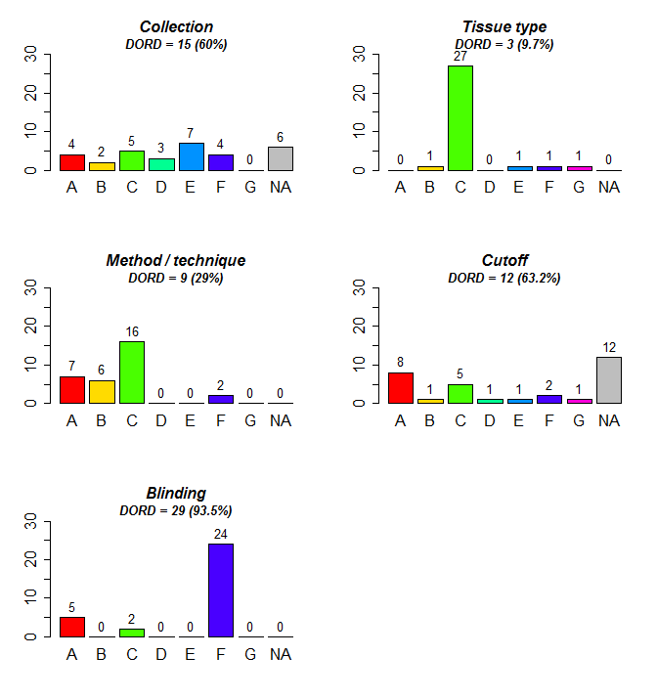
eFigure 1. Discordance and Risk of Discordance (DORD) Between Protocols and Publications for Subdomains of Biospecimen and Assays (N=31). Y-axis is number of protocols; X axis: A = Addition of an item in publication that was absent from protocol, B = Increase in specificity of information from protocol to publication, C = item present in both protocol and publication and completely concordant, D = item present but decreased specificity from protocol to publication, E = item present in the protocol but not in the publication, F = item absent from both protocol and publication, G = Explicit discordance, NA=not applicable given the biomarker or specimen characteristics.

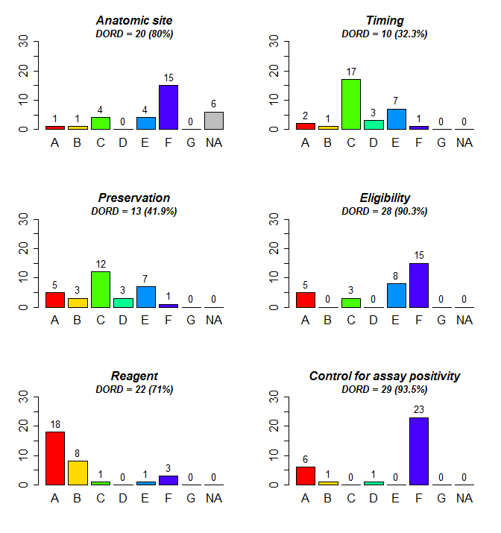eFigure2. Discordance and Risk of Discordance (DORD) Between Protocols and Publications for the 6 additional subdomains of Biospecimen and Assays that were assessed (N=31). Y-axis is number of protocols; X axis: A = addition of an item in publication that was absent from protocol, B = increase in specificity of information from protocol to publication, C = item present in both protocol and publication and completely concordant, D = item present but decreased specificity from protocol to publication, E = item present in the protocol but not in the publication, F = item absent from both protocol and publication, G = explicit discordance, NA=not applicable given the biomarker or specimen characteristics.

