MALDI-TOF Mass Spectrometry-based High-Throughput Screening for Inhibitors of the Cytosolic DNA Sensor cGAS
Roman P. Simon^{1,*}, Martin Winter^{1,*}, Carola Kleiner¹, Robert Ries¹, Gisela Schnapp², Annekatrin Heimann², Jun Li³, Ljiljana Zuvela-Jelaska³, Tom Bretschneider¹, Andreas H. Luippold¹, Wolfgang Reindl¹, Daniel Bischoff¹, and Frank H. Büttner¹
¹ Drug Discovery Sciences, Boehringer Ingelheim Pharma GmbH & Co. KG, Biberach an der Riß, Germany
² Medicinal Chemistry, Boehringer Ingelheim Pharma GmbH & Co. KG, Biberach an der Riß, Germany
³ Immunology & Respiratory Disease Research, Boehringer Ingelheim Pharma GmbH & Co. KG, Ridgefield (CT), USA
* These authors contributed equally to this work

Supporting Information

Corresponding authors:
Roman P. Simon and Frank H. Büttner, Boehringer Ingelheim Pharma GmbH & Co. KG, Birkendorfer Str. 65, 88397 Biberach/Riß, Germany. Email: roman.simon@boehringer-ingelheim.com; frank.buettner@boehringer-ingelheim.com
Supplemental Figure S1
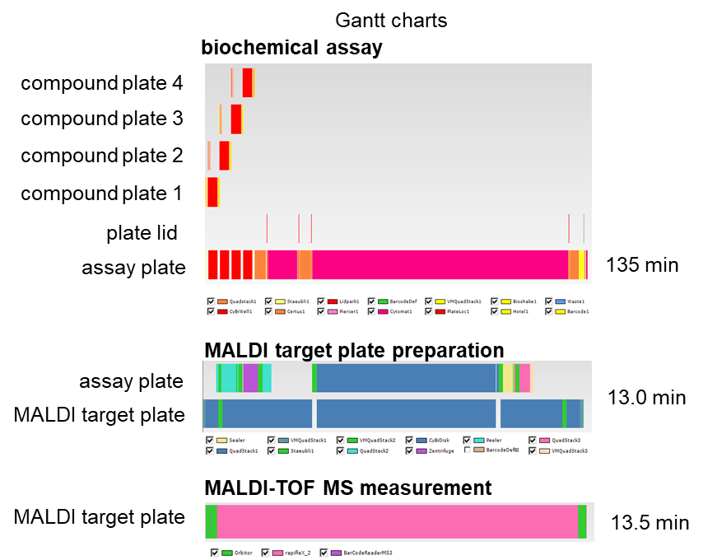
Supp. Fig. S1: Gantt charts for the plate handling process and the automated conduction of the biochemical assay (top), the MALDI target plate preparation (middle), and MALDI-TOF MS measurement (bottom).

Supplemental Figure S2
Supp. Fig. S2: cGAS activity is dependent on the presence of dsDNA. 45-bp dsDNA was titrated against 12 nM cGAS and 60 µM ATP/¹³C₁₀,¹⁵N₅-GTP, incubated for 90 minutes, and analyzed by MALDI-TOF MS. No signal was observed in the absence of dsDNA while full activation was reached from 4-324 nM dsDNA.

Supplemental Figure S3
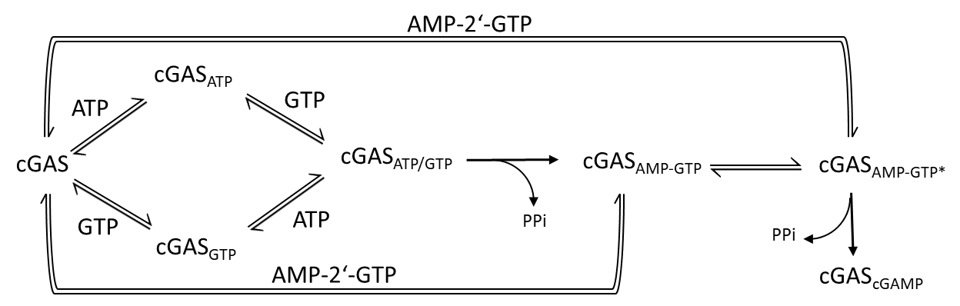
Supp. Fig. S3: Schematic mechanism of cGAS catalyzed generation of cGAMP. The linear precursor intermediate AMP-GTP can dissociate from the enzyme and competes with nucleotide substrates for binding to cGAS. However, a direct conversion of AMP-GTP into cGAMP after reorientation of the active site is also possible. The scheme is based on the mechanism proposed by Hall et al.⁸ cGAS in the scheme is shown in its dsDNA bound state.

Supplemental Figure S4
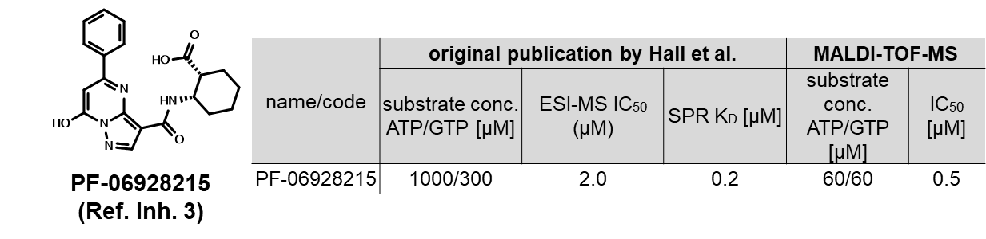
Supp. Fig. S4: Published reference cGAS inhibitor PF-06928215 (Ref. Inh. 3). Structure and assay results of Ref. Inh. 3 from its original publication compared to results from the MALDI-TOF-based assay.²³

Supplemental Figure S5
Supp. Fig. S5: Scatter plot of PoC values from the stability run of 5750 DMSO controls based on signal area.

Supplemental Figure S6
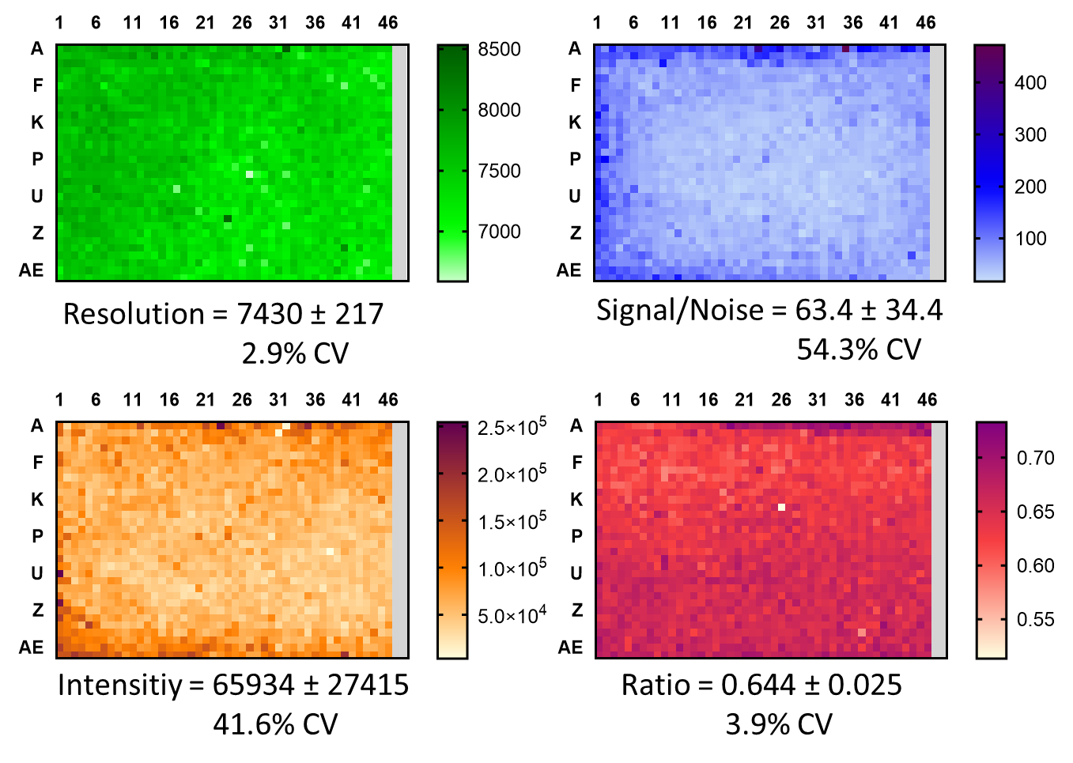
Supp. Fig. S6: Heatmaps (green: Resolution; blue: Signal/Noise; orange: Intensity; red: Ratio) of MALDI-TOF MS measurements of ¹³C₁₀,¹⁵N₅-cGAMP of a representative 1536-well plate containing 1472 DMSO controls and 64 low controls.

Supplemental Figure S7
Supp. Fig. S7: Comparison of control and Z’-values for the set of 5750 DMSO controls calculated from data determined with (S/N = 3) or without (S/N = 0) applying a peak picking threshold.

Supplemental Figure S8
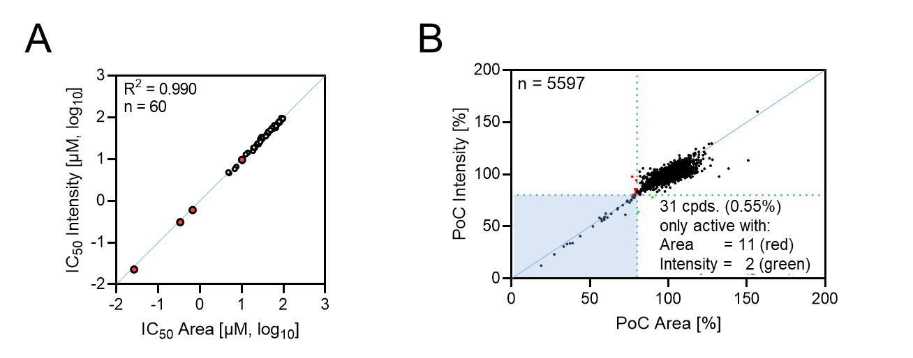
Supp. Fig. S8: Data analysis based on signal intensities rather than signal areas showed equivalent assay results. (A) Comparison of results from IC₅₀ determinations based on signal area (x-axis) or signal intensity (y-axis). Results of tool compounds are indicated in red. (B) Concordance of results from the validation set based on area-based or intensity-based data evaluation.

Supplemental Figure S9
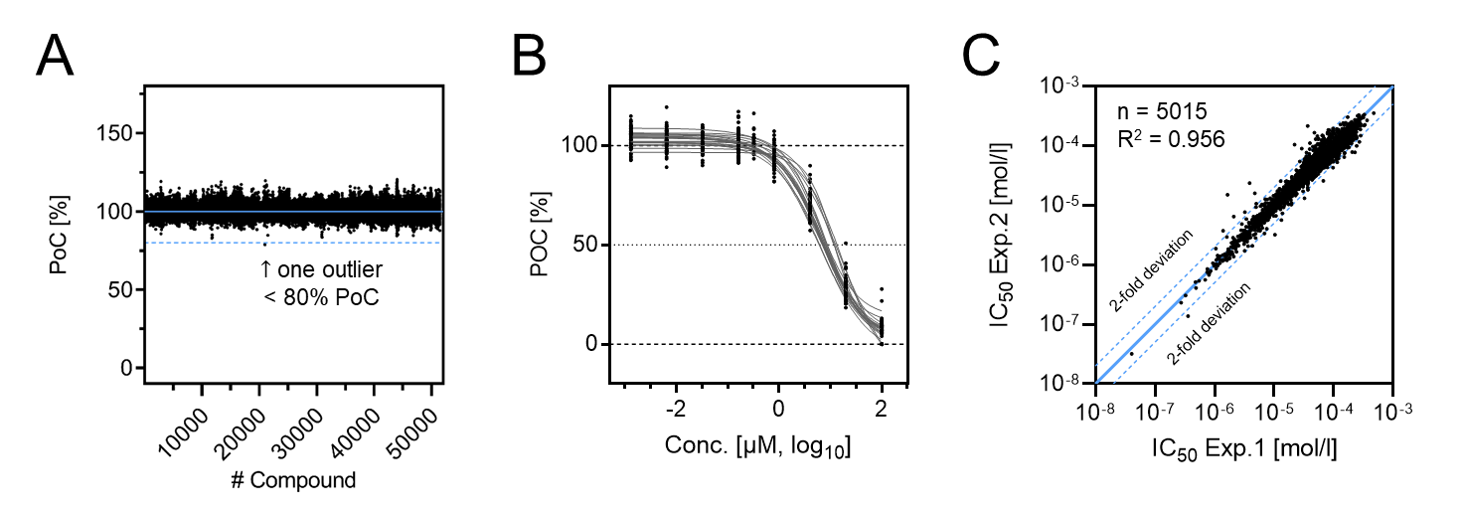
Supp. Fig. S9: Consistency of controls during the primary library screening campaign. (A) Scatter plot of PoC values for 51,486 high controls in the primary HTS screen. An average control value of 100.0% with a variation of 3.3% CV was determined. (B) IC₅₀ curves of Ref. Inh. 1 from control plates included in every screening batch (n = 19). Determined IC₅₀ values were highly consistent throughout the screen (8.87 ± 2.03 µM). (C) Correlation of IC₅₀ determinations for primary screening hits from two individual experiments.

Supplemental Figure S10
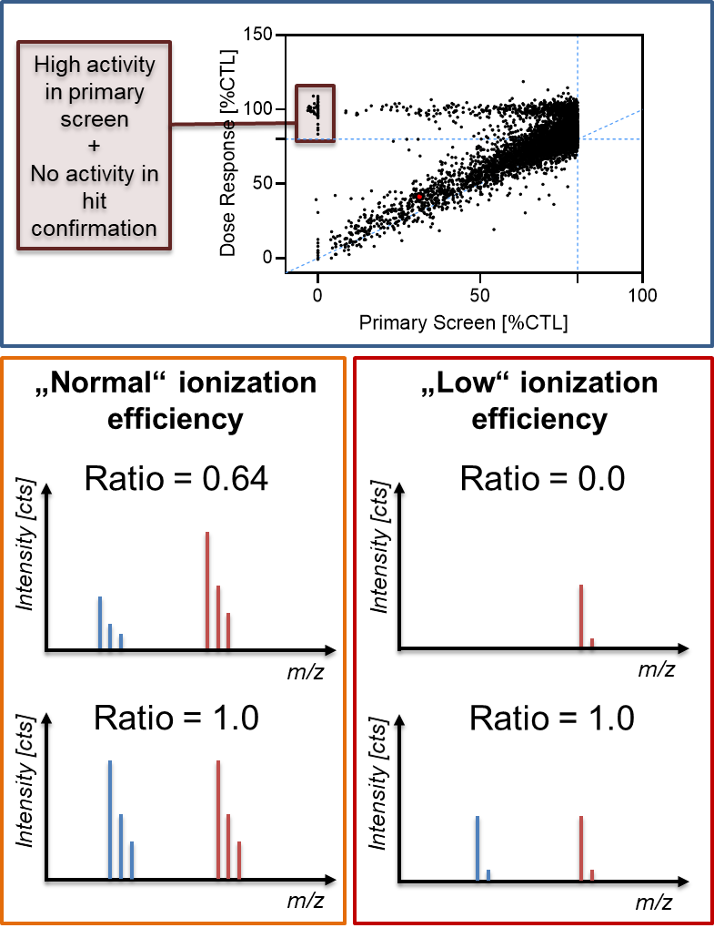
Supp. Fig. S10: Low ionization efficiency is the proposed reason for non-reproducible compound activity. Under conditions where internal standard (red) produces a higher signal than the reaction product (blue) during MALDI-TOF analysis (e.g. Ratio = 0.64), low ionization efficiencies can lead to false positive assay results due to signal intensity reduction below the detection limit. This aspect can be addressed by providing equal signal intensities of both analytes (Ratio = 1).

Supplemental Figure S11
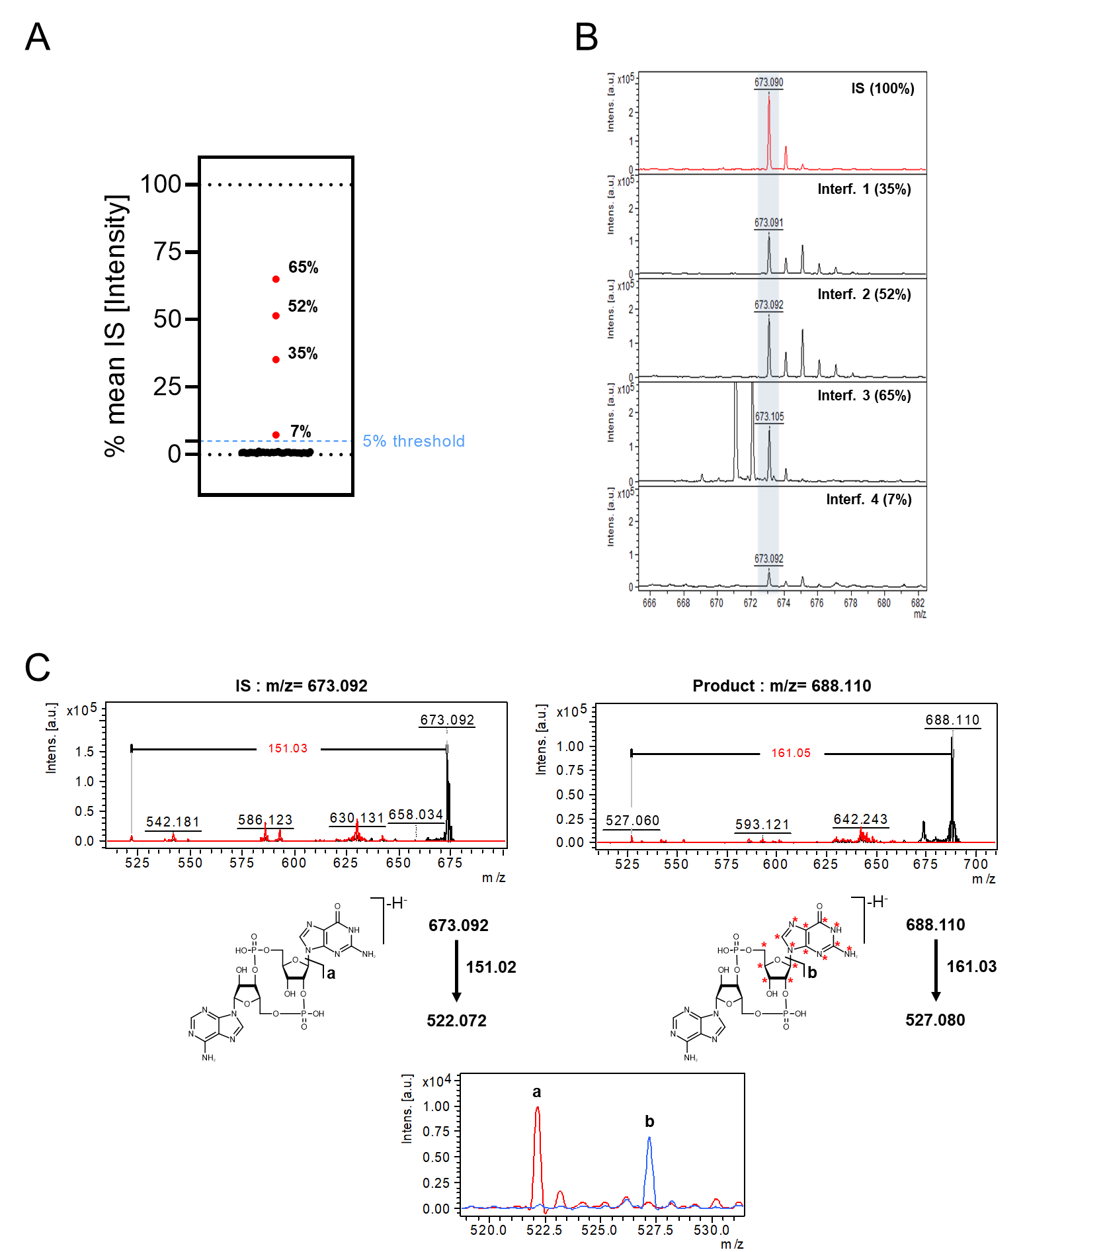
Supp. Fig. S11: Isobaric compound interference. (A) Evaluation of compound detectability under assay conditions. Replicates (n = 8) of potential interfering compounds (36 cpds.) were measured under low control conditions without internal standard in the incubation mixtures. Percent values represent average normalized signal intensities compared to internal standard (n = 16). (B) Representative MALDI-TOF spectra of internal standard (IS) and isobaric compounds (Interf. 1-4). The average normalized signal intensities are included in parentheses. (C) Visualization of the MS/MS principle for effect analysis of isobaric compounds. Fragmentation at the indicated positions and loss of the guanine residues produce two distinct ion species with a mass difference of 5 Da. Signals a and b were recorded in individual experiments and demonstrate the general feasibility to quantify cGAS activity based on fragment ions the MS/MS featured MALDI-TOF/TOF system.

