**Supplementary Materials**

**Calculation of the objective and subjective gini coefficient**

**Objective gini coefficient.** The Gini coefficient is a measure of inequality of the income distribution. It is defined as a ratio with values ranging from 0 (absolute equality) to 1 (maximal inequality). The Gini coefficient is calculated as the ratio of area A over (area A + area B). The numerator is the area between the Lorenz curve of the distribution and the uniform distribution line; the denominator is the area under the uniform distribution line (see Figure 1a).

**Subjective gini coefficient**. The measure for the subjective level of economic inequality was calculated on the basis of responses to a question in which participants were asked to think of 100 citizens living in their country and to estimate how many of these 100 people they would classify as ‘very poor’, ‘poor’, ‘average in wealth’, ‘wealthy’, ‘very wealthy’. Four steps were taken to calculate the subjective Gini. First, the five wealth categories, “very poor”, “poor”, “average in wealth”, “wealthy”, and “very wealthy”, were valued as 1, 2, 3, 4, and 5 units of wealth. Second, using the responses to the wealth distribution measure (i.e., how many people fall in each wealth category) of the participants, a histogram of cumulative wealth distribution was plotted (see Figure 1b). Third, both a line of equality and the Lorenz curve were drawn. Given the fact that there were only five observations per participant (i.e. people only had to estimate the size of 5 wealth groups), the Lorenz curve was simulated simulation by connecting the diagonal of each column’s protruding part. Finally, the subjective Gini coefficient was calculated as the ratio of area A over (area A + area B).

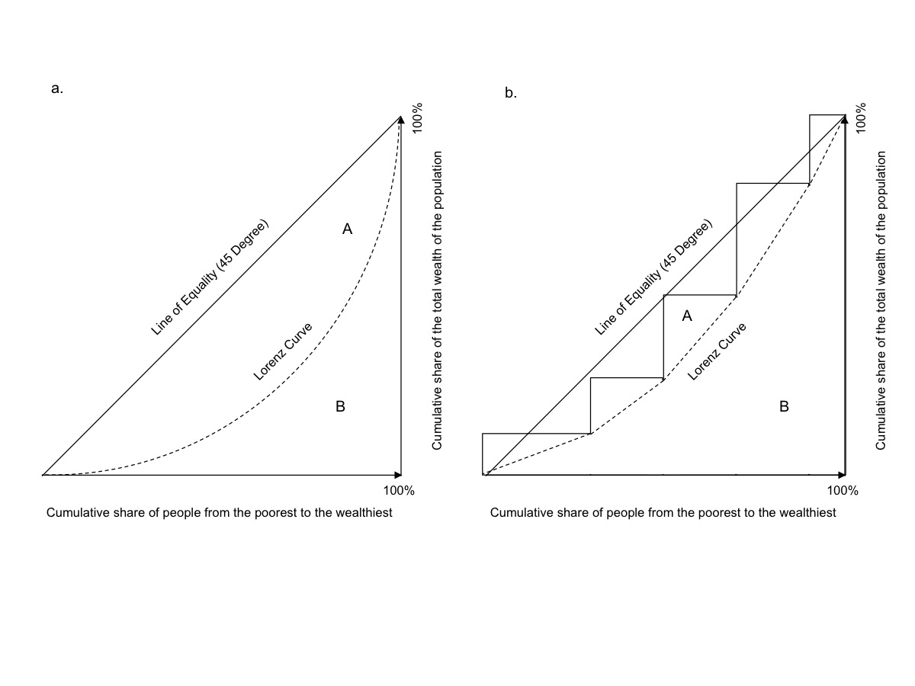*Figure 1.* Graphical representations of calculation of (a) the Gini coefficient and (b) the subjective Gini coefficient.

|  |  |  |  |  |  |  |  |  |  |
| --- | --- | --- | --- | --- | --- | --- | --- | --- | --- |
| Table 1  *Means of key variables by country (Study 1). Objective inequality, GDP per capita, the Democracy Index and homicide rate are country level variables. Subjective inequality, perceived anomie, the wish for a strong leader, political orientation are individual-level variables.* | | | | | | | | |  |
| Country | N | Objective Inequality | Subjective inequality | Perceived Anomie | Wish for a strong leader | Political orientation  (right-wing) | GDP per capita PPP (x1000 US$) | Democracy index | Homicide rate |
| Australia | 149 | .35 | .18 | 3.94 | 5.64 | 3.54 | 46.3 | 9.01 | 1.0 |
| Belgium | 242 | .28 | .19 | 4.34 | 4.64 | 3.79 | 44.7 | 7.93 | 1.9 |
| Brazil | 146 | .52 | .25 | 4.79 | 5.29 | 3.50 | 16.0 | 7.38 | 28.0 |
| Canada | 233 | .34 | .19 | 3.73 | 5.52 | 3.85 | 45.1 | 9.08 | 1.5 |
| Chile | 151 | .51 | .19 | 4.53 | 4.52 | 3.77 | 22.9 | 7.80 | 3.6 |
| China | 151 | .42 | .18 | 4.14 | 5.23 | 3.94 | 13.4 | 3.00 | 0.7 |
| Denmark | 164 | .29 | .14 | 3.59 | 4.65 | 3.87 | 47.8 | 9.11 | 1.3 |
| Finland | 113 | .27 | .17 | 3.69 | 4.54 | 3.32 | 41.5 | 9.03 | 1.6 |
| France | 150 | .33 | .21 | 4.68 | 5.52 | 3.77 | 40.2 | 8.04 | 1.2 |
| Germany (West) | 175 | .30 | .18 | 3.93 | 3.86 | 3.52 | 47.1 | 8.64 | 0.9 |
| Germany (East) | 147 | .30 | .18 | 3.97 | 3.66 | 3.34 | 47.1 | 8.64 | 0.9 |
| Hungary | 160 | .31 | .25 | 4.83 | 5.13 | 4.18 | 25.5 | 6.90 | 1.5 |
| India | 145 | .35 | .26 | 4.60 | 5.99 | 4.17 | 5.70 | 7.92 | 3.7 |
| Indonesia | 557 | .40 | .26 | 4.37 | 6.31 | 4.20 | 10.6 | 6.95 | 0.5 |
| Iran | 170 | .37 | .24 | 4.64 | 4.73 | 3.61 | 17.4 | 1.98 | 2.5 |
| Italy | 156 | .35 | .21 | 4.81 | 5.00 | 3.14 | 36.3 | 7.85 | 0.8 |
| Japan | 382 | .32 | .17 | 4.41 | 5.06 | 4.29 | 39.4 | 8.08 | 0.3 |
| Latvia | 149 | .36 | .23 | 4.63 | 6.19 | 4.15 | 23.9 | 7.48 | 3.2 |
| Malaysia | 112 | .46 | .23 | 4.36 | 6.37 | 3.89 | 25.8 | 6.49 | 2.1 |
| Pakistan | 150 | .31 | .27 | 3.73 | 6.48 | - | 4.80 | 8.92 | 7.2 |
| Poland | 180 | .32 | .22 | 5.09 | 4.94 | 4.24 | 25.7 | 4.64 | 0.7 |
| Portugal | 160 | .36 | .23 | 4.84 | 5.62 | 3.68 | 28.8 | 7.47 | 0.9 |
| Singapore | 193 | .46 | .18 | 4.63 | 5.63 | 4.29 | 83.8 | 7.79 | 0.3 |
| South-Africa | 451 | .63 | .27 | 3.80 | 6.37 | 3.83 | 13.1 | 6.03 | 32.6 |
| Spain | 277 | .36 | .21 | 4.87 | 5.22 | 2.92 | 33.7 | 7.82 | 0.7 |
| Switzerland | 448 | .32 | .16 | 4.74 | 3.58 | 3.36 | 61.3 | 8.05 | 0.5 |
| Netherlands | 208 | .28 | .16 | 3.57 | 4.41 | 3.59 | 49.1 | 9.09 | 0.7 |
| UK | 74 | .33 | .19 | 3.87 | 5.55 | 3.48 | 40.7 | 8.31 | 0.9 |
| USA (Tennessee) | 178 | .41 | .21 | 4.27 | 5.66 | 4.31 | 54.5 | 8.11 | 4.5 |
| USA (California) | 141 | .41 | .22 | 4.41 | 5.62 | 3.68 | 54.5 | 8.11 | 4.5 |

**Multilevel models predicting anomie and the wish for a strong leader**

|  |  |  |  |  |  |  |  |  |  |  |  |  |  |  |  |  |  |  |
| --- | --- | --- | --- | --- | --- | --- | --- | --- | --- | --- | --- | --- | --- | --- | --- | --- | --- | --- |
| Table 2a  *Null model and intercept only model predicting anomie and a wish for a strong leader (Study 1)* | | | | | | | | | | | | | | | | | | |
|  | | Model 0 (Null model) | | | | | | | | Model 1 (Intercept-Only model) | | | | | | | | |
|  | | Anomie perceptions | | | | Wish for a strong leader | | | | Anomie perceptions | | | | | Wish for a strong leader | | | |
|  | | *b* | | *SE* | | *b* | | *SE* | | *b* | | | *SE* | | *b* | | *SE* | |
| Intercept | | 4.33*** | | 0.01 | | 5.25*** | | 0.02 | | 4.33*** | | | 0.08 | | 5.23*** | | 0.14 | |
| Variance components | | | | | | | | | | | | | | | | | | |
|  | Individual level | | 0.76*** | | 0.01 | | 2.30*** | | 0.04 | | | 0.58*** | | 0.01 | | 1.61*** | | 0.03 | |
|  | Country level | |  | |  | |  | |  | | | 0.19*** | | 0.05 | | 0.58*** | | 0.15 | |
| Fit statistics | | | | | | | | | | | | | | | | | | |
| Log Likelihood (parameters) | | -19068.99 (4) | | | | | | | | | -17233.58 (6) | | | | | | | |
| Deviance difference | |  | | | | | | | | | 3670.81(2)*** | | | | | | | |
| AIC | | 38145.98 | | | | | | | | | 34479.17 | | | | | | | |
| *Note.* \*\*\**p* < .001 | | | | | | | | | | | | | | | | | | |

|  |  |  |  |  |  |  |  |  |  |  |  |  |  |  |  |
| --- | --- | --- | --- | --- | --- | --- | --- | --- | --- | --- | --- | --- | --- | --- | --- |
| Table 2b  *Multilevel models predicting anomie and a wish for a strong leader (Study 1)* | | | | | | | | | | | | | | | |
|  | | | Model 2a  (only control variables) | | | | Model 2b  (all individual level variables) | | | | Model 3  (all variables) | | | | |
|  | | | Anomie perceptions | | Wish for a strong leader | | Anomie perceptions | | Wish for a strong leader | | Anomie perceptions | | Wish for a strong leader | | |
|  | | | *b* | *SE* | *b* | *SE* | *b* | *SE* | *b* | *SE* | *b* | *SE* | *b* | | *SE* |
| Intercept | | | 4.62*** | 0.09 | 4.72*** | 0.15 | 4.18*** | 0.09 | 4.50*** | 0.16 | 4.67*** | 0.49 | 3.41*** | | 1.01 |
| Individual level | | |  |  |  |  |  |  |  |  |  |  |  | |  |
|  | Anomie | |  |  |  |  |  |  | 0.19*** | 0.02 |  |  | 0.19*** | | 0.02 |
|  | Subjective Inequality | |  |  |  |  |  |  |  |  |  |  |  | |  |
|  |  | Total |  |  |  |  | 2.09*** | 0.20 | 1.01** | 0.34 | 2.05*** | 0.20 | 0.96** | | 0.34 |
|  |  | Direct |  |  |  |  |  |  | 0.62 | 0.34 |  |  | 0.57 | | 0.34 |
|  |  | Subjective inequality 🡪 Anomie |  |  |  |  |  |  | 0.39*** | 0.06 |  |  | 0.38*** | | 0.06 |
|  | Political orientation (right-wing) | | -0.08*** | 0.01 | 0.15*** | 0.01 | -0.08*** | 0.01 | 0.17*** | 0.01 | -0.08*** | 0.01 | 0.17*** | | 0.01 |
|  | Gender (male) | | 0 .01 | 0.02 | -0.16*** | 0.04 | 0.02 | 0.02 | -0.17*** | 0.04 | 0.02 | 0.02 | -0.17*** | | 0.04 |
| Country level | | |  |  |  |  |  |  |  |  |  |  |  | |  |
|  | Objective Inequality | |  |  |  |  |  |  |  |  |  |  |  | |  |
|  |  | Total |  |  |  |  |  |  |  |  | 0.34 | 0.99 | 4.30* | | 2.05 |
|  |  | Direct |  |  |  |  |  |  |  |  |  |  | 4.20* | | 2.02 |
|  |  | Objective Inequality 🡪 Anomie |  |  |  |  |  |  |  |  |  |  | 0.15 | | 0.44 |
|  | GDP | |  |  |  |  |  |  |  |  | -0.01*** | 0.00 | -0.02 | | 0.01 |
|  | Democracy Index | |  |  |  |  |  |  |  |  | -0.03 | 0.04 | -0.02 | | 0.08 |
|  | Homicide Rate | |  |  |  |  |  |  |  |  | 0.01 | 0.01 | -0.02 | | 0.02 |
| Variance components | | | | | | | | | | | | | | | |
|  | Individual level | | 0.57*** | 0.01 | 1.57*** | 0.03 | 0.56*** | 0.01 | 1.55*** | 0.03 | 0.56*** | 0.01 | 1.55*** | | 0.03 |
|  | Country level | | 0.19*** | 0.05 | 0.54*** | 0.14 | 0.15*** | 0.04 | 0.51*** | 0.13 | 0.08*** | 0.02 | 0.35*** | | 0.09 |
| Fit statistics | | | | | | | | | | | | | | | |
| Log Likelihood (parameters) | | | -30412.94 (15) | | | | -22483.37 (19) | | | | -22468.07 (28) | | | | |
| Deviance difference | | |  | | | | 15859.20(4)*** | | | | 15.70(9) | | | | |
| AIC | | | 60855.89 | | | | 45004.74 | | | | 44992.14 | | | | |
| Explained variance | | |  | | | |  | | | |  | | | | |
| Individual level | | | .02 | | .02 | | .03 | | .04 | | .04 | | | .04 | |
| Country level | | | -.02 | | .07 | | .21 | | .13 | | .46 | | | .32 | |
| *Note*. In model 2a the deviance goes up compared to model 1, because of the endogenization of the control variables. This also explains why the explained variance of anomie on the country level is negative in model 2a.  * *p*<.05 \*\**p*. < .01 *** *p* < .001 | | | | | | | | | | | | | | | |

**Measurement Model Study 1**

Unfortunately, it was not possible to estimate our model using latent variables. Mplus ran into convergence problems while estimating some of the multilevel models with latent constructs (i.e., it was too computationally heavy). Therefore, it was decided to run the multilevel models with manifest variables which were created by taking the mean scores of the items of the latent variables. Nevertheless, we think it is appropriate to share the steps we took to build a measurement model. We would also like to emphasize we did not specifically look at differences between countries, but that future studies that would like to engage in such an exercise should carefully examine whether the items are invariant across different countries.

We fit a measurement model with the wish for a strong leader, and anomie as latent factors. Anomie was treated a second-order factor with the two subscales (i.e., breakdown in social fabric and breakdown in government) as first-order factors. This model (without any modifications) had an acceptable fit to the data, χ2(87) = 3959.34, *p* <.001, Comparative Fit Index (CFI) = .90, Root Mean Square Error of Approximation (RMSEA) = .09, Standardized Root Mean Square Residual (SRMR) = .07.

After fitting a measurement model on the individual level, we inspected whether the factor structure was invariant across both levels. Thus, we examined whether the factor structure found at the individual level held on the country level. First, we fit a model in which the factor loadings were restricted to be equal across the two levels. Subsequently, we fit a model in which the items were allowed to vary across the levels. While both models had an acceptable fit to the data, the model in which the items were free to vary had a slightly better fit, ∆χ2(13) = 84.67, *p* <.001. However, freeing four items of the anomie scale[1] and one item of the desire for a strong leader scale[2] significantly improved the model compared to the fully constrained model, ∆χ2(5) = 74.46, p <.001. Moreover, the fully unconstrained model was not a significantly better fit to the data than this model with partial constraints, ∆χ2(8) = 10.20, *p* = .251. This suggests that, with some modifications, we may assume that the factors measured the same construct on both levels (i.e. the latent factors measured the same constructs on the individual level and the country level). Nevertheless, given the variety in context and languages in our sample and the fact that we did not engage in theoretical reasoning for the modifications, we believe it is of utmost importance to be careful with regards to cross-country comparisons. Hence, future research looking to delve into the country differences (e.g., studies using multi-group analysis) regarding the wish for strong leader should further investigate to what extent the items measure the same construct in different contexts.

**Random Slopes**

Unfortunately, we could not test for random slopes as this made the model too complex to run with the data available. Therefore, we merely tested for random intercepts. We did, however, run two separate models in which we tested for random slopes for perceived inequality (i.e., one model with anomie as the dependent variable and one model with the wish for a strong leader as the dependent). In both cases the results were rather similar to the results of the main analyses and, more importantly, the variance of the slope was not significant. Results of these additional analyses are available upon request.

**Subjective inequality and personal SES in Study 1**

One might argue that the subjective score could be associated with personal economic status. However, we found that the correlation between the subjective inequality score and participants’ classification of their wealth were rather low, r = -.03, *p* = .018.

**Analyses with the two dimensions of anomie separately Study 1**

|  |  |  |  |  |  |  |  |  |  |  |
| --- | --- | --- | --- | --- | --- | --- | --- | --- | --- | --- |
| Table 3  *Correlations between the main variables with the two dimensions of anomie separate* | | | | | | | | | |  |
|  | 1 | 2 | 3 | 4 | 5 | 6 | 7 | 8 | 9 | |
| 1.Objective inequality |  |  |  |  |  |  |  |  |  | |
| 2.Subjective inequality | .35*** |  |  |  |  |  |  |  |  | |
| 3.Breakdown in social fabric | .19*** | .26*** |  |  |  |  |  |  |  | |
| 4.Breakdown of government | .16*** | .28*** | .38*** |  |  |  |  |  |  | |
| 5.Wish for a strong leader | .30*** | .28*** | .19*** | .19** |  |  |  |  |  | |
| 6. Political orientation (right-wing) | .05** | .01 | -.01 | -.12*** | .20*** |  |  |  |  | |
| 7. GDP | -.37*** | -.48*** | -.25*** | -.34*** | -.33*** | -.07*** |  |  |  | |
| 8. Democracy Index | -.21*** | -.25*** | -.23*** | -.11*** | -.17*** | -.08*** | .45*** |  |  | |
| 9. Gender (male) | -.07*** | -.05*** | .04** | -.01 | -.10*** | .03* | .06*** | -.02 |  | |
| 10. Homicide rate | .83*** | .33*** | .19*** | .18*** | .22*** | -.004 | -.40*** | -.02 | -.06*** | |
| *Note.* **. *p*. < .01 ***. *p* < .001 | | | | | | | | | |  |

|  |  |  |  |  |  |  |  |  |
| --- | --- | --- | --- | --- | --- | --- | --- | --- |
| Table 4  *Multilevel models predicting the two dimensions of anomie and a wish for a strong leader (Study 1)* | | | | | | | | |
|  | | | Breakdown of social fabric | | Breakdown of government | | Wish for a strong leader | |
|  | | | *b* | *SE* | *b* | *SE* | *b* | *SE* |
| Intercept | | | 4.68*** | 0.45 | 4.64*** | 0.70 | 3.41*** | 1.00 |
| Individual level | | |  |  |  |  |  |  |
|  | Breakdown of social fabric | |  |  |  |  | 0.14*** | 0.02 |
|  | Breakdown of government | |  |  |  |  | 0.06** | 0.02 |
|  | Subjective Inequality | |  |  |  |  |  |  |
|  |  | Total |  |  |  |  | 0.98** | 0.34 |
|  |  | Direct | 2.09*** | 0.24 | 2.11*** | 0.25 | 0.58 | 0.34 |
|  |  | Subjective inequality 🡪 Breakdown of social fabric |  |  |  |  | 0.28*** | 0.05 |
|  |  | Subjective inequality 🡪 Breakdown of government |  |  |  |  | 0.12** | 0.04 |
|  | Political orientation (right-wing) | | -0.03* | 0.01 | -0.13*** | 0.01 | 0.16*** | 0.01 |
|  | Gender (male) | | 0.06* | 0.03 | -0.02 | 0.03 | -0.17*** | 0.04 |
| Country level | | |  |  |  |  |  |  |
|  | Objective Inequality | |  |  |  |  |  |  |
|  |  | Total |  |  |  |  | 4.13* | 2.00 |
|  |  | Direct | 0.18 | 0.92 | 0.51 | 1.44 | 4.30* | 2.05 |
|  |  | Objective Inequality 🡪 Breakdown of social fabric |  |  |  |  | -0.01 | 0.09 |
|  |  | Objective Inequality 🡪 Breakdown of government |  |  |  |  | 0.17 | 0.51 |
|  | GDP | | -0.01 | 0.00 | -0.02** | 0.01 | -0.02* | 0.01 |
|  | Democracy Index | | -0.10** | 0.04 | 0.04 | 0.06 | -0.02 | 0.08 |
|  | Homicide Rate | | 0.01 | 0.01 | 0.00 | 0.02 | -0.02 | 0.02 |
| Variance components | | | | | | | | |
|  | Individual level | | 0.80*** | 0.01 | 0.91*** | 0.02 | 1.55*** | 0.03 |
|  | Country level | | 0.07*** | 0.02 | 0.17*** | 0.05 | 0.35*** | 0.09 |
| Fit statistics | | | | | | | | |
| Log Likelihood (parameters) | | | -31953.36(41) | | | | | |
| AIC | | | 63988.71 | | | | | |
| Explained variance | | |  | | | | | |
| Individual level | | | .02 | | .04 | | .04 | |
| Country level | | | .49 | | .36 | | .32 | |
| *Note*.* *p*<.05 \*\**p*. < .01 *** *p* < .001 | | | | | | | | |

**Additional analyses with the more specific strong leadership items**

In Study 1, we included a rather general measure of the wish for a strong leader which did not explicitly measure support for a leader who uses non-democratic means. To further the understanding of the kind of strong leader people long for, we extended this measure in Studies 2 and 3 and added four items designed to capture the extent to which participants would be in favor of a strong leader who is willing to forego democratic values, break the rules or change the status quo to achieve desired outcomes.

Even though internal consistency of all 7 items measuring the wish for a strong leader was high across all studies (i.e., all Cronbach’s alphas are .85 or higher), in order to explore whether the results for the 3 initial items were different from the 4 new items, we checked whether leaving out the 3 more general items from the full scale would affect our results. In other words, we performed additional analyses for Studies 2 and 3 in which the Strong Leader measure was only comprised of the 4 new items that more explicitly tap into the authoritarian dimension of strong leadership and compared results with the full 7 item measure.

We found that the effect of perceived inequality on the wish for a strong leader was not different when these three items were omitted compared to when we report the results for the full scale including these 3 items. In no case did effects become non-significant (see Figure 2 and Table 5). This provides greater confidence that the set of initial 3 items did not measure a different construct than the full scale which included items that explicitly tap support for a leader who uses non-democratic means.



*Figure 2.* Indirect effect of economic inequality on the wish for a strong leader (4 new items only) mediated by the perception of anomie. Study 2.

*Note.* \**p*<.05, \*\*\**p* <.001

|  |  |  |  |  |  |  |  |  |
| --- | --- | --- | --- | --- | --- | --- | --- | --- |
| *Table 5*  Means and Standard Deviations of the Wish for a Strong Leader variable per experimental condition, Study 3a and 3b | | | | | | | | |
|  | | *Low inequality condition* | | *High inequality condition* | | |  | |
|  | | *Mean* | *SD* | | *Mean* | *SD* | | *t-test* |
| Study 3a | |  |  | |  |  | |  |
|  | Wish for a strong leader (7 items) | 4.49 | 1.01 | | 5.28 | .97 | | 3.90*** |
|  | Wish for a strong leader (4 new items only) | 4.10 | 1.21 | | 4.94 | 1.19 | | 3.42** |
|  |  |  |  | |  |  | |  |
| Study 3b | |  |  | |  |  | |  |
|  | Wish for a strong leader (7 items) | 3.14 | 1.30 | | 4.61 | 1.37 | | 9.50*** |
|  | Wish for a strong leader (4 new items only) | 2.73 | 1.26 | | 4.22 | 1.43 | | 9.50*** |
| *Note*. ** *p* < .01 *** *p* < .001 | | | | | | | | |

**Group-mean centring Study 1**

Because subjective inequality and anomie perceptions can vary within a country, Study 1 results potentially confounded individual-level and country-level effects. If they are indeed confounded, centring each participant’s subjective inequality and anomie scores on the country-means of subjective inequality and anomie perceptions, respectively, would possibly provide more accurate estimates. Therefore, we ran additional analyses in which we used a different centring strategy.

Given that we are predominantly interested in the individual-level effects, we decided to unconfound them from the country-level effects by country-centring (i.e., group-centring) each individual’s subjective inequality (and anomie) score (i.e., centre within each country on the country mean rating). The rationale for this is further outlined by Raudenbush and Bryk (2002) as well as Enders and Torfighi (2007).

By definition, an individual-level variable that is centred on the country-mean will have no variance at the country level. Thus, after centring subjective inequality and anomie perceptions on their country-means, they no longer correlate with objective inequality and other country-level variables. However, in our conceptual model, anomie perceptions are related to objective inequality. Therefore, we reintroduced the country-mean of anomie perceptions on the country level as this allows us to regress anomie perceptions on the objective inequality variable.

The results for Study 1 did not change substantially with this amended centring strategy (see Figure 3 and Table 6 below). Most importantly, using this different analytical strategy the data remain consistent with our theoretical model. Nevertheless, we believe there are two noteworthy changes. Firstly, the effect of subjective inequality on perceptions of anomie reduces slightly (from .16 to .13; standardized). Secondly, the direct effect of perceived inequality on the wish for a strong leader also becomes smaller (note that the direct effect was very small and non-significant to start with). This, of course, also reduces the total effect somewhat.

**References**

Enders, C. K., & Tofighi, D. (2007). Centering predictor variables in cross-sectional multilevel models: a new look at an old issue. *Psychological methods*, *12*(2), 121-138.

Raudenbush, S.W., & Bryk, A.S. (2002). *Hierarchical linear models: Applications and data analysis methods*. Thousand Oaks, CA: Sage.



*Figure 3.* Model representing the relation between objective inequality, subjective inequality (centered) and the wish for a strong leader mediated by perceptions of anomie (centered). At the country-level, perceptions of anomie are represented by the country-mean whereas at the individual level, perceptions of anomie are country-centred. Study 1.

*Note.* Standardized coefficients presented. *\*. p* < .05*, *** p* < .001*.*

|  |  |  |  |  |  |  |  |  |
| --- | --- | --- | --- | --- | --- | --- | --- | --- |
| Table 6  *Multi-level model predicting anomie and a wish for a strong leader (using group-mean centring),* unstandardized coefficients presented *Study 1* | | | | | | | | |
|  | | | | Anomie perceptions | | Wish for a strong leader | | |
|  | | | | *b* | SE | | *b* | SE |
| Intercept (individual-level) | | | | 0.26*** | 0.03 | |  |  |
| Intercept (country-level) | | | | 4.88*** | 0.52 | | 1.26 | 1.96 |
| Individual level | | | |  |  | |  |  |
|  | Anomie (individual-level) | | |  |  | | 0.19*** | 0.02 |
|  | Anomie (country-level) | | |  |  | | 0.48 | 0.35 |
|  | Subjective inequality | | |  |  | |  |  |
|  |  | Total | | 2.04*** | 0.20 | | 0.81* | 0.34 |
|  |  | Direct | |  |  | | 0.42 | 0.34 |
|  |  | Subjective inequality 🡪 Anomie | |  |  | | 0.39*** | 0.06 |
|  | Political orientation (right-wing) | | | -0.07*** | 0.01 | | 0.17*** | 0.01 |
|  | Gender (male) | | | 0.02 | 0.02 | | -0.17*** | 0.04 |
| Country level | | | |  |  | |  |  |
|  | Objective inequality | | |  |  | |  |  |
|  |  | | Total | 0.34 | 1.06 | | 4.33* | 2.08 |
|  |  | | Direct |  |  | | 4.16* | 2.03 |
|  |  | | Objective Inequality 🡪 Anomie |  |  | | 0.17 | 0.52 |
|  | GDP | | | -0.01** | 0.004 | | -0.01 | 0.01 |
|  | Democracy Index | | | -0.03 | 0.04 | | 0.03 | 0.08 |
|  | Homicide Rate | | | 0.01 | 0.02 | | -0.02 | 0.02 |
| Variance components | | | | | | | | |
|  | Individual level | | | 0.56*** | 0.01 | | 1.55*** | 0.03 |
|  | Country level | | | 0.10*** | 0.03 | | 0.34*** | 0.09 |
| *Note. *. p* < .05*, *** p* < .001*.* | | | | | | | | |

|  |  |  |  |  |
| --- | --- | --- | --- | --- |
| Table 7  *Regression model with country dummies predicting the wish for a strong leader, Study 1* | | | | |
|  | | Wish for a strong leader | | |
|  | | *b* | SE | *p* |
| Individual level predictors | |  |  |  |
|  | Anomie | 0.16 | 0.02 | <.001 |
|  | Subjective inequality | 0.52 | 0.35 | 0.140 |
|  | Political orientation (right-wing) | 0.17 | 0.02 | <.001 |
|  | Gender (male) | -0.15 | 0.04 | <.001 |
| *Note.* Country dummies included in the analysis. | | | | |

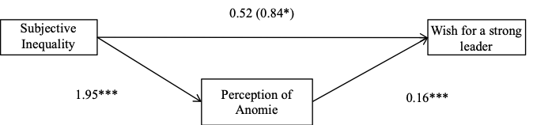

*Figure 4.* Model representing the relation between subjective inequality and the wish for a strong leader mediated by perceptions of anomie. Country dummies are included to control for differences between countries. Study 1.

*Note.* Unstandardized coefficients presented. *\*. p* < .05*, *** p* < .001*.*

**Illustrations of the inequality manipulation used in Study 3**

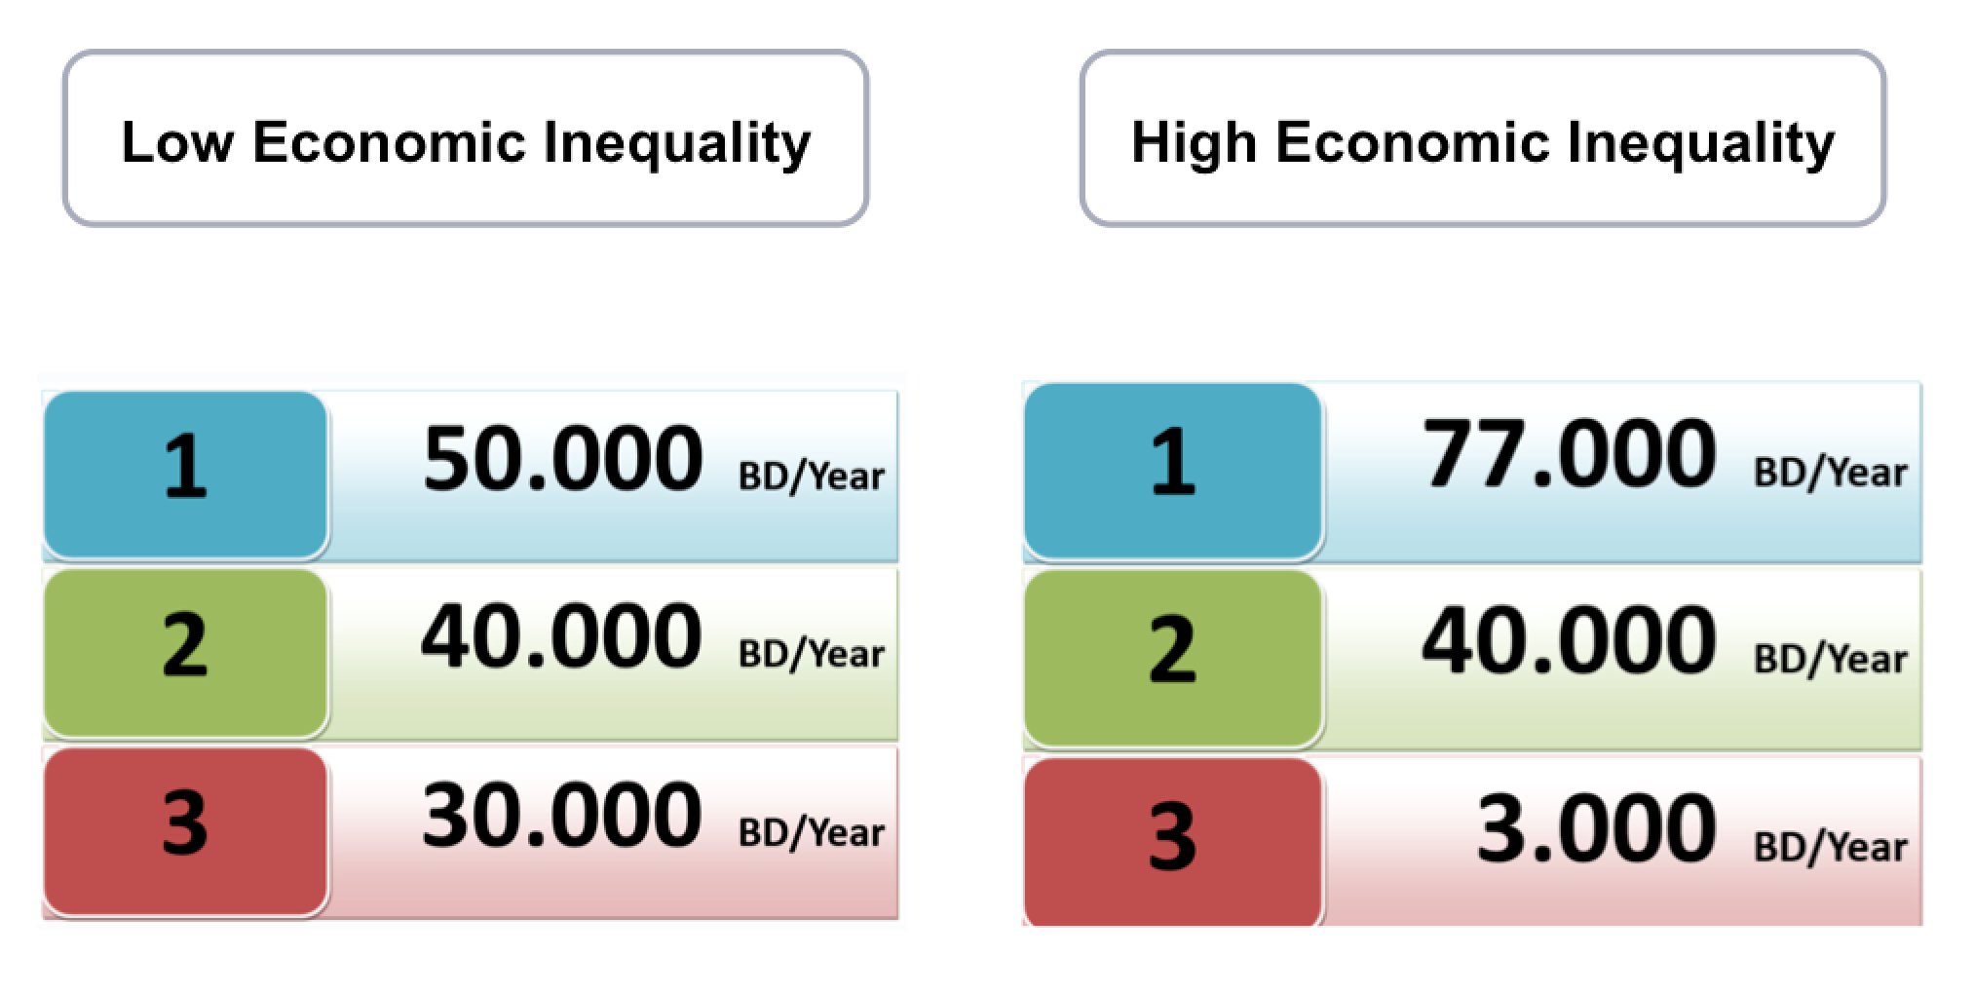

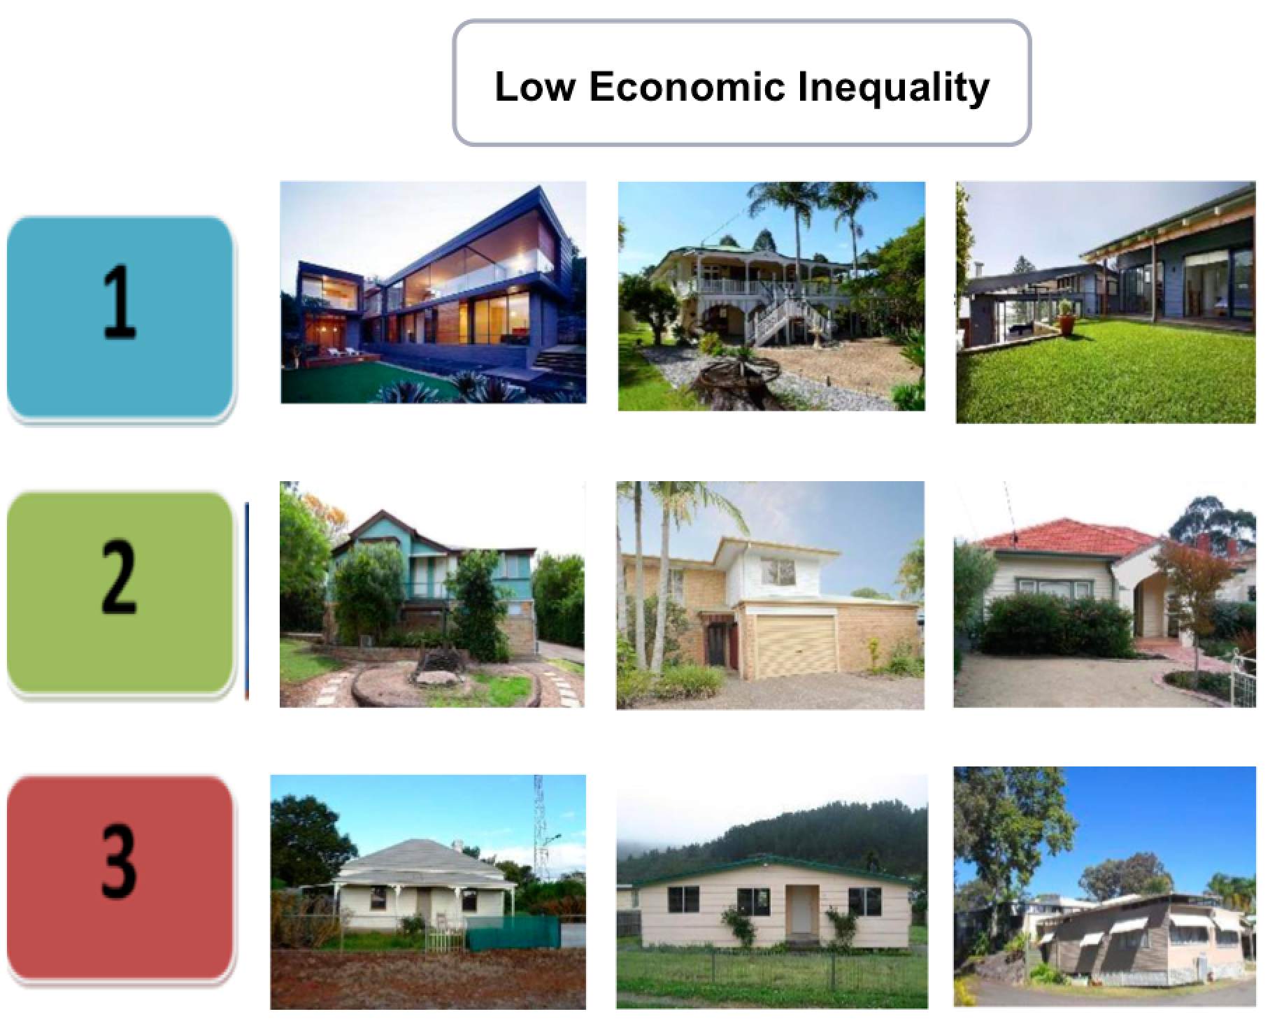

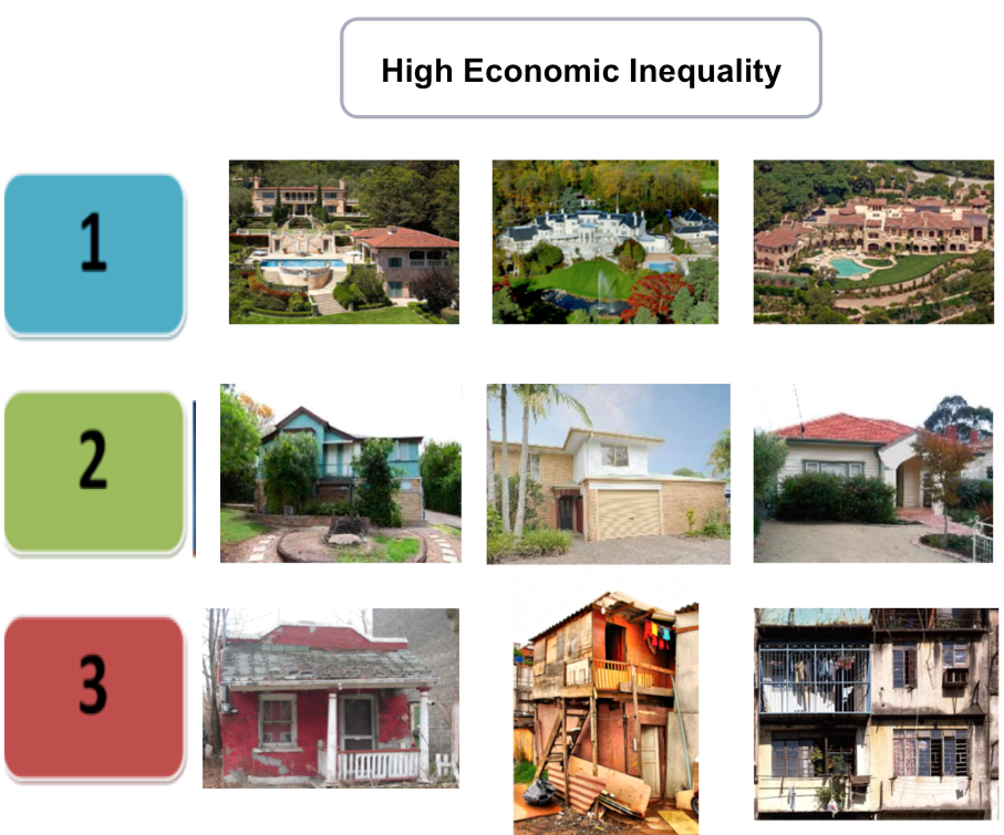

1. The statements ‘People do not know who they can trust and rely on’, ‘People think that honesty doesn’t work all the time; dishonesty is sometimes a better approach to get ahead’, ‘Most of the people think that if something works, it doesn’t really matter whether it is right or wrong’ and ‘Politicians don’t care about the problems of the average person’.
2. The statement ‘We need strong leadership in order to overcome societies' difficulties’