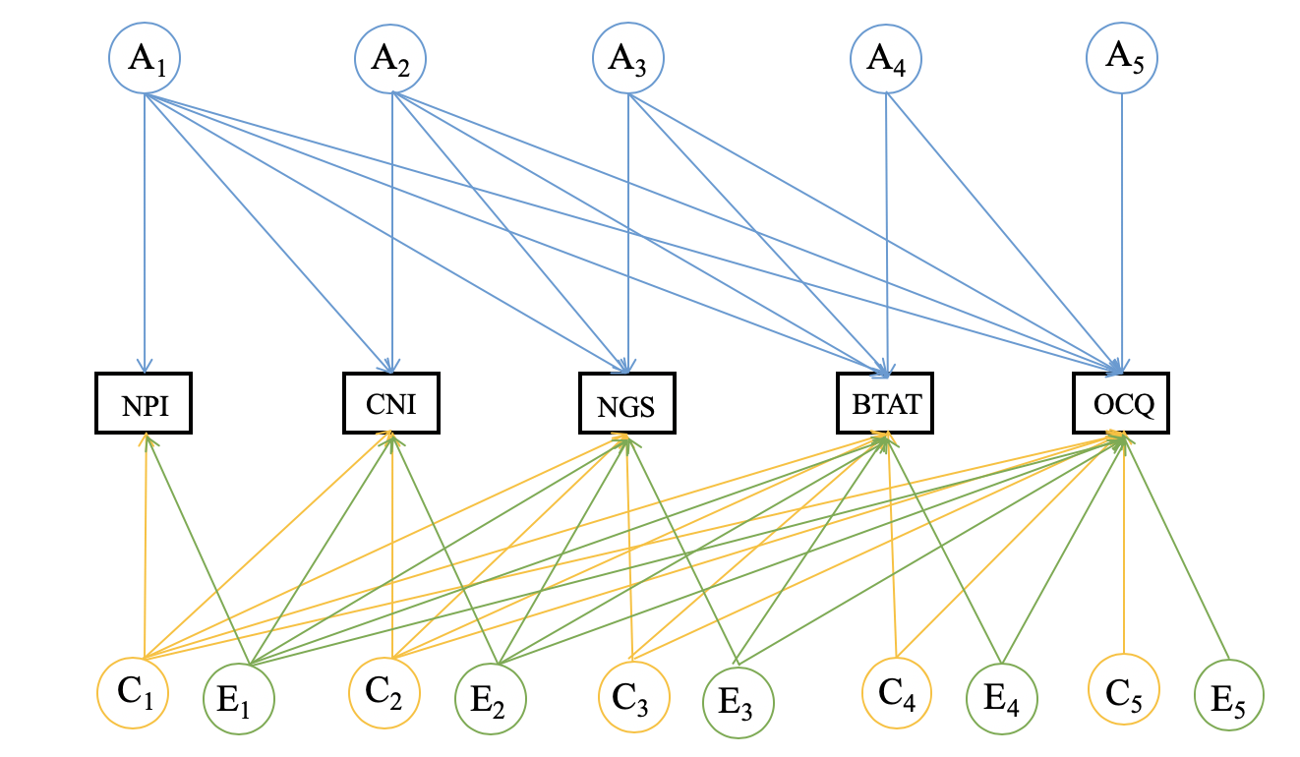
Supplementary Materials
Figure S1. An illustration of the Cholesky decomposition. We depict measured variables in rectangles. NPI: Narcissistic Personality Inventory; CNI: Communal Narcissism Inventory; NGS: Narcissistic Grandiosity Scale; BTAT: Better-than-Average Task; OCQ: Over-Claiming Questionnaire. We present A₁₋₅ (additive genetic factor), C₁₋₅ (shared environmental factor), and E₁₋₅ (non-shared environmental factor) in circles.
Table S1. Standardized Estimates of Model Parameters from the Cholesky Model of Self-Enhancement Manifestations
Variable | NPI | CNI | NGS | BTAT | OCQ
A₁ | .64 [.40, .74] | .30 [.01, .51] | .30 [.00, .51] | .32 [.00, .55] | .22 [.00, .47]
A₂ |  | .49 [.23, .63] | .40 [.15, .55] | .11 [.00, .36] | .04 [.00, .32]
A₃ |  |  | .04 [.00, .35] | .21 [.00, .47] | .00 [.00, .66]
A₄ |  |  |  | .01 [.00, .43] | .44 [.00, .66]
A₅ |  |  |  |  | .24 [.00, .63]
C₁ | .22 [.00, .50] | .15 [.00, .50] | .41 [.00, .60] | .47 [.00, .65] | .25 [.00, .57]
C₂ |  | .26 [.00, .48] | .00 [.00, .39] | .21 [.00, .51] | .32 [.00, .57]
C₃ |  |  | .00 [.00, .39] | .00 [.00, .44] | .00 [.00, .49]
C₄ |  |  |  | .00 [.00, .37] | .00 [.00, .49]]
C₅ |  |  |  |  | .00 [.00, .42]
E₁ | .74 [.66, .81] | .20 [.10, .31] | .35 [.25, .45] | .20 [.09, .31] | .04 [.00, .15]
E₂ |  | .74 [.66, .81] | .22 [.13, .32] | .34 [.25, .44] | .12 [.02, .22]
E₃ |  |  | .65 [.59, .71] | .18 [.10, .26] | .12 [.03, .21]
E₄ |  |  |  | .63 [.56, .69] | .07 [.00, .16]
E₅ |  |  |  |  | .71 [.63, .78]
Note. The model fit statistics: -2LL = 7490.00, df = 2980, AIC = 1530.00, BIC = -9546.74. NPI: Narcissistic Personality Inventory; CNI: Communal Narcissism Inventory; NGS: Narcissistic Grandiosity Scale; BTAT: Better-than-Average Task; OCQ: Over-Claiming Questionnaire. A₁₋₅, C₁₋₅, and E₁₋₅, respectively, represent genetic, shared environmental, and non-shared environmental influences on these measures. 95% confidence intervals are in brackets.

In the main text, all analyses were based on the whole twin sample. In order to test the robustness of the main findings, we excluded participants whose scores on the NPI, CNI, BTAT, or AWBS were three standard deviations above the mean value of the whole sample (see Table S2 for number of twin pairs retained). Hereafter, we repeated all the analyses by using the sample without outliers. To increase statistical power of genetic model-fitting, we used all available data even if the data from several twin pairs were missing on one or two sibling(s) of the pair.

Table S2. Twin Intraclass Correlations (ICC) for all Measures (Based on Data Without Outliers)
Measure | ICC_{MZ} | N_{MZ} | ICC_{DZ} | N_{DZ}
NPI | .65 [.52, .75] | 152 | .31 [.05, .50] | 149
CNI | .55 [.39, .68] | 151 | .43 [.22, .59] | 150
NGS | .57 [.41, .69] | 152 | .44 [.23, .60] | 151
BTAT | .58 [.42, .70] | 150 | .47 [.27, .62] | 151
OCQ | .66 [.52, .75] | 152 | .43 [.21, .58] | 151
SWLS | .61 [.47, .72] | 152 | .42 [.19, .58] | 151
AWBS | .56 [.39, .68] | 151 | .35 [.10, .53] | 149
Note. NPI: Narcissistic Personality Inventory; CNI: Communal Narcissism Inventory; NGS: Narcissistic Grandiosity Scale; BTAT: Better-Than-Average Task; OCQ: Over-Claiming Questionnaire; SWLS: Satisfaction with Life Scale; AWBS: Affective Well-Being Scale. MZ: monozygotic twins, DZ: dizygotic twins. N: number of twin pairs, which varies across measures due to exclusion of extreme scores. 95% confidence intervals are in brackets.

Table S3. Standardized Estimates of Model Parameters from the Cholesky Decomposition of Self-Enhancement Manifestations (Based on Data Without Outliers)
Variable | NPI | CNI | NGS | BTAT | OCQ
A₁ | .66 [.37, .74] | .31 [.00, .49] | .32 [.00, .51] | .36 [.00, .57] | .23 [.00, .43]
A₂ |  | .44 [.13, .61] | .38 [.08, .55] | .08 [.00, .37] | .00 [.00, .37]
A₃ |  |  | .04 [.00, .36] | .18 [.00, .46] | .05 [.00, .66]
A₄ |  |  |  | .02 [.00, .42] | .51 [.00, .66]
A₅ |  |  |  |  | .00 [.00, .62]
C₁ | .17 [.00, .52] | .18 [.00, .57] | .46 [.00, .65] | .46 [.00, .65] | .26 [.00, .59]
C₂ |  | .29 [.00, .50] | .00 [.00, .40] | .16 [.00, .50] | .29 [.00, .57]
C₃ |  |  | .12 [.00, .41] | .11 [.00, .45] | .02 [.00, .49]
C₄ |  |  |  | .00 [.00, .37] | .00 [.00, .49]]
C₅ |  |  |  |  | .00 [.00, .42]
E₁ | .74 [.66, .81] | .19 [.09, .30] | .34 [.24, .44] | .20 [.09, .31] | .04 [.00, .15]
E₂ |  | .75 [.68, .82] | .23 [.14, .32] | .36 [.26, .45] | .13 [.03, .22]
E₃ |  |  | .65 [.59, .71] | .17 [.08, .25] | .12 [.02, .20]
E₄ |  |  |  | .63 [.56, .69] | .04 [.00, .14]
E₅ |  |  |  |  | .71 [.63, .78]

Note. The model fit statistics: -2LL = 7420.82, df = 2974, AIC = 1472.82, BIC = -9581.62. NPI: Narcissistic Personality Inventory; CNI: Communal Narcissism Inventory; NGS: Narcissistic Grandiosity Scale; BTAT: Better-Than-Average Task; OCQ: Over-Claiming Questionnaire. A₁₋₅, C₁₋₅, and E₁₋₅, respectively, represent genetic, shared environmental, and non-shared environmental influences on these measures.

Table S4. Multivariate Genetic Model-Fitting for Self-Enhancement Manifestations: Model Fit Statistics (Based on Data Without Outliers)
Model | -2LL | df | AIC | BIC | Model Comparison
 |  |  |  |  | ∆χ² | ∆df | p
Independent pathway ACE model | 7446.31 | 2989 | 1468.31 | -9641.88 | - | - | -
Common pathway ACE model | 7462.74 | 2997 | 1468.74 | -9671.20 | 16.43 | 8 | .04
Note. -2LL = twice the negative log-likelihood, the difference between -2LL of two models is subjected to chi-square (χ2) distribution. Three fit indices are reported: change in chi-square (Δχ2), Akaike’s Information Criterion (AIC), and Bayesian Information Criterion (BIC). Δdf = change in degrees of freedom (df).

Table S5. Standardized Estimates of Model Parameters from the Independent Pathway Model of Self-Enhancement Manifestations (Based on Data Without Outliers)
Variable | A_{C} | C_{C} | E_{C} | A_{S} | C_{S} | E_{S}
NPI | .44 [.17, .69] | .24 [.00, .45] | .34 [.22, .46] | .45 [.00, .56] | .00 [.00, .42] | .65 [.57, .73]
CNI | .39 [.12, .57] | .30 [.04, .49] | .52 [.40, .63] | .00 [.00, .45] | .35 [.00, .44] | .60 [.51, .67]
NGS | .61 [.34, .72] | .24 [.00, .52] | .51 [.40, .63] | .00 [.00, .27] | .00 [.00, .28] | .56 [.48, .63]
BTAT | .37 [.00, .62] | .48 [.17, .66] | .52 [.40, .63] | .21 [.00, .38] | .00 [.00, .31] | .56 [.47, .64]
OCQ | .14 [.00, .40] | .43 [.22, .61] | .21 [.09, .33] | .50 [.17, .63] | .00 [.00, .42] | .71 [.63, .78]
Note. NPI: Narcissistic Personality Inventory; CNI: Communal Narcissism Inventory; NGS: Narcissistic Grandiosity Scale; BTAT: Better-Than-Average Task; OCQ: Over-Claiming Questionnaire. Ac, Cc, and Ec, respectively, represent genetic, shared environmental, and non-shared environmental influences common to all the measures. A_{S}, C_{S}, and E_{S,} respectively, represent genetic, shared environmental, and non-shared environmental influences specific to each measure. 95% confidence intervals are in brackets.

Table S6. Standardized Estimates of Model Parameters, as well as Genetic and Environmental Effects from the Common Pathway Model of Self-Enhancement Manifestations (Based on Data Without Outliers)
Variables | Path parameters |  |  |  |  | a² |  | c² |  | e²
 | Factor loading | A | C | E |  | Common | Specific | Common | Specific | Common | Specific
Latent trait | - | .62 [.02, .83] | .44 [.01, .72] | .65 [.55, .75] |  | .38 | - | .19 | - | .42 | -
NPI | .60 [.53, .66] | .48 [.10, .57] | .01 [.00, .41] | .64 [.57, .72] |  | .14 | 0.23 | .07 | .00 | .15 | .42
CNI | .72 [.67, .77] | .00 [.00, .43] | .33 [.01, .42] | .61 [.54, .68] |  | .20 | 0.00 | .10 | .11 | .22 | .37
NGS | .80 [.75, .84] | .00 [.00, .33] | .22 [.00, .33] | .57 [.50, .64] |  | .25 | 0.00 | .12 | .05 | .27 | .32
BTAT | .77 [.72, .82] | .29 [.00, .40] | .00 [.00, .35] | .56 [.49, .64] |  | .23 | 0.08 | .12 | .00 | .25 | .32
OCQ | .40 [.32, .48] | .59 [.23, .68] | .00 [.00, .49] | .70 [.63, .78] |  | .06 | 0.35 | .03 | .00 | .07 | .49

Note. NPI: Narcissistic Personality Inventory; CNI: Communal Narcissism Inventory; NGS: Narcissistic Grandiosity Scale; BTAT: Better-Than-Average Task; OCQ: Over-Claiming Questionnaire. For each variable, we divided variance into proportions due to genetic (a²), shared environmental (c²), and non-shared environmental (e²) effects. We further decomposed every effect into part accounted for by common factor and that by specific factor. 95% confidence intervals are in brackets.
Variables | Path parameters |  |  |  |  | a² |  | c² |  | e²
 | Factor loading | A | C | E |  | Common | Specific | Common | Specific | Common | Specific
Latent trait₁ | - | .62 [.01, .83] | .44 [.00, .70] | .65 [.55, .75] |  | .39 | - | .19 | - | .42 | -
Latent trait₂ | - | .54 [.01, .78] | .40 [.00, .71] | .74 [.62, .86] |  | .29 | - | .16 | - | .55 | -
NPI | .58 [.51, .64] | .48 [.10, .57] | .02 [.02, .42] | .66 [.58, .73] |  | .13 | .23 | .07 | .00 | .14 | .43
CNI | .72 [.67, .77] | .00 [.00, .44] | .33 [.00, .42] | .61 [.53, .67] |  | .20 | .00 | .10 | .11 | .22 | .37
NGS | .80 [.75, .84] | .00 [.00, .32] | .21 [.02, .32] | .56 [.50, .63] |  | .25 | .00 | .12 | .04 | .27 | .32
BTAT | .78 [.73, .82] | .29 [.00, .40] | .00 [.00, .35] | .56 [.49, .63] |  | .23 | .09 | .12 | .00 | .25 | .31
OCQ | .41 [.33, .49] | .59 [.23, .67] | .00 [.00, .49] | .70 [.62, .77] |  | .06 | .35 | .03 | .00 | .07 | .48
SWLS | .81 [.72, .91] | .31 [.02, .49] | .14 [.01, .42] | .48 [.31, .60] |  | .19 | .10 | .11 | .02 | .36 | .23
AWBS | .65 [.56, .73] | .46 [.00, .56] | .00 [.00, .44] | .61 [.51, .70] |  | .12 | .21 | .07 | .00 | .23 | .37
Table S7. Standardized Estimates of Model Parameters, as well as Genetic and Environmental Effects from the Common Pathway Model Incorporating Self-Enhancement manifestations and Psychological Wellbeing (Based on Data Without Outliers)
Note. The model fit statistics: -2LL = 10468.09, df = 4191, AIC = 2086.09, BIC = -13491.97. Latent trait₁ represents the common factor underlying the five self-enhancement measures. Latent trait₂ represents the common factor underlying the two well-being measures. NPI: Narcissistic Personality Inventory; CNI: Communal Narcissism Inventory; NGS: Narcissistic Grandiosity Scale; BTAT: Better-Than-Average Effect; OCQ: Over-Claiming Questionnaire; SWLS: Satisfaction with Life Scale; AWBS: Affective Well-Being Scale. For each variable, we divided variance into proportions due to genetic (a²), shared environmental (c²), and non-shared environmental (e²) effects. We further decomposed every effect into part accounted for by common factor and part accounted for by specific factor. 95% confidence intervals are in brackets.

