LC-MS/MS parameters and representative chromatogram for QPHH-IM and MFH-C samples
Chemicals
Chloroform (Merck), acetone (Merck) and methanol (Merck) were used for preparation of the extracts. 100 mg/L curcumin (85 % purified in house) solution was freshly prepared as stock solution was used as an Internal Standard (IS). Following compounds were used as standards in LC-MS/MS analysis : Salisilic acid (99%, Sigma-Aldrich), Caffeic Acid (98%, Sigma-Aldrich), p-coumaric acid (98% Sigma aldrich), Kaempferol (99%, Sigma-Aldrich), Penduletin 95%, Supelco), Apigenin (95 %, Sigma-Aldrich), Acacetin (95%, Sigma-Aldrich), Luteolin (95%, Sigma-Aldrich), Diosmetin (95%, Sigma-Aldrich), Nepetin ( 98%, Supelco), taxifolin (85 % Sigma-Aldrich), Eupatilin (98%, Sigma-Aldrich).

Preparation of Honey Extracts for HPLC-MS/MS Measurements
10 g of honey samples were extracted with 3 x 40 mL n-BuOH-Water-CHCl_{3.} After the separation of phases, the organic phase collected and evaporated until dryness. The residue weighed to 10 mL of volumetric flask and dissolved in 5 mL of MeOH in ultrasonic bath. Then, 100 μL of curcumin solution (from 100 ppm stock solution) was added as an internal standard and diluted to the volume with mobile phase and mixed and warmly heated to get clear solution. The solution was ﬁltered through a 0.45 µm Millipore Millex-HV ﬁlter and the final solution (1 mL) was transferred into a capped auto sampler vial, from which 10 μL of sample was injected to LC for each run. The samples in the auto sampler were kept at 15 ºC during the experiment (Baki et al., 2018 Yılmaz et al. 2017)
Instruments and Chromatographic Conditions
LC-MS/MS experiments were performed on a Zivak® Multitasker and Zivak® Tandem Gold Triple quadrupole (Istanbul, Turkey) mass spectrometry equipped with a Fortis C18 column (150 x 3.0 mm i.d., 5μm particle size). The mobile phase was composed of water (A, 0.1 % formic acid) in water (B, 0.1 % formic acid in methanol), the gradient programme of which was 0-1.00 minute 70 % A and 30 % B, 1.01-20.00 minutes 100 % B and finally 20.01-25.00 55 % 70 and 30 % B. The flow rate of the mobile phase was 0.30 mL/min, and the column temperature was set to 30 ^{ο}C. The injection volume was 10 μL (Carikci et al., 2018; Han et al., 2018)

Optimization of HPLC Methods and LC/MS/MS Procedure
The best mobile phase solution was determined to be a gradient of acidified methanol and water system. Such a mobile phase was found to be satisfactory for the ionization abundance and separation of the compounds. The best ionization of small and relatively polar antioxidants was obtained by ESI source (Han et al., 2018; Hamad et al., 2017). The optimum ESI parameters were determined as 2.40 mTorr CID gas pressure, 5000.00 V ESI needle voltage, 600.00 V ESI shield voltage, 300.00 °C drying gas temperature, 50.00 °C API housing temperature, 55 psi nebulizer gas pressure and 40.00 psi drying gas pressure. The detailed mass parameter of each target compound was given in Table 3. (Yılmaz et al, 2017, Çarıkçı et al. 2018)

Validation of Experiments and Uncertainty Evaluation
During the validation experiments, curcumin was used as an internal standard. The validation parameters consisted of linearity, repeatability, Recovery, LOD (limit of detection) and LOQ (limit of quantification) experiments. The linearity for each compound for the reported method was determined by analysing standard solution. The correlation coefficients (R²) and linear regression equations of the reported compounds are presented in Table 2, where y is the peak area and x is the concentration. The summary of validation and uncertainty data for each compound were given in Table 2. Detailed procedures of uncertainty evaluation are also available in the literature (Goren et al., 2007; Goren et al., 2018; Han et al., 2018).

Table 2. Validation and uncertainty parameters of for LC-MS/MS method.
Compound | Linear regression | R² | Recovery | LOD/LOQ (ppb) | U₉₅ % | ETİLİ  (mg/kg) | Flower  (mg/kg)
Salicylic acid | y=+0,2121x+0,0436 | 0.99 | 94.3 | 0.7/3.5 | 18.2 | 60.4 | 4.4
p-Coumaric acid | y=+0,2876x+0,0292 | 0.97 | 95.2 | 0.8/3.9 | 20.1 | 18.9 | 2.1
Caffeic acid | y=+0,2543x+0,0169 | 0.96 | 92.8 | 1/5.0 | 20.6 | 6.0 | <LOQ
Kaempferol | y=+0,0095x-0,0040 | 0.96 | 93.3 | 0.3/1.5 | 12.1 | 15.2 | <LOQ
Penduletin | y=+0,1385x-0,0073 | 0.99 | 100.1 | 0.6/3.1 | 7.8 | 1.2 | <LOQ
Apigenin | y=+0,1329x+0.0511 | 0.98 | 99.7 | 1.1/6.0 | 10.8 | 5.9 | <LOQ
Acacetin | y=+0,6369x+0,0719 | 0.98 | 95.3 | 1.2/6.0 | 5.7 | 7.0 | 2.5
Luteolin | y=+0,2217x+0,0351 | 0.98 | 99.8 | 0.7/3.5 | 4.2 | 3.7 | <LOQ
Diosmetin | y=+1,1820x+0,3212 | 0.98 | 100.2 | 0.6/3.0 | 3.8 | 0.7 | <LOQ
Taxifolin | y=+0.0735x+0,00009 | 0,97 | 91.8 | 3.1/15.0 | 10.1 | 4.2 | <LOQ
Eupatilin | y=+0.5231x+0.0755 | 0,98 | 96.2 | 0.9/4.0 | 15.7 | <LOQ | <LOQ
Nepetin | y=+0,3282x-0,0643 | 0.98 | 100.1 | 2.2/11.0 | 10.6 | 0,6 | <LOQ

Table 3. LC–MS/MS parameters of reported compounds
No | Name | MW | Parent ion | Daughter ion | Collision Energy | Ionization Mode
1 | Curcumin* | 368.4 | 369.3 | 176.9 | 20 | Positive
2 | Salicylic acid | 138.12 | 137.0 | 93.0 | 16 | Negative
3 | p-Coumaric acid | 164.04 | 163.0 | 118.5 | 14 | Negative
4 | Caffeic acid | 180.15 | 179.0 | 134.0 | 16 | Negative
5 | Kaempferol | 316.3 | 285.0 | 92.50 | 30 | Negative
6 | Penduletin | 344.3 | 345.2 | 311.0 | 25 | Positive
7 | Apigenin | 270.24 | 269.0 | 148.6 | 24 | Negative
8 | Acacetin | 284.26 | 283.0 | 268.0 | 22 | Negative
9 | Luteolin | 286.23 | 285.0 | 132.0 | 35 | Negative
10 | Diosmetin | 300.26 | 299.0 | 284.0 | 20 | Negative
11 | Taxifolin | 304.25 | 303.0 | 124.5 | 20 | Negative
12 | Eupatilin | 344.15 | 343.0 | 328.0 | 18 | Negative
13 | Nepetin | 316.26 | 315.0 | 300.0 | 20 | Negative

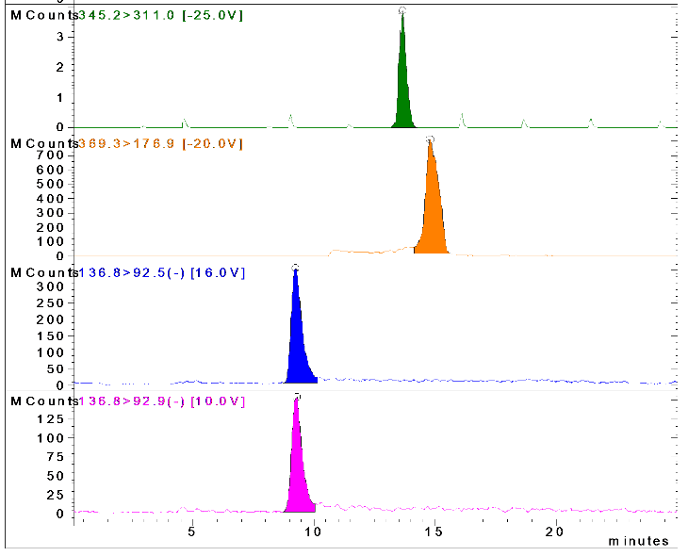
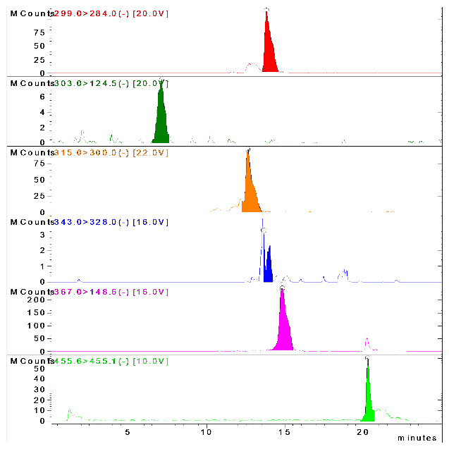
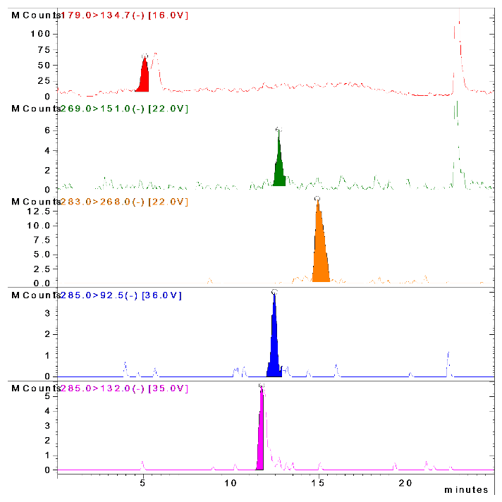

Figure 1. LC-MS/MS chromatogram of identified compounds in ETILI honey

S.Baki , A. N. Tufan , M. Altun , F. Özgökçe , K. Güçlü and M Özyürek (2018) Microwave-assisted extraction of polyphenolics from some selected medicinal herbs grown in Turkey. Rec. Nat. Prod. 12,29-39.
H. Yılmaz, S. Çarıkçı, T. Kılıç, T. Dirmenci, T. Arabacı and A. C. Gören (2017). Screening of chemical composition, antioxidant and anticholinesterase activity of section Brevifilamentum of Origanum (L.) species, Rec. Nat. Prod. 11, 439–455.
Goren, Ahmet C; Sahin, Gozde; Gumilcineli, Ismail; Binici, Burcu 2018. Rapid and reliable 25-OH vitamin D2 and 25-OH vitamin D3 measurements by multitasker LC-MS/MS . J.Chem.Metrol. 12:1,17-25.
Goren, Ahmet C; Bilsel, G.; Bilsel, M. (2007). Rapid and simultaneous determination of 25-OH-vitamin D2 and D3 in human serum by LC/MS/MS: validation and uncertainty assessment, J. Chem. Metrol.1, 1-10.
Carikci, Sema; Kılıç, Turgut; Özer, Züleyha; Dirmenci, Tuncay; Arabacı, Turan; Goren, A.C. 2018. Quantitative determination of some phenolics in Origanum laevigatum Boiss. extracts via validated LC-MS/MS method and antioxidant activity. J.Chem.Metrol. 12:2,121-127.
H. Han, H. Yılmaz and İ.Gülçin (2018). Antioxidant activity of flaxseed (Linum usitatissimum L.) shell and analysis of its polyphenol contents by LC-MS/MS. Rec. Nat. Prod. 12, 397–402.

