Supplementary Material
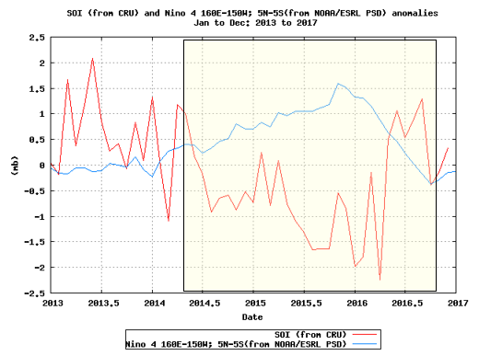
Figure S1. The SOI in the red line (from the Climatic Research Unit [CRU]) and the Niño 4 SST anomalies in the blue line (from NOAA/ESRL/PSD) from January 2013 to December 2017. The extent of the 2014-2016 ‘protracted’ El Niño episode is shown in transparent yellow shading (Source: Global Climate Observing System (GCOS) Working Group on Surface Pressure (WG-SP): Analyze & Plot Long Range Climate Time Series).
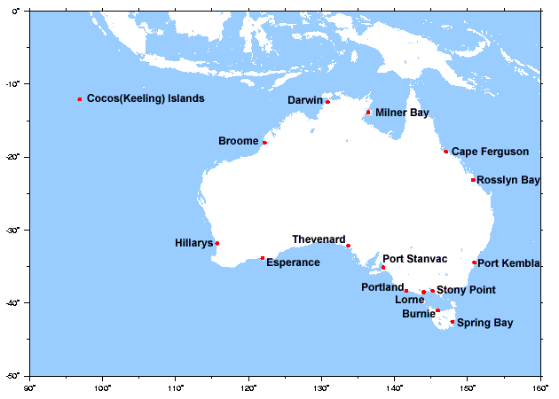
Figure S2. Australian Baseline Sea Level Monitoring Project SEAFRAME (SEA-Level Fine Resolution Acoustic Measuring Equipment) tide gauge stations. (Source: Australian Bureau of Meteorology, Australian Baseline Sea Level Monitoring Project: http://www.bom.gov.au/oceanography/projects/abslmp/abslmp.shtml).

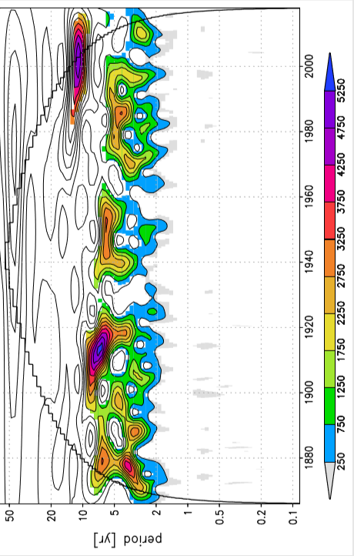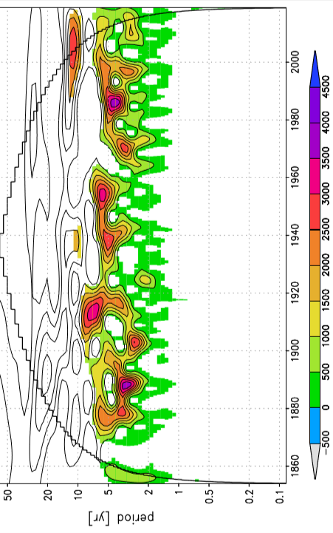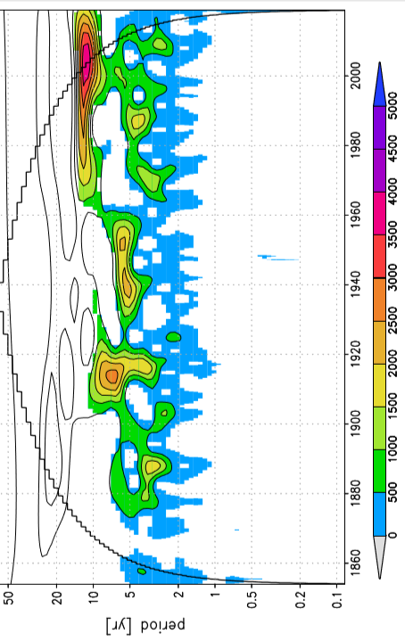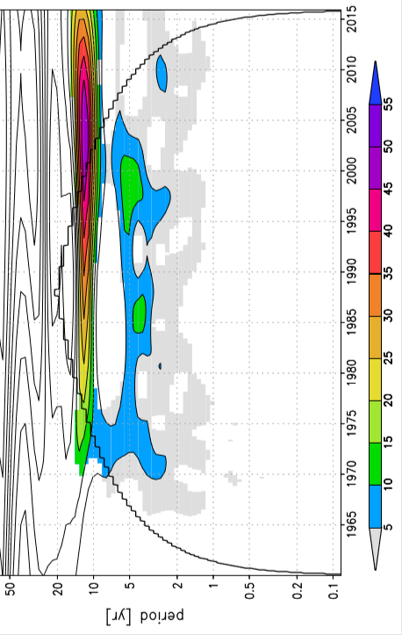
a
c
b
d
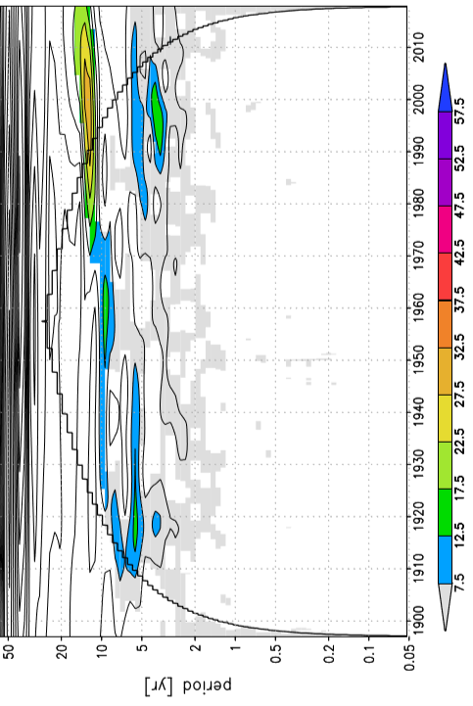
e
Figure S3. Power of Morlet 6 wave transform analysis of various instrumental ENSO measures and indices (a. the SOI [1866-2019], b. Niño 3.4 [1854-2019] and c. Niño 4 [1854-2019] SST anomalies) and sea level anomalies at two locations on the Australian coast (d. Darwin [1959-2016] and e. Fremantle [1897-2018]). Niño 3.4 and Niño 4 SSTs are from ERSSTv5. (Source: Generated using the KNMI Climate Explorer: https://climexp.knmi.nl/start.cgi).

A: SST
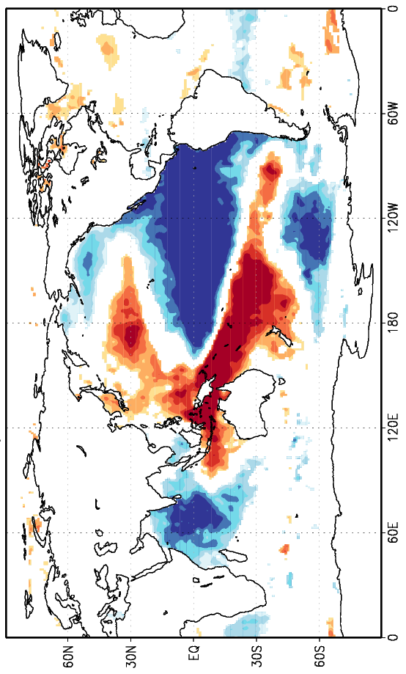 a
b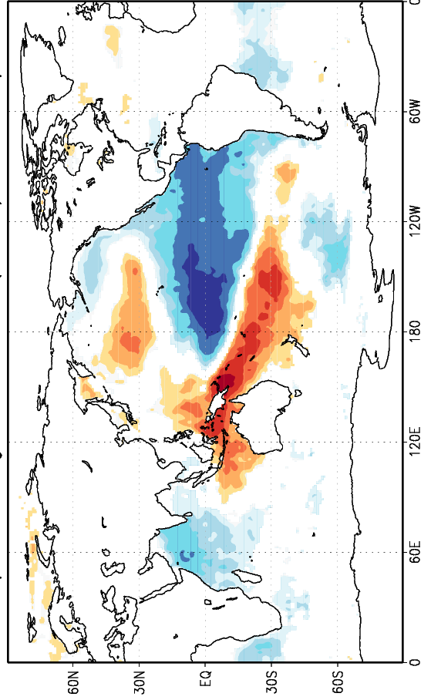 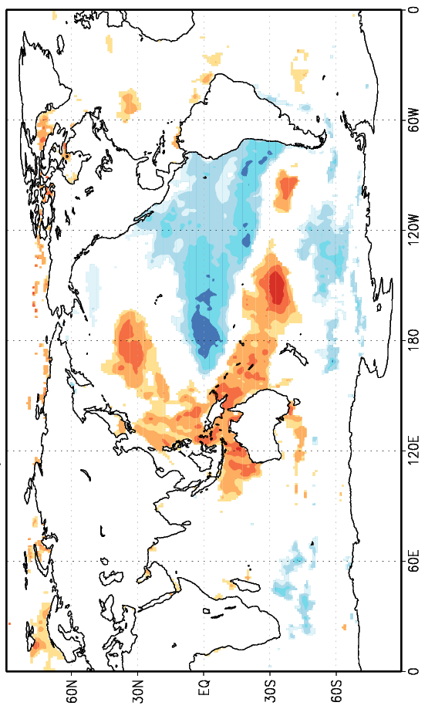 c
B: OHC
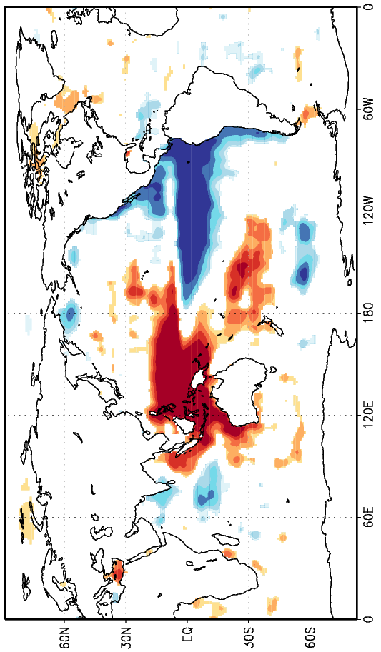 a
b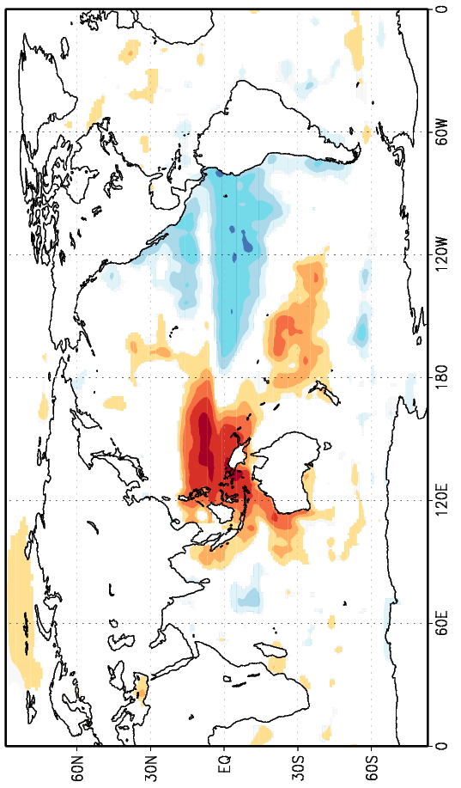 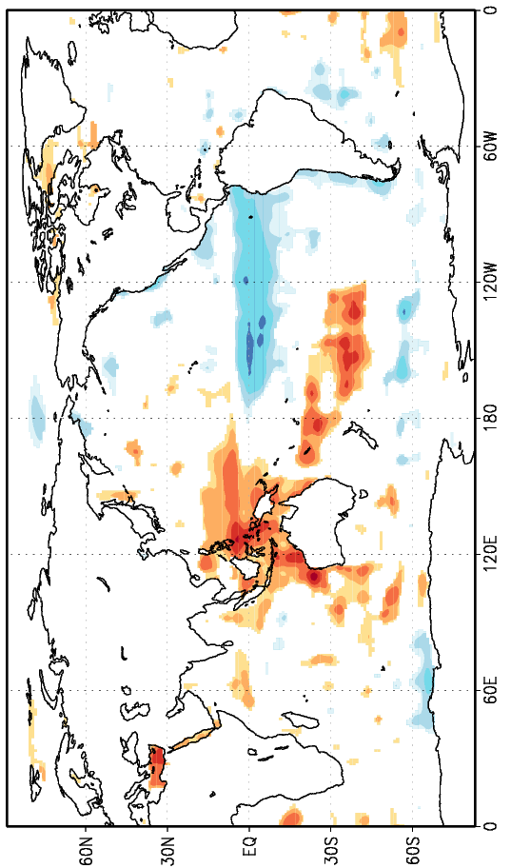 c
C: SSS
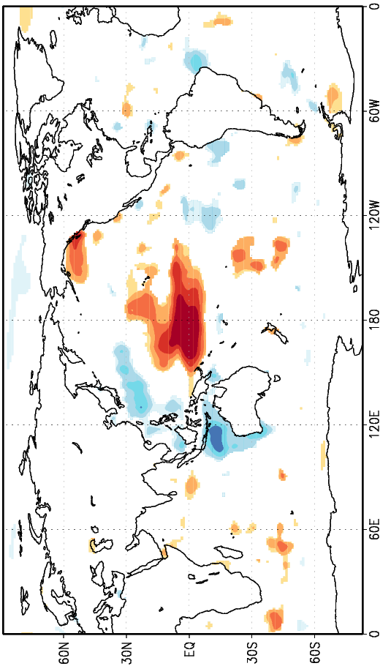 a
b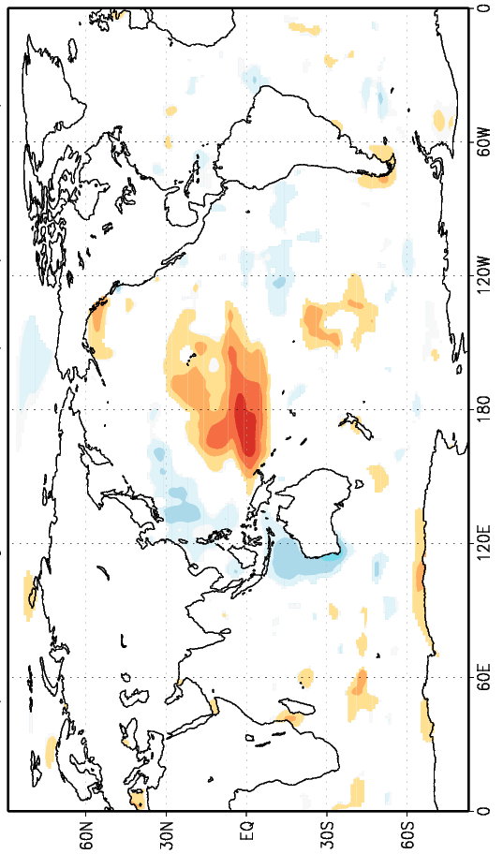 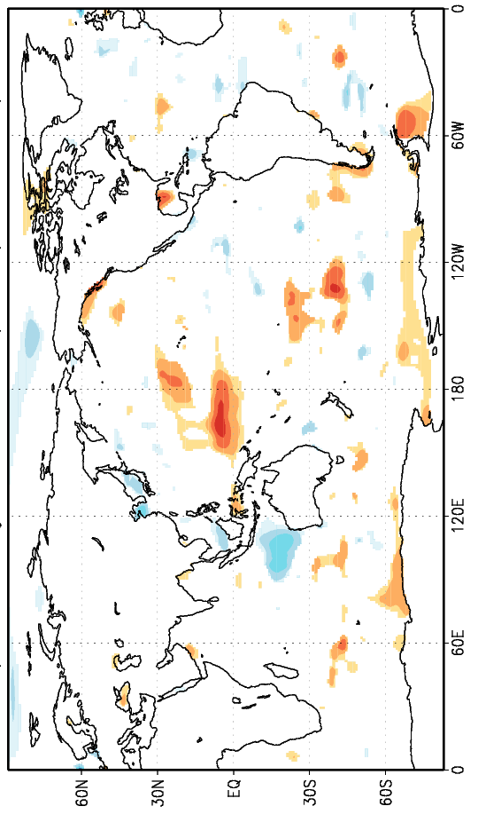 c
Figure S4. Global correlations between a. Darwin (1959-2018), b. Fremantle (1897-2018) and c. Townsville (1959-2018) sea level with A panels: sea surface temperature (SST), B panels: oceanic heat content (OHC) and C panels: sea surface salinity (SSS) anomalies during the September-November (SON) season p<5%. Correlation values shown in the bar below the panels. (Source: Generated using the KNMI Climate Explorer: https://climexp.knmi.nl/start.cgi).

List of Supplementary Material
Figure S1. The SOI in the red line (from the Climatic Research Unit [CRU]) and the Niño 4 SST anomalies in the blue line (from NOAA/ESRL/PSD) from January 2013 to December 2017. The extent of the 2014-2016 ‘protracted’ El Niño episode is shown in transparent yellow shading (Source: Global Climate Observing System (GCOS) Working Group on Surface Pressure (WG-SP): Analyze & Plot Long Range Climate Time Series).
Figure S2. Australian Baseline Sea Level Monitoring Project SEAFRAME (SEA-Level Fine Resolution Acoustic Measuring Equipment) tide gauge stations. (Source: Australian Bureau of Meteorology, Australian Baseline Sea Level Monitoring Project: http://www.bom.gov.au/oceanography/projects/abslmp/abslmp.shtml).
Figure S3. Power of Morlet 6 wave transform analysis of various instrumental ENSO measures and indices (a. the SOI [1866-2019], b. Niño 3.4 [1854-2019] and c. Niño 4 [1854-2019] SST anomalies) and sea level anomalies at two locations on the Australian coast (d. Darwin [1959-2016] and e. Fremantle [1897-2018]). Niño 3.4 and Niño 4 SSTs are from ERSSTv5. (Source: Generated using the KNMI Climate Explorer: https://climexp.knmi.nl/start.cgi).
Figure S4. Global correlations between a. Darwin (1959-2018), b. Fremantle (1897-2018) and c. Townsville (1959-2018) sea level with A panels: sea surface temperature (SST), B panels: oceanic heat content (OHC) and C panels: sea surface salinity (SSS) anomalies during the September-November (SON) season p<5%. Correlation values shown in the bar below the panels. (Source: Generated using the KNMI Climate Explorer: https://climexp.knmi.nl/start.cgi).

