Online Appendices

Table A1

Coding Reliability
 | 2009 |  | 2013
 | TV | Newspaper | TV | Newspaper
Politics | .78 | .81 | .71 | .77
 | (n = 57) | (n = 108) | (n = 62) | (n = 59)
Polity | .57 | .86 | .86 | 1.00
 | (n = 8) | (n = 112) | (n = 6) | (n = 8)
Policy | .72 | .83 | .83 | .74
 | (n = 87) | (n = 95) | (n = 81) | (n = 98)
Weighted average | .73  (n=152) | .83  (n=315) | .78  (n=149) | .76  (n=165)
Note. Krippendorff’s alpha. Numbers extracted from GLES methods report. Original reliability testing data not accessible for computation of confidence intervals or alternative coefficients of coding reliability.

Table A2

Correlations Between Press, TV, and Public Agendas
 |  | 2009 |  |  | 2013
 |  | Press | TV | Public | Press | TV | Public
2009 | Press | --- | .940 *** | .503 ** | .857 *** | .876 *** | .148
 | TV |  | --- | .494 ** | .890 *** | .942 *** | .125
 | Public |  |  | --- | .355 * | .415 * | .675 ***
2013 | Press |  |  |  | --- | .971 *** | .108
 | TV |  |  |  |  | --- | .159
 | Public |  |  |  |  |  | ---
Note. Pearson’s product-moment correlation coefficient.
* p<.05; ** p<.01; *** p<.001

Table A3

An example of extracting baselines and spikes of public salience “International Conflict”
 | Raw data | Baseline  (initial) | Coverage above baseline | Cumul. coverage  above  baseline | Spike  size | Spike (yes/no) | Spike number | Baseline  (final) | Description
 | (1) | (2) | (3) | (4) | (5) | (6) | (7) | (8)
1 | 0.000 | 0.044 | 0.000 | 0.000 | 0.000 | 0 |  | 0.033 | (1) is the raw data as measured: day 44: 0.192 weighted issue mentions per person concerned an international conflict issue  (2) Baseline for calculating the spikes: 0.044 is the average share of issue mentions concerning international relations issues. Everything above that baseline is a potential spike in public salience.  (3) How much is (1) higher than (2) on the respective day? If (1) is lower than (2), (3) is set to 0 (no negative numbers possible).  (4) (3) is cumulated for phases during which (3) is greater than 0 (i.e. (1) is greater than (2)).  (5) the highest value of (4) in a phase (that is a potential spike, i.e. continuous above-average public salience)  (6) Yes/no: Is the phase of above-average coverage large enough to be conceived as a spike?  (7) Number of the spike  (8) Initial baseline minus size of the (in this case: two) spike(s).
2 | 0.037 | 0.044 | 0.000 | 0.000 | 0.000 | 0 |  | 0.033
3 | 0.017 | 0.044 | 0.000 | 0.000 | 0.000 | 0 |  | 0.033
4 | 0.035 | 0.044 | 0.000 | 0.000 | 0.000 | 0 |  | 0.033
5 | 0.080 | 0.044 | 0.036 | 0.036 | 0.036 | 0 |  | 0.033
6 | 0.033 | 0.044 | 0.000 | 0.000 | 0.000 | 0 |  | 0.033
7 | 0.009 | 0.044 | 0.000 | 0.000 | 0.000 | 0 |  | 0.033
8 | 0.040 | 0.044 | 0.000 | 0.000 | 0.000 | 0 |  | 0.033
9 | 0.021 | 0.044 | 0.000 | 0.000 | 0.000 | 0 |  | 0.033
10 | 0.006 | 0.044 | 0.000 | 0.000 | 0.000 | 0 |  | 0.033
11 | 0.018 | 0.044 | 0.000 | 0.000 | 0.000 | 0 |  | 0.033
12 | 0.034 | 0.044 | 0.000 | 0.000 | 0.000 | 0 |  | 0.033
13 | 0.054 | 0.044 | 0.010 | 0.010 | 0.037 | 0 |  | 0.033
14 | 0.071 | 0.044 | 0.037 | 0.037 | 0.037 | 0 |  | 0.033
15 | 0.022 | 0.044 | 0.000 | 0.000 | 0.000 | 0 |  | 0.033
16 | 0.018 | 0.044 | 0.000 | 0.000 | 0.000 | 0 |  | 0.033
17 | 0.025 | 0.044 | 0.000 | 0.000 | 0.000 | 0 |  | 0.033
18 | 0.023 | 0.044 | 0.000 | 0.000 | 0.000 | 0 |  | 0.033
19 | 0.051 | 0.044 | 0.007 | 0.007 | 0.007 | 0 |  | 0.033
20 | 0.043 | 0.044 | 0.000 | 0.000 | 0.000 | 0 |  | 0.033
21 | 0.010 | 0.044 | 0.000 | 0.000 | 0.000 | 0 |  | 0.033
22 | 0.043 | 0.044 | 0.000 | 0.000 | 0.000 | 0 |  | 0.033
23 | 0.021 | 0.044 | 0.000 | 0.000 | 0.000 | 0 |  | 0.033
24 | 0.052 | 0.044 | 0.008 | 0.008 | 0.008 | 0 |  | 0.033
25 | 0.000 | 0.044 | 0.000 | 0.000 | 0.000 | 0 |  | 0.033
26 | 0.023 | 0.044 | 0.000 | 0.000 | 0.000 | 0 |  | 0.033
27 | 0.001 | 0.044 | 0.000 | 0.000 | 0.000 | 0 |  | 0.033
28 | 0.019 | 0.044 | 0.000 | 0.000 | 0.000 | 0 |  | 0.033
29 | 0.016 | 0.044 | 0.000 | 0.000 | 0.000 | 0 |  | 0.033
30 | 0.023 | 0.044 | 0.000 | 0.000 | 0.000 | 0 |  | 0.033
31 | 0.010 | 0.044 | 0.000 | 0.000 | 0.000 | 0 |  | 0.033
32 | 0.006 | 0.044 | 0.000 | 0.000 | 0.000 | 0 |  | 0.033
33 | 0.033 | 0.044 | 0.000 | 0.000 | 0.000 | 0 |  | 0.033
34 | 0.046 | 0.044 | 0.002 | 0.002 | 0.002 | 0 |  | 0.033
35 | 0.003 | 0.044 | 0.000 | 0.000 | 0.000 | 0 |  | 0.033
36 | 0.045 | 0.044 | 0.001 | 0.001 | 0.001 | 0 |  | 0.033
37 | 0.000 | 0.044 | 0.000 | 0.000 | 0.000 | 0 |  | 0.033
38 | 0.034 | 0.044 | 0.000 | 0.000 | 0.000 | 0 |  | 0.033
39 | 0.013 | 0.044 | 0.000 | 0.000 | 0.000 | 0 |  | 0.033
40 | 0.039 | 0.044 | 0.000 | 0.000 | 0.000 | 0 |  | 0.033
41 | 0.108 | 0.044 | 0.064 | 0.064 | 0.440 | 1 | 1 | 0.033
42 | 0.137 | 0.044 | 0.157 | 0.157 | 0.440 | 1 | 1 | 0.033
43 | 0.109 | 0.044 | 0.222 | 0.222 | 0.440 | 1 | 1 | 0.033
44 | 0.192 | 0.044 | 0.370 | 0.370 | 0.440 | 1 | 1 | 0.033
45 | 0.114 | 0.044 | 0.440 | 0.440 | 0.440 | 1 | 1 | 0.033
46 | 0.030 | 0.044 | 0.000 | 0.000 | 0.000 | 0 |  | 0.033
47 | 0.066 | 0.044 | 0.022 | 0.022 | 0.039 | 0 |  | 0.033
48 | 0.062 | 0.044 | 0.039 | 0.039 | 0.039 | 0 |  | 0.033
49 | 0.024 | 0.044 | 0.000 | 0.000 | 0.000 | 0 |  | 0.033
50 | 0.078 | 0.044 | 0.034 | 0.034 | 0.223 | 1 | 2 | 0.033
51 | 0.054 | 0.044 | 0.044 | 0.044 | 0.223 | 1 | 2 | 0.033
52 | 0.064 | 0.044 | 0.064 | 0.064 | 0.223 | 1 | 2 | 0.033
53 | 0.055 | 0.044 | 0.075 | 0.075 | 0.223 | 1 | 2 | 0.033
54 | 0.079 | 0.044 | 0.109 | 0.109 | 0.223 | 1 | 2 | 0.033
55 | 0.113 | 0.044 | 0.177 | 0.177 | 0.223 | 1 | 2 | 0.033
56 | 0.090 | 0.044 | 0.223 | 0.223 | 0.223 | 1 | 2 | 0.033
57 | 0.026 | 0.044 | 0.000 | 0.000 | 0.000 | 0 |  | 0.033
58 | 0.055 | 0.044 | 0.011 | 0.011 | 0.046 | 0 |  | 0.033
59 | 0.047 | 0.044 | 0.013 | 0.013 | 0.046 | 0 |  | 0.033
60 | 0.077 | 0.044 | 0.046 | 0.046 | 0.046 | 0 |  | 0.033
Note. Raw data: Number of weighted issue mentions per person per day.

Table A4

Media and Public Salience by Issue and Year
 | 2009 |  |  |  | 2013 |  |  |  | Total salience
 | TV | NP | Public |  | TV | NP | Public |  | Media | Public
 | (n=1800) | (n=1793) | avg | max | (n=2028) | (n=2212) | avg | max | (n=7833) | avg
Economic Crisis | 1043 | 643 | 0.318 | 0.450 | 784 | 604 | 0.088 | 0.165 | 3074 | 0.203
Political Alienation | 150 | 287 | 0.079 | 0.183 | 139 | 204 | 0.091 | 0.234 | 780 | 0.085
Intelligence Service | 19 | 10 | 0.002 | 0.018 | 206 | 247 | 0.052 | 0.153 | 482 | 0.027
International Conflict | 65 | 98 | 0.040 | 0.159 | 138 | 150 | 0.032 | 0.114 | 451 | 0.036
Defense | 51 | 127 | 0.002 | 0.024 | 112 | 90 | 0.003 | 0.027 | 380 | 0.003
Taxes | 46 | 51 | 0.029 | 0.085 | 98 | 154 | 0.025 | 0.064 | 349 | 0.027
Economy | 126 | 194 | 0.134 | 0.227 | 2 | 22 | 0.037 | 0.090 | 344 | 0.086
Infrastructure | 19 | 16 | 0.002 | 0.012 | 99 | 101 | 0.016 | 0.045 | 235 | 0.009
Health | 23 | 48 | 0.042 | 0.088 | 61 | 75 | 0.027 | 0.056 | 207 | 0.035
Domestic Security | 28 | 26 | 0.009 | 0.056 | 36 | 94 | 0.010 | 0.045 | 184 | 0.010
Extremism | 76 | 25 | 0.005 | 0.025 | 21 | 53 | 0.006 | 0.031 | 175 | 0.005
International Relations | 42 | 65 | 0.007 | 0.027 | 18 | 43 | 0.007 | 0.025 | 168 | 0.007
Income | 10 | 16 | 0.074 | 0.143 | 92 | 45 | 0.225 | 0.381 | 163 | 0.150
Labor / Employment | 34 | 59 | 0.497 | 0.605 | 30 | 30 | 0.215 | 0.329 | 153 | 0.356
Family | 10 | 10 | 0.040 | 0.130 | 51 | 44 | 0.063 | 0.171 | 115 | 0.051
European Union | 7 | 32 | 0.003 | 0.014 | 35 | 32 | 0.036 | 0.093 | 106 | 0.019
Energy | 15 | 19 | 0.010 | 0.037 | 20 | 47 | 0.066 | 0.152 | 101 | 0.038
Migration | 1 | 12 | 0.014 | 0.036 | 17 | 40 | 0.059 | 0.131 | 70 | 0.037
Pensions | 5 | 10 | 0.026 | 0.132 | 12 | 38 | 0.079 | 0.185 | 65 | 0.052
Budget | 6 | 17 | 0.069 | 0.128 | 7 | 33 | 0.067 | 0.120 | 63 | 0.068
Education | 7 | 15 | 0.114 | 0.196 | 6 | 18 | 0.099 | 0.173 | 46 | 0.107
(Ecology) | 1 | 0 | 0.034 | 0.073 | 19 | 20 | 0.020 | 0.053 | 40 | 0.027
(Crime) | 14 | 5 | 0.005 | 0.039 | 3 | 9 | 0.002 | 0.018 | 31 | 0.003
(International Terrorism) | 2 | 5 | 0.001 | 0.013 | 12 | 10 | 0.001 | 0.012 | 29 | 0.001
(Climate) | 0 | 3 | 0.008 | 0.031 | 7 | 5 | 0.003 | 0.028 | 15 | 0.005
(Housing) | 0 | 0 | 0.001 | 0.009 | 3 | 4 | 0.007 | 0.033 | 7 | 0.004
Note. Media salience: total number of news stories; public salience: percentage of issue mentions.

Table A5

Development in media salience: key parameters
 | Media salience descriptors |  |  |  | Public salience descriptors
 | Spike momentum |  | Issue baseline |  | Spike momentum |  | Issue baseline
 | 2009 | 2013 | 2009 | 2013 | 2009 | 2013 | 2009 | 2013
Issue | News stories per spike (n) |  | News stories per day (n) |  | Issue mentions per person per spike (n) |  | Issue mentions per person per day (n)
01 Labor | 45.35 | 11.00 | 0.79 | 0.51 | 0.68 | 0.32 | 0.51 | 0.21
02 Education | 3.90 | 3.68 | 0.30 | 0.27 | 0.17 | 0.15 | 0.10 | 0.09
03 Income | 4.13 | 16.02 | 0.36 | 0.76 | 0.18 | 0.43 | 0.07 | 0.20
04 Taxes | 20.46 | 23.97 | 0.93 | 2.08 | 0.00 | 0.00 | 0.03 | 0.03
05 Energy | 6.72 | 8.70 | 0.23 | 0.43 | 0.00 | 0.18 | 0.01 | 0.06
06 European Union | 3.65 | 11.36 | 0.35 | 0.44 | 0.00 | 0.17 | 0.00 | 0.03
07 Extremism | 11.41 | 11.71 | 1.11 | 0.52 | 0.00 | 0.00 | 0.00 | 0.01
08 Family | 4.83 | 11.29 | 0.17 | 0.82 | 0.00 | 0.20 | 0.04 | 0.07
09 Intelligence Serv. | 8.79 | 33.66 | 0.19 | 3.80 | 0.00 | 0.50 | 0.00 | 0.03
10 Health | 12.24 | 13.29 | 0.57 | 0.93 | 0.26 | 0.00 | 0.04 | 0.03
11 Budget | 3.85 | 8.87 | 0.32 | 0.30 | 0.19 | 0.20 | 0.07 | 0.06
12 Infrastructure | 5.25 | 24.44 | 0.32 | 1.69 | 0.00 | 0.00 | 0.00 | 0.01
13 Domestic Security | 10.40 | 29.07 | 0.55 | 0.96 | 0.00 | 0.00 | 0.01 | 0.01
14 Int. Conflict | 92.27 | 23.34 | 1.18 | 2.60 | 0.33 | 0.25 | 0.03 | 0.02
15 Int. Relations | 14.95 | 9.02 | 0.79 | 0.45 | 0.00 | 0.00 | 0.01 | 0.01
16 Economic crisis | 141.40 | 105.47 | 21.03 | 14.29 | 0.46 | 0.19 | 0.28 | 0.08
17 Migration | 3.57 | 8.87 | 0.16 | 0.41 | 0.00 | 0.43 | 0.01 | 0.06
18 Pensions | 4.50 | 12.17 | 0.18 | 0.34 | 0.22 | 0.51 | 0.03 | 0.07
19 Pol. Alienation | 32.01 | 25.56 | 5.68 | 3.55 | 0.17 | 0.24 | 0.08 | 0.08
20 Defense | 19.10 | 30.56 | 2.33 | 1.47 | 0.00 | 0.00 | 0.00 | 0.00
21 Election | 6.67 | 7.15 | 0.67 | 0.42 | 0.00 | 0.00 | 0.00 | 0.00
22 Economy | 28.44 | 5.22 | 3.91 | 0.18 | 0.20 | 0.00 | 0.12 | 0.04
Mean | 21.99 | 19.75 | 1.92 | 1.69 | .13 | .17 | .07 | .05
SD | 32.66 | 20.59 | 4.38 | 2.93 | .18 | .17 | .12 | .06
Note. Media salience: number of news stories per day; public salience: share of issue mentions per day.

Table A6

Occurrence of media-led, simultaneous, and public-led agenda relations, and estimates of strength of agenda relations.
 | Granger causality/cIRF test results
 | TV |  |  |  |  |  |  |  | Newspapers
 | 2009 |  |  |  | 2013 |  |  |  | 2009 |  |  |  | 2013
Issue | M | S | P | Strength | M | S | P | Strength | M | S | P | Strength | M | S | P | Strength
01 Int. Conflict | +4 |  | –10 | .514** |  |  | +10 | .336 | +3 |  | –14 | .532** |  |  | –14 | .360
02 Intellig. Serv. |  |  |  | .000 | +8 | +0 | +6 | .120** | +13 |  |  | .502** | +2 | +0 |  | .133*
03 Extremism | +14 |  | +14 | .032* |  | +0 |  | .309 |  |  |  | .008 | +7 | +0 |  | .334*
04 Domestic Security |  |  |  | .222 |  |  |  | .158 | –9 |  |  | .000 | +10 |  |  | .217**
05 Labor |  |  |  | .190 |  | +0 |  | .118 |  |  |  | .000 |  |  |  | .130
06 Migration |  | –0 |  | .024 | +5 |  |  | .215** |  | –0 | –12 | .000 |  |  |  | .191
07 Family |  |  | –10 | .010 | +7 | +0 | –8 | .221* | +10 | +0 |  | .044** |  | +0 | –11 | .154
08 Economic crisis |  |  | –10 | .117 |  |  |  | .133 |  |  | –14 | .000 |  |  | +11 | .169
09 Defense |  | +0 | +2 | .020 | +11 |  | –9 | .121** |  |  | –9 | .029 | +10 | +0 |  | .221**
10 European Union |  |  | –12 | .179 |  |  |  | .188 |  |  | +11 | .000 | –8 |  |  | .000
11 Taxes |  | +0 |  | .138 | +5 |  |  | .053** |  |  | –11 | .077 |  |  |  | .052
12 Economy |  |  |  | .000 |  |  |  | .000 | +14 |  |  | .296** | –10 |  |  | .000
13 Budget |  | +0 | –14 | .176 |  |  |  | .057 |  | –0 | +3 | .000 |  |  | +13 | .041
14 Health | +1 |  |  | .157** |  |  |  | .104 |  | –0 |  | .000 |  |  | +10 | .000
15 Int. Relations | –14 |  |  | .000 |  |  |  | .086 | +14 | +0 |  | .154** |  | –0 |  | .000
16 Pensions | +2 |  |  | .049** | +3 |  | +11 | .093** |  |  |  | .000 |  | +0 |  | .057
17 Election |  | +0 |  | .144 | –6 | –0 |  | .000 |  |  | +6 | .033 |  |  | +3 | .000
18 Income | +4 | +0 |  | .020* |  | –0 |  | .000 |  |  |  | .000 | +7 |  |  | .106*
19 Education | –4 | –0 |  | .000 | +9 |  |  | .122* |  | –0 |  | .000 |  |  |  | .000
20 Energy | –14 |  |  | .000 |  |  |  | .057 |  | –0 |  | .000 |  |  |  | .046
21 Pol. Alienation |  |  | +5 | .000 | +9 |  |  | .076* | –2 | –0 | +4 | .000 |  | –0 | +10 | .000
22 Infrastructure |  |  |  | .000 |  |  |  | .052 | –11 |  |  | .000 |  |  |  | .000
Note. Sorted by summed strengths of agenda-setting effects. Column “M”: Granger-causality test for the hypothesis that the media lead, and the public follows; “S”: Granger-causality test for the hypothesis that there is a simultaneous/instantaneous relation between media and public salience; “P”: Granger-causality test for the hypothesis that the public leads, and the media follow; “+”: Significant Granger causality test with positive cIRF; “–” significant Granger causality test with negative cIRF; Numbers behind “+” and “–“ give the number of days after which the cIRF is maximal, i.e. effects are strongest. Strength: Absolute estimate of the strength of the positive, media-led agenda relations (“agenda-setting effects”). In later stages of the analysis, it is standardized to range 1-100 and then logarithmized for further analyses. Brackets behind issue labels: number of instances there was a significant positive media-led agenda relation (=a media agenda-setting effect)
* p<.05; ** p<.01 for media salience granger-causing positive effects on public salience.

Figure A1. Effects of baseline in media (left column) and public salience (right column) on likelihood (top row) and strength (bottom row) of agenda-setting effects. Estimate from model (3): thick line and confidence region; year-specific estimates: slim lines.

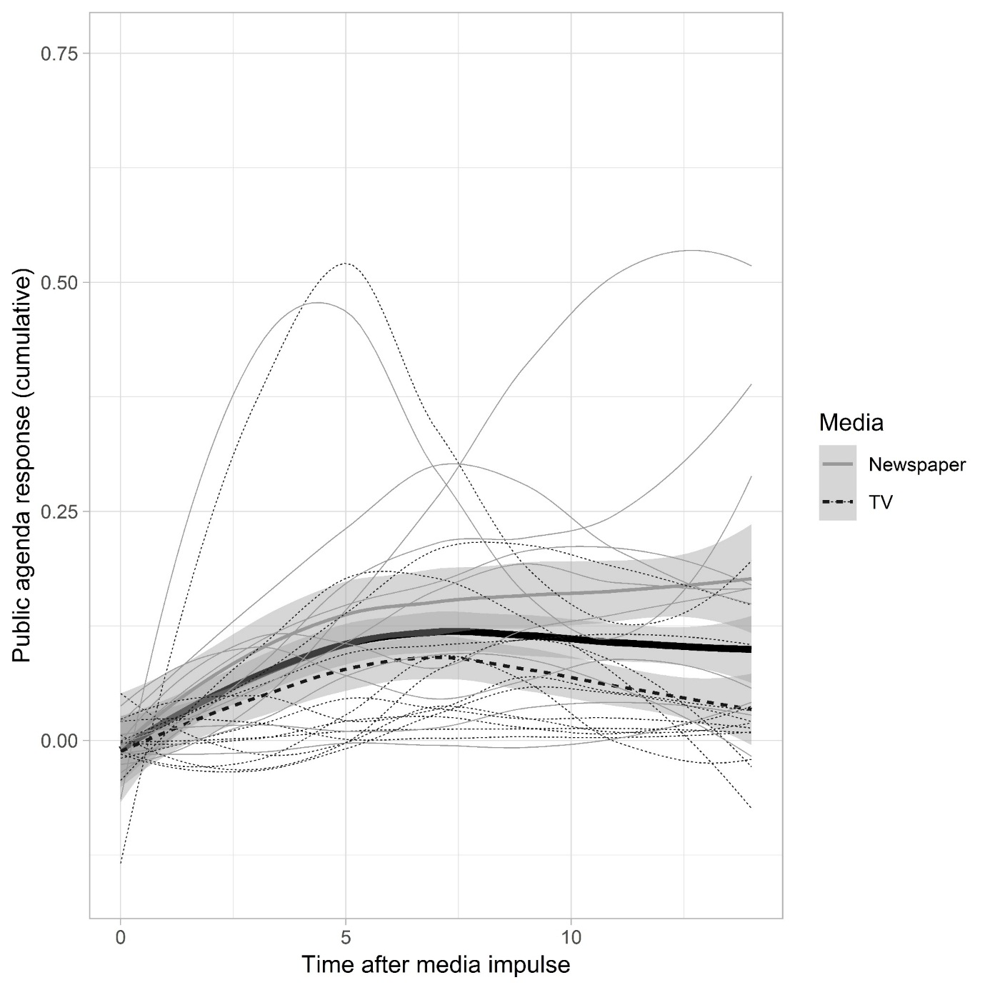

Figure A2. Cumulative impulse-response functions for the 23 issues with positive, media-led agenda relations, aggregated by media type and globally; individual time series overplot the aggregated data. The peak is where cumulative agenda-setting effects of a media salience impulse is at its maximum.

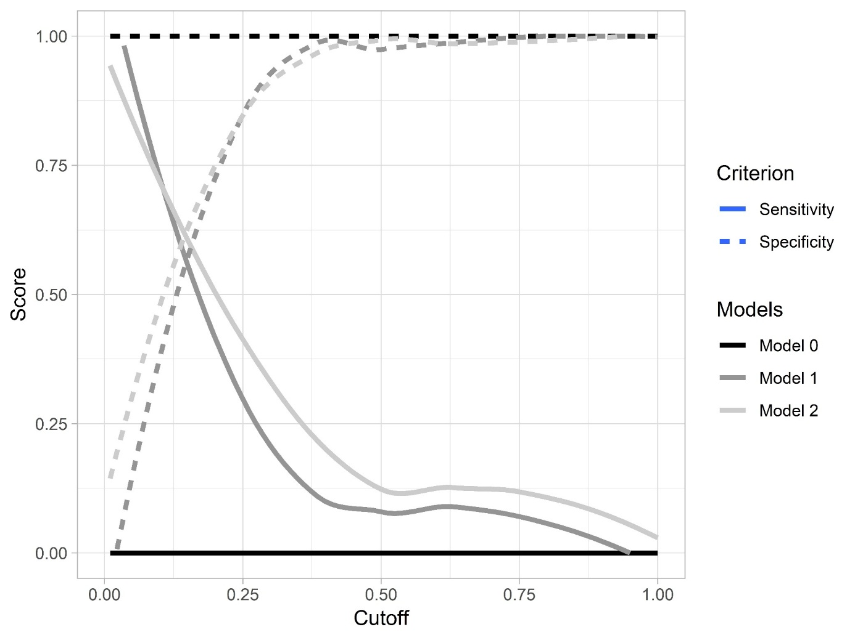

Figure A3. Sensitivity and specificity of predictions of occurrence of agenda-setting effects.

