Arcusa et al. Dust-drought interactions over the last 15,000 years: a network of lake sediment records from the San Juan Mountains, Colorado. Supplement material for submission to The Holocene.

Table S1. Coring information and core metadata.
Lake | Core name | Coring location (lat,lon) | Length (cm) | Instrument type | Water depth (m)
Crater | CTR16-1 | 37.38813333  -106.6946333 | 94 | Universal gravity corer | 21.4
 | CTR16-8 | 37.38871389  -106.6949083 | 412.5 | Modified percussion corer | 20.8
Clear | CLR17-1 | 37.826713  -107.786234 | 109 | Modified percussion corer | 30.2
 | CLR17-4 | 37.826434  -107.787175 | 300 | Modified percussion corer | 34.4
Columbine | COL17-1 | 37.861977  -107.76842 | 124 | Modified percussion corer | 20.5
 | COL16-1 | 37.861944  -107.779472 | 89 | Universal gravity corer | 25

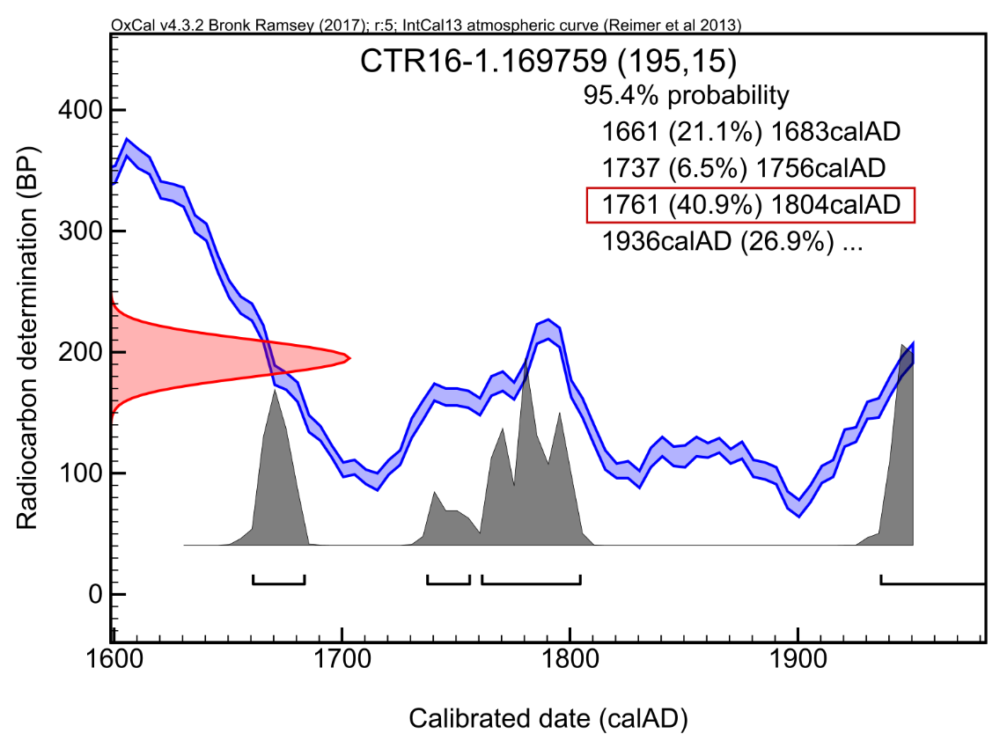
S1. Radiocarbon sample 169759 for Crater Lake with a radiocarbon determination of 195 ± 15 BP has a multimodal calibrated date estimate. By default BACON used the oldest age (1661-1683 calAD) but based on results from other lakes we estimated that using the mode with the highest probability (1761-1804 calAD) was more appropriate.
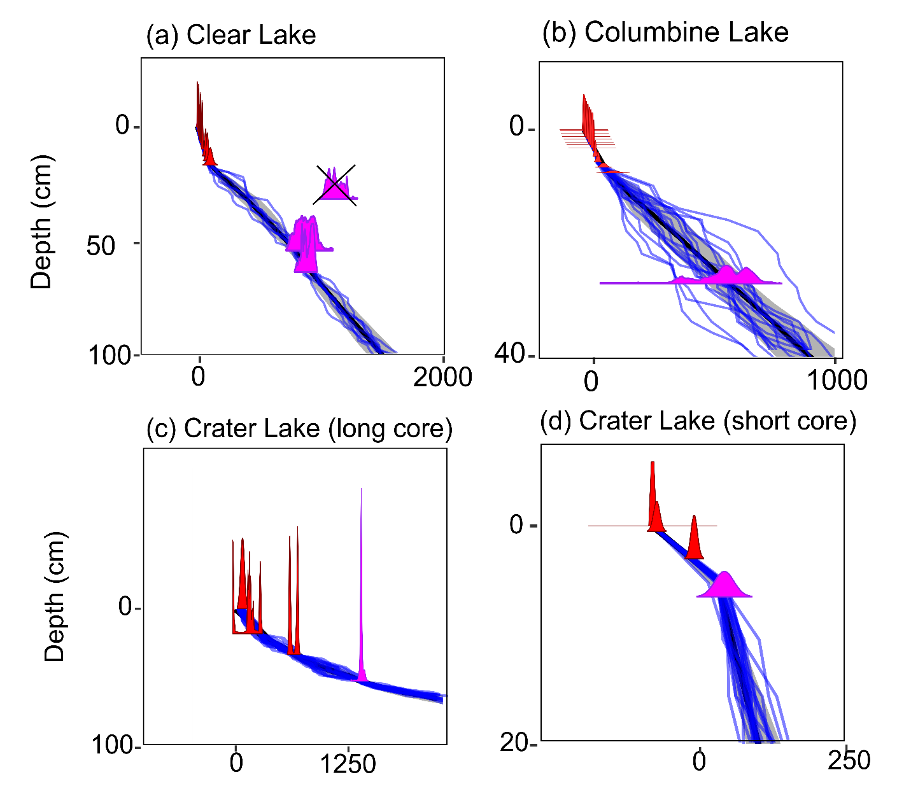
S2. Age depth models for (a) Clear Lake, (b) Columbine Lake, (c) Crater Lake long record and (d) Crater Lake short record showing the transition from ²¹⁰Pb to ¹⁴C in more detail.

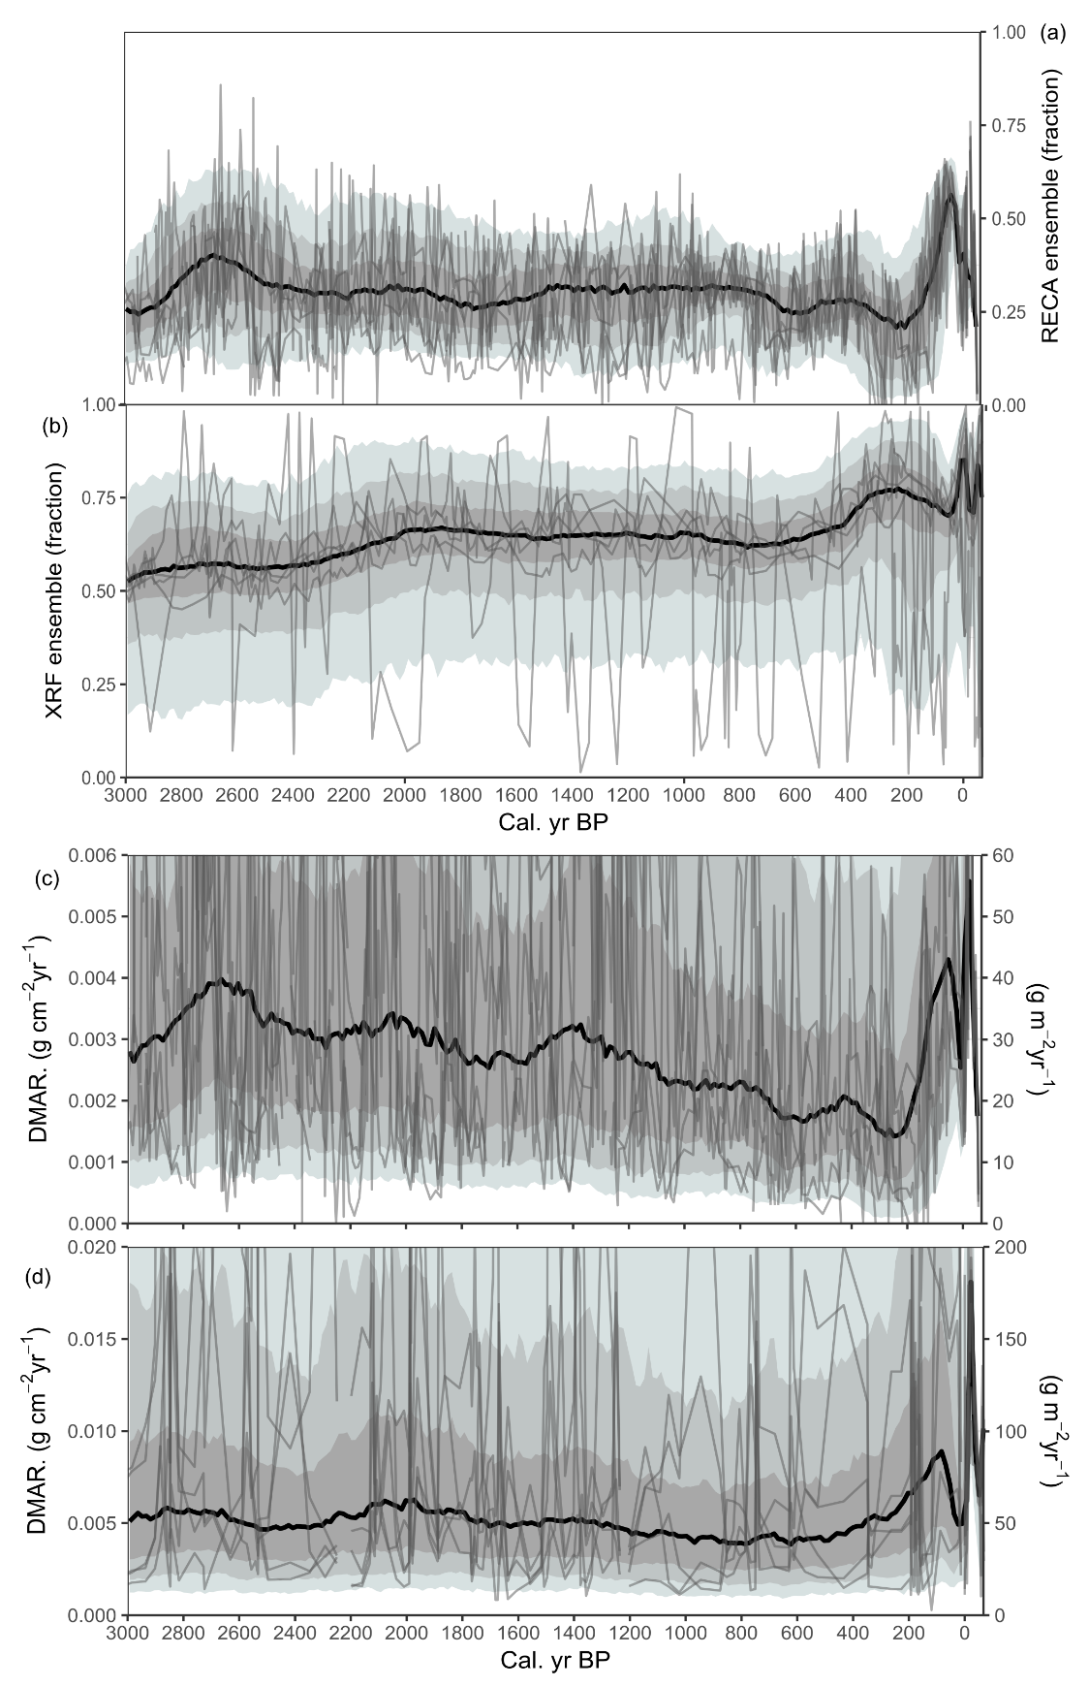
S3. Columbine Lake dust records. RECA dust concentration (a), XRF end-member dust concentration (b), RECA DMAR (c), and XRF DMAR (d). Grey bands indicate highest density region range of 97.5, 90, and 75%. Grey lines are randomly selected ensemble members. Black line represents 50% highest density region range.
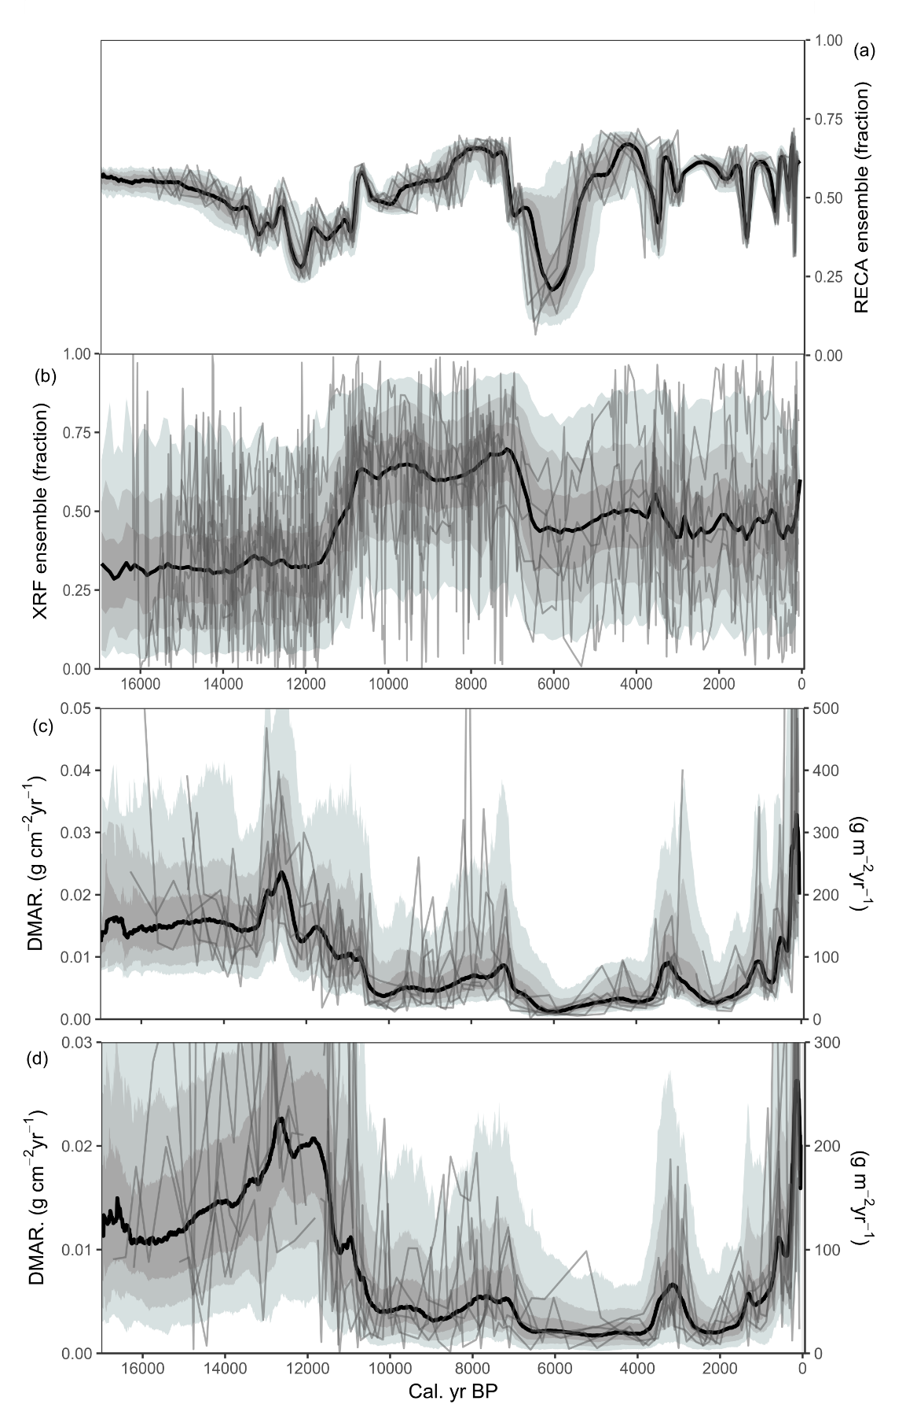
S4. Crater Lake long core dust records. RECA dust concentration (a), XRF end-member dust concentration (b), RECA DMAR (c), and XRF DMAR (d). Grey bands indicate highest density region range of 97.5, 90, and 75%. Grey lines are randomly selected ensemble members. Black line represents 50% highest density region range.
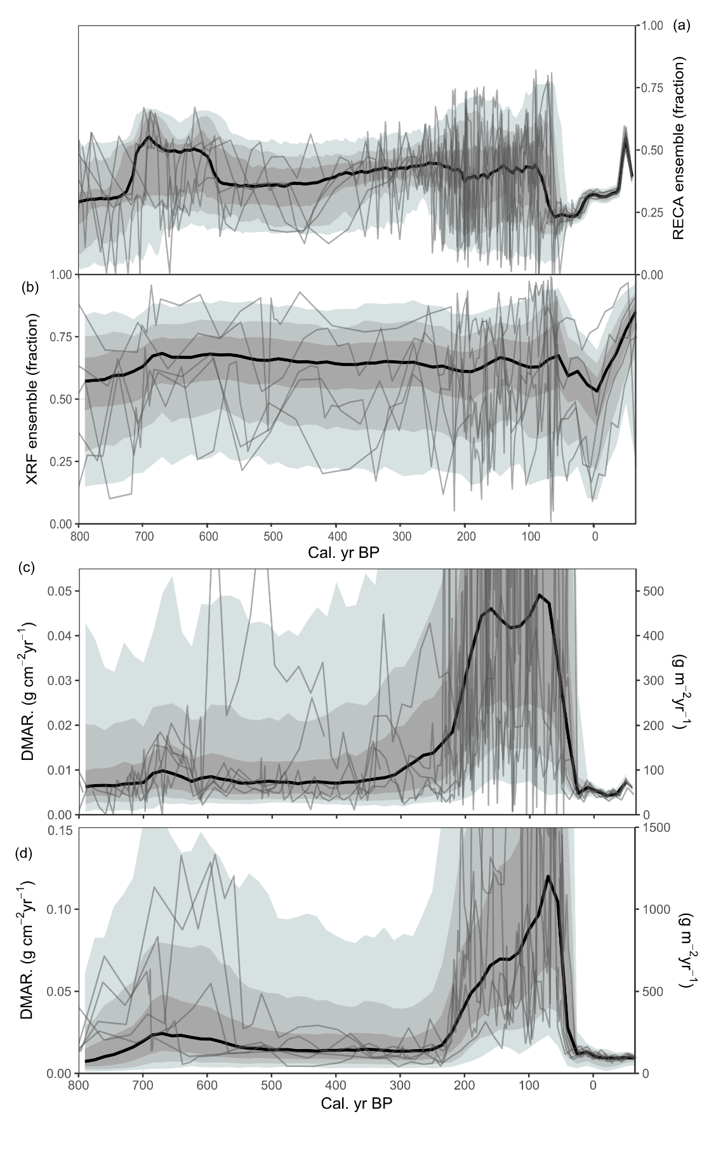
S5. Crater Lake short core dust records. RECA dust concentration (a), XRF end-member dust concentration (b), RECA DMAR (c), and XRF DMAR (d). Grey bands indicate highest density region range of 97.5, 90, and 75%. Grey lines are randomly selected ensemble members. Black line represents 50% highest density region range.

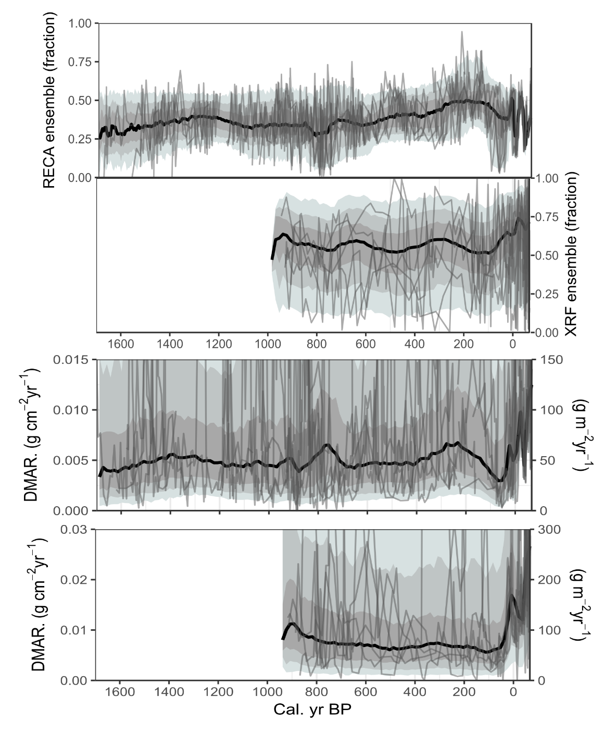
S6. Clear Lake short core dust records. RECA dust concentration (a), XRF end-member dust concentration (b), RECA DMAR (c), and XRF DMAR (d). Grey bands indicate highest density region range of 97.5, 90, and 75%. Grey lines are randomly selected ensemble members. Black line represents 50% highest density region range.
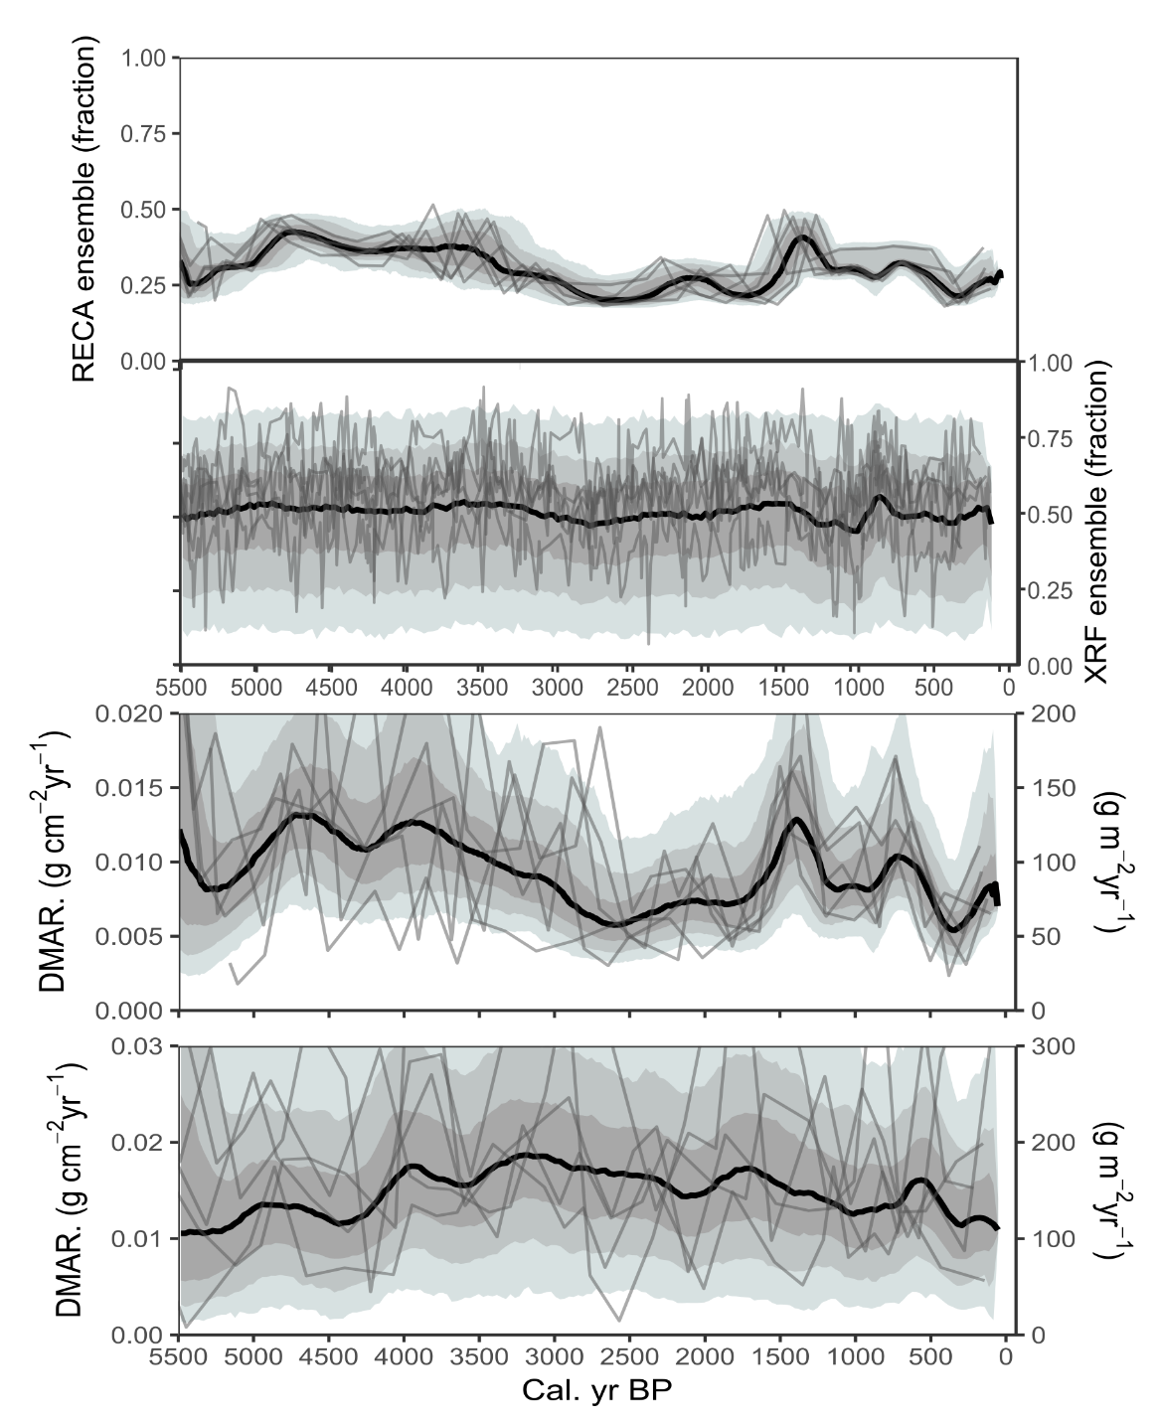
S7. Clear Lake long core dust records. RECA dust concentration (a), XRF end-member dust concentration (b), RECA DMAR (c), and XRF DMAR (d). Grey bands indicate highest density region range of 97.5, 90, and 75%. Grey lines are randomly selected ensemble members. Black line represents 50% highest density region range.
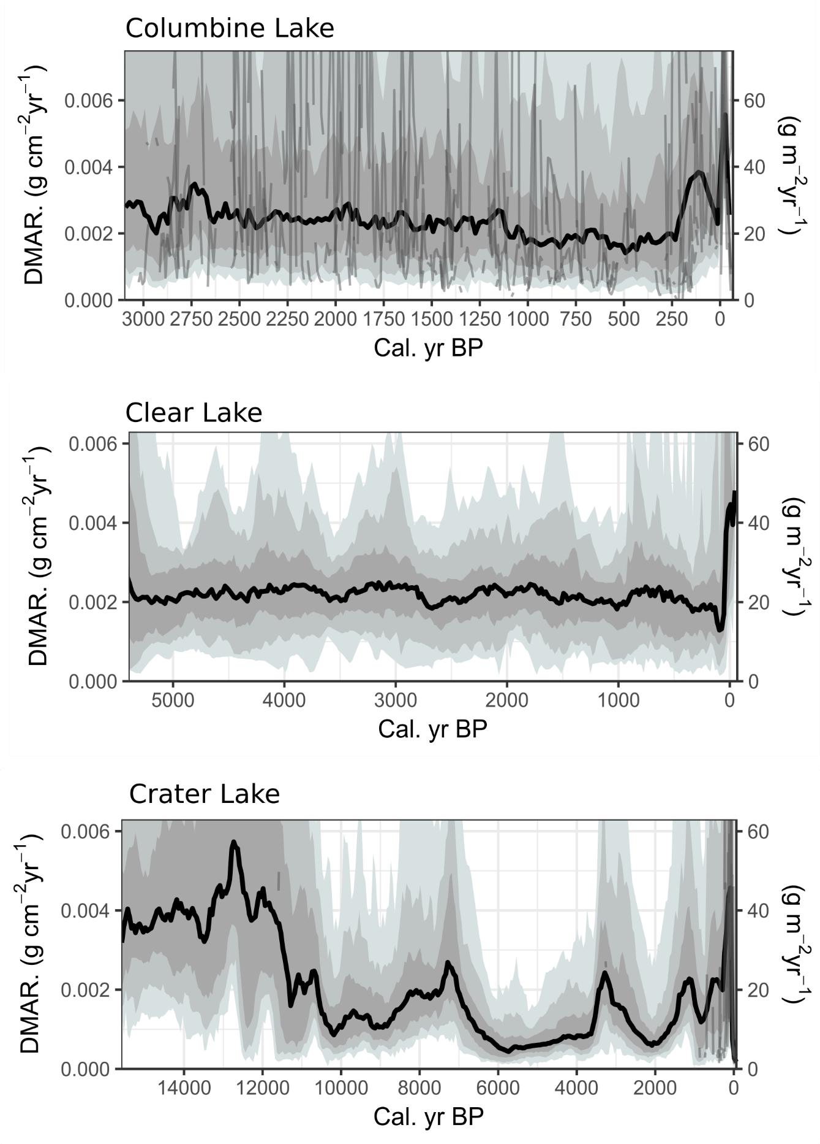
S8. Combined XRF and RECA DMAR for each lake. Separate cores from the same lake are also combined. Note the difference in time scales. Combining records reduces the variability. Grey bands indicate highest density region range of 97.5, 90, and 75%. Grey lines are randomly selected ensemble members. Black line represents 50% highest density region range.

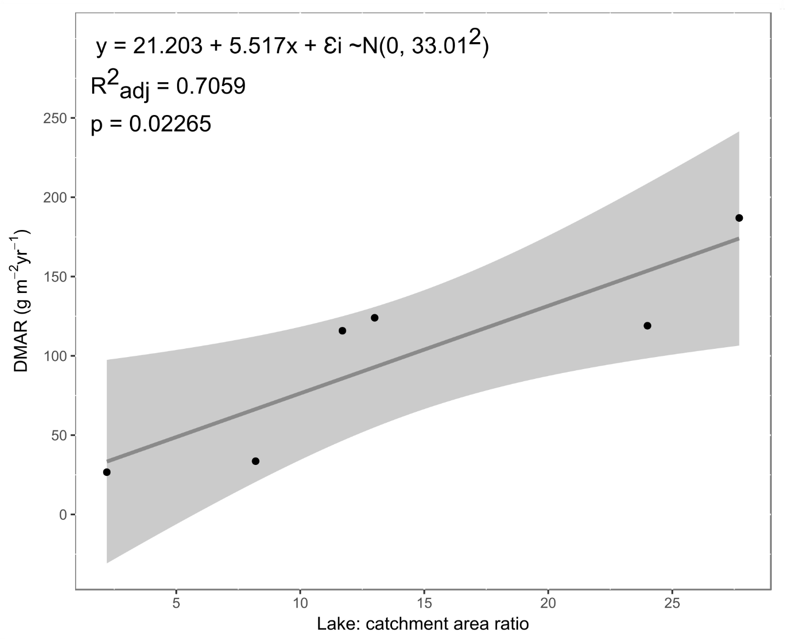
S9. Linear regression predicting mean late Holocene DMAR from lake: catchment area ratio. The relationship might be better described as exponential rather than linear to avoid negative confidence intervals. This was not attempted in this study.
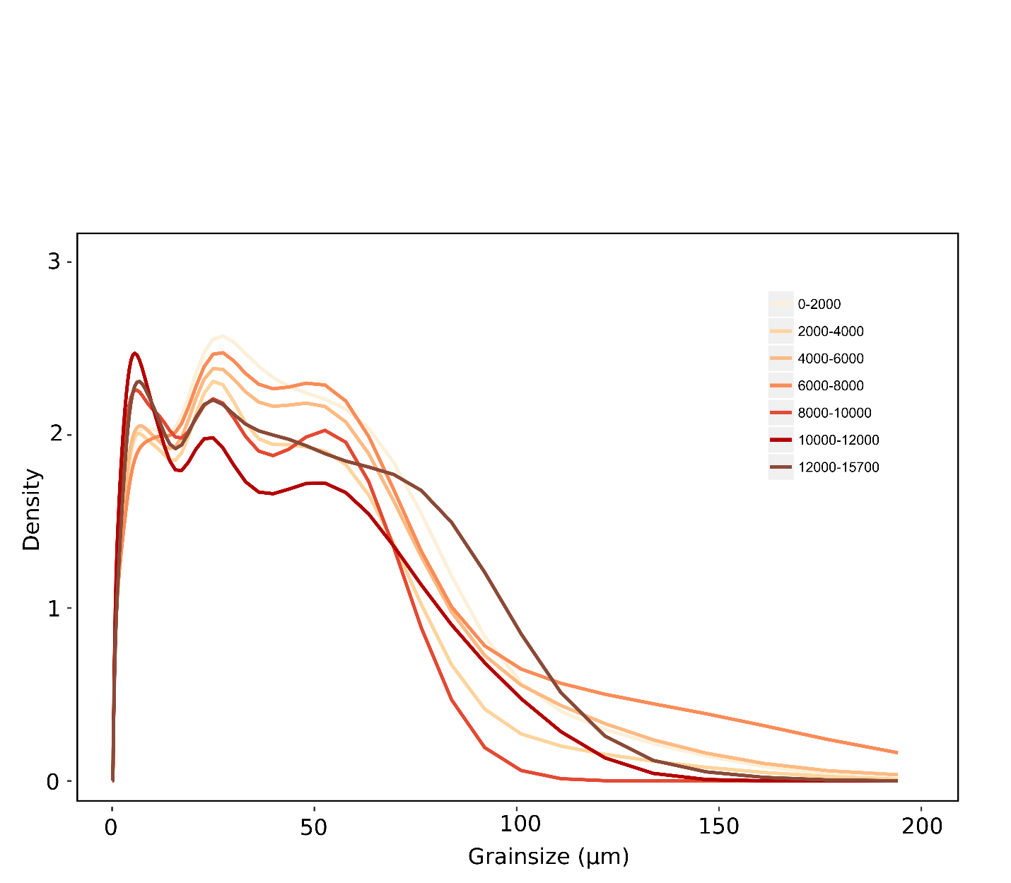
S10. Grainsize distribution of selected periods in Crater Lake long record. Notice the shift in maximum density from ~3 to ~20 µm with time.
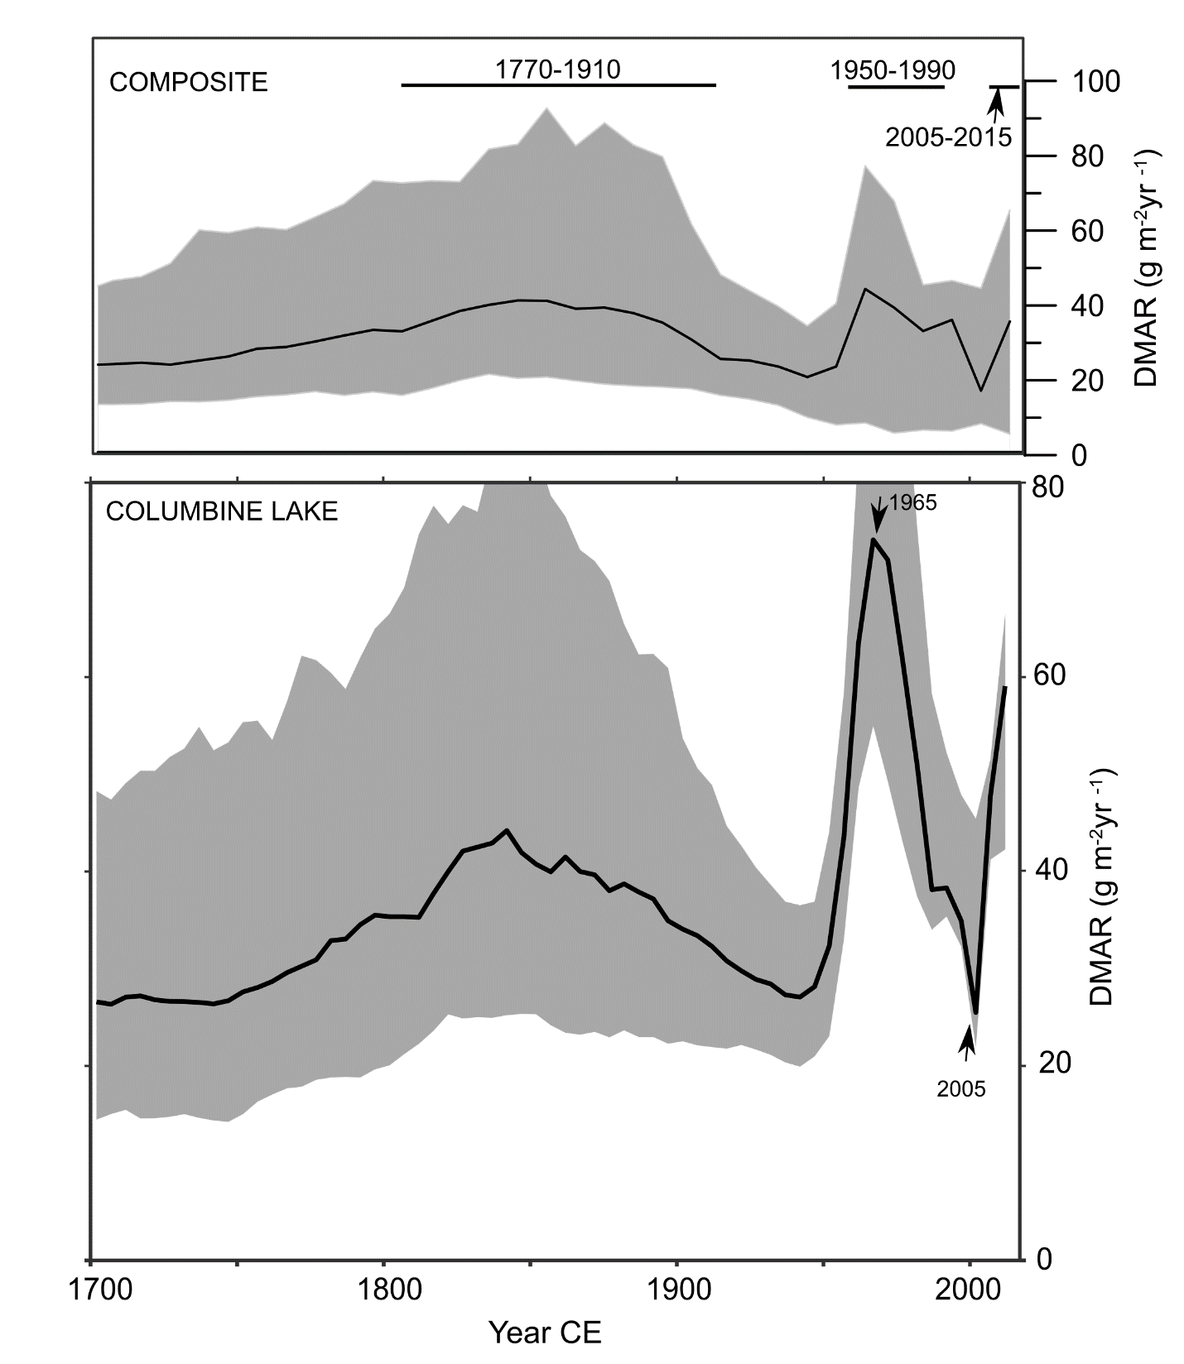
S11. Dust mass accumulation rate (DMAR) of the last 300 years for the composite (top) and Columbine Lake (bottom) records. Grey bands represent highest density region range of 75 %. Black line represents 50% highest density region range. Black bars in top panel indicate three periods of higher DMAR referred in the text.
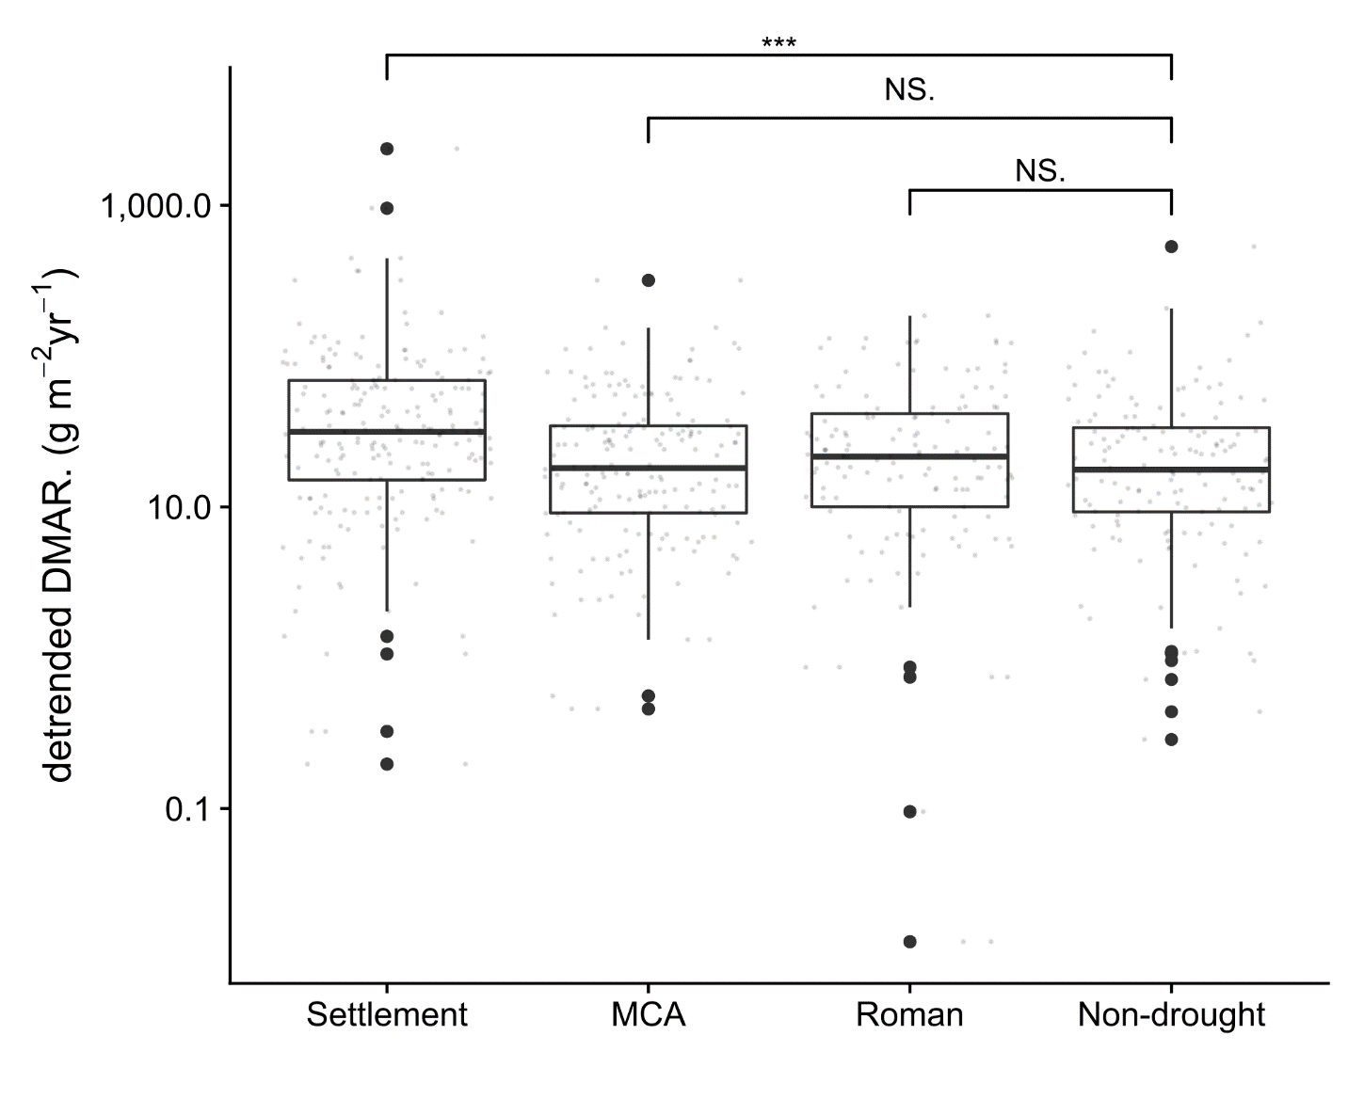
S12. Boxplot of late Holocene DMAR from Columbine Lake during settlement (1800-1950 CE), Medieval Climate Anomaly megadrought (1000-1400 CE), and Roman megadrought (1-400 CE) as compared to non-drought, pre-settlement years (360-540 and 960-1540 CE). Significance in the difference in mean is indicated with *** for p < 0.001 and N.S. for non-significant using the Wilcox test. Each DMAR ensemble member was detrended to avoid spurious results due to the decreasing trend seen in the record.
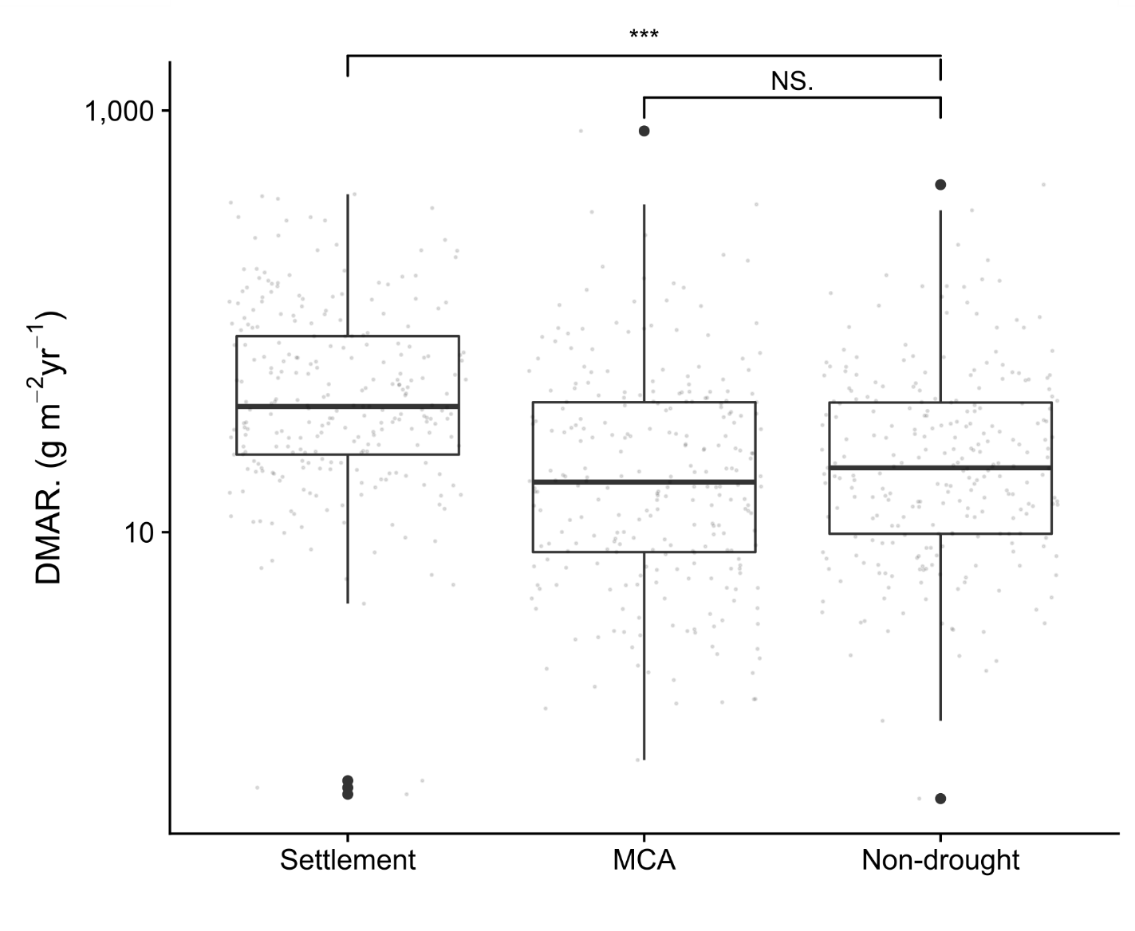
S13. Boxplot of late Holocene DMAR from Crater Lake (short and long core combined) during settlement (1800-1950 CE), Medieval Climate Anomaly megadrought (1000-1400 CE), and Roman megadrought (1-400 CE) as compared to non-drought, pre-settlement years (360-540 and 960-1540 CE). Significance in the difference in mean is indicated with *** for p < 0.001 and N.S. for non-significant using the Wilcox test. Note the Roman megadrought period was not included because the records contained too few (< 20) dated samples.
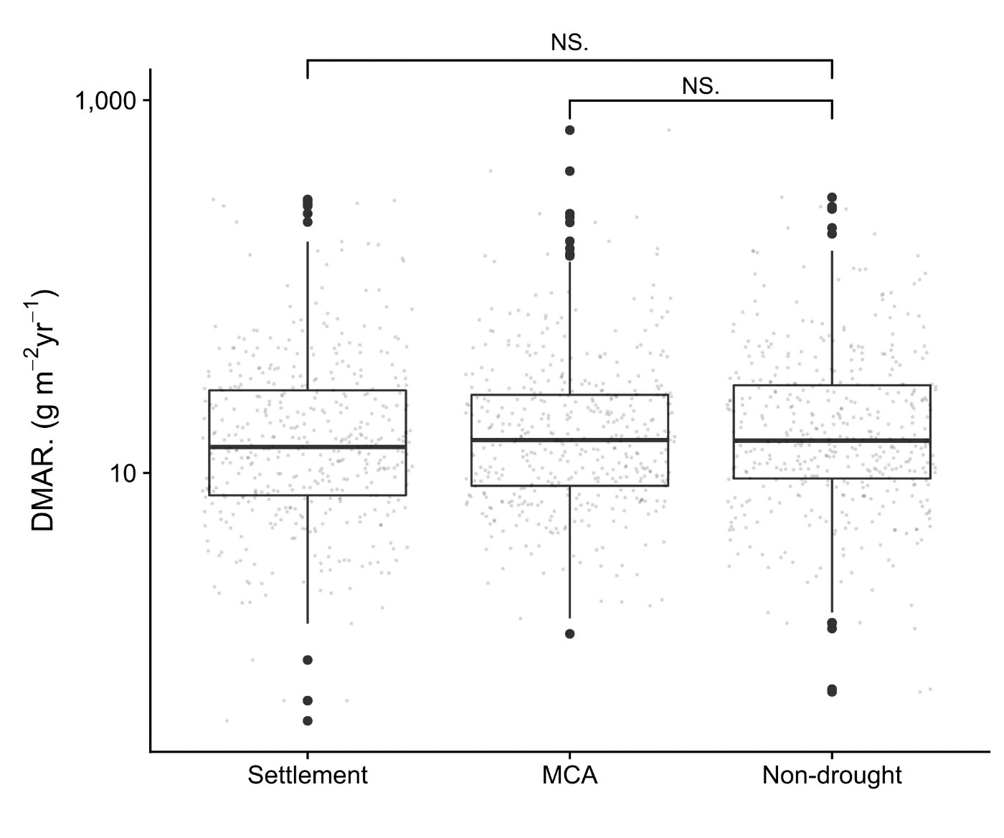
S14. Boxplot of late Holocene DMAR from Clear Lake (short and long core) during settlement (1800-1950 CE), Medieval Climate Anomaly megadrought (1000-1400 CE), and Roman megadrought (1-400 CE) as compared to non-drought, pre-settlement years (360-540 and 960-1540 CE). Significance in the difference in mean is indicated with *** for p < 0.001 and N.S. for non-significant using the Wilcox test. Note the Roman megadrought period was not included because the records contained too few (< 20) dated samples. The width of uncertainty in the estimated DMAR masks any significant differences in the mean.

