Online Appendix

Table 3 Summary statistics of major variables
Statistic | N | Mean | St. Dev. | Min | Max
Case Acceptance | 1,059 | 0.734 | 0.442 | 0 | 1
Ideological Unity | 1,061 | 0.787 | 0.098 | 0.452 | 0.974
Government Party | 1,064 | 0.540 | 0.499 | 0 | 1
Government Loss (t-1) | 1,064 | 0.034 | 0.181 | 0 | 1
Vote Loss | 1,064 | 1.525 | 2.076 | 0.000 | 11.200
Electoral Proximity | 1,061 | 7.339 | 4.166 | 0.090 | 14.610
Appeal | 1,062 | 0.771 | 0.420 | 0 | 1
Subject Matter | 1,050 | 0.624 | 0.485 | 0 | 1
Left-Right | 1,062 | -3.645 | 18.868 | -34.573 | 29.927
Initiator | 1,061 | 0.341 | 0.474 | 0 | 1
Party Age (log) | 1,064 | 3.778 | 0.983 | 0.000 | 4.949
Membership Size (log) | 1,064 | 12.649 | 1.145 | 9.929 | 13.837

Table 4 Logit Model without random effects

DV: Case accepted | (1) | (2) | (3) | (4) | (5)
Ideological Unity |  | -2.252** (1.076) |  |  | -2.207**  (1.092)
Government Party |  |  | 0.154  (0.170) |  | 0.162  (0.182)
Government Loss (t-1) |  |  | 2.289**  (1.027) |  | 2.115**  (1.033)
Vote Loss |  |  |  | 0.100**  (0.041) | 0.116*** (0.043)
Electoral Proximity |  |  |  | 0.037**  (0.018) | 0.030*  (0.018)
Appeal | 0.910***  (0.181) | 0.858*** (0.183) | 0.873*** (0.181) | 0.854*** (0.183) | 0.748*** (0.187)
Subject Matter | -0.513***  (0.166) | -0.516*** (0.167) | -0.532*** (0.167) | -0.521*** (0.168) | -0.548*** (0.168)
Initiator | 0.245  (0.165) | 0.228  (0.165) | 0.245  (0.165) | 0.271  (0.167) | 0.259  (0.167)
Left-Right | 0.014***  (0.004) | 0.010**  (0.004) | 0.013*** (0.004) | 0.014*** (0.004) | 0.010**  (0.005)
Party Age (log) | 0.225**  (0.113) | 0.131  (0.121) | 0.169  (0.118) | 0.151  (0.116) | -0.008  (0.131)
Membership Size (log) | -0.538***  (0.106) | -0.451*** (0.112) | -0.518*** (0.107) | -0.522*** (0.106) | -0.408*** (0.116)
Constant | 6.659***  (1.074) | 7.743*** (1.244) | 6.529*** (1.087) | 6.372*** (1.075) | 7.272*** (1.225)
Observations | 1,045 | 1,044 | 1,045 | 1,044 | 1,044
Log Likelihood | -565.814 | -562.326 | -560.697 | -559.115 | -552.315
AIC | 1,145.628 | 1,140.653 | 1,139.395 | 1,136.230 | 1,128.629
*p<0.1; **p<0.05; ***p<0.01; Party-clustered standard errors in parentheses.

Table 5 Hierarchical Logit Model with both Economic Left-Right and Open-Close ideological variables
DV: Case accepted | (2a) | (2b) | (3) | (4) | (5a) | (5b)
Policy Agreement | -1.996* (1.097) | -2.252** (1.076) |  |  | -1.992* (1.099) | -2.207** (1.092)
Ideology (Open-Closed) | 0.008  (0.008) |  |  |  | 0.012  (0.008)
Government Party |  |  | 0.154  (0.170) |  | 0.094  (0.188) | 0.162  (0.182)
Government Loss (t-1) |  |  | 2.289** (1.027) |  | 2.006* (1.037) | 2.115** (1.033)
Vote Loss |  |  |  | 0.100** (0.041) | 0.129*** (0.044) | 0.116*** (0.043)
Electoral Proximity |  |  |  | 0.037** (0.018) | 0.032* (0.018) | 0.030* (0.018)
Appeal | 0.864*** (0.183) | 0.858*** (0.183) | 0.873*** (0.181) | 0.854*** (0.183) | 0.743*** (0.187) | 0.748*** (0.187)
Subject Matter | -0.510*** (0.167) | -0.516*** (0.167) | -0.532*** (0.167) | -0.521*** (0.168) | -0.542*** (0.169) | -0.548*** (0.168)
Initiator | 0.227  (0.165) | 0.228  (0.165) | 0.245  (0.165) | 0.271  (0.167) | 0.258  (0.168) | 0.259  (0.167)
Ideology (Left-Right) | 0.006  (0.006) | 0.010** (0.004) | 0.013*** (0.004) | 0.014*** (0.004) | 0.005  (0.006) | 0.010** (0.005)
Party Age (log) | 0.131  (0.121) | 0.131  (0.121) | 0.169  (0.118) | 0.151  (0.116) | -0.013 (0.131) | -0.008  (0.131)
Membership Size (log) | -0.506*** (0.123) | -0.451*** (0.112) | -0.518*** (0.107) | -0.522*** (0.106) | -0.473*** (0.125) | -0.408*** (0.116)
Constant | 8.315*** (1.351) | 7.743*** (1.244) | 6.529*** (1.087) | 6.372*** (1.075) | 8.082*** (1.345) | 7.272*** (1.225)
Variance (Party RE)
Observations | 1,044 | 1,044 | 1,045 | 1,044 | 1,044 | 1,044
Log Likelihood | -561.739 | -562.326 | -560.697 | -559.115 | -551.252 | -552.315
AIC | 1,143.478 | 1,142.653 | 1,141.395 | 1,138.230 | 1,130.505 | 1,130.629
*p<0.1; **p<0.05; ***p<0.01; Standard errors in parentheses.

Figure 3: Correlation Plot of Main Variables
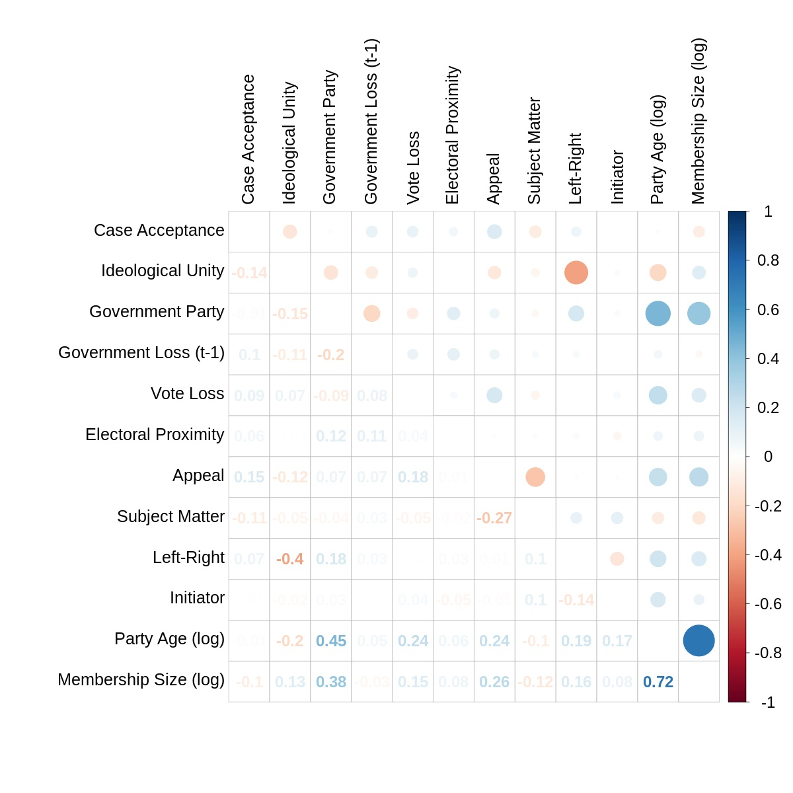

Table 6: Fixed Effects Logit Models of Case Acceptance (Rejection) by German Party Tribunals, 1967-2015.
 |  | (1) | (2) | (3) | (4) | (5)
Vote Loss |  |  | 0.093**  (0.042) |  |  | 0.114***  (0.043)
Electoral Proximity |  |  | 0.035*  (0.018) |  |  | 0.026  (0.018)
Policy Agreement |  |  |  | -3.474**  (1.407) |  | -3.327**  (1.416)
Government Party |  |  |  |  | 0.149  (0.176) | 0.130  (0.186)
Government Loss (t-1) |  |  |  |  | 2.269**  (1.033) | 2.128**  (1.043)
Appeal |  | 0.809***  (0.199) | 0.789***  (0.201) | 0.805***  (0.200) | 0.786***  (0.200) | 0.754***  (0.203)
Subject Matter |  | -0.537***  (0.169) | -0.536***  (0.170) | -0.538***  (0.169) | -0.546***  (0.169) | -0.547***  (0.171)
Initiator |  | 0.222  (0.169) | 0.249  (0.171) | 0.207  (0.170) | 0.209  (0.170) | 0.227  (0.172)
Ideology (Left-Right) |  | 0.010  (0.007) | 0.010  (0.007) | 0.001  (0.008) | 0.010  (0.008) | 0.003  (0.008)
Party Age (log) |  | -0.093  (0.281) | -0.157  (0.281) | -0.331  (0.310) | -0.166  (0.287) | -0.450  (0.313)
Membership Size (log) |  | -0.900**  (0.417) | -0.728*  (0.428) | -0.685  (0.425) | -0.718  (0.443) | -0.250  (0.465)
CSU |  | -0.760  (0.626) | -0.438  (0.645) | -0.454  (0.639) | -0.520  (0.653) | 0.231  (0.690)
FDP |  | -0.628  (0.962) | -0.223  (0.982) | -0.798  (0.977) | -0.216  (1.021) | 0.189  (1.042)
Greens |  | -1.257  (1.228) | -0.860  (1.241) | -0.916  (1.255) | -0.761  (1.299) | 0.164  (1.326)
SPD |  | 0.223  (0.446) | 0.214  (0.449) | 0.176  (0.453) | 0.273  (0.453) | 0.165  (0.460)
Linke |  | -1.919  (1.247) | -1.471  (1.259) | -2.148*  (1.299) | -1.500  (1.306) | -1.058  (1.345)
Constant |  | 12.907**  (5.857) | 10.445*  (5.986) | 13.817**  (6.013) | 10.629*  (6.218) | 7.868  (6.393)
N |  | 1,045 | 1,044 | 1,044 | 1,045 | 1,044
Log Likelihood |  | -563.358 | -557.455 | -558.767 | -558.528 | -549.874
AIC |  | 1,150.716 | 1,142.911 | 1,143.535 | 1,145.056 | 1,133.749
*p<0.1; **p<0.05; ***p<0.01
Standard errors in parentheses.

Table 7: Hierarchical Logit Models of Case Acceptance (Rejection) by German Party Tribunals, 1967-2015, and interactions with subject matter.
 | (1) | (2) | (3) | (4) | (5)
Vote Loss |  | 0.082 (0.065) |  |  | 0.106 (0.067)
Vote Loss X Subject |  | 0.026 (0.081) |  |  | 0.017 (0.083)
Electoral Proximity |  | 0.051 (0.033) |  |  | 0.045 (0.033)
Days to Elec. X Subject |  | -0.020 (0.039) |  |  | -0.020 (0.039)
Policy Agreement |  |  | -0.515 (1.831) |  | -0.371 (1.816)
Policy Agree. X Subject |  |  | -2.374 (2.074) |  | -2.487 (2.070)
Government Party |  |  |  | 0.277 (0.272) | 0.384 (0.290)
Gov. Party X Subject |  |  |  | -0.187 (0.317) | -0.319 (0.335)
Government Loss (t-1) |  |  |  | 0.820 (1.081) | 0.759 (1.098)
Gov. Loss X Subject |  |  |  | 15.533 (1,291.270) | 15.329 (1,264.919)
Appeal | 0.910*** (0.181) | 0.853*** (0.183) | 0.858*** (0.183) | 0.871*** (0.182) | 0.746*** (0.188)
Subject Matter | -0.513*** (0.166) | -0.412 (0.336) | 1.397 (1.675) | -0.444* (0.245) | 1.741 (1.738)
Initiator | 0.245 (0.165) | 0.269 (0.167) | 0.232 (0.165) | 0.245 (0.165) | 0.264 (0.168)
Ideology (Left Right) | 0.014*** (0.004) | 0.014*** (0.004) | 0.010** (0.004) | 0.013*** (0.004) | 0.010** (0.005)
Party Age (log) | 0.225** (0.113) | 0.152 (0.116) | 0.126 (0.121) | 0.173 (0.118) | -0.009 (0.131)
Membership Size (log) | -0.538*** (0.106) | -0.521*** (0.106) | -0.449*** (0.112) | -0.519*** (0.107) | -0.409*** (0.117)
Constant | 6.659*** (1.074) | 6.283*** (1.098) | 6.336*** (1.705) | 6.471*** (1.095) | 5.594*** (1.695)
N | 1,045 | 1,044 | 1,044 | 1,045 | 1,044
Log Likelihood | -565.814 | -558.937 | -561.689 | -559.030 | -549.662
AIC | 1,147.628 | 1,141.874 | 1,143.378 | 1,142.061 | 1,135.324
*p<0.1; **p<0.05; ***p<0.01
Standard errors in parentheses.

