Appendix 2. Choice set examples.

We used a dual response design in which respondents were forced to make a choice between two personal health record (PHR) alternatives first, and subsequently asked to make an unforced choice. In this paper, we only use responses from the unforced choices.

Opt-out:
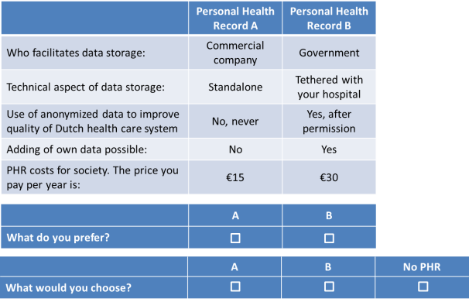

Neither:
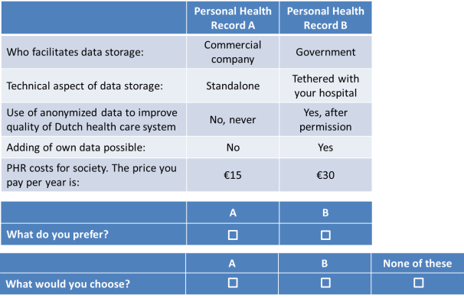

Status quo and opt-out:
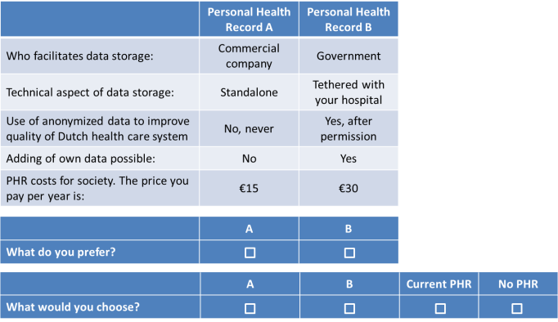

PHR introductory text:
There are many different definitions of personal health records (PHRs). It is important that everyone completes this survey with the same definition in mind. We will therefore first describe what is meant with PHRs in this survey.

A PHR is a digital tool that enables you to collect, manage and share information about your health, for example, information on diagnosis, treatments, referrals, etc. This information can be obtained from your healthcare providers (e.g. medical specialist, general practitioners, physiotherapist) and/or yourself. Some PHRs include additional functionalities, for example, being able to schedule appointments with your healthcare provider, request mediation refills, provide medication reminders, advice and/or information on health and diseases.

In a PHR you can control the data. You decide yourself who you provide access to your data and what parts of your PHR this person can see. Persons that were not given access by you cannot see your data. A PHR is complementary to the registration systems used by healthcare providers.

Explanation of attributes:
- Facilitating party for data storage of PHR data: PHRs are offered by various parties. For example, by commercial parties (such as Microsoft or a health insurer), independent non-profit organizations (such as patient organizations), the government or healthcare providers/healthcare institutions.
- Level of connectivity: If your PHR is linked to an existing e-healthcare system, data will automatically be kept up-to-date. Some PHRs offer the possibility to be linked to one other system, for example with the system of your general practitioner or your hospital. Other PHRs are linked to multiple systems. If your PHR is not linked, you must take action yourself to keep your PHR up to date.
- Use of anonymized data by third parties: In your PHR, data about your health is collected and stored. This data contains a lot of information for healthcare professionals, researchers and policy makers. This information can be made anonymous by deleting personal information. Anonymous data can be used to improve healthcare in the Netherlands.
- Option to upload a person’s own data into the PHR: In some PHRs, you can add information yourself. For example, notes on your medical data, data from health apps, or blood sugar or blood pressure values. In other PHRs you cannot add your own data and you only have insights in your medical files.
- Costs: the price you pay per year to make this PHR available to society.

