Figure S2. Real-time PCR results for E. coli 2011C-4315 (A) and E. coli 2012C-4431 (B) performed using DNA isolated from bacterial suspensions treated with heat stabilization via the Denator Stabilizor T1 instrument and untreated control suspensions. Compatible dose responses of amplification and melt curves are observed for both strains.

A)
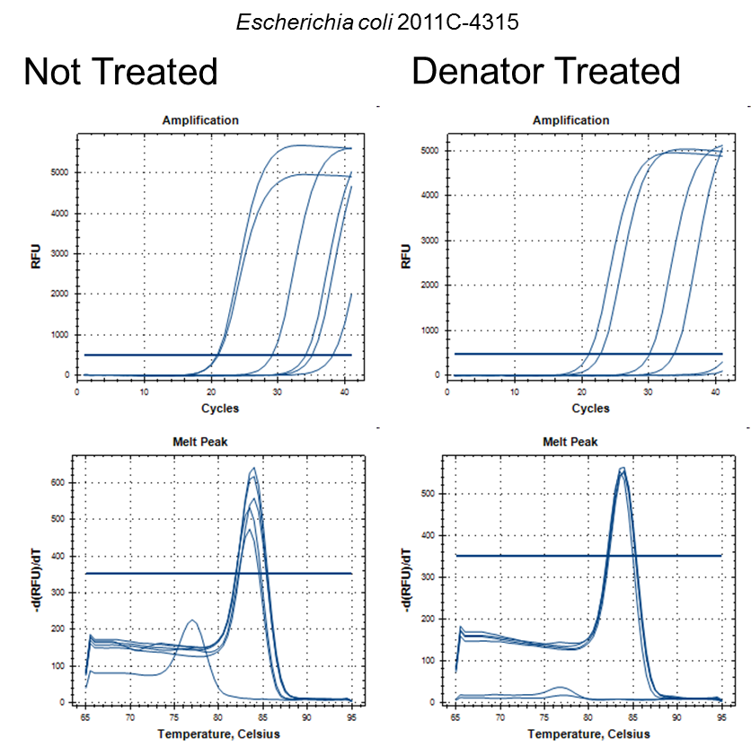

B)
