DIFFERENCES BETWEEN PROTOCOL AND REVIEW

The original protocol for this manuscript is registered at PROSPERO (CRD42018104339)
- Peer-reviewers disagreed with our choice of only included short-term studies. We therefore revised our original decision and when we updated our search on January 20th, 2019, we additionally screen for long-term PD studies and tapering investigations. However, since our search terms demonstrated only a few long-term PD studies that did not evaluate the same adverse events, and an investigation without a comparison between SSRIs or BZs with a placebo was an impeditive factor to be included in our statistical analysis, it was unfeasible to summarize long-term PD treatment evidence in a paper. When evaluate tapering in PD, our search strategy, with the included suggested terms, resulted in 3 studies assessing tapering in PD (one comparing tapering between SSRI sertraline and placebo in PD and two comparing tapering between BZs alprazolam and placebo in PD). Since these studies presented different types of adverse events, summarize then in one statistical analysis would be misleading. However, since headache and tremor appeared in both BZs studies, we performed a meta-analysis in R software only with BZs evidence. The results showed that BZs tapering presented a higher risk of causing tremor and headache than placebo in PD patients (OR=6.27, I²=0, p<0.01, and OR=5.07, I²=0, p<0.01, respectively). Consider that tapering results were only evaluated in BZs and not in SSRIs, we included the forest plots and the results in supplementary material. However, we understand the importance of evaluating BZs and SSRIs in long-term treatment and tapering. Therefore, to make it possible, we suggest that future research should focus on a more broadly population than just PD patients.

Forest plots BZs tapering:

- Forest plot 1. Headache and BZs tapering
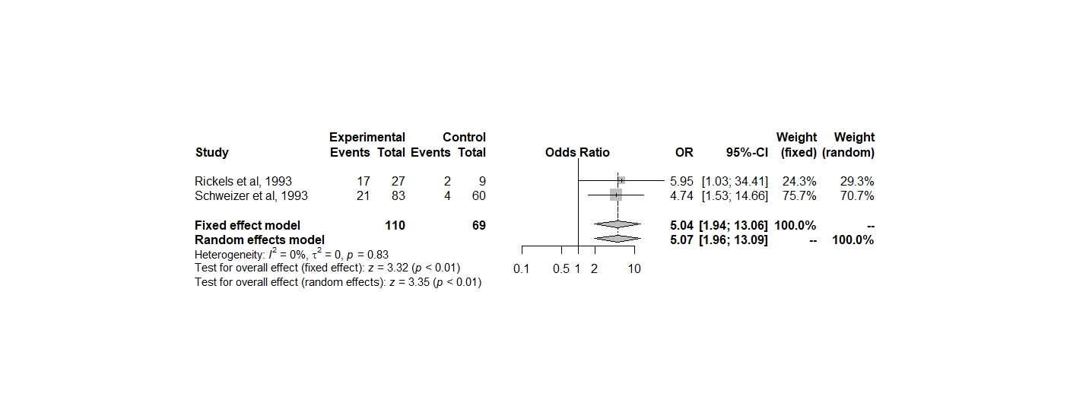

- Forest plot 2. Tremor and BZs tapering
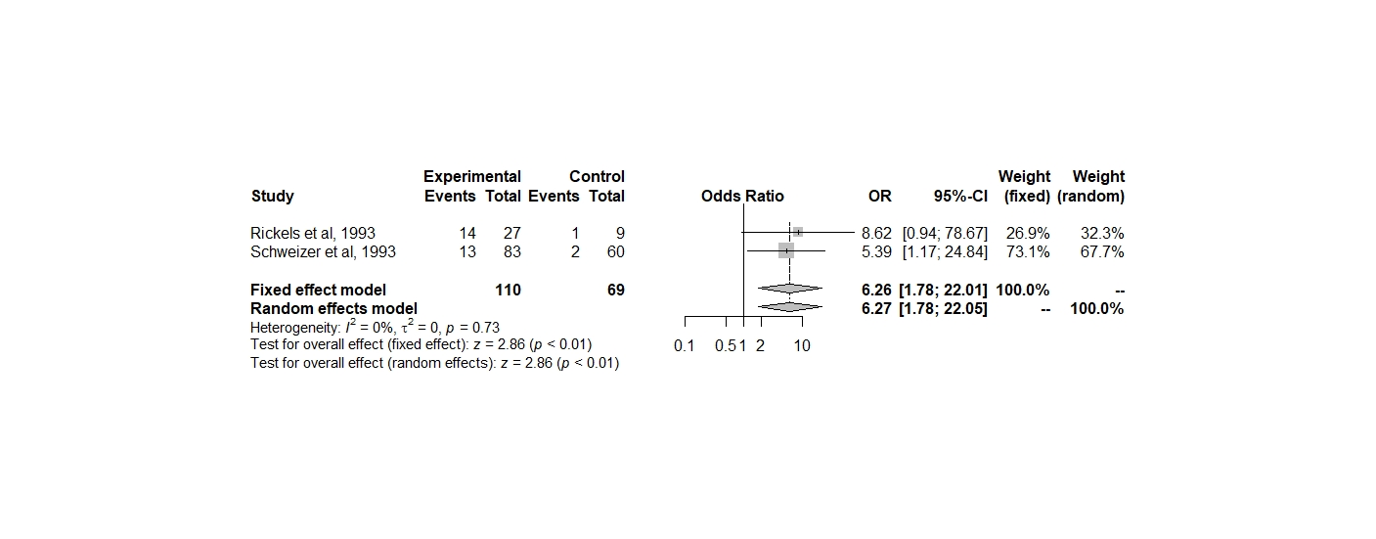
- Peer-reviewers asked for the analysis of further outcomes. We therefore added craving, dependence, addiction, tolerance, withdrawal, tapering, discontinuation syndrome, impaired driving, driving under the influence, driving while intoxicated, disinhibited behavior, bruising, as other major side-effects that have been discussed in the debate around the BZs and/or SSRIs drugs. Special searches were run on these on January 20th, 2019, search terms are detailed below.

Search Terms:
“panic disorder” OR “panic attacks” AND paroxetine OR sertraline OR fluoxetine OR citalopram OR escitalopram OR fluvoxamine OR alprazolam OR bretazenil OR bromazepam OR chlordiazepoxide OR cinolazepam OR clonazepam OR cloxazolam OR clorazepate OR deloramzeapam OR diazepam OR estazolam OR etizolam OR ﬂudiazepam OR ﬂunitrazepam OR ﬂurazepam OR ﬂutoprazepam OR halazepam OR ketazolam OR loprazolam OR lorazepam OR lormetazepam OR medazepam OR nimatazepam OR nitrazepam OR nodazepam OR oxazepam OR phenazepam OR pinazepam OR prazepam OR premazepam OR quazepam OR temazepam OR tetrazepam OR triazolam OR benzodiazepines OR SSRI OR selective serotonin reuptake inhibitors AND inﬂuenza-like symptom* OR flu-like symptom* OR diaphoresis OR sweating OR ﬂushing OR headache OR convulsions OR seizures OR muscle aches OR muscular pains OR myalgia* OR fatigue OR lack of energy OR lethargy OR somnolence OR stiffness OR arthralgias OR palpitations OR skin rash OR itching OR abdominal pain OR abdominal cramps OR nausea OR vomit* OR dry retching OR loss of appetite OR weight loss OR anorexia OR appetite disturbance OR diarrhea OR constipation OR sleep disturbance* OR nightmares or vivid dream* OR ataxia OR dizziness OR lightheadedness OR vertigo OR blurred vision OR difﬁculty in focusing OR visual disturbance OR sore eyes OR electric shock sensations OR numbness OR fasciculation OR paresthesia OR restless legs OR tingling OR muscle twitches OR hyperosmia OR photophobia OR hyperaccusis OR tinnitus OR altered taste OR metallic taste in mouth OR taste perversion OR jerks OR myoclonic jerks OR jumpiness OR tremors OR shaking OR Incoordination OR impaired perception of movement OR imbalance OR unsteady gait OR parkinsonism OR agitation OR aggression OR anger OR irritability OR restlessness OR tension OR delirium OR confusion OR poor concentration OR poor memory OR decreased concentration OR slowed thinking OR memory problems OR amnesia OR hallucination OR catatonia OR psychosis OR depressed mood OR emotional lability OR depression OR nervousness OR anxiety OR depersonalization OR derealization OR bleed* OR suicide OR suicide, attempted OR suicide, ideation OR mortality OR "drug-related side effects and adverse reactions" OR "sleep initiation and maintenance disorders" OR "disorders of excessive somnolence" OR accidental falls OR gastrointestinal hemorrhage OR cardiovascular diseases OR obesity OR metabolic syndrome OR hypertension OR "QTc prolongation" OR bradycardia OR tachycardia OR anorgasmia OR precocious ejaculation OR erectile dysfunction OR loss of libido OR low sex drive OR sexual impotence OR falls OR bruising OR addiction OR craving OR dependence OR tolerance OR addiction OR withdrawal OR tapering OR “discontinuation syndrome” OR “impaired driving” OR “driving under the influence” OR “driving while intoxicated” OR “disinhibited behavior”. In the search terms, we included items for PD short-term treatment non-regimented by European or North American regulatory agencies with the intention of providing the broadest search possible to avoid missing data. We (LAQ and AEN) manually checked which trials should be included in the systematic review a posteriori.

Search results

Web of Science Search- 25th april 2018

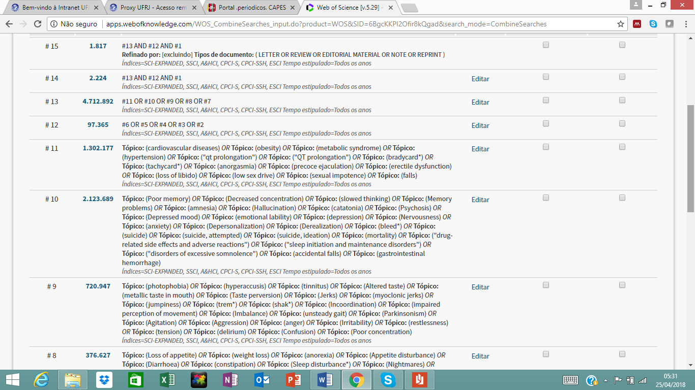

Pubmed Search- 25th april 2018
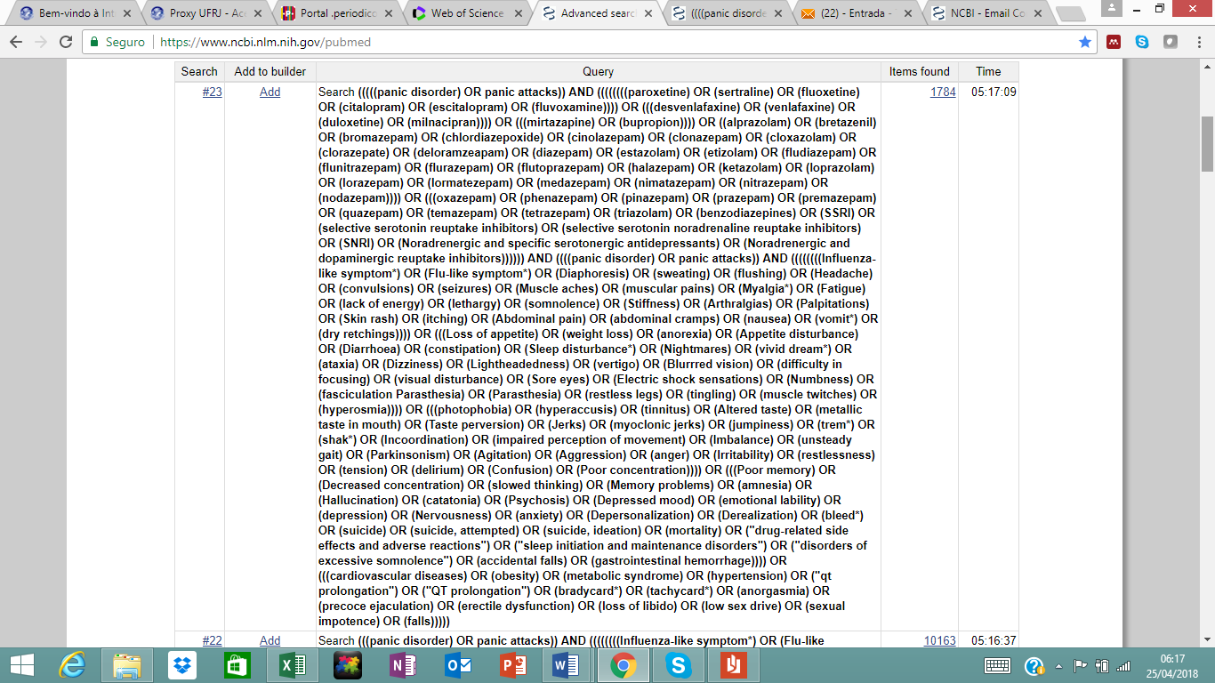

Cochrane Central Register of Controlled Trials Search- 25th april 2018
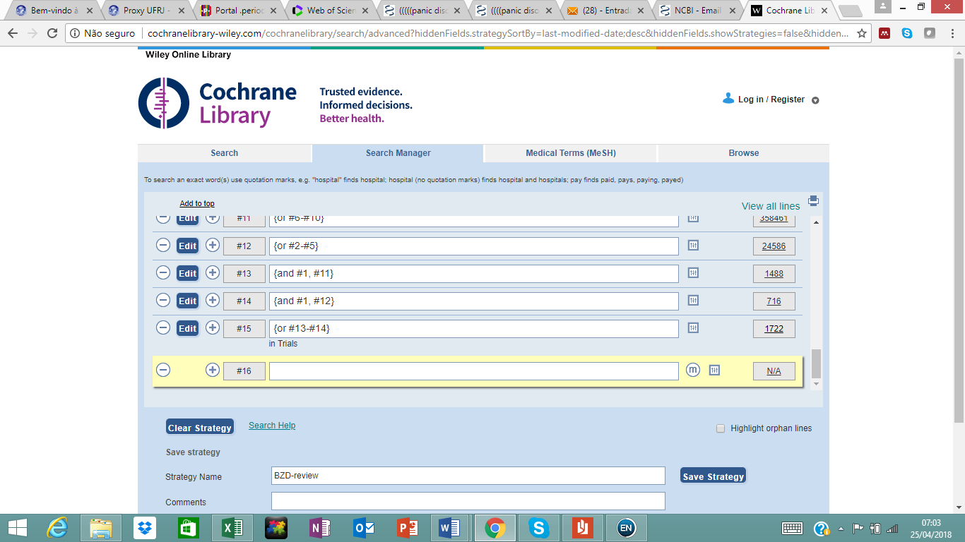

Web of Science Search- 20th January 2019
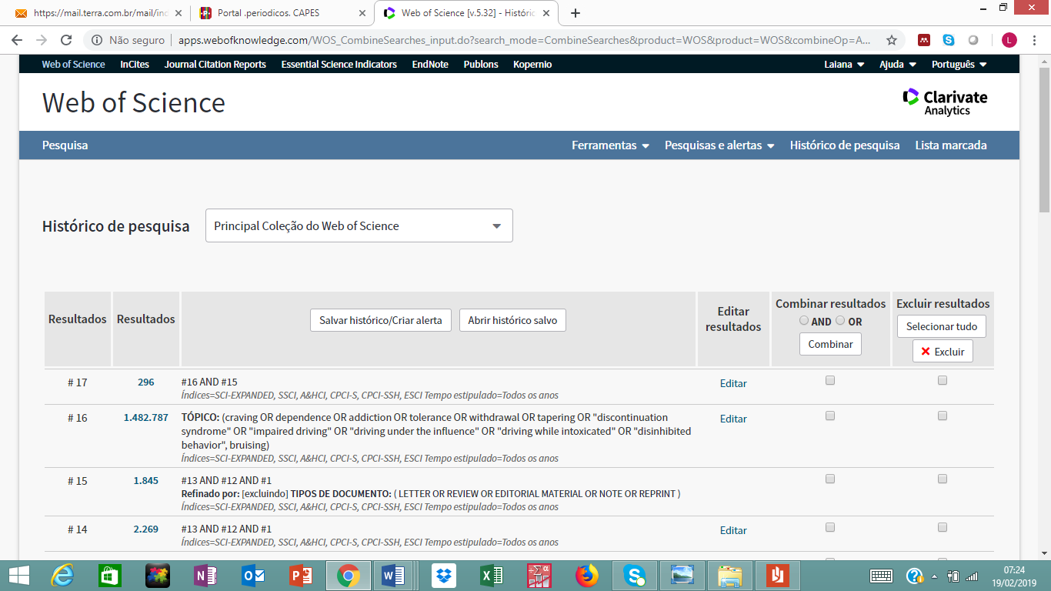

Pubmed Search- 20th January 2019
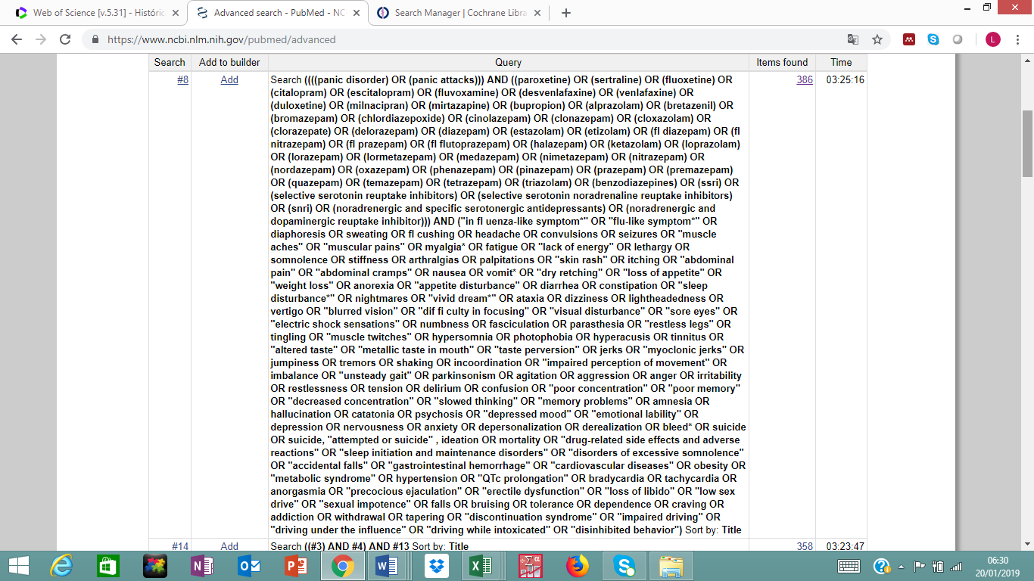

Cochrane Central Register of Controlled Trials Search- 20th January 2019

