WEB APPENDIX A
Robustness-to-Bad-Deals Study
This study tests whether DPF is moderated by whether the premium option is a "good deal" or a "bad deal," to test whether the DPF effect is different from previously established price framing methods. Specifically, Price Partitioning has been shown to make products more attractive under “good deal” conditions, but less attractive under “bad deal” conditions, when manipulating the offer value using variations in quality (Bertini and Wathieu 2008). Using a similar experimental approach keeping the prices constant and varying the quality of the premium option, this study shows that the DPF effect is robust to bad deals. We predict the DPF effect to be robust to quality-induced value variation because the driving mechanism for DPF framing is the increased salience of the price difference (versus the total price of the premium option), which is unaffected by the quality of the deal, irrespective of the source of the value variation. In other words, this study highlights the different mental processes and behavioral effects arising from DPF and PP under bad-deal conditions.
Method
Participants and Design. Five hundred and seventeen UK participants recruited through Prolific Academic took part in the main experiment (67% female, M_{age} = 36.7). This experiment uses a 2 (framing: inclusive-price vs. differential-price) x 3 (premium option quality levels: 8 hours vs. 7 hours vs. 6 hours for a train journey) between-participants design. The dependent variable of interest was the proportion of premium options selected.
Procedure. Participants were instructed to imagine themselves buying a train ticket and shown two different train-route options on one web page. Train A takes 10 hours to reach its destination and tickets retail for €79.00. The other option, Train B, offered a shorter journey for €109.00 in the IPF condition (for €30.00 more in the DPF condition). The premium train journey option took either 8 hours, 7 hours, or 6 hours to reach the destination. The instruction specified that the view along the way was not scenic and that both trains offered a similar level of comfort. Participants were instructed to choose their preferred train journey.
Pre-test
We pre-tested the extent to which the premium option prices used in this study (a shorter €109.00 train journey of either 8 hours, 7 hours, or 6 hours; compared to a longer €79.00 train journey of 10 hours) were perceived as good or bad deals (1 = a very bad deal; 9 = a very good deal; Bertini and Wathieu 2005) on a separate sample taken from the same UK Prolific population as the main study (n = 191). Using a between-participants design, the chosen prices led to significantly different ratings on deal attractiveness (F(2,188) = 9.80, p < .001). Planned contrasts revealed that the 8-hour journey (M = 4.31, SD = 1.62) was rated as significantly worse than the 7-hour journey (M = 5.02, SD = 1.70; t(188) = 2.50, p = .01) and the 6-hour journey (M = 5.57, SD = 1.50; t(188) = 4.41, p < .001), and that the two latter condition. Were also significantly different from each other (t(188) = 1.95, p = .05). More importantly, when comparing these values to the mid-point on the scale (x = 5), the 8-hours journey was rated as significantly worse than the mid-point (t(190) = 5.66, p < .001; suggesting a bad deal), the 7-hour journey offer did not significantly differ from the mid-point (t < 1), and the 6-hour journey was significantly above the mid-point (t(190) = 4.68, p < .001; suggesting a good deal), validating our bad deal manipulation.
Results
Using logistic regression with two dummy coded variables (using the intermediate option as the reference category), we found no significant two-way interaction between the quality-level and price-framing conditions (Z’s < 1) suggesting no difference in the price-framing effect between the different quality levels (i.e., duration of the train routes). Importantly, we observed a significant main effect of the price-framing condition (b = .74, SE = .32, Z = 2.29, p < .05). That is, across good and bad deals, a significantly higher proportion of people selected the premium, but more expensive choice option in the DPF conditions overall (P = 43%) compared to the IPF condition (P = 32%; Cohen’s d = .27); further supporting H1). We also observed a significant main effect of the 6-hour journey dummy (b = 1.01, SE = .33, Z = 3.10, p < .01) consistent with a larger proportion of participants selecting the premium option as commuting time decreases.
PROPORTION OF PREMIUM OPTIONS SELECTED BY PRICE-FRAMING AND QUALITY-LEVEL CONDITIONS

Discussion
This study provides additional evidence that the DPF effect is distinct from a standard price partitioning effect by showing how the effect is robust across “good” and “bad” deals. Whereas price partitioning leads to a reversal effect in the presence of bad deals because of its attentional mechanism (Bertini and Wathieu 2008), the DPF effect is robust to bad deals. We conducted a replication of this robustness study where quality was kept constant and prices varied (See Web Appendix B). The results again supported the robustness of the DPF effect across bad deals. Thus, we have not found any total-price limit or threshold for the effect. We explain this result by the consumers’ focus on the smaller cost difference (vs. the total price of the premium option) as they make their subjective value assessment of the cost of upgrade from the standard option across the range of available deals.

Stimuli

Imagine that you are planning a trip.
You are looking to purchase a train ticket that will bring you to your next destination. Two train routes are available on the date you wish to travel.
Train A takes longer to reach your destination but is cheaper. Train B is faster but more expensive.
The view along the way is not scenic and the trains offer a similar level of comfort.

- IPF/8-hour condition
Train A  Takes 10 hours  for £79.00 | Train B  Takes 8 hours  for £109.00

- DPF/6-hour condition
Train A  Takes 10 hours  for £79.00 | Train B  Takes 6 hours  for £30.00 more

WEB APPENDIX B
Deal-Attractiveness Robustness Study
This study provides further evidence that the DPF effect is robust across price levels, given a constant level of quality. That is, while other forms of price framing (specifically, Price Partitioning) have been shown to make products more attractive under “good deal” conditions, but less attractive under “bad deal” conditions because of the increased focus on the partitioned attribute (Bertini and Wathieu 2008), we expect the price-focalism-driven effect of DPF on consumer choice to be robust to variations in deal attractiveness. We make this prediction because the driving mechanism for DPF framing is the salience of the cost difference (versus the total price), which is unaffected by the quality of the deal (i.e., the focal price under DPF is always smaller than IPF).
Pre-test
Using a between-participants design, we pre-tested the extent to which the premium option prices used in this study (27-inch computer monitors priced at $259.99, $319.99, and $379.99) were perceived as good or bad deals (1 = a very bad deal; 9 = a very good deal; Bertini and Wathieu 2005), on a separate sample taken from the same MTurk population as the main study (n = 91). (The actual market prices for these 23-inch and 27-inch monitors were $199.99 and $259.99 respectively.) As expected, the chosen prices led to significantly different ratings on deal attractiveness (F(2,88) = 14.68, p < .001). Using planned contrasts, the $379.99 price (M = 3.19, SD = 1.40) was rated as significantly worse than the $319.99 price (M = 4.70, SD = 2.05; t(88) = 2.21, p < .05) and the $259.99 price (M = 5.82, SD = 2.26; t(88) = 5.41, p < .001). The $319.99 and $259.99 prices were also significantly different from each other (t(88) = 2.96, p < .01). Furthermore, when comparing these values to the mid-point on the scale (x = 5), the $379.99 offer was rated as significantly worse than the mid-point (t(90) = 7.79, p < .001; suggesting a bad deal), the $319.99 offer did not significantly differ from the mid-point (t(90) = 1.29, p = .20), and the $259,99 offer was significantly above the mid-point (t(90) = 3.53, p < .001; suggesting a good deal) validating our bad deal manipulation.
Method
Participants and Design. Four hundred and four participants recruited through Amazon MTurk took part in the main experiment (47% female, M_{age} = 35.7). This experiment uses a 2 (framing: inclusive-price vs. differential-price) x 3 (premium option price levels: $259.99 vs. $319.99 vs. $379.99) between-participants design. The dependent variable of interest was the proportion of premium options selected.
Procedure. As in Study 1, participants were instructed to imagine themselves shopping for a new computer monitor and shown two different monitor options (23-inch vs. 27-inch) on one web page, where the 23-inch version retailed at $199.99. In the IPF conditions, the premium 27-inch monitor was available for either “$259.99,” “$319.99,” or “$379.99” depending on the price condition, whereas the same size upgrades in the DPF conditions were offered for “$60.00 more,” “$120.00 more,” or “$180.00 more” respectively. Participants were instructed to select the monitor they would normally choose. After selecting the monitor of their choice, participants rated the extent to which the premium choice option appeared expensive compared to the standard option using one 7-point item: “Compared to the 23-inch version, how much more expensive is the 27-inch version?”; 1: No more expensive; 7: Very much more expensive.
Results

Product Choice. Results from a logistic regression with two dummy coded variables to account for multicategorical price levels suggested no significant dummy1*priceframing interaction (Z < 1) and a significant dummy2*priceframing interaction (b = .74, SE = .61, Z = 1.20, p > .20) suggesting no difference in the price-framing effect between the price levels. Following a traditional demand function, we observed two significant effects of the price-level condition (dummy1: b = -1.30, SE = .41, Z = 3.14, p < .01; dummy2: b = -1.99, SE = .49, Z = 4.02, p < .001), consistent with a smaller proportion of participants selecting the premium option as its price increases. More importantly, we observed a significant main effect of DP versus IP price framing (b = .72, SE = .35, Z = 2.06, p < .05) further supporting H1. Overall, across price-level conditions, a significantly higher proportion of people selected the premium, but more expensive choice option in the DPF conditions overall (P = 37%) compared to the IPF condition (P = 22%; b = .73, SE = .22, Wald χ² = 10.72, p = .001; Cohen’s d = .40).
PROPORTION OF PREMIUM OPTIONS SELECTED AND PERCEIVED EXPENSIVENESS BY PRICE-FRAMING AND PRICE-LEVEL CONDITIONS
 | Price Level
Price Framing | $259.99/  $60.00 more | $319.99/  $120.00 more | $379.99/  $180.00 more
Proportion selecting the premium option
IPF | 42% | 16% | 9%
DPF | 60% | 23% | 30%
Perceived Expensiveness (relative difference)
(1-7; higher scores mean more expensive)
IPF | 4.45 (1.23) | 5.73 (0.88) | 5.91 (0.85)
DPF | 3.79 (1.23) | 5.51 (1.46) | 5.43 (1.70)

Perceived Expensiveness. Mirroring the choice data, there was no interaction between price framing and price level in predicting the perception of expensiveness (b = .09, SE = .15, t < 1). However, consistent with H2, there was a significant main effect of price framing on judgments of expensiveness (b = -.45, SE = .13, t(400) = 3.43, p < .001) providing support for our proposed mechanism. The premium option was perceived to be less expensive overall in the DPF condition (M = 4.92, SD = 1.67) compared to the IPF condition (M = 5.36, SD = 1.19). There was also a significant main effect of the price level (b =.73, SE = .11, t(400) = 6.47, p < .001) consistent with participants perceiving the premium option as more expensive as its price increased.
Mediation. We conducted a mediation analysis to test whether perceived expensiveness could explain the difference in the proportion of premium options selected between the price-framing conditions, controlling for the price-level condition. Using a 5,000 bootstrap resampling method (Hayes 2013), there was a significant indirect effect (b = .35, SE = .12, CI₉₅ [.14, .62]) of price framing on the proportion of premium options selected, mediated by perceived expensiveness, supporting H2. As noted, the premium choice option was perceived to be less expensive in the DPF condition than in the IPF condition (b = -.45, SE = .13, t(401) = 3.44, p < .001, CI₉₅ [-.70, -.19]). In turn, the more expensive the premium product was perceived, the less likely people were to select it (b = -.79, SE = .11, Z = 7.21, p = .001, CI₉₅ [-1.01, -.58]).
Discussion
This study offers a conceptual replication of Web Appendix A, providing further evidence that the effect of DPF is robust across “good” and “bad” deals, further differentiating this from a standard price partitioning effect where a bad-deal reversal effect would have been expected (Bertini and Wathieu 2008): This demonstration extends the results of Web Appendix A by offering a replication in a context where price vary, keeping quality constant, as opposed to keeping price constant and varying quality. This study also shows that the increase in the proportion of participants selecting the premium choice option in the DPF over the IPF condition is consistent with a shift in the perceived expensiveness of the product. This result can be explained by the fact that the perceived expensiveness of the premium option is always lower in DPF than in IPF, no matter how large the price difference between products is.
WEB APPENDIX C
Differential Quality Frame Effect Replication Study
Given the somewhat surprising finding in Study 2 that a differential quality framing (DQF) does not affect choices, we conducted a conceptual replication of this effect using a different product category.
Method
Participants and Design. Two hundred and thirty-five undergraduate students took part in this laboratory experiment (62% female, M_{age} = 19.5). The experiment used a one-factor three-level (framing: inclusive-price vs. differential-price vs. differential-quality) between-participants design. The dependent variable was the proportion of participants selecting the premium option.
Procedure. Participants were instructed to imagine themselves shopping for a new external hard drive and shown two different hard drive options on one web page. Both hard drives were identical on every feature (i.e., brand, size, compatibility, data transfer rate, color) except for storage capacity and price. The smaller hard drive, which was the standard option, was presented as “2 TB storage capacity for $119.99 total.” The other hard drive, the premium option, was the larger version and thus, retailed for more. The premium hard drive was offered under three different framings. In the IPF condition, it was presented as “3 TB storage capacity for $169.99 total.” (Note that while we label it IPF, this condition also employs Inclusive Quality Framing, and so provides a control baseline against which to judge both experimental conditions.) In the DPF condition, it was presented as “3 TB storage capacity for $50.00 more.” Finally, in the DQF condition, it was presented as “1 TB additional storage capacity for $169.99 total.” Participants were instructed to select the hard drive they would normally choose.
Results
Results from a logistic regression with two dummy coded variables revealed a significant effect of the framing condition on the proportion of participants selecting the premium choice option (χ²(2) = 6.45, p < .05). Most importantly, the proportion of participants selecting the premium option in the DPF condition (P = 48%) was significantly higher than in the IPF condition (P = 33%; b = .65, SE = .33, Wald χ²(1) = 3.76, p = .05; Cohen’s d = .36), supporting again H1. Furthermore, the proportion of premium choices in the DPF condition was also significantly higher than that in the DQF condition (P = 29%; b = .80, SE = .34, Wald χ²(1) = 5.63, p < .05). Finally, there was no significant difference in the proportion of premium choice options selected between the IPF and the DQF conditions (b = .15, SE = .34, Wald χ²(1) = .20, p > .85).
Discussion
This study replicates the benefit of DPF and casts doubt on the ability of the more general compensatory trade-off or anchoring and adjustment models to explain the effect. Thus, the results further support the pricing focalism model: DPF increases the focus on the price difference when assessing the cost of the upgrade and hence lowers the perceived expensiveness of the premium option (because DPF is always numerically smaller than IPF). Because the null effect of DQF was somewhat surprising, and because null results can be hard to interpret (e.g., perhaps terabytes are hard for consumers to understand and so have no impact in any frame), we ran a third study dedicated to comparing IPF, DPF, and DQF, with different and more familiar stimuli (flight prices and travel times). The results, summarized in Web Appendix D, are the same: DPF influences choices, but DQF does not. The next study further tests these results with incentive compatible outcomes and directly tests the role of perceived expensiveness as a mediator of the DPF effect.
Stimuli
Inclusive Price Framing condition
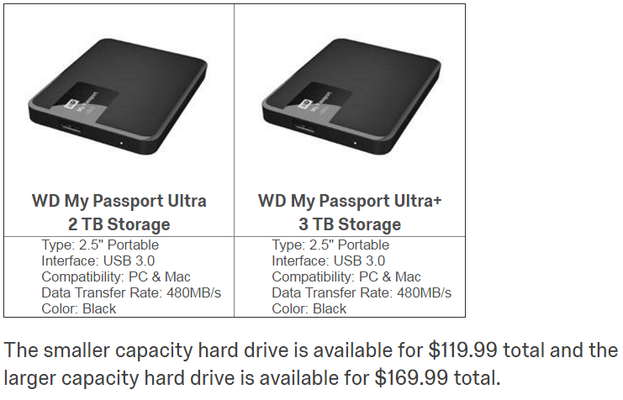
Differential Price Framing condition
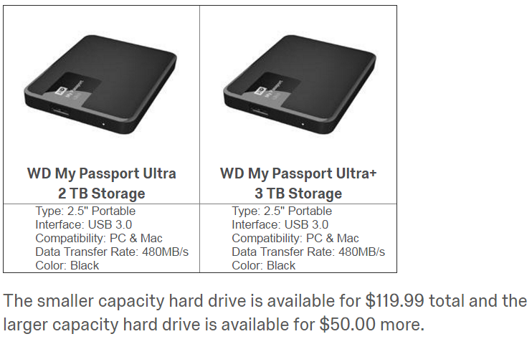
Differential Quality Framing condition
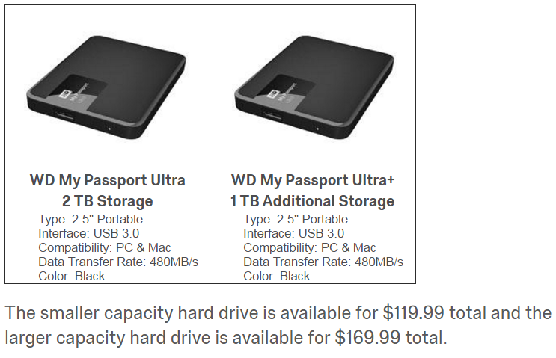
WEB APPENDIX D
Differential Time Framing Study
This study further tested whether the effectiveness of differential framing was unique to price framing and expensiveness judgments, or whether other focal attributes (such as the flight time) could be similarly influenced by differential framing.
Method
Participants and Design. Four hundred US participants (39% female, M_{age} = 32) were recruited through Prolific Academic. The experiment used a 2 (attribute focus: price vs. time) x 2 (attribute framing: inclusive vs. differential) between participants design. The dependent variable of interest was the choice proportion of "Flight B," the "differential" flight (i.e., the flight with differential price in the price condition, or the flight with differential time in the time condition).
Procedure. Participants were asked to choose between two flights from Chicago (ORD) to Los Angeles (LAX), where one flight was cheaper but took longer to reach the destination because of a connection. In the price condition, participants chose between "flight A, a 9-hour flight that costs $250 or flight B, a 5-hour flight that costs $399 [$149 more]", whereas in the time condition, participants chose between "flight A, a $399 flight that takes 5 hours or flight B, a $250 flight that takes 9 hours [4 hours more]". Thus, although the flights were the same in each condition, the order was reversed, such that in the price condition, flight B was more expensive (and shorter), and in the time condition, flight B was longer (and cheaper). Furthermore, the position and font size of the attributes (price and time) in the stimuli was reversed such that in the price condition, price was the focal attribute (more prominent position, bigger font), and in the time condition, flight time was the focal attribute.
Then, on a subsequent page, participants rated the expensiveness of each option using the same items as in Study 4. These items were used to compute a difference score representing the relative difference in expensiveness between the options. Similarly, participants rated the perceived length of each of the flights, and we calculated a difference score from these items as well.
Results
DIFFERENTIAL TIME FRAMING STUDY: DEPENDENT VARIABLES BY ATTRIBUTE FOCUS AND ATTRIBUTE FRAMING CONDITIONS
 | Attribute Focus Condition
Attribute Framing | Price | Time
Proportion selecting Flight B
Inclusive | 32% | 63%
Differential | 46% | 57%
Perceived Expensiveness of Flight A
(1-5; higher scores mean more expensive)
Inclusive | 2.33 (1.01) | 3.93 (0.98)
Differential | 2.74 (1.19) | 3.94 (0.93)
Perceived Expensiveness of Flight B
(1-5; higher scores mean more expensive)
Inclusive | 4.09 (0.88) | 2.52 (0.95)
Differential | 3.90 (1.01) | 2.62 (0.94)
Perceived Length of Flight A
(1-5; higher scores mean longer)
Inclusive | 4.33 (0.83) | 2.44 (0.91)
Differential | 4.32 (0.92) | 2.58 (0.93)
Perceived Length of Flight B
(1-5; higher scores mean longer)
Inclusive | 2.60 (0.96) | 4.45 (0.86)
Differential | 2.68 (1.04) | 4.41 (0.76)

Product Choice. Results from a 2 x 2 logistic regression suggested no main effect of attribute framing (b = -0.25, SE = 0.29, Wald χ²(1) = 0.75, p > .35), indicating no overall effect of differential framing, but this was qualified by a two-way interaction between attribute focus and attribute framing (b = 0.88, SE = 0.41, Wald χ²(1) = 6.60, p < .05). Follow-up pairwise comparisons revealed that in the price condition, people chose the more expensive option more often in the differential frame (P = 46%) than in the inclusive frame (P = 32%; b = .63, SE = .29, Wald χ²(1) = 4.55, p < .05; Cohen’s d = .30), in support of H1. Conversely, in the time condition, there was no significant difference in the selection of the longer option between the differential (P = 57%) and the inclusive frame (P = 63%; b = -0.25, SE = 0.29, Wald χ²(1) = 0.75, p > .35, Cohen’s d = 0.10).
Perceived Expensiveness. Results from a 2 x 2 ANOVA predicting judgements of relative expensiveness (i.e., the difference in perceived expensiveness of the two flights) found a main effect of attribute framing (F(1,396) = 5.78, p = .01), and a marginal interaction (F(1,396) = 6.52, p = .08). Pairwise comparisons confirmed that the differential frame reduced the difference in perceived expensiveness in the differential frame (M = 1.16, SD = 1.72) as compared to the inclusive frame (M = 1.76, SD = 1.36; t(198) = 2.75, p = .01), but that there was no difference in the time condition between the differential frame (M = 1.32, SD = 1.28) and the inclusive frame (M = 1.41, SD = 1.36; t < 1). Furthermore, as in previous studies, perceptions of expensiveness mediated the effect of framing on choices. Specifically, when looking at the price condition, there was a significant indirect effect (b = .06, SE = .03, CI₉₅ [.01, .11]) of differential framing on the proportion of premium options selected through the difference in perceived expensiveness, supporting H2.
Perceived Length. Neither the main effect of differential pricing on perceived flight length (F(1,396) = 1.04, p > .30) nor the interaction of differential pricing and attribute condition (F < 1) were significant. Likewise, pairwise comparisons of perceived length were not significantly different in the time condition (t(198) = 1.02, p > .30), nor the price condition (t < 1). Likewise, there was no significant effect of time framing on choices via perceptions of flight length.
Discussion
The results of this study replicate our previous findings: differential price framing (DPF) reduces judgments of the relative expensiveness of the premium option, increasing its choice share. Simultaneously, this study demonstrates that differential framing does not operate uniformly across domains: differential time framing did not affect judgments of flight length, nor on flight choice. This result replicates the DPF vs. DQF results from Study 2 and Web Appendix C, using a design where price and quality were equally featured in their respective conditions, balancing order, font-size, and position. It seems that when consumers are making cost-benefit judgments, differential framing influences judgments of costs but not judgments of benefits (i.e., the perceived lower cost of the premium option does not seem to affect price-quality inferences). We discuss this finding further in the General Discussion section.
Stimuli

Price condition
Flight A, Both conditions
Flight B, Inclusive price condition
Flight B, Differential price condition
Time condition
Flight A, Both conditions
Flight B, Inclusive time condition
Flight B, Differential time condition

WEB APPENDIX E
Price-Difference-Bigger-Than-Base Study
We designed this study to test whether the effect of DPF on the selection of premium choice options is robust to contexts where the price difference equates or surpasses the price of the cheaper option to compare the effect of DPF against those of price partitioning. That is, previous literature on price partitioning has shown that as the value of the quality gain decreases, the beneficial effect of a price partitioning diminishes and eventually reverses (Bertini and Wathieu 2008). Instead, because we predict that consumer make choices relying on an assessment Δ$X in under DPF for their decision (versus $X₂ under IPF) and that Δ$X << $X₂ do not predict such a mitigation of DPF effect when the cost difference increases relative to the standard price (e.g., becomes greater).
Method
Participants and Design. Six hundred and twenty-one panel UK participants from recruited through Prolific Academic took part in this experiment (67% female, M_{age} = 35.5) in exchange for payment. This experiment used a 2 (framing: inclusive-price vs. differential-price) x 4 (price level: €30/€60 vs. €30/€70 vs. €30/€80 vs. €30/€90) between participants design. The dependent variable of interest was the proportion of premium options selected.
Procedure. Participants were instructed to imagine themselves visiting France, shopping for a train ticket from Paris to Marseille. They considered two different travel options on one web page. Both trains were leaving Paris at the same time. One train cost €30 total and took seven hours to reach the destination because of stops along the way. The other was direct, taking only three hours to reach Marseille, but more expensive. Depending on the experimental condition, participants could select this premium flight for either “€60 total”/ “€70 total”/ “€80 total”/ “€90 total” (IPF conditions) or “€30 more”/ “€40 more”/ “€50 more”/ “€60 more” (DPF condition). Participants were instructed to select the train journey they would normally choose.
Results
Results from a logistic regression with four dummy coded variables to account for multicategorical price levels and using the €30/€90 condition used as reference category revealed no two-way interaction between the price-framing and the price-level conditions in predicting the choice of premium options (Z’s < 1). We instead observed a main effect of the price-framing condition (b = .80, SE = .33, Z = 2.46, p < .05), again supporting H1. Results also revealed two significant price-level dummies; we do not focus on these effects. Overall, across price-level conditions, we observed a larger proportion of participants selecting the premium option in the DPF (P = 67%) compared to the IPF (P = 53%) condition (see figure below; Cohen’s d = .34).
PROPORTION OF PREMIUM OPTIONS SELECTED BY PRICE-FRAMING AND PRICE-LEVEL CONDITIONS

Discussion
The results from this study suggest that the usual benefit of DPF in increasing the selection of premium choice options is robust to the context where the cost difference increases relative to the price of the standard option (e.g., is equal or increasingly larger). These results further support the distinction between DPF and price-partitioning.
Stimuli

Imagine that you are visiting France.
After visiting Paris for a few days, you have decided to spend the next portion of your trip in the South, near Marseille. You show up at the train station one morning, two train routes are leaving shortly.
One train is cheaper but gets you to your destination later because it makes stops along the way. The other one is a direct train. It is faster but more expensive.

(IPF and €30/€90 condition)
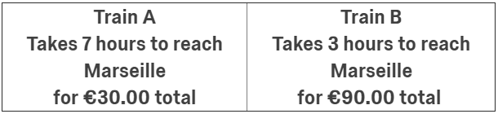

(DPF and €30/€90 condition)
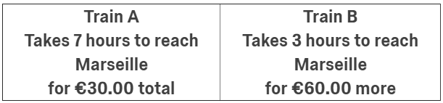

WEB APPENDIX F
Price-Computation-Difficulty Study
We designed this study to test whether the effect of DPF on the selection of premium choice options is robust to various levels of price computational difficulty. That is, we wished to test if our effect was robust to conditions where computing the price difference between the options what relatively effortless (e.g., $150.00 vs. $200.00) compared to relatively difficult (e.g., $169.00 vs. $219.00; see Thomas and Morwitz 2009), such that the DPF would not bring more focus to the price difference between the options (e.g., $50) beyond what participants could compute themselves when the price difference is easy to compute.
Method
Participants and Design. Six hundred and eleven online panel participants from recruited through Amazon Mechanical Turk took part in this experiment (57% female, M_{age} = 37.7) in exchange for payment. This experiment used a 2 (framing: inclusive-price vs. differential-price) x 4 (price level: easy-low vs. difficult-low vs. difficult-high vs. easy-high) between participants design. The dependent variable of interest was the proportion of premium options selected.
Procedure. Using a design similar to the one used un Web Appendix D, participants were asked to choose between two flights from New York (JFK) to Los Angeles (LAX), where one flight was cheaper but took longer to reach the destination because of a connection. Depending on the experimental condition, the price of the standard (i.e., slower and cheaper) and premium flight (i.e., faster and more expensive) ware available respectively for either: $150.00 vs. $200.00 (easy-low condition), $169.00 vs. $219.00 (hard-low condition), $189.00 vs. $239.00 (hard-high condition), or $200.00 vs. $250.00 (easy-high condition) in the IPF conditions. In comparison, the premium flight was constantly priced as “$50.00 more” in the DPF conditions. We used this low-high price approach to control for the varying ratio of the $50 price difference on the total price of each option when manipulating the computing difficulty (adapted from Thomas and Morwitz 2009). Participants were instructed to select the flight they would normally choose. On a subsequent page, participants rated the expensiveness of each option using the same items as in Study 6. These items were used to compute a difference score representing the relative difference in expenses between the options (M_{Premium}-M_{Standard}).
Manipulation Check
The extent to which the four prices differences used in this study ($150.00 vs. $200.00, $169.00 vs. $219.00, $189.00 vs. $219.00, $200.00 vs. $250.00) were perceived easy or hard to compute was pretested on a separate sample taken from the same population as the main study (n = 54), using a within-sample design ("the average person would find the price difference between the two prices:" 1 = very easy to compute; 7 = very hard to compute). Results suggest that the chosen price differences differ significantly in ease of computation ratings (F(3,51) = 53.39, p < .001). Using post-hoc comparisons, the $150.00-$200.00 price difference (M = 1.43, SD = .88) was rated as significantly easier to compute than the $169.00-$219.00 price difference (M = 3.59, SD = 1.31; t(53) = 12.12, p < .001) and the $189.00-$239.00 price difference (M = 3.70, SD = 1.38; t(53) = 11.79, p < .001), but not different from the $200.00-$250.00 price difference ( M = 1.31, SD = .75; t(53) = 1.18, p > .20). The $200.00-$250.00 price difference was also rated as significantly easier to compute than the $169.00-$219.00 (t(53) = 11.47, p < .001) and $189.00-$239.00 price difference (t(53) = 11.35, p < .001). Furthermore, the $169.00-$219.00 and $189.00-$239.00 price differences were not significantly different from each other (t < 1). These results validate our easy-to-compute vs. hard-to-compute price-difference manipulations.
Results
Product Choice. Results from a logistic regression with three dummy coded variables to account for multicategorical price levels suggested no main effect of the price-level condition and no two-way interaction between the price-framing and the price-level conditions in predicting the choice of premium options (χ²(1)’s < 1). We instead observed a main effect of the price-framing condition (b = .71, SE = .34, χ²(1) = 4.29, p < .05; Cohen’s d = .39) consistent with an overall larger proportion of participants selecting the premium option in the DPF (P = 65%) compared to the IPF condition (P = 54%), these results again support H1.
Expensiveness. Results from an ANOVA suggested no significant two-way interaction between the price-framing and the price-level condition in predicting the difference score for the expensiveness rating between the standard and the premium options (F’s < 1). Consistent with our general prediction, there was a main effect of the price-framing condition (F(1,603) = 11.99, p = .001) such that the perceived expensiveness difference between the options was smaller in the DPF (M = .44, SD = 1.34) compared to the IPF condition (M = .81, SD = 1.36). There was also a main effect of the price-level condition (F(3,603) = 2.61, p = .05); we do not focus on this effect.
Mediation. Next, we conducted an indirect effect analysis to test whether the expensiveness difference score observed between the standard and premium options could explain the selection of the premium choice option across price-level conditions. Consistent with our prediction, there was a significant indirect effect (b = .26, SE = .08, CI₉₅ [.13, .42]) of price framing on the proportion of premium options selected through the difference in perceived expensiveness when controlling from the price-level conditions, supporting H2. This effect relied on a significant effect of the perceived expensiveness difference in predicting the selection of the premium option (b-path: b = -.70, SE = .09, Z = 8.16, p = .001, CI₉₅ [-.86, -.53]).

COMPUTATION-DIFFICULTY STUDY: DEPENDENT VARIABLES BY PRICE-FRAMING AND PRICE-LEVEL CONDITIONS
 | Price-Level Conditions
Price Framing | Easy-Low  ($150.00-$200.00) | Hard-Low ($169.00-$219.00) | Hard-High ($189.00-$239.00) | Easy-High ($200.00-$250.00)
Proportion selecting the premium option
IPF | 55% | 49% | 52% | 59%
DPF | 71% | 62% | 59% | 68%
Standard Option Expensiveness (indirect flight)
(1-5; higher scores mean more expensive)
IPF | 2.36 (1.22) | 2.37 (1.02) | 2.36 (1.01) | 2.40 (1.03)
DPF | 2.63 (1.23) | 2.64 (1.14) | 2.62 (.99) | 2.86 (1.06)
Premium Option Expensiveness (direct flight)
(1-5; higher scores mean more expensive)
IPF | 3.36 (1.23) | 3.22 (1.09) | 3.25 (1.22) | 2.93 (1.06)
DPF | 2.96 (1.26) | 3.28 (1.12) | 3.21 (1.11) | 3.08 (1.02)

Discussion
The results from this study suggest that the usual benefit of DPF in increasing the selection of premium choice options is robust to the computation difficulty of the price difference. That is, even when computing the price difference between the choice options is effortless, highlighting this price difference increases the choice of the premium option. This direct comparison between 0-ending prices (i.e., easy-to-compute) and 9-ending prices (i.e., hard-to-compute) also rules out an alternative explanation relying on an underestimation of the price difference for 9-ending prices (Schindler and Kirby 1997). We note that these results are conceptually consistent with our findings of Study 1, suggesting that the DPF effect is robust to also displaying the total price of the purchase—despite making the cost of the premium option accessible to consumers, we replicate the DPF effect. Taken together, these results provided further support for our explanation relying on the always smaller number reported in DPF compared to IPF, reducing the perceived cost of the premium option.

Stimuli

Inclusive Price Framing condition
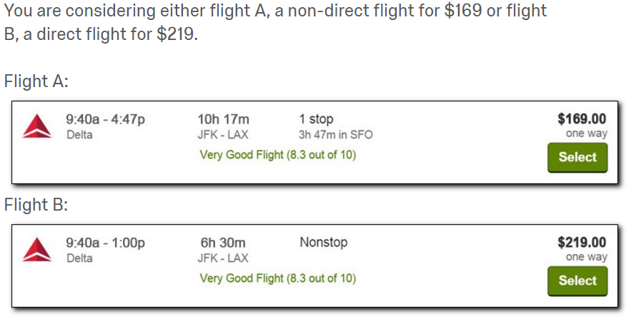

Differential Price Framing condition
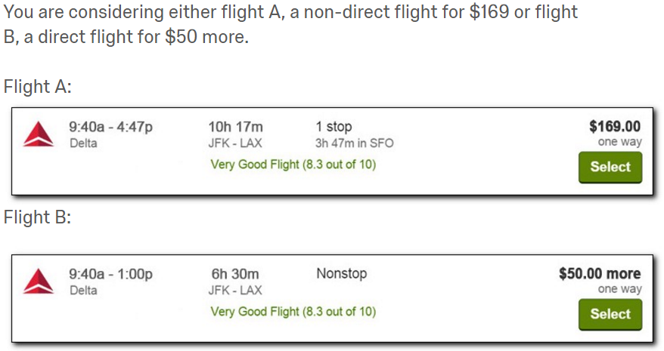

WEB APPENDIX G
EXPERIMENTAL STIMULI AND DETAILED RESULTS
Study 1: Stimuli
Inclusive Price Framing Condition
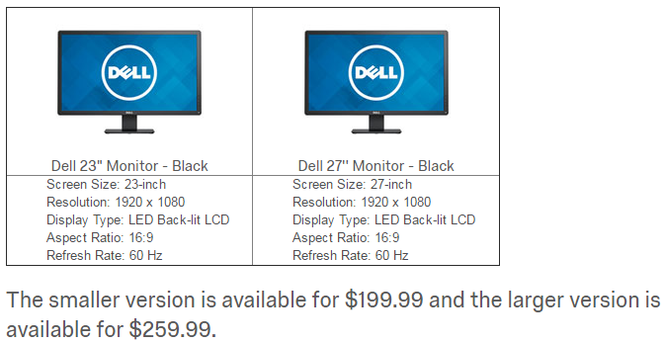

Differential Price Framing condition
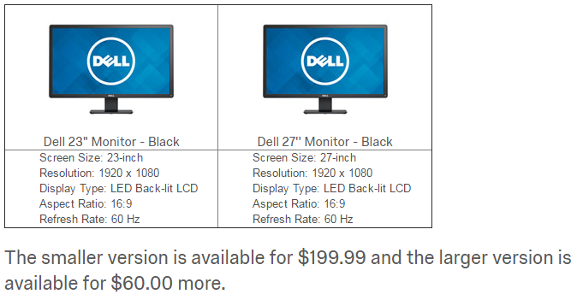

Differential Price Framing + total price condition (Study 1 only)
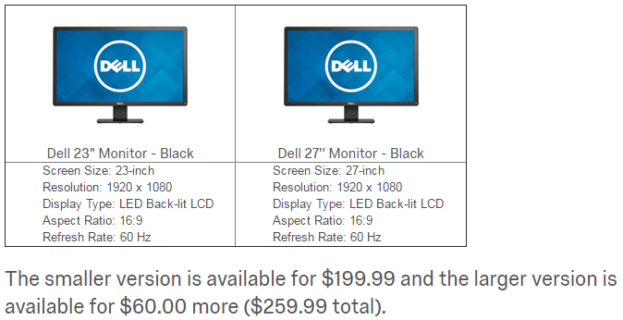
Study 2: Stimuli
- Inclusive Price Framing

Which will you choose to buy?
- $9.99/month New York Times web and app
- $16.99/month New York Times web, app, print, podcast, and crossword

- Differential Price Framing

Which will you choose to buy?
- $9.99/month New York Times web and app
- +$7.00/month New York Times web, app, print, podcast, and crossword

- Differential Quality Framing
Which will you choose to buy?
- $9.99/month New York Times web and app
- B. $16.99/month +print, podcast, and crossword

STUDY 2: EXPENSIVENESS, VALUE, AND EVALUABILITY RATINGS BY PRICE FRAMING CONDITION
Price Framing | Standard Option A | Premium Option B | Difference Score (B - A)
Perceived expensiveness (1-7; higher scores indicate more expensive)
IPF | 4.08 (1.42) | 5.31 (1.42) | 1.23 (1.41)
DQF | 3.92 (1.30) | 5.42 (1.06) | 1.51 (1.08)
DPF | 4.56 (1.30) | 4.75 (1.42) | 0.20 (1.40)
ANOVA | F(2,250) = 5.03,  p = .01, η_{p}² = .04 | F(2,250) = 10.63,  p < .01, η_{p}² = .05 | F(2,250) = 23.06,  p < .001, η_{p}² = .16
Perceived value of services (1-7; higher scores indicate more value)
IPF | 4.41 (1.46) | 4.52 (1.35) | .10 (1.53)
DQF | 4.42 (1.34) | 4.16 (1.37) | -.26 (1.42)
DPF | 4.54 (1.21) | 4.63 (1.54) | .09 (1.98)
ANOVA | F(2,250) = 0.24,  p = .79, η_{p}² = .00 | F(2,250) = 2.50,  p = .09, η_{p}² = .02 | F(2,250) = 1.29,  p = .28, η_{p}² = .01
Evaluability of price (1-7; higher scores indicate more difficult to evaluate)
IPF | 3.44 (1.28) | 3.70 (1.42) | 0.26 (1.62)
DQF | 3.07 (1.20) | 3.89 (1.41) | 0.81 (1.48)
DPF | 3.06 (1.32) | 3.69 (1.46) | 0.63 (1.57)
ANOVA | F(2,250) = 2.44,  p = .09, η_{p}² = .02 | F(2,250) = 0.48,  p = .62, η_{p}² = .00 | F(2,250) = 2.75,  p = .07, η_{p}² = .02
Evaluability of services (1-7; higher scores indicate more difficult to evaluate)
IPF | 3.18 (1.41) | 3.69 (1.46) | 0.51 (1.68)
DQF | 2.99 (1.29) | 3.74 (1.39) | 0.75 (1.41)
DPF | 3.12 (1.37) | 3.77 (1.50) | 0.64 (1.58)
ANOVA | F(2,250) = 0.47,  p = .63, η_{p}² = .00 | F(2,250) = 0.06,  p = .94, η_{p}² = .00 | F(2,250) = 0.54,  p = .58, η_{p}² = .00

The perceived value of Option A, Option B, and the difference score did not vary significantly by framing condition Bootstrapped mediations by perceived value difference scores were not significant, either for DQF (b = -.34, SE = .23, CI₉₅ [-.82, .09]) or DPF (b = -.02, SE = .27, CI₉₅ [-.56, .52]). Furthermore, ratings of the evaluability of the prices, services, and difference scores did not vary by framing condition and bootstrapped mediation of DPF or DQF by evaluability judgments (of price, quality, or difference scores) were all non-significant.
Study 3: Stimuli

Buyer Inclusive Price Framing (Differential Price Framing) condition:

Imagine you need a commuter bicycle and are looking to purchase a lightly-used second-hand one on Craigslist.
You have found an ad for two bicycles and have contacted the seller about your interest in purchasing one of them.

The two bicycles are both made by Schwinn, have the same frame and tires, but differ in that one has regular “generic” parts and one has premium “brand-name” parts.
- The first bicycle is a 3-speed bicycle with generic brand parts.
- The second bicycle is a 21-speed bicycle with Shimano parts.
The seller is offering to sell you the 3-speed bicycle for $150 or the 21-speed bicycle for $210 ($60 more).

Seller Inclusive Price Framing (Differential Price Framing) condition:

Imagine you own two lightly-used second-hand commuter bicycles and are looking to sell one on Craigslist.
You have posted an ad for your two bicycles and have been contacted by a buyer interested in purchasing one of them.

The two bicycles are both made by Schwinn, have the same frame and tires, but differ in that one has regular “generic” parts and one has premium “brand-name” parts.

- The first bicycle is a 3-speed bicycle with generic brand parts.
- The second bicycle is a 21-speed bicycle with Shimano parts.​
The buyer is offering to purchase from you the 3-speed bicycle for $150 or the 21-speed bicycle for $210 ($60 more).

Study 4: stimuli

Introduction prompt (constant across conditions)

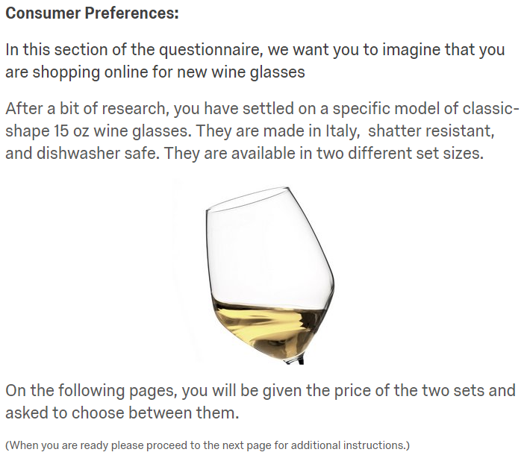

Study 4: stimuli (Cont’d)

Slow-is-Accurate condition

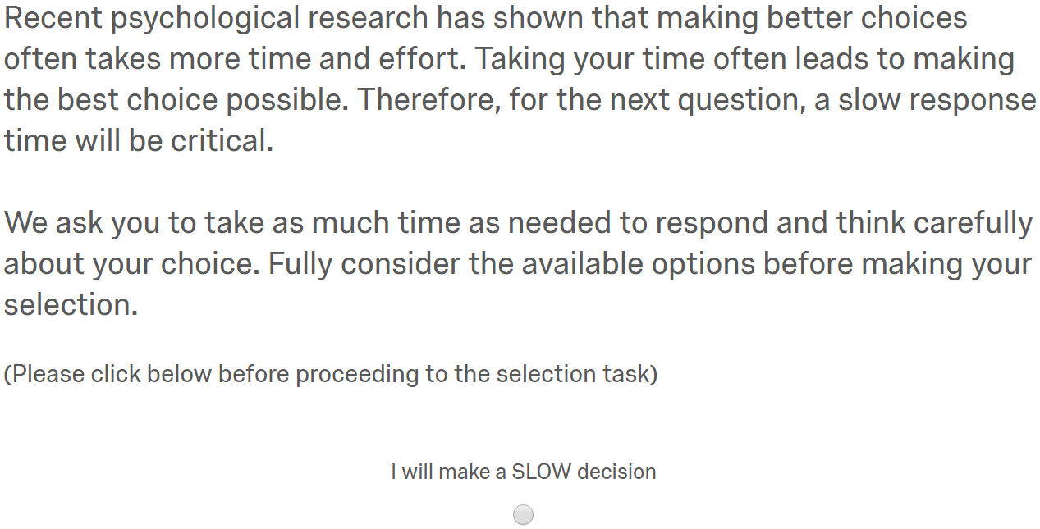

Fast-is-Accurate condition

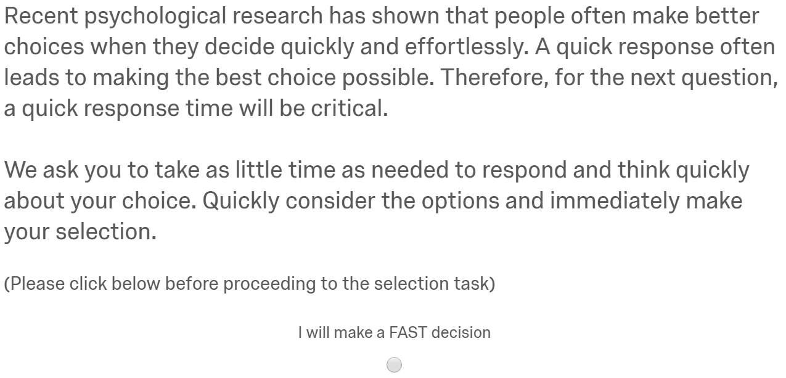

Study 4: stimuli (Cont’d)

Integrated Price Framing condition

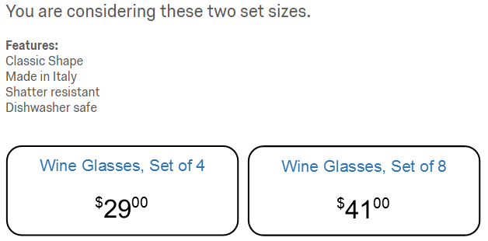

Differential Price Framing condition
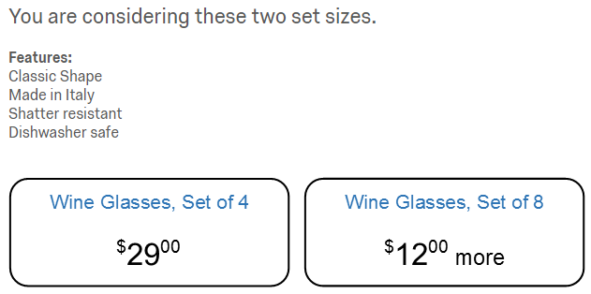

STUDY 4: DEPENDENT VARIABLES BY PRICE FRAMING
AND SPEED OF PROCESSING CONDITION
 | Speed of Processing
Price Framing | Control | Fast | Slow
Proportion selecting the premium option
IPF | 52% | 47% | 63%
DPF | 68% | 65% | 55%
Decision-making duration (in seconds)
IPF | 21.48 (49.27) | 7.62 (4.74) | 32.50 (61.22)
DPF | 19.98 (13.89) | 10.15 (8.73) | 35.98 (30.81)
Standard Option Expensiveness (4 wine glasses)
(1-5; higher scores mean more expensive)
IPF | 3.07 (1.13) | 3.26 (1.03) | 3.28 (1.05)
DPF | 3.46 (1.15) | 3.53 (1.06) | 3.40 (1.13)
Premium Option Expensiveness (8 wine glasses)
(1-5; higher scores mean more expensive)
IPF | 2.84 (1.17) | 3.05 (1.16) | 2.60 (1.14)
DPF | 2.53 (1.20) | 2.63 (1.27) | 2.61 (1.26)
Expensiveness Difference Score (Premium - Standard)
(smaller scores mean smaller perceived price differences between options)
IPF | -.19 (1.63) | -.20 (1.59) | -.68 (1.41)
DPF | -1.09 (1.42) | -.89 (1.60) | -.79 (1.59)
Retailer Trust
(1-7; higher scores mean more trustworthy)
IPF | 4.61 (1.04) | 4.52 (.83) | 4.58 (1.05)
DPF | 4.59 (1.05) | 4.58 (1.10) | 4.52 (.96)
Proportion successfully recalling the prices of each option (+/-$1)
IPF | 69% | 60% | 79%
DPF | 76% | 64% | 81%

