Worm Growth

Measure the worm below.

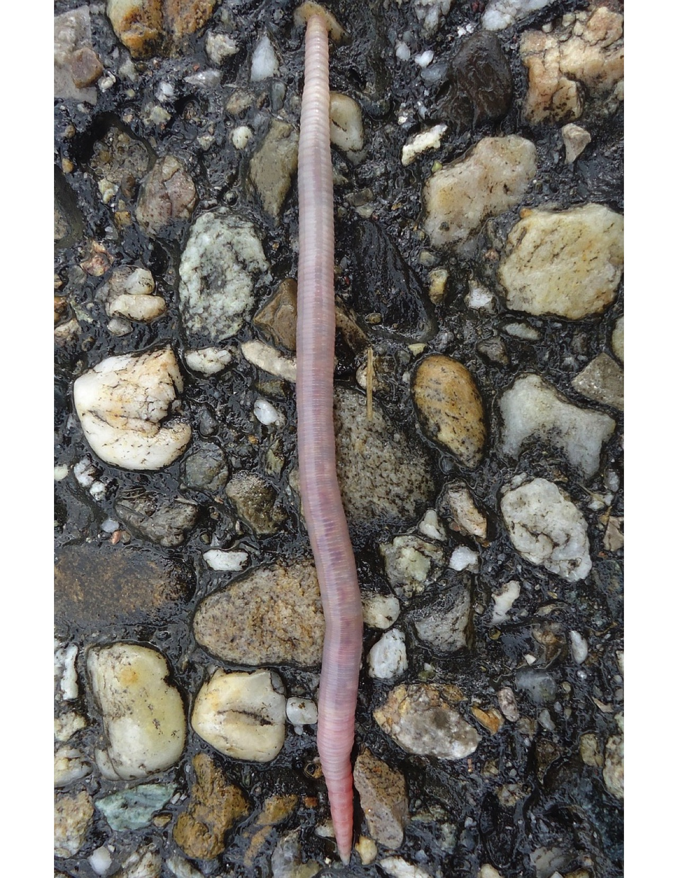
How long was the worm this week? ________cm.

Draw last week’s worm below (5 cm.)

