Common Core Math Standards
1.MD.A.2, 1.MD.C.4, 1.OA.A.1, Bridging Standard 1.MD.A
Lesson Objective(s)
- Students will measure and express the length of an object as a whole number of centimeter units.
- Students will organize, represent, and interpret data using a bar graph to answer questions about the data.
- Students will clarify the problem at hand and solve a take-from problem by counting down and writing a subtraction equation.
Vocabulary (new in bold)
Height, taller, shorter, estimate, unit, centimeter, length
Materials
If time allows, 6.3 Recording Sheet for each student and teacher; 1 centimeter ruler for each student and teacher

State the Learning Target
Explain today’s learning target:
I can solve a take-from problem about how much an earthworm grew in a week using a bar graph and an equation.
Warm-up: Review Vocabulary (5 minutes)
.
Use the Teacher and Student iPads. Select Review Vocabulary.

Touch the word that means (say the definition).
Wait for students to respond.

Yes, (word) means (definition). What word, everyone? (Word.)
☒ If a student selects the wrong word, even if they self-correct, point to the correct word on your iPad and say the correct word and the definition to the group. For example, touch data and say, Data means information we use to answer questions. Then repeat the direction, Everyone, touch the word that means information we use to answer questions, and continue. After all the words have been reviewed, select “Retest” to retest missed words.

Statistical Investigation: (20 minutes)
Overview: Given a picture of an earthworm and information about its growth, students will measure and use that information to determine how long it was last week.
Select Word Problem. Point to the earthworms.

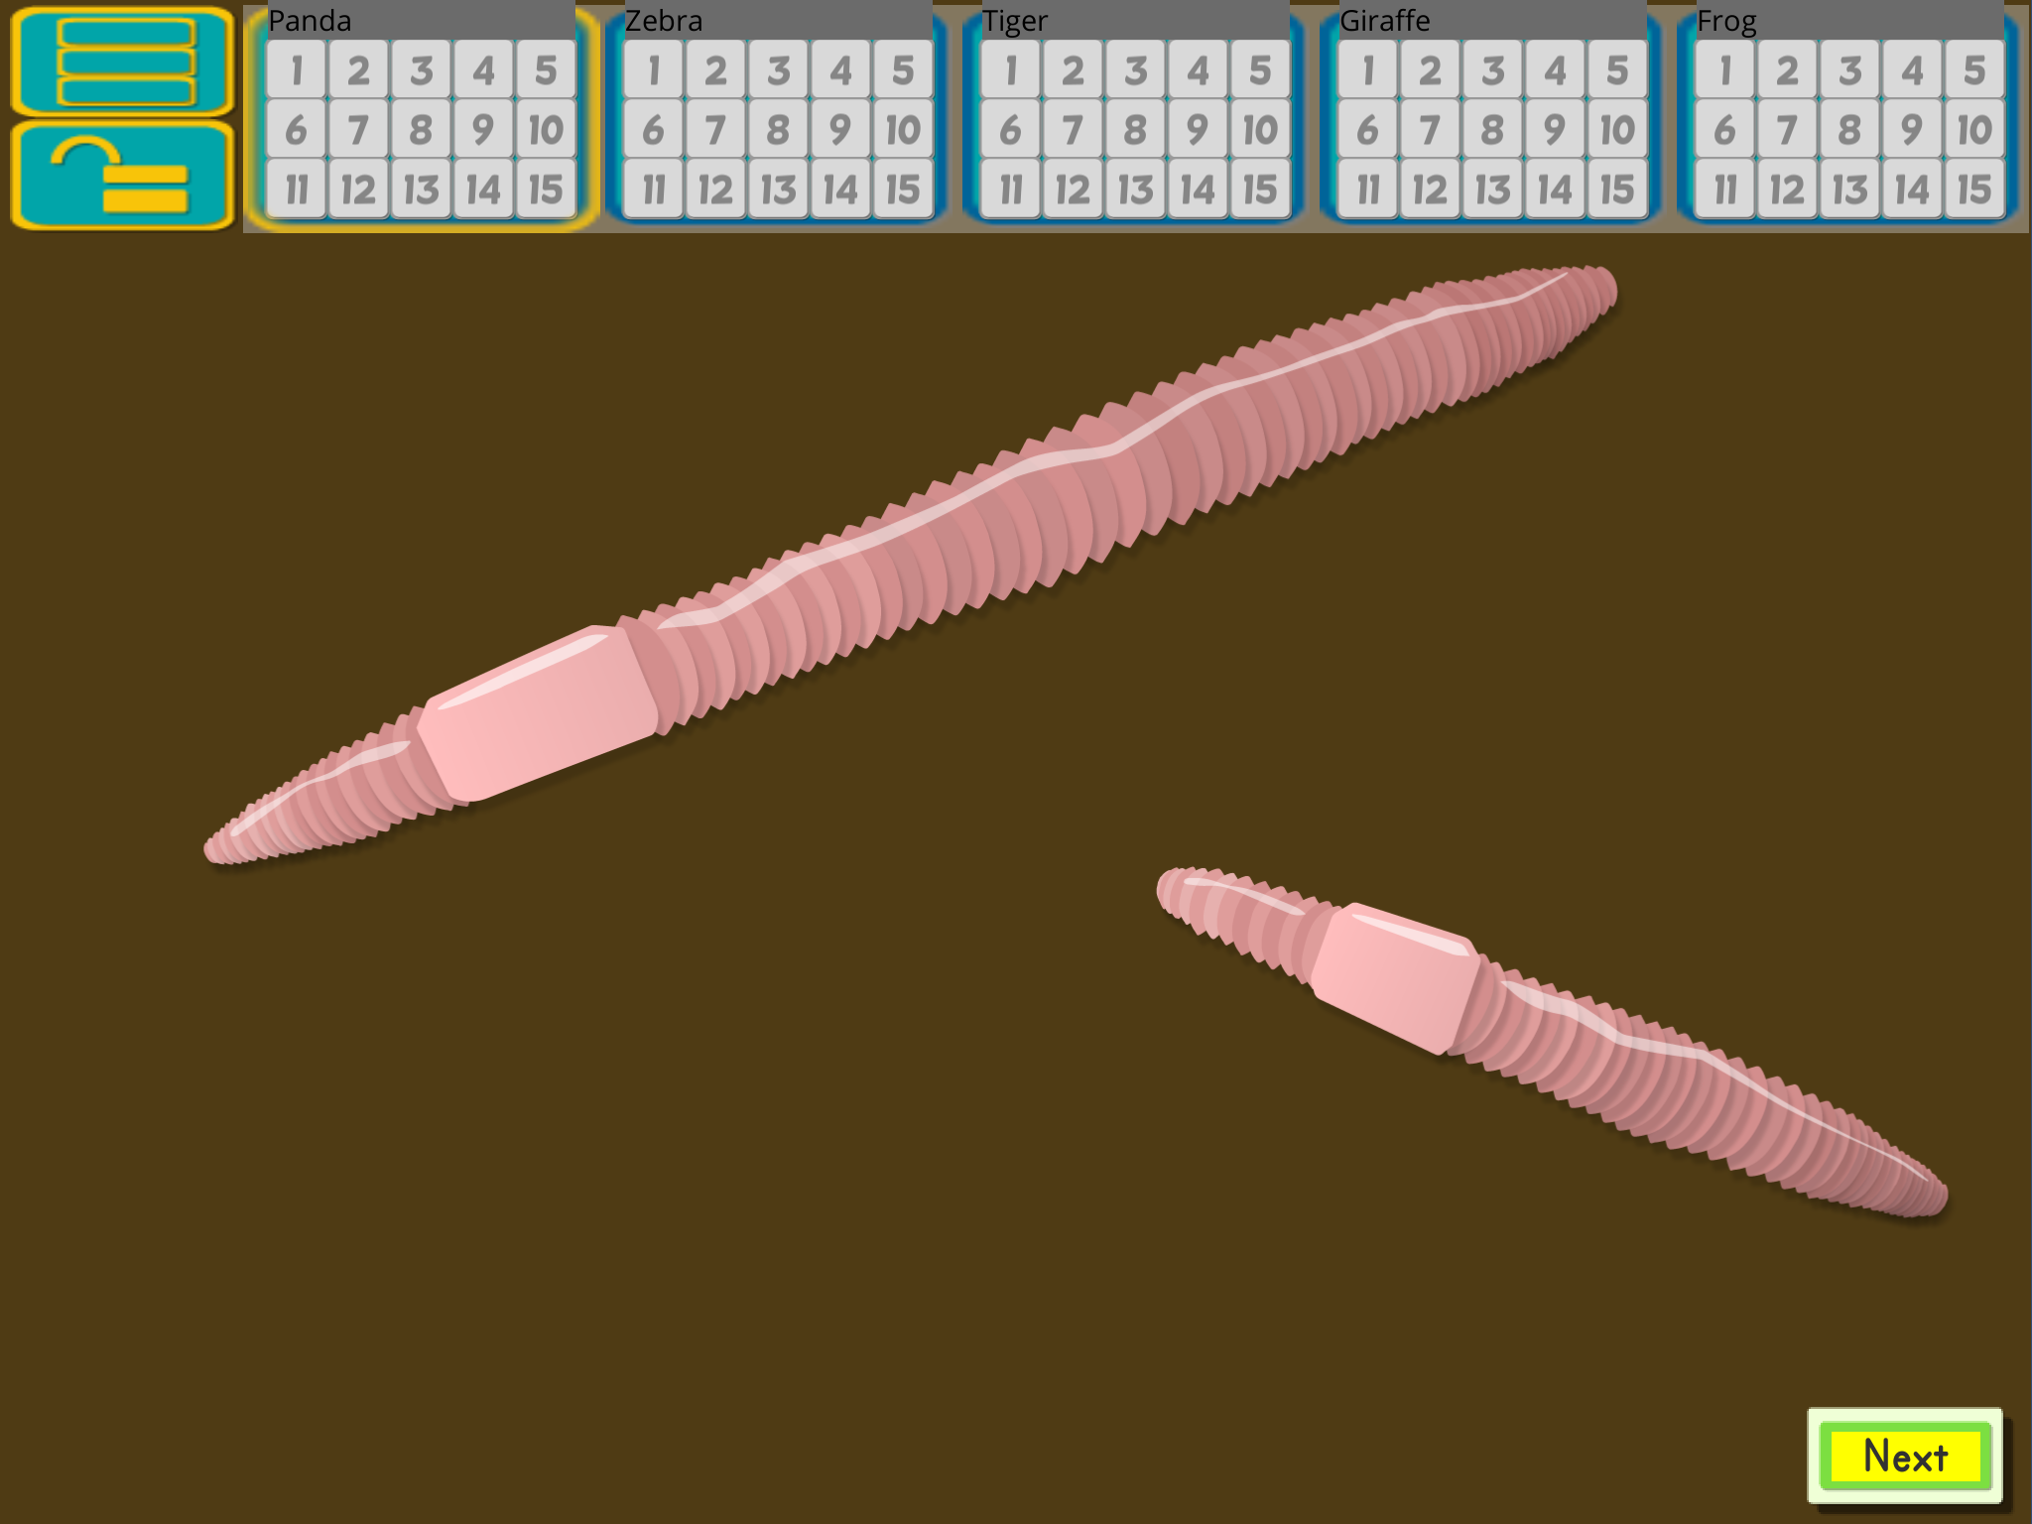
These are earthworms. Show me a thumb up if you have ever seen an earthworm.
Students respond.
Earthworms live underground, and there are around 6,000 different types of them around the world! When we breathe, we breathe with our lungs. Earthworms, on the other hand, breathe through their skin.
Baby earthworms hatch from eggs, and the ones that we find in the dirt can grow up to 35 centimeters long. Show me with your hands what you think 35 centimeters long looks like.
Allow students to show you their estimate, and then confirm the length.

Does anyone know anything else about earthworms?

Allow students to contribute any other things that they know.
Today we are going to look at a picture of a worm, and we will examine how it grew in one week.
Point to the worms as you explain the following.
This is how long the worm is this week. Since last week, it has grown 4 centimeters longer. I wonder how long the worm was last week.

Display statistical investigation step #1
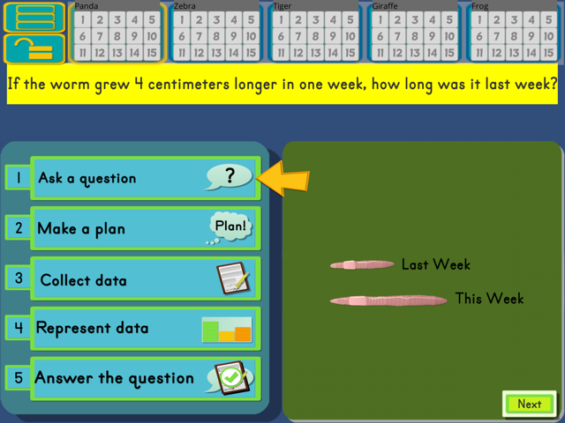
What is the first step in a statistical investigation, everyone?
Ask a question.
We have a picture of what the worm looks like this week. We know that the worm grew 4 centimeters since last week to reach this length, so our question is (refer to the question in the yellow banner): If the worm grew 4 centimeters longer in one week, how long was it last week?

Display statistical investigation step #2
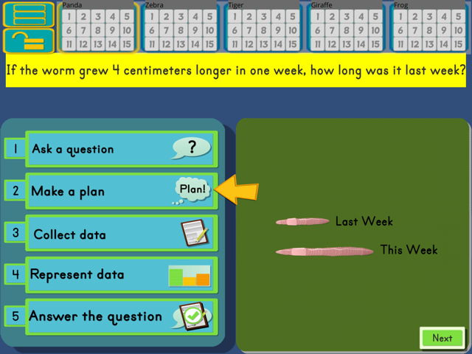
What is the second step in a statistical investigation, everyone?
Make a plan.
This question is different than the question we asked about the sunflower and the puppy. In those 2 investigations, we measured how long something used to be to figure out how long it is now. Our question is different today. Today we are measuring how long something is this week to figure out how long it was last week.
We know what our worm looks like this week (refer to the picture). And we know that it grew 4 centimeters to reach this length. We need to use this information to figure out how long it was last week.
Now think about what our plan should be to answer this question. Show me a thumb up when you have an idea.
Provide appropriate think time, and then call on a few students to share ideas. This may be a difficult concept, so provide guidance as needed and lead the discussion to the following plan:
- Measure the picture of the worm; record current length.
- Figure out what 4 centimeters shorter than the current length is to find how long the worm was last week.
Call on students to share their plan and have them explain why it is a good plan.

Display statistical investigation step #3
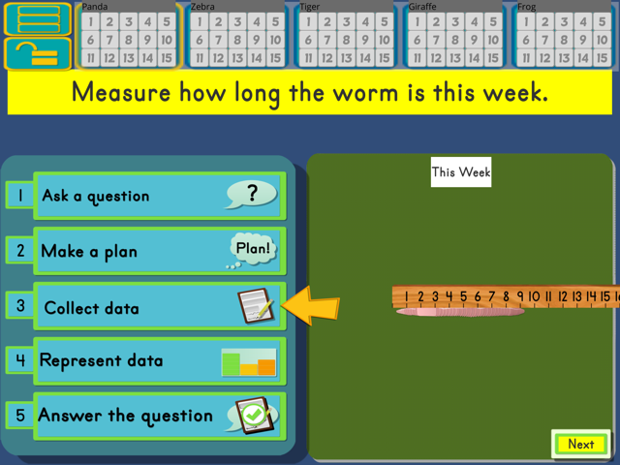
What is the third step in a statistical investigation, everyone?
Collect data.
We will collect data by measuring how long the worm is this week. We’ll pretend this ruler shows centimeters. Measure how long the worm is this week by moving your ruler to the worm. Thumb up when you know how many centimeters, or units long it is.
Monitor and assist as needed.

How long is the worm this week, everyone?
9 cm. long.

Display statistical investigation step #4

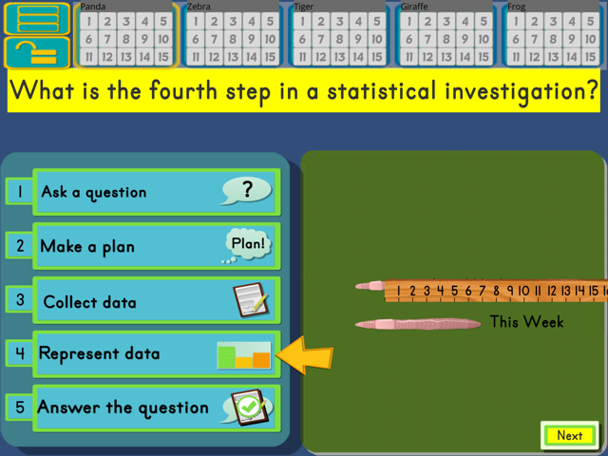
What is the fourth step in a statistical investigation, everyone?

Represent the data.

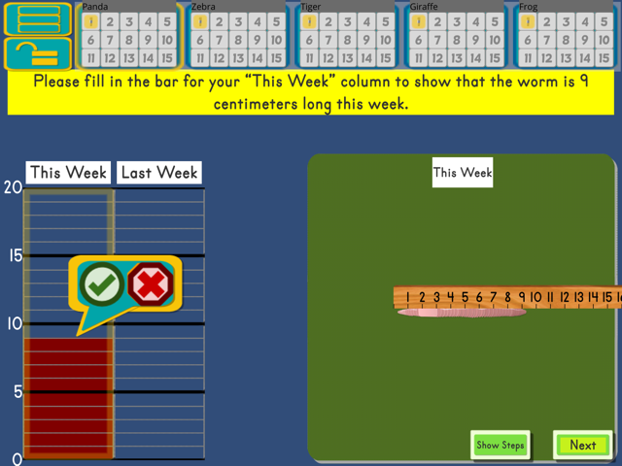
We can represent the worm’s length on a bar graph, like we did with the sunflower and the puppy. Please fill in the bar for your “This Week” column to show that the worm is 9 centimeters long this week.
Monitor and provide feedback as needed.
Now that we have the worm’s length for this week represented on our graph, we can use this to answer our question.

Display statistical investigation step #5
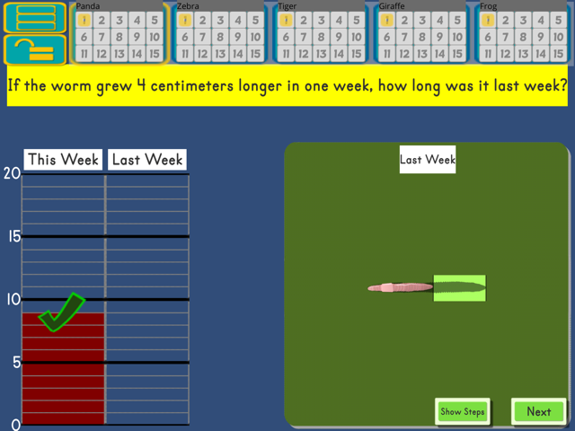

Have students point to the yellow arrow on step 5.

What is the fifth step in a statistical investigation, everyone?

Answer the question.

Let’s read our question again together. If the worm grew 4 centimeters longer in one week, how long was it last week?
This type of problem is a take-from problem. A take-from problem has a starting total, a take-from amount and the amount left. What type of problem is this?

Take-from.
Yes, a take-from problem because it has a starting total, a take-from amount and the amount left.
We are going to take 4 centimeters from this week’s worm to solve for how long the worm was last week.
Let’s finish filling in our graph to answer the question. How many centimeters did the worm grow since last week?
4 centimeters.
Yes, the worm grew 4 centimeters since last week. Do you think this means that we should fill in 4 more or fewer spaces on the graph to represent its length last week?
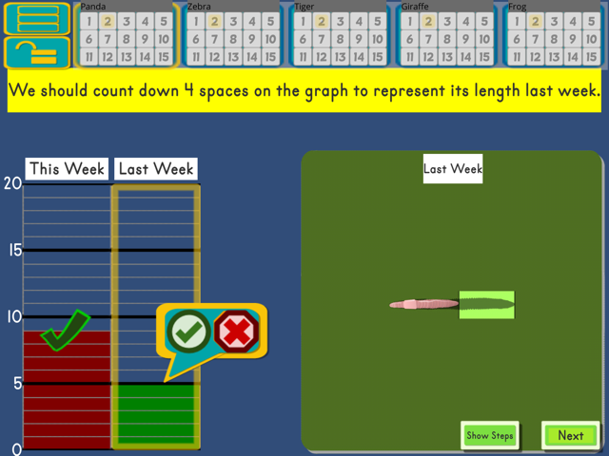
Provide think time and call on a few students to share their answer and explain why they think that. After several students share answers, confirm that students need to fill in fewer spaces.

Put your finger at the top of the “This Week” column.
Ensure that all students do so.

Should we count up or count down? (Down.)
Right. We should count down 4 spaces on the graph to represent its length last week. Move your finger across and count down 4 spaces to fill in the column for “Last Week”.
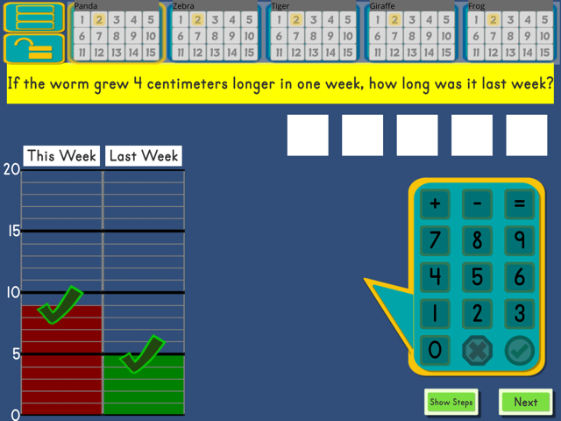
Provide support as needed so that all students do so correctly.

Everyone, how long was the worm last week?
5 centimeters long.
So our question was: If the worm grew 4 cm longer in one week, how long was it last week? You used the graph to find that the worm was 5 centimeters long last week. We can also set up a subtraction equation to answer our question.
Let’s write the equation together. In subtraction equations, we always start with the biggest number. What number we should we start our subtraction equation with, everyone? (9)

Enter that on your keypad.

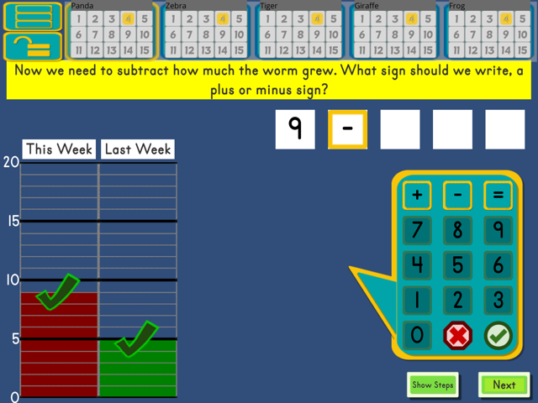
Ensure all students do so.
Now we need to subtract how much the worm grew. What sign should we write, a plus or minus sign?
A minus sign.

Yes, enter a minus sign on your keypad.

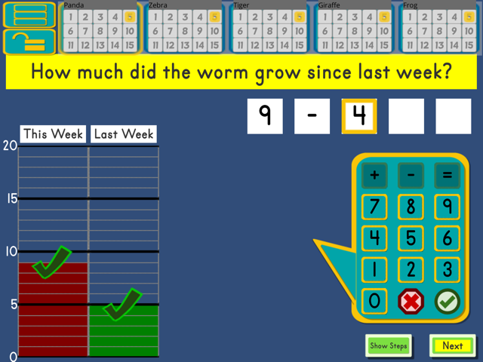
Now we’ll subtract how much the worm grew since last week. How much did the worm grow since last week, everyone?
4 centimeters.

Yes, enter that on your keypad.

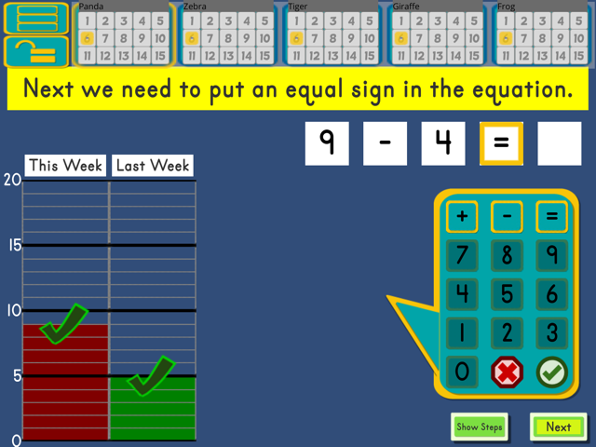
Next we need to put an equal sign in the equation. Please do that now.

Ensure all students do so.

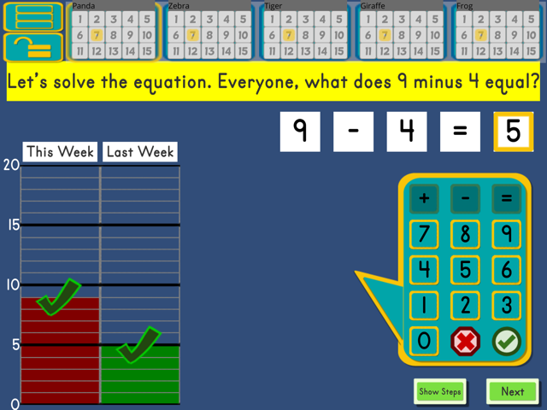
Let’s solve the equation. Everyone, what does 9 minus 4 equal? When you know, enter the answer on your keypad.
Monitor and assist as needed.

Everyone, what does 9 minus 4 equal?
5.

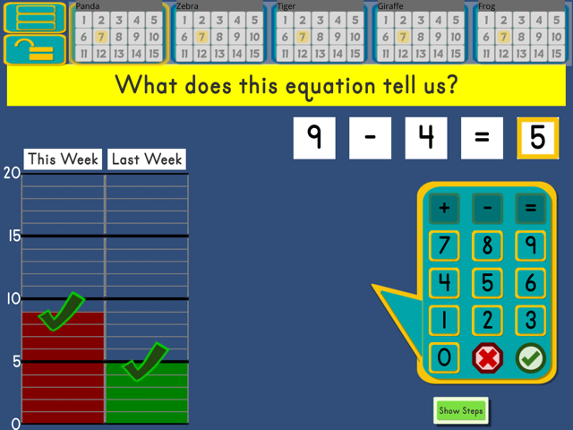
Yes, 9 – 4 = 5. What does this equation tell us? Show me a thumb up when you have an idea.
Provide think time, and then have partners tell one another. Once partners are done sharing, call on a student to share their answer with the group.
Example: The worm was 5 centimeters long last week.

Everyone, did we answer our question?
(Have students reread the question.)

So our plan worked. Why did the plan work? Thumb up when you have an idea.
Have partners explain their thinking to one another.
Wrap-up (5 minute)
Everyone, what type of math problem did we answer today?

Take-from.

Show me a thumb up when you can tell me what a take-from problem is.
Wait for all students to show a thumb up, and then call one 1 or 2 to share the following:
A take-from problem has a starting total, a take-from amount and the amount left.
If time allows, pass out centimeter rulers and 6.3 Recording Sheets.
Have students measure the worm and record the length in the space provided.
Have students draw a horizontal line to represent the worm’s length this month.
- If time allows, let students draw a worm within the endpoints.
Provide guidance as needed for students to do this.

