THE SECRET INGREDIENT IS ME

CUSTOMIZATION PROMPTS SELF-IMAGE-CONSISTENT PRODUCT PERCEPTIONS

WEB APPENDIX

Contents

WEB APPENDIX A – TABLE 1: OVERVIEW OF ALL INTERVIEWS 2

WEB APPENDIX B – STUDY 1:  T-SHIRT STIMULI 12

WEB APPENDIX C – STUDY 1: PRE-TEST – T-SHIRT 14

WEB APPENDIX D – STUDY 2A & B: PRE-TEST – GREEK YOGURT & MUESLI 15

WEB APPENDIX E – STUDY 2A: PHOTO OF THE EXPERIMENTAL SETUP 16

WEB APPENDIX F – STUDY 2A: FOLLOW-UP ANALYSES 17

WEB APPENDIX G – STUDY 2B: MUESLI SELECTION 19

WEB APPENDIX H – STUDY 2B: PRE-TEST AND INGREDIENTS 20

WEB APPENDIX I – STUDY 2B: ANALYSIS OF SOCIAL MEDIA BEHAVIOR 21

WEB APPENDIX J – STUDY 2B: RECOMMENDATION LIKELIHOOD TO HEALTH-CONSCIOUS SEGMENTS 22

WEB APPENDIX K – STUDY 3: PRE-TEST FOR ACTIVITIES 23

WEB APPENDIX L – THRILL AND ADVENTURE SEEKING SCALE (SSS-TAS, ZUCKERMAN 1971) 24

WEB APPENDIX M – STUDY 3: RECOMMENDATION LIKELIHOOD TO ADVENTUROUS TARGET SEGMENT 25

WEB APPENDIX N – STUDY 4: PRE-TEST AND SELECTED INGREDIENTS 26

WEB APPENDIX O – STUDY 4: RECOMMENDATION LIKELIHOOD 27

WEB APPENDIX P – STUDY 5: ORGANIC LOGO STIMULI 28

WEB APPENDIX Q – STUDY 5: ANALYSIS OF HEALTHINESS PERCEPTIONS AND RECOMMENDATION TO TARGET GROUPS 29

WEB APPENDIX R – INTERNAL META-ANALYSIS 31

WEB APPENDIX S - BOLSTER INDIVIDUALS’ SELF-IMAGE AS A HEALTHY EATER; STUDY IN GD 33

WEB APPENDIX T – GIFT GIVING: SELF-IMAGE-CONSISTENT PRODUCT PERCEPTIONS IN A SELF-PURCHASING VERSUS GIFT-GIVING CONTEXT 35

WEB APPENDIX U – LIKELIHOOD TO CUSTOMIZE; STUDY IN GD 36

## WEB APPENDIX A – TABLE 1: OVERVIEW OF ALL INTERVIEWS

|  |  |  |  |  |  |  |  |
| --- | --- | --- | --- | --- | --- | --- | --- |
|  | **Company** | **Function** | **Years of experience** | **In which way does your company engage the customer?** | **Advantages of customer engagement** | **Disadvantages of customer engagement** | **The impact of customer engagement on product perception** |
| **1** | **Chocolate Manufacturer** | Online Marketing Manager | 1.5 years; 3 years in total | Customers can create their own chocolate step by step: (1) they first choose a base, (2) then refine the base, (3) add toppings, and (4) choose a package design | **Data**: we know what chocolate creations customers like and can offer them as off-the-shelf alternatives.  **Satisfaction**:  customers are more satisfied when they create their very own chocolate choosing out of a wide variety of options. | **Reaching a good balance** between customization and choosing off-the-shelf alternatives; we want to increase the segment of people choosing readily available options.  **Delivery time**: delivering customized chocolates takes longer. | **More positive perceptions** because the product fits customers’ preferences and “they have made it themselves.” |
| **2** | **Developer and Manufacturer of Protein Bars** | CEO, Protein bar Innovator, Author of a book on customization | + 12 years | Customers design their own protein bars choosing out of a list of ingredients; we provide them with information on how they can customize the bars. The reason for this approach is that many customers want specific ingredients in their diet. | **Feeling proud**: people feel proud of their bar, they take ownership for it and report **higher satisfaction**.  **Word of mouth**: customers also talk more about customized products which means more buzz, more word of mouth, bragging about the product, and more referrals for the company. | **Bad customization outcome**: if customers create a bad bar, they take complete ownership of making something bad and often don’t communicate the bad outcome to the company. As a consequence, they might not buy again.  **Higher cost.** | **Positive** because of feeling proud.  It also changes **specific product attributes** such as healthiness (healthier!) and tastiness. |
| **3** | **Multinational Food and Beverage Company** | Brand Manager Chocolate | + 5 years; 10 years in total | We are launching a chocolate atelier in which customers can make their own chocolate and completely customize the chocolate (e.g., flavor and shape). | **Positive impact** for the brand (and indirectly for the company). We want to improve the brand image, trigger emotions (which is crucial for chocolate) and create engagement to ultimately increase quality perceptions and willingness to pay. | **Budget**:customization should be a long-term strategy (rolled out to different cities etc.) to be effective but this is costly.  Overall, **no negative impact on perceptions but well-trained staff** in chocolate atelier is crucial. The staff has to be well trained and should know how to talk about the chocolate. If that can be guaranteed, there should not be any disadvantages. | We are a mass producing mainstream brand and the chocolate atelier is just one pillar of what we do. We hope the atelier will positively impact our brand image through buzz and PR. But for now, it only concerns a **small proportion** of our customers.  For each individual person that customizes we think that we can increase **quality perceptions** because customers are exposed to how our chocolate is produced (for instance without palm oil). |
| **4** | **Multinational Toy production company** | Marketing and Sales Manager | 6 years; 20 years in total | We employ a community, an open innovation community that started in 2008 as an opportunity to make fans’ ideas reality. Fans (age +13) can submit their own ideas for new products, and vote for other members’ ideas. Members collect votes for their ideas online, and ideas that receive 10,000 votes have a chance of being selected to become part of the product portfolio. | **Creativity and imagination** of the community; through the ideas platform, fans have a unique opportunity to influence and co-create future products.  What started as a playful experiment has evolved into a global phenomenon of crowdsourcing user-driven innovation. | None, but we have to be clear on what criteria need to be met before a set will get a chance to become part of the product portfolio. | The developed sets have **a positive effect on the brand and the organization**. The ability for fans to influence our product portfolio with their ideas is something that we are very proud of and works very well as can be seen by +1 million members, +26.000 ideas submitted, +166 ideas with 10.000 supporters, and 23 ideas launched. |
| **5** | **Meal Preparation and Delivery Company** | Analytics & Strategy Manager in Marketing | 6 months; 4 years in total | We create healthy meals in kit, portion, bag them, and send them to customers. Customers can customize meals in the sense that each week, they can choose options in meals (meat or no meat) and add ingredients. They cannot customize ingredients within a recipe, but they can add ingredients (add, not change). | **Better fit with preferences**; People have very different preferences when it comes to food. We have a wide variety of options to match customers taste and the possibility to customize, e.g., more or less meat, more exotic, more conventional, etc. | **Logistics/distribution/stock management**:  We can predict the number of customers but not the recipes that they will choose; purchasing is a big problem and some meals might get out of stock. | **More positive**; we get less complaints than usual restaurants. Customers look to themselves because they are the creator and that makes the view of the product more positive. Maybe some customers would rather like to rely on our expertise but in general the perception should be more positive. |
| **6** | **Multinational Manufacturer of Footwear** | Digital Marketing Specialist | 2 years; 3.5 years in total | We have a specific business unit which allows consumers to personalize their shoes. They can pick colors they like, add their name on the shoe and/or logo/country flags. | **Consumer excitement** which increases brand loyalty.  **Insights in consumer** trends regarding shoe models/color trends. | No major drawbacks for company but it is important to **decrease likelihood of returned products** (returned product cannot be sold for profit). Drawback for consumers is **delivery time**; consumer might expect product to be delivered within a few days | **Positive impact on perception.** Crucial requirement: product needs to meet the expectations; problematic if colors turn out differently and expectations aren’t met. |
| **7** | **Multinational juvenile products company** | Global Consumer Insights Research Manager | 2.5 years; 9 years in total | *(1) Idea generation:* We engage the customer in every step of new product development. We are also engaged in crowdsourcing (for instance, for naming products) and have consumer days, where we invite consumers to come over and learn about our brand. We had competitions where consumers can suggest ideas.  *(2) Customization of off-the-shelve alternatives*; we allow customers to customize accessories and pick certain features (e.g., wheels/seats/colour). | *(1) Idea generation:*  A product should **add value to a consumer**; you never know whether it will unless you check with them. Our products are global products and global differences matter; thus, getting the voice of the consumer allows us to find out what is needed in different markets.  *(2) Customization of ready product*: Greater **perceived ownership**. Product feels more like theirs. | *(1) Idea generation:*  **Costly and timely:** very expensive (especially if you do it on a global scale);  *(2) Customization:*  **Sometimes not really necessary**: we might be afraid that people create crazy combinations but in fact they go for mainstream products that we could have produced ourselves at lower cost. It gives people the perception of choice, but they tend not to use it and rely on the experts anyway.  **Complex logistics:** Warehouse requires us to have so many SKUS | *(2) Customization:* We are very cautious of the type of configurations that customers can have. We made sure that the color options are limited to assure that the end product still looks good. Engraving a name, mixing colors could result in less premium perception. |
| **8** | **Multinational Car Manufacturer** | Manager Product and Proposition Marketing | 1.5 years; 6 years in total | *(1) Idea generation:*  We invite people to speak about their needs and preferences. For instance, we learned that our target group is very interested in cinema and, thus, cooperated with a well-known cinema and offered a limited edition (private lease offer).  *(2) Customization:* We create standard products and then offer a wide variety of features. | *(1) Idea generation:*  Involving the customer has the big advantage that we have some **certainty** that the car will be sold; greater likelihood for success.  *(2) Customization*  **Competitive advantage** as main competitor doesn’t offer extended customization. We know that people want their own, unique car. Giving customers “their own/unique” car increases purchase likelihood. | *(1) Idea generation:*  **Time consuming**: if we only listen to five people in our team, it goes much faster. Engaging customers takes time/money. If we want to act on developments (trends) in the market, we have to be fast and sometimes there is not enough time to co-create/generate ideas.  **Sensitive information** might need to be revealed.  *(2) Customization:*  Accessories to create your own car are quite **expensive** because they have to be fitted after production at the dealership. Biggest disadvantage is that it might exceed people’s budget. If they see that the accessories are too expensive, they might defer the purchase of the car. | *(1) Idea generation:*  I only see advantages.  *(2) Customized vs. off-the-shelve alternative:* I don’t really think that there is any impact on how the car is perceived. I only see that the car fits better to their personality. |
| **9** | **Multinational Personal Care Company** | Marketing Manager | 8 months, +3 years in total | We engage in “social listening” (= scan Facebook, twitter etc., different reviews on websites) and use consumer feedback to develop and improve products. We do qualitative and quantitative product testing.  We invite “Brand aficionados”, and, involve them in anything as simple as testing concept or as complex as developing the concept from scratch.  Collaborations and co-creations with influencers. | **Delight and satisfy the needs of consumers** | **Lack of knowledge of needs/preferences**: when you ask consumers what they want/need, they might not know exactly. You need to dig deep into consumer sentiment to understand their needs. | It **depends on the industry** and the consumers involved in the product creation process; the more representative they are, the higher the chance that the end product will make consumers happy.  Difficult to predict what people will feel about it but if the product is **personalized consumers will be happier** because it is especially for them. |
| **10** | **Multinational Electronics company** | Senior Manager, Head of Customer Operations | + 5 years; + 20 years in total | We offer a configuration system that allows customers to customize products (i.e., tablets) for their purposes. We sell tablets to companies and, customization is very important here because it allows businesses to customize the tablet to their purposes. | Customization has become “**an industry standard**.” If you don’t offer it, you are not competitive. | **Distribution channels limit customization opportunities** especially with respect to the hardware (software customization is less of an issue).  Distributors as middle men have little incentive to let consumers customize because they want to minimize SKUs. | **Positive impact** because it allows customers to customize a product according to their own tastes. If a product corresponds with customers’ taste, they like it better. |
| **11** | **Car Sharing Service** | Senior Manager Marketing | 4 years; 13 years in total | We apply co-creation in the context of market research; we try to get valuable insights from customers and then apply it in the creation process. We organized a hackathon (event in which computer programmers collaborate intensively on developing a software product.) | **Customer insights**: if we engage customers in the product development process, we know best what they are looking for. | **Privacy concerns**: biggest challenge is to figure out how much customers can be involved and share with us without facing privacy/legality issues. | **More positive perceptions**: if customers were involved in the co-creation and company positions product accordingly, it is valuable because customers “feel that they are listened to/have a say.”  If the quality of the product doesn’t meet the standard, the impact could be negative. |
| 12 | **Company for Microbiome Research** | Product Manager | 10 months; 15 years in total | We developed a new product in biotech space and the product is testing services developed by microbiome. We engage customers through involving them in market research (surveys and qualitative interviews). We ask them on their potential use of the product, paying points, motivations, and problems that the product should solve. | **Product validation:** involving customers in the product development process shows us whether there is a need for a product and whether our value proposition aligns with customers’ needs. This helps develop features that correspond to customers’ needs. | **Expensive and time consuming**: it requires a representative and large enough sample to assure validity.  **Interpretation of findings** can be complicated | **More positive** because the product better matches customers’ needs. |
| **13** | **Multinational Manufacturer of Consumer Goods** | R&D Section Head Strategic Innovation | 19 years | Long tradition in engaging customers in the product development process in a variety of ways from deep qualitative interviews to active co-creation workshops and studies that allow qualitative assessment. The idea is to get early feedback and then gradually refine the product into a clear proposition. | **Validation of your persona** for who the innovation is for; biggest point is making sure that you talk to the right person.  **Creativity**: lots of insights  **Fast iterations**: you can iterate quite fast and can stop ideas early if consumers are not looking for the product create. | **Challenge:** consumers will only guide you to improve what they know. Approach is not applicable if you want to change direction (e.g., create new needs).  You can **get too niche**. If you have very dominant personalities, they can lead you in a certain direction that is not representative for the average consumer.  You have to take **cross-cultural differences** into account. | That depends. It is important to take into account what are the product requirements that make a difference for the customers. If you are able to define them (validate them well) during the process, then customization can be very insightful. |
| **14** | **Multinational Manufacturer of Consumer Goods** | Associate Director R&D | 10 years; 22 years in total | We engage customers in a variety of different ways and use a variety of tools to really search what consumers want (often they don’t know themselves). We come up with a hypothesis of what consumers’ real problem is and then a small team tries to validate this hypothesis. We create prototypes and test them with consumers to see whether we go in the right direction. We invite consumers to come to our location and spend time with us in workshops where we interview them, show a prototype and ask them questions. | **Greater fit with consumer preferences**  It is **faster and cheaper** if we engage the customer in every step of the product development because we can make adjustments immediately if necessary. | **Confidentiality**  Wrong **customer segment**: it is problematic if you engage the wrong consumers (i.e., they are not representative of target segment). | **Totally positive** |
| **15** | **Multinational Technology Company** | Director of Innovation | 2 years; 13 in total | On the B2B side, partners have a latitude to customize the equipment that they order.  On the B2C side, we are probably lagging behind in terms of letting end consumers customize their products. | **Create a sense of ownership**  **Gather insights** that replace/add to traditional marketing research  **Create word of mouth**  **Improve image of a brand** | **Complexity**: customers don’t take all necessary factors (e.g., timeliness, ease of use, cost, profit, vision of a company) into account. | **Positive** but it depends on the **type of product**; if it requires special knowledge (e.g., banking), customer engagement is less helpful as customers lack the expertise. |
| **16** | **Company selling Outdoor and Recreation gear/Clothing** | Digital Product Manager | 6 months; 15 years in total | We are not engaging in product customization; previous e-commerce company offered “made-to-order” building material. Reasons to do so are (1) styles that customers demand are not available and (2) allow exclusivity. | It will create **engagement**; engagement prompts **product and brand loyalty and increases customer lifetime value.**  Customization shows **upcoming trend** and, thus, fulfils market research purposes; the company can learn what off-the-shelve alternatives to offer. | **Costs**: Assembly lines are cost-efficient.  **Greater uncertainty** | **More positive perceptions**: customers can show their identity through a product. The only negative feeling that could emerge is “**regret**” (I could have designed it differently) but this is eventually positive because customers will design another product; it increases customer lifetime value/retention. |

## WEB APPENDIX B – STUDY 1:  T-SHIRT STIMULI

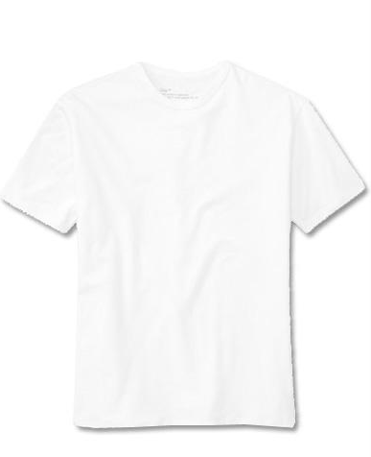

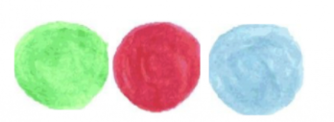

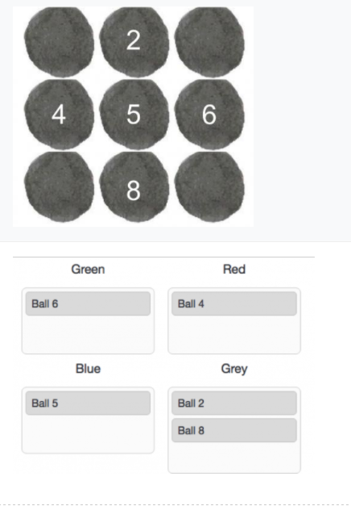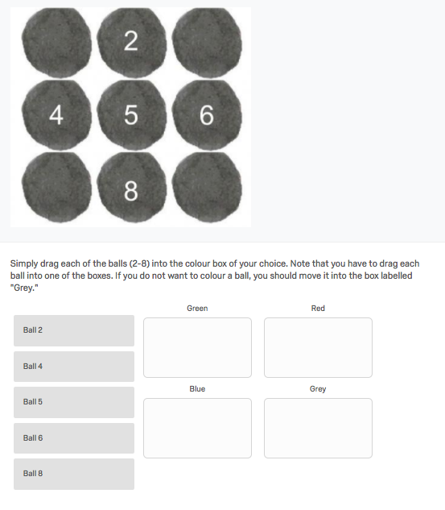

**Noncustomizer 1**

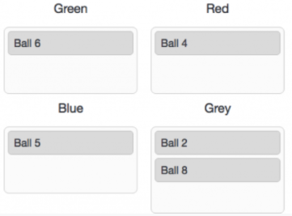

**Noncustomizer 2**

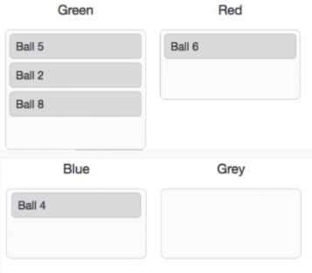

**Noncustomizer 3**

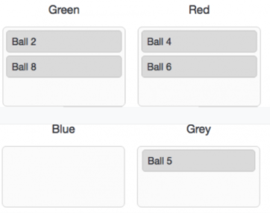

## WEB APPENDIX C – STUDY 1: PRE-TEST – T-SHIRT

N = 101 (38% female, mean age = 35.8, SD = 12.24)

Perceived fashionability = 3.76, SD = 2.50 (scale from 0 = not fashionable at all to 10 = very fashionable)

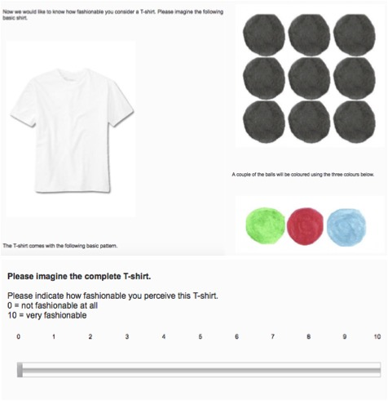

## WEB APPENDIX D – STUDY 2A & B: PRE-TEST – GREEK YOGURT & MUESLI

N = 100 (46% female, mean age = 34.5, SD = 12.56)

**Muesli**

Perceived healthiness = 7.36, SD = 1.77 (scale from 0 = not healthy at all to 10 = very healthy)

**Greek Yogurt**

Perceived healthiness = 7.2, SD = 1.67 (scale from 0 = not healthy at all to 10 = very healthy)

## WEB APPENDIX E – STUDY 2A: PHOTO OF THE EXPERIMENTAL SETUP

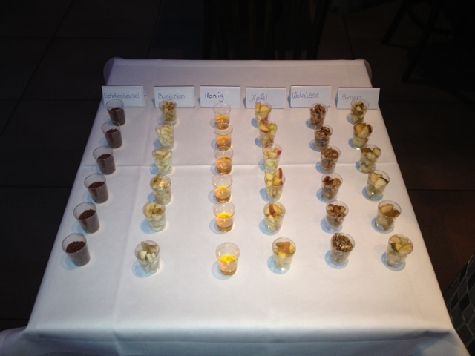

## WEB APPENDIX F – STUDY 2A: FOLLOW-UP ANALYSES

**Yoked design: analysis of pairs**

Our analysis includes 44 useable pairs. For each of the pairs, we explored whether customizers (C) evaluated the yogurt as less healthy (in line with our prediction), as healthier (against our prediction) or equal to noncustomizers (NC).

The table below provides an overview of the results. Specifically, it lists the three possible directions (column 1) and specifies the number of pairs corresponding to each of the three possible directions in absolute numbers and as a percentage (column 2).

For C > NC (row 1) and C < NC (row 2), we also looked at the difference between the two means for each of the pairs. Columns 3-4 list the range, the mean as well as the SD of the mean differences.

|  |  |  |  |  |  |
| --- | --- | --- | --- | --- | --- |
| **Direction** | **Frequencies** | **Range of Mean Differences** | **Average of Mean Differences** | **Average of SD of Mean Difference** | **Comparison of customizers and noncustomizers (t-test)** |
| C > NC | 13 (29.5%) | 0.5 to 4.00 | 1.81 | 1.16 | C = 8.58  SD = 1.24  Non-C = 6.77;  SD = 1.13;  t(24) = -3.89, *p* = .001;  d = 0.83 |
| C = NC | 9 (20.5%) | 0 | 0 | 0 | t=0 |
| C < NC | 22 (50.0 %) | -6 to -.05 | -2.55 | - 1.56 | C = 6.48  SD = 1.90  Non-C = 8.98  SD = 1.55  t(42) = -4.78, *p* < .001  d = 1.02 |

**Brief summary of the results:**

Our analysis shows that our hypothesis (C < NC) holds for half of the pairs (50%). The average mean difference is -2.55. The negative value implies that C provided a lower score for healthiness for the yogurt than NC. We think that this points to a quite substantial influence of customizers’ self-image in product perception considering that the outcome was in fact identical for both customizers and noncustomizers.

The results of 13 pairs revealed the opposite tendency so that C assigned a higher score for healthiness (hence, the positive value) than noncustomizers. Notably, the mean difference is lower (1.81).

Nine pairs did not differ in their healthiness evaluation of the yogurt; for these pairs no evaluative bias observed. Interestingly, this was most likely to occur for participants’ who evaluated the product as very healthy (six out of nine pairs evaluated the yogurt as very healthy and assigned the highest possible score, 10).

The fact that our hypothesis (C < NC) holds for a certain segment of our participants (50%) but not for another, smaller segment (30%) could be suggestive evidence for our hypothesis that customization only results in lower healthiness perceptions for individuals who hold the self-image as unhealthy eaters but not for those who consider themselves healthy eaters.

## WEB APPENDIX G – STUDY 2B: MUESLI SELECTION

**Example for customizer condition**

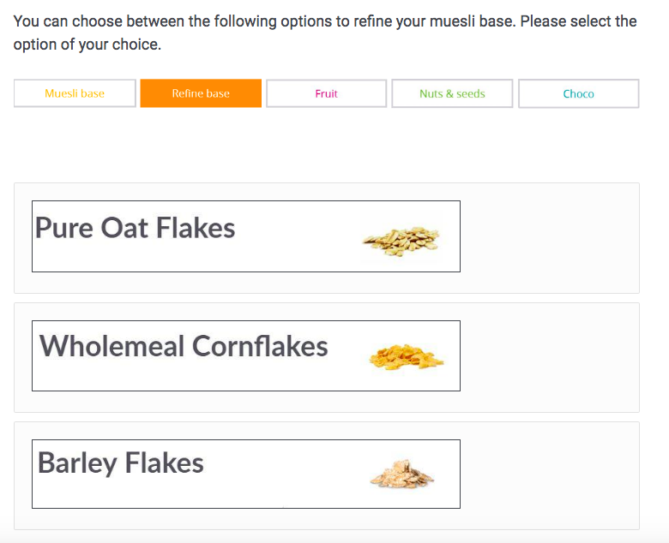

**Example for noncustomizer condition**

Participants were randomly assigned to see one of the options available to customizers

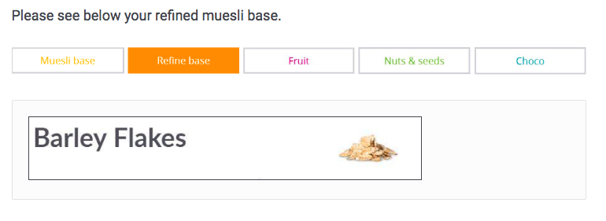

## WEB APPENDIX H – STUDY 2B: PRE-TEST AND INGREDIENTS

N = 66 (59 % female; mean age = 36.14, SD = 12.67)

Healthiness measured on a 11-point Likert scale (0 = very unhealthy to 10 = very healthy)

|  |  |  |
| --- | --- | --- |
| *Categories* | *All Ingredients included in pre-test* | *Selected ingredients and perceived healthiness* |
| **Muesli Base** | Oat flakes | Buckwheat flakes; Mhealth = 7.08Rye flakes; Mhealth = 7.05 Spelt Quinoa crunchy; Mhealth = 7.15 |
| Amaranth flakes |
| Rice flakes |
| Barley flakes |
| Honey flakes |
| Oat crunchy |
| Spelt flakes |
| Wholemeal cornflakes |
| Wheat and honey boon |
| **Buckwheat flakes** |
| **Rye flakes** |
| Wheat flakes |
| **Spelt Quinoa Crunchy** |
| **Refine Base** | **Pure Oat flakes** | Pure Oat flakes; Mhealth =7.48 Barley flakes; Mhealth = 7.41Wholemeal cornflakes; Mhealth = 7.29 |
| Amaranth flakes |
| Rice flakes |
| **Barley flakes** |
| Honey flakes |
| Oat crunchy |
| Spelt flakes |
| **Wholemeal cornflakes** |
| Wheat and honey boon |
| Buckwheat flakes |
| Rye flakes |
| Wheat flakes |
| Quinoa flakes |
| **Fruits** | Papaya | Cranberries; Mhealth = 7.85Raspberries; Mhealth = 7.83Bananas; Mhealth = 7.85 |
| **Cranberries** |
| Raisins (green) |
| Dates |
| Strawberries |
| Apricots |
| Pineapple |
| Mango |
| **Raspberries** |
| **Bananas** |
| Morello cherries |
| Grapes |
| Figs |
| Raisins |
| Physalis |
| Plums |
| **Nuts** | Pecans | Pistachios; Mhealth = 7.00Pumpkin seeds; Mhealth = 7.04Pine Nuts; Mhealth = 7.07 |
| Poppy seeds |
| Sesame seeds |
| Almonds |
| **Pistachios** |
| Hazelnut |
| Apple-cinnamon crunchy |
| Walnuts |
| Macadamia |
| Brazil nuts |
| **Pumpkin seeds** |
| Hemp nuts |
| Sunflower seeds |
| **Pine Nuts** |
| **Chocolate** | Cranberry chocs | Espresso Chocs; Mhealth = 2.87 Choco cornflakes; Mhealth = 2.79Chocolate pieces; Mhealth = 2.90 |
| Chocolate boons |
| Banana-chocs |
| **Espresso chocs** |
| **Chocolate cornflakes** |
| Sultana chocs |
| **Chocolate pieces** |
| Coconut chips |
| Chocoholic crunchies |

## WEB APPENDIX I – STUDY 2B: ANALYSIS OF SOCIAL MEDIA BEHAVIOR

For each participant, we counted the number of hashtags indicating healthy eating. These hashtags directly mentioned health, or they referred to a balanced meal, good nutrition, fitness, dieting, or weight loss. On average, across participants, 1.27 hashtags (out of a total of 5 possible hashtags) indicated healthy eating.

We regressed the number of “healthy” hashtags on customization, healthy self-image, their interaction, and campus locations. We found a significant customization x self-image interaction (β = .12, t(201) = 2.89, *p* = .004). There was no other significant effect (*p’s* >.12).

Relying on the Johnson-Neyman procedure, customizers (vs. noncustomizers) generated significantly fewer healthy hashtags (*p* <. 05) for all values of self-image equal to or lower than 5.7, corresponding to the 34th percentile of self-image. In addition, customizers (vs. noncustomizers) generated marginally significantly or significantly more healthy hashtags (*p* <. 10) for all values of self-image equal to or higher than 8.6, corresponding to the 90th percentile of self-image.

## WEB APPENDIX J – STUDY 2B: RECOMMENDATION LIKELIHOOD TO HEALTH-CONSCIOUS SEGMENTS

We averaged recommendations for a healthy person and for a dieter (r = .70, *p* < .001). We regressed this recommendation index on customization, healthy self-image, their interaction, and campus locations. We found a significant main effect of self-image (β = .16, t(201) = 2.30, *p* = .02), and a significant customization x self-image interaction (β = .25, t(201) = 3.75, *p* < .001). There was no significant main effect of customization (*p* = .99), or of campus location (*p* = .11).

The Johnson-Neyman procedure revealed that customizers (vs. noncustomizers) were significantly less likely to recommend muesli to a healthy/dieting person (*p* < .05) for all values of self-image equal to or lower than 5.4. In addition, customizers (vs. noncustomizers) were significantly more likely to recommend muesli to a healthy/dieting person (*p* < .05) for all values of self-image equal to or higher than 7.4.

## WEB APPENDIX K – STUDY 3: PRE-TEST FOR ACTIVITIES

N = 80 (38 % female; mean age = 32.49, SD = 9.37)

Adventurousness measured on a 7-point Likert scale (0 = not at all adventurous to 7 = very adventurous)

|  |  |
| --- | --- |
| **All activities included in pre-test**  Playing golf, Yoga class, painting, cooking class, viewing/photographing natural scenery, segwaying, visiting historic sites, guided tours of cities, viewing/photographing wildlife, fishing, shooting range, horseback riding, paintballing, day hiking, tree climbing, stand-up paddle boarding, quad driving, driving off-road, diving, mountain biking, snorkeling, water skiing, jet skiing, canoeing/kayaking, windsurfing, surfing, rafting, ziplining, parasailing, rock climbing | **Selected activities: Moderate adventurousness (Study 3)**  Viewing/photographing natural scenery  Madv = 2.88  Segwaying  Madv = 2.89  Guided city tours  Madv = 2.99  Visiting historic sites  Madv = 2.94  Viewing/photographing wildlife  Madv = 3.15 |

## WEB APPENDIX L – THRILL AND ADVENTURE SEEKING SCALE (SSS-TAS, ZUCKERMAN 1971)

Likert scale (1 = strongly disagree to 5 = strongly agree)

|  |
| --- |
| I enjoy many of the rides in amusements parks. |
| I often wish I could be a mountain climber. |
| I sometimes like to do things that are a little frightening. |
| I would like to take up the sport of water-skiing. |
| I would like to try surfboard riding. |
| I would like to learn to fly an airplane. |
| I would like to go scuba diving. |
| I like to drive in open convertibles. |
| I would like to try parachute jumping. |
| Sometimes I like to swim far out from the shore. |
| I like to dive off the high board. |
| I would like to drive or ride on a motorcycle. |
| I would like to sail a long distance in a small but seaworthy sailing craft. |
| I think I would enjoy the sensations of skiing very fast down a high mountain slope. |

## WEB APPENDIX M – STUDY 3: RECOMMENDATION LIKELIHOOD TO ADVENTUROUS TARGET SEGMENT

Recommendations to “a person who cares about adventure” and to a “risk-taker” were highly correlated (r = .76; *p* < .001) and averaged. We regressed this recommendation index on customization, self-image (mean-centered), and their interaction, and found a significant main effect for customizer (β = .17, t(204) = 2.57, *p* = .01), a marginally significant main effect of self-image (β = .11, t(204) = 1.68, *p* =.09), and most importantly a significant interaction effect (β = .21, t(204) = 3.18, *p* = .002).

The Johnson-Neyman procedure showed that for all values of adventurous self-image lower than or equal to 1.5, customization (vs. nocustomization) resulted in marginally significantly (*p* < .10) lower recommendation likelihood to adventurous target groups. In contrast, for all values of self-image higher or equal to 3.0, customization (vs. nocustomization resulted in significantly (*p* < .05) higher recommendation likelihood.

## WEB APPENDIX N – STUDY 4: PRE-TEST AND SELECTED INGREDIENTS

N = 78 (55% female; mean age = 34.27, SD = 11.95)

Healthiness measured on a 11-point Likert scale (0 = very unhealthy to 10 = very healthy)

|  |  |  |
| --- | --- | --- |
| **Categories** | **All Ingredients included in the pre-test** | **Selected ingredients and perceived healthiness** |
| **Meats** | ham | Beef; Mhealth = 5.67Crabstick; Mhealth = 5.71 Canned tuna; Mhealth = 5.79 |
| **beef** |
| **crabstick** |
| shrimp |
| chicken |
| **canned tuna** |
| **Vegetables** | **carrot** | Carrot; Mhealth =8.69 Cucumber; Mhealth = 8.69spinach; Mhealth = 8.72 |
| **cucumber** |
| **spinach** |
| **Cheese** | **hard cheese** | Hard cheese; Mhealth = 4.62Cream cheese; Mhealth = 4.35 |
| **cream cheese** |
| **Other** | tofu |  |

## WEB APPENDIX O – STUDY 4: RECOMMENDATION LIKELIHOOD

We averaged the recommendations to the health-conscious and to the dieting friend (r = .78; *p* < .001). The regression of recommendation on the two contrast-coded manipulation variables, self-image, and interactions, revealed a positive main effect of self-image (β = .19, t(490) = 4.28, *p* < .001), but no significant main effects of the manipulation variables (*p*’s >.38). Most importantly, the interaction effects of self-image and “customization vs. nocustomization”, and of self-image and “customization vs. chosen” were both significant (respectively, β = -.13, t(490) = -2.59, *p* = .01; β = .26, t(490) = 5.25, *p* < .001).

Relying on the Johnson-Neyman procedure, we found that customizers were significantly (*p* < .05) less likely to recommend gimbap to a health-conscious or dieting person, compared with noncustomizers for all values of self-image equal to or lower than 4.0, and compared with choosers for all values of self-image equal to or lower than 5.4. In addition, customizers were significantly (*p* < .05) more likely to recommend gimbap to a health-conscious or a dieting person, compared with noncustomizers for all values of self-image equal to or higher than 8.8, and compared with choosers for all values of self-image equal to or higher than 7.4.

## **WEB APPENDIX P – STUDY 5: ORGANIC LOGO STIMULI**

**Example for customizer with label condition**

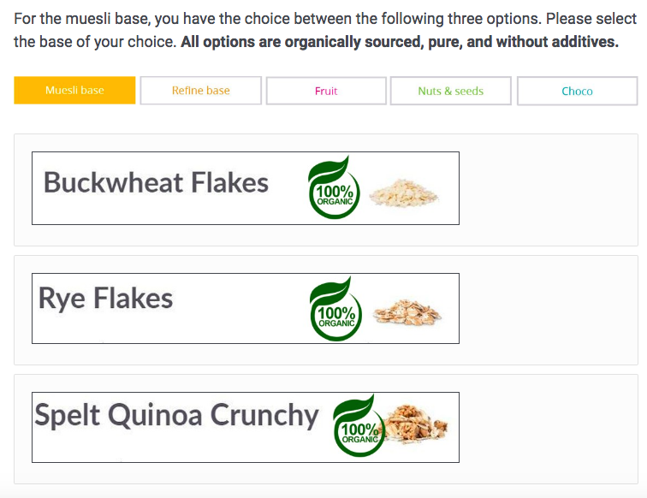

**Example for noncustomizer with label condition**

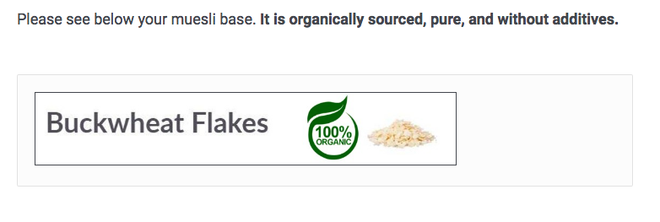

## WEB APPENDIX Q – STUDY 5: ANALYSIS OF HEALTHINESS PERCEPTIONS AND RECOMMENDATION TO TARGET GROUPS

In the following, we provide the detailed analysis for the following dependent variables: healthiness perceptions, recommendation to a healthy person, recommendation to a dieting person. We verified our hypotheses regarding the customization x self-image interaction for all three dependent variables. We verified our hypotheses regarding the customization x label x self-image three-way interaction for only two of the variables (healthiness perceptions, and recommendation to a healthy person).

*Healthiness Perceptions*. We regressed healthiness perceptions on customization (coded -1 for nocustomization, and +1 for customization), label (coded -1 for no label, and +1 for organic label), the mean-centered healthy self-image score, and all interactions. We found a significant main effect of customization indicating lower healthiness perceptions in the customization (vs. no-customization) condition (β = -.26, t(793) = -8.17 *p* < .001 ), a significant main effect of label indicating higher healthiness perceptions in the organic label (vs. no label) condition (β = .21, t(793) = 6.47, *p* < .001 ), a significant main effect of healthy self-image (β = .21, t(793) = 6.55, *p* < .001 ), a significant customization x self-image interaction (β = .15, t(793) = 4.68, *p* < .001), and a significant customization x label x self-image three-way interaction (β = -.07, t(793) = -2.15, *p* = .03). There were no other significant effects (*p’s* >. 3).

Follow-up analyses revealed that the customization x self-image interaction was highly significant in the absence of “organic” labels (β = .20, t(397) = 4.39, *p* < .001). This interaction was still significant in the presence of “organic” labels, although to a much lesser extent than in the no label condition (β = .09, t(396) = 1.99, *p* = .05). Notice that the stronger interaction effect in the no label (vs. organic label) condition is evidenced by the three-way interaction mentioned above. We relied on the Johnson-Neyman procedure to probe these interaction effects. In the absence of organic labels, customizers (vs. noncustomizers) perceived muesli as significantly less healthy (*p*<.05) for all values of self-image equal to or lower than 7.8. In the presence of an organic label, customizers (vs. noncustomizers) always perceived muesli as significantly less healthy, although as suggested by the analysis below, the organic label (vs. no label) still mitigated the effect of customization on perceived healthiness, especially among participants with an unhealthy self-image.

Follow-up analyses also revealed that the label x self-image interaction was marginally significant among customizers (β = -.08, t(400) = -1.69, *p* = .09), but non-significant among noncustomizers (β = .06, t(393) = 1.34, *p* = .18). We relied on the Johnson-Neyman procedure to probe the interaction effect in the customization condition. We found that among customizers, the organic label (vs. no label) made participants perceive muesli as significantly healthier (p<.05) for all values of self-image equal to or lower than 8.3.

*Recommendation to a healthy person*. We regressed recommendations to a healthy person on customization, label, the mean-centered healthy self-image score, and all interactions. We found a significant main effect of customization indicating lower recommendations in the customization (vs. no-customization) condition (β = -.17, t(793) = -5.25 *p* < .001 ), a significant main effect of label indicating higher recommendations in the organic label (vs. no label) condition (β = .21, t(793) = 6.36, *p* < .001 ), a significant main effect of healthy self-image (β = .19, t(793) = 5.89, *p* < .001 ), a significant customization x self-image interaction (β = .12, t(793) = 3.64, *p* < .001), and a significant customization x label x self-image three-way interaction (β = -.07, t(793) = -2.25, *p* = .02). There were no other significant effects (*p’s* >. 5).

Follow-up analyses revealed that the customization x self-image interaction was highly significant in the absence of “organic” labels (β = .18, t(397) = 3.77, *p* < .001), but not in the presence of organic labels (β = .05, t(396) = 1.10, *p* = .27). We relied on the Johnson-Neyman procedure to probe the significant interaction effect. In the absence of “organic” labels, customizers (vs. noncustomizers) were significantly less likely to recommend muesli (*p* <. 05) for all values of self-image equal to or lower than 7.2.

Follow-up analyses also revealed that the label x self-image interaction was marginally significant among customizers (β = -.08, t(400) = -1.64, *p* = .10), but non-significant among noncustomizers (β = .07, t(393) = 1.55, *p* = .12). We relied on the Johnson-Neyman procedure to probe the interaction effect in the customization condition. We found that among customizers, the organic label (vs. no label) made participants more likely to recommend muesli (*p*<.05) for all values of self-image equal to or lower than 8.5.

*Recommendation to a dieting person*. We regressed recommendations to a dieting person on customization, label, the mean-centered healthy self-image score, and all interactions. We found a significant main effect of customization indicating lower recommendations in the customization (vs. no-customization) condition (β = -.17, t(793) = -4.94 *p* < .001 ), a significant main effect of label indicating higher recommendations in the organic label (vs. no label) condition (β = .20, t(793) = 6.09, *p* < .001 ), a significant main effect of healthy self-image (β = .17, t(793) = 5.06, *p* < .001 ), and a significant customization x self-image interaction (β = .10, t(793) = 2.91, *p* = .004), There were no other significant effects (*p’s*>.5). In particular, contrary to our hypotheses, we failed to find a significant customization x label x self-image three-way interaction (β = -.01, t(793) = -.30, *p* = .77).

We relied on the Johnson-Neyman procedure to probe the significant interaction effect of customization x self-image (across both label conditions). Customizers (vs. noncustomizers) were less likely to recommend muesli (*p* <. 05) for all values of self-image equal to or lower than 8.4.

## WEB APPENDIX R – INTERNAL META-ANALYSIS



We performed a single paper meta-analysis of the effect of customization (vs. nocustomization) on attribute perception (top figures) and on product recommendation to a target group (bottom figures). The effect sizes were estimated among participants low in attribute-related self-image (one standard deviation below the average self-image score; left-hand side figures) and among participants high in attribute-related self-image (one standard deviation above the self-image average score; right-hand side figures).

* In Study 1, the product attribute was the fashionability of T-Shirt, and the self-image was fashionability self-image.
* In Studies 2b, 4, and 5, the product attribute was the healthiness of muesli (S2b and S5) or gimbap (S4), the target groups for recommendations were health-conscious/dieting people, and the self-image was healthy self-image.
* In Studies 3, the product attribute was the adventurousness of vacation packages, the target groups for recommendations were adventurous/risk-seeking people, and the self-image was adventurous self-image.

We focused on the measures and manipulations that were comparable across studies. Hence:

* We did not include Study 2a (field study)
* We did not include the “choice” condition in Study 4, nor the “label” condition in Study 5.
* We did not include the social media communication (“hashtags”) dependent variable, measured in Studies 2b and 5.

In order to compute the effect sizes, we used the “metan” program in Stata, which allows performing meta-analyses based on regression unstandardized coefficients (this was necessary to study the overall effect at different levels of the self-image moderator). Hence the effect sizes correspond to the unstandardized regression coefficients for the effect of customization. We used a random-effect model because the contexts differed greatly across the studies, hence we could only assume that we were working with multiple true effects.

Overall, we found crossover effects: among participants low in attribute-related self-image, customization led to unfavorable attribute perception (effect size = -.49) and lower recommendations (-.49). In contrast, among participants high in attribute-related self-image, customization led to favorable attribute perception (effect size = .32) and higher recommendations (.45).

## WEB APPENDIX S - BOLSTER INDIVIDUALS’ SELF-IMAGE AS A HEALTHY EATER; STUDY IN GD

N = 455 (50% female, mean age = 19.10, SD = 1.58) students participated in this lab study for extra credits. We had to exclude one participant who participated twice, nine participants because the internet connection failed, 14 because the pictures that we showed didn’t load properly and/or 17 participants who reported being allergic to some of the ingredients that they could choose from. This leaves 414 valid responses.

**Control condition** (N = 208)

“We conduct this study for a company that sells muesli online. Before we present you with the muesli and ask you questions about it, the company would like to know your opinion regarding online buying. Nowadays, consumers can increasingly purchase products online. Please explain how important online buying in in your everyday life.”

**Treatment condition** (N = 206)

“We conduct this study for a company that sells muesli online. Before we present you with the muesli and ask you questions about it, the company would like to know your opinion regarding healthy eating. Nowadays, consumers have become increasingly aware that eating healthy is very important for personal well-being. Please explain how you try to be a healthy eater in your everyday life.”

**Customizers** (N = 215)

“We want to learn more about consumers' preferences and behaviors towards muesli. Therefore, **we would like you to digitally mix your own muesli**. It is very important for the study that you really imagine creating your own muesli and imagine eating it. On the next pages, **we will walk you through the customization process step by step and you can customize your own muesli.** Note: we will show you several pictures; please make sure that all pictures loaded correctly before you answer any questions.”

**Noncustomizers** (N = 199)

We want to learn more about consumers' preferences and behaviors towards muesli. Therefore, **your muesli will be digitally prepared for you**. It is very important that you really imagine that your muesli is being prepared and that you are eating it. On the next pages, **we will walk you through the preparation process of your muesli step by step**. Note: we will show you several pictures; please make sure that all pictures loaded correctly before you answer any questions.”

**Results**

An analysis of variance with customization and image manipulation as independent variables and healthiness perceptions as the dependent variable revealed a marginally significant interaction effect (F(3, 410) = 3.25, *p* = .072). In our control condition, we replicated the interaction effect between customization and measured self-image as a healthy eater (β = .14, t(204) = 2.1, *p* = .04) so that customizers with an unhealthy self-image (all values lower than or equal to 7.28) perceived the muesli as less healthy than noncustomizers. However, for participants with a bolstered healthy self-image, we no longer found a difference between customizers and noncustomizers with respect to perceived healthiness of the muesli (F(1, 204) = .28, *p* = .6).

## WEB APPENDIX T – GIFT GIVING: SELF-IMAGE-CONSISTENT PRODUCT PERCEPTIONS IN A SELF-PURCHASING VERSUS GIFT-GIVING CONTEXT

We speculated that the effect of self-image-consistent product perceptions (as a consequence of customization) is more likely to occur in a self-purchasing than in a gift-giving context. To provide preliminary evidence for this assumption, we utilized the context of vacation packages and manipulated whether participants customized/received a product for themselves or as a gift for a friend.

*Method*

*Participants and design.* This study employed a 2 (customization: customizer vs. non- customizer) x 2 (intended product recipient: self vs. friend) x measured self-image between-subjects design. Two-hundred-and-seventy-nine participants (61% female) took part in this study distributed online via British prolific. We randomly assigned participants to a customizer (N = 140) or noncustomizer (N = 139) condition; in addition, we manipulated whether the product was intended for the self (N = 139) or for a friend (N = 140).

*Materials and procedure.* Following Study 3 (in the main body of the paper), participants were asked to imagine a vacation in Costa Rica, and that their accommodation offered a package with three different leisure activities. In the “friend” condition, participants also imagined that they would offer this package as a gift to a friend. Participants in the customization condition were allowed to customize this package (either for themselves, or for the friend), while participants in the no-customization condition obtained a prepared vacation package (intended either for themselves, or for the friend).

All the possible activities were equally adventurous based on the same pre-test as in Study 3, although we selected activities that were much more adventurous than in Study 3 (see Web Appendix K). Specifically, customizers could choose three activities among six adventurous activities: driving off-road, mountain biking, snorkelling, water skiing, jet skiing and canoeing/kayaking. Noncustomizers were assigned a specific vacation package with three activities (canoeing/kayaking, driving off-road, and jet skiing).

Once participants customized (received) the vacation package, they indicated its perceived adventurousness on an 11-point scale (0 = not at all adventurous to 10 = very adventurous), and completed the Thrill and Adventure Seeking Scale (SSS-TAS; Zuckerman 1971). In addition, we measured whether participants perceived themselves as more or less adventurous than their friends using three items: “I am much more adventurous than my friends”, “I think I am the least adventurous person in my friends group”, and “I am the most adventurous person in my friends group” (1 = strongly disagree to 5 = strongly agree).

*Results*

In this study, we utilized two distinct measures of adventurous self-image: the Thrill and Adventure Seeking Scale (SSS-TAS; α = .89), and a scale measuring adventurous self-image relative to friends (α = .81). Neither of our manipulations impacted these measures (*p’s* > .18).

*Effect on perceived adventurousness.* We regressed the perceived adventurousness of the vacation package on customization (noncustomizers coded as -1 and customizers coded as 1), product recipient (friend coded as -1 and self-coded as +1), the mean-centered SSS-TAS, and all interaction effects. The results revealed a significant negative main effect of customization (β = -.30, *t*(271) = -5.20, *p* < .001)—presumably because by design the package was somewhat adventurous, leaving “more room” for a decrease in perceived adventurousness driven by self-image—, a significant effect of recipient type (β = -.14, *t*(271) = -2.49, *p* = .01), and a significant main effect of self-image (β = .13, t(271) = 2.29, *p* = .02). More importantly, the three-way interaction effect between customization, recipient, and self-image was marginally significant (β = .10, t(271) = 1.70, *p* =.09). All other effects were insignificant (*p’s* > .32).

Follow-up analyses revealed that when the package was intended for the self, the customization x self-image interaction was marginally significant (β = .13, t(135) = 1.88, *p* =.07), in line with H1. A Johnson-Neyman procedure showed that customization (vs. no-customization) significantly (*p* < .05) decreased adventurousness perceptions among participants with a SSS-TAS score lower than or equal to 3.6. In contrast, when the package was intended for a friend, the customization x self-image interaction was no longer significant (*p* = .61).

We repeated all analyses with the measure capturing participants’ self-image in relation to their friend (rather than SSS-TAS). The pattern of results was consistent—and even stronger—than the results reported above, in particular, the hypothesized three-way interaction of customization x intended recipient x self-image was statistically significant (*p* = .045).

## WEB APPENDIX U – LIKELIHOOD TO CUSTOMIZE; STUDY IN GD

N = 82 (38% female, mean age = 30.23, SD = 10.58) participants on British Prolific that passed the attention check

**General Customization Tendencies** (α = .80)

7-point Likert scale, 1 = strongly disagree to 7 = strongly agree

* In general, I like to customize products.
* When I have the possibility, I customize the product.
* I never customize products.

**Self-Image as a Healthy Eater** (α = .85)

11-point Likert scale, 0 = does not describe me to 10 = describes me

* Do you describe yourself as a healthy eater?
* Do you describe yourself as someone who eats in a nutritious manner?
* Do you describe yourself as someone who is careful about what I eat?