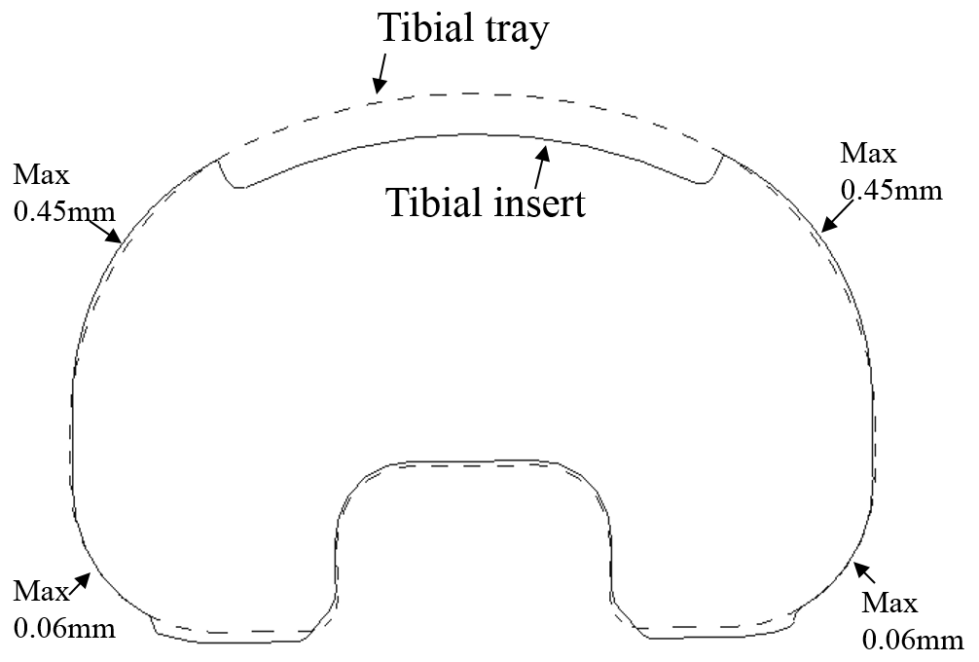
S-Figure 1. Geometric contours of the tibial insert (solid line) and tray (dashed line) at the original position.

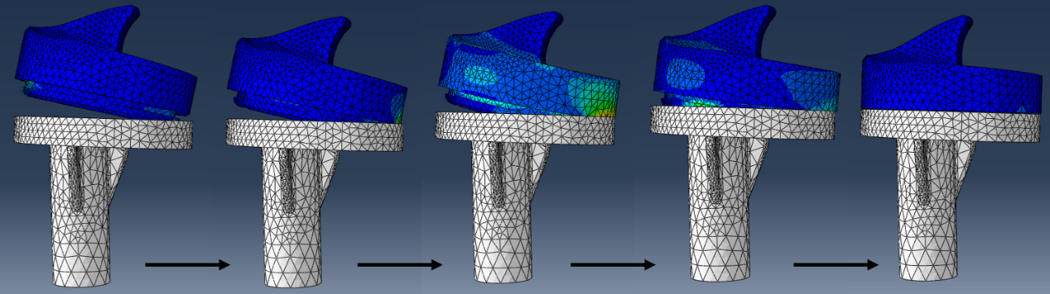
S-Figure 2. Simulation of the interference assembly of tibial insert

