Appendix 1: The distribution of plenary parliamentary questions among members of (Flemish and Francophone) party groups (GINI-coefficients for party groups per year)

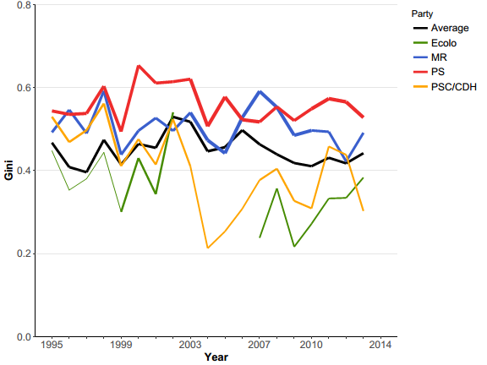

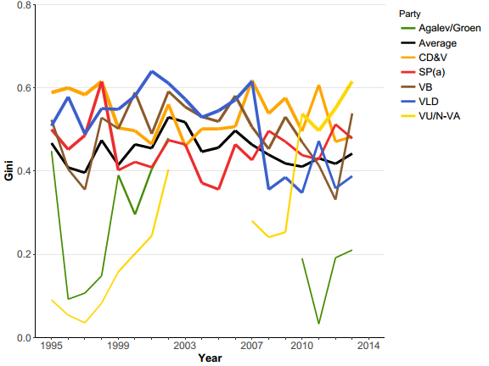

As the Gini-coefficient is to a certain degree sensitive for party group size, the thickness of the lines in the Figures shows how large a party group was at that moment in time (thinner line=small party group, thicker line= large party group).

