STUDY MATERIALS

EXPOSURE TO VIOLENCE (ETV) SCALE

Below are some questions about violence and how it may have affected you or your family and friends. Please choose Yes or No, and if Yes, indicate the number (#) of times over the course of your life. The number can be an estimate.
In your lifetime:
1. Have you seen someone else get chased when you thought they could really get hurt?

Yes (If Yes: How many times? Enter value below) _____________________________
No

2. Have you seen someone else get hit, slapped, punched, or beaten up? This does not include when they were playing or fooling around.

Yes (If Yes: How many times? Enter value below) _____________________________
No

3. Have you seen someone else get attacked with a weapon, like a knife or bat? This does not include getting shot or shot at.

Yes (If Yes: How many times? Enter value below) _____________________________
No

4. Have you seen someone else get shot? This doesn't include seeing someone shot with a BB gun or any type of toy gun.

Yes (If Yes: How many times? Enter value below) _____________________________
No

5. Have you seen someone else get shot AT, but not actually wounded?

Yes (If Yes: How many times? Enter value below) _____________________________
No

6. OTHER THAN WHAT YOU HAVE ALREADY NOTED have you heard gunfire nearby? This does not include hearing gunfire while hunting or at a shooting range.

Yes (If Yes: How many times? Enter value below) _____________________________
No

7. Have you seen someone else get killed as a result of violence, like being shot, stabbed, or beaten to death?

Yes (If Yes: How many times? Enter value below) _____________________________
No

8. Have you been chased when you thought that you could really get hurt?

Yes (If Yes: How many times? Enter value below) _____________________________
No

9. Have you been hit, slapped, punched, or beaten up?

Yes (If Yes: How many times? Enter value below) _____________________________
No

10. Have you been attacked with a weapon, like a knife or bat? Again, this does not include getting shot or shot at.

Yes (If Yes: How many times? Enter value below) _____________________________
No

11. Have you been shot? Again, this doesn't include being shot with a BB gun or any type of toy gun.

Yes (If Yes: How many times? Enter value below) _____________________________
No

12. Have you been shot AT, but not actually wounded?

Yes (If Yes: How many times? Enter value below) _____________________________
No

13. Have you been sexually assaulted, molested, or raped?

Yes (If Yes: How many times? Enter value below) _____________________________
No

INSTRUCTIONS FOR ECONOMIC GAMES

PLEASE READ THESE INSTRUCTIONS CAREFULLY!
We are interested in how people make decisions that affect the amount of money they can earn for themselves and other people. You will receive $10 per hour for participating in this study, plus the chance to earn an additional amount. You can earn up to an additional $20 (beyond the $10/hour).
Today, you will take part in a series of interactions.
In each interaction, you will be matched with other people from the New Haven area that saw our flyer and completed a phone conversation, just like you. For each interaction you will be matched with different people that have come in for this study.
The rules for each interaction will be different, so please read the instructions carefully as they are presented on each screen! Feel free to use the paper and pencil next to you if needed.
Some interactions will have different "roles" for different people. We will ask you what you would like to do if you were each one of the roles (called Person in the interactions).
What you do in one interaction should NOT affect your decisions in another. So, at the end of the study we will choose one of your interactions and role and use the outcome of that interaction to determine how much extra money you’ll get. This amount will be added to your total earning for the day.
Because only one interaction will count, but you don't know which one it will be, it is in your best interest to treat each decision like it’s the one that matters for how much additional money you can earn.
We're interested in your choices, and we're not interested in "tricking" you in any way. If you have any questions, please let us know.
When you are ready for the first interaction, click NEXT to continue.

DICTATOR GAME

One of you will be Person A, and one of you will be Person B.
Person A starts with $10.
This interaction has one single decision: Person A chooses how much of the $10 (if any) to give to Person B, and how much of the $10 to keep for him/herself.
Person B can’t do anything about the decision and will get whatever Person A gives. Person A will keep the rest of the money.

The picture below shows what the interaction looks like:

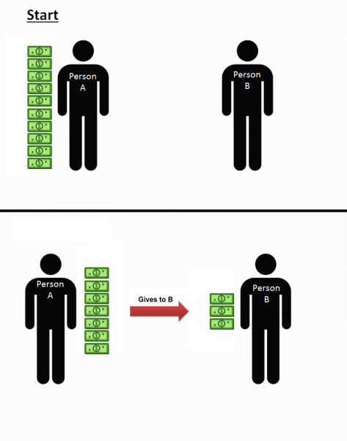

Here's an example with numbers:
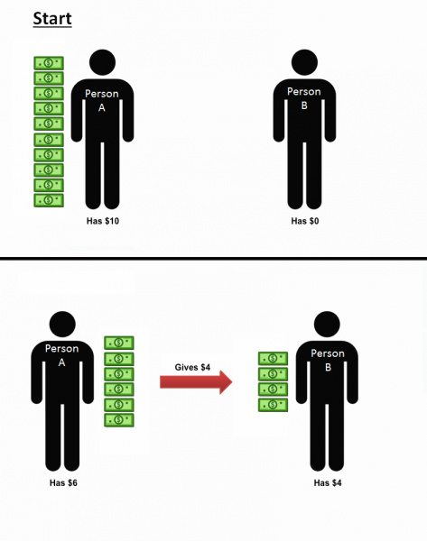
Let's make sure the instructions for this interaction are clear:
For practice, what choice by Person A earns the most for Person B?
Giving $0
Giving $5
Giving $10

For practice, what choice by Person A earns the most for Person A?
Giving $0
Giving $5
Giving $10

If participant does not understand instructions: Let's make sure instructions are completely clear. Have the RA walk through the parts of the task with you again. [repeat comprehension questions]

Ok! Now let's have you select for real. Remember, this choice can go toward how much extra you can earn.
Person A
If you are Person A in this interaction, how much of the $10 will you give to Person B? You can choose any amount below.
$0
$1
$2
$3
$4
$5
$6
$7
$8
$9
$10

Thanks! Let us know you have finished and we'll come back in.

TRUST GAME

In this interaction, you are matched with one other brand-new person from the community. Forget all of the other rules and situations you followed before this interaction.

One of you will be Person A, and one of you will be Person B.
Both of you will start with $5.
Person A will make a choice, then Person B will respond to that choice.
First, Person A can choose to give their $5 to Person B or not to give their $5 to Person B.
If Person A gives their $5 to Person B, then those dollars are TRIPLED (3x) to become $15. Person B would then have $20, because they started with $5 and then on top of that got the $15 (3 x $5) from Person A.
Person B can then choose how much of the $15 they want to give back to Person A (between $0 and $15). Any money Person B gives back to Person A will not be tripled (so, if Person B gives back $5, Person A gets $5).

The picture below shows what the interaction looks like:

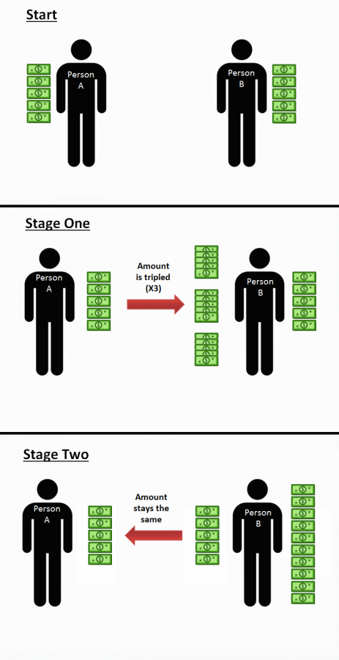

Here's an example with numbers:

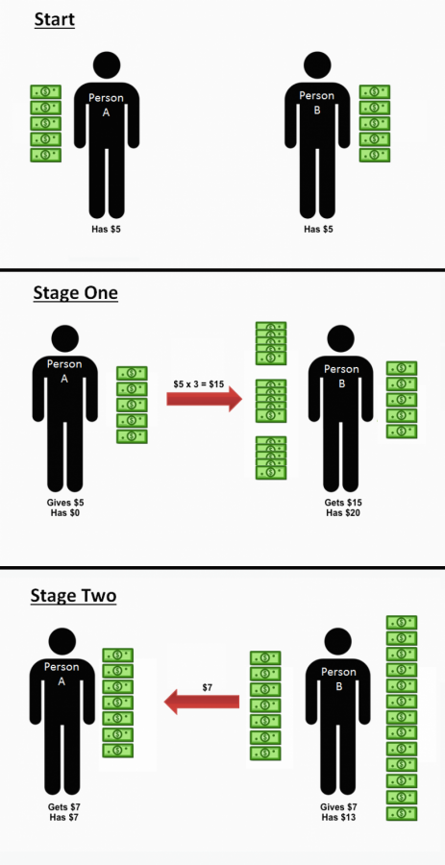

Let’s make sure the instructions for this interaction are clear:
For practice, what choice by Person A earns the most for Person B?
Giving $0
Giving $5

For practice, what choice by Person A earns the most for Person A?
Giving $0
Giving $5
It depends on what Person B chooses

If participant does not understand instructions: Let's make sure instructions are completely clear. Have the RA walk through the parts of the task with you again. [repeat comprehension questions]

Ok! Now let's have you select for real. Remember, this choice can go toward how much extra you can earn.
Person A
If you are Person A, do you want to give your $5 to Person B?
Yes
No

Let's have you select for real. Remember, this choice can go toward how much extra you can earn.
Person B
If you are Person B and Person A gives you $5 (which is multiplied by 3 to become $15 and added to the $5 you started with, which means that you have $20), how much money do you want to give back to Person A? You can choose any amount below.
$0
$1
$2
$3
$4
$5
$6
$7
$8
$9
$10
$11
$12
$13
$14
$15

Thanks! Let us know you have finished and we'll come back in.

PUBLIC GOODS GAME

In this interaction, you are matched with three other brand-new people from the community. Forget all of the other rules and situations you followed before this interaction.

All four of you will start with $5.
Each of you will choose how much of this $5 to give to the group in order to help all four people and how much of the $5 to keep for yourself.
All four of you decide how much money to give to the group at the same time.
Once everyone has made their choice, all the dollars that people gave to the group are doubled (2x) and then split equally among the four of you.
This means that, if everyone gives all of their $5 to the group, there would be a total of $20 given. This would be doubled to $40 (2 x $20 = $40), so you would earn $10 as a result ($40/4 = $10 per person).
But, every time you give a dollar to the group, you only get $0.50 back, because that dollar is doubled ($1 x 2 = $2) then split among the group ($2/4=$0.50).
So, giving money to the group always raises the total amount that the four of you earn. BUT, you will always earn more money for yourself by keeping your money instead up giving it up.

The picture below shows what the interaction looks like:

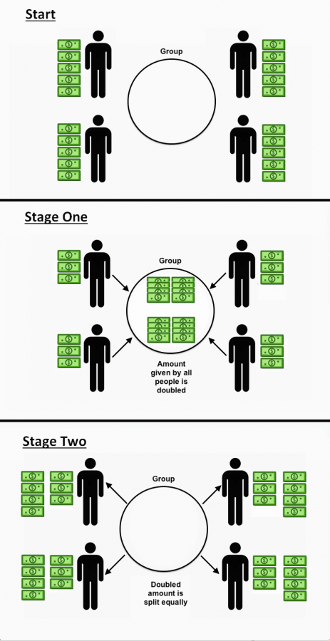

Here's an example with numbers:

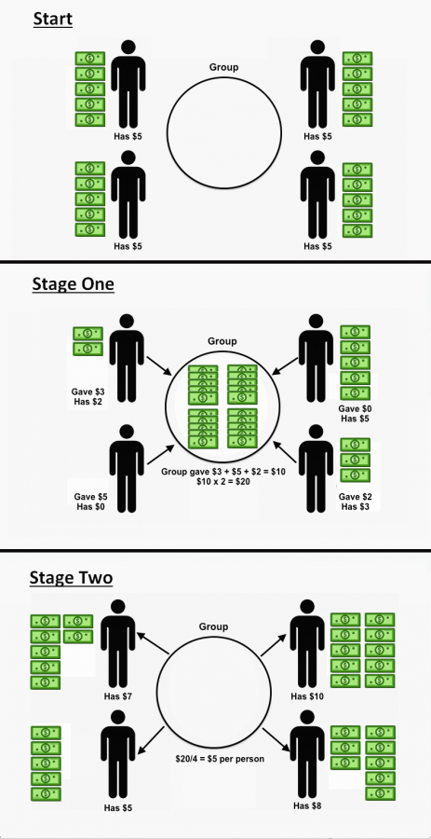
Let's make sure the instructions for this interaction are clear:
For practice, how much money would you give to the group in order to make sure everyone in the group earns as much money as possible?
$0
$2
$5

For practice, how much money would you give to the group in order to make sure you yourself earn as much money as possible?
$0
$2
$5

If participant does not understand instructions: Let's make sure instructions are completely clear. Have the RA walk through the parts of the task with you again. [repeat comprehension questions]

Ok! Now let's have you select for real. Remember, this choice can go toward how much extra you can earn.
How much of your $5 will you give to the group? You can choose any amount below.
$0
$1
$2
$3
$4
$5

Thanks! Let us know you have finished and we'll come back in.

THIRD PARTY PUNISHMENT GAME

In this interaction, you are matched with two other brand-new people from the community. Forget all of the other rules and situations you followed before this interaction.

One of you will be Person A, one of you will be Person B, and one of you will be Person C.
All of you will start with $10.
Person A will make a choice, then Person C will respond to that choice.
First, Person A will choose to either take all of Person B’s $10, or not to take any money from Person B.
If Person A decides to take Person B’s $10, then Person C can pay to make Person A lose money. For every $1 Person C pays, Person A loses $5 (Person C would pay $1 to make Person A lose $5, $2 to make Person A lose $10, $3 to make Person A lose $15, or $4 to make Person A lose all $20).
If Person A chooses not to take $10 from Person B, Person C doesn’t do anything.
Person B does not make any decisions in this interaction.

The picture below shows what the interaction looks like:

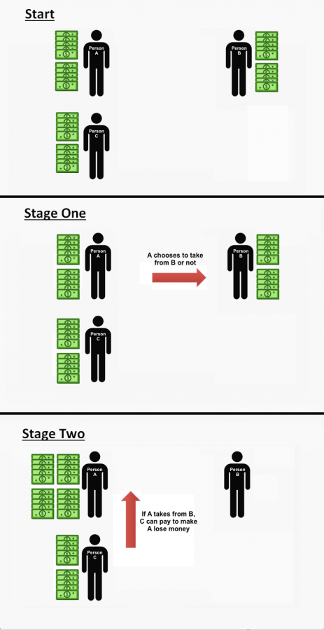
Here's an example with numbers:
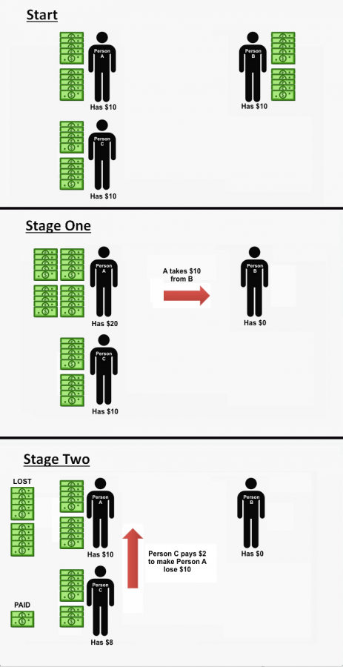

Let's make sure the instructions for this interaction are clear:
For practice, how much would Person C pay to make Person A lose the most money?
$0
$2
$4

For practice, how much would Person C pay to make themselves have the most money?
$0
$2
$4

If participant does not understand instructions: Let's make sure instructions are completely clear. Have the RA walk through the parts of the task with you again. [repeat comprehension questions]

Ok! Now let's have you select for real. Remember, this choice can go toward how much extra you can earn.
Person A
If you are Person A, will you take Person B’s $10?
Yes - Take
No - Don't Take

Let's have you select for real. Remember, this choice can go toward how much extra you can earn.
Person C
If you are Person C and Person A decides to take Person B’s $10, how much will you (Person C) pay to make Person A lose money? You can choose any amount below.
Pay $0 so that Person A loses $0
Pay $1 so that Person A loses $5
Pay $2 so that Person A loses $10
Pay $3 so that Person A loses $15
Pay $4 so that Person A loses $20

Thanks! Let us know you have finished and we'll come back in.

SECOND PARTY PUNISHMENT GAME

In this interaction, you are matched with one other brand-new person from the community. Forget all of the other rules and situations you followed before this interaction.

One of you will be Person A, and one of you will be Person B.
Both people will start with $5.
This interaction has two parts. In each part, both people (you and the other person from the community) will make your choice without knowing what the other person will choose.
Stage 1:
First, both of you will choose to either give up your $5 so that the other person gets $10 or not to give up your $5.
Stage 2:
You both receive an extra $4 for Stage 2. Based on the other person’s choice in Stage 1, you each then decide whether to pay some or all of this $4 to make the other person lose money. For every $1 you spend in Stage 2, the other person loses $4. (For example, if you spend $2, the other person will lose $8.)
Note: You can never have less than $0 in this interaction. (For example, if you spend $2 to make the other person lose $8, but they only have $5, the other person will only lose $5 and their amount will be $0).

The picture below shows what the interaction looks like:
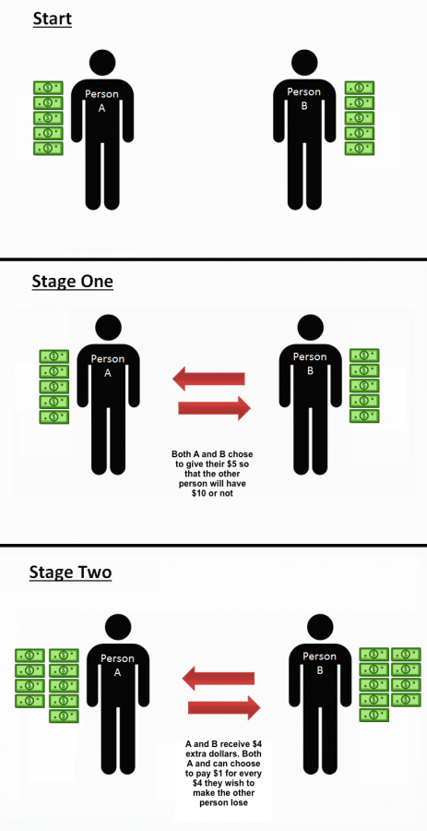

Here's an example with numbers:
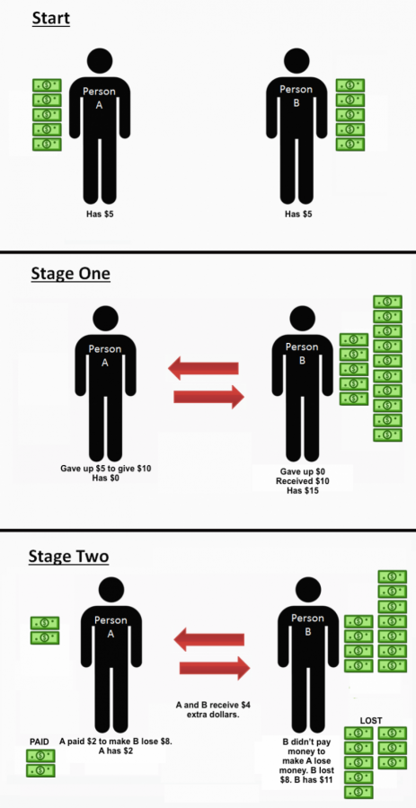

Let's make sure the instructions for this interaction are clear:
For practice, which choice in Stage 1 earns the most money for the other person?
Giving up $5
NOT giving up $5

For practice, how much would Person B pay to make Person A lose the most money?
$0
$2
$4

For practice, how much would Person B pay to make Person A lose the least amount of money?
$0
$2
$4

If participant does not understand instructions: Let's make sure instructions are completely clear. Have the RA walk through the parts of the task with you again. [repeat comprehension questions]

Ok! Now let's have you select for real. Remember, this choice can go toward how much extra you can earn.
Stage 1
Will you give up $5 to give the other person $10?
Yes
No

Let's have you select for real. Remember, this choice can go toward how much extra you can earn.
Stage 2
Depending on if the other person gives up $5 to give you $10, please use the sliders below to tell us how much you will pay to make them lose money. Remember that you receive an extra $4 in this stage, which you can keep OR spend on making the other person lose money.
If the other person DOES GIVE UP $5 TO GIVE YOU $10, how much will you pay to make them lose money? (Remember every $1 you pay takes $4 from the other person) You can choose any amount below.
 | $0 | $.5 | $1 | $1.5 | $2 | $2.5 | $3 | $3.5 | $4

 | 0 | 1 | 1 | 2 | 2 | 3 | 3 | 4

Let's have you select for real. Remember, this choice can go toward how much extra you can earn.
If the other person DOES NOT GIVE UP $5 TO GIVE YOU $10, how much will you pay to make them lose money? (Remember every $1 you pay takes $4 from the other person) You can choose any amount below.
 | $0 | $.5 | $1 | $1.5 | $2 | $2.5 | $3 | $3.5 | $4

 | 0 | 1 | 1 | 2 | 2 | 3 | 3 | 4

Thanks! Let us know you have finished and we'll come back in.

ULTIMATUM GAME

In this interaction, you are matched with one other brand-new person from the community. Forget all of the other rules and situations you followed before this interaction.

One of you will be Person A, and one of you will be Person B.
Person A will make a choice, then Person B will respond to that choice.
First, Person A will make an offer on how to split $10 with Person B, choosing any amount between $0 and $10.
Then, Person B will either accept or reject this offer.
If Person B accepts, then Person B will get the amount that Person A offered, and Person A will keep the rest of the money not given to Person B.
If Person B rejects the offer, then both Person A and Person B will get $0 (nothing).

The picture below shows what the interaction looks like:
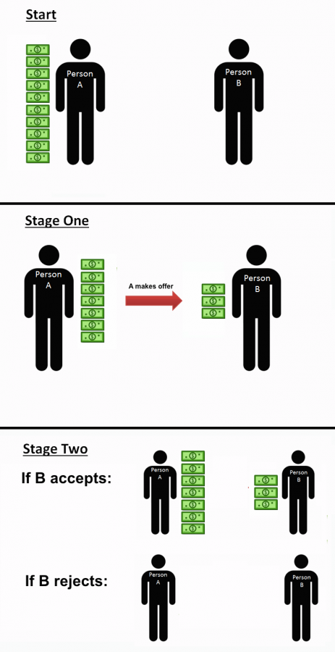

Here's an example with numbers:

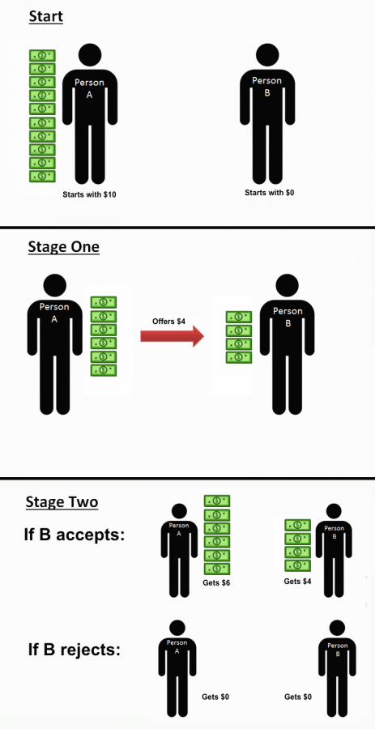
Let's make sure the instructions for this interaction are clear:
For practice, what choice by Person A earns the most for Person B?
Giving $0
Giving $5
Giving $10

For practice, what choice by Person A earns the most for Person A?
Giving $0
Giving $5
Giving $10
It depends on what Person B chooses

For practice, what choice by Person B earns the most for Person B?
Accepting the offer
Rejecting the offer

If participant does not understand instructions: Let's make sure instructions are completely clear. Have the RA walk through the parts of the task with you again. [repeat comprehension questions]

Ok! Now let's have you select for real. Remember, this choice can go toward how much extra you can earn.
Person A
If you are Person A, how much of the $10 will you offer to Person B? You can choose any amount below.
$0
$1
$2
$3
$4
$5
$6
$7
$8
$9
$10

Let's have you select for real. Remember, this choice can go toward how much extra you can earn.
Person B
If you are Person B, please use the slider below to indicate your lowest acceptable offer. That is, if the offer that Person A gives you is below the amount you choose on the slider, you would reject the offer, giving you and Person A $0, and if the offer Person A gives you is above or equal to this amount, you would accept the offer. You can choose any amount below.
 | $0 | $1 | $2 | $3 | $4 | $5 | $6 | $7 | $8 | $9 | $10

 | 0 | 1 | 2 | 3 | 4 | 5 | 6 | 7 | 8 | 9 | 10

Thanks! Let us know you have finished and we'll come back in.

