S1. Approach of isolating individual contributions to PET (Fu and Feng, 2014)
We define and . The subscripts “0” and “1” represent the mean values for the preindustrial period and the mid-Holocene, respectively. The change in a variable x from the preindustrial period to the mid-Holocene is denoted by . Then the change in PET using equation (1) can be written in the form:
From this equation (note that the change in wind speed is small), we can isolate the effect of temperature change as the PET using T_{mean} in the mid-Holocene but RH, U, and AE from the preindustrial period minus the PET using all the inputs from the preindustrial period. The effects of the changes in RH, AE or U are estimated by subtracting PET calculated using RH, AE or U in the preindustrial period but other inputs for the mid-Holocene from that using the inputs from the mid-Holocene.

Table S1. Records documenting aridity changes between the mid-Holocene and the present day for South Asia, South America, Australia and southern Africa. Latitude and longitude are expressed by the standard convention, with + for °N or °E, and − for °S or °W, respectively. N/A denotes not available.
Methods: A = sediment; B = pollen or plant microfossil; C = speleothem; D = organic matter; E = diatom; F = loess and palaeosol; G = dune; H = plant leaf wax.
Sites | Locality | Latitude (°) | Longitude (°) | Elevation (m ASL) | Methods | Record length (¹⁴C ka) | Number of dates (¹⁴C) | Changes | References
Asia (mainly South Asia)
Didwana | N India | 27.33 | 74.58 | N/A | B | ca. 19 | 7 | Wetter | Singh et al. (1990)
Didwana | N India | 27.33 | 74.58 | N/A | A | 12.8 | 7 | Wetter | Wasson et al. (1984)
Gujjar Hut | N India | 30.83~30.87 | 78.78~78.85 | ca. 3500 | B | 6.9 cal | 3 | Wetter | Phadtare (2000)
Lake Sanai | N India | 26.12 | 81.02 | N/A | A; B | 14.8 | 7 | Wetter | Sharma et al. (2006)
Lunkaransar | N India | 28.39 | 73.78 | N/A | A | 10.9 cal | 15 | Wetter | Enzel et al. (1999)
Tso Kar | N India | 33.17 | 78.00 | 4527 | B | 15.2 cal | 32 | Wetter | Demske et al. (2009)
Tso Kar | N India | 33.30 | 78.00 | 4527 | A; B | 36.9 | 41 | Wetter | Wünnemann et al. (2010)
Deosila | NE India | 25.97 | 90.95 | N/A | B | 6.3 | 4 | Wetter | Dixit and Bera (2011)
Sandynallah | S India | 11.00~11.50 | 76.00~77.33 | 2200 | A | >40 | 39 | Wetter | Rajagopalan et al. (1997)
Sandynallah | S India | 11.44 | 76.63 | ca. 2200 | B | 30 | 4 | Drier | Vasanthy (1988)
Nal Sarovar | W India | 22.80 | 72.00 | N/A | A | 6.8 | 8 | Drier | Prasad et al. (1997)
Wadhwana Lake | W India | 22.18 | 73.48 | N/A | A; B | ca. 7.5 cal | 8 | Wetter | Prasad et al. (2014)
Qunf Cave Q5 | Oman | 17.17 | 54.30 | 650 | C | 10.3~2.7; 1.4~0.4 | 18 (Th-U) | Wetter | Fleitmann et al. (2003)
South America
Arroyo Sauce Chico | Argentina | −38.08 | −62.27 | N/A | B | >7 | 1; 1 (TL) | Wetter | Prieto (1996)
Chasico | Argentina | −38.40 | −62.85 | 88 | F | 17.7 cal | 5; 3 (OSL) | Drier | Zech et al. (2009)
Misiones D4 | Argentina | −27.39 | −55.53 | 330 | F | 34.5 | 13 | Drier | Zech et al. (2009)
Mallin Book | Argentina | −41.33 | −71.58 | 800 | B | 12.9 | 9 | Drier | Markgraf (1983)
Vaca Lauquen | Argentina | −36.83 | −71.08 | 1450 | B; E | 10.1 | 3 | Drier | Markgraf (1987)
Upper Parana River Basin | Argentina and Brazil | −23.72 | −53.17 | 250~320 | A; B | 42.5 | 9; 4 (TL) | Unclear | Stevaux (2000)
Laguna Bella Vista | Bolivia | −13.62 | −61.55 | 200~900 | B | >50.8 | 15 | Drier | Mayle et al. (2000)
Laguna Chaplin | Bolivia | −14.47 | −61.06 | 200~900 | B | 38.1 | 14 | Drier | Mayle et al. (2000)
Laguna Sucuara (L1) | Bolivia | −16.83 | −62.04 | 255 | F | 9.5 cal | 4 | Drier | Zech et al. (2009)
Agua Preta de Baixo | Brazil | −18.42 | −41.83 | 470 | D | 10.8 cal | 6 | Drier | Turcq et al. (2002)
Aguas Emendadas | Brazil | −15.57 | −47.58 | 1040~1170 | B; D | 30.5 | 8 | Drier | Barberi et al. (2000)
Cambara do Sul | Brazil | −29.05 | −50.10 | 1040 | B; D | 42.7 | 7 | Drier | (Behling et al., 2004)
Caracarana | Brazil | 3.84 | −59.78 | 104 | D | 11.3 cal | 10 | Drier | Turcq et al. (2002)
Carajas N3 | Brazil | −6.14 | −50.19 | 680 | D | 10.6 cal | 8 | Drier | Turcq et al. (2002)
Crominia | Brazil | −17.25~−17.33 | −49.33~−49.47 | 710 | A; B | 32.1 | 5 | Drier | Salgado-Labouriau et al. (1997)
Comprido Lake | Brazil | −2.21 | −53.90 | N/A | A; D | 9 | 14 | Drier | Moreira et al. (2013)
Dom Helvecio | Brazil | −19.68 | −42.58 | 280 | D | 9.4 cal | 4 | Drier | Turcq et al. (2002)
Lago do Pires | Brazil | −17.95 | −42.22 | 390 | B | 9.5 | 6 | Drier | Behling (1995a)
Lagoa Feia | Brazil | −15.57 | −47.31 | 855 | D | 11 cal | 13 | Drier | Turcq et al. (2002)
Lagoa Nova | Brazil | −17.97 | −42.20 | 390 | B; D | 10.2 | 4 | Drier | Behling (2003)
Lagoa Santa | Brazil | −19.63 | −43.90 | 740 | B | >5.4 | 2 | Drier | Parizzi et al. (1998)
Morro de Itapeva | Brazil | −22.78 | −45.53 | 1850 | B; D | 35 | 9 | Drier | Behling (1997a)
Pantano da Mauritia | Brazil | −6.35 | −50.39 | 740 | A; B; D | 25 cal | 7 | Drier | Hermanowski et al. (2012)
Salitre de Minas | Brazil | −19.00 | −46.77 | 1050 | B | 32 | 14 | Drier | Ledru (1993)
Samambaia Lake | Brazil | −22.60 | −53.38 | N/A | A | 32.7 TL | 7 (TL) | Unclear | Parolin et al. (2008)
Saquinho | Brazil | −10.40 | −43.22 | 480 | B | 11 | 6 | Wetter | De Oliveira et al. (1999)
Serra Campos Gerais | Brazil | −24.67 | −50.22 | 1200 | B; D | 12.5 | 4 | Drier | Behling (1997b)
Serra da Bocaina 2 | Brazil | −22.71 | −44.57 | ca. 1650 | B; D | 10 cal | 3 | Drier | Behling et al. (2007)
Serra da Boa Vista | Brazil | −27.70 | −49.15 | 1160 | B | 13.9 | 4 | Drier | Behling (1995b)
Serra do Rio Rastro | Brazil | −28.38 | −49.55 | 1420 | B | 11.2~1 | 3 | Drier | Behling (1995b)
Serra dos Carajas | Brazil | −6.58 | −49.50 | 600–800 | A | 33.2 | 18 | Drier | Sifeddine et al. (2001)
Serra Norte de Carajas (N 4) | Brazil | −5.83~−6.58 | −49.50~−52.00 | 800 | D | 11.8 cal | 8 | Drier | Cordeiro et al. (2008)
Volta Velha | Brazil | −26.07 | −48.63 | 5 | B | 37.6 | 9 (1 is false) | Drier | Behling and Negrelle (2001)
GIK 17748-2 | Chile | −32.75 | −72.03 | Water depth 2545 | A | ca. 15.6 cal | 6 | Drier | Lamy et al. (1999)
Laguna Aculeo | Chile | −33.83 | −70.92 | 350 | B | 9.6 cal | 14; 15 (²¹⁰Pb) | Drier | Villa-Martínez et al. (2003)
Laguna Aculeo | Chile | −33.83 | −70.90 | 350 | A; B; E | 9.6 cal | 17 | Drier | Jenny et al. (2002)
Laguna Miscanti | Chile | −23.73 | −67.77 | 4140 | B | 22 | 17 | Drier | Grosjean et al. (2001)
Laguna Miscanti | Chile | −23.73 | −67.77 | 4140 | A | 15.5 | 6 | Drier | Valero-Garcés et al. (1996)
Palo Colorado | Chile | −32.08 | −71.48 | N/A | B | 9.4 cal | 11 | Drier | Maldonado and Villagrán (2006)
Quebrada Puripica | Chile | −22.72 | −68.09 | ca. 3200~3600 | A | 7.9 cal | 35 | Wetter | Rech et al. (2003)
Quebrada Puripica | Chile | −22.80 | −68.06 | 3250 | A | 6.2 | 15 | Drier | Grosjean et al. (1997)
Quereo | Chile | −31.83 | −71.50 | ca. 25 | B | 11.6 | 8 | Drier | Villagrán and Varela (1990)
Laguna Lome Linda | Colombia | 3.30 | −73.38 | 310 | B | 8.7 | 8 (1 is poor) | Drier | Behling and Hooghiemstra (2000)
El Junco | Ecuador | 0.00 | −91.05 | ca. 650 | A; B | 10.3 | 6 | Drier | Colinvaux (1972)
Lago Lagunillas | Peru | −15.44 | −70.44 | ca. 4200 | E | 8.0 cal | 14 | Drier | Ekdahl et al. (2008)
Lake Aricota | Peru | −17.37 | −70.28 | 2800 | A | 7.1 cal | 29 | Wetter | Placzek et al. (2001)
Pumacocha | Peru | −10.70 | −76.06 | 4300 | A | 11.2 cal | 18 | Drier | Bird et al. (2011)
Lake Titicaca | Peru and Bolivia | −16.00~−17.50 | −68.50~−70.00 | 3810 | A; E | ca. 27.5 cal | 25 | Drier | Baker et al. (2001)
Los Ajos | Uruguay | −33.70 | −53.95 | 200 | B | 14.8 | 6 | Drier | Iriarte (2006)
Lake Valencia | Venezuela | 10.27 | −67.75 | 402 | A; B | 12.9 | 9 | Wetter | Bradbury et al. (1981)
Lake Valencia | Venezuela | 10.17 | −67.75 | 400 | A | ca. 12.6 | 13 | Wetter | Curtis et al. (1999)
Cariaco Basin | Venezuela | 10.71 | −65.17 | Water depth 893 | A | 14 | 10 | Wetter | Haug et al. (2001)
Australia
Whitehaven Swamp | E Australia | −20.30 | 149.06 | 45 | A; B | ca. 7 | 1 | Wetter | Genever et al. (2003)
Lake Euramoo | NE Australia | −17.17 | 146.63 | 718 | A; B | 23 cal | 22 (3 are excluded); 14 (²¹⁰Pb) | Wetter | Haberle (2005)
Nelly Bay | NE Australia | −19.00 | 147.00 | N/A | Coral | 6.223–5.918 cal | N/A | Drier | Lough et al. (2014)
Black Springs | NW Australia | −15.63 | 126.39 | N/A | A; B | 9.1 cal | 11 | Wetter | Field et al. (2017)
Middens, Flinders Ranges | SC Australia | −31.30 | 139.00 | N/A | B | 7.7 | 34 | Wetter | McCarthy and Head (2001)
Yudnamutana | SC Australia | −30.19 | 139.42 | ca. 8 | C | 11.6 U-Th | 10 (U-Th) | Wetter | Quigley et al. (2010)
Bega Swamp | SE Australia | −36.04 | 149.75 | N/A | B | 13.9 cal | 39 | Wetter | Hope et al. (2004)  Donders et al. (2007)
Club Lake | SE Australia | −36.42 | 148.29 | 1955 | B | 9.7 | 13 | Wetter | Martin (1986)
Lake Gnotuk | SE Australia | −38.22 | 143.10 | N/A | A | 21.8 OSL | 15; 15(OSL) | Wetter | Wilkins et al. (2013)
Lake Keilambete | SE Australia | −38.21 | 142.88 | N/A | A | 9.4 OSL | 13; 14(OSL) | Wetter | Wilkins et al. (2013)
Sperm Whale Head | SE Australia | −37.74 | 148.08 | N/A | B | 7.2 | 4 | Wetter | Hooley et al. (1980)
Southern Africa
1078 Hole C | Angola | −11.91 | 13.4 | >1000 | B | 44.9 | 8 | Wetter | Dupont et al. (2008)
Lake Challa | Kenya and Tanzania | −3.32 | 37.7 | 880 | H | 25 cal | 19 | Drier | Tierney et al. (2011)
River Mouth | Congo | −5.94 | 11.47 | N/A | H | 35.8 | 15 | Wetter | Schefuß et al. (2005)
Lake Rukwa | Tanzania | −8.42 | 32.72 | 793 | B | 16.8 | 9 | Wetter | Vincens et al. (2005)
Lake Malawi | Tanzania | −9.97 | 34.22 | N/A | H | 24.3 cal | 14 | Wetter | Castañeda et al. (2007)
Lake Ngami | Botswana | −20.5 | 22.4 | 922 | A | ca. 40.5 | 6 | Drier | Huntsman-Mapila et al. (2006)
Stampriet Aquifer | Namibia | −24 | 19.5 | 1125~1250 | Noble gas | 30 | N/A | Wetter | Stute et al. (1998)
Wonderwerk Cave | South Africa | −27.8 | 23.6 | 1680 | C | 35 | 16 | Drier | Brook et al. (2010)
Lake Eteza | South Africa | −28.5 | 32.2 | 14 | B | 10.2 cal | 19 | Wetter | Neumann et al. (2010)
Rietvlei wetland | South Africa | −34.4 | 21.5 | 17 | B | 16 cal | 9 | Drier | Quick et al. (2015)
Katbakkies Pass | South Africa | −32.9 | 19.6 | 1170 | B | 7 cal | 8 | Wetter | Chase et al. (2015)

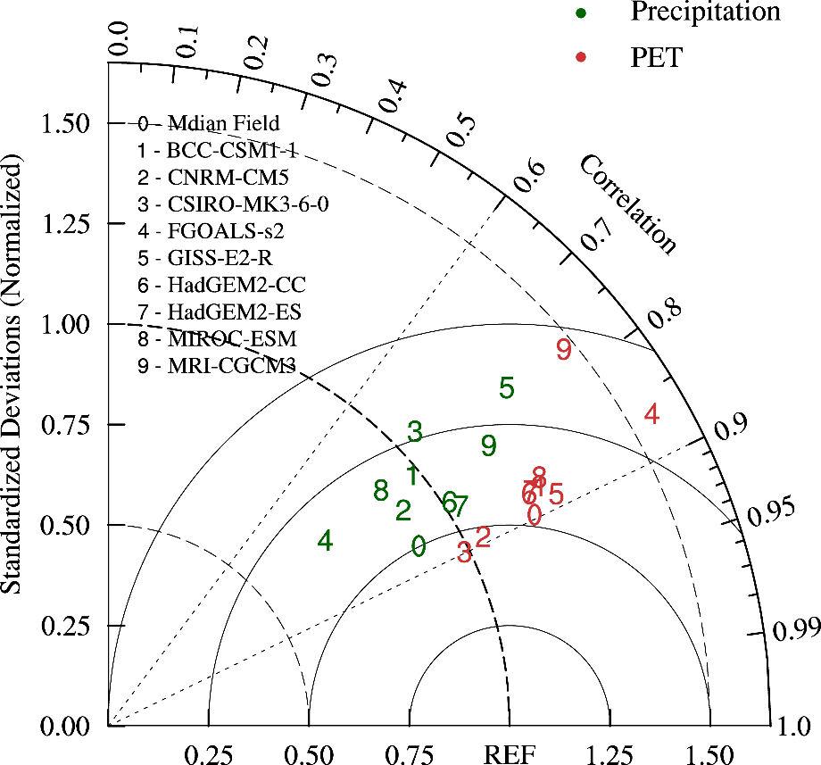
Fig. S1. Taylor diagram (Taylor, 2001) for displaying normalized pattern statistics of climatological annual precipitation and PET from 60°S to 60°N between PMIP3 models for the preindustrial period and observations for the period 1981–2010. Green number represents precipitation comparisons between models and PREC/L; red number represents PET comparison between models and NCEP-2; observations are regarded as the reference values (REF). The radial distance from the origin is the normalized standard deviation of a model; the spatial correlation coefficient between a model and the reference is expressed by the azimuthal position of the model; and the normalized centred root-mean-square difference between a model and the reference is their distance apart. The standard deviation and the centred root-mean-square difference are normalized by the observed standard deviation.

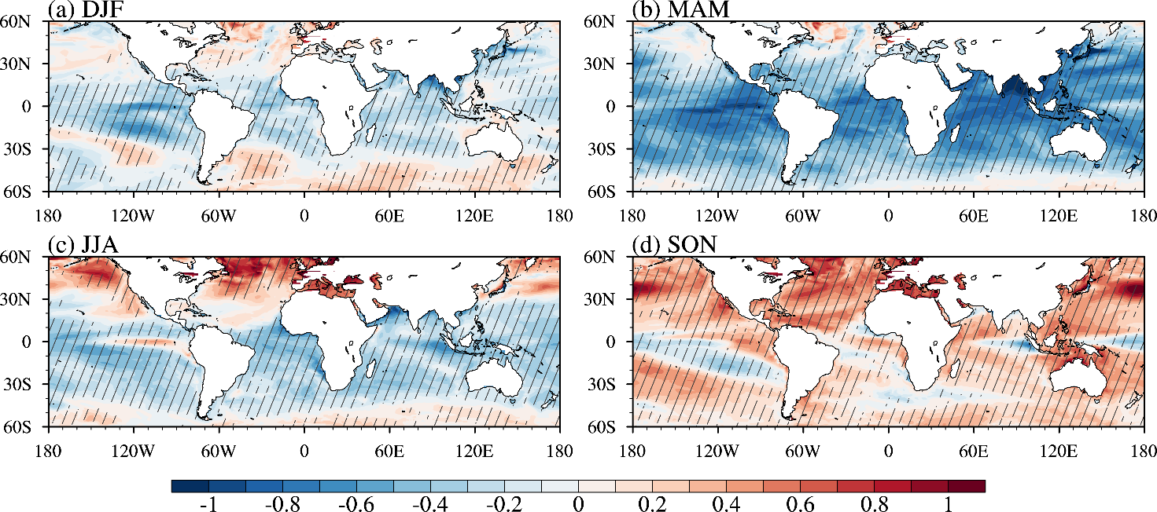
Fig. S2. The mid-Holocene change in sea surface temperature (°C) for (a) December–February, (b) March–May, (c) June–August, and (d) September–November. Diagonal lines denote that at least 6 of 9 models agree on the sign of the change.

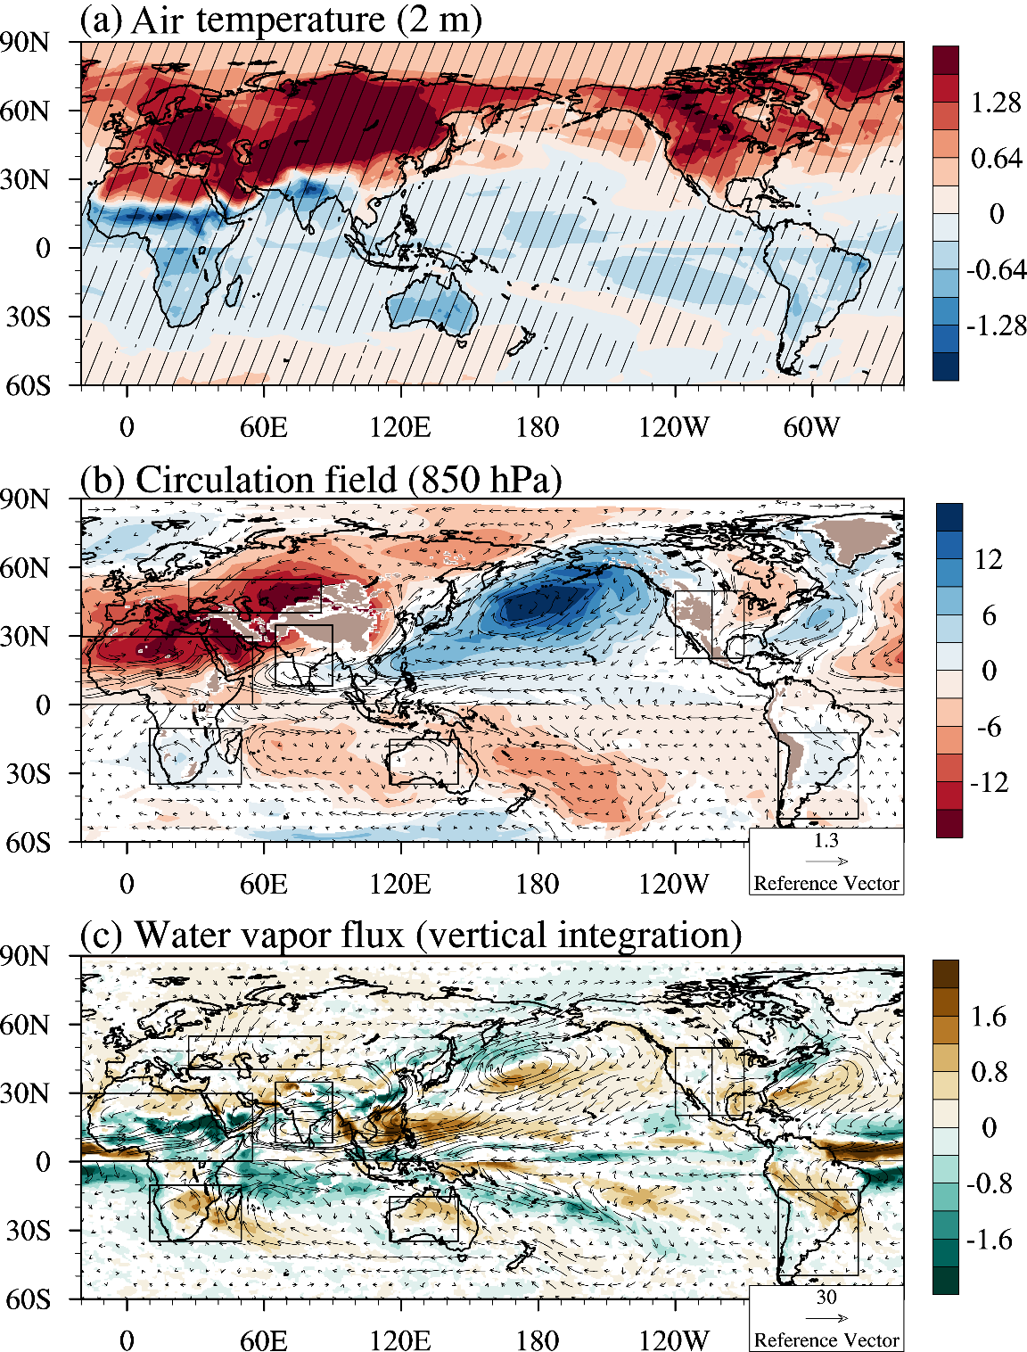
Fig. S3. Relative to the preindustrial period, the mid-Holocene change during summertime (June–August for the northern hemisphere and December–February for the southern hemisphere) in (a) near-surface air temperature at 2 m (°C), (b) the geopotential height (m) and wind filed (m·s⁻¹) at 850 hPa, and (c) the water vapor flux (g·cm⁻¹·s⁻¹) and its divergence (10⁻³ g·m⁻²·s⁻¹) integrated from the surface to 200 hPa. Diagonal lines in (a) denote that at least 6 out of 9 models agree on the sign of the change. Divergence in (b–c) is plotted only where at least 6 out of 9 models agree on the sign.

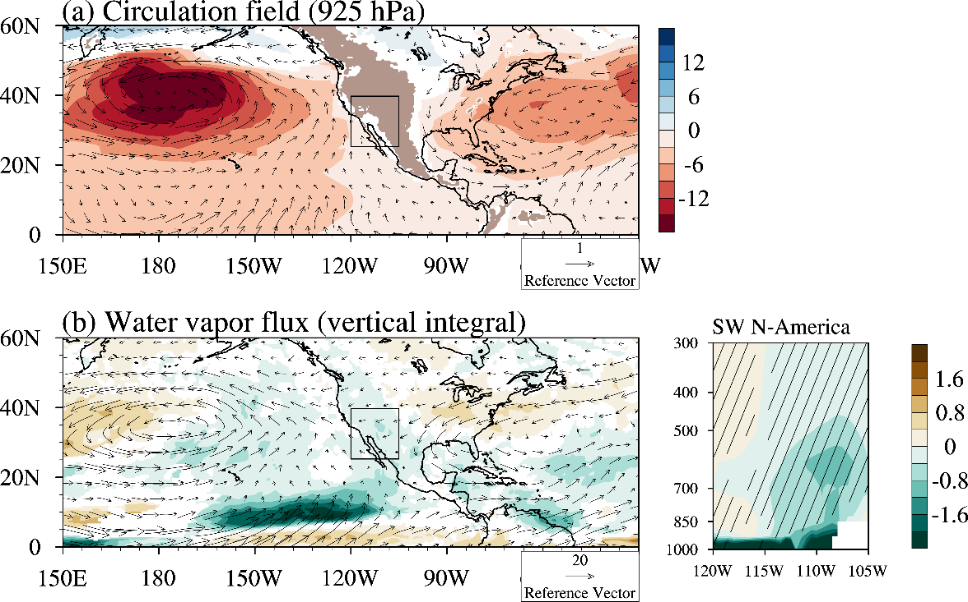
Fig. S4. The left-hand parts are same as Figs. S3b–c but in boreal spring (March–May) and for 925 hPa in (a). The right-hand figure in (b) shows the meridional-mean (25–40°N) change of the water vapor divergence for southwestern North America. Diagonal lines denote that at least 6 out of 9 models agree on the sign of the change.

References
Baker PA, Seltzer GO, Fritz SC et al. (2001) The history of South American tropical precipitation for the past 25,000 years. Science 291: 640–643.
Barberi M, Salgado-Labouriau ML and Suguio K (2000) Paleovegetation and paleoclimate of “Vereda de Águas Emendadas”, central Brazil. Journal of South American Earth Sciences 13: 241–254.
Behling H (1995a) A high resolution Holocene pollen record from Lago do Pires, SE Brazil: vegetation, climate and fire history. Journal of Paleolimnology 14: 253–268.
Behling H (1995b) Investigations into the Late Pleistocene and Holocene history of vegetation and climate in Santa Catarina (S Brazil). Vegetation History and Archaeobotany 4: 127–152.
Behling H (1997a) Late Quaternary vegetation, climate and fire history from the tropical mountain region of Morro de Itapeva, SE Brazil. Palaeogeography, Palaeoclimatology, Palaeoecology 129: 407–422.
Behling H (1997b) Late Quaternary vegetation, climate and fire history of the Araucaria forest and campos region from Serra Campos Gerais, Paraná State (South Brazil). Review of Palaeobotany and Palynology 97: 109–121.
Behling H (2003) Late glacial and Holocene vegetation, climate and fire history inferred from Lagoa Nova in the southeastern Brazilian lowland. Vegetation History and Archaeobotany 12: 263–270.
Behling H, Dupont L, DeForest Safford H et al. (2007) Late Quaternary vegetation and climate dynamics in the Serra da Bocaina, southeastern Brazil. Quaternary International 161: 22–31.
Behling H and Hooghiemstra H (2000) Holocene Amazon rainforest–savanna dynamics and climatic implications: high-resolution pollen record from Laguna Loma Linda in eastern Colombia. Journal of Quaternary Science 15: 687–695.
Behling H and Negrelle RRB (2001) Tropical rain forest and climate dynamics of the Atlantic lowland, southern Brazil, during the Late Quaternary. Quaternary Research 56: 383–389.
Behling H, Pillar VD, Orlóci L et al. (2004) Late Quaternary Araucaria forest, grassland (Campos), fire and climate dynamics, studied by high-resolution pollen, charcoal and multivariate analysis of the Cambará do Sul core in southern Brazil. Palaeogeography, Palaeoclimatology, Palaeoecology 203: 277–297.
Bird BW, Abbott MB, Rodbell DT et al. (2011) Holocene tropical South American hydroclimate revealed from a decadally resolved lake sediment δ¹⁸O record. Earth and Planetary Science Letters 310: 192–202.
Bradbury JP, Leyden B, Salgado-Labouriau M et al. (1981) Late Quaternary environmental history of Lake Valencia, Venezuela. Science 214: 1299–1305.
Brook GA, Scott L, Railsback LB et al. (2010) A 35 ka pollen and isotope record of environmental change along the southern margin of the Kalahari from a stalagmite and animal dung deposits in Wonderwerk Cave, South Africa. Journal of Arid Environments 74: 870–884.
Castañeda IS, Werne JP and Johnson TC (2007) Wet and arid phases in the southeast African tropics since the last glacial maximum. Geology 35: 823–826.
Chase BM, Lim S, Chevalier M et al. (2015) Influence of tropical easterlies in southern Africa's winter rainfall zone during the Holocene. Quaternary Science Reviews 107: 138–148.
Colinvaux PA (1972) Climate and the Galapagos islands. Nature 240: 17–20.
Cordeiro RC, Turcq B, Suguio K et al. (2008) Holocene fires in East Amazonia (Carajás), new evidences, chronology and relation with paleoclimate. Global and Planetary Change 61: 49–62.
Curtis JH, Brenner M and Hodell DA (1999) Climate change in the Lake Valencia Basin, Venezuela, ~12600 yr BP to present. The Holocene 9: 609–619.
De Oliveira PE, Barreto AMF and Suguio K (1999) Late Pleistocene/Holocene climatic and vegetational history of the Brazilian caatinga: the fossil dunes of the middle São Francisco River. Palaeogeography, Palaeoclimatology, Palaeoecology 152: 319–337.
Demske D, Tarasov PE, Wünnemann B et al. (2009) Late glacial and Holocene vegetation, Indian monsoon and westerly circulation in the Trans-Himalaya recorded in the lacustrine pollen sequence from Tso Kar, Ladakh, NW India. Palaeogeography, Palaeoclimatology, Palaeoecology 279: 172–185.
Dixit S and Bera S (2011) Mid-Holocene vegetation and climatic variability in tropical deciduous sal (Shorea robusta) forest of lower Brahmaputra valley, Assam. Journal of the Geological Society of India 77: 419–432.
Donders TH, Haberle SG, Hope G et al. (2007) Pollen evidence for the transition of the eastern Australian climate system from the post-glacial to the present-day ENSO mode. Quaternary Science Reviews 26: 1621–1637.
Dupont LM, Behling H and Kim JH (2008) Thirty thousand years of vegetation development and climate change in Angola (Ocean Drilling Program Site 1078). Climate of the Past 4: 107–124.
Ekdahl EJ, Fritz SC, Baker PA et al. (2008) Holocene multidecadal- to millennial-scale hydrologic variability on the South American Altiplano. The Holocene 18: 867–876.
Enzel Y, Ely LL, Mishra S et al. (1999) High-resolution Holocene environmental changes in the Thar Desert, northwestern India. Science 284: 125–128.
Field E, McGowan HA, Moss PT et al. (2017) A late Quaternary record of monsoon variability in the northwest Kimberley, Australia. Quaternary International 449: 119–135.
Fleitmann D, Burns SJ, Mudelsee M et al. (2003) Holocene forcing of the Indian monsoon recorded in a stalagmite from southern Oman. Science 300: 1737–1739.
Fu Q and Feng S (2014) Responses of terrestrial aridity to global warming. Journal of Geophysical Research: Atmospheres 119: 7863–7875.
Genever M, Grindrod J and Barker B (2003) Holocene palynology of Whitehaven Swamp, Whitsunday Island, Queensland, and implications for the regional archaeological record. Palaeogeography, Palaeoclimatology, Palaeoecology 201: 141–156.
Grosjean M, Núñez L, Cartajena I et al. (1997) Mid-Holocene climate and culture change in the Atacama Desert, northern Chile. Quaternary Research 48: 239–246.
Grosjean M, van Leeuwen JFN, van der Knaap WO et al. (2001) A 22,000 ¹⁴C year BP sediment and pollen record of climate change from Laguna Miscanti (23°S), northern Chile. Global and Planetary Change 28: 35–51.
Haberle SG (2005) A 23,000-yr pollen record from Lake Euramoo, wet tropics of NE Queensland, Australia. Quaternary Research 64: 343–356.
Haug GH, Hughen KA, Sigman DM et al. (2001) Southward migration of the intertropical convergence zone through the Holocene. Science 293: 1304–1308.
Hermanowski B, da Costa ML and Behling H (2012) Environmental changes in southeastern Amazonia during the last 25,000 yr revealed from a paleoecological record. Quaternary Research 77: 138–148.
Hooley AD, Southern W and Kershaw AP (1980) Holocene vegetation and environments of sperm whale head, Victoria, Australia. Journal of Biogeography 7: 349–362.
Hope G, Kershaw AP, van der Kaars S et al. (2004) History of vegetation and habitat change in the Austral–Asian region. Quaternary International 118–119: 103–126.
Huntsman-Mapila P, Ringrose S, Mackay AW et al. (2006) Use of the geochemical and biological sedimentary record in establishing palaeo-environments and climate change in the Lake Ngami basin, NW Botswana. Quaternary International 148: 51–64.
Iriarte J (2006) Vegetation and climate change since 14,810 ¹⁴C yr B.P. in southeastern Uruguay and implications for the rise of early Formative societies. Quaternary Research 65: 20–32.
Jenny B, Valero-Garcés BL, Villa-Martínez R et al. (2002) Early to mid-Holocene aridity in central Chile and the southern westerlies: the Laguna Aculeo record (34°S). Quaternary Research 58: 160–170.
Lamy F, Hebbeln D and Wefer G (1999) High-resolution marine record of climatic change in mid-latitude Chile during the last 28,000 years based on terrigenous sediment parameters. Quaternary Research 51: 83–93.
Ledru M-P (1993) Late Quaternary environmental and climatic changes in central Brazil. Quaternary Research 39: 90–98.
Lough JM, Llewellyn LE, Lewis SE et al. (2014) Evidence for suppressed mid-Holocene northeastern Australian monsoon variability from coral luminescence. Paleoceanography 29: 581–594.
Maldonado A and Villagrán C (2006) Climate variability over the last 9900 cal yr BP from a swamp forest pollen record along the semiarid coast of Chile. Quaternary Research 66: 246–258.
Markgraf V (1983) Late and postglacial vegetational and paleoclimatic changes in subantarctic, temperate, and arid environments in Argentina. Palynology 7: 43–70.
Markgraf V (1987) Paleoenvironmental changes at the northern limit of the subantarctic Nothofagus forest, lat 37°S, Argentina. Quaternary Research 28: 119–129.
Martin ARH (1986) Late glacial and Holocene alpine pollen diagrams from the Kosciusko National Park, New South Wales, Australia. Review of Palaeobotany and Palynology 47: 367–409.
Mayle FE, Burbridge R and Killeen TJ (2000) Millennial-scale dynamics of southern Amazonian rain forests. Science 290: 2291–2294.
McCarthy L and Head L (2001) Holocene variability in semi-arid vegetation: new evidence from Leporillus middens from the Flinders Ranges, South Australia. The Holocene 11: 681–689.
Moreira LS, Moreira-Turcq P, Cordeiro RC et al. (2013) Holocene paleoenvironmental reconstruction in the eastern Amazonian basin: Comprido lake. Journal of South American Earth Sciences 44: 55–62.
Neumann FH, Scott L, Bousman CB et al. (2010) A Holocene sequence of vegetation change at Lake Eteza, coastal KwaZulu-Natal, South Africa. Review of Palaeobotany and Palynology 162: 39–53.
Parizzi MG, Salgado-Labouriau ML and Kohler HC (1998) Genesis and environmental history of Lagoa Santa, southeastern Brazil. The Holocene 8: 311–321.
Parolin M, Volkmer-Ribeiro C and Stevaux JC (2008) Use of spongofacies as a proxy for river-lake paleohydrology in Quaternary deposits of central-western Brazil. Revista Brasileira de Paleontologia 11: 187–198.
Phadtare NR (2000) Sharp decrease in summer monsoon strength 4000–3500 cal yr B.P. in the Central Higher Himalaya of India based on pollen evidence from alpine peat. Quaternary Research 53: 122–129.
Placzek C, Quade J and Betancourt JL (2001) Holocene lake-level fluctuations of lake Aricota, southern Peru. Quaternary Research 56: 181–190.
Prasad S, Kusumgar S and Gupta SK (1997) A mid to late Holocene record of palaeoclimatic changes from Nal Sarovar: a palaeodesert margin lake in western India. Journal of Quaternary Science 12: 153–159.
Prasad V, Farooqui A, Sharma A et al. (2014) Mid–late Holocene monsoonal variations from mainland Gujarat, India: A multi-proxy study for evaluating climate culture relationship. Palaeogeography, Palaeoclimatology, Palaeoecology 397: 38–51.
Prieto AR (1996) Late Quaternary vegetational and climatic changes in the Pampa grassland of Argentina. Quaternary Research 45: 73–88.
Quick LJ, Carr AS, Meadows ME et al. (2015) A late Pleistocene–Holocene multi-proxy record of palaeoenvironmental change from Still Bay, southern Cape Coast, South Africa. Journal of Quaternary Science 30: 870–885.
Quigley MC, Horton T, Hellstrom JC et al. (2010) Holocene climate change in arid Australia from speleothem and alluvial records. The Holocene 20: 1093–1104.
Rajagopalan G, Sukumar R, Ramesh R et al. (1997) Late Quaternary vegetational and climatic changes from tropical peats in southern India – An extended record up to 40,000 years BP. Current Science: 60–63.
Rech JA, Pigati JS, Quade J et al. (2003) Re-evaluation of mid-Holocene deposits at Quebrada Puripica, northern Chile. Palaeogeography, Palaeoclimatology, Palaeoecology 194: 207–222.
Salgado-Labouriau ML, Casseti V, Ferraz-Vicentini KR et al. (1997) Late Quaternary vegetational and climatic changes in cerrado and palm swamp from Central Brazil. Palaeogeography, Palaeoclimatology, Palaeoecology 128: 215–226.
Schefuß E, Schouten S and Schneider RR (2005) Climatic controls on central African hydrology during the past 20,000 years. Nature 437: 1003–1006.
Sharma S, Joachimski MM, Tobschall HJ et al. (2006) Correlative evidences of monsoon variability, vegetation change and human inhabitation in Sanai lake deposit: Ganga Plain, India. Current Science 90: 973–978.
Sifeddine A, Martin L, Turcq B et al. (2001) Variations of the Amazonian rainforest environment: a sedimentological record covering 30,000 years. Palaeogeography, Palaeoclimatology, Palaeoecology 168: 221–235.
Singh G, Wasson RJ and Agrawal DP (1990) Vegetational and seasonal climatic changes since the last full glacial in the Thar Desert, northwestern India. Review of Palaeobotany and Palynology 64: 351–358.
Stevaux JC (2000) Climatic events during the late Pleistocene and Holocene in the Upper Parana River: Correlation with NE Argentina and South-Central Brazil. Quaternary International 72: 73–85.
Stute, M, Talma, AS., 1998. Glacial temperatures and moisture transport regimes reconstructed from noble gas and δ¹⁸O, Stampriet aquifer, Namibia. In: Isotope Techniques in the Study of Environmental Change. Vienna: IAEA Vienna Symposium 1997, pp. 307–328.
Taylor KE (2001) Summarizing multiple aspects of model performance in a single diagram. Journal of Geophysical Research: Atmospheres 106: 7183–7192.
Tierney JE, Russell JM, Damste JSS et al. (2011) Late Quaternary behavior of the East African monsoon and the importance of the Congo Air Boundary. Quaternary Science Reviews 30: 798–807.
Turcq B, Albuquerque ALS, Cordeiro RC et al. (2002) Accumulation of organic carbon in five Brazilian lakes during the Holocene. Sedimentary Geology 148: 319–342.
Valero-Garcés BL, Grosjean M, Schwalb A et al. (1996) Limnogeology of Laguna Miscanti: evidence for mid to late Holocene moisture changes in the Atacama Altiplano (Northern Chile). Journal of Paleolimnology 16: 1–21.
Vasanthy G (1988) Pollen analysis of Late Quaternary sediments: evolution of upland savanna in Sandynallah (Nilgiris, South India). Review of Palaeobotany and Palynology 55: 175–192.
Villa-Martínez R, Villagrán C and Jenny B (2003) The last 7500 cal yr B.P. of westerly rainfall in Central Chile inferred from a high-resolution pollen record from Laguna Aculeo (34°S). Quaternary Research 60: 284–293.
Villagrán C and Varela J (1990) Palynological evidence for increased aridity on the central Chilean coast during the Holocene. Quaternary Research 34: 198–207.
Vincens A, Buchet G, Williamson D et al. (2005) A 23,000 yr pollen record from Lake Rukwa (8°S, SW Tanzania): New data on vegetation dynamics and climate in Central Eastern Africa. Review of Palaeobotany and Palynology 137: 147–162.
Wasson RJ, Smith GI and Agrawal DP (1984) Late Quaternary sediments, minerals, and inferred geochemical history of Didwana Lake, Thar Desert, India. Palaeogeography, Palaeoclimatology, Palaeoecology 46: 345–372.
Wilkins D, Gouramanis C, De Deckker P et al. (2013) Holocene lake-level fluctuations in Lakes Keilambete and Gnotuk, southwestern Victoria, Australia. The Holocene 23: 784–795.
Wünnemann B, Demske D, Tarasov P et al. (2010) Hydrological evolution during the last 15 kyr in the Tso Kar lake basin (Ladakh, India), derived from geomorphological, sedimentological and palynological records. Quaternary Science Reviews 29: 1138–1155.
Zech W, Zech M, Zech R et al. (2009) Late Quaternary palaeosol records from subtropical (38°S) to tropical (16°S) South America and palaeoclimatic implications. Quaternary International 196: 107–120.

