Figure S1.

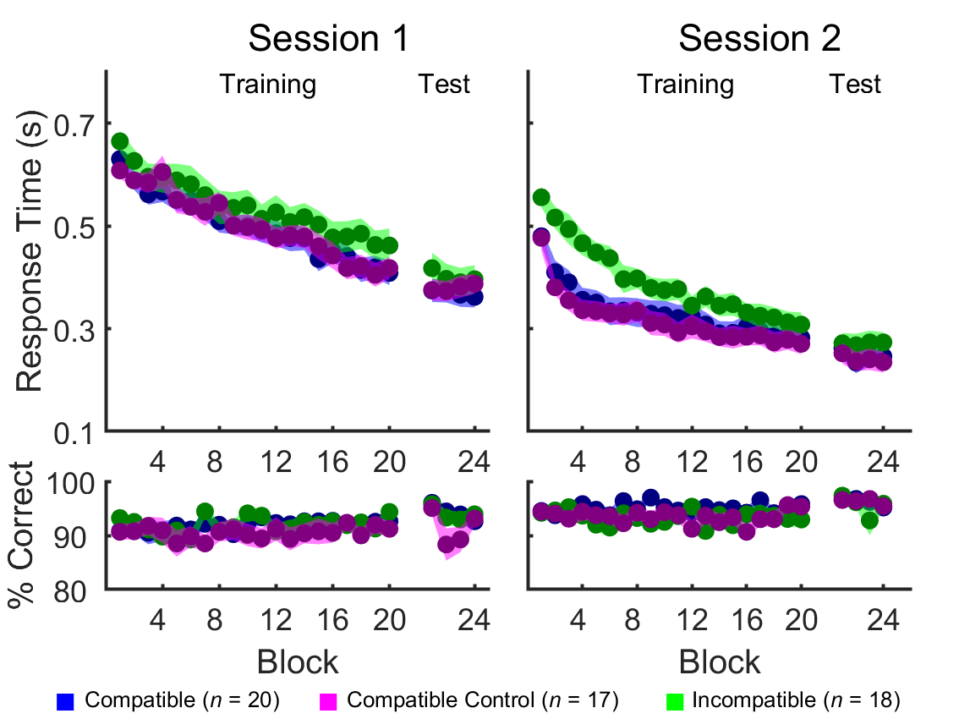
Figure S1: Response time (top) and percentage of correct transitions (bottom) computed across all transitions are plotted for the Compatible Control group (magenta) as part of Experiment 1b as well as the Compatible (blue) and Incompatible (green) groups from Experiment 1a. Shaded regions represent standard error of the mean. There were no group differences in Session 1 Training or Test phases (see main text for statistics), indicating comparable performance prior to the experimental manipulation. The Compatible Control group was significantly faster than the Incompatible group during Session 2 Training (RT: F_{(1,33)}=8.97, Ƞ_{p}²=0.214, p=0.005; % Correct: F_{(1,33)}=0.11, Ƞ_{p}²=0.003, p=0.74), replicating the results from Experiment 1a and demonstrating that the ordinal compatibility of the complete (8-element) sequences across the two testing days – and not the similarity of the beginning elements of the sequences only - influences motor performance. Figure 4 in the main text depicts RT and percentage correct separately for the shared novel and learned transitions in Session 2.

Figure S2.
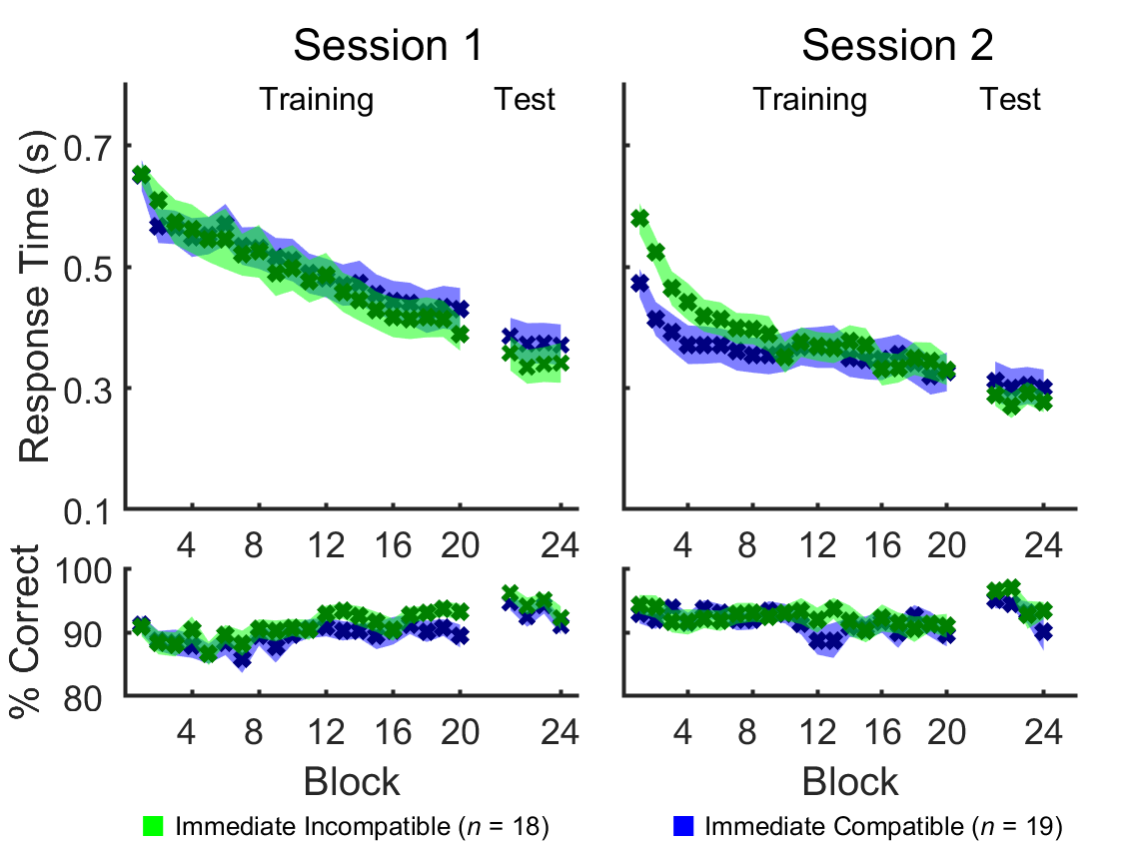
Figure S2: Response time (top) and percentage of correct transitions (bottom) computed across all transitions are plotted for Immediate Incompatible (green) and Immediate Compatible (blue) groups from Experiment 2. Shaded regions represent standard error of the mean. There were no group differences in Session 1 Training or Test phases (see main text for statistics), indicating comparable performance prior to the experimental manipulation. In contrast to Experiment 1a, there were no group differences in Session 2 training phase (RT: F_{(1,35)}=0.64, Ƞ_{p}²=0.018, p=0.43; % Correct: F_{(1,35)}=0.13, Ƞ_{p}²=0.004, p=0.72), demonstrating the ordinal compatibility of the sequences across the two testing days fails to influence motor performance if the memory trace acquired on Day 1 does not have the opportunity to consolidate overnight. See Figure 5 in the main text for depiction of the shared novel and learned transitions in Session 2.

