APPENDIX

Table 1A. Characteristics of the TTOs whose Heads were interviewed by the authors.ª
 | TTO A | TTO B | TTO C | TTO D | TTO E | TTO F | TTO G
TTO staff | 70 (+3 part−time) | 10 | 52 | 40 | 9 | 42 | 1
Research budget | £68.28m | £3.41m | £119.60m | £33.80m | £48.11m | £94.34m | £1.2m
Specialization | Spinoffs | KTPs | Spinoffs/  Licensing | Spinoffs/  Licensing/KTPs | Spinoffs/  Licensing/KTPs | Spinoffs/  Licensing | Licensing
First spinoff | 1967 | 1999 | 1963 | 1977 | 1981 | 1984 | 2007
No. of spinoffs | 59 | 14 | 68 | 55 | 31 | 76 | 2
Location | Scotland | London | England | Scotland | England | London | London
Autonomy | 1 (1998) to 3 (today) | 2 | 3 | 2 | 2 | 3 | 1
Length of the interview | 68mins | 66mins | 49mins | 67mins | 99mins | 57mins | 49mins
ª TTO names have been removed for anonymity.

Table 2A. Evidence of TTO awareness of the commercialization leader

TTO | Key quotes from interviews
A | “We’ve had quite a lot of experience here in the university of playing around equity stakes. We pinched that strategy from, I think it was Stanford or MIT, where we insisted on a non−dilutable equity stake...’[…] ‘I know it has worked with some, e.g. Oxford... Surrey and Southampton have done it, but we just don’t like it. We don’t like that deal structure...”
B | “...the real model of what should be done in the pathways is King’s College. It’s worth talking to them – they are very good with spinouts.’[...] ‘...if you look at the reports on commercial activities you know... Oxford, Cambridge, Imperial are top of the scale.’ ‘...there is a lot that we can learn from all the universities...  I mean there is a whole body of work that you ought to be leading up to with regards to the difficulty of spinouts in universities... And there’s people who are much more experts than me in doing that. Loads of discussion papers, maybe you should look up some like UNICO, they have some discussion papers.”
C | “Well we mostly cooperate and meet up with the other three and we talk about our common problems and issues and it doesn’t matter whether it is Cambridge or Stanford or whoever it is.’ [...] ‘Obviously, each of the tech−transfers particularly the bigger ones are all run on different grounds. I mean Imperial Innovations is an AIM−listed company, so their strategy will have to be slightly different from ours. Cambridge is quite similar to us… we know what their KPIs at Cambridge are and they watch us as well. But this is not in a competitive sense really, it’s benchmarking yourself. Because we have to benchmark ourselves against what has to be Cambridge and Imperial so I think that’s healthy.”
D | “Probably the ones who have the best track records are Edinburgh (it has the biggest research base). In England you hear about Oxford and Cambridge and, obviously, Imperial...’ […] ‘I think it’s fair to say that other schools have come to us, to learn from us. I mean, there are offices that are run by people who started their careers here.”
E | “The sort of people that we would consider being with would be the Imperials, they are the sort of biotechs. UCL is quite good...’ [...] ‘...we have good schools here, you know Oxford, Cambridge and Imperial. OK, they have a very high profile in technology transfer and they have done very, very well.”
F | “We have a good relationship with Imperial so we often swap ideas with Imperial, discuss with them and do the same with Oxford and Cambridge.”
G | “Imperial, UCL and Oxford are doing great but they are in a kind of different league from us. We’ve used UCL for advice because they have done social enterprises before as they are big in health care. We have also been part of a group and we’ve had some funding for commercialization activities in SW London. So Brunel, Royal Holloway, St. George’s, Roehampton and Westminster were all part of it. So those institutions are pretty cooperative.”

Table 3A. Evidence of varying degrees of strategic and operational autonomy among TTOs
 | Mandate | Autonomy 0 | Autonomy 1 | Autonomy 2 | Autonomy 3
STRATEGIC | a) React/  adapt to emerging issues (e.g. competitors moves) |  | “We had a meeting today and we discussed about a new technique for doing it and it is quite a lot more expensive and it takes more time but as time goes on that may come down in price and become quicker. It is a kit that the hospital uses and we have to keep an eye on that to make sure that when we come out with our product that it occupies the place in the market where we are aiming after. That kind of thing I discuss with potentially the research/enterprise director in the faculty and with the academics.”  [TTO G] | “In the last 3 years, as far as spinouts are concerned, electrical engineering has become quite dominant – it’s one of the research departments that is closest to the market, and work has been done there in collaboration with firms like Scottish Power, so research there is addressing specific market needs. So it’s a market pool...” [TTO D] | “We don’t have anything like Biofusion but we have two deals, one with IP Group but it’s totally different from all the others… The other one we have is with Technikos which is in the medical engineering sciences so again anything that is from the engineering... So it doesn’t affect how we commercialise things. But the timing suited us because we got a new chemistry building and same way we could build a medical engineering centre” [TTO C]
 | b) Take strategic decisions independently (e.g. suppliers) | “I wasn’t here in the early 90’s and I don’t think my boss was either. There were only 1−2 people... Maybe the strategy was there but it takes a while to develop the rules that will ensure that you get the results you wanted otherwise you can stop spending...” [TTO B] | “We have a lot of autonomy but we have to check back with the management team in the Faculty but also up to the Vice−Chancellor. The person I need to keep updated is primarily the Dean of the Faculty and the Pro−Vice−Chancellor of Enterprise”. [TTO G]  “We are getting some advice from UCL and in order to do that, we just had to renew the contract we had with them and we asked the Dean to sign off that but I have freedom as to how I use that resource.” [TTO G] | “We have corporate strategy where each department will generate enterprise strategy and that will go into faculty enterprise strategy.” [TTO B]  “The other half of my role is to manage the university’s relationship as a shareholder with existing spinout companies and hopefully to help maximize the returns from those companies by adding value to them” [TTO D]  “Maybe I’m not talking like a traditional TTO manager – more like a marketing or sales person. I view the university personally as a business: it’s an academic business, a non−profit business, a charity business, but a business nonetheless.” [TTO E] | “It looks as if we are going to move towards a much more active strategy of managing out equity, whereby we look at selling a lot of our equity to secondary funds or we look to, perhaps, sell back our shares to the companies at a reasonable valuation.” [TTO A]  “…we have a Board, an external Chairman of the Board and three external Directors and then another three Directors and myself, our Managing Director and our Vice President of Enterprise… But it’s quite nice to have an autonomous Board and be independent and able to do what we want. “ [TTO F]
 | c) Have bargaining power over other actors within the university (e.g. scientists or administrators) | “Most company formation support was provided through what we used to call our Business Development teams. Basically, we had commercial people and they did licensing, they did commercial research contracts… and an academic who wanted to set up a company they did their best.” [TTO A] | “Lots of these things come down to building relationships and trust, so the ones that I work closely with accept the advice and approach to how we do the commercialization. If it gets to a situation where we have different opinions, then we can go up the chain... up to Director of Research.” [TTO G] | “So, we have business development managers based in the faculties, we have this core of people with our Head of Research and Business Development, the Deputy and a couple of Managers sitting here plus, we have some staff which support the academics with research grants.” [TTO B]  “We do get proposals from academics saying ‘I’ll just apply for that funding and do some interesting work’ and we would say ‘No, you won’t, you’ll get some commercial value to your proposal as well – there’s got to be a proper business plan, there’s got to be evidence of commercial need rather than just an interesting project that you want to do.” [TTO D] | “So we do involve the academics when we can, we don’t force them because sometimes it can be very good, but at the end of the day we don’t do a deal against an academic’s wishes. But a lot of the times there is a close partnership particularly in a spinout, the project manager and the academic become very close to each other during that period...” [TTO C]
 | d) Possess critical strategic resources (e.g. knowledge, networking or even physical resources like space) | “Until 2000 this office was quite small because it was funded by the university. So there would be someone looking after the enterprises, someone looking after KTPs and consultancy – it was maybe half a dozen people.” [TTO B] | “I got control over the budget... for that and when we need academic space... I haven’t really needed additional space resources on that but that is a project by project thing. Part of the last spinout deal was working on some space at St George’s where they are located and I helped in the negotiations for that.... You wouldn’t get an outside company having that deal from them. So I helped to influence the recognition that there was some value in the company being set up internally.” [TTO G]  “We decided that it would be more cost−effective to have an external company than do it in−house. That company were experts in taking more volume and they had the technique to create a lot rather than having us trying to do it because we are not good at mass production...” [TTO G] | “Some conflicts of interest have to be carefully managed and sometimes they cause friction. Some spinouts had to be set up and occupy space within the university and they needed particularly lab space etc.” [TTO D]  “…most of the funds that we have are ultimately derived from grant opportunities from the government to set up certain things – I think it’s one million per year or something and if you look at how much the university spends it is insignificant… So we have the legal department – all of what they do is research contracts such as ESRC or EU contracts.” [TTO E] | “ETTC...was established years ago as a joint venture of the university and the city council (the city council is technically still a shareholder but they are not involved anymore)... It has become the vehicle for incubation activities... It owns two buildings and it has a deal to run incubation in two other buildings... it buys staff from Edinburgh Research and Innovation which is the TTO... So, it has to wash its own feet and it has to maintain some funds for emergencies...” [TTO A]  “We also have 6 staff dealing with consultancies, and then we have what we call back−office staff dealing with legal, patenting, finance... We’ll also provide payroll services for our spinouts and subsidiaries, so that they don’t have to − they need such resources − so our HR people will do it for them.” [TTO F]
OPERATIONAL | a) New product development | “[They] have a much smaller university but I suspect the lower limit of the university that can profitably or successfully help in company formation activity, so they have a guy who runs the whole thing just pretty much on his own.” [TTO A] | “I work on ideas to become products somehow... I think what will become a product with this RMSA will be something that we license aspects of that product... the chemical processes and possibly the design to a third party who will then sell the product.... We also have another product we work on, that is an [interactive] app in the medical sector for people undergoing cancer treatment and can self−manage their condition and get advice on how to do that and also the mechanism for contacting health care and to reduce the need for the amount of visits that. That’s going to be a software product that I think will end up being licensed to someone else who knows how to get to that market.” [TTO G] | “And this university works very much within that in that we have a lot of social projects which don’t necessarily bring in a lot of money but they help all the community which is embedded in this region of London.” [TTO B]  “I’d say that there are two parts in my role: One is getting new spinouts formed and funded, and that can involve the business planning, the funding, putting commercial management in place, mentoring the academics and making them work through their ideas and what the rules about a potential spinout company would be…” [TTO D] | “We also run incubation facilities as well, the UE has four incubation facilities in this campus, and as I said, they run on a commercial basis and they have to break even and maybe make a small profit to contribute to the overall activity. Importantly, they also provide a nurturing place for the companies to grow and develop and therefore have high chances of survival. I am responsible for that as well. To some extent I am responsible for getting something back from the companies, and in particular, I’m responsible for the equity portfolio.” [TTO A]  “…are we going to spin−out something that we would see as a totally unethical company? No!” [TTO C]
 | b) Modification of existing products | “It has been making small investments between 5−50 grand into university companies. So we have this burgeoning activity − no single strategy, but loosely linked because the individuals decided to talk to one another...” [TTO A] | “There is ongoing research done by the university” [TTO G] | “Before they [IP Group] came on board we had more people in the TTO and we had to have specialists in the office who were familiar with/intimately involved with VC markets and knew how they worked or had perhaps formed spinouts in the past…. you ended up creating spinouts perhaps but they were a little bit unready and most of them tended to be undercapitalised and with the wrong management team but when IP Group came on board we now have a different character within the TTO.” [TTO E] | “With regards to whether a technology might be successful for a spinout, there have been cases where we should have licensed instead of spinning out a company. We would have made more money more quickly from licensing. I think where you’ve got a platform technology or a number of products (a pipeline) then I think it’s natural to make it into spinout (and when you think there is the potential to raise investment). When there’s one technology product, it’s natural for it to go down the licensing route. I think also when there’s a huge amount of development that we are not geared up to do then it’s better to license it to a partner who can actually do all that work. So it’s a combination of what the technology actually is and what the founders want and to a certain extend what resources we have at the time.” [TTO F]
 | c) Modification of production processes | “There must have been somebody around handling IP, but I think it’s probably mid−90’s this sort of idea... Originally the TTO was much more focused on IP than on commercialisation, and then it gradually evolved. We now manage the IP relationship and we constantly use our IP to benefit the university in whichever way we can, which is not necessarily to achieve a commercial return.” [TTO E] |  | “…we’ve had three investments from the IP Group and it wasn’t a model that we fancied... We felt that they would put pressure to focus on winners and the day to day input and reliance on the funds is something we weren’t comfortable with…” [TTO D]  “We are much more interested in the quality of the target, not the quantity of the target. And there are certain parts of the university that keep coming up with good stuff, so we tend to nurture those nuggets within the university. Occasionally we put up applications to merge things along but we’re not sure about the way... there are all sorts of ways.” [TTO E] | “I mean there are examples of joint research but... sometimes we get a call from one of the other universities looking to assist on a company formation project – so my group providing support and we do that as best as we can – but that’s very occasional.” [TTO A/Joint Ventures]  “We will also set up spinout companies where we will invest and have external investors to bring in money in return for equity. We do what we call Collaboration Agreements where a company might fund contract research for two years and then have back−to−back licensing… so any of the IP developed over those two years will go to the company… we will get royalties based on that.” [TTO F]
 | d) Creation or abolition of structural teams/taskforces within the TTO | “…what happened was when I started in 2000 they had a group called [XYZ Ventures] which did licensing and spinouts. Before that they had a small group run my [someone] pretty much on his own that did spinouts and all the licensing was done within the Contracts Research Office (CRO) at [XYZ]. So you had a ventures’ group that just dealt with companies and then you had anything else effectively.” [TTO F] |  | “Regarding the TTO, it has recently taken on more responsibilities in terms of support from student and alumni activities and providing business support services there... As a result of that we have become more proactive because it tended to be more reactive in the past.” [TTO D]  “Within the TTO we have two people who look after IP and manage licenses and we have two people (myself and a colleague) who do the license negotiation and the spinout activity, so that’s four people in total. In another part of the office we have three people doing KTPs, we have somebody who writes large bids to Research Councils, which often involves getting on−board an industrial partner who might be someone who would commercialise stuff at the end. And if you are looking at the enterprise setup, we probably pay for two people to do the incubation.” [TTO E] | “So UE has one full−time employee working on student company formation from this office and we are looking to expand that, and because of the scale of what is possible, the university really appreciates that.  So we have 4 professional full−time employees working solely on company formation from this office essentially, as well as others who are attached to this office but do not work full−time. The school of informatics has some activities of its own but we assist them when we can. It’s a modest−size team but it’s growing and the outputs are significant.” [TTO A]  “The key people in the tech−transfer or what we call project managers are the ones who negotiate the deals, spin−out the companies and we have fairly comprehensive programmes.” [TTO C]
 | e) Recruitment and promotion |  |  | “Our current director has been here for a long time, the European Funding Manager was the first ever person to be appointed to that position over 20 years ago, so that kind of established a consistency of approach which is helpful.” [TTO D]  “So when you’re advertising for people, if you want somebody with a second degree for the biotech sector you get inundated with applications. If you want someone with a second degree in physics and engineering in technology transfer, then you won’t get very many at all. Ideally, you should have both but if you don’t have a choice you pick the business.” [TTO E] | “In the first instance, most company formation support was provided through what we used to call our Business Development teams. Basically, we had commercial people and they did licensing, they did commercial research contracts, and an academic who wanted to set up a company they did their best.... It became apparent that it was inappropriate for these business development people to be working for the university and doing license deals and supporting companies that would then come back looking for those licenses. So this university started looking at ways of separating the company formation support from the licensing activity but because we had the scale, we also recognized that it might be worthwhile pushing company formation a bit more...” [TTO A]

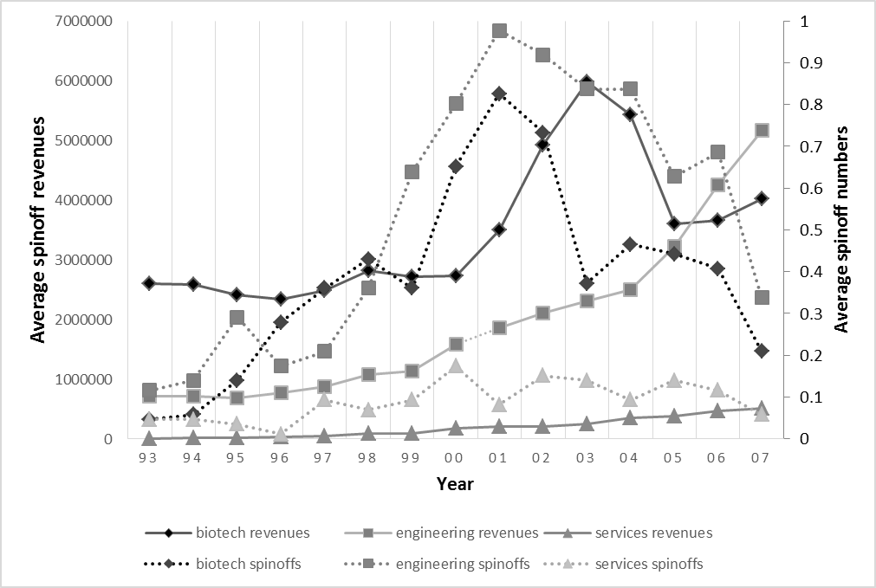
Figure 1A. TTO average spinoff revenues (GBP) and average spinoff numbers by economic activity in England and Scotland, 1993-2007

