Journal of Intelligent Material Systems

and Structures
Supplementary Materials

Magnetorheological Elastomer Peristaltic Fluid Conveying System for non-Newtonian Fluid with an Analogic Moisture Loss Process
Chenjun Wu, Qingxu Zhang, Xinpeng Fan, Yihu Song*, and Qiang Zheng*

MOE Key Laboratory of Macromolecular Synthesis and Functionalization, Department of Polymer Science and Technology, Zhejiang University, Hangzhou 310027, China
Fig. S1 Magnetic properties of the MRE applied in simulations. P.3
Fig. S2 Driving voltage with a period of 0.7 s and corresponding current in electromagnets 1 and 2. P.3
Fig. S3 Total pumped volume of the outflow, the backflow, and the net pumped volume of the MRE-PFCS for fluids with varied k and constant m (m = 0). P.4
Fig. S4 Net pumped volume of Newtonian fluids with the constant viscosity of 1.66 Pa·s and varied m during the first working cycle with the period of 0.7 s. Corresponding volume of the non-Newtonian fluids with the same values in viscosity at zero shear rate are also shown for comparison. P.5 Fig. S5 Net pumped volume of Bingham fluids with varied yield stress during the first working cycle with the period of 0.7 s P.6
Fig. S6 Maximum cell Reynolds number of the fluids in the MRE-PFCS P.7
Table S1 Geometric parameters of the MRE-PFCS P.8

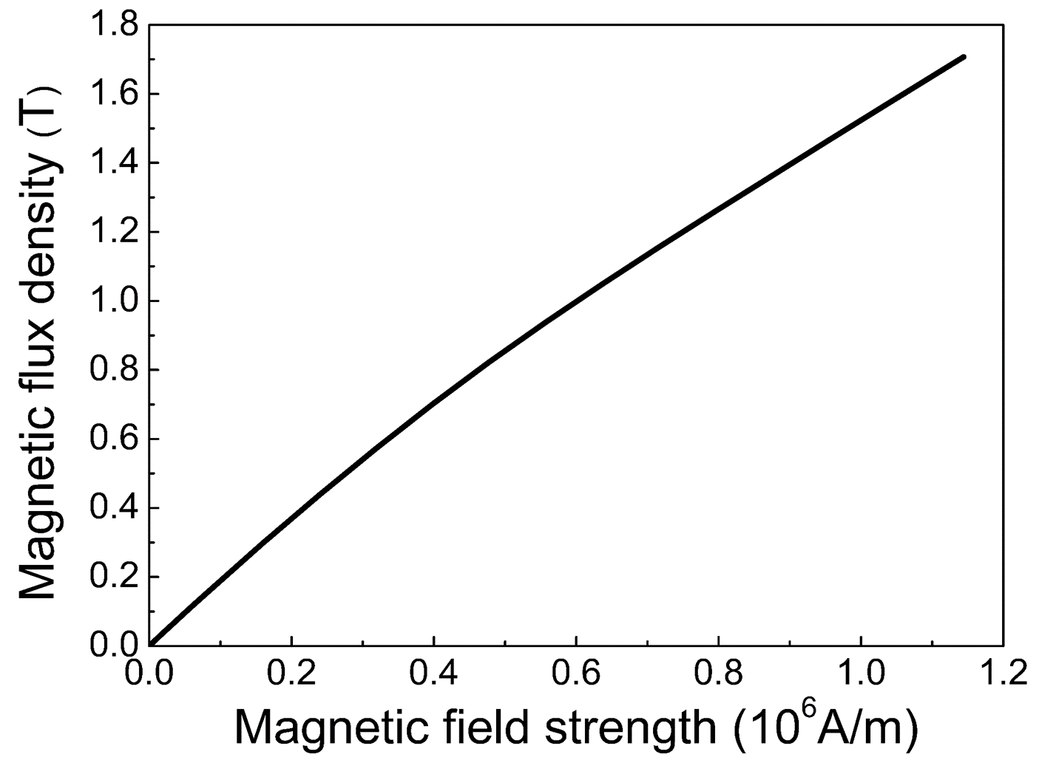
FIG. S1. Magnetic property of MRE applied in the simulation.
Fig. S1 shows magnetic property of magnetorheological elastomer (MRE) applied in simulation. MRE is a typical soft magnetic material with a narrow hysteresis loop thus a section of the loop is selected in the simulation.

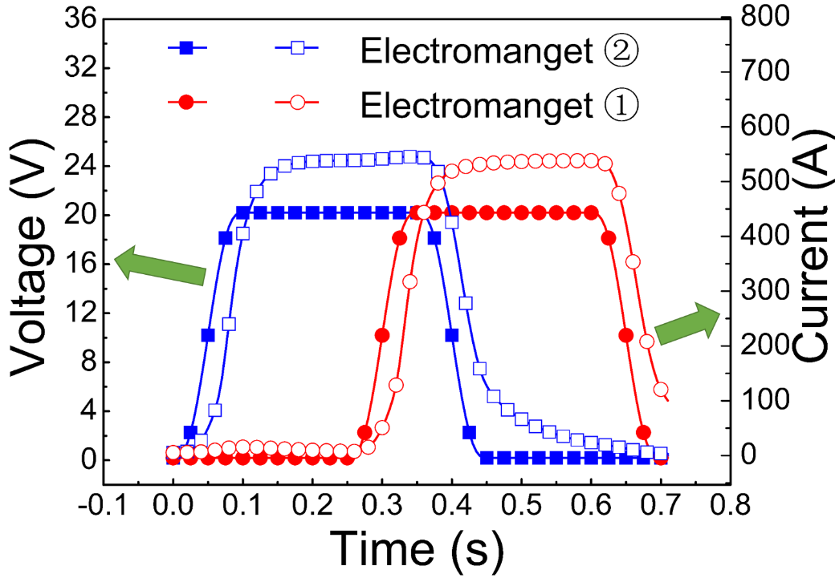
FIG. S2. Driving voltage with a period of 0.7 s and corresponding current in coils 1 and 2.
Fig. S2 illustrates driving voltage with a period of 0.7 s and corresponding current in coils 1 and 2. Obviously, the delay of the current to the voltage leads to the corresponding delay of the magnetization of the MRE tube to voltage.

FIG. S3. Total pumped volume of outflow and backflow, and the net pumped volume of the MRE-PFCS for fluids with varied k and constant m (m = 0).
Since parameter k plays an important role for the net pumped volume, m is fixed at zero. Fig. S3 shows total pumped volume of outflow and backflow, and the net pumped volume of the MRE-PFCS. The total pumped volumes of outflow and backflow are more pronounced with decreasing k. The net pumped volume is the Gaming result between the outflow and backflow. Hence, for the fluid with k = 0.1 and m = 0, the relatively high outflow and backflow lead to the lowest net pumped volume, as shown in Fig. 3.

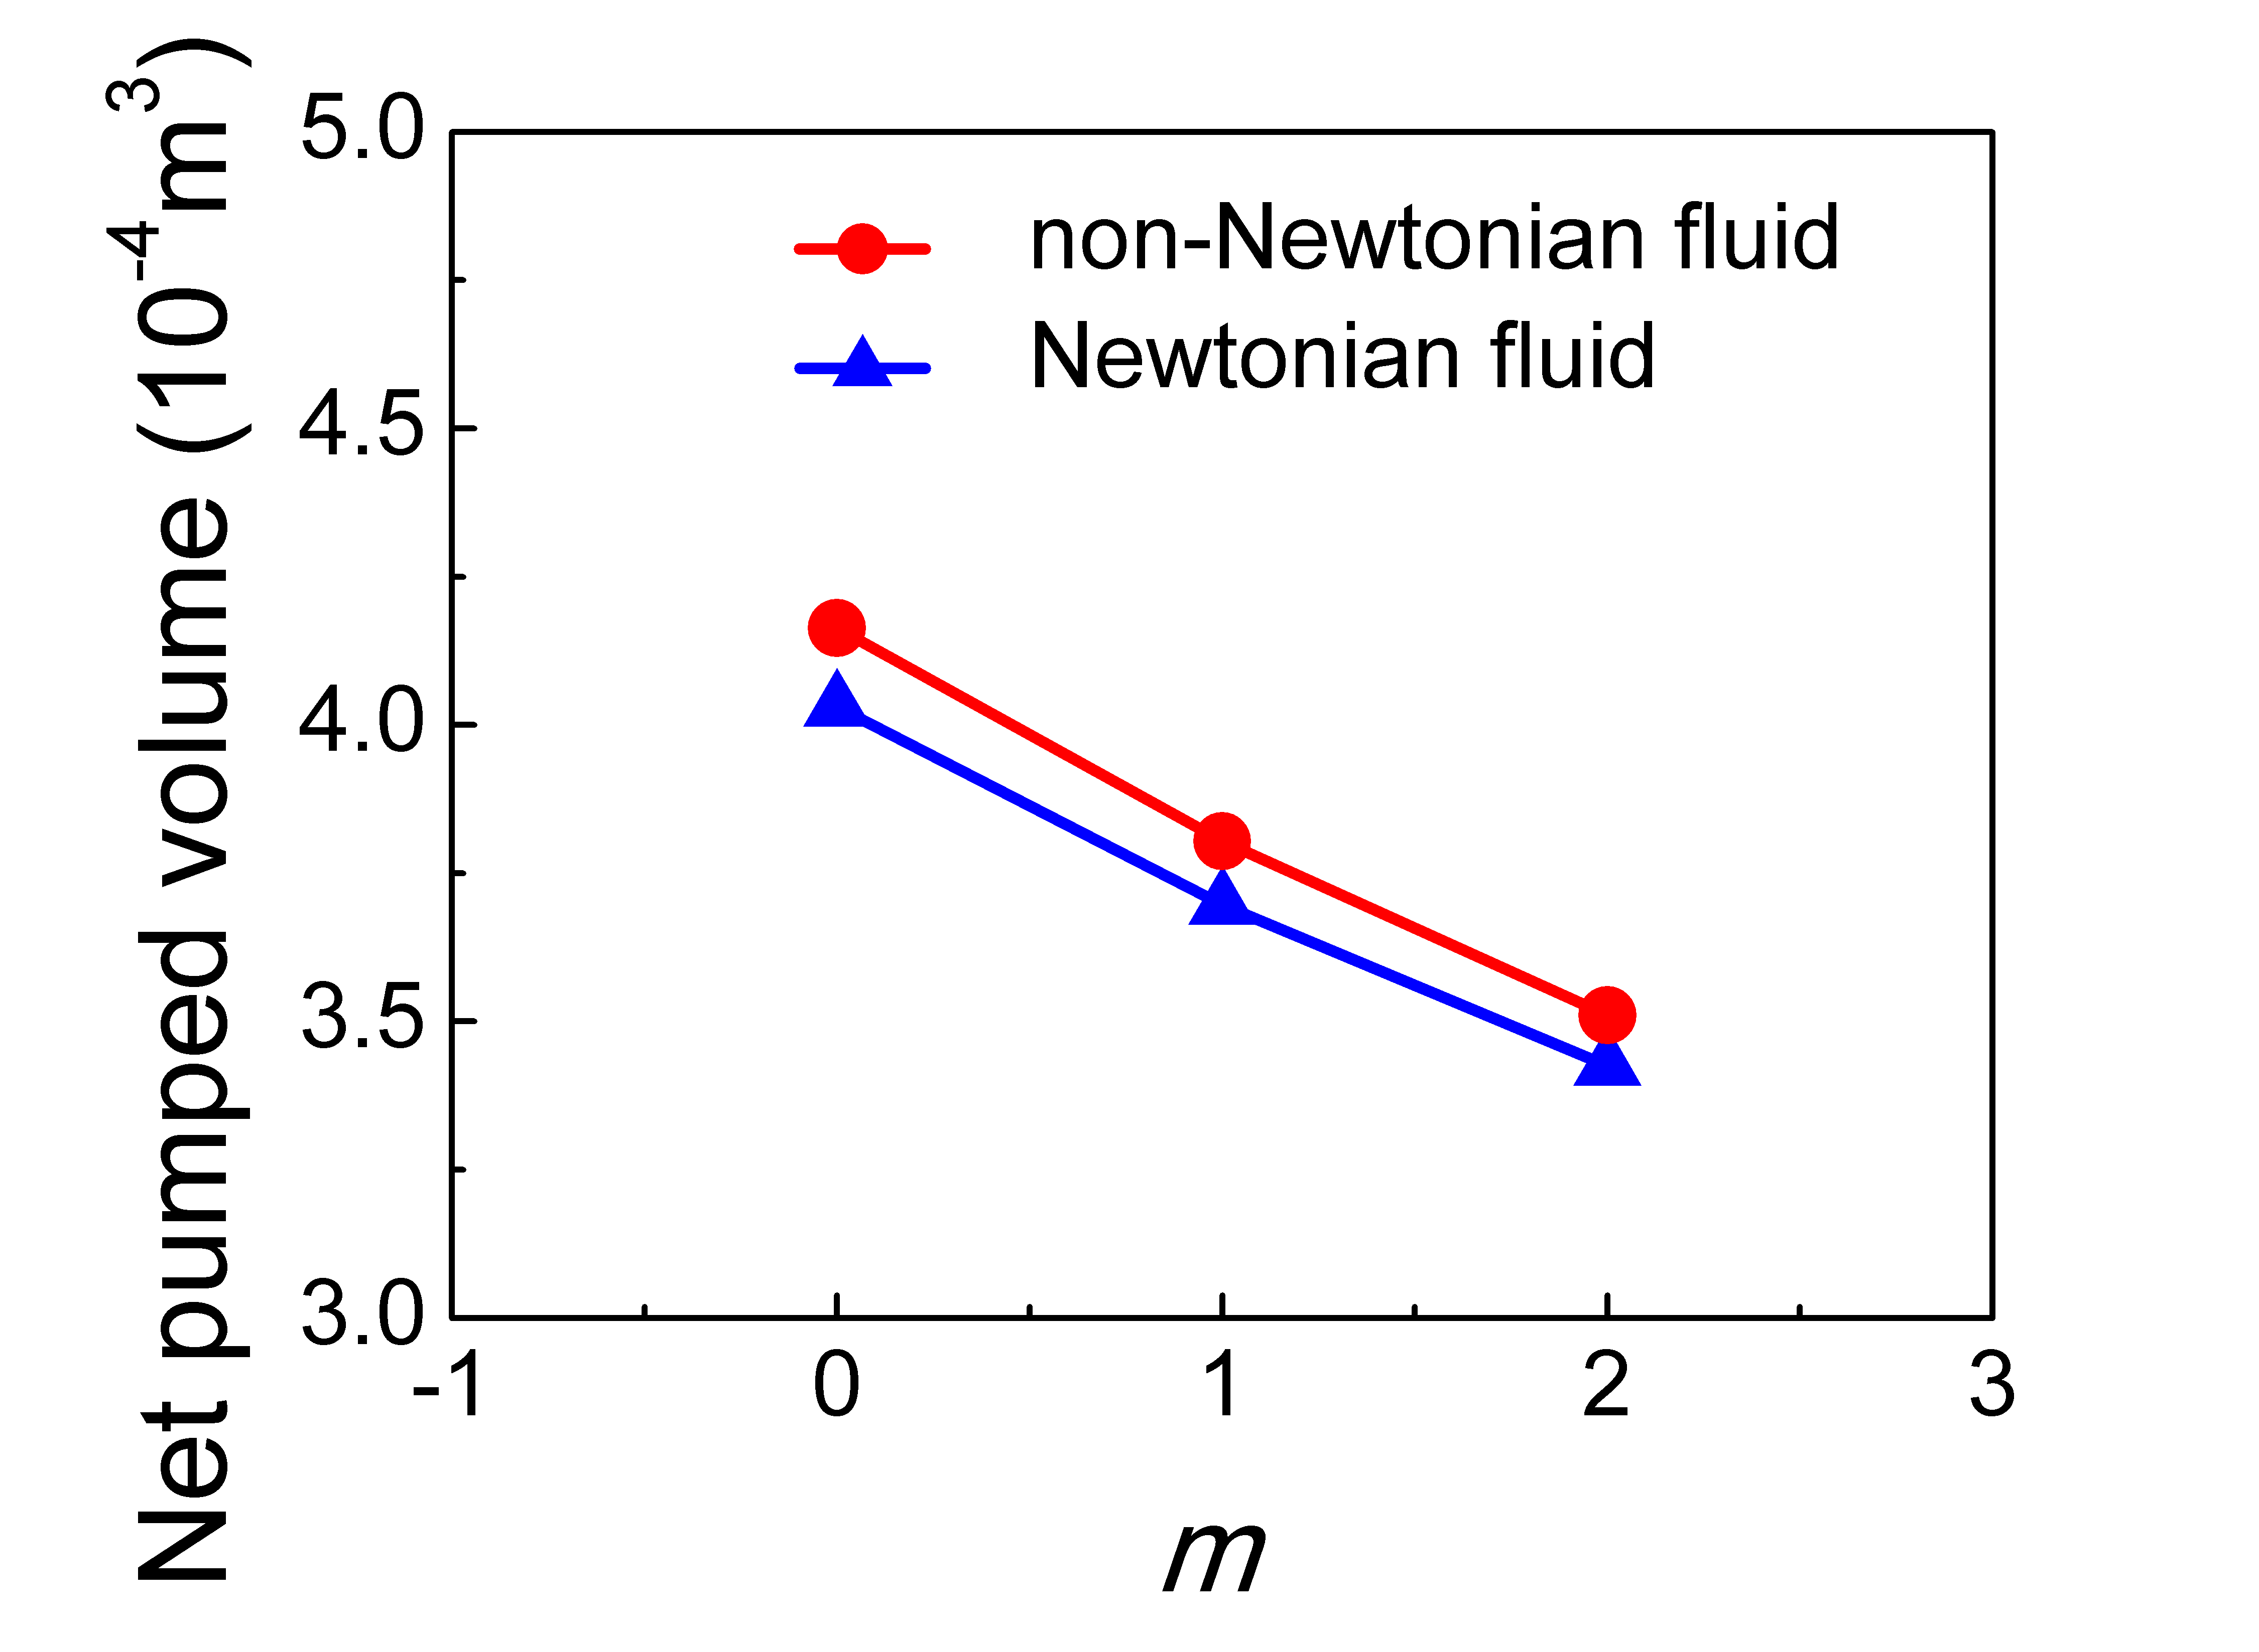
FIG. S4. Net pumped volume of Newtonian fluids with the constant viscosity of 1.66 Pa·s and varied m during the first working cycle with the period of 0.7 s. Corresponding volume of the non-Newtonian fluids with the same values in viscosity at zero shear rate are also shown for comparison.
The Newtonian fluids with a constant viscosity of $1.66 Pa·s$ and varied m, as the comparison in the analogic moisture loss process, is simulated. Fig. S4 illustrates the conveying performance of the MRE-PFCS for Newtonian and non-Newtonian fluids with the same viscosity at zero shear rate and varied m. The MRE-PFCS displays more superior in conveying the shear thinning fluid in comparison with the Newtonian fluid, which can be attributed to the lower viscosity of the shear thinning fluid. With increasing m, the net pumped volume declines for both Newtonian and non-Newtonian fluids.

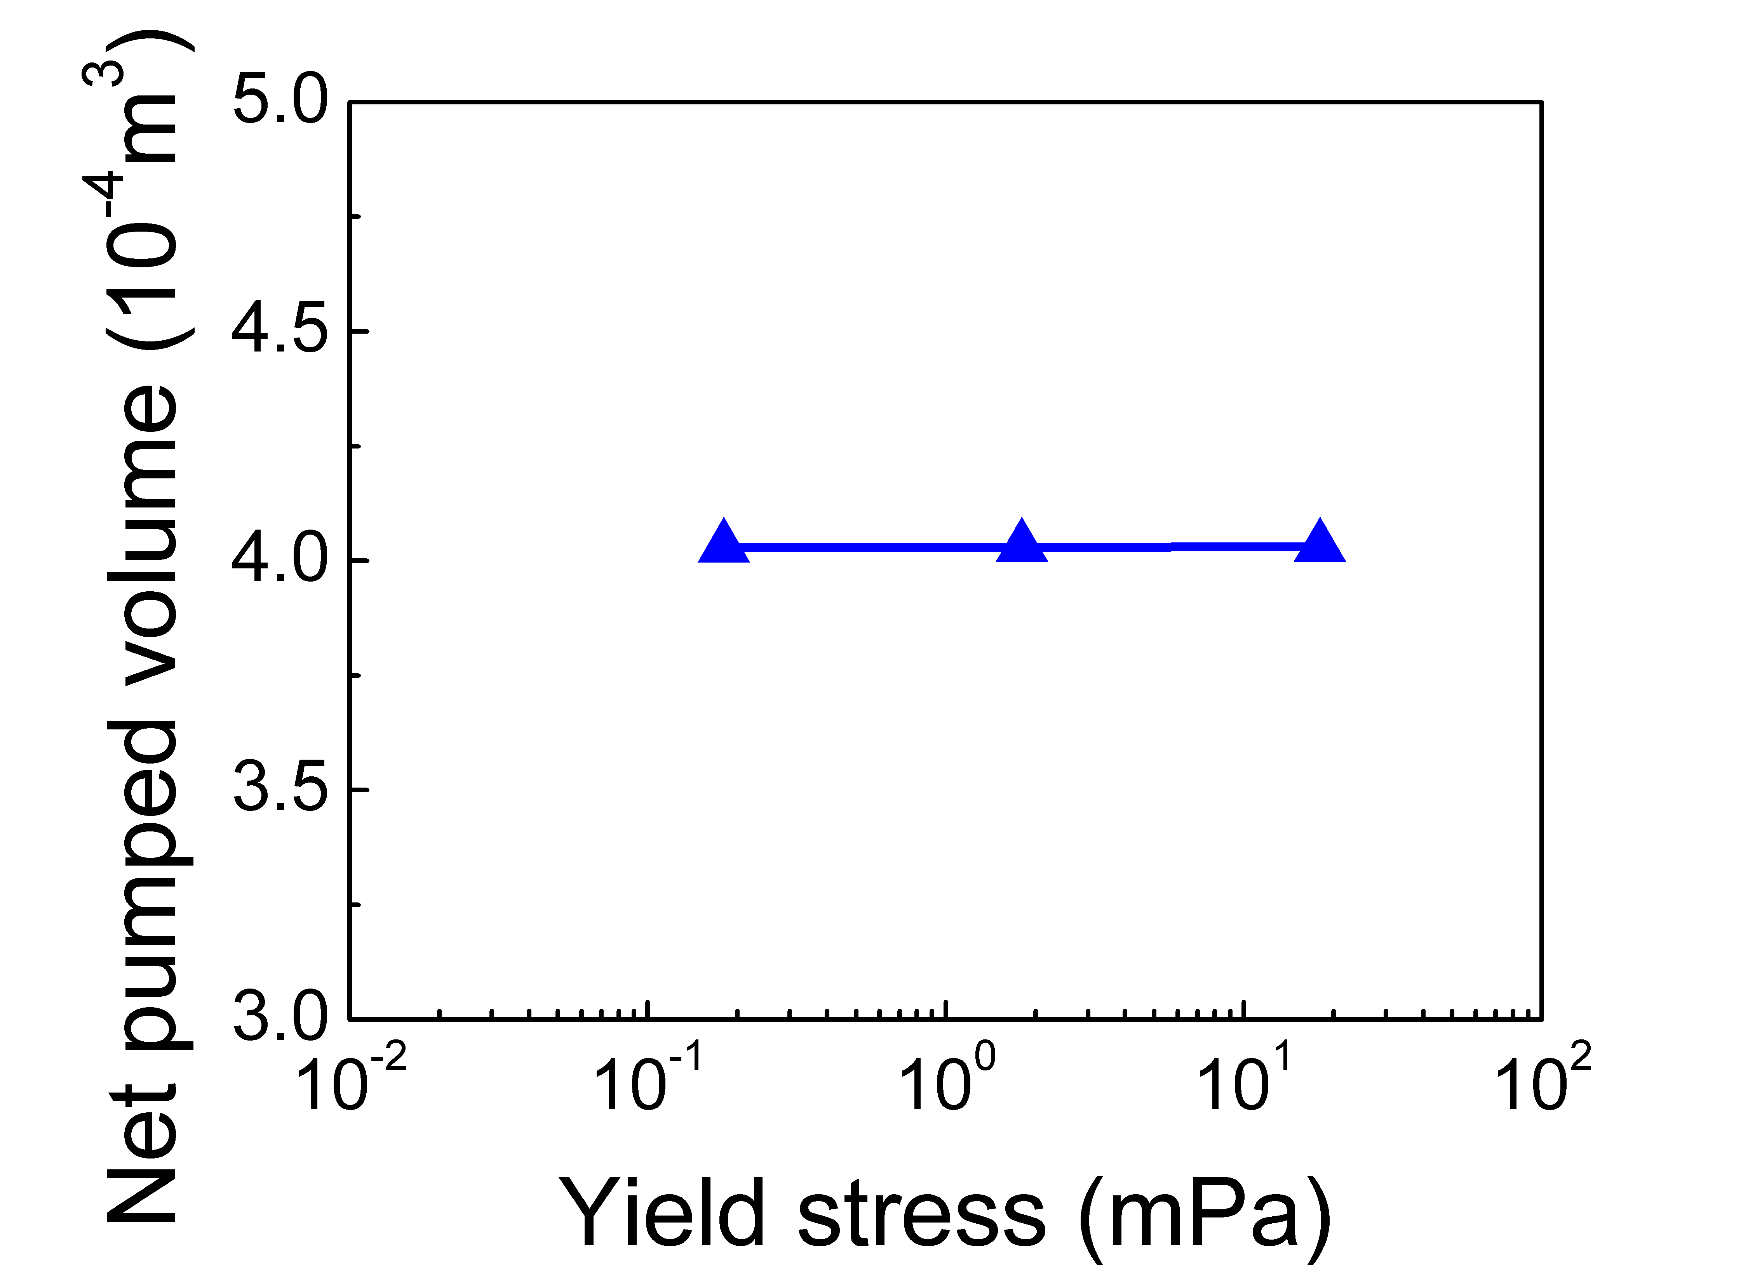
FIG. S5. Net pumped volume of Bingham fluids with varied yield stress during the first working cycle with the period of 0.7 s.
In the simulation, the rheological properties of Bingham fluids are characterized by Bingham-Papanastasiou model (Ellwood et al., 1990; Khan and Sultan, 2018; Papanastasiou, 1987)
$$τ=[η_{p}+\frac{τ_{y}\left(1-e^{-m_{p}\dot{γ}}\right)}{\dot{γ}}]\dot{γ}$$
where η_{p}, $\dot{γ}$, and $τ_{y}$ represent the plastic viscosity, the shear rate and the yield stress of the fluid, respectively.$m_{p}$ is the stress growth exponent. Typically, $m_{p}≥100$ is able to meet the requirements of the approximation of the ideal viscoplastic behaviour (Ellwood., 1990). Plastic viscosity is fixed at $1.66 Pa·s$. For sensitive fluids especially human blood, the yield stress is in the milli-Pascal scale (Picart et al., 1998). The values of $τ_{y}$ are taken as $0.18 mPa$, $1.8 mPa$, and $18 mPa$, respectively, to evaluate the performance of the MRE-PFCS in the Bingham fluid conveying. The period of the driving voltage is set at 0.7 s. The conveying performance of the MRE-PFCS for fluids with varied values of $τ_{y}$ is illustrated in Fig. S5. The results show that the net pumped volume of the Bingham fluids is independent on $τ_{y}$, verifying the capability of the MRE-BPFCS on the conveying for the fluids with yield stress
FIG. S6. Maximum cell Reynolds number of the fluids in the MRE-PFCS
Maximum cell Reynolds number of the fluids is calculated to quantitatively evaluate the ratio of inertia force to viscous force in the fluids, defined as follow
$$Re=\frac{ρvl}{u}$$
where ρ and $u$ are fluid density and vicosity, v is the magnitude of velocity, and l is the length of element. Fig. S6 shows the Maximum cell Reynolds number of the fluids calculated from 0 s to 0.7 s. The results show that both viscosity at zero shear rate (k) and moisture loss (m) affect the Maximum cell Reynolds number. However, the former plays a more important role. With increasing k, the values of Maximum cell Reynolds number reduces, resulting in feebler fluctuations observed in Fig. 3 (c, d, e). Similar trend is found in the relationship between m and Maximum cell Reynolds number.
Table S1. Geometric parameters of the PFCS
l_{m} | 320 mm
l_{c} | 150 mm
w_{c} | 30 mm
d_{i} | 40 mm
g | 10 mm
a_{o} | 50 mm
a_{i} | 40 mm
b_{o} | 12.5 mm
b_{i} | 6 mm
h | 11.5 mm

Reference
Ellwood KRJ, Georgiou GC, Papanastasiou TC, et al. (1990) Laminar jets of Bingham‐plastic liquids. Journal of Rheology 34(6): 787-812. DOI: 10.1122/1.550144
Khan NA and Sultan F (2018) Numerical Analysis for the Bingham-Papanastasiou Fluid Flow Over a Rotating Disk. Journal of Applied Mechanics and Technical Physics 59(4): 638-644. DOI: 10.1016/j.jnnfm.2013.09.006
Korte W. (2008) Cancer and thrombosis: an increasingly important association. Supportive Care in Cancer 16(3): 223-228. DOI: 10.1007/s00520-007-0376-y
Papanastasiou TC (1987) Flows of materials with yield. Journal of Rheology 31(5): 385-404. DOI: 10.1122/1.549926
Picart C, Piau J M, Galliard H, et al. (1998) Human blood shear yield stress and its hematocrit dependence. Journal of Rheology 42(1): 1-12.

